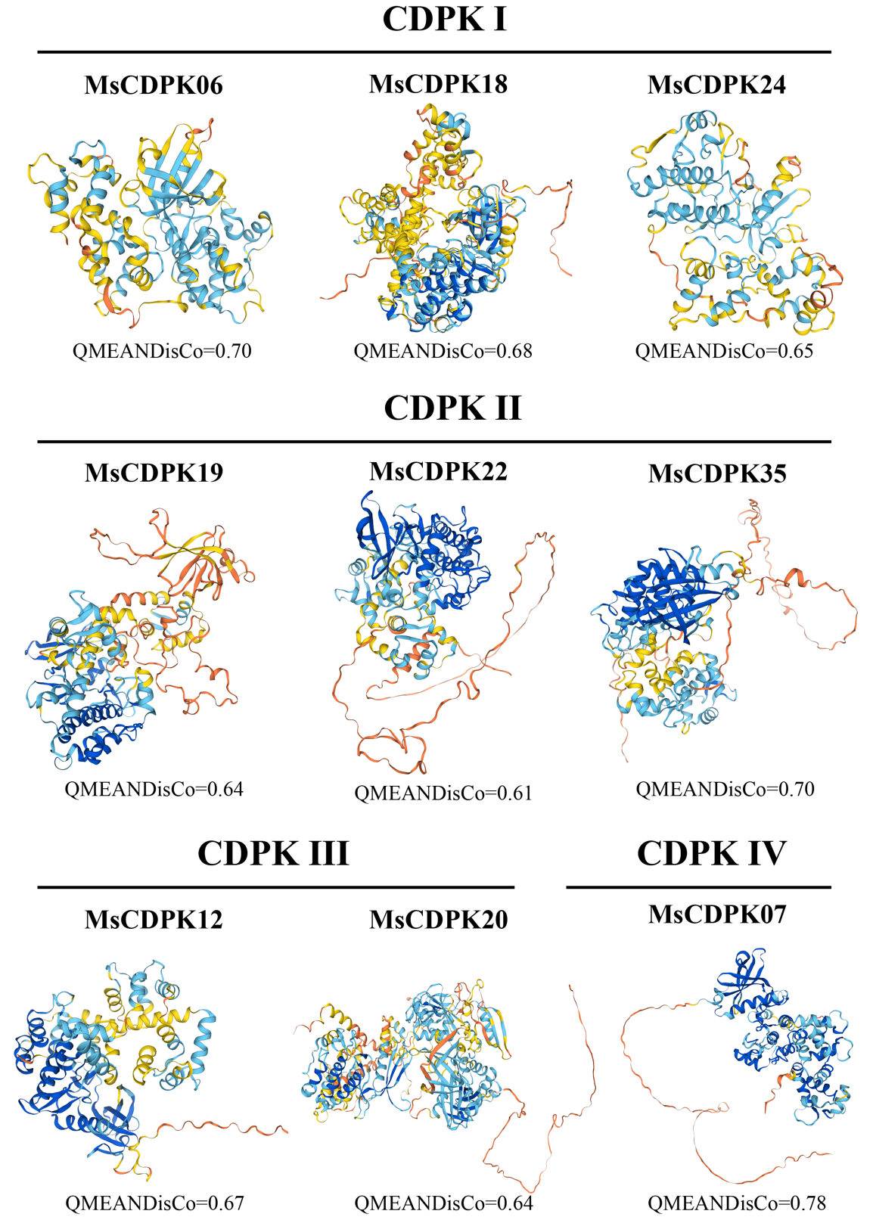
Fig. S1 Predicted 3D structures of MsCDPK proteins. The quality of these predicted models was assessed using the GMQE value.
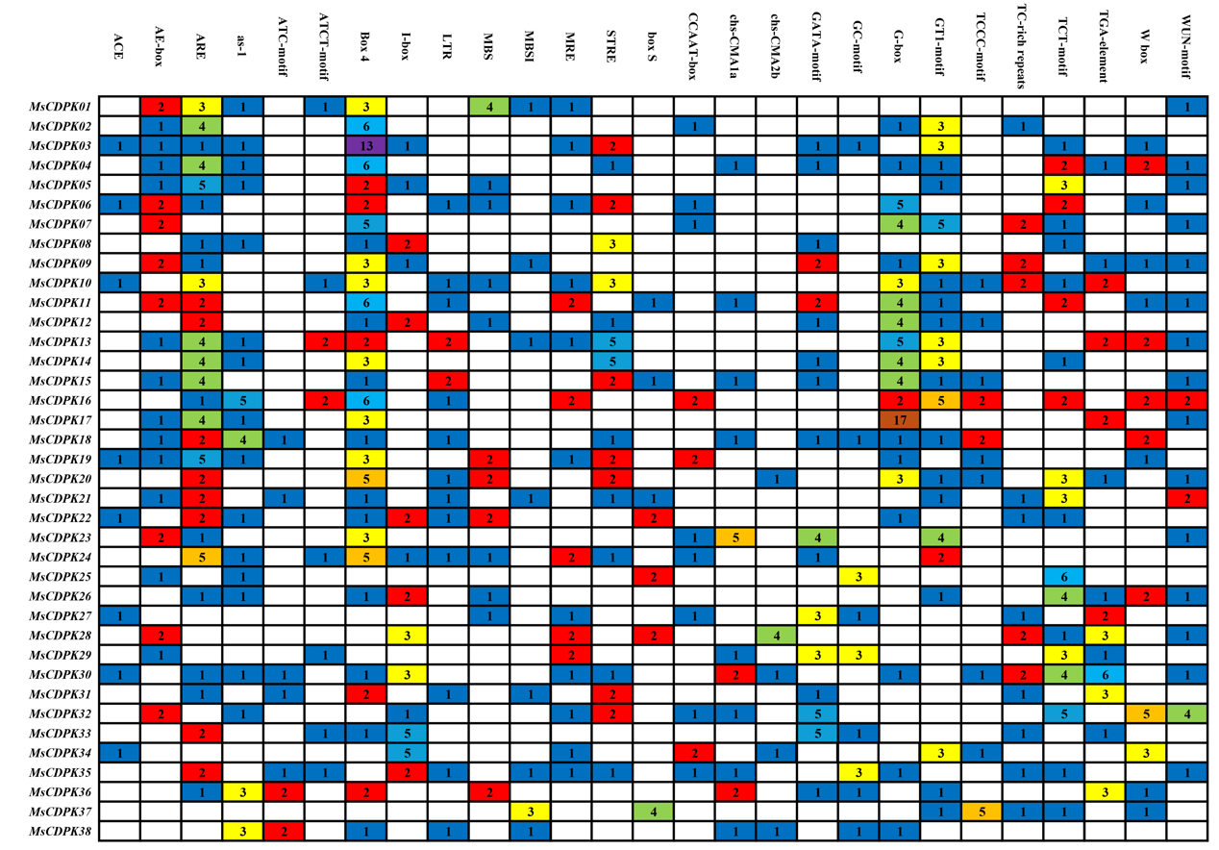
Fig. S2 Prediction of cis-acting elements in MsCDPK gene promoters. These cis-acting elements were identified by PlantCARE. The values in each square represent the number of each element in every gene.

