Supplementary Information

Model | JW-HD144N
Rated power (P_{max}) | 555 W
Open circuit voltage (V_{oc}) | 50.40 V
Short circuit current (I_{sc}) | 13.93 A
Maximum power voltage (V_{mpp}) | 42.20 V
Maximum power current (I_{max}) | 13.16 A
Bifaciality factor | 0.8
Supplementary Table 1: Electrical characteristics of the bifacial solar panels used in the APV systems

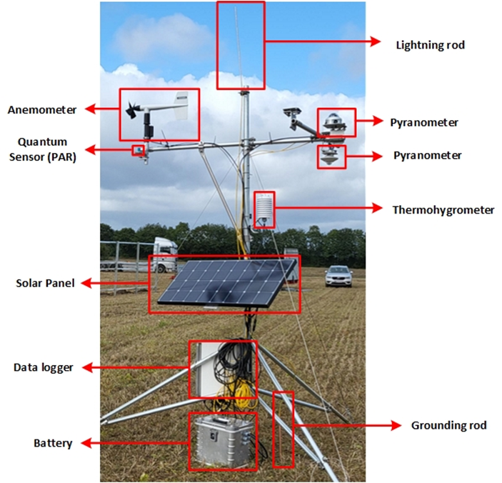
Supplementary Figure 1. Weather station.

Supplementary Note 1. Description of the model of electricity generation
We modelled the hourly electricity generation of both PV systems using pvlib [Anderson 2023] and in situ measurements of Global Horizontal Irradiance (GHI) and Diffuse Horizontal Irradiance (DHI). Parameters for the solar panels were obtained from its datasheet. The self-shadowing among solar panels is modelled using pvfactors [Anoma 2017] which implements two-dimensional view factors of the ground and sky to calculate incident irradiance on every surface at any time. For the monthly estimation, we used irradiance from the Typical Meteorological Year (TMY) obtained from PVGIS using satellite data (SARAH2) for the period 2005-2020. The code used for the modelling is available at https://github.com/martavp/agrivoltaic_foulum/blob/main/figure_paper.py

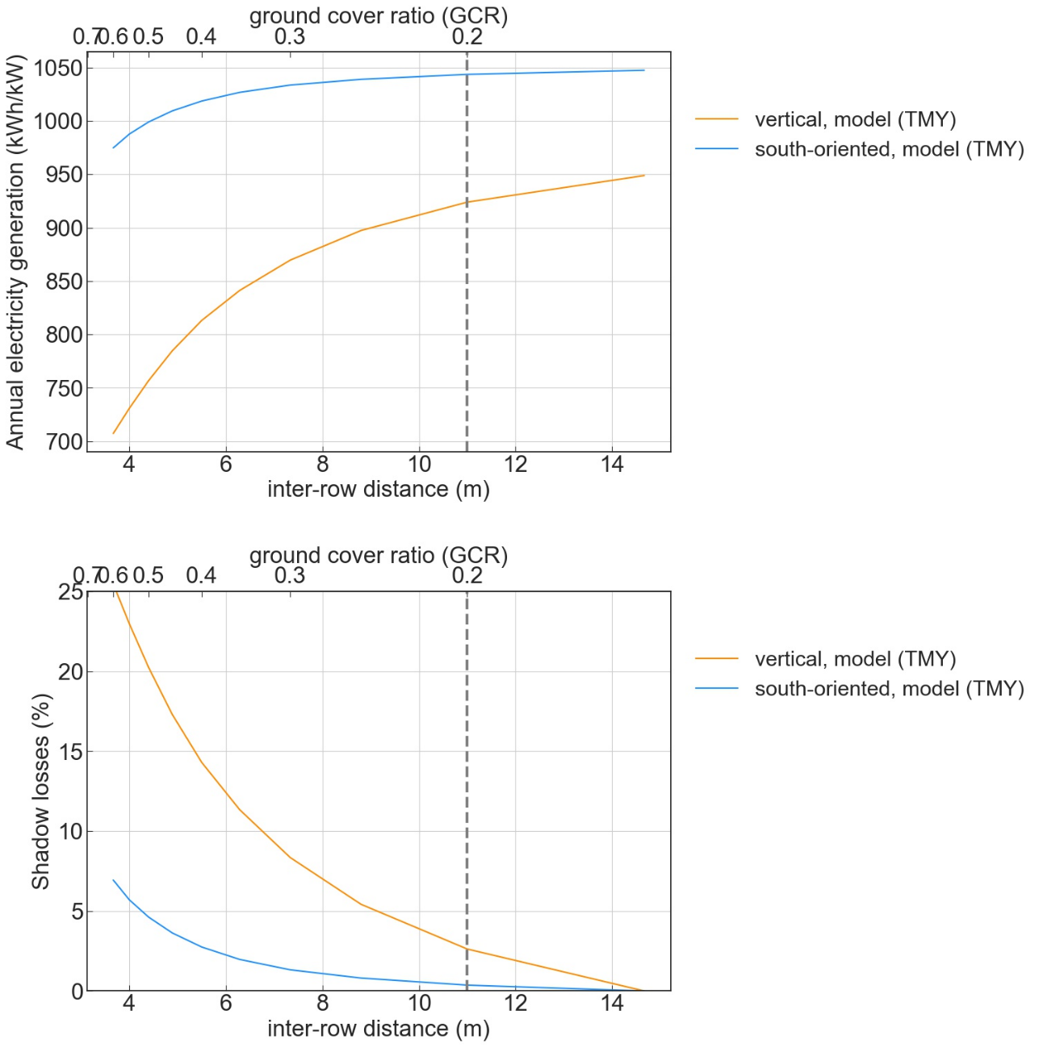
Supplementary Figure 2. (top) Annual electricity generation from vertical and south-oriented solar panels as a function of the inter-row distance (lower x-axis) and ground cover ratio, GCR (upper x-axis). (bottom) Annual losses due to self-shadowing for the vertical and south-oriented solar panels as a function of the inter-row distance (lower x-axis) and ground cover ratio, GCR (upper x-axis)

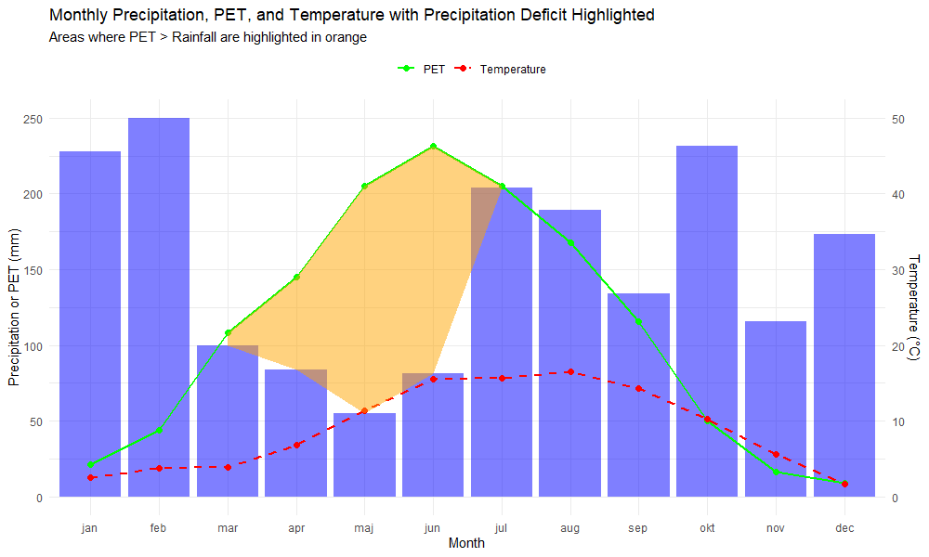
Supplementary Figure 3. Precipitation deficit.

Supplementary Note S3. Description of statistical analysis on the crops yield.
Statistical analyses were conducted using linear mixed-effects models to evaluate the effects of the solar panels’ configuration (vertical or south-oriented), location within the strip (outside vs. between solar panels), and their interactions on dry weight yields. The model included solar panels’ configuration, location, and product type (Grain, Grass-Clover, Straw) as fixed effects, with sub-strip (position relative to solar panels) treated as a random effect to account for the spatial variability within the fields’ main strip. Pairwise comparisons of estimated marginal means (EMMs) were performed using Tukey's HSD post-hoc test to identify significant differences in yields between the solar panels’ configuration. To specifically assess the potential impact of the solar panels’ configuration on the yields in the outside solar panel's location, contrasts were extracted and analyzed separately for each product type. These analyses were used to determine if pooling yield data across the setups was justified when calculating the Land Equivalent Ratio (LER). All statistical analyses were performed using R, with the lmerTest package used for mixed-effects modeling and the emmeans package for post-hoc comparisons. Significance was set at p < 0.05.

Supplementary Note S4. Description of the statistical analysis on leaf temperature, stomatal conductance and quantum efficiency of photosystem-II
Statistical analysis was performed using R software. Linear models were fitted, and residuals were assessed for normality using Q-Q plots and the Shapiro-Wilk test, as well as for homogeneity of variances using Bartlett's test. Pairwise comparisons were conducted with the “glht” function applying Tukey's method and adjusting for the False Discovery Rate (FDR). Post hoc analysis and visualizations were done using the “postHoc” package. For non-parametric data, differences among groups were evaluated using the Kruskal-Wallis test.

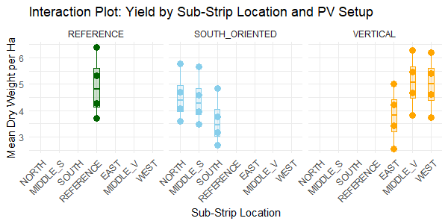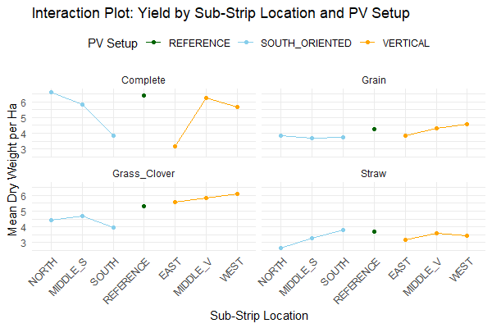Supplementary Figure 4. Interaction plot of overall crop yields for the two PV systems, compared to the open-field yield.

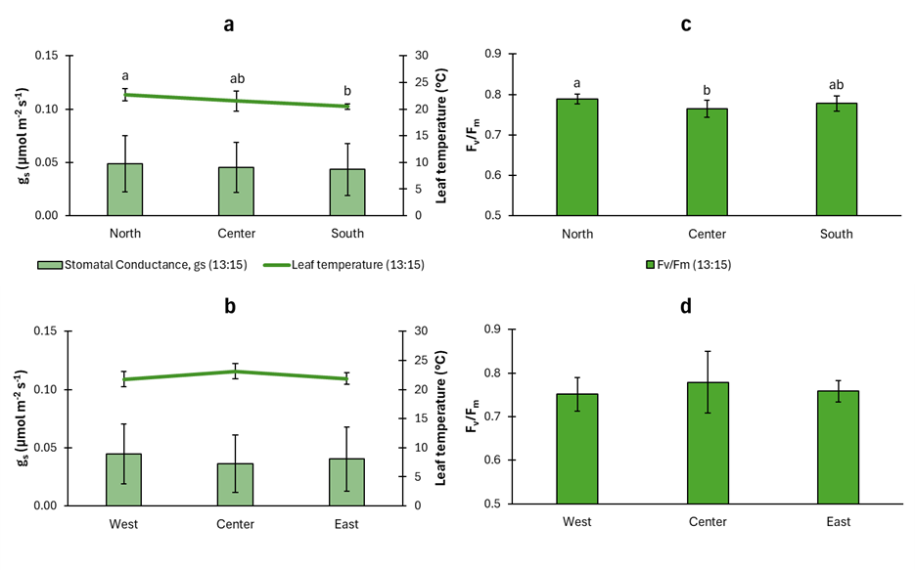Supplementary Figure 6: Measurements of stomatal conductance (gs, µmol m⁻² s⁻¹), leaf temperature (°C), and maximum quantum efficiency of photosystem-II (F_{v}/F_{m}) in different samples, measured in winter wheat at the open field. Panels (a) and (b) represent measurements taken at 13:15 in (a) the North, Center, and South locations, and (b) in the West, Center, and East locations (b). Panels (c) and (d) illustrate F_{v}/F_{m} values at the same locations. Stomatal conductance (g_{s}) is shown in solid bars, while leaf temperature is shown with solid lines. Data represents mean values and error bars represent standard deviation (10 samples were taken in each location). Different subscripts above the bars indicate significant differences between groups (p < 0.05). See Fig. 6 in the main text for values measured between the vertical and south-oriented solar panels.

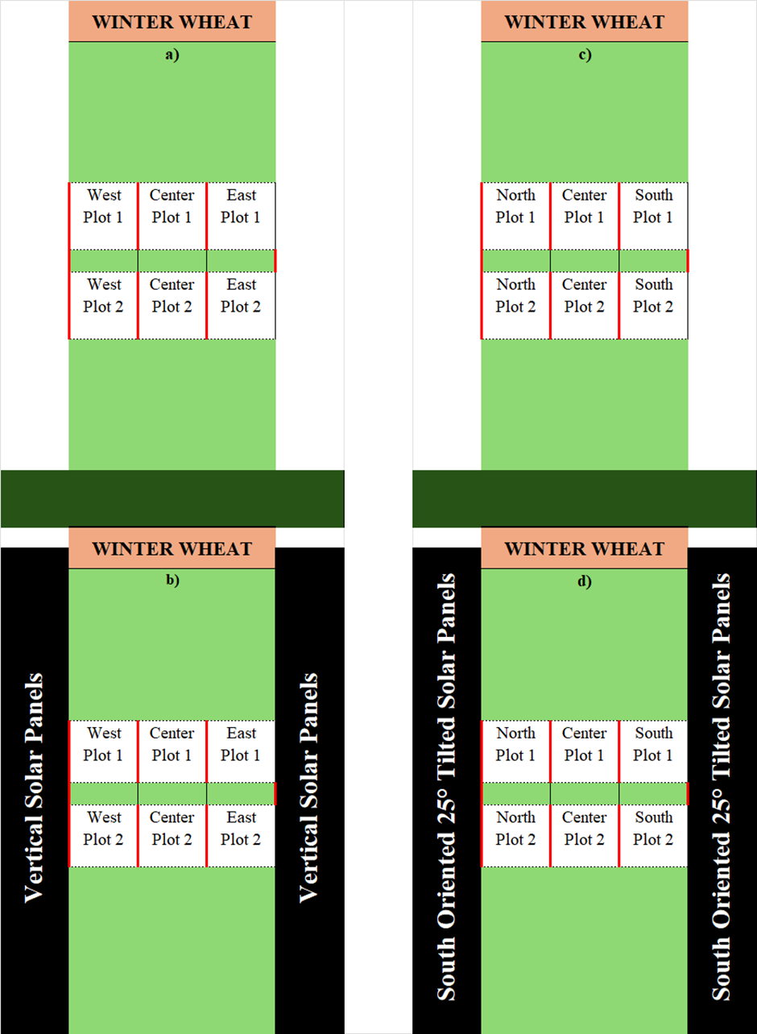
Supplementary Figure 7: Schematic layout of experimental plots for winter wheat growth in relation to photovoltaic (PV) panels. Plots a) and c) represent control sections without PV panels, while b) and d) show winter wheat grown between vertical solar panels and south-oriented tilted solar panels, respectively. Each subplot (West, Center, East) in a) and b); (North, Center, South) in c) and d) contains smaller divisions, where five plant replicates were measured per subplot. Measurements included leaf temperature, stomatal conductance, and maximum quantum efficiency of Photosystem II (F_{v}/F_{m}).

