Supplement
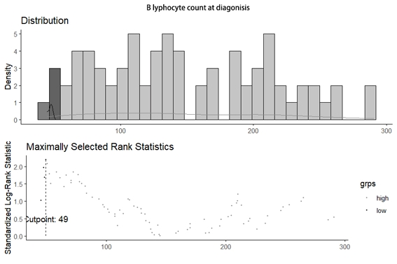
Figure 1. The optimal B lymphocyte count cutoff value was determined by using the surv_cutpoint function.

