Supplementary Information
3D printing of ultra-strong Co-free maraging steel via multifunctional alloy design

Hu Li^{1, 2}†, Shubo Gao³†, Kun Zhou^{3,*}, Liming Tan¹, Weiming Ji³, Liuliu Han⁴, Yong Liu^{1,*}

¹ State Key Laboratory of Powder Metallurgy, Central South University, Changsha 410083, China
² Center for Advanced Studies in Precision Instruments, Hainan University, Haikou 570228, China
³ Singapore Centre for 3D Printing, School of Mechanical and Aerospace Engineering, Nanyang Technological University, 50 Nanyang Avenue, Singapore 639798, Singapore
⁴ Max Planck Institute for Sustainable Materials, Max-Planck-Straße 1, 40237 Düsseldorf, Germany

*Corresponding authors: Y. Liu (yonliu@csu.edu.cn) and K. Zhou (kzhou@ntu.edu.sg).
†These authors contributed equally to this work.

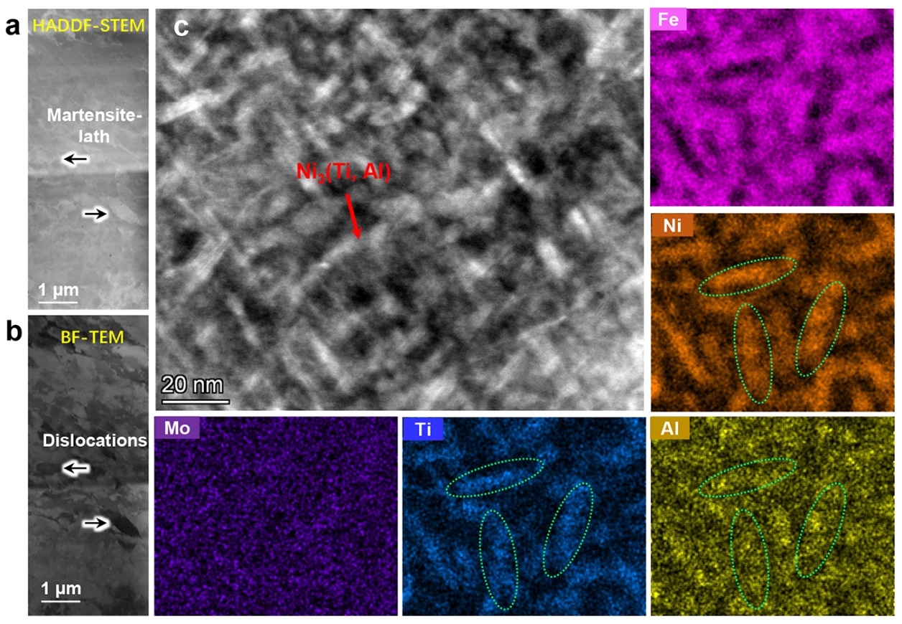
Supplementary Fig. 1. Microstructure and corresponding element distribution of MS1-HT sample. a, b Low-magnification of HADDF-STEM and BF-TEM images of MS1-HT maraging steel revealed the presence of fine lath martensite (~420 nm) and dislocations pile-up. c High-magnification of DF-TEM image and EDS show the nanoprecipitates enriched with nickel, titanium, and aluminum within the martensite lath.
Supplementary Fig. 2. Atomic resolution TEM images and APT analysis of MS1-HT sample. a HADDF-STEM images taken along the <111> zone axis. b A close-up image (inside the purple rectangle in a) shows a low lattice mismatch of 0.7% ± 0.05 between the martensite matrix and precipitates. The formula: was used to calculate the lattice mismatch. Here, a_{p} and a_{α} refer to the lattice constants of the precipitates and martensite matrix, respectively. c, d FFT analysis of the precipitates (inside rectangles in b) demonstrates superlattice diffraction outside the α diffraction spots, indicating the formation of L1₂ precipitates in martensite matrix. e Atomic-resolution EDS demonstrates that the precipitates are enriched with nickel, titanium, and aluminum elements. f A three-dimensional atom probe tomography was conducted on the MS1-HT sample at the iso-concentration surface slice. g Proximity histogram showing the composition distribution across the selected precipitates in f. h The partial elemental distribution of carbides reveals the regulatory effect of yttrium on impurities such as nitrogen in steel.
Supplementary Fig. 3. Engineering stress-strain curves and strain distributions of maraging steels under different conditions. a Engineering stress-strain curves of MS1-AP and MS2-AP maraging steels. The basic alloy was also presented for comparison. b Strain distribution maps of MS1-AP maraging steel at different strain stages were monitored by DIC. c Engineering stress-strain curves of MS3 alloy prepared using both traditional methods (casting and rolling) and LPBF processes, show that 3D printing technology has strict selectivity for alloy composition. d Comparison of mechanical properties between the tailored compositions (FeNiTiAlMoY) in this study and traditional maraging steels with different cobalt content: 12Co(13Ni-400)¹, 12Co(18Ni-350)², 9Co(18Ni300)³, and Co-free⁴.

Supplementary Fig. 4. Engineering stress-strain curves and raw material cost of heat-treated maraging steels. a Engineering stress-strain curves of MS1-HT and MS2-HT maraging steels. The inner illustration shows the change of Vickers hardness of MS1 and MS2 steels with different aging time. b Comparison of product of strength and elongation of maraging steels with different cobalt content and raw material cost.

Supplementary Fig. 5. The powder morphology and its particle size distribution of MS1 alloy. a, b Low- and high-magnification SEM of maraging steel powder. c Morphology of a powder at the cross-section, show the fine grain size (~ 1 μm). d The size distribution of powder and corresponding cumulative curves.

Supplementary Table 1. Composition of martensite matrix and austenite cell boundary of MS1-HT sample measured by APT (at.%).
Type | Fe | Ni | Mo | Ti | Al
Cell boundary | Bal. | 19.4 ± 2.3 | 3.6 ± 1.1 | 5.5 ± 1.1 | 0.4 ± 0.2
Matrix | Bal. | 7.6 ± 2.4 | 2.4 ± 2.1 | 0.3 ± 0.1 | 0.2 ± 0.1

Supplementary Table 2. Summary of thermal conductivity and mechanical properties of the maraging steels studied through 3D printing.
Steel | Thermal conductivity (W/(mK)) | Impact toughness (J) | Ultimate tensile strength  (MPa) | Yield strength  (MPa) | Elongation  (%) | Rockwell hardness  (HRC)
MS1-AP | 17.6 ± 0.6 | 28 ± 3.4 | 1303 ± 15 | 1008 ± 8 | 18.4 ± 0.8 | 41 ± 1
MS1-HT | 16.2 ± 0.4 | 11 ± 2.1 | 2294 ± 23 | 2015 ± 11 | 5.75 ± 0.1 | 56 ± 0.3
MS2-AP | 15.3 ± 0.6 | 21 ± 2.2 | 1143 ± 22 | 871 ± 15 | 11.9 ± 1.5 | 36 ± 0.9
MS2-HT | 12.2 ± 0.1 | 4 ± 1.2 | 1990 ± 5 | 1817 ± 18 | 2.5 ± 1.2 | 53 ± 0.6

References
1 Wang, S. et al. Regulating precipitation behavior in an ultrahigh-strength, high-molybdenum maraging steel via laser powder bed fusion. Scr. Mater. 252, 116245 (2024).
2 Wei, S. et al. Effect of heat treatment on the microstructure and mechanical properties of 2.4 GPa grade maraging steel fabricated by laser powder bed fusion. Addit. Manuf. 59, 103190 (2022).
3 Kučerová, L. et al. Microstructural characterisation and in-situ straining of additive-manufactured X3NiCoMoTi 18-9-5 maraging steel. Mater. Sci. Eng. A. 750, 70-80 (2019).
4 Riabov, D. et al. Design and characterization of a cobalt-free stainless maraging steel for laser-based powder bed fusion. Mater. Des. 223, 111180, 111180 (2022).

