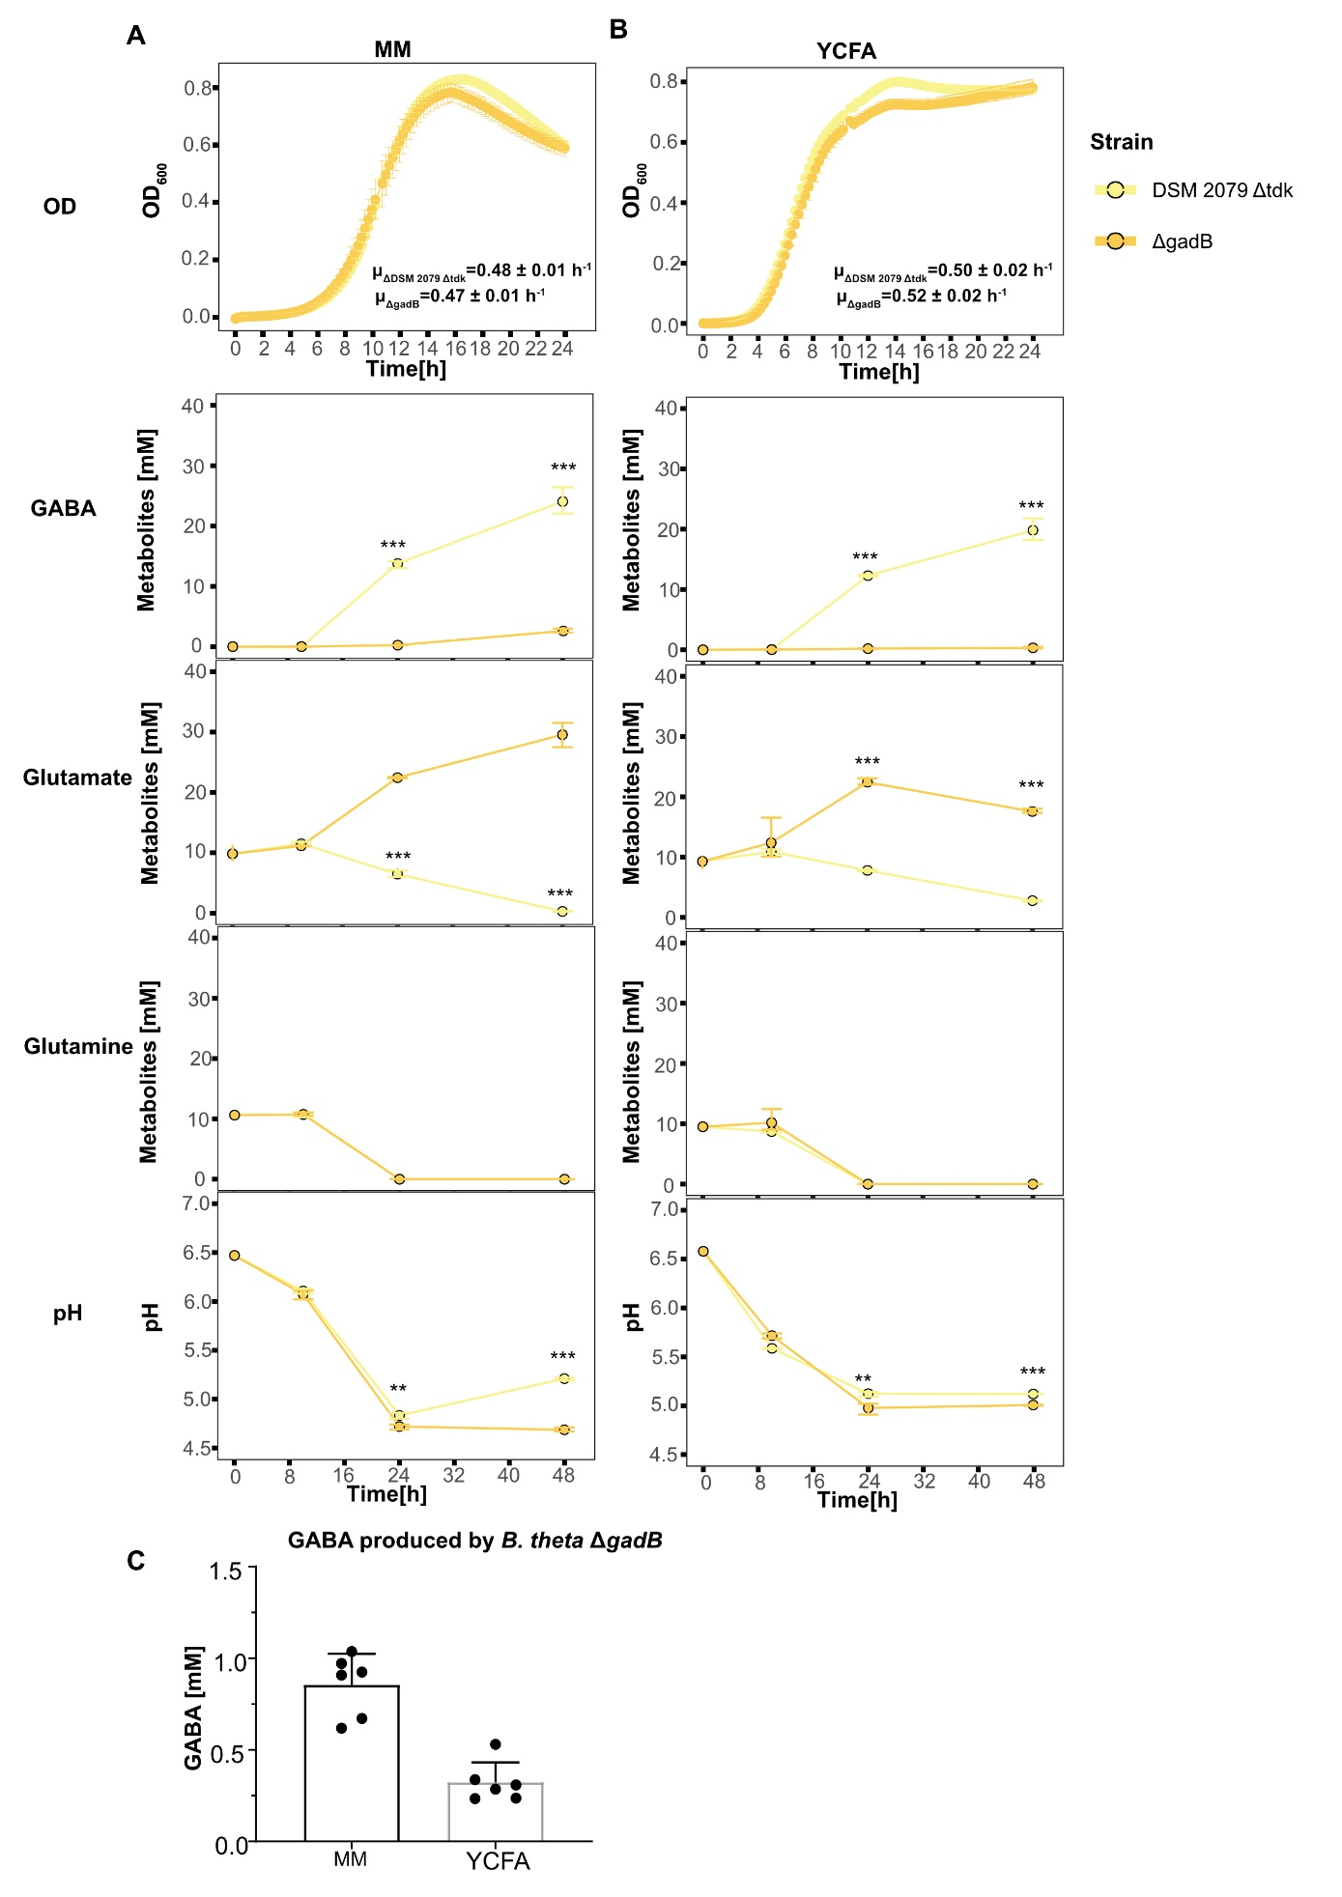
Supplementary Fig. 1 Comparison of growth and metabolic activity of B. theta DSM 2079 Δtdk and B. theta ΔgadB. (A-B) Growth and metabolic activity of B. theta DSM 2079 Δtdk and B. theta ΔgadB in MM supplemented with 10 mM glutamate and 10 mM glutamine (A) and YCFA with 10 mM glutamine (B). (C) GABA levels produced by B. theta ΔgadB in MM with 10 mM glutamate and 10 mM glutamine and YCFA with 10 mM glutamine after 48 h measured with GABA ELISA kit. An unpaired t test was performed on OD, metabolites and pH to test the significance between B. theta DSM 2079 Δtdk and B. theta ΔgadB. * p<0.05, ** p<0.01 and *** p<0.001.

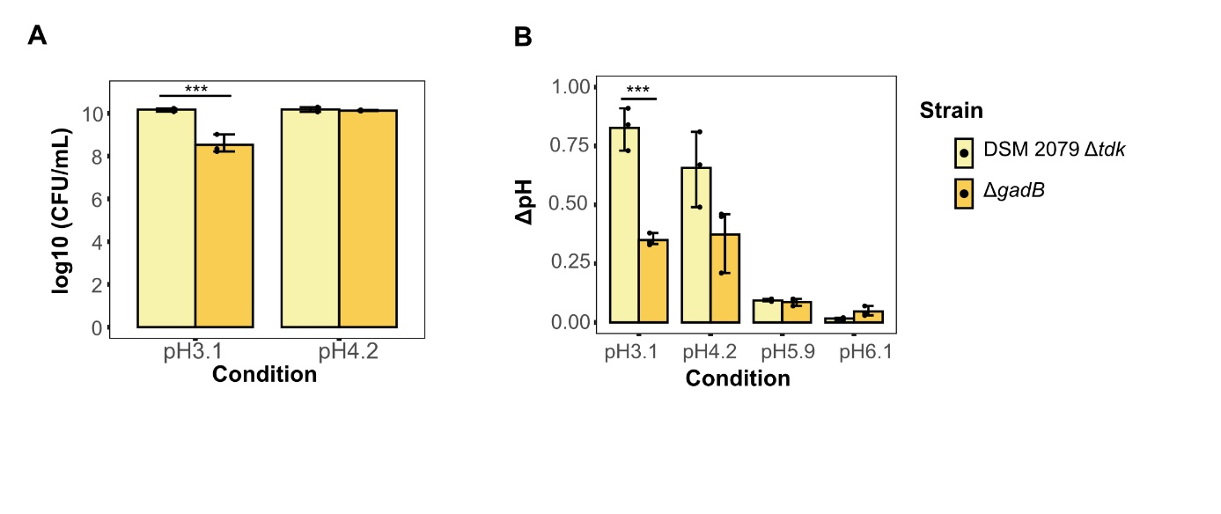
Supplementary Fig. 2 Functionality of gadB in acid stress in B. theta DSM 2079 Δtdk and B. theta ΔgadB. (A-B) Viable cell counts (CFU) measured by plating methods (A) and shift of pH (B) when B. theta DSM 2079 Δtdk and B. theta ΔgadB were exposed to pH 3.1, 4.2, 5.9 and 6.1 for 1 hour in MM supplemented with 10 mM glutamate. An unpaired t test was performed on CFU and ΔpH to test the significance between B. theta DSM 2079 Δtdk and B. theta ΔgadB. * p<0.05, * * p<0.01 and *** p<0.001.
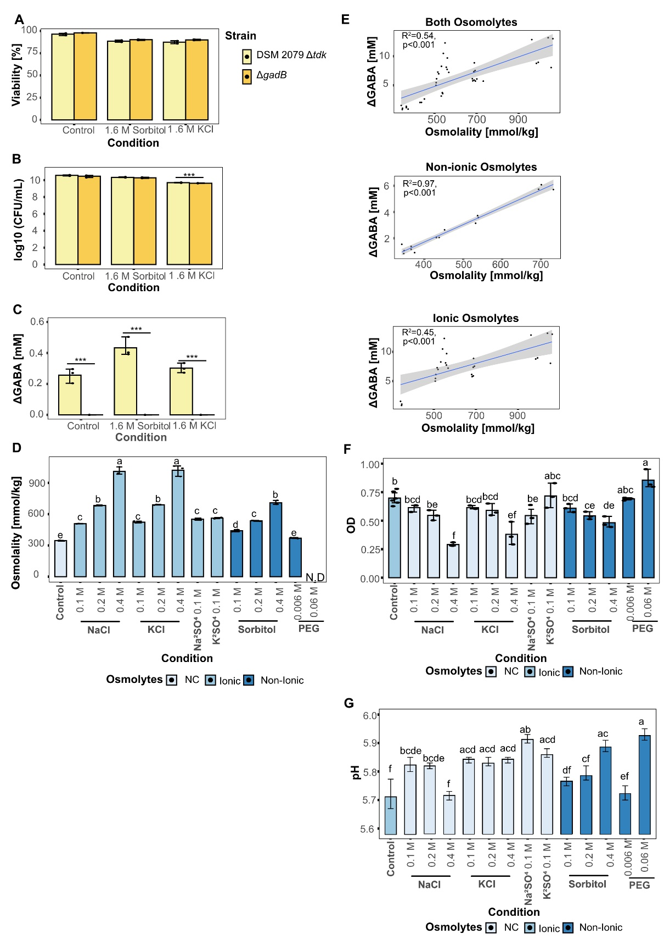
Supplementary Fig. 3 Modulation of GABA production by osmotic stress in B. theta. (A-C) Viability by flow cytometry (A), viable cell counts by plating (B), GABA production (C) by B. theta DSM 2079 Δtdk and B. theta ΔgadB exposed to osmotic stress induced by 1.6 M KCl or sorbitol in MM supplemented with 10 mM glutamate for 2 h at pH 5.5. (D) Osmolality value in the YCFA supplemented with 40 mM glutamate with a range of ionic and non-ionic osmolytes. (E) Correlation of GABA concentration produced by B. theta DSM 2079 after 48 h and media osmolality. (F-G) End OD (F) and pH (G) value of B. theta DSM 2079 grown in the YCFA supplemented with 40 mM glutamate with a range of ionic and non-ionic osmolytes after 48 h. An unpaired t test was performed on viability (A), CFU (B) and ΔGABA (C) to test the significance between B. theta DSM 2079 Δtdk and B. theta ΔgadB. One-way ANOVA was performed on the osmolality (D), OD (F) and pH (G) to determine the main effects of condition, followed by Tuckey’s test for post-hoc analysis to correct for multiple comparisons. Different letters indicate significant differences. * p<0.05, ** p<0.01, *** p<0.001, and **** p<0.0001.

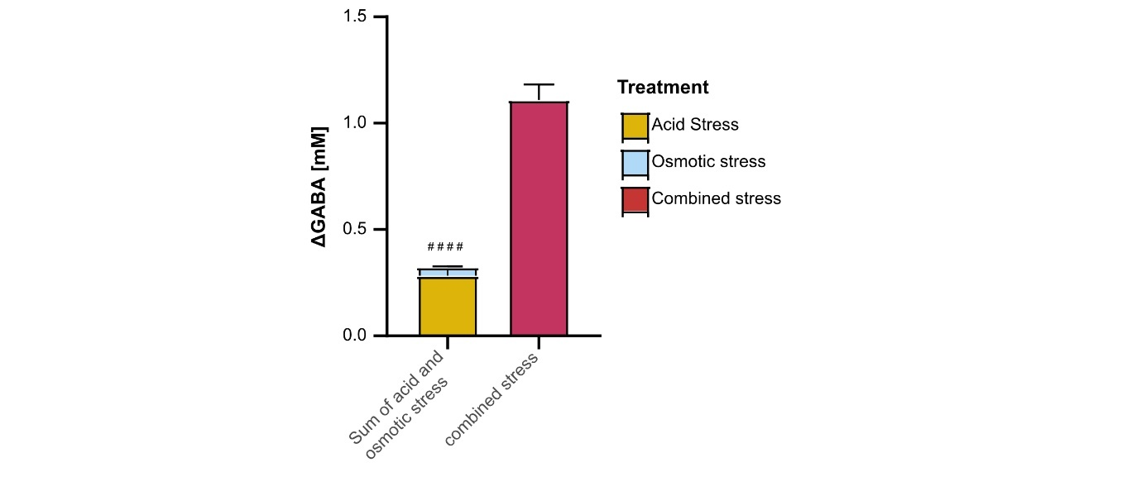
Supplementary Fig. 4 Comparison of GABA production by B. theta DSM 2079 under acid and osmotic stress and combined stress in Fig 1C. Comparison of statistics sum of ΔGABA in acid and osmotic stress conditions and ΔGABA in combined stress. Data were presented as mean and ±SD of three replicates. An unpaired t test was performed on ΔGABA. # p<0.05, ## p<0.01, ### p<0.001 and #### p<0.0001.

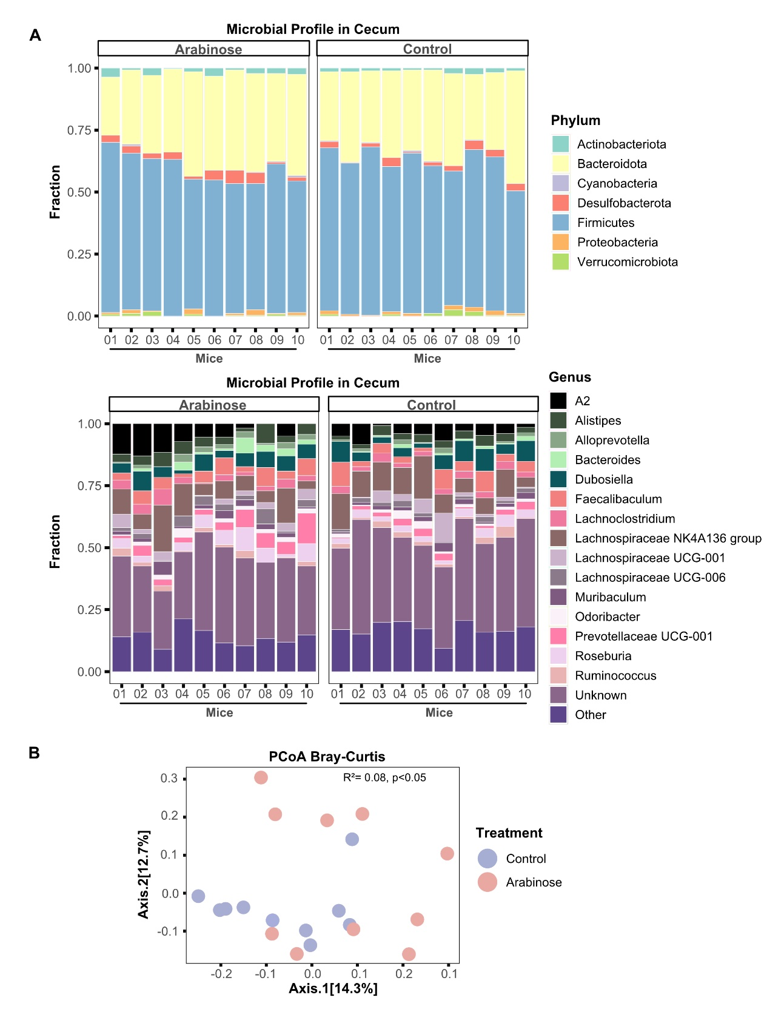
Supplementary Fig. 5 Impact of arabinose induced pH reduction on cecal microbial community in SPF mice. (A-B) Comparison of microbial profile at phylum and genus levels (A) and PCoA analysis (B) using Bray-Curtis distance between control and arabinose treatment group (n=10 in both groups). Microbial communities were compared between control and arabinose group in PCoA analysis through permutational multivariate analysis of variance (PERMANOVA).
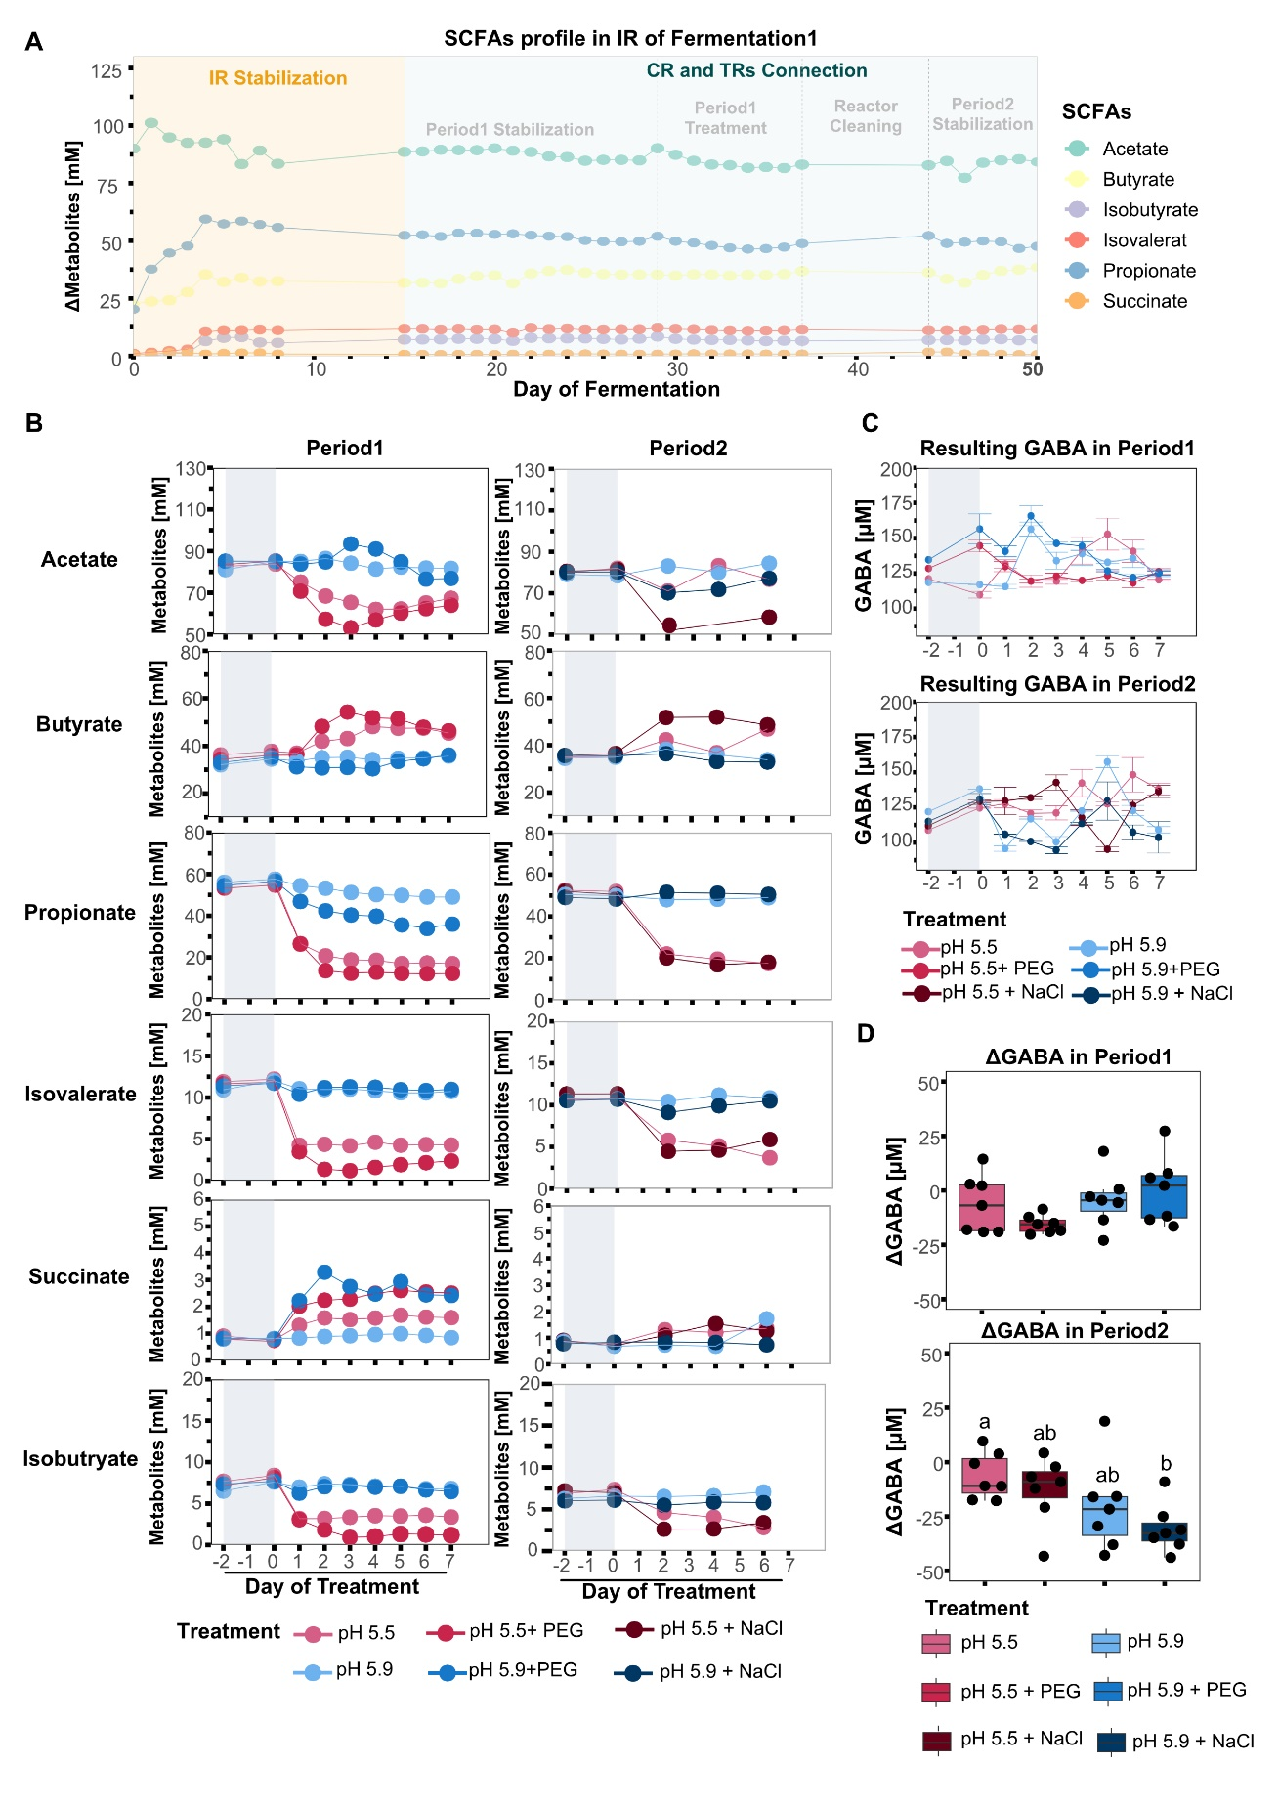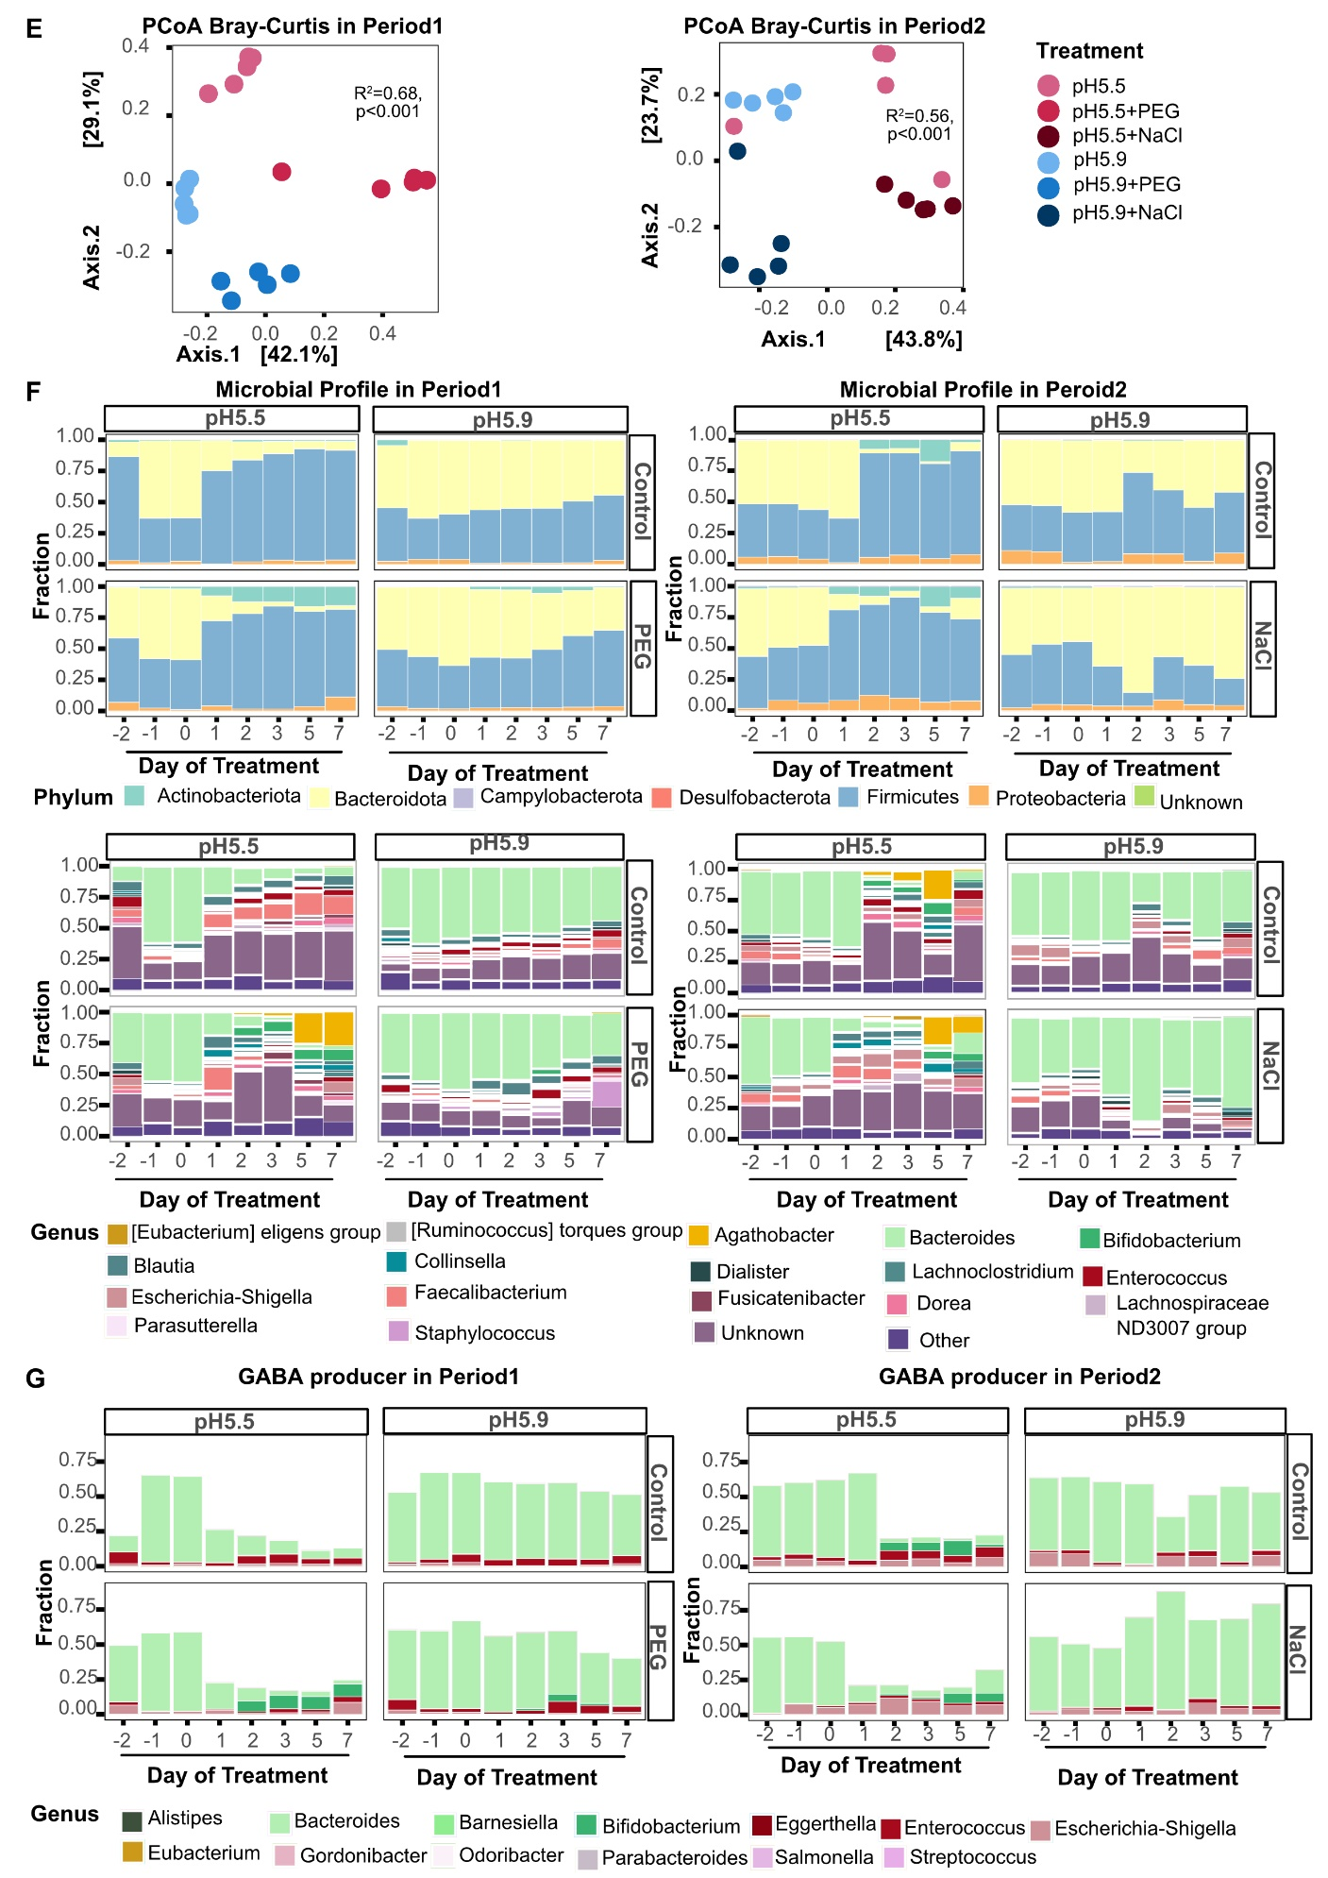
Supplementary Fig. 6 Effect of pH and osmolality on metabolites and microbial composition in PolyFermS under representative proximal colon conditions. (A) Profile of SCFAs and intermediates in IR over Fermentation1. (B-C) Shift of SCFAs, intermediates (B) and resulting GABA (C) in CR and TRs after application of acid (in both periods: 5.9 for normal pH, and 5.5. for low pH) and/or osmotic stress (0.042M PEG in Period1, and 0.1 M NaCl in Period2). (D) Boxplot of ΔGABA levels in Period1 (top panel) an Period2 (bottom panel) from Day 1 to 7. ΔGABA corresponds to medium-corrected GABA concentrations. (E) PCoA analysis using Bray-Curtis distance to compare the microbial communities after acid and osmotic stress in both periods through PERMANOVA. (F-G) Shift of microbial profile (phylum and genus level, F) and GABA producers (G) in CR and TRs after application of acid and osmotic stress in both periods. Repeated measures one-way ANOVA was performed on ΔGABA to determine the main effects of treatment (D), followed by Tuckey’s test for post-hoc analysis to correct for multiple comparisons. Different letters indicate significant differences.
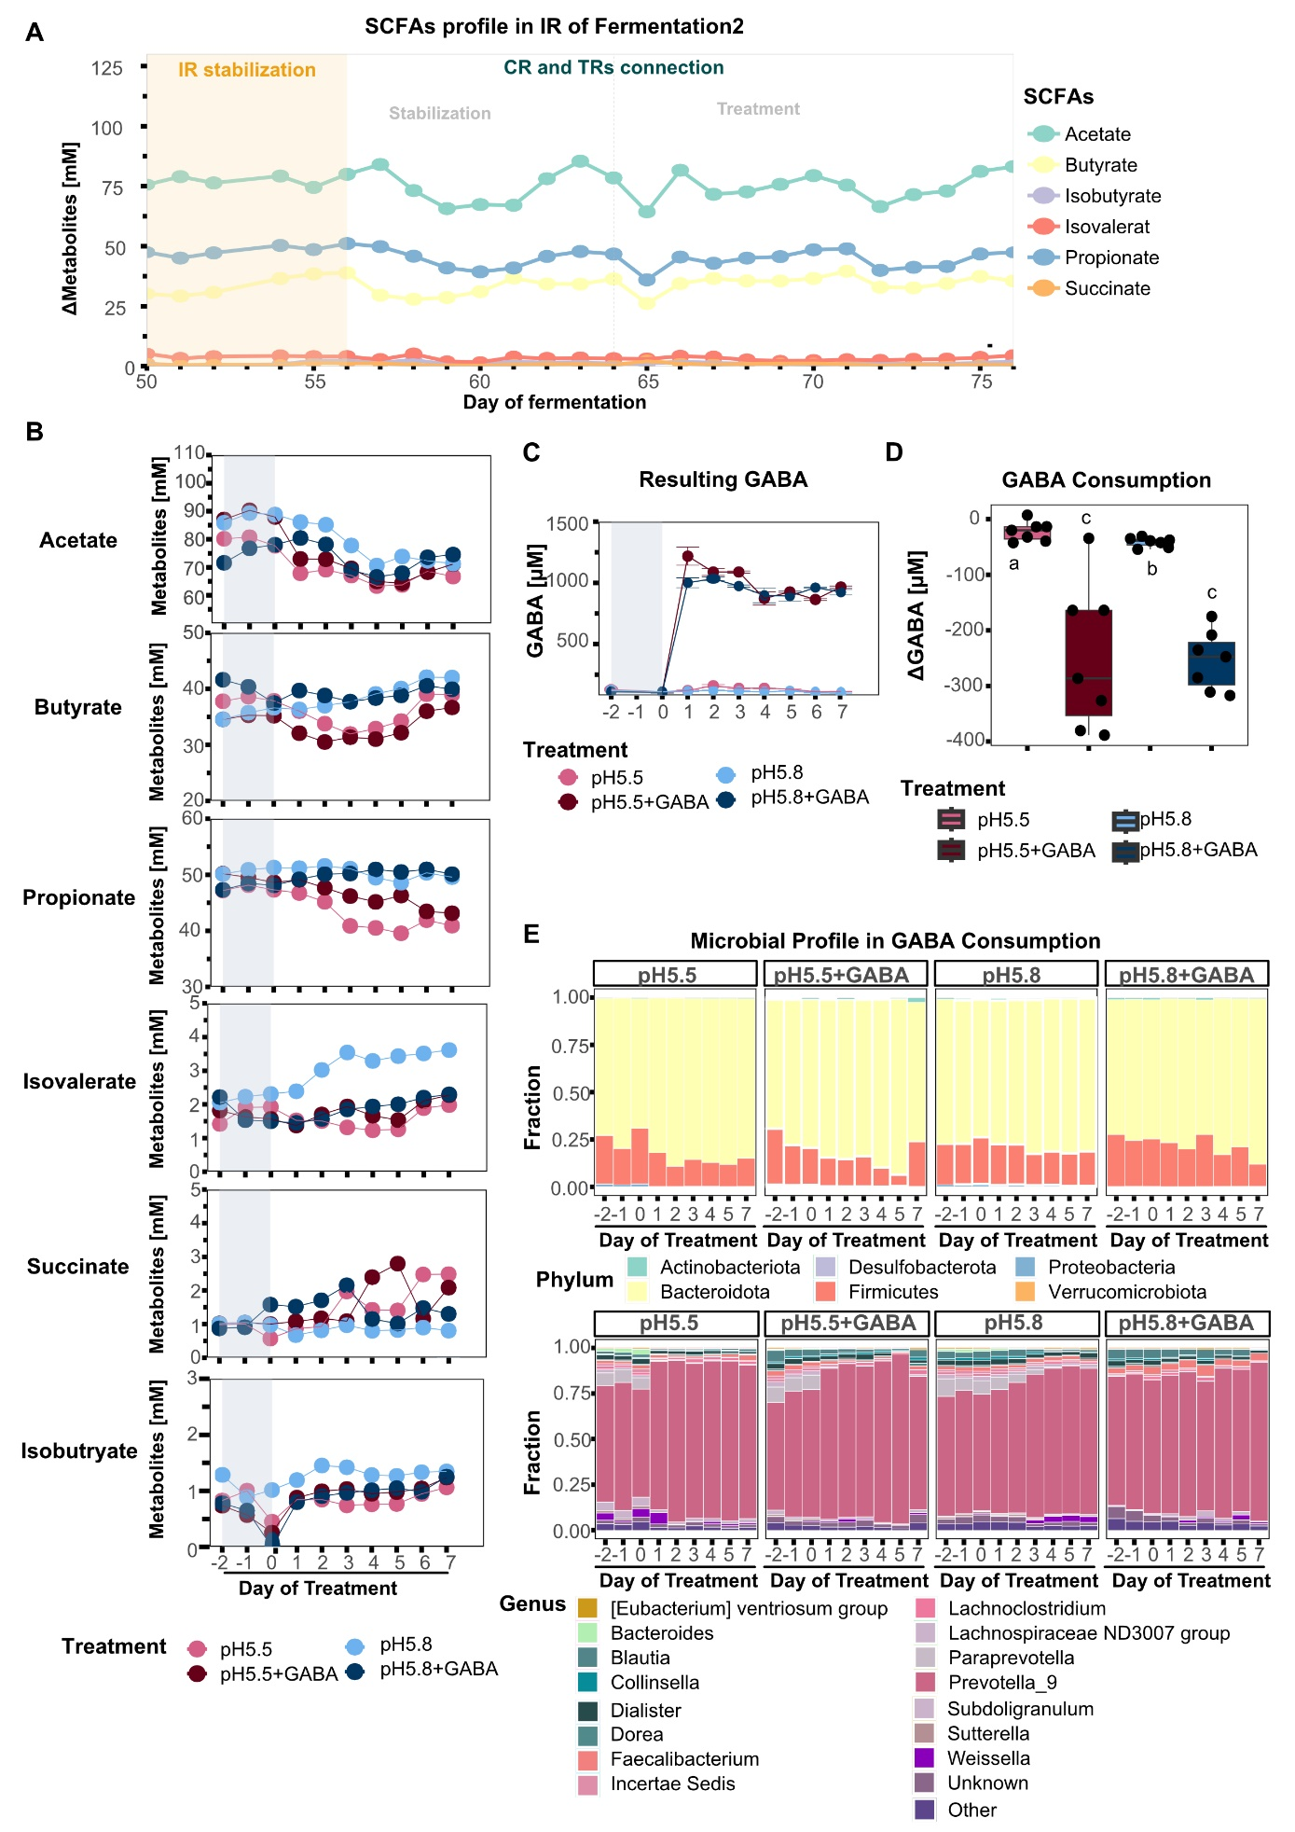
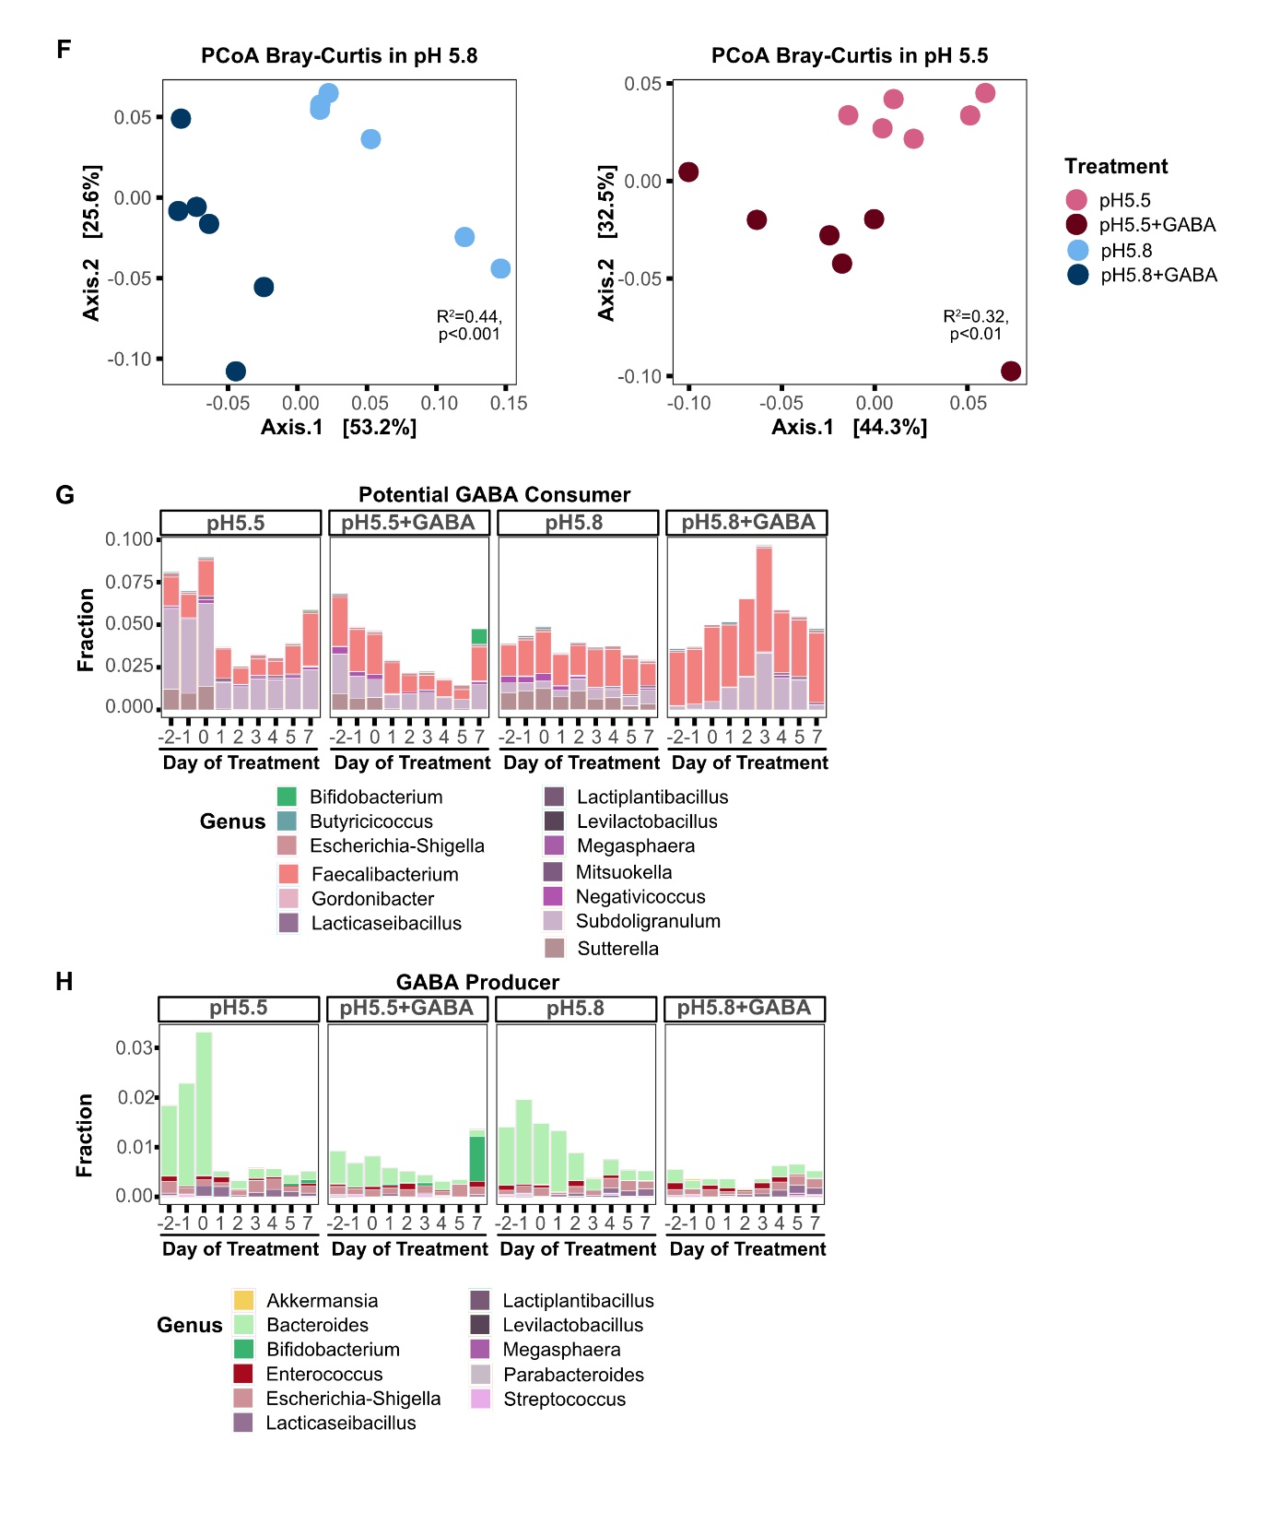
Supplementary Fig. 7 Metabolites and microbiota response to GABA supplementation in complex community in PolyFermS. (A) Profile of SCFAs and intermediates in IR over Fermentation2. (B-C) Shift of SCFAs, intermediates and resulting GABA (C) in CR and TRs after application of acid stress (pH 5.8 as control and pH 5.5 as low pH) and daily supplementation of 1 mM GABA in pH 5.5 and pH 5.8 compared to control. (D) Boxplot of ΔGABA levels from Day 1 to 7. ΔGABA corresponds to medium-corrected GABA concentrations. (E) Shift of microbial profile (phylum and genus level) in CR and TRs after application of acid and daily supplementation of 1 mM GABA in both pH. (F) PCoA analysis using Bray-Curtis distance to compare the microbial communities with/without daily 1 mM GABA supplementation in pH 5.5 and pH 5.8 through PERMANOVA. (G-H) Shift of potential GABA consumers (G) and GABA producers (H) in CR and TRs after application of acid stress and with/without daily supplementation of 1 mM GABA in both pH. Repeated measures one-way ANOVA was performed on ΔGABA (D) to determine the main effects of treatment, followed by Tukey’s test for post-hoc analysis to correct for multiple comparisons. Different letters indicate significant differences.
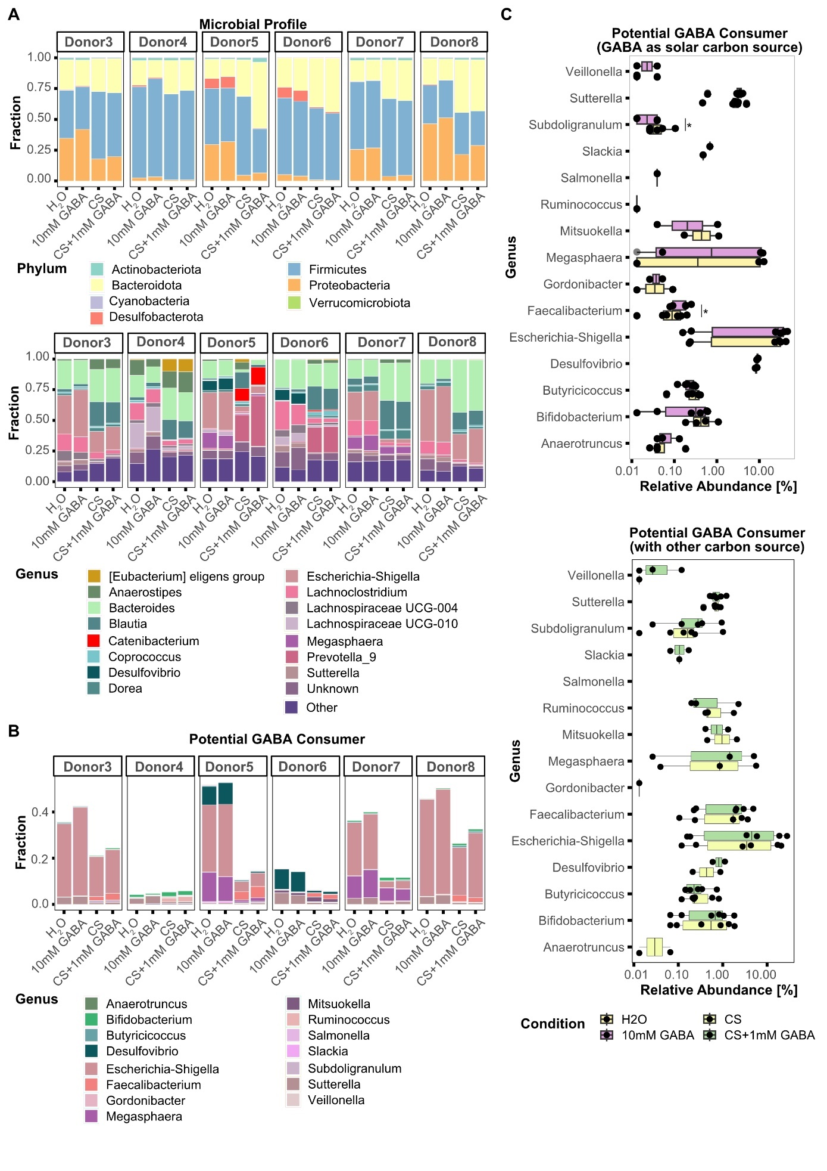
Supplementary Fig. 8 GABA consumption by human gut microbiota in distinct donors using ex vivo high-throughput batch fermentation. (A-B) Fraction of fecal microbial communities at phylum and genus level (A) and potential GABA consumer at genus level (B) for each donor after 48 h batch incubation in CS, CS + 1 mM GABA, H₂O and 10 mM GABA. (C) Comparison of potential GABA consumer (measured by 16S rRNA gene amplicon sequencing) with the consumption of GABA in in two conditions: GABA as solar carbon source condition (top panel) and a mix of 6 dietary fibers and mucin (other carbon source, bottom panel). Significantly altered genera are marked by stars. A paired t-test was performed on potential GABA consumers to test the significance between treatment. * p<0.05.

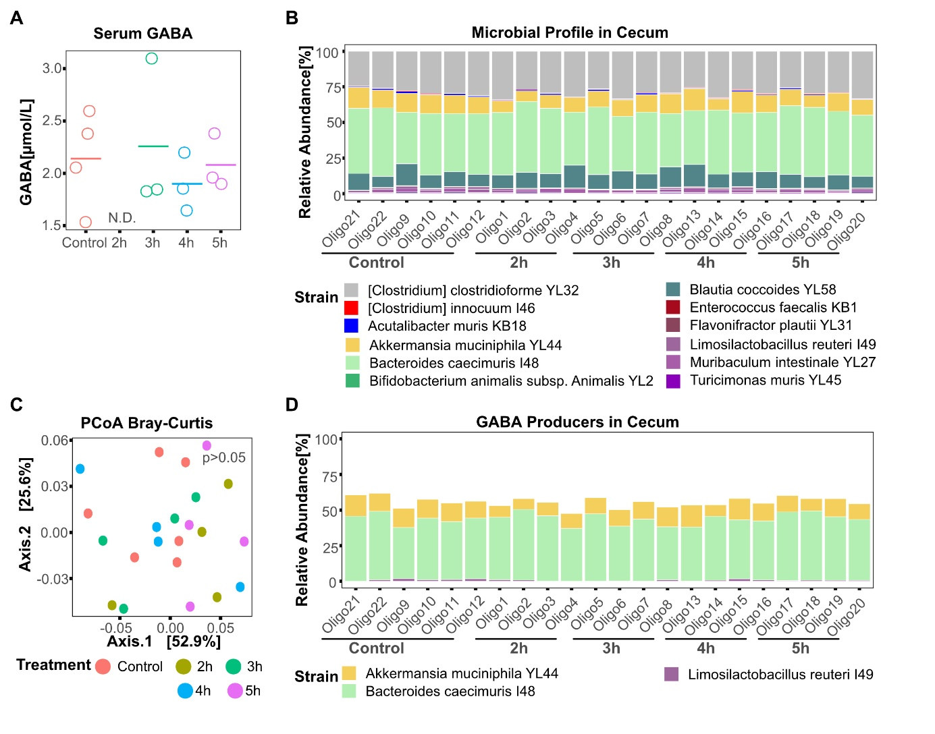
Supplementary Fig. 9 Impact of arabinose induced pH reduction on GABA levels in Oligo-MM¹² mice. (A) Serum GABA (n=4 in Control and n=3 each in Treatment) in Oligo-MM¹² mice was measured after 2, 3, 4, and 5 hours. (B) Cecal microbial profile of Oligo-MM¹² mice in control, and after 2, 3, 4, and 5 hours (n=6 in Control and n=4 each in Treatment). (C) PCoA analysis using Bray-Curtis distance to compare the microbial communities between control (n=6) and arabinose treatment after 2, 3, 4, and 5 (n=4 each) through PERMANOVA. (D) Relative abundance of GABA producer in Oligo-MM¹² mice in control, and after 2, 3, 4, and 5 hours (n=6 in Control and n=4 each in Treatment).

