公式章 1 节 1Supplementary Information

An interpretable predictive framework based on rules and machine learning: rule extraction，validation and adaptive integration with machine learning
Huiran Zhangª, Mengmeng Daiª, Yudian Linª, Pin Wuª, Lei Huang^{d}, Huanyu Xu^{d}, Shengzhou Li^{e}, Yan Xu^{f}, Zheng Tang^{g}, Jinchang Zhang^{d}, Renchao Che^{b,*}, Tao Xu^{c,*}, Dongbo Dai^{a,*}
ª School of Computer Engineering and Science, Shanghai University, Shanghai 200444, China
^{b} Laboratory of Advanced Materials, Shanghai Key Lab of Molecular Catalysis and Innovative Materials Department of Materials Science, Fudan University, Shanghai
200438, China
^{c} Department of Mechanical Engineering and Science, Kyoto University, Nishikyo-ku, Kyoto 615-8540, Japan
^{d} Materials Genome Institute, Shanghai University, Shanghai 200444, China
^{e} Department of Computer Science, University of Tsukuba, Tsukuba 305-8573, Japan
^{f} College of Mathematics and Physics, Shanghai University of Electric Power, Shanghai 200090, China
^{g} Faculty of Engineering, University of Toyama, Toyama 930-8555, Japan

Corresponding author:
*dbdai@shu.edu.cn
*xu.tao.44a@st.kyoto-u.ac.jp
*rcche@fudan.edu.cn

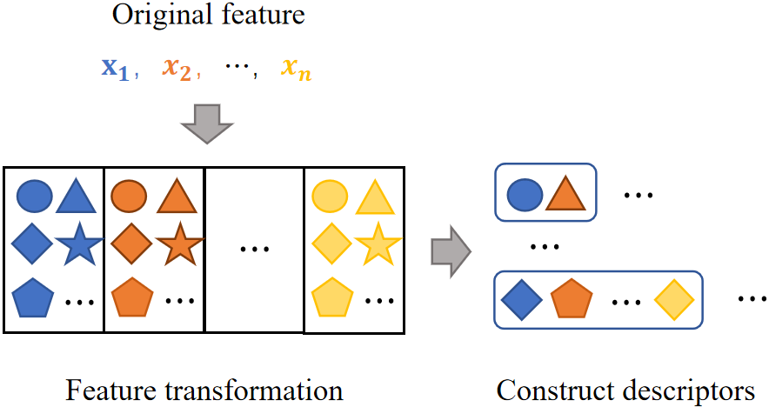
Supplementary Figure 1 Automatic feature engineering construction descriptors.

Supplementary note in Supplementary Figure 1
Automated Feature Engineering: Feature engineering enhances the correlation between original features and target properties by creating new descriptors and providing more information. We perform nonlinear transformations of the original features using mathematical prototype functions, generating a set of nonlinear transformed features. Then, we multiply the nonlinearly transformed features derived from different original features to construct a multi-dimensional descriptor set. The overall process is illustrated in Supplementary Figure 1. The specific steps to construct this are as follows:
Step1：The features in the dataset are $x=\left\{x_{1},x_{2},⋯,x_{n}\right\}$, where N represents the number of input original features, and $x_{i}$ denotes the i-th feature, with the target property being y.
Step2：For each feature $x_{i}$, select mathematical prototype functions, including but not limited to $x^{−1}、\sqrt{x}、e^{x}、x^{2}、x^{3}、\ln{x}$, etc. Transform the selected original features into nonlinear features, resulting in a set of nonlinear transformed features:
$$f_{i}=\left\{f_{i1},f_{i2},⋯,f_{im}\right\} (1)$$
where $m$ is the number of mathematical functions, and $f_{i1}$ represents a specific nonlinear transformed feature of the original feature.
Step3：Multiply the nonlinearly transformed features derived from different original features to construct a multi-dimensional descriptor set:
$$D=\left\{d_{2},d_{3},⋯,d_{N}\right\} (2)$$
Where $d_{2}$ represents the two-dimensional descriptor set, and so on.
Through the above steps, the total number of constructed descriptors can be represented as:
$$\sum_{d=2}^{N}{C_{N}^{d}m^{d}} (3)$$
For instance, if there are 4 original features and 7 selected mathematical functions, a total of 4067 two- to four-dimensional descriptors can be constructed.
Descriptors Filtering: Following the automated feature engineering, if the number of features and selected mathematical prototype functions are many, the resulting number of constructed descriptors explodes. To alleviate the computational burden during regression, we use the Pearson correlation coefficient to calculate the correlation between descriptors and the target property, filtering out descriptors below a certain threshold. The Pearson correlation coefficient measures the linear relationship between descriptors and the target property. When the linear correlation between descriptors and the target property is high, linear regression is typically better able to capture this relationship, yielding better fitting results.
Regression: Linear regression algorithms are simple, and the obtained model expressions are easier to interpret. Therefore, we use linear regression to fit the constructed descriptors. Each filtered descriptor in the set $d_{i}$ is treated as an input x for linear regression, with the goal of finding a linear function that models the relationship between the descriptors and the target property:
$$f\left(x\right)=wx+b (4)$$

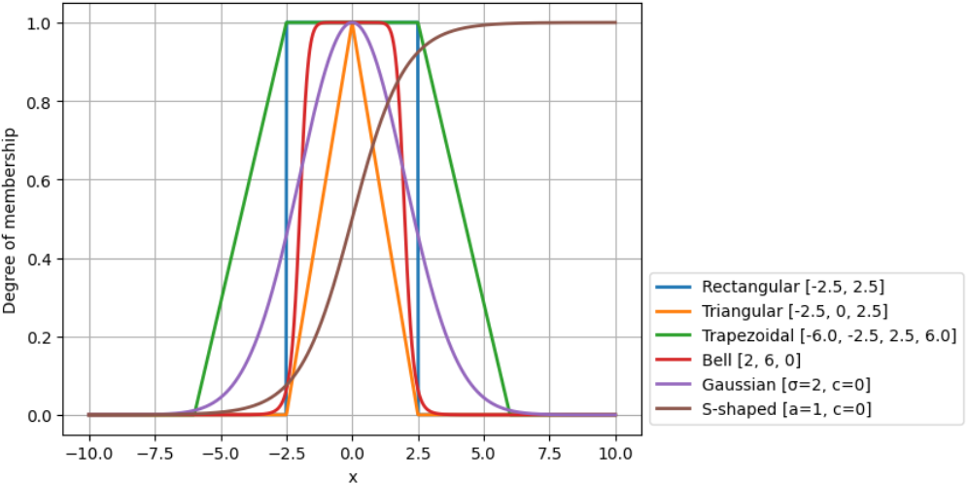
Supplementary Figure 2 Commonly used membership functions of different shapes.

Supplementary note in Supplementary Figure 2
The rectangular membership function represents the clear relationship between the input value and the rule with 0 or 1 correlation values:
$$P_{rect}\left(x,a,b\right)=\left\{\begin{aligned}0，x≤a \\ 1，a≤x≤b \\ 0，x≥b\end{aligned}\right. (5)$$
where parameters a and b define the left and right boundaries of the rectangle. The triangular membership function:
$$P_{trian}\left(x,a,b,c\right)=\left\{\begin{aligned}0，x≤a \\ \frac{x−a}{b−a}，a≤x≤b \\ \frac{\frac{c−x}{c−b}，b≤x≤c}{0，x≥c}\end{aligned}\right. (6)$$
where a and c determine the positions where the triangle intersects the x-axis, and parameter b determines the horizontal position of the "peak" of the triangle, thereby altering the slopes of the sides. The trapezoidal membership function assigns a correlation value of 1 to samples within the rule boundaries and uses a linear function to map a correlation value greater than 0 for input values that are close to but not within the rule boundaries, based on the following equation:
$$P_{trape}\left(x,a,b,c\right)=\left\{\begin{aligned}0，x≤a \\ \frac{\frac{x−a}{b−a}，a≤x≤b}{1，b≤x≤c} \\ \frac{\frac{d−x}{d−c}，c≤x≤d}{0，x≥d}\end{aligned} \right. (7)$$
where a and d determine the positions where the trapezoid intersects the x-axis, and b and c determine the slopes of the sides. The bell-shaped membership function provides a smooth transition from values within the rule boundaries to values outside the rule boundaries, based on the following equation:
$$P_{bell}\left(x,a,b,c\right)=\frac{1}{1+{\left|\frac{x−c}{a}\right|}^{2b}} (8)$$
Where $c$ controls the center position of the bell shape, the midpoint of the regular interval is taken ($c=L_{min}+{\left(L_{max}−L_{min}\right)}/2$), $a$ controls the width of the bell shape. The higher the value, the wider the bell, takes the length of the half between the regular boundaries ($a={\left(L_{max}−L_{min}\right)}/2$), and $b$ controls the shape of the bell. The larger the value, the flatter the bell; the smaller the value, the sharper the bell. The Gaussian membership function has a shape similar to a normal distribution curve:
$$P_{guass}\left(x,σ,c\right)=e^{−\frac{{\left(x−c\right)}^{2}}{2σ^{2}}} (9)$$
where parameter $σ$ usually positive and determines the width of the curve, and parameter c determines the center of the curve. The S-shaped membership function usually adopts the form of a Sigmoid function:
$$P_{sigmoid}\left(x,a,c\right)=\frac{1}{1+e^{−a\left(x−c\right)}} (10)$$
where the positive and negative sign of the parameter $a$ determines whether the opening of the S-type membership function faces left or right, and the value controls the steepness of the curve. The higher the value, the steeper the curve; the lower the value, the flatter the curve. The parameter c is the center point of the curve.
For example, for the rule "$a≤x≤b$", we can use the rectangular membership function (Eqs. (5)) to represent the sample that satisfies the boundary value as 1, the sample that does not satisfy as 0, and then add the membership value as a new feature to the feature set. Alternatively, a bell-shaped membership function (Eqs. (8)) can be used to smoothly transition the sample values outside the boundary from 1 to 0, adjusting the parameters a, b, and c to accommodate different rules. These two ways of calculating the membership value, I .e., from a simple non -1 or 0 representation to a smoother continuous mapping, improve the information granularity of the informed features of fuzzy rules. This shift will allow us to more fully understand and analyze the relationship between features, rather than simply expressing them as binary presence or absence. Through continuous mapping, we can quantify the differences and similarities between features and further uncover more details and patterns hidden in the data. In addition, this method can capture the degree of continuity and variation between features, thereby providing more accurate analysis results. Compared with simple binary coding, continuous mapping can better reflect the actual differences in features and play a more important role in modeling and prediction.

Dataset 2
Supplementary Table 1 The top five rules for quality function score obtained using the subgroup discovery algorithms in dataset 2.
 | Quality | Subgroup | Size_sg | Size_dataset | Mean_sg | Mean_dataset
1 | 76843.57 | ${VEC}_{2}<0.44$  AND $X_{P1}≥1.69$ | 198 | 418 | 1182.65 | 794.55
2 | 76724.36 | $$X_{P1}≥1.69$$ | 209 | 418 | 1161.65 | 794.55
3 | 74105.76 | $$T_{m1}≥1871.10$$  AND $X_{P1}≥1.69$ | 183 | 418 | 1199.50 | 794.55
4 | 73264.21 | $${VEC}_{2}<0.44$$ | 209 | 418 | 1145.10 | 794.55
5 | 72517.09 | $T_{m1}≥1871.10$  AND ${VEC}_{2}<0.44$ | 178 | 418 | 1201.95 | 794.55

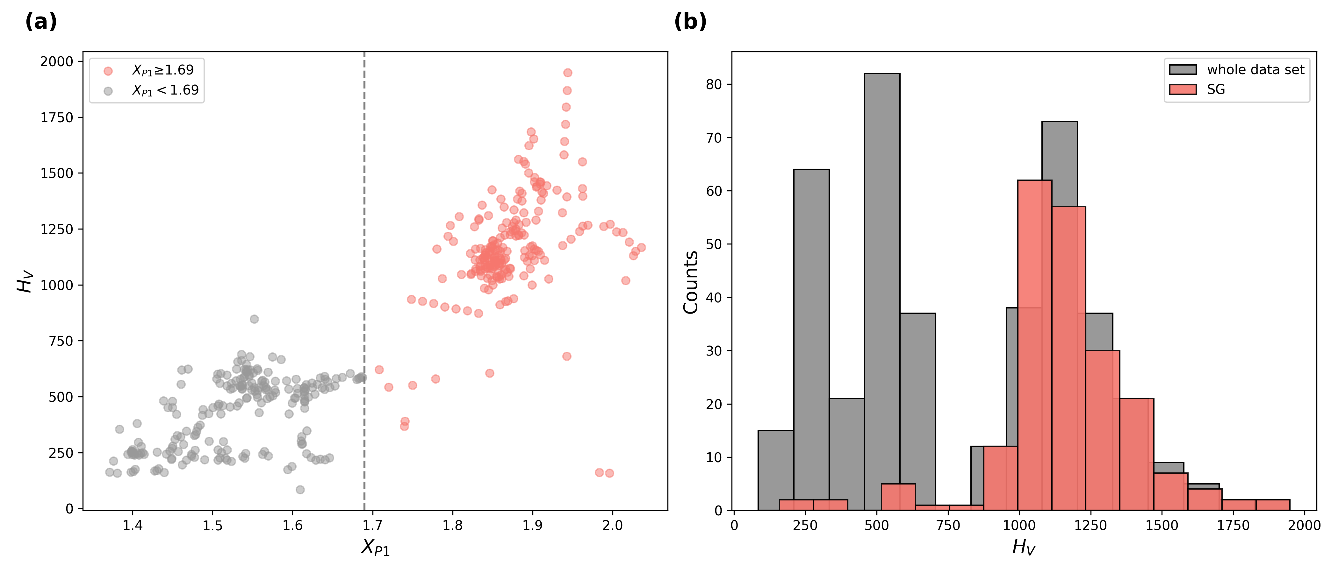
Supplementary Figure 3 The distribution of vickers hardness of amorphous alloys values for the rule subgroups and the entire dataset in dataset 2.

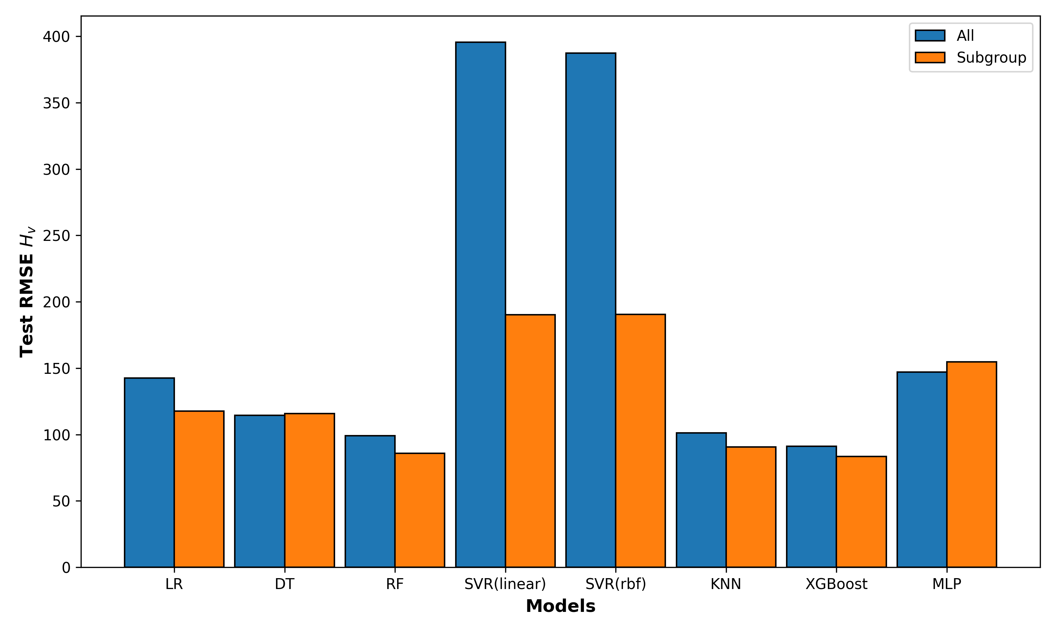
Supplementary Figure 4 RMSE test set for dataset 2 on eight different ML methods. All: represents the RMSE of the entire dataset. Subgroup: represents the average RMSE of each subgroup after rule partitioning.

Supplementary Table 2 The $SDSS$ of rule and random subgroups for eight ML methods and their means.
Models | $${SDSS}_{Rule}$$ | $${SDSS}_{Random}$$
LR | 0.22 | 0.96
DT | 0.28 | 0.93
RF | 0.18 | 0.94
SVR(linear) | 0.27 | 1.00
SVR(rbf) | 0.26 | 1.00
KNN | 0.18 | 0.95
XGBoost | 0.20 | 0.95
MLP | 0.36 | 1.09
 | 0.24±0.06 | 0.98±0.05

$$H_{V}=\left\{\begin{aligned}w_{1}∗\ln{X_{P2}}∗{T_{m1}}^{2}+b_{1}， X_{P1}<1.6875 \\ w_{2}∗{X_{P1}}^{2}∗T_{m1}+b_{2}， X_{P1}≥1.6875\end{aligned}\right. (S19)$$

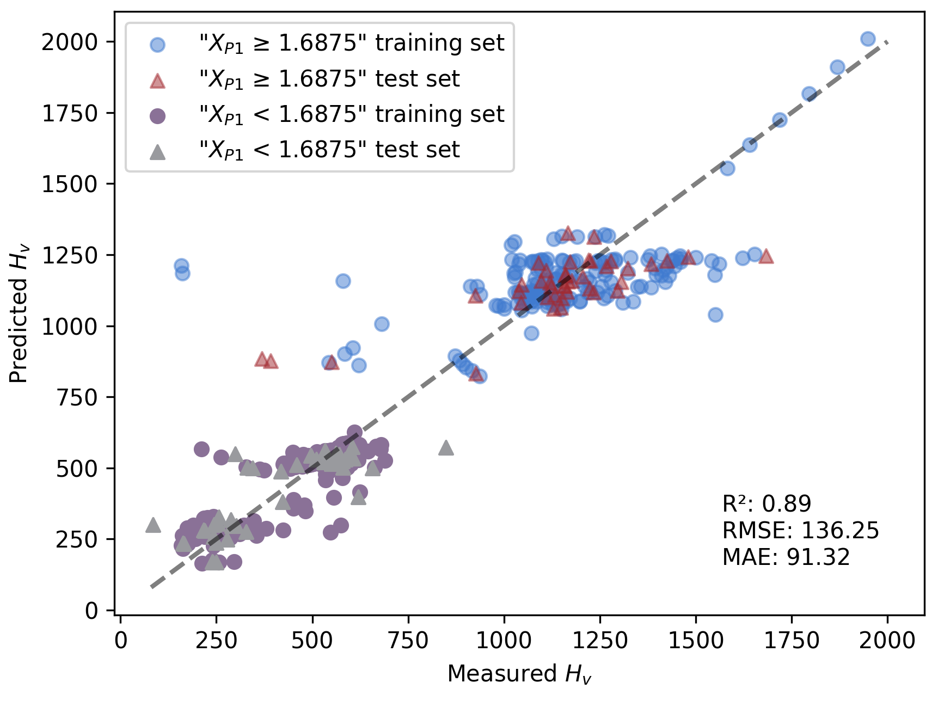
Supplementary Figure 5 Comparison of the the true $H_{V}$ values with the predicted values of implementing rule subgroup and divide-and-conquer strategy in dataset 2.

Dataset 3
Supplementary Table 3 The top five rules for quality function score obtained using the subgroup discovery algorithms in dataset 3.
 | Quality | Subgroup | Size_sg | Size_dataset | Mean_sg | Mean_dataset
1 | 1416.39 | $$F_{Nb}≥9$$ | 180 | 540 | 33.64 | 25.77
2 | 776.08 | $$VF=1.562$$ | 108 | 540 | 32.96 | 25.77
3 | 483.50 | $F_{Nb}≥9$ AND $NF=64$ | 60 | 540 | 33.83 | 25.77
4 | 482.53 | $F_{Nb}≥9$ AND $M_{Nb}≥19$ | 60 | 540 | 33.82 | 25.77
5 | 469.97 | $F_{Nb}≥9$ AND $NF=16$ | 60 | 540 | 33.61 | 25.77

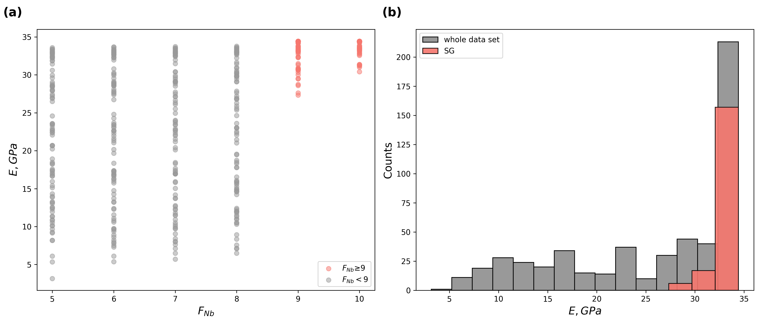
Supplementary Figure 6 The distribution of Young’s modulus of Ti-Nb alloys values for the rule subgroups and the entire dataset in dataset 3.

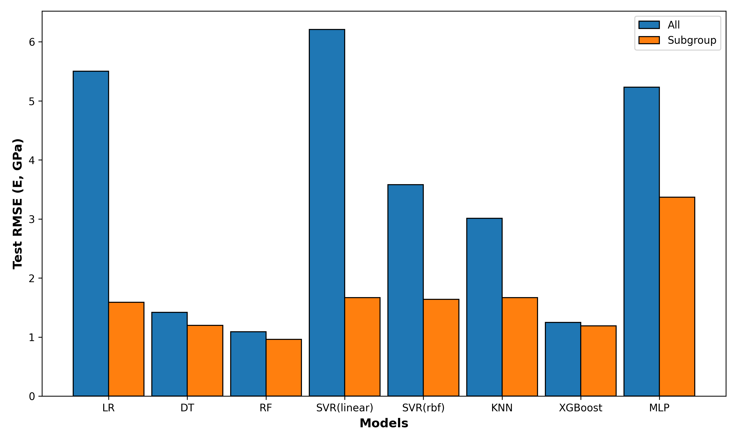
Supplementary Figure 7 RMSE test set for dataset 3 on eight different ML methods. All: represents the RMSE of the entire dataset. Subgroup: represents the average RMSE of each subgroup after rule partitioning.

Supplementary Table 4 The $SDSS$ of rule and random subgroups for eight ML methods and their means.
Models | $${SDSS}_{Rule}$$ | $${SDSS}_{Random}$$
LR | 0.11 | 1.00
DT | 0.08 | 1.01
RF | 0.06 | 0.99
SVR(linear) | 0.12 | 0.99
SVR(rbf) | 0.12 | 1.02
KNN | 0.12 | 0.98
XGBoost | 0.08 | 0.97
MLP | 0.26 | 0.99
 | 0.12±0.06 | 0.99±0.02

$$E=\left\{\begin{aligned}w_{1}∗\frac{\sqrt{VF}}{M_{Nb}}+b_{1}， F_{Nb}<9 \\ w_{2}∗\frac{\sqrt{VF}}{{F_{Nb}}^{2}}+b_{2}， F_{Nb}≥9\end{aligned}\right. (S20)$$

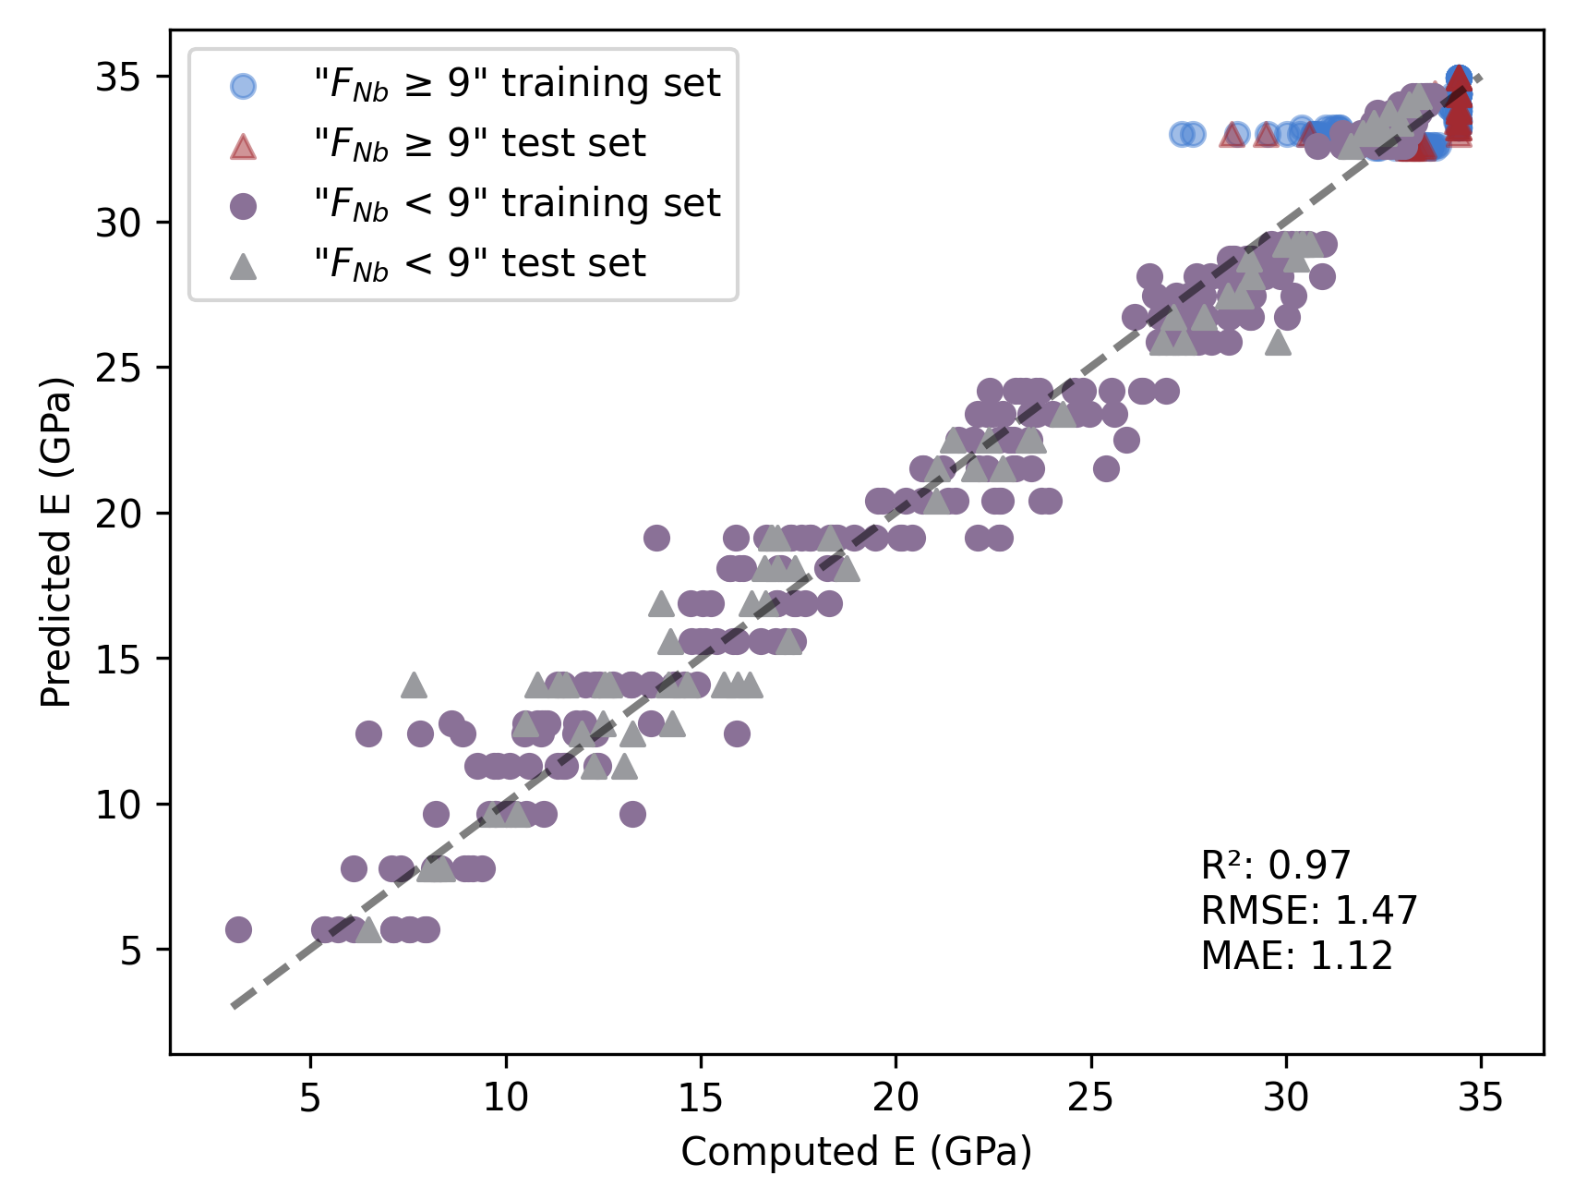
Supplementary Figure 8 Comparison of the the true $E$ values with the predicted values of implementing rule subgroup and divide-and-conquer strategy in dataset 3.

Dataset 5
Supplementary Table 5 The top ten rules for quality function score obtained using the subgroup discovery algorithms in dataset 5.
 | Quality | Subgroup | Size_sg | Size_dataset | Mean_sg | Mean_dataset
1 | 1489.17 | $d<0.16$ AND $valence <2$ | 46 | 224 | 42.57 | 10.20
2 | 1109.29 | $$valence <2$$ | 87 | 224 | 22.95 | 10.20
3 | 1055.53 | $$d<0.16$$ | 112 | 224 | 19.62 | 10.20
4 | 951.26 | $d<0.16$  AND  $electronegativity<0.40$  AND  $$valence<2$$ | 33 | 224 | 39.03 | 10.20
5 | 938.11 | $electronegativity<0.40$  AND  $$valence<2$$ | 35 | 224 | 37.00 | 10.20
6 | 573.57 | $d<0.16$  AND  $$electronegativity<0.40$$ | 86 | 224 | 16.87 | 10.20
7 | 537.91 | $$d<0.16$$  AND  $$electronegativity≥0.40$$  AND  $$valence<2$$ | 13 | 224 | 51.58 | 10.20
8 | 481.95 | $d<0.16$  AND  $$electronegativity≥0.40$$ | 26 | 224 | 28.74 | 10.20
9 | 382.62 | $$electronegativity<0.40$$ | 108 | 224 | 13.74 | 10.20
10 | 171.29 | $$electronegativity≥0.40$$  AND  $$valence<2$$ | 52 | 224 | 13.49 | 10.20

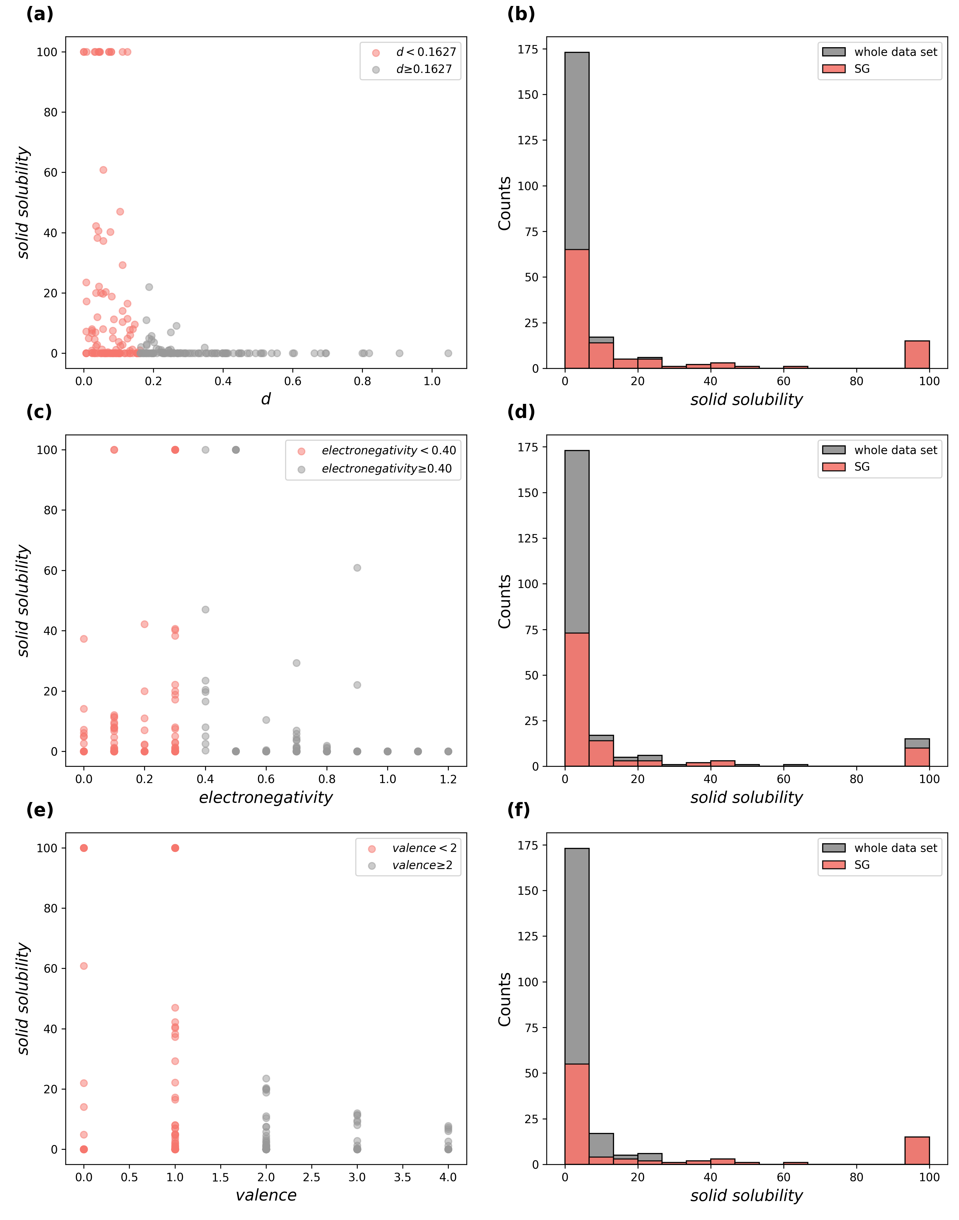
Supplementary Figure 9 The distribution of solid solubility of binary alloys values for the three rule subgroups and the entire dataset in dataset 5.

Supplementary Table 6 The $SDSS$ of rule 3: $d<0$.1627 and random subgroups for eight ML methods and their means.
Models | $${SDSS}_{Rule}$$ | $${SDSS}_{Random}$$
LR | 0.40 | 0.94
DT | 0.76 | 0.87
RF | 0.59 | 0.87
SVR(linear) | 0.86 | 0.87
SVR(rbf) | 0.83 | 0.87
KNN | 0.55 | 0.89
XGBoost | 0.73 | 0.86
MLP | 0.64 | 0.88
 | 0.67±0.15 | 0.88±0.03

Supplementary Table 7 The $SDSS$ of rule 9: $electronegativity<0$.40 and random subgroups for eight ML methods and their means.
Models | $${SDSS}_{Rule}$$ | $${SDSS}_{Random}$$
LR | 0.52 | 0.95
DT | 0.78 | 0.88
RF | 0.66 | 0.88
SVR(linear) | 0.85 | 0.84
SVR(rbf) | 0.84 | 0.84
KNN | 0.54 | 0.89
XGBoost | 0.75 | 0.89
MLP | 0.80 | 0.86
 | 0.72±0.13 | 0.88±0.04

Supplementary Table 8 The $SDSS$ of rule 2: $valence<2$ and random subgroups for eight ML methods and their means.
Models | $${SDSS}_{Rule}$$ | $${SDSS}_{Random}$$
LR | 0.69 | 0.91
DT | 0.64 | 0.80
RF | 0.55 | 0.87
SVR(linear) | 0.86 | 0.83
SVR(rbf) | 0.85 | 0.83
KNN | 0.48 | 0.89
XGBoost | 0.61 | 0.86
MLP | 0.70 | 0.85
 | 0.67±0.13 | 0.86±0.04

