Supplementary Figures
Figure S1. Homology modeling of WT AtADTs.
Predicted AtADT structures were obtained from AlphaFold (Jumper et al., 2021) and the transit peptide was removed as it has poor homology to known structures and is modeled with low confidence. Structures were viewed and superimposed in Chimera X (Pettersen et al., 2021) to identify any structural differences between strict ADTs and ADT/PDTs. Dark blue: ADT1, light blue: ADT2, yellow: ADT3, grey: ADT4, pink: ADT5, orange: ADT6.
- Structures from AlphaFold. Top: all six AtADTs superimpose, in front and side views. Bottom: Structures of either ADT1 and ADT5, ADT2 and ADT5 or ADT4 and ADT5 superimposed. All structures are very similar, with the exception of a small linker in the ACT domain.
Figure S2. Detection of ADT proteins in pha2 and aro8aro9.
As many of the AtADT chimeras and point mutants were unable to support growth of the pha2 yeast strain, we performed Western Blots to ensure that they were expressed under inducing conditions. Shown is a sample Western blot for both the pha2 and aro8aro9 strain. Total protein was size separated and probed with an anti-GFP antibody to detect the ADT-ECFP fusion proteins. Bands of ~75 kDa correspond to AtADT-GFP fusion proteins, while the ~25 kDa bands are likely cleaved GFP. A second, smaller band approximately ~70 kDa was detected for some AtADT-GFP fusion proteins, indicating possible cleavage of the transit peptide.
A. Detection of AtADT chimera fusion proteins in pha2. Total soluble protein was extracted from the untransformed pha2 strain (pha2), pha2 transformed with an empty vector (pDEST), and induced pha2 yeast cells expressing the various AtADTs chimeras. In addition, 15µg of protein was loaded from each strain, as well as purified GFP.
B. Detection of AtADT L341F and F341L mutants in aro8aro9. Total soluble protein was extracted from the aro8aro9 strain transformed with both empty vectors (vector), and induced aro8aro9 yeast cells expressing the various AtADTs fusion proteins. For each fusion protein, 25µl of total protein was loaded under inducing (+) and non-inducing (-) conditions.
S3. Complete set of controls for ACAI assay.
Transformed aro8aro9 cultures were spotted alone and in combination onto SD media made with either glucose or galactose. Media of each carbon source were also prepared with Phe or without Phe. Only in the presence of both the AtPPA-AT and an AtADT yeast cells were able to complete the arogenate pathway, synthesize Phe, and therefore grow on media lacking Phe. Media selecting for expression vectors (lacking histidine and leucine, but containing Phe) is shown under column V. An equal number of cells (1 x 10⁵ cells/mL) were spotted for all cell cultures and shown are representative images taken after 12 days of growth. As negative controls, the untransformed aro8aro9 strain was spotted along with strains carrying both empty destination vectors alone (His vector, Leu vector), both empty destination vectors together (both vectors).
A. Empty vector and single transformation controls for AtADT L341F and F341L mutants.
B. Empty vector and single transformation controls for AtADT A335V and V335A mutants.
C. Empty vector and single transformation controls for AtADT A337S and S337A mutants.

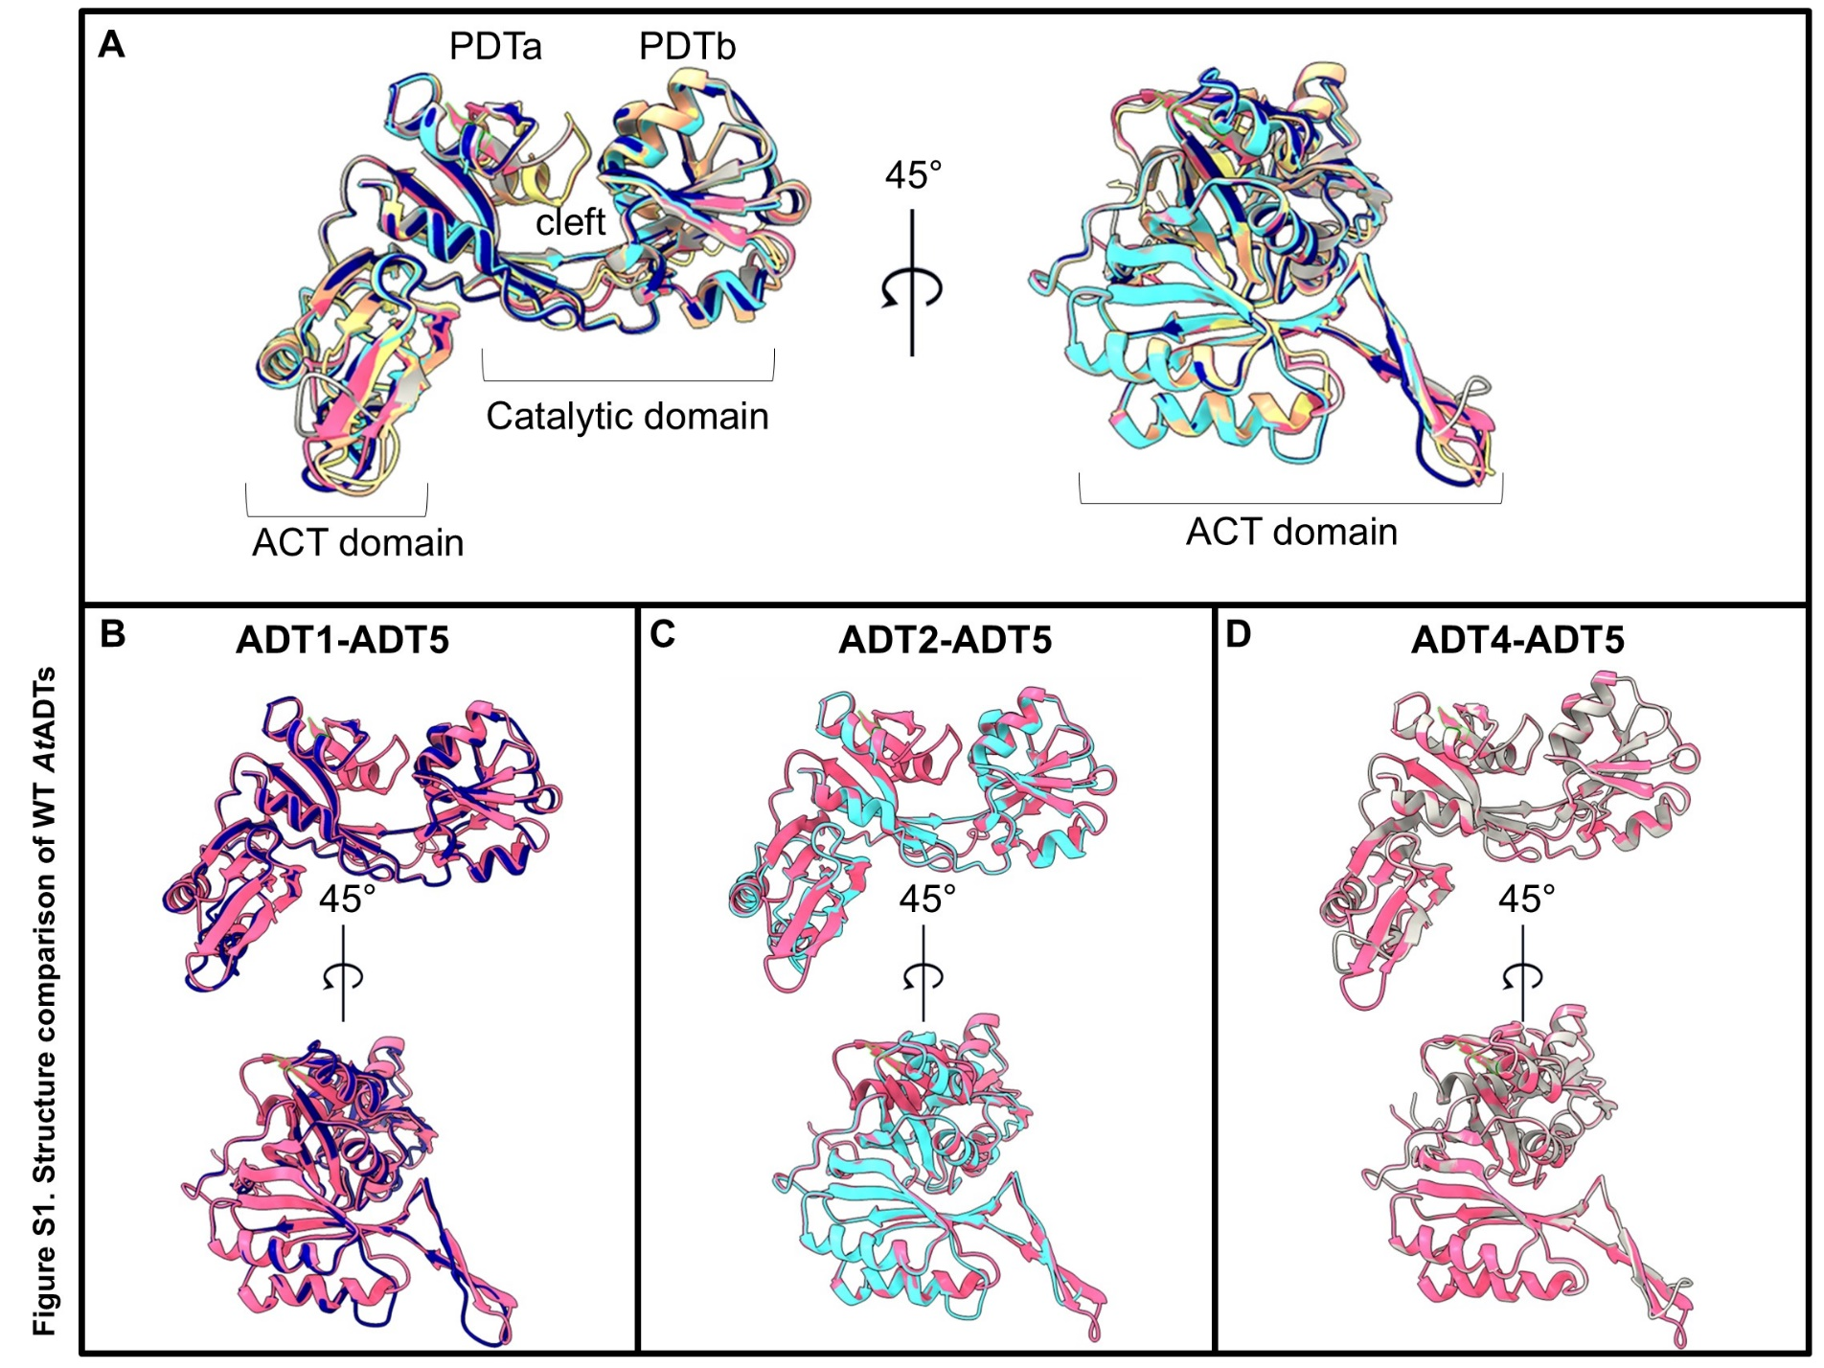
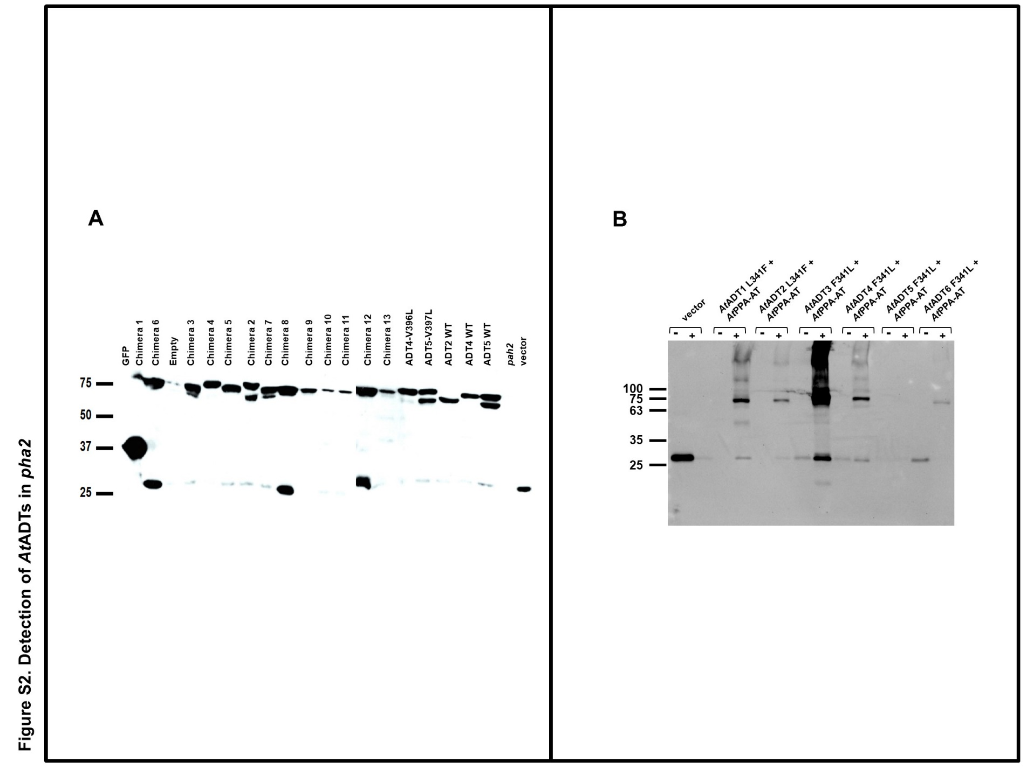
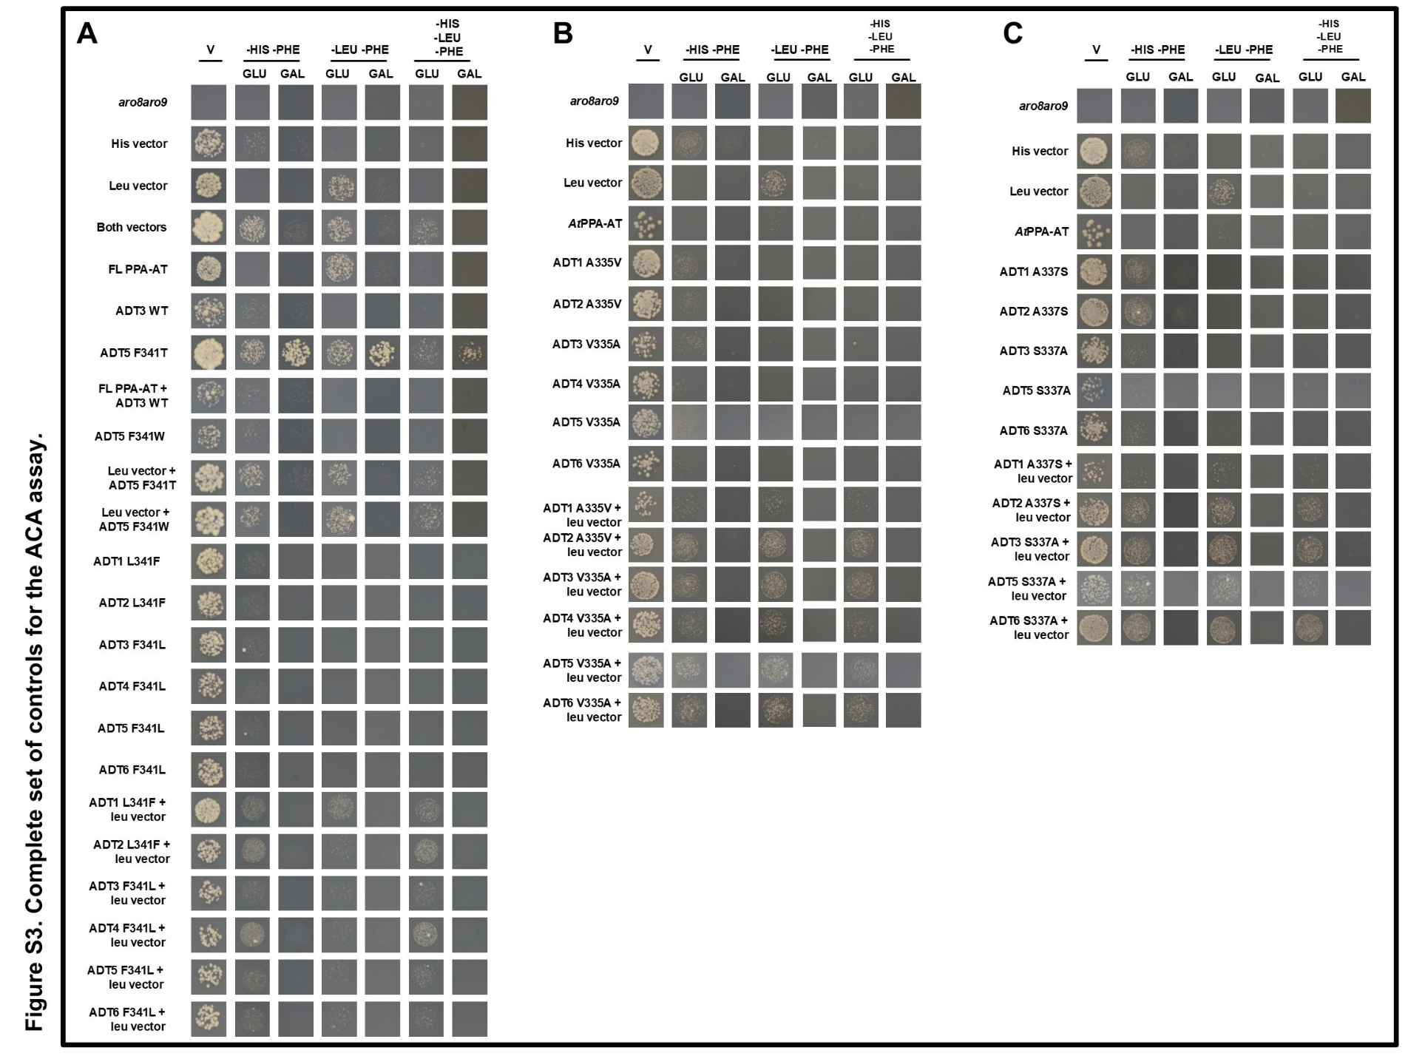
Table S1. List of sequences used for phylogeny analysis
Species | Name | Accession number
Chlamydomonas reinhardtii | CrADT | XM_001696529 (NCBI)
Medicago truncatula | MtADT-A | Medtr2g084875 (Phytozome)
Oryza sativa | MtADT-B | Medtr2g088130 (Phytozome)
Oryza sativa | MtADT-C | Medtr4g055310 (Phytozome)
Oryza sativa | MtADT-D | Medtr4g061070 (Phytozome)
Oryza sativa | MtADT-E | Medtr4g132250 (Phytozome)
Oryza sativa | OsADT-A | LOC_Os03g17730 (Phytozome)
Oryza sativa | OsADT-B | LOC_Os04g33390 (Phytozome)
Oryza sativa | OsADT-C | LOC_Os07g49390 (Phytozome)
Oryza sativa | OsADT-D | LOC_Os09g39230 (Phytozome)
Oryza sativa | OsADT-E | LOC_Os10g37980 (Phytozome)
Oryza sativa | OsADT-F | LOC_Os07g32774 (Phytozome)
Sorghum bicolor | SbADT-A | Sobic.001G320700 (Phytozome)
Sorghum bicolor | SbADT-B | Sobic.001G410000 (Phytozome)
Sorghum bicolor | SbADT-C | Sobic.002G133100 (Phytozome)
Sorghum bicolor | SbADT-D | Sobic.006G066200 (Phytozome)
Arabidopsis thaliana | AtADT1 | AT1G11790 (TAIR)
Arabidopsis thaliana | AtADT2 | AT3G07630 (TAIR)
Arabidopsis thaliana | AtADT3 | AT3G27820 (TAIR)
Arabidopsis thaliana | AtADT4 | AT3G44720 (TAIR)
Arabidopsis thaliana | AtADT5 | AT5G22630 (TAIR)
Arabidopsis thaliana | AtADT6 | AT1G08520 (TAIR)
Petunia x hybrida | PhADT1 | FJ790412.1 (NCBI)
Petunia x hybrida | PhADT2 | FJ790413.1 (NCBI)
Petunia x hybrida | PhADT3 | FJ790414.1 (NCBI)
Glycine max | GmADT9 | Glyma.09G004200 (Phytozome)
Glycine max | GmADT11A | Glyma.11G189100 (Phytozome)
Glycine max | GmADT11B | Glyma.11G151288 (Phytozome)
Glycine max | GmADT12A | Glyma.12G181800 (Phytozome)
Glycine max | GmADT12B | Glyma.12G085500 (Phytozome)
Glycine max | GmADT12C | Glyma.12G193000 (Phytozome)
Glycine max | GmADT12D | Glyma.12G072500.1 (Phytozome)
Glycine max | GmADT13A | Glyma.13G319000 (Phytozome)
Glycine max | GmADT13B | Glyma.13G309300 (Phytozome)
Glycine max | GmADT17 | Glyma.17G012600 (Phytozome)
Pinus pinaster | PpADT-A | KX010923 (NCBI)
Pinus pinaster | PpADT-B | KX010924 (NCBI)
Pinus pinaster | PpADT-C | KX010925 (NCBI)
Pinus pinaster | PpADT-D | KX010926 (NCBI)
Pinus pinaster | PpADT-E | KX010927 (NCBI)
Pinus pinaster | PpADT-F | KX010928 (NCBI)
Pinus pinaster | PpADT-G | KX010929 (NCBI)
Pinus pinaster | PpADT-H | KX010930 (NCBI)
Pinus pinaster | PpADT-I | KX010931 (NCBI)
Sphagnum fallax | SfADT-A | Sphfalx03G027000 (Phytozome)
Sphagnum fallax | SfADT-B | Sphfalx06G126300 (Phytozome)
Sphagnum fallax | SfADT-C | Sphfalx07G103900 (Phytozome)
Sphagnum fallax | SfADT-D | Sphfalx13G095600 (Phytozome)

