Supplementary information for
Liver X receptor β-selective agonist CE9A215 regulates Alzheimer’s disease-associated pathology in a 3xTg-AD mouse model
So Young Ban^{a,b,1}, Yunkwon Nam^{c,1}, Thi Thuong Do^{b}, Byeong-Hyeon Kim^{c}, Soo Jung Shin^{c}, My Tuyen Thi Nguyen^{e}, Jaehan Kim^{e}, Minho Moon^{c,d,*}, Jong-Tae Park^{a,b,**}
ªDepartment of Food Science and Technology, Chungnam National University, Daejeon 34134, Republic of Korea
^{b}CARBOEXPERT Inc., Daejeon 34134, Republic of Korea
^{c}Department of Biochemistry, College of Medicine, Konyang University, Daejeon 35365, Republic of Korea
^{d}Research Institute for Dementia Science, Konyang University, Daejeon 35365, Korea
e Department of Food and Nutrition, Chungnam National University, Daejeon 34134, Republic of Korea
*Correspondence to: Department of Biochemistry, College of Medicine, Konyang University, 158, Gwanjeodong-ro, Seo-gu, Daejeon 35365, Republic of Korea.
**Correspondence to: Department of Food Science and Technology, Chungnam National University, Daejeon 34134, Republic of Korea
E-mail address: hominmoon@konyang.ac.kr (M. Moon), jtpark@cnu.ac.kr (J-T. Park)
¹These authors contributed equally to this work

Materials and Methods
1. Cell cultivation.
Complete medium consisted of Dulbecco’s Modified Eagle Medium (DMEM; Hyclone, Logan, UT, USA) supplemented with 10% fetal bovine serum (FBS; Hyclone) and 1X Penicillin and Streptomycin (Hyclone) for antibiotic solution. All cells were cultured in a CO₂ incubator containing 5% CO₂ at 37°C. BV2 cells were treated with 0.1 μg/mL of LPS (Sigma, St Louis, MO, USA) for 24 hours. To analyze the cytokine levels, BV2 cells were treated with 3.125, 6.25, 12.5, and 25 μM concentrations of pure inotodiol for 20 hours. After cultivation, cells were collected for PCR analysis and stored at -80°C before analysis [1].

Supplementary figure
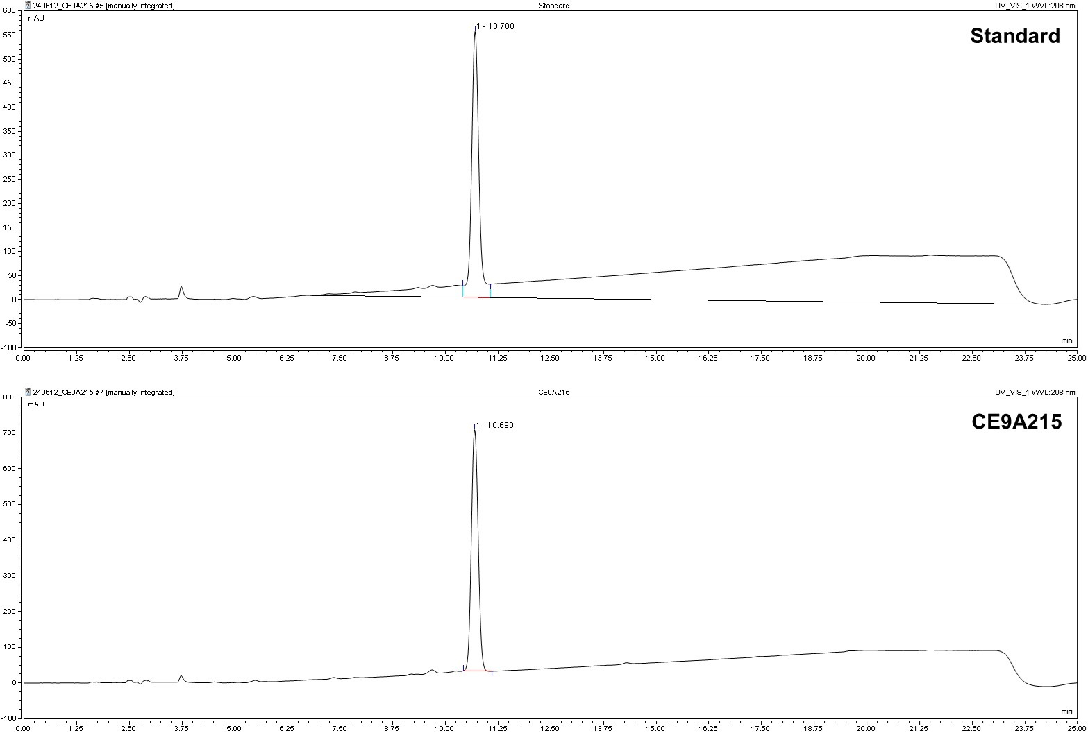
Supplementary figure 1. High-performance liquid chromatography with Evaporative Laser. Scattering Detector (HPLC-ELSD) analysis of CE9A215. HPLC-ELSD chromatograms indicated the retention times and peaks of a standard and CE9A215.

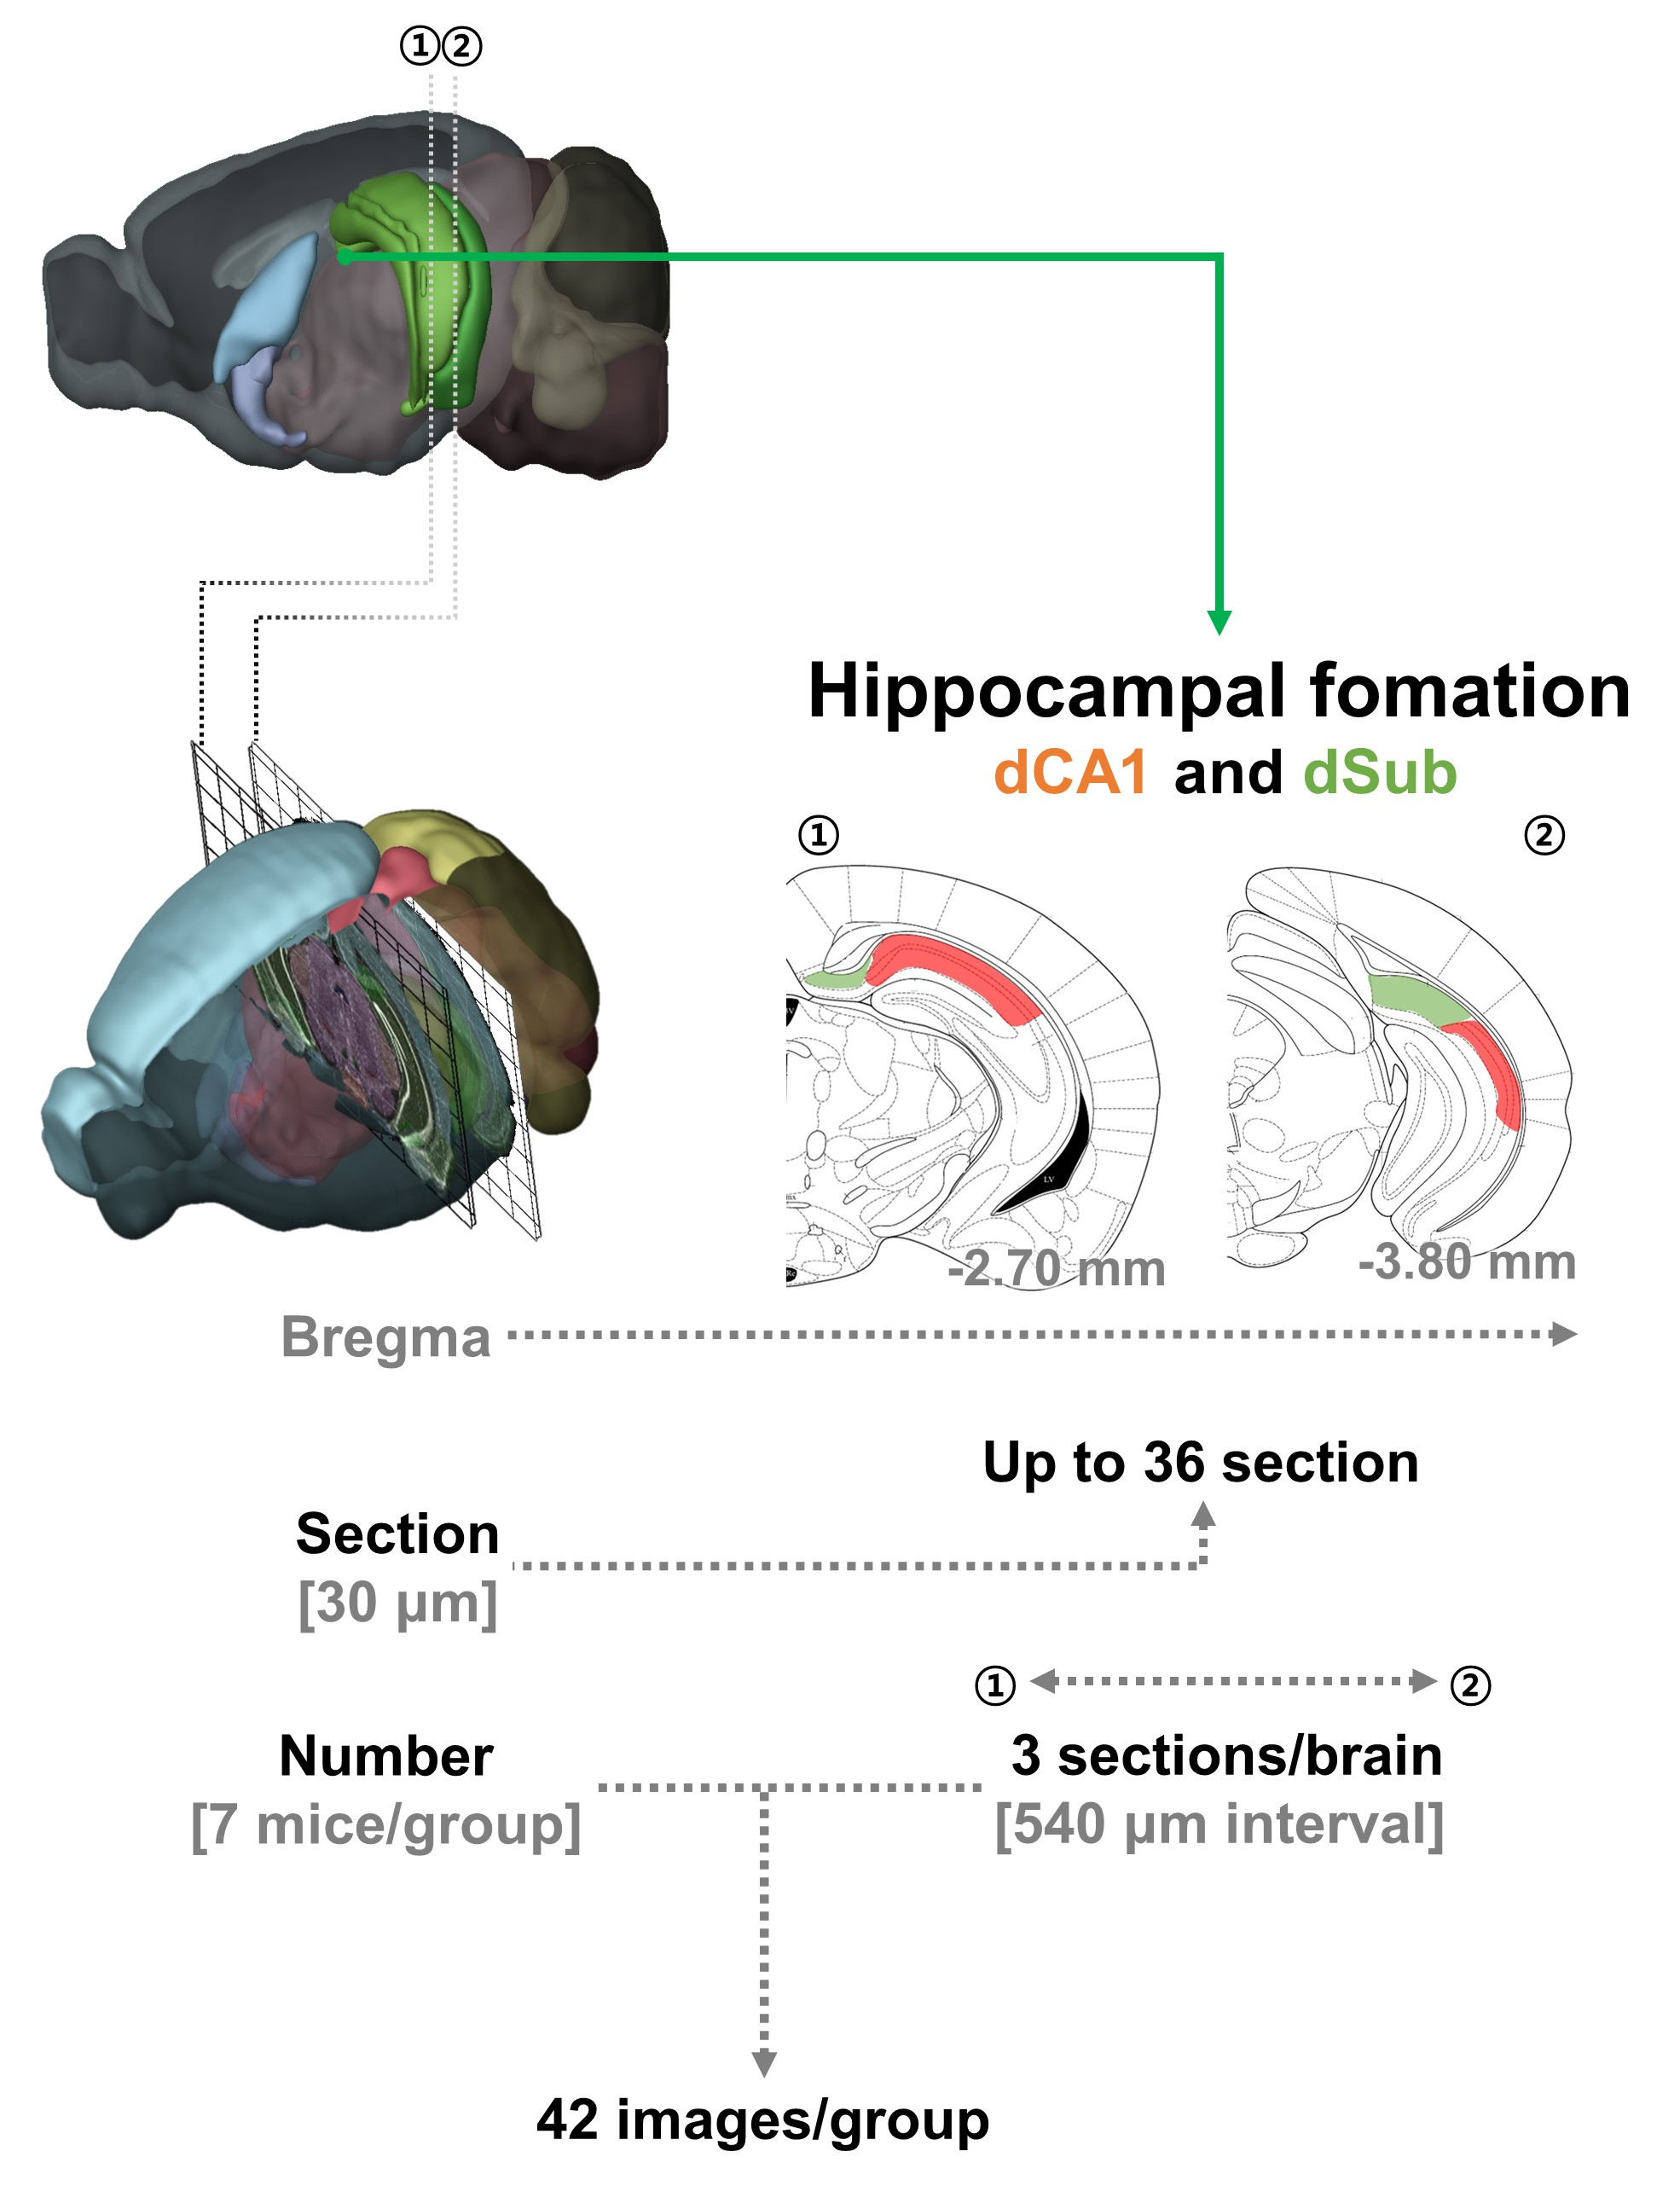
Supplementary figure 2. Preparation of mouse brain tissues for immunoreactivity. From ① to ②, the dorsal CA1 (dCA1) and dorsal subiculum (dSub) of caudal domain was designated from -2.70 mm to -3.80 mm from the bregma. Fixed and cryoprotected mouse brains were coronally sectioned at a thickness of 30 μm in cryostat. Thirty-six (dCA1 and dSub part) sections per mouse were obtained using the cryosection. In the dCA1 and dSub part, three sections per brain were taken from 7 mice at 540 μm intervals to obtain 42 images for the dCA1 and dSub. The acquired images were subjected to topographical quantification and statistical analysis in a blind manner.

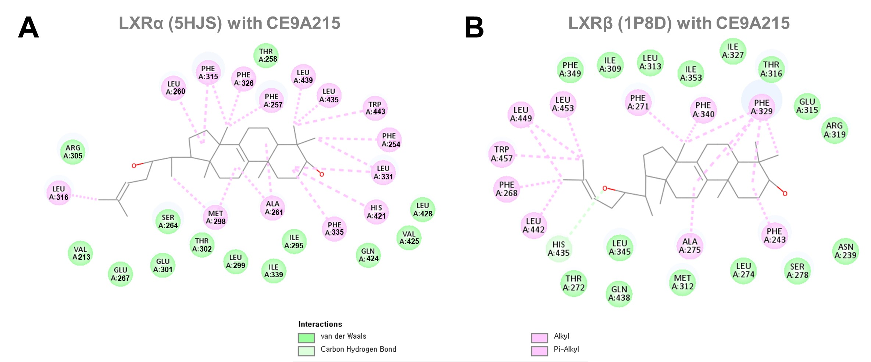
Supplementary figure 3. Molecular docking of LXRα (5HJS) or LXRβ (1P8D) with CE9A215 (A) The two-dimensional representation of interaction of CE9A215 with 5HJS. (B) The two-dimensional representation of interaction of CE9A215 with 1P8D.

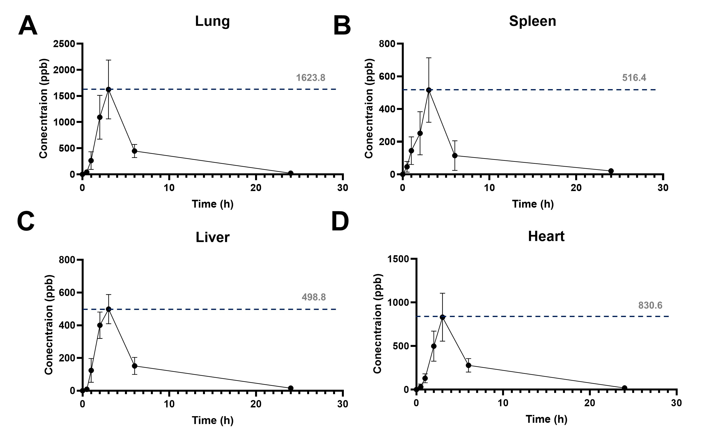
Supplementary figure 4. The concentrations of CE9A215 in the peripheral organs in mice. Graphs of CE9A215 clearance in the (A) lung, (B) spleen, (C) liver, and (D) heart of ICR mice intragastrically administered with 10 mg/kg CE9A215.

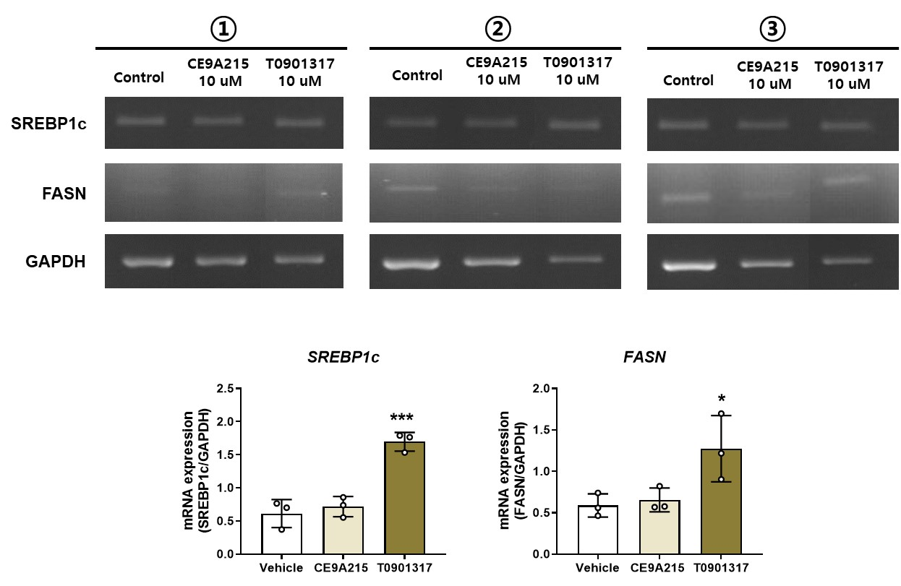
Supplementary figure 5. Effects of CE9A215 and T0901317 on mRNA expressions of SREBP1c and FASN in HepG2 cells.

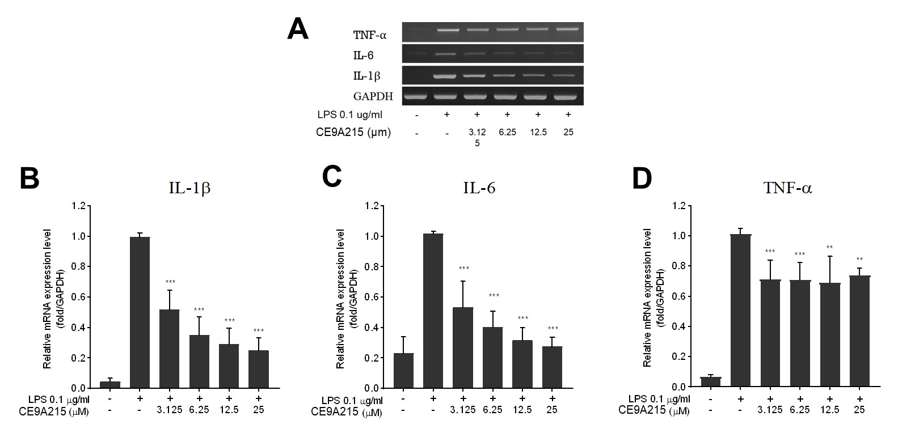
Supplementary figure 6. The dose-dependent effect of CE9A215 on the pro-inflammatory cytokines in LPS-treated BV2 microglial cells. (A) PCR results, (B) Relative mRNA expression levels. The data are represented as the mean ± standard error of the mean. Analysis ANOVA with Fisher’s least significant difference test was used to determine the significance of differences. *p < 0.05, **p < 0.01, and ***p < 0.001, vehicle-treated group evoked by LPS vs CE9A215-treated groups evoked by LPS.
Supplementary tables
Supplementary table 1. The mobile phase gradients and HPLC-ELSD instrument conditions.
The mobile phase gradients |  |  | HPLC-ELSD condition
Time (min) | A (%)  DW | B (%)  Methanol | Injection volume  (mL) | Flow rate  (mL/min) | Gas flow (L/min) | Drift-tube temperature  (°C) | Column temperature  (°C)
0 | 20 | 80 | 10 | 1 | 3 | 90 | 50
5.0 | 5 | 95
10.0 | 5 | 95
10.1 | 0 | 100
20.0 | 0 | 100
20.1 | 20 | 80
25 | 20 | 80

Supplementary table 2. The mobile phase gradients and HPLC-MS/MS instrument condition.
The mobile phase gradients |  |  | HPLC-MS/MS condition
Time (min) | A (%)  DW | B(%)  Methanol | Injection volume  (mL) | Flow rate  (mL/min) | Column temperature  (°C) | Mode
0 | 25 | 75 | 2 | 0.2 | 40 | Positive
2 | 25 | 75
6 | 10 | 90
8 | 3 | 97
16 | 0 | 100
17 | 25 | 75
20 | 25 | 75

Supplementary table 3. The positive mode and MS/MS conditions.
Positive mode conditions
Dry gas temperature  (°C) | Dry gas flow rate  (L/min) | Nebulizer pressure  (psi) | Sheath gas temperature (°C) | Sheath gas flow rate  (L/min) | Capillary voltage (V) | Nozzle voltage  (V)
270 | 10 | 40 | 300 | 11 | 3500 | 500

Supplementary table 4. Mouse primer sequences using qPCR
Gene | Primer sequences | Temperature (℃)
APOE | F: AAC CGC TTC TGG GAT TAC CT  R: TGT GTG ACT TGG GAG CTC TG | 60
ABCA1 | F: GCA GAT CAA GCA TCC CAA CT  R: CCA GAG AAT GTT TCA TTG TCC A | 60
SREBP-1c | F: AAC CTC ATC CGC CAC CTG  R: TGG TAG ACA ACA GCC GCA TC | 60
AQP1 | F: CTG CTG GCG ATT GAC TAC ACT G  R: CTC ACC CGC AAC TTC TCA AAC C | 55
AQP4 | F: CTG GAG CCA GCA TGA ATC CAG  R: TTC TTC TCT TCT CCA CGG TCA | 55
GAPDH | F: ACC CAG AAG ACT GTG GAT GG  R: CAC ATT GGG GGT AGG AAC AC | 60

Supplementary table 5. Primary and secondary antibodies using immunoblotting and immunostaining.
Antibodies | Concentration | Source
Mouse anti-β−actin antibody | 1:1000 | Santa cruz
Mouse anti-tau (Tau-5) antibody | 1:500 | Santa cruz
Mouse anti-phospho-tau (S396) antibody | 1:500 | Santa cruz
Mouse anti-phospho-tau (T181) antibody | 1:500 | Santa cruz
Rabbit anti-phospho-tau (T205) antibody | 1:500 | Abcam
Rabbit anti-phospho-tau (T231) antibody | 1:500 | Abcam
Mouse anti-GSK3β antibody | 1:500 | Santa cruz
Mouse anti-phospho-GSK3β antibody | 1:500 | Santa cruz
Rabbit anti-AKT antibody | 1:500 | Cell signaling
Rabbit anti-phospho-AKT antibody | 1:500 | Cell signaling
Goat anti-Mouse IgG (H+L) secondary antibody, HRP | 1:1000 | Invitrogen
Goat anti-Rabbit IgG(H+L) secondary antibody, HRP | 1:1000 | Invitrogen
Mouse anti-4G8 antibody | 1:2000 | BioLegend
Mouse anti-phospho-tau (AT8) antibody | 1:500 | Thermo Fisher Scientific
Goat anti-ionized calcium binding adapter molecule-1 (Iba-1) antibody | 1:1000 | Abcam
Donkey Alexa 488-conjugated anti-mouse IgG antibody | 1:300 | Thermo Fisher Scientific
Donkey Alexa 594-conjugated anti-goat IgG antibody | 1:300 | Thermo Fisher Scientific

References
[1] T.M.N. Nguyen, S.-Y. Ban, K.-B. Park, C.-K. Lee, S.-W. Lee, Y.-J. Lee, S.-M. Baek, J.-K. Park, M.T.T. Nguyen, J. Kim, Evaluation of toxicity and efficacy of inotodiol as an anti-inflammatory agent using animal model, Molecules 27(15) (2022) 4704.

