Supplement to “Assessing the impact of group antenatal care on uptake of intermittent preventive treatment in pregnancy in Atlantique Department, Benin: a cluster randomized controlled trial"

Supplemental Methods

G-ANC implementation
G-ANC materials were translated into French and adapted to the Beninese context through a stakeholders’ workshop in January 2021 using Jhpiego’s G-ANC model (Figure S1, S2).³⁰ Each intervention facility was provided with G-ANC facilitation materials, automated blood pressure devices and weighing scale for self-assessments, plastic chairs, a privacy screen, exam bed, and some basic supplies. Several intervention HFs also received a tent to create a meeting space. The study provided airtime to providers to call women in G-ANC before each meeting to remind them to attend. Refreshments were provided at the end of every meeting. Group-ANC registers were used to track cohort participants’ attendance and IPTp administration.

Training, monitoring, and supervision. ANC providers at all 40 study sites received a half-day onsite ANC technical update from between December 2020 and March 2021 to standardize basic care, including IPTp and gestational age estimation. Three providers per intervention facility (total 60) were invited to the G-ANC facilitation training. Due to staff shortages in many facilities, only 54 providers (39 nurses and midwives and 15 health aides [MA]; 1-4 providers per facility) serving the 20 intervention facilities participated in the five-day hands-on training on G-ANC facilitation in February 2021, including an orientation to study procedures and scheduling women to join an appropriate cohort. In addition, two health officials per health zone were trained (total of six supervisors). Additional G-ANC trainings were conducted in December 2021 and January 2022 for 12 newly assigned providers as staff transfers left six intervention facilities without enough providers to conduct G-ANC. After training, providers in the intervention facilities were supported to begin the intervention. Intervention facilities were encouraged to enroll as many women into G-ANC as possible.

Group-ANC specific registers were used to track cohort participants’ attendance and IPTp administration. Study staff abstracted monthly attendance data per cohort per meeting in aggregate. Study staff conducted monthly and quarterly visits to intervention and control facilities, respectively, to monitor progress and support providers. During these visits, G-ANC meetings were observed using a fidelity checklist. The study team together with HZ officials conducted quarterly meetings with G-ANC facilitators from intervention facilities in each health zone to discuss challenges and share best practices. Study staff also maintained a study log to record events that may have affected the study (such as staff transfers, etc.).

Participant recruitment adjustments. Enrollment in G-ANC was lower than anticipated, in part due to the COVID-19 pandemic, limited staff availability, and the time available to perform administrative tasks such as obtaining consent from women during ANC clinics, scheduling meetings, and follow up with groups. Thus, in November 2021, five research assistants (RA), all of whom had midwifery training, were hired to support facilities with administrative duties for the study. In August 2022, ten additional RAs were added to assist with a post-partum survey and study activities.

Baseline and endline cross-sectional surveys and post-partum survey.
Experienced staff were hired and trained for 4 days to conduct baseline and endline household surveys during November 2-December 12, 2020, and October 24-December 2, 2022, respectively. The CDC’s open-source Sampling app was used to delineate enumeration areas (EA) in catchment areas of the 40 study health facilities, and randomly select 63 households in each of those areas. To assure that at least 33 of the households included a woman aged 15-49 who had experienced a live birth in the previous 12 months, enumerated households were classified by whether there was a resident meeting this criterion.

During the two days of questionnaire administration in each EA, a standardized questionnaire to collect information on demographics, malaria prevention and ANC experiences was administered to women who had experienced birth in the previous 12 months, or, in households without such a member, to one adult household member. Households in which residents were absent were revisited at least twice before being declared absent. Malaria RDTs were administered by trained community health workers to all children aged six—59 months after obtaining caregiver consent; those testing positive were treated according to national guidelines. Data was collected on electronic tablets using CommCare software (version 2.52, Dimagi) and uploaded daily to a CommCare database. Survey supervision was provided by study staff.

Data management and analysis
Data collection tools for the baseline, endline and delivery surveys were pre-programmed with validation and logic checks using CommCare electronic data collection software. ANC data was collected by providers on paper registers and subsequently entered in a CommCare database by study staff. Data was stored on password-protected laptops and tablets, with restricted access to questionnaires and data by study staff only. Systematic routines were developed to check for data entry discrepancies, range, and consistency. Discrepancies were resolved by reference to the original data collection forms.

Statistical analyses were performed using SAS version 9.4 (Charlotte, NC). A difference in differences analysis was done using proc genmod to estimate the change in the proportion of women receiving both ANC and IPTp from baseline to endline in intervention versus control facilities. The effects of gravidity, ITN use, marriage, education, age, and socioeconomic status were assessed. For the cross-sectional survey analysis, only socioeconomic status was retained in the models as it was the only significant confounder. The post-partum survey was analyzed using proc surveyfreq to account for clustering and weighting. The primary outcome assessed was the proportion of recently pregnant women at the cluster level who received 3 or more doses of IPTp (IPTp3).

Secondary outcomes, calculated at the cluster level, included:
- The proportion of women who received 1, 2, or 4 or more dose of IPTp
- The proportion of women who made 1, 2, 3, 4, 6, or 8 ANC visits
- The gestational age at the time of first ANC and at 1st dose of IPTp
- Proportion of women who recently gave birth who had a facility-based delivery
- Proportion of women who recently gave birth who received quality antenatal care, defined as having blood pressure measured, a urine test, a blood test, being protected against tetanus, receiving iron and folic acid, receiving albendazole for de-worming, receiving an ITN, and receiving IPTp
- Mean birthweight of infants

Supplemental Results
Table S1. Demographic characteristics of women in the post-partum survey
 | Individual ANC | G-ANC | p-value
Total | 1320 | 186
Mean age, years (SD) | 25.8 (25.3-26.4) | 26.1 (25.1-27.1) | 0.59
Married/ living together, n (%) | 94.8 (92.6-97.0) | 97.6 (94.8-100) | 0.18
Education
No education (1) | 34.0 (28.3-39.8) | 23.7 (15.8-31.7) | 0.004
Primary (2) | 38.7 (33.4-43.9) | 40.0 (31.7-48.3) | 0.004
Secondary or higher | 27.3 (21.9-32.7) | 36.3 (26.4-46.1) | 0.004
Slept under an ITN last night | 85.5 (78.1-93.0) | 91.3 (85.7-96.9) | 0.11
Parity
1 pregnancy | 26 (21.3-30.8) | 23.3 (17.8-28.8) | 0.54
2 pregnancies | 21.5 (18.2-24.8) | 24.7 (20.1-29.3) | 0.54
3 pregnancies | 52.4 (48.9-55.9) | 52 (45.1-58.9) | 0.54
Prior pregnancies, mean (SD) | 2.9 (2.7-3.1) | 2.9 (2.6-3.2) | 0.72

Table S2. Coverage of ANC and IPTp among women in the post-partum survey, by receipt of G-ANC vs individual ANC
 | Individual ANC | G-ANC | p-value
Total | 1320 | 186
ANC2 | 94.7 (91.8-97.6) | 100 (100-100) | -
ANC3 | 80.3 (73.2-87.4) | 97.2 (94.8-99.6) | 0.001
ANC4 | 57.7 (47.7-67.7) | 90.7 (85.9-95.6) | 0.0003
ANC6 | 19.9 (12.1-27.6) | 61.6 (46-77.2) | 0.003
ANC8 | 5.2 (1.5-8.8) | 29.6 (8.5-50.7) | <.0001
IPTp1 | 97.8 (95.3-100) | 85.9 (74.1-97.7) | 0.10
IPTP2 | 76.9 (70.4-83.5) | 81.2 (69.6-92.8) | 0.48
IPTP3 | 45.4 (36.6-54.2) | 66.7 (54.2-79.1) | <.0001
IPTP4 | 16 (11.3-20.6) | 44.7 (33.2-56.3) | <.0001
IPTP5 | 3.1 (1.9-4.4) | 20.3 (10.4-30.1) | <.0001
*All but one woman in the individual ANC group attended at least 1 ANC visit, and only 5 women (all individual ANC attendees) attended only 2 ANC visits. Due to having no women in the G-ANC group who attended only 1 or 2 ANC visits, no statistics can be calculated for these outcomes.

Table S3. Quality of care during pregnancy, post-partum survey
 | Individual | G-ANC | p-value
Total | 1320 | 186
Proportion of women who attended any ANC* | 99.9 | 100
Proportion receiving ANC in the Public Sector only | 97.7 (96.4-99) | 99.1 (97.7-100) | -
Proportion receiving ANC in the Private Sector only | 0.9 (0.4-1.4) | 0 | -
Proportion receiving ANC in both Public and Private Sectors | 1.4 (0.2-2.6) | 0.9 (0-2.3) | -
Average wait time at the health facility before being seen by the ANC provider (minutes) | 116 (89-143) | 97 (73-122) | 0.0003
Average total time at the health facility for ANC (minutes) | 175 (151-199) | 191 (162-219) | 0.01
Average total time away from home to attend ANC (minutes) | 258 (218-297) | 295 (235-355) | 0.0004
Cost (one-way) to get to HF (mean) | 263 (236-291) | 240 (217-263) | 0.04
Received Quality Care (composite, received all 7 ANC interventions): | 61.6 (52.2-71.0) | 64.7 (50.0-79.5) | 0.62
Blood pressure measured at least once (proportion) | 99.9 (99.8-100) | 100 (100-100) | -
Urine sample taken at least once (proportion) | 95.4 (92-98.8) | 98.8 (97-100) | 0.01
Blood sample taken at least once (proportion) | 90.4 (82.6-98.1) | 91.3 (83.6-99.1) | 0.67
Infant protected from tetanus | 79.3 (72.5-86.0) | 86.0 (78.0-94.1) | 0.03
Iron tablets or iron syrup (yes/ no) | 99.7 (99.4-100) | 100 (100-100) | -
Duration of iron supplementation during pregnancy | 26.7 (25.0-28.3) | 24.1 (21.0-27.2) | <.0001
Proportion treated for intestinal worms | 90.3 (86.3-94.2) | 92.8 (87.5-98.2) | 0.26
Proportion who received an ITN from ANC | 79.8 (71.0-88.5) | 88.6 (80.0-97.3) | <.0001
Mean birth weight | 3007 (2969-3045) | 3111 (3051-3171) | 0.001
*Only one woman reported not attending ANC

Figure S1. Map of Atlantique Dept with intervention and control facilities
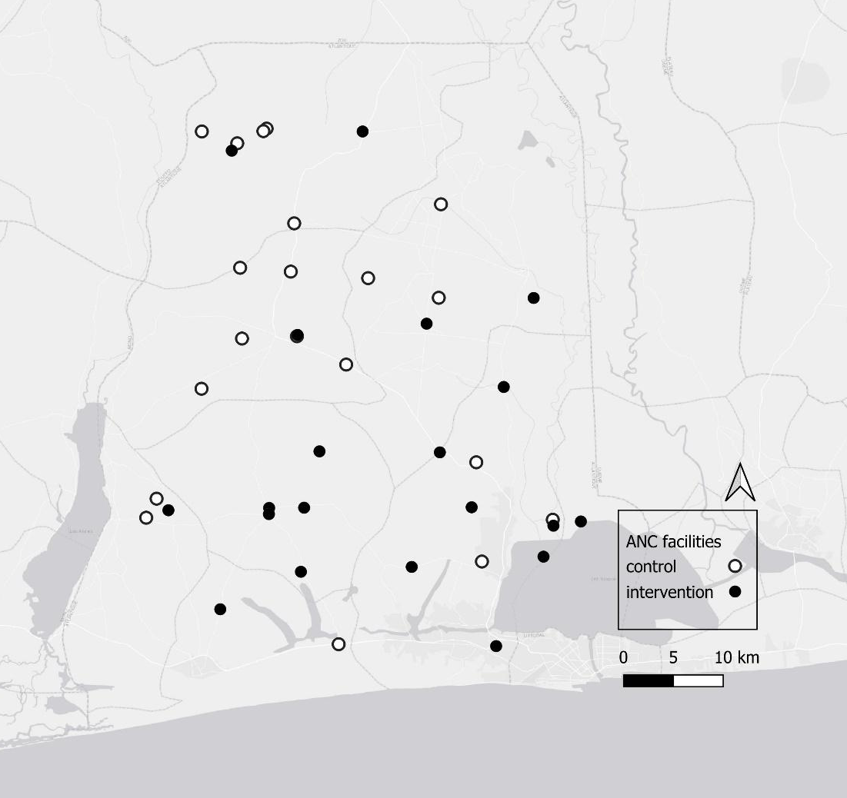

Figure S2. Proposed G-ANC Intervention with Timing and Illustrative Content of Meetings
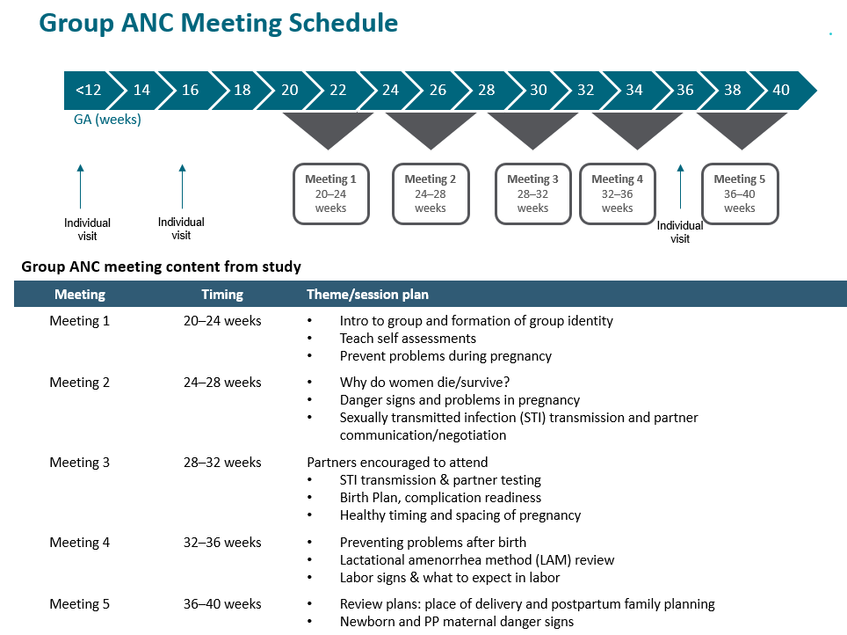

NOTES: National ANC guidelines recommend a minimum of 8 ANC contacts. Per recommendations, women should have multiple ANC contacts in the third trimester at 30, 34, 36, 38, and 40 weeks GA, thus women will be reminded to come for additional individual ANC visits between and after the 5th meeting as needed.
The recommendation for IPTp in Benin is to start at 16 weeks GA and then have monthly doses. Women who came for their first ANC visit at 13–14 weeks GA were encouraged to return for an individual ANC visit at 16 weeks GA, before the first group meeting.

