Supplementary materials

S1 Introduction figures/tables

S1.1 Table S1. Showing the details of the contingencies underlying the task for each block.
Screen |  | Contingency Information
Block Name | Description | Trials (n) | Mean | SD
Practice 1 | Practice round screen 1 | 3 | -0.07 | 0.045
Practice 2 | Stable learning environment | 10 | 0 | 0.12 or 0.03
Noise | Learning when the SD changes (high and low noise) | 40 | 0 | 0.12 or 0.03
Volatility | Learning when the mean changes (high volatility) | 40 | 0.35, -0.35 | 0.06
Combined Uncertainty | Learning with combined SD and mean changes | 84 | 0.35, -0.35, 0.14, -0.21 | 0.12 or 0.03
Bivalent Combined Uncertainty | Learning with combined SD and mean changes. Includes gains and losses. | 42 | 0.35, -0.21 | 0.12 or 0.03

S1.2 Task Instructions

Table S2. Showing instructions given to participants during the space task.
Screen Name | description | Text prompt –
Introduction | Intro screen 1 | `It is your first mission with the Intergalactic Space Defenders. However, a near miss has left you marooned on a planet that deals with all the waste and rubbish from the surrounding planets!'
Introduction | Intro screen 2 | "Old spacecraft of all shapes and sizes are flown into orbit above you, one at a time. As they disintegrate, useful parts fall off them. Your job is to catch the parts so you can build a rocket and escape."
Introduction | Intro screen 3 | "Each spacecraft will be too high for you to see. To successfully capture the falling parts you will have to estimate two things:  1. The location of the passing spacecraft. This will help you estimate where the parts will be falling from.  ii) The size of the passing spacecraft. For example, if the parts are falling from a large space craft, they are likely to be more spread out.  You will be given information about the incoming spacecraft at the start of each level that will help you to figure out the sizes and locations of the spacecraft."
Introduction | Intro screen 4 | "You have an electromagnetic ray to capture the falling parts and bring them in, so you can build the rocket. IMPORTANT: You only have a small amount of fuel, so you must use the least amount of power possible to bring the parts in (the smallest ray possible)."
Introduction | Intro screen 5 | You will get a HIGHER SCORE for catching the falling parts with a SMALLER ray - but remember you will get zero points if you miss it!
Introduction | Intro screen 6 | After seeing where the last spacecraft piece fell, turn the ray ON by pressing UP and then press the RIGHT and LEFT arrows to position the electromagnet. Use the UP and DOWN arrows to increase and decrease its power.  Give it a try now!'
Introduction | Intro screen 7 | On a computer you can use the LEFT and RIGHT keyboard keys. Press enter, space or click to continue.'
Practice  Block 1 | Practice round screen 1 | PRACTICE ROUND: You have 5 seconds to complete each turn. You must pass all 3 turns in the practice round to continue.  Turn the electromagnetic ray ON (red to green) by pressing UP, and then press the RIGHT and LEFT arrows to position the electromagnet. Use the UP and DOWN arrows to increase and decrease its power.  PRACTICE ROUND INFORMATION:  Number of incoming spacecraft: 1  Size of incoming spacecraft: Small  Location of incoming spacecraft: ONE location likely
 | Practice round screen 2 | Good job! A quick reminder:  The Spacecraft will pass overhead one at a time - but may be different sizes, and in different locations. Information at the start of each level will help you to figure this out.
 | Practice round screen 3 | "'Catch the parts that fall off the passing spacecraft using the smallest ray you feel is possible. This will earn you the most points. Every time you earn 500 points you get a bonus payment!. Do you want to repeat the tutorial? "
Practice  Block 2 | Stable learning environment | Level 1 INFORMATION:  Number of incoming spacecraft: 1  Size of incoming spacecraft: No information  Location of incoming spacecraft: One location likely
Noise Block | Learning when the SD changes | Level 2 INFORMATION:  Number of incoming spacecraft: 2  Size of incoming spacecraft: One large, one small. No information on the order they will pass.  Location of spacecraft: One location likely
Volatility Block | Learning when the mean changes | Level 3 INFORMATION:  Number of incoming spacecraft: Multiple  Size of incoming spacecraft: All around the same size  Location of incoming spacecraft: Multiple locations likely
Combined Uncertainty  Block | Learning with combined SD and mean changes | Level 4 INFORMATION  Number of incoming spacecraft: A large amount  Size of incoming spacecraft: All different sizes  Location of incoming spacecraft: Multiple locations likely
Bivalent Combined Uncertainty  Block | Learning with combined SD and mean changes Round includes loses. | Level 5 INFORMATION:  Number of incoming spacecraft: A large amount  Size of incoming spacecraft: All different sizes  Location of incoming spacecraft: Multiple locations likely  IMPORTANT: If the falling spacecraft parts are not caught in this round you will LOOSE points, and potentially LOOSE the money you have earnt. BUT if you do catch the falling parts you will earn DOUBLE POINTS! Catch the parts in the smallest ray possible and earn 20 points each time!

S2 Computational Modelling for Experiment 1 and 2

S2.1 Methods for comp modelling: HGF: JGET and novel response model

An extension of the standard HGF model (C. Mathys et al., 2011; C. D. Mathys et al., 2014) was used to model the data from Experiment 1 and 2 in a block wise fashion. Note that within the Matlab-based HGF toolbox subjects are fitted individually based on a quasi-Newton algorithm. In short, the HGF is an approximation of Bayesian learning but based on (prediction) error based learning rules. Crucially, higher-level beliefs determine the weight that is given to lower-level prediction errors that again affect higher-level beliefs. For instance, if a subject believes the environment to be stable (volatility belief is low) prediction errors are thereby “explained away” and won’t lead to a strong update on lower levels. Respectively, high updating takes place when volatility is believed to be high. For a more in depth explanation of the HGF, please see the original publications (Mathys et al., 2011, 2014). Here, the behavioural data was modelled using the HGF: Jumping Gaussian Estimation model (JGET; as implemented tapas-toolbox of the TNU project (Frassle et al. 2021)), that was designed to independently capture learning about the mean x and variance α (see Fig. 6 in the main manuscript). Both streams for learning about x and α emerge from an additional, common level that brings together beliefs about x₁ and α₁. In the decision model (modified version of the ‘tapas_gaussian_obs’-script; Frassle et al. 2021), we used the latter trajectories to predict the following trial-by-trial responses: belief about mean x₁ → rover position and β₁ weighting the belief about noise α₁ → beam width. Since instructions differed by blocks, we also chose different priors for the blocks (see Table S3).

Table S3. Showing priors set for the HGF modelling by block.
Parameter |  | Noise block  M(VAR) | Volatility block  M(VAR) | Noise and volatility & Bivalent noise and volatility blocks  M(VAR)
κ (in logspace) | u | 1 (0) | 1 (0) | 1 (0)
 | x | 0 (0) | 1 (1) | 1 (1)
 | a | 1 (1) | 0 (0) | 1 (1)
ω₁ | u | 0 (0) | 0 (0) | 0 (0)
 | x | 0 (16) | 3 (16) | 3 (16)
 | a | 0 (16) | 0 (0) | 3 (0)
ω₂ or θ | x | 0 (0) | -8 (16) | -8 (0)
 | a | 0 (0) | 0 (0) | -12 (0)
$$µ_{2}^{0}$$ | x | 1 (0) | 1 (0) | 1 (0)
 | a | -1 (0) | 0 (0) | 0 (0)
$σ_{1}^{0}$ (in logspace) | x | 0.1 (0) | 0.1 (0) | 0.1 (0)
 | a | 1 (0) | 0.1 (0) | 0.1 (0)
$σ_{2}^{0}$ (in logspace) | x | 1 (0) | 0.01 (0) | 0.01 (0)
 | a | 1 (0) | 0.01 (0) | 0.01 (0)
β (in log-space) | a | 1 (16)  10 (16)  0.01 (16)
ζ | x
 | a (in log-space)
Abbreviations: M (variance), variance equalling 0 means these parameters were fixed; u=input; x=mean learning, a=variance learning

S2.2 Bayesian Model Comparison: (no) higher-level learning in non-volatile conditions
In line with the instructions, we only allowed for a coupling of levels when there was real volatility for either noise (kappa_a for the noise block) or mean (kappa_x for the volatility block), whereas we kept the kappa of the non-volatile construct fixed at 0 (resulting in no upper-level learning).
In order to test whether our task manipulation had worked here, we set up additional models for the noise block and the volatility block with free kappas of the non-volatile construct (free kappa_x for the noise block, free kappa_a for the volatility block) and ran those on the data from experiment 2. Bayesian model comparison (Stephan et al. 2009) revealed that our initial models captured the data better than the new models with free kappas (PXP for protected exceedance probability (Rigoux et al. 2014); PXP for the noise block kappa_x fixed = 1; PXP for the volatility block kappa_a fixed = 0.63; see Figure S1).
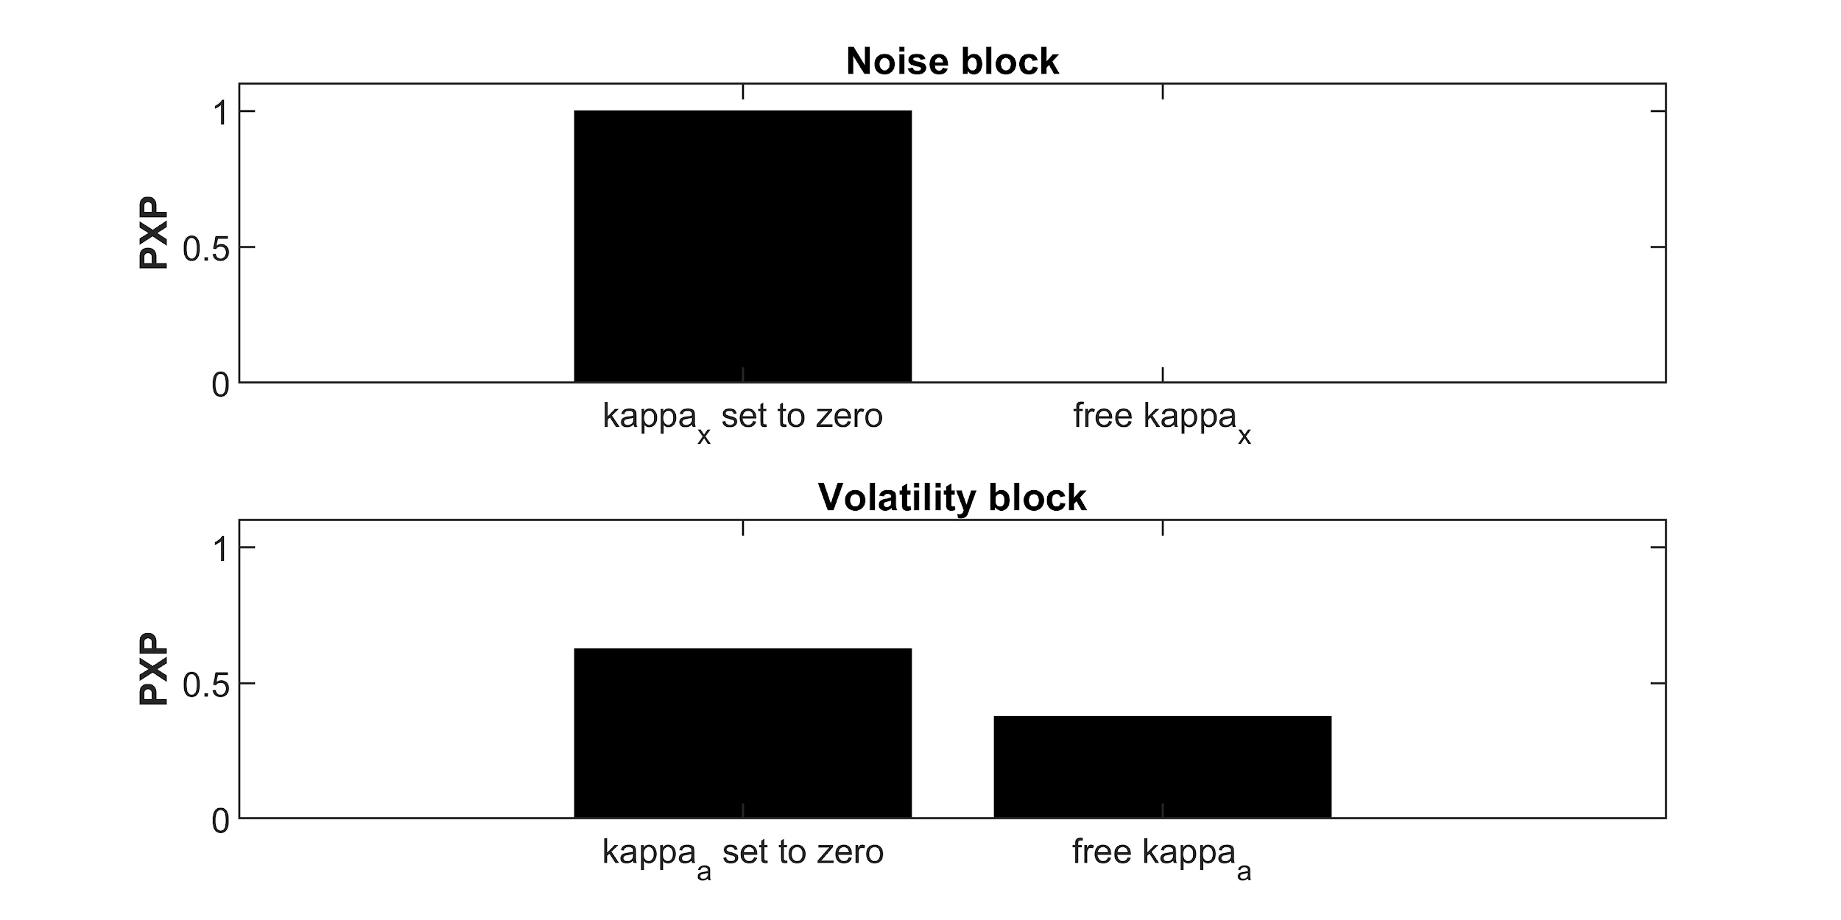
Figure S1. Model comparison for different kappa settings of the noise block and the volatility block. On the left: the prior solution reported in the main text, on the right: the alternative solution with free kappas for the respectively non-volatile condition. PXP = protected exceedance probability.

S3 Experiment 1

S3.1 Methods

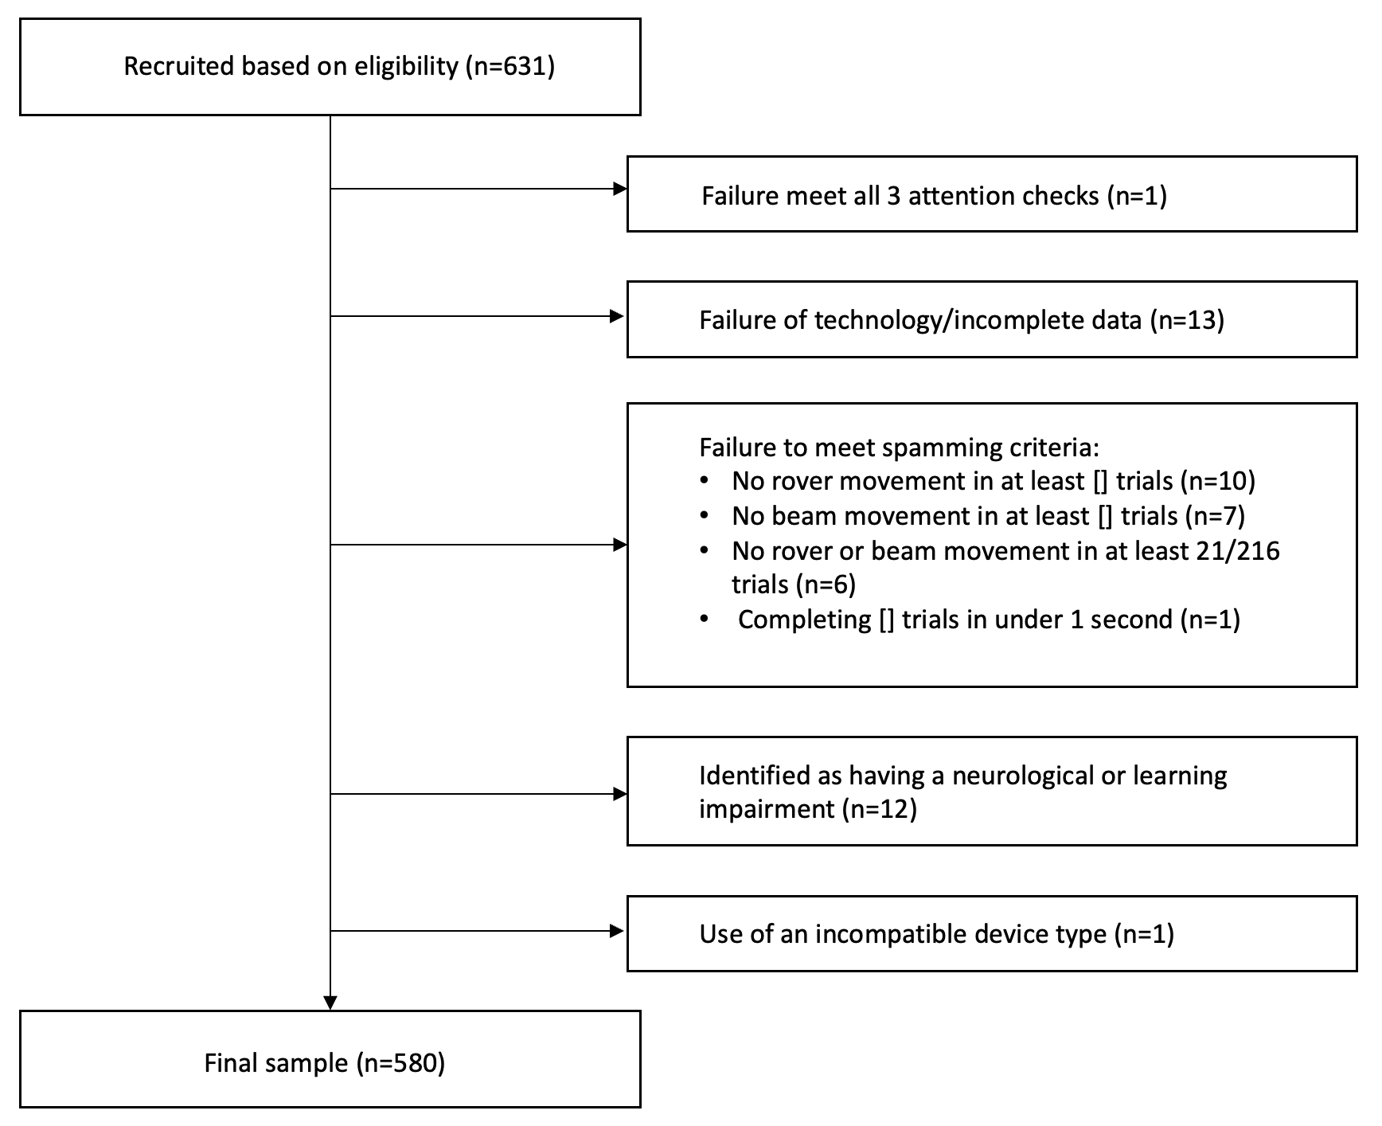
Figure S2. Showing a flow diagram of the exclusion criteria used in this study, and the number of participants excluded for each criterion.

S3.2 Results (experiment 1)

S3.2.1 Correlations between symptom scales:

Table S4. showing the correlation between different symptoms. ***: p < .001
Symptom scales | 1 | 2 | 3 | 4 | 5
1. GPTS | - | - | - | - | -
2. PDI | 0.52*** | - | - | - | -
3. SPQ | 0.52*** | 0.57*** | - | - | -
4. MASQ Anxiety | 0.59*** | 0.36*** | 0.49*** | - | -
5. MASQ Depression | 0.43*** | 0.31*** | 0.52*** | 0.65*** | -
GPTS = Green Paranoia Thoughts Scale; PDI = Peters Delusion Inventory; SPQ = Schizotypy Personality Questionnaire; MASQ = Mood and Anxiety Symptom Questionnaire

S3.2.2 Model selection results

Score.
Table S5. Showing model selection outcome for model sets predicting score (averaged level-wise for each individual)
Model for Score (average by level) in Genpop Sample | K | deltaAICc | AICc weight (%) | marginal R2
null | 5 | 70.43 | 0 | 0
level*masqCombined_anxiety + level*spq_total + level*pdi_total + level*green_total + level*masqCombined_depression + age + gender + device_type + education + ethnicity | 35 | 13.75 | 0 | 0.21
device_type + gamers*level + gender + masqCombined_depression + green_total + spq_total*level + masqCombined_anxiety | 22 | 0 | 0.99 | 0.21

Performance Error.
Table S6. Showing model selection outcome for model sets predicting performance error (averaged level-wise for each individual).
Model for logged Perfe (average by level) in Genpop Sample | K | deltaAICc | AICc weight (%) | marginal R2
null | 5 | 145.26 | 0 | 0
level*masqCombined_anxiety + level*spq_total + level*pdi_total + level*green_total + level*masqCombined_depression + age + gender + device_type + education + ethnicity | 35 | 0 | 1 | 0.21
device_type + gender + masqCombined_depression + level + green_total + pdi_total:level + masqCombined_anxiety | 18 | 5151.28 | 0 | 0.55

Beam width
Table S7. Showing model selection outcome for model sets predicting beam width (averaged across high and low noise conditions for each individual).
Model for beam width in Genpop Sample | K | deltaAICc | AICc weight (%) | marginal R2
null | 5 | 494.99 | 0 | 0
device_type + gamers*SDhigh +  gender + masqCombined_depression*SDhigh +  green_total*SDhigh + pdi_total*SDhigh + spq_total*SDhigh + masqCombined_anxiety*SDhigh | 21 | 4.21 | 0 | 0.10
gamers*SDhigh + gender +  masqCombined_depression*SDhigh +  masqCombined_anxiety*SDhigh +  green_total*SDhigh | 16 | 0 | 1 | 0.89

Learning rate
Table S8. Showing model selection outcome for model sets predicting learning rate.
Model for LR in Genpop Sample | K | deltaAICc | AICc weight (%) | marginal R2
null | 5 | 75.79 | 0 | 0
level*masqCombined_anxiety + level*spq_total + level*pdi_total + level*green_total + level*masqCombined_depression + age + gender + device_type + education + ethnicity | 35 | 15.7 | 0 | 0.43
device_type + gamers*level + spq_total*level + masqCombined_depression | 18 | 0 | 1 | 0.43

Noise belief (be1)
Table S9. Showing model selection outcome for model sets predicting noise belief.
Model for Noise belief (be1) in Genpop Sample | K | deltaAICc | AICc weight (%) | marginal R2
null | 4 | 12.13 | 0 | 0
level*masqCombined_anxiety + level*spq_total + level*pdi_total + level*green_total + level*masqCombined_depression + age + gender + device_type + education + ethnicity | 41 | 30.35 | 0 | 0.2
level*spq_total + level*pdi_total + education | 22 | 0 | 0.99 | 0.2

Kappa for the variance (kaa)
Table S10. Showing model selection outcome for model sets predicting kappa for the variance.
Model for logged kaa in Genpop Sample | K | deltaAICc | AICc weight (%) | marginal R2
null | 4 | 4.37 | 0.10 | 0
level*masqCombined_anxiety + level*spq_total + level*pdi_total + level*green_total + level*masqCombined_depression + age + gender + device_type + education + ethnicity | 35 | 18.74 | 0 | 0.06
level + education | 14 | 0 | 0.90 | 0.04

Kappa for the mean (kax)
Table S11. Showing model selection outcome for model sets predicting kappa for the mean.
Model for logged kax in Genpop Sample | K | deltaAICc | AICc weight (%) | marginal R2
null | 4 | 3.79 | 0.13 | 0
level*masqCombined_anxiety + level*spq_total + level*pdi_total + level*green_total + level*masqCombined_depression + age + gender + device_type + education + ethnicity | 35 | 14.52 | 0 | 0.02
level*spq_total + level*pdi_total + level*green_total | 15 | 0 | 0.87 | 0.04

S3.2.3 Additional LME model results

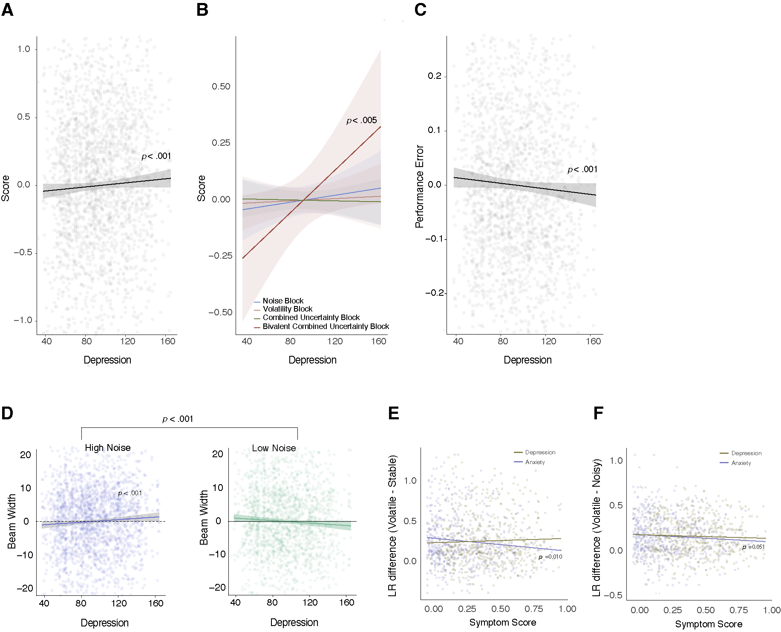

Figure S3. Showing results from experiment 1 relating to anxiety and depression symptom scales. A. Shows the positive significant relationship between increased depression symptomatology and score, Score is averaged for each person and each block, shown as the light grey dots. The standard error is also provided on the plot. B. Showing the interaction found between depression scores in the “combined uncertainty block” and the “bivalent combined uncertainty block”. Here we see that elevated depression scores show higher scores in block six - where it's possible to lose points and win extra - than those with lower depression scores. C. Showing the significant negative relationship between elevated depression scores and performance error - increased depression was associated with lower performance errors across the task (main effect). Performance errors were average across person and block, and are represented by the light grey dots. Standard error is also shown on the plot. D. Showing the relationship between depression scores and beam width use. Here, elevated depression was associated with a strategically beneficial use of the beam - they used wider beams in high noise, and smaller beams in low noise. Beam widths were averaged across noise conditions (high and low noise) for each individual (show via the purple and green dots). Standard error is also represented on the plots. E. Showing the learning rate difference/updating betweens stable and volatile environments (learning rate in volatile - learning rate in stable trials) in relation to anxiety (purple) and depression (brown) symptom scores. No relationship found for depression. However, elevated anxiety was associated with lower updates to learning rate when switching between stable and volatile conditions (r=-0.13 (p=.003)). F. Showing learning rate differences between noisy and volatile conditions. While no significant correlation was observed for depression, elevated anxiety was negatively associated with LR difference r=-0.09 (p=.045).

S4 Experiment 2

S4.1 Participants and Quality Assurance

A total of 18 individuals were excluded. Specifically, individuals were excluded if they 1) failed to move either the rover or the beam in over 10% of trials (n=8), and/or 2) completed over 50% of trials in under 1000ms (n=0), leading to a total of eight exclusions. A further seven individuals were excluded because of incomplete data, primarily due to a technology fault e.g.internet connection, or use of device type that was not sanctioned, such as a tablet (n=3).

S4.2 Model selection tables

Score.
Table S12. Showing model selection outcome for model sets predicting score (averaged level-wise for each individual).
LME Model for Score in SPQ Sample | K | deltaAICc | AICc weight (%) | marginal R2
null | 5 | 18.81 | 0 | 0
level*spqH + gender + age + education + ethnicity + device_type + employment | 21 | 18.66 | 0 | 0.25
level | 8 | 0 | 1 | 0.23

Performance error.
Table S13. Showing model selection outcome for model sets predicting performance error (averaged level-wise for each individual)
Model for logged Performance error in SPQ Sample | K | deltaAICc | AICc weight (%) | marginal R2
null | 5 | 34.6 | 0 | 0
level*spqH + gender + age + education + ethnicity + device_type + employment | 21 | 1209.76 | 0 | 0.25
education + device_type + level | 11 | 0 | 1 | 0.49

Beam width.
Table S14. Showing model selection outcome for model sets predicting beam width (averaged across high and low noise conditions for each individual)
Model for Confidence in SPQ Sample | K | deltaAICc | AICc weight (%) | marginal R2
null | 5 | 122.68 | 0 | 0
SDHigh*spqH +  gender +  age +  education +  ethnicity +  device_type +  employment | 17 | 16.51 | 0 | 0.07
SDHigh | 6 | 0 | 1 | 0.05

Learning rate
Table S15. Showing model selection outcome for model sets predicting learning rate.
Model for LR in SPQ Sample | K | deltaAICc | AICc weight (%) | marginal R2
null | 5 | 46.61 | 0 | 0
level*spqH + gender + age + education + ethnicity + device_type + employment | 21 | 9.96 | 0 | 0.49
Gender + education + ethnicity + level | 14 | 0 | 0.99 | 0.49

Noise belief (be1)
Table S16. Showing model selection outcome for model sets predicting noise belief
Model for be1 in SPQ Sample | K | deltaAICc | AICc weight (%) | marginal R2
null | 4 | 16.26 | 0 | 0
level*spqH + gender + age + education + ethnicity + device_type + employment | 15 | 3.95 | 0.12 | 0.2
level*spqH | 11 | 0 | 0.9 | 0.2

Kappa for the variance (kaa)
Table S17. Showing model selection outcome for model sets predicting kappa for the variance.
Model for logged kaa in SPQ Sample | K | deltaAICc | AICc weight (%) | marginal R2
null | 4 | 0.65 | 0.42 | 0
level*spqH + gender + age + education + ethnicity + device_type + employment | 13 | 8.48 | 0 | 0.03
level + gender | 7 | 0 | 0.6 | 0.02

Kappa for the mean (kax)
Table S18. Showing model selection outcome for model sets predicting kappa for the mean.
Model for logged kax in SPQ Sample | K | deltaAICc | AICc weight (%) | marginal R2
null | 4 | 1.76 | 0.29 | 0
level*spqH + gender + age + education + ethnicity + device_type + employment | 13 | 11.58 | 0 | 0.03
level | 6 | 0 | 0.71 | 0.02

S4.2 Additional LME model findings not reported in main text

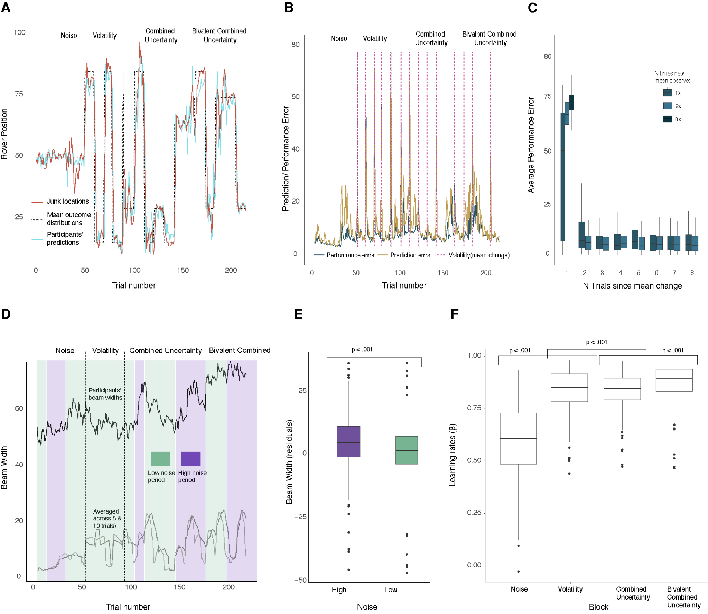
Figure S4. Task effects observed across blocks in Experiment 2. A. Rover positions matched the underlying mean. B. Prediction/performance errors increased right after mean changes and C. decreased with increasing stability of junk positions after changes. D. shows the average beam width for each trial, across all participants (black). The background is shaded in purple and green to represent high and low noise conditions respectively. The dark grey and light grey lines depict the cumulative standard deviation estimate given differing levels of coarseness, specifically over5 trials (yellow), and 15 trials (red). Dotted lines indicated block changes, with trial numbers on the x-axis. E. shows the residual beam width variance, unexplained by covariates, compared between high and low noise conditions across the whole task. F. Shows average learning rates by block. G. Top. Here, for volatile, combined, and combined bivalent combined conditions, learning rates are compared between high (purple) and low (green) noise conditions. Bottom. Average block wise learning compared for no mean change trials (lime green), and mean change trials (pink).

Learning rate differences

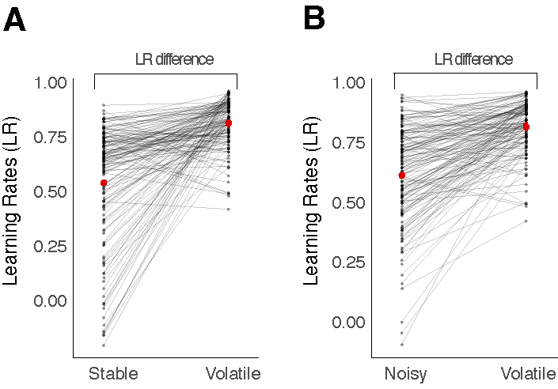

Figure S5. Showing learning rates in stable and volatile blocks. Each block dot is one person and their data is joined between conditions with a straight black line. The mean for each condition is indicated in red.

S5 Experiment 3 (in person lab experiment)

S5.1 Participants and Quality control

Table S19. Showing the detailed characteristics and symptoms of participants in Experiment 3.
 | n (%) | Mean (SD)
Demographic characteristics
Age |  | 29.94 (6.38)
Gender
Female | 10 (55.6)
Education
Postgraduate degree (MSc/MA/MRes) | 4 (22.2)
Undergraduate degree (BSc/BA) | 10 (55.6)
A Levels or equivalent diplomas (e.g. BTEC) | 4 (22.2)
Employment
Working full-time | 9 (50.0)
Working part-time | 4 (22.2)
Prefer not to say | 1 ( 5.6)
Student | 4 (22.2)
Gaming time
Rarely | 3 (16.7)
Sometimes | 7 (38.9)
Regularly | 6 (33.3)
No | 2 (11.1)
Symptoms
Green Paranoia Thoughts Scale |  | 47.39 (14.49)
Peters Delusion Inventory |  | 3.44 (3.03)
Schizotypal Personality Questionnaire |  | 8.00 (4.13)

5.2 Results

S5.3 Model selection outputs

Score.
Table S20. Showing model selection outcome for model sets predicting score (averaged level-wise for each individual).
Model for Score (average by level) in Lab Sample | K | deltaAICc | AICc weight (%) | marginal R2
null | 5 | 3.9 | 0.11 | 0
age + gender + spq_total*level +  employment + gamers + education + green_total*level +  pdi_total*level | 28 | 35.75 | 0 | 0.7
spq_total + education + green_total + pditotal*level | 16 | 0 | 0.79 | 0.51

Performance error
Table S21. Showing model selection outcome for model sets predicting logged prediction error (averaged level-wise for each individual).
Model for logged Perfe (average by level) in Lab Sample | K | deltaAICc | AICc weight (%) | marginal R2
null | 5 | 19.06 | 0 | 0
age + gender +spq_total*SDhigh +employment + gamers + education + green_total*SDhigh + pdi_total*Sdhigh | 28 | 38.89 | 0 | 0.73
pdi_total + level | 9 | 0 | 1 | 0.45

Beam width
Table S22. Showing model selection outcome for model sets predicting beam width (averaged level-wise for each individual).
Model for beam width in Lab Sample | K | deltaAICc | AICc weight (%) | marginal R2
null | 5 | 34.85 | 0 | 0
age + gender +spq_total*SDhigh +employment + gamers + education + green_total*SDhigh + pdi_total*Sdhigh | 20 | 15.3 | 0 | 0.51
spq_total + employment + education + pdi_total + Sdhigh | 13 | 0 | 1 | 0.51

Learning rate
Table S23. Showing model selection outcome for model sets predicting learning (the beta coefficient from a linear model predicting signed position change from signed prediction error).
Model for LR in Lab Sample | K | deltaAICc | AICc weight (%) | marginal R2
null | 5 | 5.57 | 0.06 | 0
age + gender +spq_total*SDhigh +employment + gamers + education + green_total*SDhigh + pdi_total*Sdhigh | 28 | 44.14 | 0 | 0.57
spq_total + employment + green_total | 13 | 0 | 0.94 | 0.44

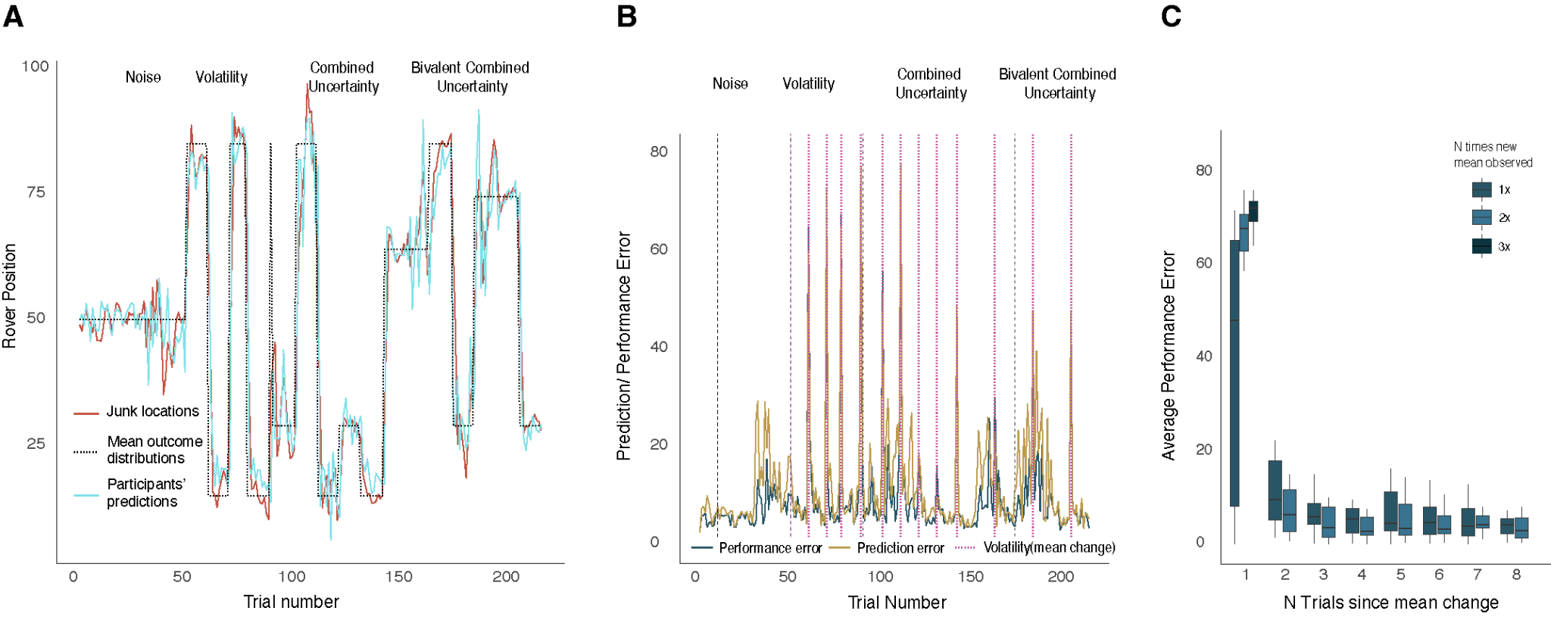
Figure S6. Task effects observed across blocks in Experiment 3. A. Rover positions matched the underlying mean. B. Prediction/performance errors increased right after mean changes and C. decreased with increasing stability of junk positions after changes.

S5.5. Relationship with psychosis-susceptibility and symptom measures

Performance (score). Results showed that participants with increased psychometric-schizotypy and/or paranoia scores displayed significantly worse scores overall (SPQ: β(SE) -0.15(0.63), p=.008; Paranoia: (β(SE)0.03(0.01), p=.002).

Acquisition of the underlying mean: performance error., No interaction was found between block and psychometric scores with regard to mean performance errors group.

Acquisition of underlying variance: beam width. Results showed that elevated SPQ was associated with use of a wider beam width across the game as a whole (β(SE)2.95(0.50), p<.001). The opposite effect was observed for elevated delusional ideation (β(SE)-0.70(0.07), p<.001). However neither of these findings interacted with block.

Learning rate. No symptom scale was found to interact with block.

S6 Overall Results Tables

Table S24. Table showing results from LMEs for Task Metrics (no symptoms) across planned contrast comparisons only. Results for all experiments (Exp 1 = general population study, Exp 2. = psychometric schizotypy high vs low groups, Exp 3. = in person study).
 |  | Exp 1. (n=580)  (β(SE, p)) | Exp 2. (n=147)  (β(SE, p)) | Exp 3. (n=19)  (β(SE, p))
Score
 | 3v4 | -0.57(0.22), p=.050) | - 0.37(0.11), p=.013) | -0.16(0.14), p=.242
 | 4v5 | -0.67(0.11), p<.001 | -0.83(0.12), p<.001) | -0.59(0.16), p = .001
 | 5v6 | -0.50(0.19), p=.011 | -0.80(0.11), p<.001) | -0.72(0.14), p<.001
Performance error
 | 3v4 | 0.50, 0.30 (p < .001) | 0.47(0.04), p=<.001 | 0.36(0.05), p<.001
 | 4v5 | 0.10(0.03), p=.036) | 0.09(0.04) p=.156 | -0.00(0.53), p=.943
 | 5v6 | 0.03(0.03), p=.256 | 0.05(0.04) p=.455 | -0.01(0.05), p=.80
Beam
 | high vs low noise | 8.57(1.52), p<.001) | 10.15(1.027), p<.001 | 10.03(1.92), p<.001
Learning rate
 | 3v4 | 0.299(0.01), p<.001 | 0.19(0.01), p=<.001 | 0.11(0.02), p<.001
 | 4v5 | 0.13(0.01), p < .001 | 0.14(0.01), p=<.001 | 0.07(0.02), p=.005
 | 5v6 | 0.01(0.01), p < .001 | 0.09(0.01), p=<.001 | 0.04(0.02), p=.045
kax
 | 3v4 | NA (3 priors  given to model) | NA (3 priors  given to model) | na
 | 4v5 | p=.490 | -0.61(0.21), p=.019 | na
 | 5v6 | 0.13(0.04), p=.032 | -0.28(0.21), p=.376 | na
kaa
 | 3v4 | NA (as 4 given to model) | NA (as 4 given to model) | na
 | 3v5 | 0.23(0.03), p<.001 | 1.17(0.16), p=.080 | na
 | 5v6 | 0.05(0.03), p=.032 | 0.08(0.17), p=.951 | na
be1
 | 3v4 | 0.03(0.01), p<.001 | 0.03(0.01), p<.001 | na
 | 4v5 | 0.05(0.01), p<.001 | 0.06(0.01), p<.001 | na
 | 5v6 | 0.03(0.01), p<.001 | 0.04(0.01), p<.001 | na

