Supporting Information
for
Introducing Metal-Sulfur-Nitride Active Sites in Metal-Organic Frameworks via Post-Synthetic Modification for Hydrogenation Catalysis
Haomiao Xie^{1*}, Milad Ahmadi Khoshooei^{1*}, Mukunda Mandal³, Simon M. Vornholt⁴, Jan Hofmann⁴, Luke M. Tufaro⁴, Kent O. Kirlikovali¹, Dawson Grimes¹, Seryeong Lee¹, Shengyi Su¹, Susanne Reischauer¹, Debabrata Sengupta¹, Kira Fahy¹, KaiKai Ma¹, Xiaoliang Wang¹, Fanrui Sha¹, Wei Gong¹, Yongwei Chen¹, Jenny G. Vitillo⁵, John S, Anderson³, Justin M Notestein¹, Karena W. Chapman⁴, Laura Gagliardi^{3 *}, Omar K. Farha^{1,2*}
¹Department of Chemistry and International Institute of Nanotechnology, and
²Department of Chemical and Biological Engineering, Northwestern University, 2145 Sheridan Road, Evanston, Illinois 60208-3113, USA
³Department of Chemistry, University of Chicago, Chicago, IL, 60637, United States
⁴Department of Chemistry, Stony Brook University, Stony Brook, NY 11794, United States
⁵Department of Science and High Technology and INSTM, Università degli Studi dell’Insubria, 22100 Como, Italy
Table of Contents
Section A. | Materials and Methods | S2-S7
Section B. | Synthetic Protocols and Characterization | S8-S11
Section C. | Single-Crystal Structures and X-ray Diffractions | S12-S17
Section D. | Adsorption Properties | S18-S20
Section E. | X-ray photoelectron spectroscopy (XPS) | S21-S32
Section F | Scanning Electron Microscopy (SEM) and Energy Dispersive X-ray spectroscopy (EDS) | S33-S40
Section G | Hydrogenation Catalysis of 4-Nitrophenol | S41-S45
Section H. | Computational Analysis | S46-56
Section I. | References | S57-S58

Section A. Materials and General Methods
All reagents were obtained from commercial suppliers and were utilized as received without additional purification.
Nuclear Magnetic Resonance (NMR) spectroscopy was performed using a Bruker Avance III 500 spectrometer operating at a frequency of 500 MHz. Chemical shifts are reported in parts per million (ppm) relative to the residual solvent peaks of non-deuterated solvents: for 1H NMR, 7.26 ppm in CDCl₃ and 3.35, 4.78 ppm in CD₃OD.
Single-crystal X-ray diffraction (SC-XRD) data of Co₂Cl₂BBTA, Co₂(OH)₂BBTA, Co₂(SH)₂BBTA, Co-MFU-4l-Cl, Co-MFU-4l-OH, Co-MFU-4l-SH, Ni-MFU-4l-Cl, Ni-MFU-4l-OH, and Ni-MFU-4l-SH were collected at 100 K, using a Rigaku Cu-Synergy/DW-Synergy diffractometer, equipped with shutter-less electronic-noise free Hybrid Photon Counting (HPC) detector and Cryostream 80-500K (Cryosystems, Oxford, United Kingdom), CuKα (λ = 1.54184 Å) microfocus source with a beam size of ~110 μm and a 4-circle Kappa geometry goniometer. The single crystals were mounted on MicroMesh (MiTeGen) with paratone oil. Electron diffraction (ED) data for Ni₂Cl₂BBTA, Ni₂(OH)₂BBTA, and Ni₂(SH)₂BBTA were collected at 293 K under vacuum using MicroED, also known as the XtaLAB Synergy-ED system. The instrument is equipped with a Rigaku HyPix-ED direct electron detector and controlled by the Rigaku Oxford Diffraction CrysAlisPro software package. The XtaLAB Synergy-ED system utilizes a 200 kV electron gun, featuring a lanthanum hexaboride crystal as the electron emitter for optimized electron optics. The structures were determined by intrinsic phasing (SHELXT 2018/2) and refined by full-matrix least-squares refinement (SHELXL-2018/3) using the Olex2 software packages. The disordered non-coordinated solvents were removed using the solvent marks option in Olex2 software. The refinement results are summarized in Table S1. Crystallographic data crystal structures in CIF format have been deposited in the Cambridge Crystallographic Data Centre (CCDC) under deposition numbers shown in the Table S1.
X-ray Diffraction (PXRD) measurements of Metal-Organic Frameworks (MOFs) were conducted at room temperature using a STOE-STADIMP powder diffractometer. This setup included an asymmetric curved Germanium monochromator utilizing CuKα1 radiation (wavelength = 1.54056 Å) and a one-dimensional silicon strip detector (MYTHEN2 1K from DECTRIS). The Cu X-ray tube, set in a line focus configuration, was operated at 40 kV and 40 mA. Samples of activated powder were placed between two Kapton foils and analyzed in transmission mode within a rotating holder. Data collection ranged from 1 to 40 degrees two-theta over a 6-minute interval. Prior to data acquisition, the instrument calibration was verified using a NIST Silicon standard (640d).
X-Ray Photoelectron Spectroscopy (XPS) measurements were performed at the KECKII/NUANCE facility at Northwestern University using a Thermo Scientific ESCALAB 250 Xi, which employs AlKα radiation (photon energy = 1486.6 eV) and includes an electron flood gun. Data analysis was conducted using Thermo Scientific Avantage Data System software. All spectra were calibrated relative to the C1s peak at 284.8 eV.
Thermogravimetric Analysis (TGA) was conducted using a TGA/DCS 1 system from Mettler-Toledo AG, based in Schwerzenbach, Switzerland, which is operated via a PC using STARe software. Samples were heated at a rate of 5 °C per minute across specified temperature intervals under an air flow of 20 mL per minute.
UV-vis Absorption Spectra were obtained using a Shimadzu UV-3600 UV/vis/NIR spectrometer, which features an integrating sphere to compensate for scatter and reflectance effects during measurement.
Fourier-Transform Infrared Spectroscopy M easurements (FTIR) were conducted at the KECKII/NUANCE facility at Northwestern University using a Nicolet iS50 spectrometer by Thermo Nicolet. This spectrometer includes a tabletop optics module (TOM), which facilitates Polarization Modulation Infrared Reflection Absorption Spectroscopy (PM-IRRAS). Spectra were recorded over a wavelength range from 4000 to 400 cm⁻¹.
Scanning Electron Microscopy (SEM) and Energy Dispersive Spectroscopy (EDS) analyses were performed using a Hitachi SU8030 at the KECKII/NUANCE facility at Northwestern University. Samples were pre-coated with an 18 nm layer of osmium. The EDS data were analyzed using the New Oxford AZtec EDS software.
Hydrogenation Catalysis were carried out in Parr reactors equipped with Teflon liners, which were pre-cleaned using aqua regia. The reactors were initially purged three times with argon at 7 bar, followed by three purges with hydrogen at 13.7 bar. Post-reaction, the products and catalysts were separated using a centrifuge. The catalysts were then washed with appropriate solvents prior to reuse.
Pair Distribution Function Analysis
In situ X-ray Scattering data, suitable for XRD and PDF analysis, were collected at beamline 28-ID-1 of the National-Synchrotron-Light-Source-II at Brookhaven National Laboratory. Samples were loaded in either borosilicate (for dichlorination experiments) or polyimide capillaries (OD ~1.1 mm) and assembled within a flow-cell apparatus that either allows for a constant flow of a solution over the sample¹ or in a gas-flow furnace that allows for heating in a desired gas environment.² X-ray scattering images were collected using high-energy X-rays (λ = 0.1653 Å) at sample-to-detector distances optimized for PDF and XRD analysis.
Data were collected for ex situ samples as well as in situ dechlorination and sulfidation of a Co-BBTA sample. For the dechlorination experiment the sample was loaded in a borosilicate capillary and a 1 M KOH solution was directed over the sample while data were collected at PDF distance for 10 s per scan. The dechlorination was also studied in an ex situ approach using a more dilute KOH solution (0.01 M) where the reaction was quenched at certain intervals to visualize the changes in a longer time resolution. The in situ sulfidation using H₂S as sulfiding agent was conducted using NaHS (10 mg) as a precursor, which was primed with diluted H₂SO₄ (100 mL), evolving H2S gas was directed over the sample using N₂ as carrier gas, while data were collected at PDF distance.
The sample-to-detector distance and instrument geometry were optimized within GSAS-II based on the scattering collected for a CeO₂ standard.³ Images were reduced to one-dimensional intensity data as a function of scattering angle. The scattering contribution from the sample environment was subtracted and the data converted into PDFs, G(r), within xPDFsuite (Q_{max} = 21.48 Å⁻¹).⁴

Computational Methods

Periodic DFT Calculations
Geometries of all studied MOFs were optimized using periodic boundary conditions with the PBESol-D3(0) density functional⁶ in Vienna Ab-initio Simulation Package (VASP, version 6.4.0).⁷ Dispersion interactions were accounted for using Grimme’s D3 method.⁸ Valence-core interactions were described by the projector augmented wave (PAW) method.^{9,10} The valence electrons included in the calculations for each atom type were: C (4), H (1), N (5), O (6), S (6), Cl (7), Co (9), Ni (10), Zn (12). A 520 eV plane-wave energy cutoff was employed, and geometries were relaxed until atomic forces were below 0.01 eV/Å. Brillouin zone sampling was performed using a Γ-point only 1 × 1 × 1 k-mesh. These optimized structures were used as the basis for finite-sized cluster model calculations.

DFT Calculations on Cluster Models
Cluster calculations were performed using DFT as implemented in Gaussian 16 (Rev. B.01).¹¹ Geometry optimizations and frequency calculations were carried out at the TPSSh-D3(BJ)/basis-I level of theory,^{12,13} where basis-I denotes def2-SVP for nonmetals and def2-TZVP with SDD effective core potential for Co, Ni, and Zn.^{14,15} An “ultrafine” grid was utilized for numerical integration. The natures of all stationary points were verified by calculating quasi-harmonic vibrational frequencies. Entropic terms were obtained using the rigid-rotor-harmonic-oscillator (RRHO) approximation, with the free-rotor approximation applied for vibrational modes below100 cm⁻¹.¹⁶
Single-point electronic energies were recomputed at the M06-D3(0)/basis-II level,^{17,18} where basis-II is def2-TZVP for all atoms with SDD effective core potential for Co, Ni, and Zn, ^{14,15} employing the SMD continuum solvation model with solvent parameters for methanol (MeOH). Final Gibbs free energies (G) at 423.15 K were calculated by combining this electronic energy with thermal contributions to G from TPSSh-D3(BJ)/basis-I calculations.

Thermodynamic Corrections
To account for the change of standard-state concentration from 1 atm pressure in the gas phase to 1 M in the solution phase, an entropy correction term of 1.89 kcal mol⁻¹ was added to the absolute free energies of all computed species. For MeOH solvent, the pure liquid (24.72 mol/L) was used as the standard state. The correction to the Gibbs free energy due to the change in the standard state was calculated as follows:^{19,20}
G° = G^{1atm} + RT ln(C°/C^{1atm})
Here, G° denotes the Gibbs free energy relative to the appropriate standard state in solution phase. G^{1atm} refers to the ideal gas standard Gibbs free energy at 298.15 K under a standard state of 1 atm. C° represents the concentration in the standard reference state (specifically, 24.72 M for MeOH), while C^{1atm} is the concentration of an ideal gas at standard pressure (1 atm), given by C^{1atm} = 1/V_{m} = P/RT. The correction term for each MeOH molecule in the equation above is equal to 2.7 kcal mol⁻¹. To emulate experimental reaction conditions, partial pressures of H₂ and MeOH (p_{H2} and p_{MeOH}) were considered to be 19.34 and 8.78 atm at 423.15 K, respectively, and the G correction term was calculated accordingly.²¹ These thermodynamic parameter calculations were facilitated by the use of the Shermo code.²²

Section B. Synthetic Protocols and Characterization
The powder samples of Co₂Cl₂BBTA and Ni₂Cl₂BBTA were synthesized with methods reported in the literature.²³
Synthesis of the powder samples of M₂Cl₂BBTA.
A 7 mL DMF solution of H₂BBTA (1H,5H-benzo(1,2-d:4,5-d′)bistriazole, 30 mg, 0.19 mmol) and a 7 mL MeOH solution of MCl₂·6H₂O (M = Co, Ni; 100 mg, 0.42 mmol) were combined in an 8 dram vial. Concentrated HCl (12 M) was then added (0.1 mL for Co and 3 mL for Ni). The mixture was incubated at 65°C for 72 hours. The resulting powder was washed three times with DMF and three times with MeOH. To remove any residual DMF within the cavity, Soxhlet extraction with methanol was conducted twice, each for 36 hours. Activation was conducted under dynamic vacuum at 120 ℃ for 24 hours before adsorption measurements.
Synthesis of the powder samples of M₂(OH)₂BBTA.
M₂Cl₂BBTA (100 mg) is dispersed in 100 mL KOH (1 M) aqueous solution under N₂ for 12 hours. The product was washed with water and MeOH three times and dried under N₂ flow. Activation was conducted under dynamic vacuum at 120 ℃ for 24 hours before adsorption measurements.
Synthesis of the powder samples of Co₂(SH)₂BBTA.
Co₂(OH)₂BBTA (30 mg) was dispersed in 4 mL of methanol in a 4-dram vial containing a stir bar. The mixture was sealed and exposed to in situ generated H₂S, produced from 19 mg of NaHS and 0.5 mL of concentrated H₃PO₄, for 5 hours. After exposure, the product was washed three times with methanol and dried under a flow of nitrogen. The sample was then activated at 100 ℃ for 24 hours prior to conducting adsorption measurements.
Synthesis of the powder samples of Ni₂(SH)₂BBTA.
Ni₂(OH)₂BBTA (30 mg) was dispersed in 4 mL of methanol in a 4-dram vial containing a stir bar. The mixture was sealed and exposed to in situ generated H₂S, produced from 19 mg of NaHS and 0.5 mL of concentrated H₃PO₄, for 12 hours. After exposure, the product was washed three times with methanol and dried under a flow of nitrogen. The sample was then activated at 100°C for 24 hours prior to conducting adsorption measurements.
Synthesis of the single-crystal samples of Co₂Cl₂BBTA.
A synthesis mixture was prepared by combining a 4 mL solution of H₂BBTA (20 mg, 0.125 mmol) in DEF, a 4 mL methanol solution of CoCl₂·6H₂O (60 mg, 0.252 mmol), and 0.2 mL of 38% HCl in a 6 dram vial. This vial was then placed in a preheated oven at 70°C. After three days, needle-like pink single crystals had formed.
Post-synthetic conversion of the single-crystal samples of Co₂Cl₂BBTA to Co₂(OH)₂BBTA.
Single-crystal sample of Co₂Cl₂BBTA(~5 mg) was treated with 4 mL KOH(0.1 M) for 4 hours at room temperature and then washed with deionized water 3 times. The morphology of the crystals maintains the same but with a darker color.
Post-synthetic conversion of the single-crystal samples of Co₂Cl₂BBTA to Co₂(OH)₂BBTA.
Single-crystal sample of Co₂(OH)₂BBTA(~3 mg) was dispersed in 2 mL MeOH and treated with in situ generated H₂S( generated by mixing 20 mg NaHS with 0.5 mL concentrated H₃PO₄) for 4 hours at room temperature and then washed with MeOH 3 times. The morphology of the crystals maintains the same but turned into a dark brown color.
Synthesis of powder samples of Zn-MFU-4l-Cl
The preparation of Zn-MFU-4l-Cl was performed according to the previously reported procedure.²⁴ In a 100-dram scintillation vial H₂BTDD (100 mg, 0.36 mmol), ZnCl₂ (1.0 g, 7.3 mmol) and DMF (60 mL) were heated for 18 h at 140 °C and cooled down to room temperature. The precipitate was collected by centrifuged and washed with 20 mL DMF for 3 times and followed by 20 mL MeOH for 3 times, and 20 mL CH2Cl2 for 3 times. Then the solid was dried for 24 h at 180 °C under vacuum. Yield brown microcrystalline powder.
Transmetalation of Zn-MFU-4l-Cl to Co-MFU-4l-Cl
The transmetallation of Zn-MFU-4l-Cl to Co-MFU-4l was performed according to the previously reported procedure.²⁴ Anhydrous cobalt (II) chloride (0.5 g, 2.1 mmol) was dissolved in DMF (16 mL) and MFU-4l (100 mg, 0.08 mmol) was added to the solution. The reaction mixture was stirred for 20 h at 140 °C in a 20-dram vail. The dark-green or dark-blue precipitate was centrifuged, washed with DMF, methanol and dichloromethane.
Transmetalation of Zn-MFU-4l-Cl to Ni-MFU-4l-Cl
The transmetallation of Zn-MFU-4l-Cl to Ni-MFU-4l was performed according to the previously reported procedure.²⁴ Nickel(II) chloride (0.6 g, 2.6 mmol) was dissolved in N,Ndimethylacetamide (16 mL) and MFU-4l (100 mg, 0.08 mmol) was added to the solution. The reaction mixture was heated for 20 h at 60 °C in a 100-dram scintillation vial. N,Ndimethylacetamide was exchanged with fresh N,N-dimethylacetamide and then added Nickel(II) chloride (0.4 g) and heated for 20 h at 60 °C. The green precipitate was centrifuged, washed with N,N-dimethylacetamide, methanol and dichloromethane.
Synthesis of powder samples of M-MFU-4l-OH
M-MFU-4l-Cl (50 mg) was treated with 50 mL of a 1 M aqueous solution of 4-ethylmorpholine for 12 hours. Subsequently, the samples were washed with water three times. The resulted powder sample was dried under N₂ flow and activated under 120 ℃ before adsorption measurements.
Synthesis of powder samples of M-MFU-4l-SH
M-MFU-4l-OH (30 mg) was dispersed in 4 mL MeOH. The mixture was sealed and exposed to in situ generated H₂S, produced from 50 mg of NaHS and 0.5 mL of concentrated H₃PO₄, for 12 hours. Subsequently, the brown sample was washed with water three times. The resulted powder sample was dried under N₂ flow and activated under 120 ℃ before adsorption measurements.
Post-synthetic conversion of the single-crystal samples of M-MFU-4l-Cl to M-MFU-4l-OH.
Single crystal samples of M-MFU-4l-Cl (approximately 2 mg) were treated with 4 mL of a 1 M aqueous solution of 4-ethylmorpholine for 12 hours. Subsequently, the samples were washed with water and MeOH three times. The morphology of the crystals remained unchanged, resulting in a pale green color for M = Ni and pale pink for M = Co, respectively.
Post-synthetic conversion of the single-crystal samples of M-MFU-4l-OH to M-MFU-4l-SH.
Single crystal samples of M-MFU-4l-OH (approximately 2 mg) were dispersed in 4 mL MeOH The mixture was sealed and exposed to in situ generated H₂S, produced from 50 mg of NaHS and 0.5 mL of concentrated H₃PO₄, for 12 hours. The morphology of the crystals remained unchanged, resulting in a dark brown color.

Section C. Single-Crystal Structures
Table S1. Crystal data and structure refinements of M₂X₂BBTA and M-MFU-4l-X where M = Co and Ni, X = Cl, OH and SH.
Identification code | Co₂Cl₂BBTA | Co₂(OH)₂BBTA | Co₂(SH)₂BBTA
Empirical formula | C₆H₂Cl₂Co₂N₆O₂ | C₆H₂Co₂N₆O₄ | C₆H₂Co₂N₆S₇
Formula weight | 378.89 | 339.98 | 500.44
Temperature/K | 100.15 | 100.15 | 100.15
Crystal system | trigonal | trigonal | trigonal
Space group | R-3m | R-3m | R-3m
a/Å | 24.5743(9) | 24.655(5) | 23.891(2)
b/Å | 24.5743(9) | 24.655(5) | 23.891(2)
c/Å | 8.3838(2) | 7.9848(18) | 7.8380(9)
α/° | 90 | 90 | 90
β/° | 90 | 90 | 90
γ/° | 120 | 120 | 120
Volume/Å³ | 4384.6(3) | 4204(2) | 3874.3(8)
Z | 9 | 9 | 9
ρ_{calc}g/cm³ | 1.586 | 1.593 | 1.958
μ/mm⁻¹ | 16.202 | 14.436 | 23.065
F(000) | 2088 | 2034 | 2250
Crystal size/mm³ | 0.35 × 0.01 × 0.01 | 0.3 × 0.01 × 0.01 | 0.03 × 0.01 × 0.01
Radiation | CuKα (λ = 1.54184) | CuKα (λ = 1.54184) | CuKα (λ = 1.54184)
2Θ range for data collection/° | 7.194 to 150.104 | 7.17 to 95.06 | 7.4 to 135.824
Index ranges | -25 ≤ h ≤ 29, -29 ≤ k ≤ 23, -10 ≤ l ≤ 7 | -19 ≤ h ≤ 19, -20 ≤ k ≤ 23, -7 ≤ l ≤ 7 | -28 ≤ h ≤ 28, -28 ≤ k ≤ 22, -9 ≤ l ≤ 6
Reflections collected | 5782 | 2106 | 2839
Independent reflections | 1075 [R_{int} = 0.0288, R_{sigma} = 0.0191] | 477 [R_{int} = 0.1730, R_{sigma} = 0.1030] | 850 [R_{int} = 0.1123, R_{sigma} = 0.0947]
Data/restraints/parameters | 1075/0/45 | 477/0/46 | 850/21/60
Goodness-of-fit on F² | 1.159 | 1.045 | 1.053
Final R indexes [I>=2σ (I)] | R₁ = 0.0542, wR₂ = 0.1576 | R₁ = 0.0886, wR₂ = 0.2431 | R₁ = 0.0870, wR₂ = 0.2181
Final R indexes [all data] | R₁ = 0.0565, wR₂ = 0.1595 | R₁ = 0.1050, wR₂ = 0.2546 | R₁ = 0.1152, wR₂ = 0.2371
Largest diff. peak/hole / e Å⁻³ | 1.44/-0.60 | 0.66/-0.62 | 1.37/-1.16
CCDC Number | 2376631 | 2376626 | 2376634
* Empirical formula, formula weight and ρ_{calc} include the solvent molecules from the applied solvent masks.
Table S1. Continued
Identification code | Ni₂Cl₂BBTA | Ni₂(OH)₂BBTA | Ni₂(SH)₂BBTA
Empirical formula | C₆H₆Cl₂N₆Ni₂O_{3.66} | C₆H₆N₆Ni₂O₄ | C₆H_{4.4}N₆Ni₂O_{2.38}S₂
Formula weight | 409.07 | 343.54 | 380.14
Temperature/K | 293(2) | 293(2) | 293(2)
Crystal system | trigonal | trigonal | trigonal
Space group | R-3m | R-3m | R-3m
a/Å | 24.456(14) | 24.89(3) | 24.35(4)
b/Å | 24.456(14) | 24.89(3) | 24.35(4)
c/Å | 8.099(3) | 7.979(3) | 8.098(4)
α/° | 90 | 90 | 90
β/° | 90 | 90 | 90
γ/° | 120 | 120 | 120
Volume/Å³ | 4195(5) | 4281(10) | 4159(13)
Z | 9 | 9 | 9
ρ_{calc}g/cm³ | 1.457 | 1.199 | 1.366
μ/mm⁻¹ | 0 | 0 | 0
F(000) | 554 | 473 | 529
Crystal size/mm³ | 0.0005 × 0.0002 × 0.0001 | 0.0004 × 0.0001 × 0.0001 | 0.0004 × 0.0001 × 0.00005
Radiation | electron diffractometer  JEOL JSM-2300ED, LaB6 (λ = 0.0251) | electron diffractometer  JEOL JSM-2300ED, LaB6 (λ = 0.0251) | electron diffractometer  JEOL JSM-2300ED, LaB6 (λ = 0.0251)
2Θ range for data collection/° | 0.118 to 1.438 | 0.116 to 1.348 | 0.118 to 1.3
Index ranges | -20 ≤ h ≤ 21, -24 ≤ k ≤ 24, -8 ≤ l ≤ 8 | -21 ≤ h ≤ 21, -23 ≤ k ≤ 23, -7 ≤ l ≤ 7 | -18 ≤ h ≤ 19, -22 ≤ k ≤ 22, -7 ≤ l ≤ 7
Reflections collected | 3607 | 2648 | 2565
Independent reflections | 541 [R_{int} = 0.4564, R_{sigma} = 0.2814] | 460 [R_{int} = 0.2993, R_{sigma} = 0.2061] | 397 [R_{int} = 0.3714, R_{sigma} = 0.2078]
Data/restraints/parameters | 541/57/46 | 460/63/40 | 397/69/46
Goodness-of-fit on F² | 0.914 | 0.977 | 1.107
Final R indexes [I>=2σ (I)] | R₁ = 0.1164, wR₂ = 0.2580 | R₁ = 0.1300, wR₂ = 0.3100 | R₁ = 0.1547, wR₂ = 0.3496
Final R indexes [all data] | R₁ = 0.1690, wR₂ = 0.2990 | R₁ = 0.1685, wR₂ = 0.3390 | R₁ = 0.2078, wR₂ = 0.3842
Largest diff. peak/hole / e Å⁻³ | 0.15/-0.20 | 0.32/-0.14 | 0.24/-0.37
CCDC Number | 2385609 | 2385610 | 2385611
* Empirical formula, formula weight and ρ_{calc} include the solvent molecules from the applied solvent masks.

Table S1. Continued
Identification code | Co-MFU-4l-Cl | Co-MFU-4l-OH | Co-MFU-4l-SH
Empirical formula | C₃₆H₁₂Cl₄Co₄N₁₈O_{12.1}Zn | C_{64.8}H_{127.2}Co₄N₁₈O_{46.8}Zn | C₆₀H₁₀₈Co₄N₁₈O_{40.43}S_{1.57}Zn
Formula weight | 1380.33 | 2208.53 | 2079.91
Temperature/K | 100.0(7) | 100.0(10) | 100.15
Crystal system | cubic | cubic | cubic
Space group | Fm-3m | Fm-3m | Fm-3m
a/Å | 30.8165(5) | 30.7820(10) | 30.8219(14)
b/Å | 30.8165(5) | 30.7820(10) | 30.8219(14)
c/Å | 30.8165(5) | 30.7820(10) | 30.8219(14)
α/° | 90 | 90 | 90
β/° | 90 | 90 | 90
γ/° | 90 | 90 | 90
Volume/Å³ | 29265.1(14) | 29167(3) | 29280(4)
Z | 8 | 8 | 8
ρ_{calc}g/cm³ | 0.627 | 1.006 | 0.944
μ/mm⁻¹ | 4.587 | 4.255 | 4.387
F(000) | 5443 | 9235 | 8644
Crystal size/mm³ | 0.01 × 0.01 × 0.01 | 0.01 × 0.01 × 0.01 | 0.01 × 0.01 × 0.01
Radiation | Cu Kα (λ = 1.54184) | Cu Kα (λ = 1.54184) | CuKα (λ = 1.54184)
2Θ range for data collection/° | 8.114 to 94.958 | 8.124 to 95.098 | 8.114 to 94.936
Index ranges | -28 ≤ h ≤ 28, -28 ≤ k ≤ 25, -29 ≤ l ≤ 29 | -29 ≤ h ≤ 17, -26 ≤ k ≤ 29, -28 ≤ l ≤ 18 | -20 ≤ h ≤ 25, -28 ≤ k ≤ 15, -29 ≤ l ≤ 10
Reflections collected | 11442 | 9223 | 4138
Independent reflections | 732 [R_{int} = 0.0816, R_{sigma} = 0.0295] | 730 [R_{int} = 0.1234, R_{sigma} = 0.0489] | 731 [R_{int} = 0.1516, R_{sigma} = 0.0975]
Data/restraints/parameters | 732/54/65 | 730/52/54 | 731/72/61
Goodness-of-fit on F² | 1.098 | 1.062 | 1.025
Final R indexes [I>=2σ (I)] | R₁ = 0.0854, wR₂ = 0.2449 | R₁ = 0.0493, wR₂ = 0.1394 | R₁ = 0.0773, wR₂ = 0.2421
Final R indexes [all data] | R₁ = 0.1000, wR₂ = 0.2640 | R₁ = 0.0741, wR₂ = 0.1622 | R₁ = 0.1147, wR₂ = 0.2732
Largest diff. peak/hole / e Å⁻³ | 0.98/-1.02 | 0.46/-0.28 | 0.55/-0.54
CCDC Number | 2376630 | 2376629 | 2376628
* Empirical formula, formula weight and ρ_{calc} include the solvent molecules from the applied solvent masks.

Table S1. Continued
Identification code | Ni-MFU-4l-Cl | Ni-MFU-4l-OH | Ni-MFU-4l-SH
Empirical formula | C₃₆H_{122.4}Cl₄N₁₈Ni₄O_{69.18}Zn | C₃₆H₁₂N₁₈Ni₄O_{15.95}Zn | C₆₀H₁₀₈N₁₈Ni₄O_{41.08}S_{0.92}Zn
Formula weight | 2356.75 | 1251.97 | 2068.61
Temperature/K | 100.15 | 100.15 | 100
Crystal system | cubic | cubic | cubic
Space group | Fm-3m | Fm-3m | Fm-3m
a/Å | 30.7457(7) | 30.7537(18) | 30.8207(5)
b/Å | 30.7457(7) | 30.7537(18) | 30.8207(5)
c/Å | 30.7457(7) | 30.7537(18) | 30.8207(5)
α/° | 90 | 90 | 90
β/° | 90 | 90 | 90
γ/° | 90 | 90 | 90
Volume/Å³ | 29064(2) | 29087(5) | 29277.1(15)
Z | 8 | 8 | 8
ρ_{calc}g/cm³ | 1.077 | 0.572 | 0.939
μ/mm⁻¹ | 2.14 | 1.005 | 1.393
F(000) | 9823 | 4988 | 8635
Crystal size/mm³ | 0.01 × 0.01 × 0.01 | 0.01 × 0.01 × 0.01 | 0.01 × 0.01 × 0.01
Radiation | CuKα (λ = 1.54184) | CuKα (λ = 1.54184) | Cu Kα (λ = 1.54184)
2Θ range for data collection/° | 8.134 to 95.246 | 8.132 to 95.214 | 8.114 to 95.23
Index ranges | -28 ≤ h ≤ 28, -17 ≤ k ≤ 28, -23 ≤ l ≤ 29 | -25 ≤ h ≤ 27, -17 ≤ k ≤ 29, -28 ≤ l ≤ 25 | -18 ≤ h ≤ 28, -29 ≤ k ≤ 29, -27 ≤ l ≤ 17
Reflections collected | 7229 | 6499 | 7744
Independent reflections | 728 [R_{int} = 0.0939, R_{sigma} = 0.0421] | 729 [R_{int} = 0.1918, R_{sigma} = 0.0925] | 732 [R_{int} = 0.0549, R_{sigma} = 0.0260]
Data/restraints/parameters | 728/29/65 | 729/96/58 | 732/35/61
Goodness-of-fit on F² | 1.01 | 1.013 | 1.136
Final R indexes [I>=2σ (I)] | R₁ = 0.0523, wR₂ = 0.1552 | R₁ = 0.0784, wR₂ = 0.2491 | R₁ = 0.0515, wR₂ = 0.1617
Final R indexes [all data] | R₁ = 0.0659, wR₂ = 0.1643 | R₁ = 0.1155, wR₂ = 0.2689 | R₁ = 0.0609, wR₂ = 0.1692
Largest diff. peak/hole / e Å⁻³ | 0.24/-0.35 | 0.84/-0.59 | 1.08/-0.29
CCDC Number | 2376627 | 2376633 | 2376632
* Empirical formula, formula weight and ρ_{calc} include the solvent molecules from the applied solvent masks.

Table S2. Refined Unit cell parameters of Ni₂X₂BBTA where X = Cl, OH and SH from PXRD.
 | Ni₂Cl₂BBTA | Ni₂(OH)₂BBTA | Ni₂(SH)₂BBTA
Space group | R-3m | R-3m | R-3m
a/Å | 24.441(6) | 24.608(4) | 24.16(2)
b/Å | 24.441(6) | 24.608(4) | 24.16(2)
c/Å | 8.200(3) | 8.021(2) | 8.087(7)
α/° | 90 | 90 | 90
β/° | 90 | 90 | 90
γ/° | 120 | 120 | 120
Volume/Å³ | 4242(4) | 4206(2) | 4088(10)

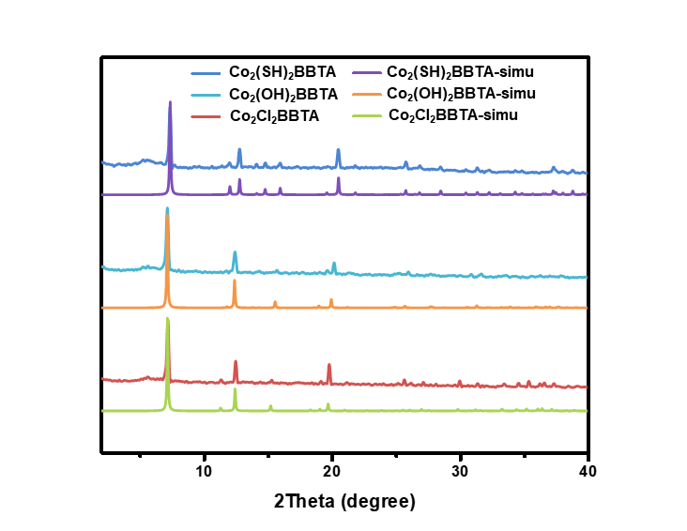
Figure S1. Experimental and simulated PXRD of Co₂X₂BBTA, where X = Cl, OH and SH.
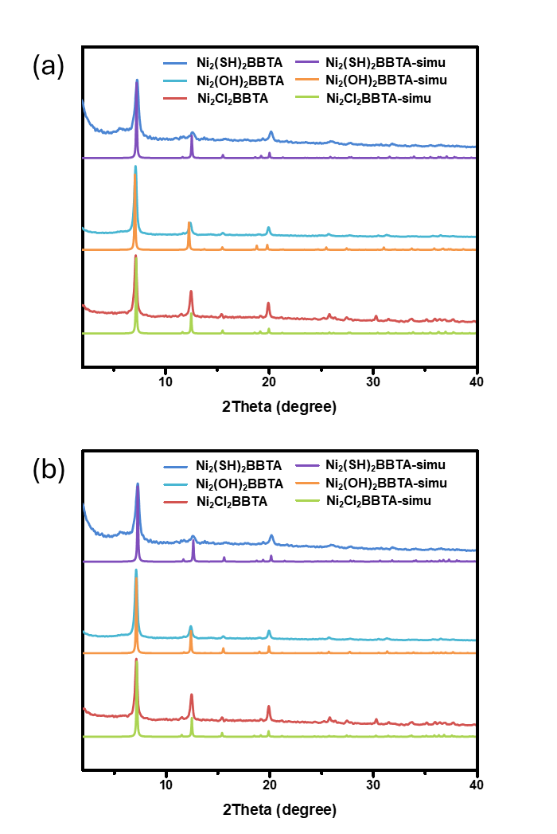
Figure S2. Experimental and simulated PXRD patterns (a) from electron diffractions and (b) unit cell refinements of Ni₂X₂BBTA, where X = Cl, OH and SH.

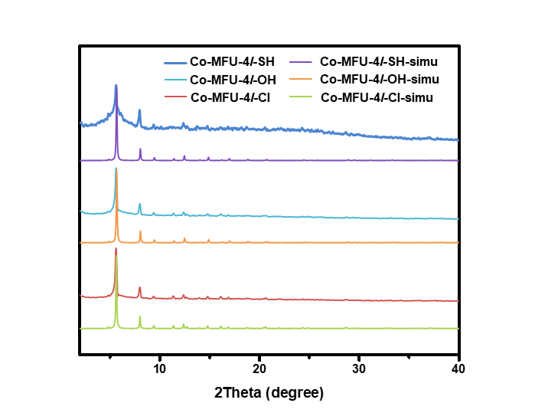
Figure S3. Experimental and simulated PXRD of Co-MFU-4l-X, where X = Cl, OH and SH.
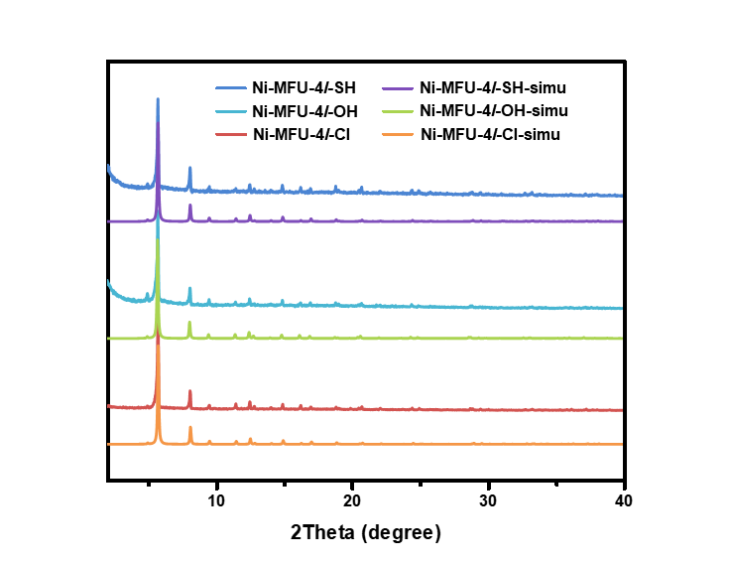
Figure S4. Experimental and simulated PXRD of Ni-MFU-4l-X, where X = Cl, OH and SH.

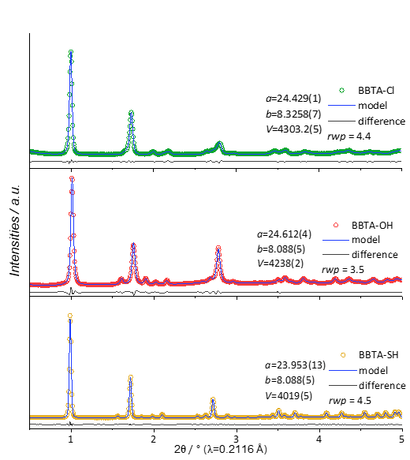
Figure S5. Refinement of trigonal R -3 m model against PXRD data of Co₂X₂BBTA, where X = Cl, OH and SH, after individual ligand substitution procedures.
Section D. Sorption Properties
The theoretical pore volume (PV_{calc}) of the MOFs were calculated by the equation shown below:
$${PV}_{calc}= \frac{n}{ρ}$$
Where n is the void rate that calculated by Mercury software with probe size as 1.8 Å and grid spacing as 0.3 Å; ρ is the theoretical density of the MOFs calculated from cif files. The theoretical N₂ sorption amounts, A_{calc}, were calculated with the equation as below:
$$A_{calc}= \frac{{PV}_{calc}∙ρ_{N_{2},l}}{M_{N_{2}}}∙V_{molar}$$
Where $ρ_{N_{2},l}$ is the density of liquid N₂ at 77 K, $M_{N_{2}}$ is the molar mass of N₂ and $V_{molar}$ is the molar volume of a gas.

Table S3. Theoretical and experimental porosity data of M₂X₂BBTA and M-MFU-4l-X where M = Co and Ni, X = Cl, OH and SH.
MOF | n(%) | ρ (g cm⁻³) | PV_{calc}(cm³ g⁻¹) | PV_{exp}  (cm³ g⁻¹) | A_{calc} (cm³ g⁻¹) | A_{exp}  (cm³ g⁻¹) | BET Area  (m² g⁻¹) | Langmuir surface area (m² g⁻¹)
Co₂Cl₂BBTA | 58.1 | 1.182 | 0.491 | 0.482 | 317 | 312 | 1180 | 1195
Co₂(OH)₂BBTA | 58.9 | 1.095 | 0.538 | 0.612 | 347 | 400 | 1490 | 1470
Co₂(SH)₂BBTA | 54.6 | 1.312 | 0.416 | 0.294 | 269 | 200 | 650 | 640
Co₂(SH)₂BBTAª | 38.8 | 1.435 | 0.270 | 0.294 | 175 | 200 | 650 | 640
Ni₂Cl₂BBTA | 57.7 | 1.234 | 0.468 | 0.483 | 302 | 330 | 1190 | 1195
Ni₂(OH)₂BBTA | 60.9 | 1.047 | 0.582 | 0.658 | 376 | 427 | 1420 | 1470
Ni₂(SH)₂BBTA | 57.3 | 1.221 | 0.469 | 0.297 | 303 | 228 | 730 | 705
Ni₂(SH)₂BBTAª | 47.7 | 1.228 | 0.388 | 0.297 | 250 | 228 | 730 | 705
Co-MFU-4l-Cl | 71.7 | 0.627 | 1.144 | 1.154 | 738 | 746 | 2750 | -
Co-MFU-4l-OH | 74.8 | 0.564 | 1.327 | 1.411 | 857 | 910 | 3480 | -
Co-MFU-4l-SH | 72.0 | 0.608 | 1.184 | 1.094 | 764 | 702 | 2660 | -
Ni-MFU-4l-Cl | 71.7 | 0.601 | 1.193 | 1.190 | 770 | 768 | 2900 | -
Ni-MFU-4l-OH | 74.6 | 0.550 | 1.356 | 1.449 | 875 | 940 | 3440 | -
Ni-MFU-4l-SH | 72.7 | 0.605 | 1.202 | 1.141 | 776 | 726 | 2720 | -
a with a H₂O terminal group

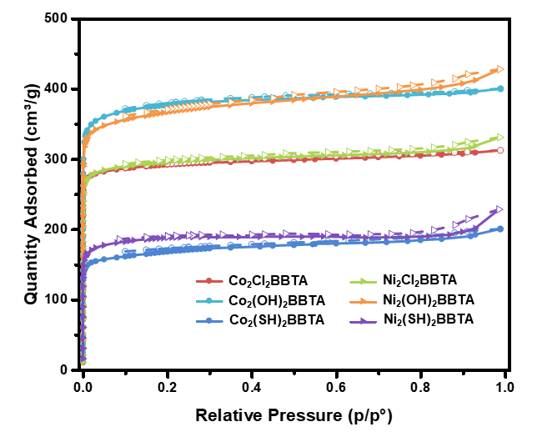
Figure S6. N₂ isotherms of M₂X₂BBTA at 77 K (where M = Co and Ni, X = Cl, OH and SH)
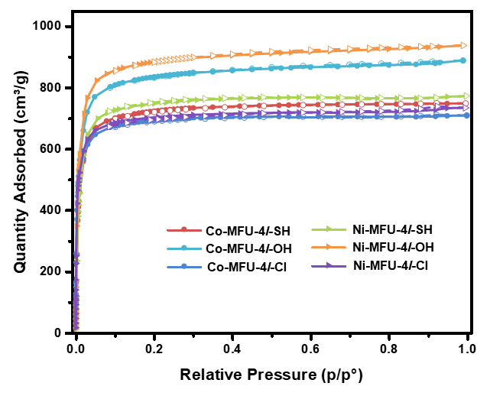
Figure S7. N₂ isotherms of M-MFU-4l-X at 77 K (where M = Co and Ni, X = Cl, OH and SH)

Section E. X-ray photoelectron spectroscopy (XPS)
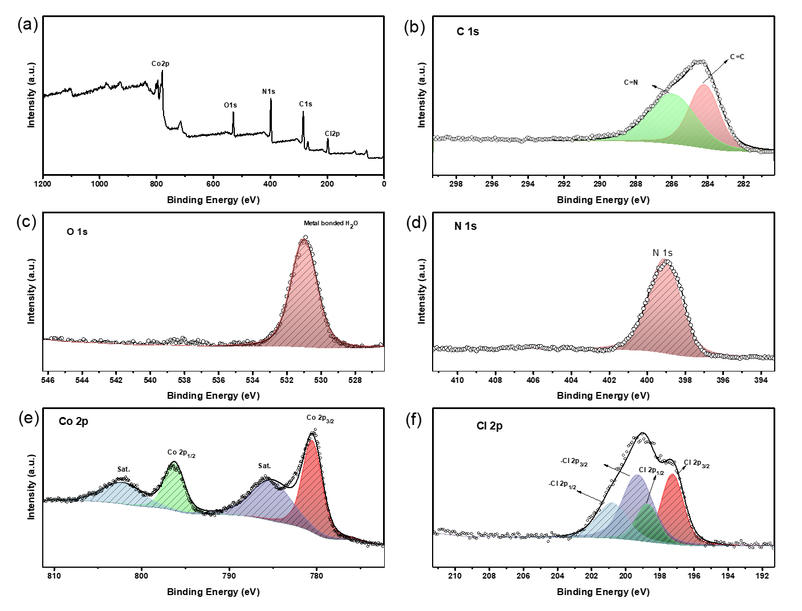
Figure S8. XPS spectra of Co₂Cl₂BBTA: (a) survey, (b) C1s, (c)O1s, (d)N1s, (e) Co2p and (f) Cl2p.
Table S4. Summary of XPS spectra peaks of Co₂Cl₂BBTA
Element | Chemical State | Bonding Energy(eV) | Atomic % per Co
C | C=C | 284.15
C | C=N | 285.93
O | H₂O (coordinates to Co) | 530.99
N | N=C/N=N | 399.98
Cl | Cl⁻ 2p_{3/2} | 197.22 | 91%
Cl | Cl⁻ 2p_{1/2} | 198.72 | 91%
Cl | -Cl 2p_{3/2} | 199.26 | 91%
Cl | -Cl 2p_{1/2} | 200.76 | 91%
Co | Co²⁺ 2p_{3/2} | 780.46 | 100%
Co | Co²⁺ 2p_{1/2} | 796.25 | 100%
Co | Co²⁺ 2p_{3/2, sat.} | 785.15 | 100%
Co | Co²⁺ 2p_{1/2, sat.} | 802.27 | 100%

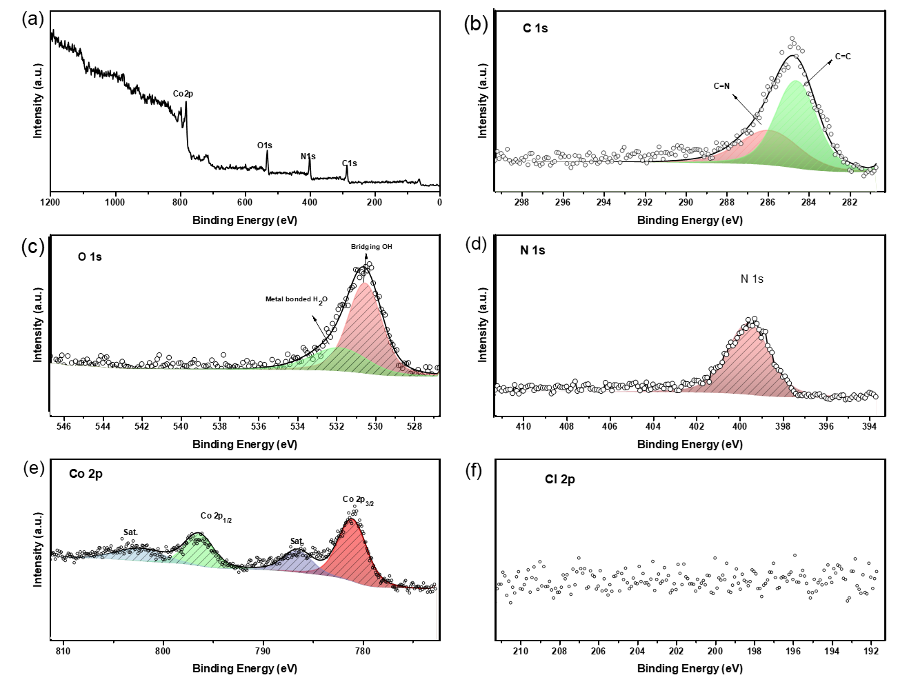
Figure S9. XPS spectra of Co₂(OH)₂BBTA: (a) survey, (b) C1s, (c)O1s, (d)N1s, (e) Co2p and (f) Cl2p.
Table S5. Summary of XPS spectra peaks of Co₂(OH)₂BBTA
Element | Chemical State | Bonding Energy(eV) | Atomic % per Co
C | C=C | 285.91
C | C=N | 284.60
O | μ₂-OH | 530.53
O | H₂O (coordinates to Co) | 531.84
N | N=C/N=N | 399.58
Cl | N/A | N/A | 0%
Co | Co²⁺ 2p_{3/2} | 781.02 | 100%
Co | Co²⁺ 2p_{1/2} | 796.40 | 100%
Co | Co²⁺ 2p_{3/2, sat.} | 786.49 | 100%
Co | Co²⁺ 2p_{1/2, sat.} | 802.28 | 100%

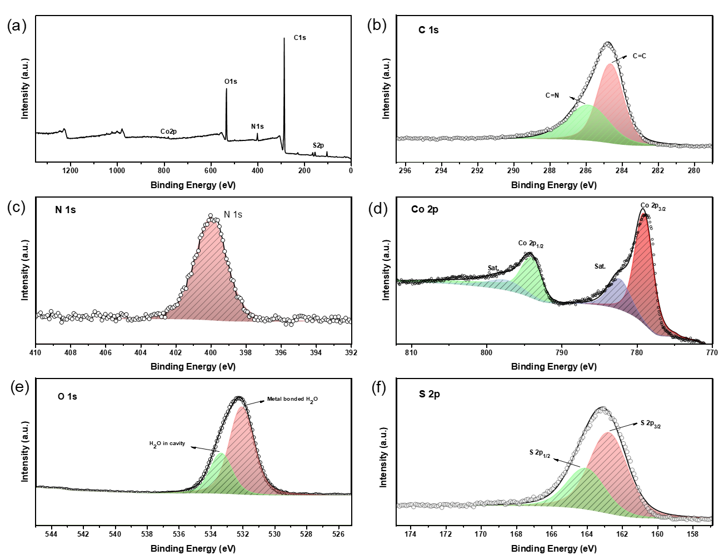
Figure S10. XPS spectra of Co₂(SH)₂BBTA: (a) survey, (b) C1s, (c)N1s, (d) Co2p, (e) O1s and (f) S2p.
Table S6. Summary of XPS spectra peaks of Co₂(SH)₂BBTA
Element | Chemical State | Bonding Energy(eV) | Atomic % per Co
C | C=C | 284.61
C | C=N | 285.84
O | H₂O (coordinates to Co) | 532.05
O | H₂O (in cavity) | 533.35
N | N=C/N=N | 399.98
S | S²⁻ 2p_{3/2} | 162.74 | 92%
S | S²⁻ 2p_{1/2} | 164.04 | 92%
Co | Co²⁺ 2p_{3/2} | 779.01 | 100%
Co | Co²⁺ 2p_{1/2} | 793.99 | 100%
Co | Co²⁺ 2p_{3/2, sat.} | 782.29 | 100%
Co | Co²⁺ 2p_{1/2, sat.} | 797.35 | 100%

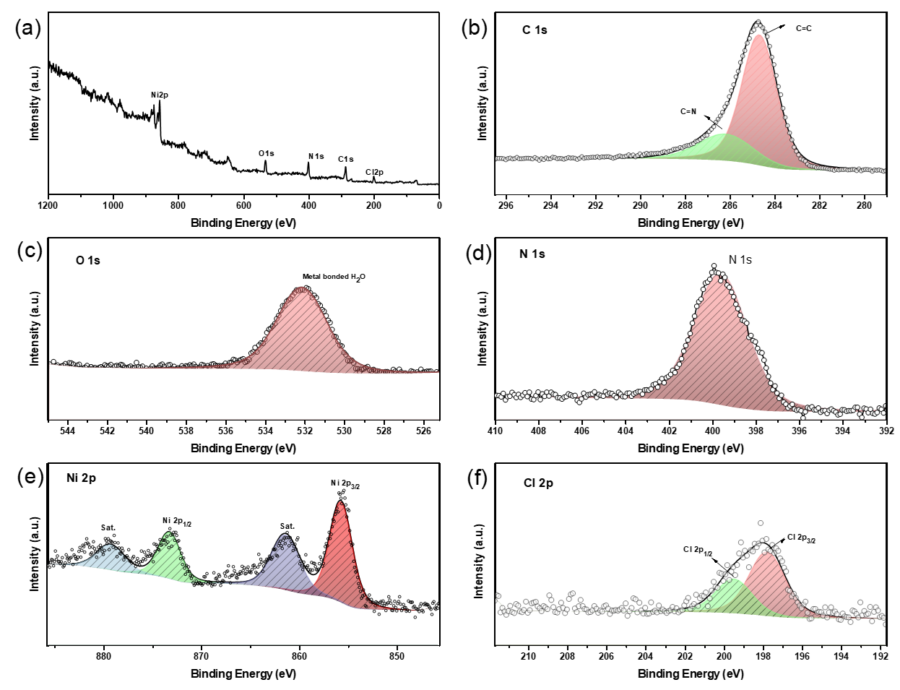
Figure S11. XPS spectra of Ni₂Cl₂BBTA: (a) survey, (b) C1s, (c)O1s, (d)N1s, (e) Ni2p and (f) Cl2p.
Table S7. Summary of XPS spectra peaks of Ni₂Cl₂BBTA
Element | Chemical State | Bonding Energy(eV) | Atomic % per Ni
C | C=C | 284.67
C | C=N | 287.48
O | H₂O (in cavity) | 531.29
N | N=C/N=N | 399.58
Cl | Cl⁻ 2p_{3/2} | 197.77 | 98%
Cl | Cl⁻ 2p_{1/2} | 199.47 | 98%
Ni | Ni²⁺ 2p_{3/2} | 855.70 | 100%
Ni | Ni²⁺ 2p_{1/2} | 873.24 | 100%
Ni | Ni²⁺ 2p_{3/2, sat.} | 861.37 | 100%
Ni | Ni²⁺ 2p_{1/2, sat.} | 879.26 | 100%

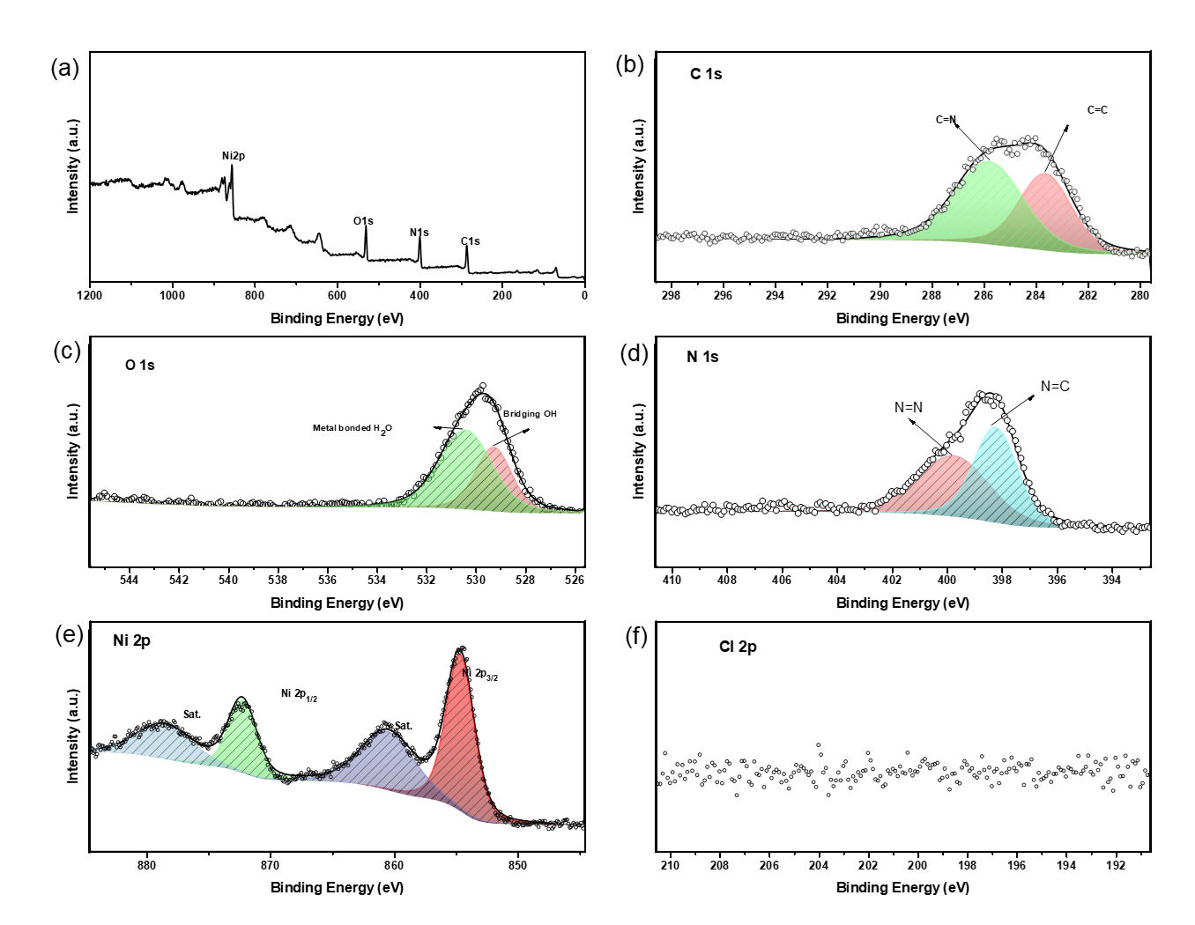
Figure S12. XPS spectra of Ni₂(OH)₂BBTA: (a) survey, (b) C1s, (c)O1s, (d)N1s, (e) Ni2p and (f) Cl2p.
Table S8. Summary of XPS spectra peaks of Ni₂(OH)₂BBTA
Element | Chemical State | Bonding Energy(eV) | Atomic % per Ni
C | C=C | 283.63
C | C=N | 285.79
O | μ₂-OH | 529.27
O | H₂O (coordinates to Co) | 530.4
N | N=C | 399.74
N | N=N | 398.22
Cl | N/A | N/A | 0%
Ni | Ni²⁺ 2p_{3/2} | 854.65 | 100%
Ni | Ni²⁺ 2p_{1/2} | 872.24 | 100%
Ni | Ni²⁺ 2p_{3/2, sat.} | 860.52 | 100%
Ni | Ni²⁺ 2p_{1/2, sat.} | 878.52 | 100%

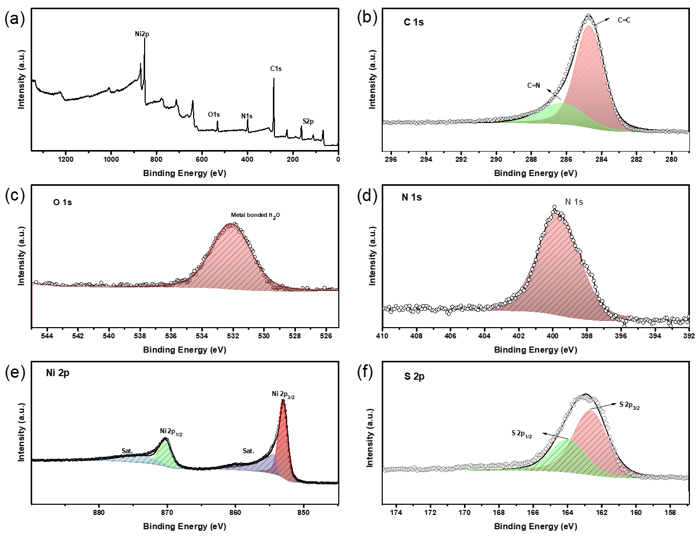
Figure S13. XPS spectra of Ni₂(SH)₂BBTA: (a) survey, (b) C1s, (c)O1s, (d)N1s, (e) Ni2p and (f) Cl2p.
Table S9. Summary of XPS spectra peaks of Ni₂(SH)₂BBTA
Element | Chemical State | Bonding Energy(eV) | Atomic % per Ni
C | C=C | 284.66
C | C=N | 286.17
O | H₂O (in cavity) | 532.13
N | N=C/N=N | 399.59
S | S²⁻ 2p_{3/2} | 162.61 | 104%
S | S²⁻ 2p_{1/2} | 163.91 | 104%
Ni | Ni²⁺ 2p_{3/2} | 852.97 | 100%
Ni | Ni²⁺ 2p_{1/2} | 870.27 | 100%
Ni | Ni²⁺ 2p_{3/2, sat.} | 854.27 | 100%
Ni | Ni²⁺ 2p_{1/2, sat.} | 874.26 | 100%

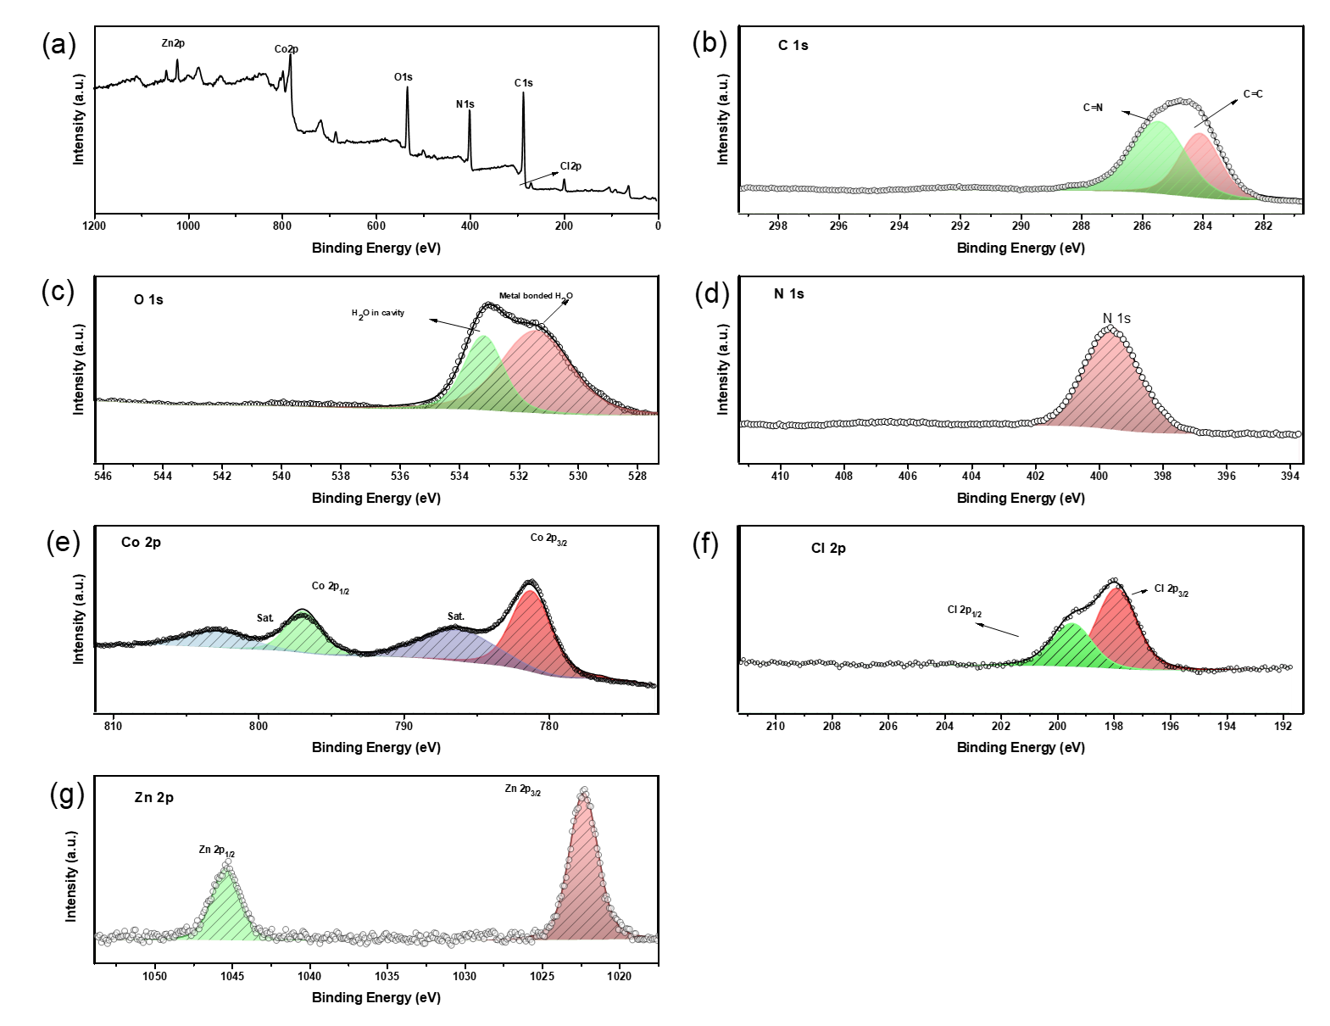
Figure S14. XPS spectra of Co-MFU-4l-Cl: (a) survey, (b) C1s, (c)O1s, (d)N1s, (e) Ni2p and (f) Cl2p.
Table S10. Summary of XPS spectra peaks of Co-MFU-4l-Cl
Element | Chemical State | Bonding Energy(eV) | Atomic % per 1/5 metal
C | C=C | 284.06
C | C=N | 285.43
O | H₂O (coordinates to Co)/O-C | 531.39
O | H₂O (in cavity) | 533.15
N | N=C/N=N | 399.55
Cl | Cl⁻ 2p_{3/2} | 197.86 | 488%
Cl | Cl⁻ 2p_{1/2} | 199.44 | 488%
Co | Co²⁺ 2p_{3/2} | 781.18 | 384%
Co | Co²⁺ 2p_{1/2} | 796.87 | 384%
Co | Co²⁺ 2p_{3/2, sat.} | 786.21 | 384%
Co | Co²⁺ 2p_{1/2, sat.} | 802.70 | 384%
Zn | Zn²⁺ 2p_{3/2} | 1022.25 | 116%
Zn | Zn²⁺ 2p_{1/2} | 1045.35 | 116%
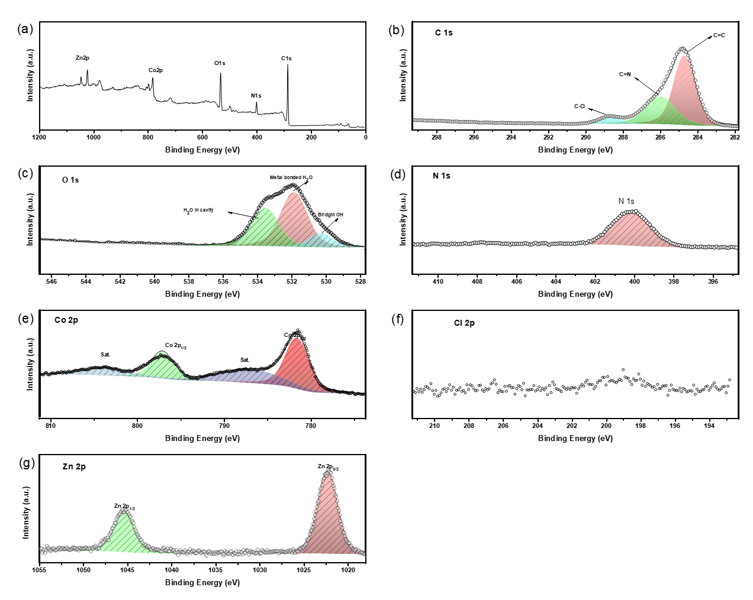
Figure S15. XPS spectra of Co-MFU-4l-OH: (a) survey, (b) C1s, (c)O1s, (d)N1s, (e) Ni2p and (f) Cl2p.
Table S11. Summary of XPS spectra peaks of Co-MFU-4l-OH
Element | Chemical State |  | Bonding Energy(eV) | Atomic % per 1/5 metal
C | C=C |  | 284.69
C | C=N |  | 285.95
C | C-O |  | 288.66
O | -OH (bridging) |  | 530.30
O | H₂O (coordinates to Co)/O-C |  | 531.86
O | H₂O (in cavity) |  | 533.52
N | N=C/N=N |  | 399.55
Cl | N/A | N/A |  | 0%
Co | Co²⁺ 2p_{3/2} |  | 781.58 | 409%
Co | Co²⁺ 2p_{1/2} |  | 797.06 | 409%
Co | Co²⁺ 2p_{3/2, sat.} |  | 786.71 | 409%
Co | Co²⁺ 2p_{1/2, sat.} |  | 803.5 | 409%
Zn | Zn²⁺ 2p_{3/2} |  | 1022.29 | 91%
Zn | Zn²⁺ 2p_{1/2} |  | 1045.35 | 91%
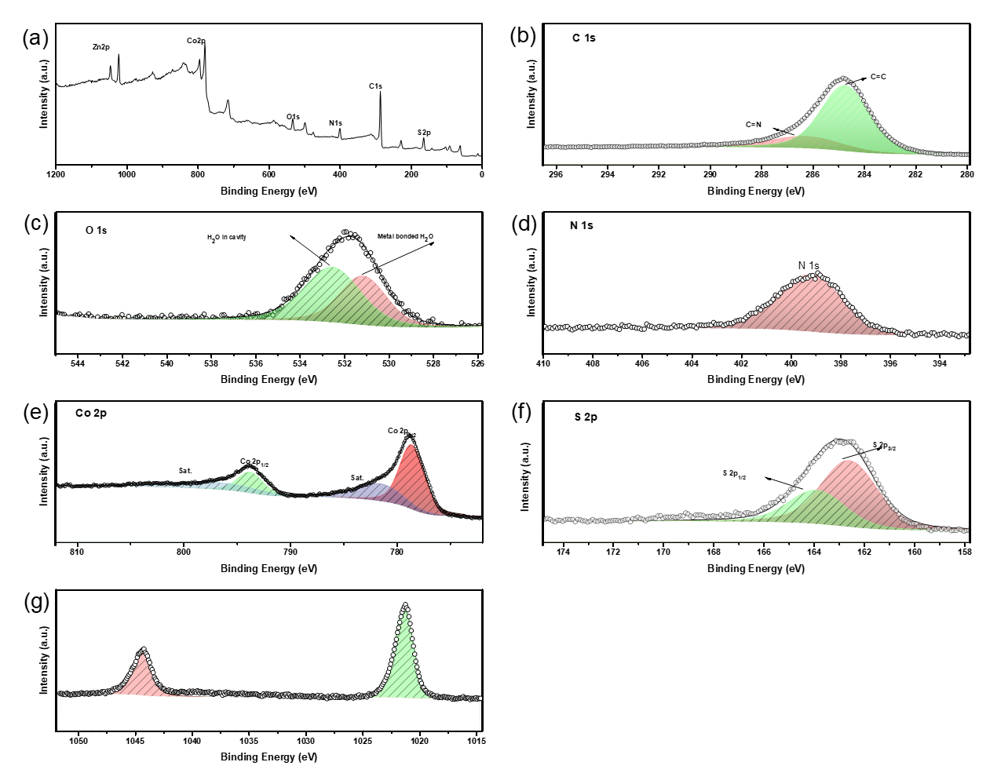
Figure S16. XPS spectra of Co-MFU-4l-SH: (a) survey, (b) C1s, (c)O1s, (d)N1s, (e) Ni2p and (f) Cl2p.
Table S12. Summary of XPS spectra peaks of Co-MFU-4l-SH
Element | Chemical State | Bonding Energy(eV) | Atomic % per 1/5 metal
C | C=C | 284.72
C | C=N | 286.25
O | H₂O (coordinates to Co)/O-C | 531.14
O | H₂O (in cavity) | 532.52
N | N=C/N=N | 399.18
S | S²⁻ 2p_{3/2} | 162.57 | 367%
S | S²⁻ 2p_{1/2} | 163.87 | 367%
Co | Co²⁺ 2p_{3/2} | 778.55 | 399%
Co | Co²⁺ 2p_{1/2} | 793.71 | 399%
Co | Co²⁺ 2p_{3/2, sat.} | 781.5 | 399%
Co | Co²⁺ 2p_{1/2, sat.} | 796.66 | 399%
Zn | Zn²⁺ 2p_{3/2} | 1022.25 | 101%
Zn | Zn²⁺ 2p_{1/2} | 1045.35 | 101%

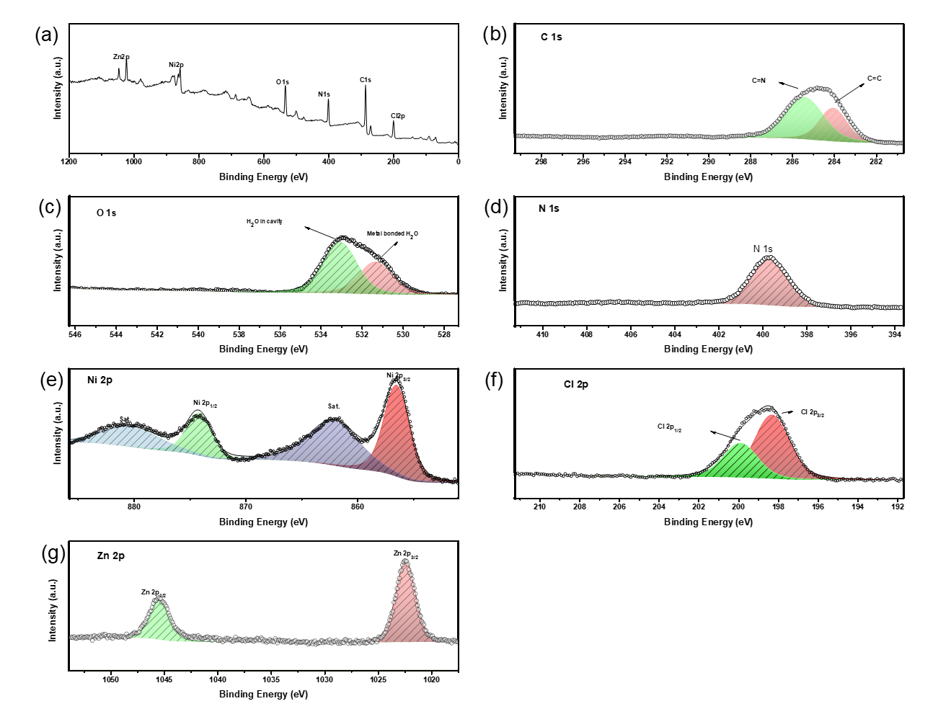
Figure S17. XPS spectra of Ni-MFU-4l-Cl: (a) survey, (b) C1s, (c)O1s, (d)N1s, (e) Ni2p and (f) Cl2p.
Table S13. Summary of XPS spectra peaks of Ni-MFU-4l-Cl
Element | Chemical State | Bonding Energy(eV) | Atomic % per 1/5 metal
C | C=C | 284.04
C | C=N | 285.41
O | H₂O (coordinates to Co)/O-C | 531.33
O | H₂O (in cavity) | 533.05
N | N=C/N=N | 399.66
Cl | Cl⁻ 2p_{3/2} | 198.3 | 377%
Cl | Cl⁻ 2p_{1/2} | 199.88 | 377%
Ni | Ni²⁺ 2p_{3/2} | 856.50 | 273%
Ni | Ni²⁺ 2p_{1/2} | 874.17 | 273%
Ni | Ni²⁺ 2p_{3/2, sat.} | 862.11 | 273%
Ni | Ni²⁺ 2p_{1/2, sat.} | 880.23 | 273%
Zn | Zn²⁺ 2p_{3/2} | 1022.41 | 227%
Zn | Zn²⁺ 2p_{1/2} | 1045.41 | 227%
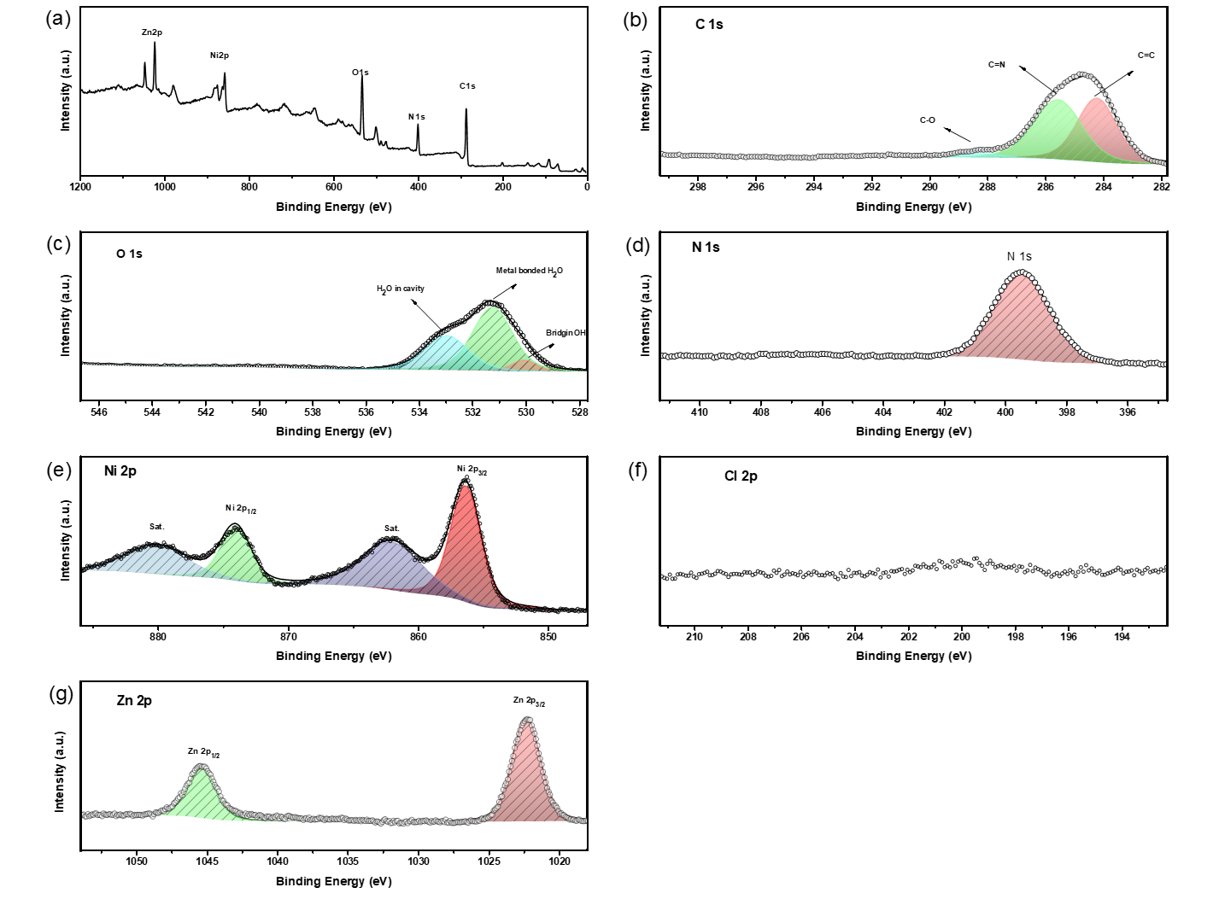
Figure S18. XPS spectra of Ni-MFU-4l-OH: (a) survey, (b) C1s, (c)O1s, (d)N1s, (e) Ni2p and (f) Cl2p.
Table S14. Summary of XPS spectra peaks of Ni-MFU-4l-OH
Element | Chemical State |  | Bonding Energy(eV) | Atomic % per 1/5 metal
C | C=C |  | 284.20
C | C=N |  | 285.54
C | C-O |  | 288.27
O | -OH (bridging) |  | 530.03
O | H₂O (coordinates to Co)/O-C |  | 531.22
O | H₂O (in cavity) |  | 532.94
N | N=C/N=N |  | 399.41
Cl | N/A | N/A |  | 0%
Ni | Ni²⁺ 2p_{3/2} |  | 856.29 | 305%
Ni | Ni²⁺ 2p_{1/2} |  | 873.99 | 305%
Ni | Ni²⁺ 2p_{3/2, sat.} |  | 861.99 | 305%
Ni | Ni²⁺ 2p_{1/2, sat.} |  | 880.05 | 305%
Zn | Zn²⁺ 2p_{3/2} |  | 1022.29 | 195%
Zn | Zn²⁺ 2p_{1/2} |  | 1045.35 | 195%

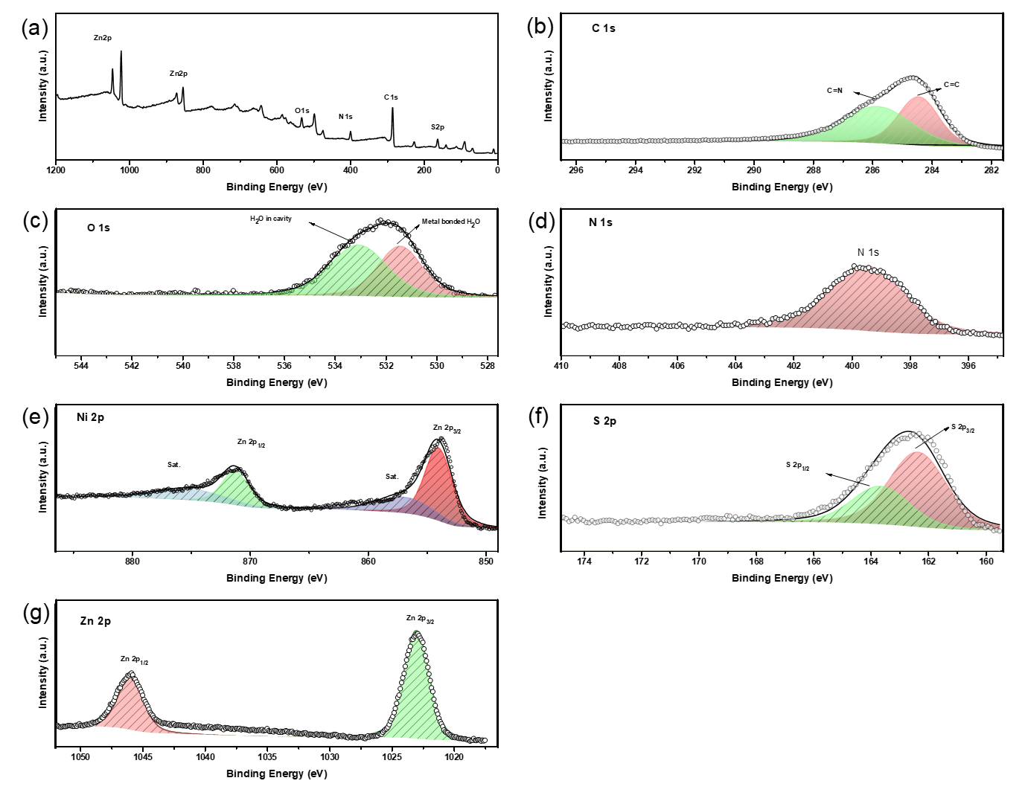
Figure S19. XPS spectra of Ni-MFU-4l-SH: (a) survey, (b) C1s, (c)O1s, (d)N1s, (e) Ni2p and (f) Cl2p.
Table S15. Summary of XPS spectra peaks of Ni-MFU-4l-SH
Element | Chemical State | Bonding Energy(eV) | Atomic % per 1/5 metal
C | C=C | 284.42
C | C=N | 285.82
O | H₂O (coordinates to Co)/O-C | 531.43
O | H₂O (in cavity) | 533.07
N | N=C/N=N | 399.46
S | S²⁻ 2p_{3/2} | 162.35 | 294%
S | S²⁻ 2p_{1/2} | 163.65 | 294%
Ni | Ni²⁺ 2p_{3/2} | 854.01 | 212%
Ni | Ni²⁺ 2p_{1/2} | 871.24 | 212%
Ni | Ni²⁺ 2p_{3/2, sat.} | 856.83 | 212%
Ni | Ni²⁺ 2p_{1/2, sat.} | 875.16 | 212%
Zn | Zn²⁺ 2p_{3/2} | 1023.01 | 288%
Zn | Zn²⁺ 2p_{1/2} | 1045.96 | 288%
Section F. Scanning Electron Microscopy (SEM) and Energy Dispersive X-ray spectroscopy (EDS)
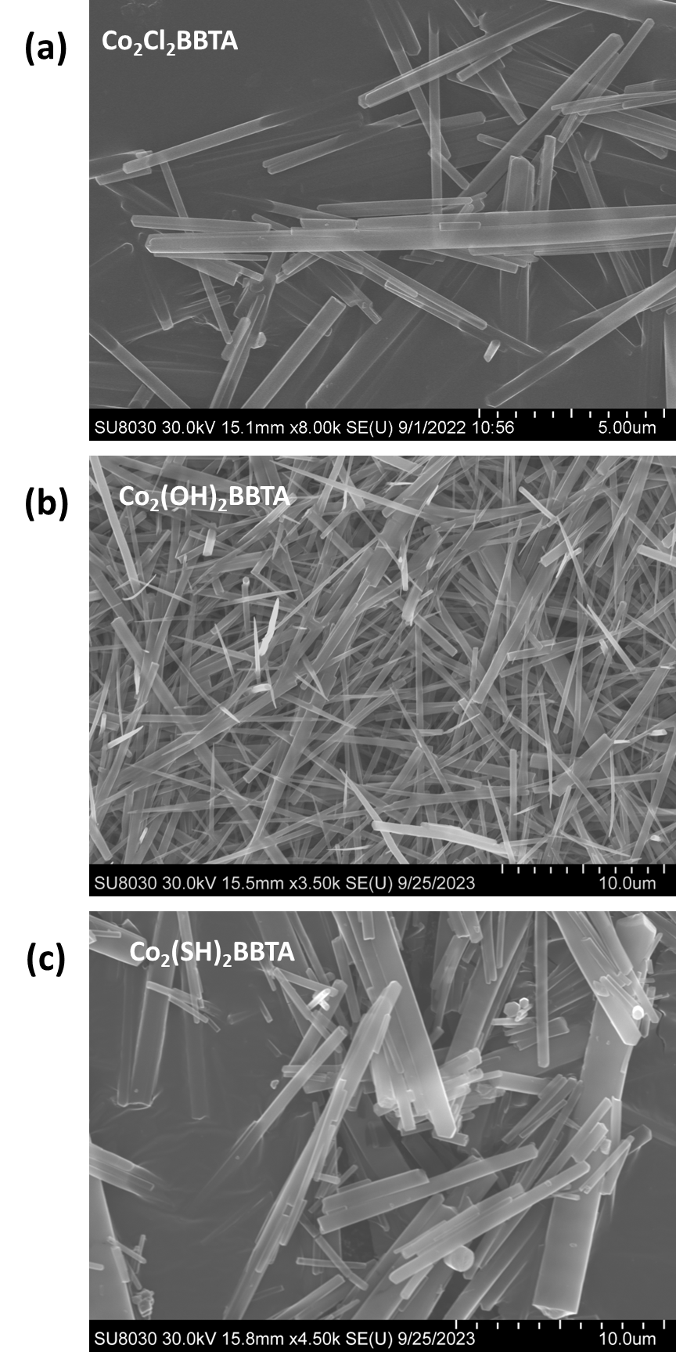
Figure S20. SEM images of (a) pristine Co₂Cl₂BBTA and post-synthetically converted (b) Co₂(OH)₂BBTA, (c) Co₂(SH)₂BBTA.

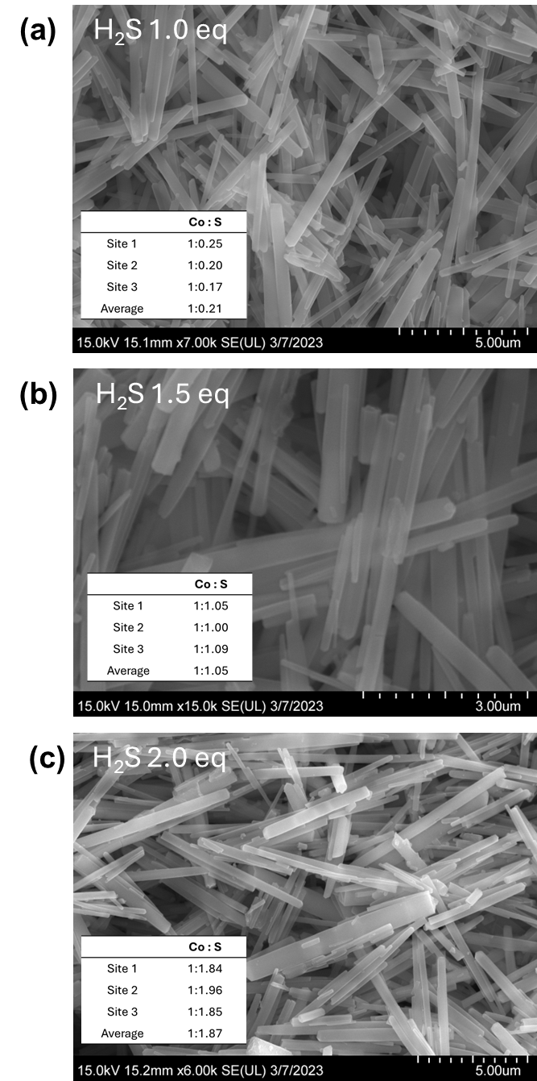
Figure S21. SEM and EDS results of Co:S ratio of Co₂(SH)₂BBTA with different equivalence (a) 1.0 eq. (b) 1.5 eq and (c) 2.0 eq of H₂S used.

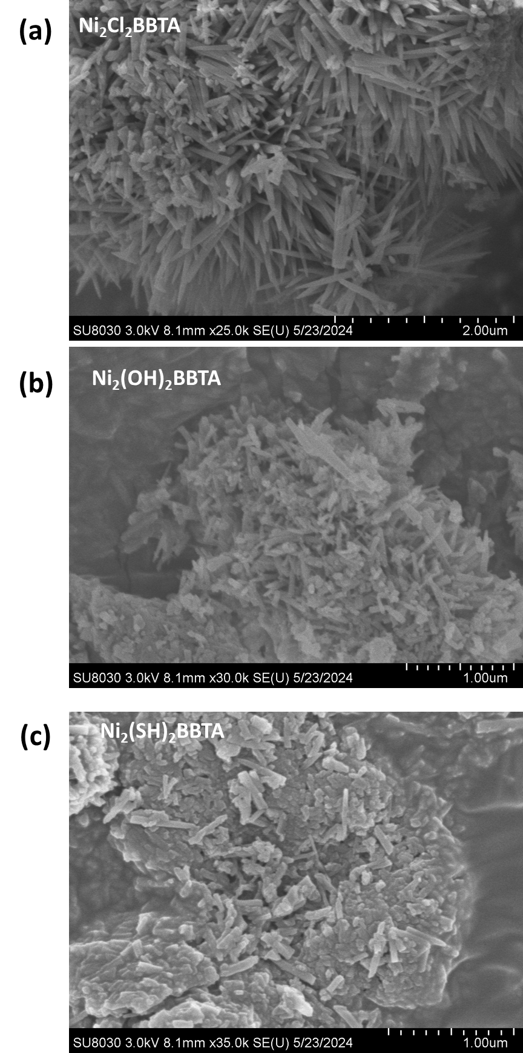
Figure S22. SEM images of (a) pristine Ni₂Cl₂BBTA and post-synthetically converted (b) Ni₂(OH)₂BBTA, (c) Ni₂(SH)₂BBTA.

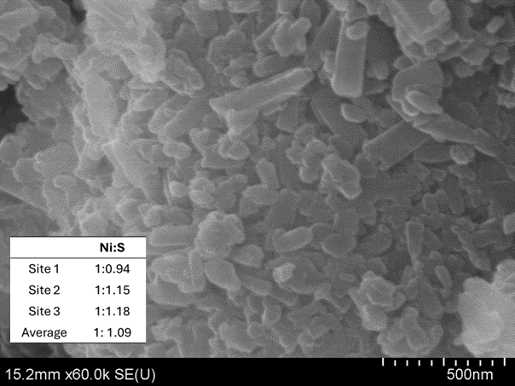
Figure S23. SEM and EDS results of Ni:S ratio of Ni₂(SH)₂BBTA

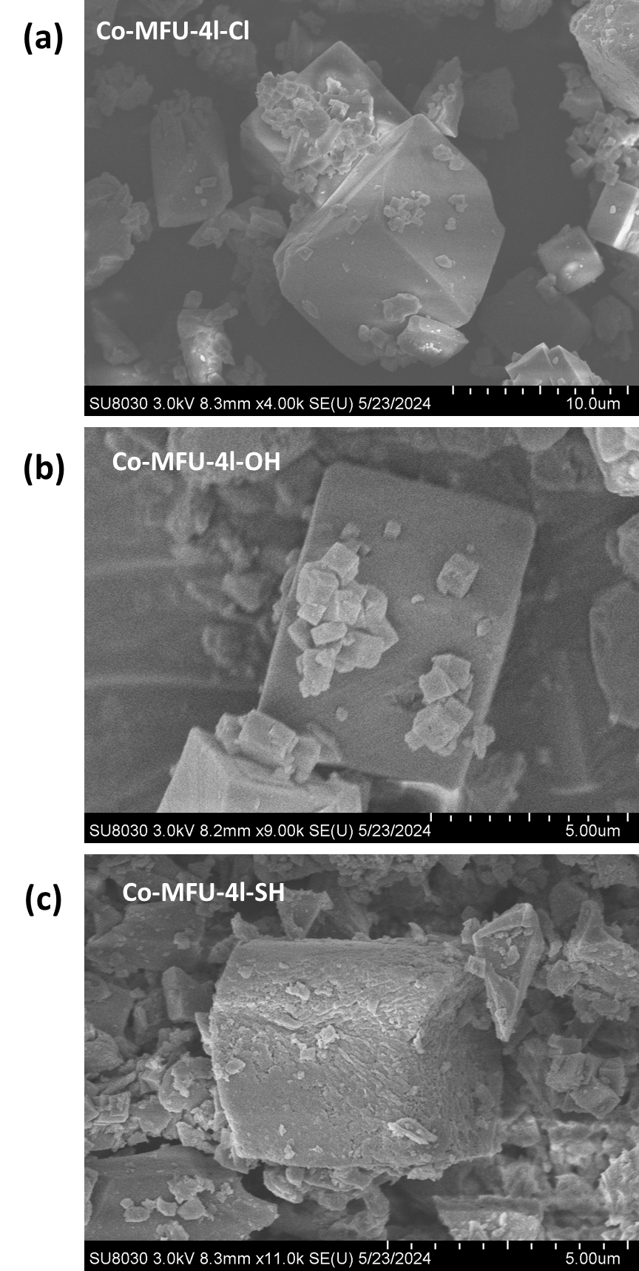
Figure S24. SEM images of (a) pristine Co-MFU-4l-Cl and post-synthetically converted (b) Co-MFU-4l-OH, (c) Co-MFU-4l-SH.

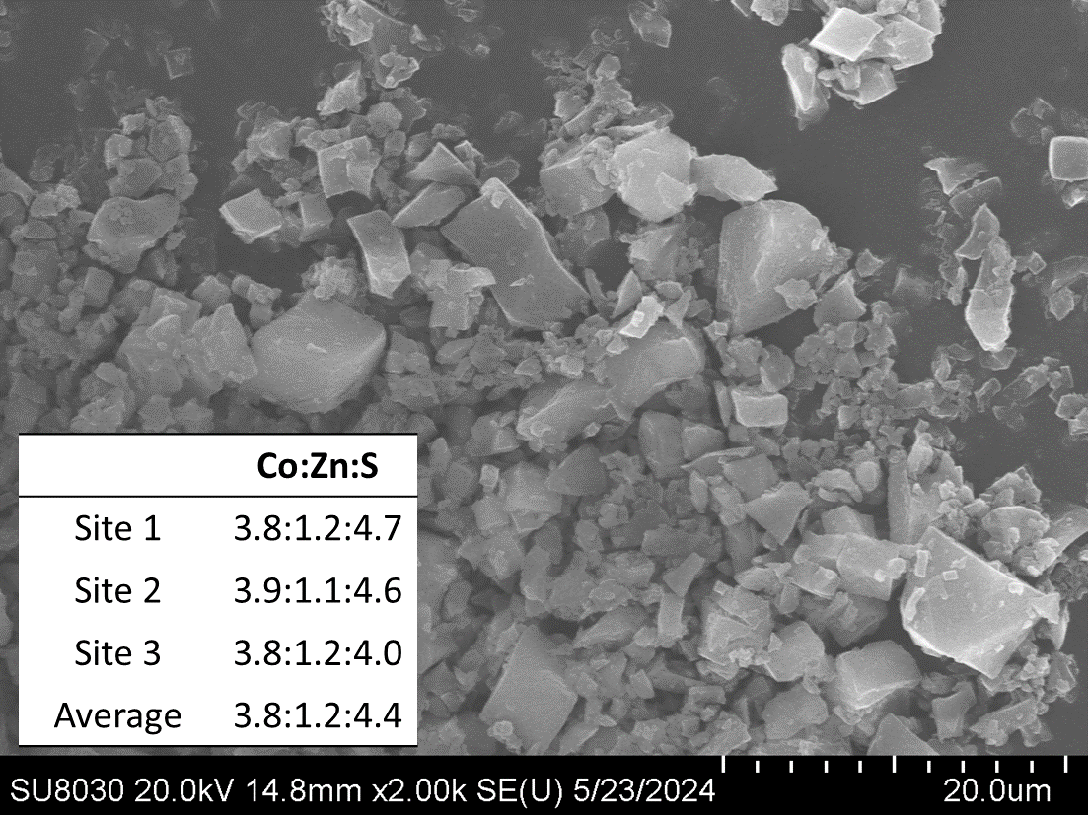
Figure S25. SEM and EDS results of Co:Zn:S ratio of Co-MFU-4l-SH

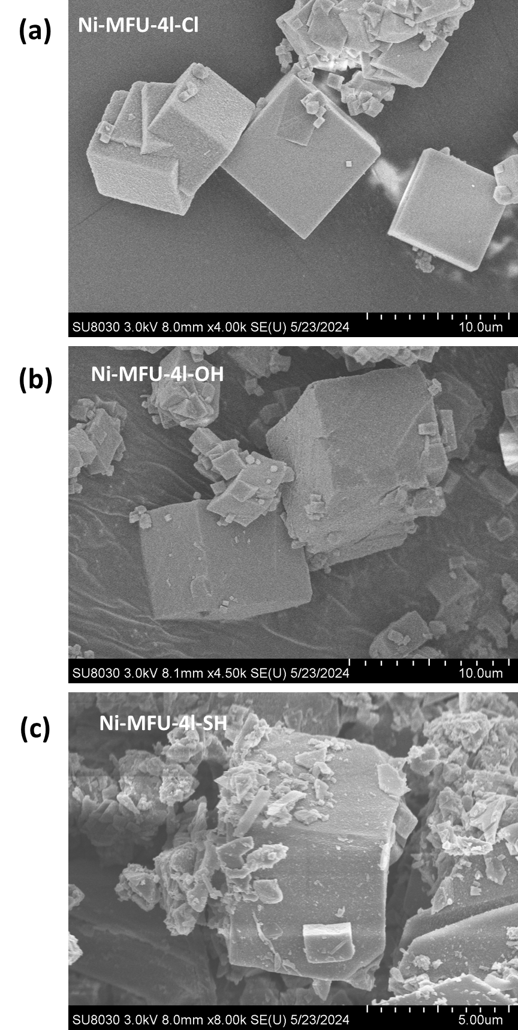
Figure S26. SEM images of (a) pristine Ni-MFU-4l-Cl and post-synthetically converted (b) Ni-MFU-4l-OH, (c) Ni-MFU-4l-SH.

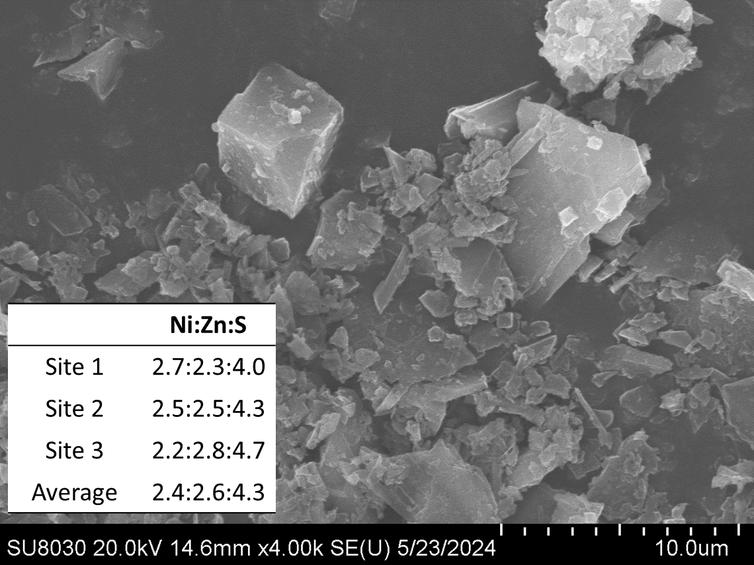
Figure S27. SEM and EDS results of Ni:Zn:S ratio of Ni-MFU-4l-SH

Section G. Hydrogenation Catalysis of 4-Nitrophenol

The experiment was conducted using a Parr reactor. Initially, 20 mg of 4-nitrophenol was dissolved in 6 mL of methanol (MeOH) within a 25 mL Teflon liner. The MOFs were added in an amount corresponding to 10% based on the metal sites. The reactor system was purged with argon at 10 bar pressure three times, followed by purging with hydrogen gas at 13.8 bar pressure three times. The final pressure of hydrogen gas was kept at 13.8 bar at room temperature. Subsequently, the mixture was heated to 150°C for 4.25 hours and then allowed to cool to room temperature. The product was separated using a centrifuge, and the conversion rate was monitored via NMR spectroscopy. The turnover frequency measurements were formed with 1.5 mol% Co₂(SH)₂BBTA and 5 mol% Ni-MFU-4l-SH.

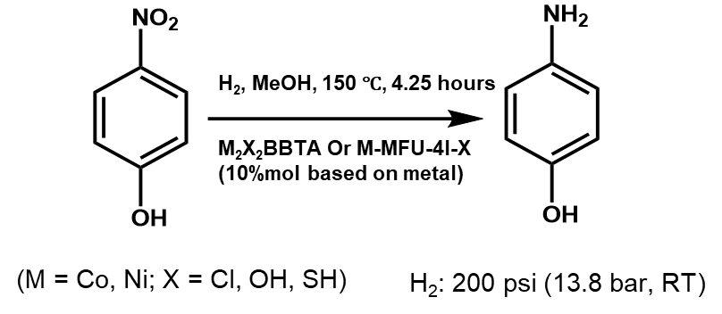
Figure S28. Hydrogenation of 4-nitrophenol to 4-aminophenol.
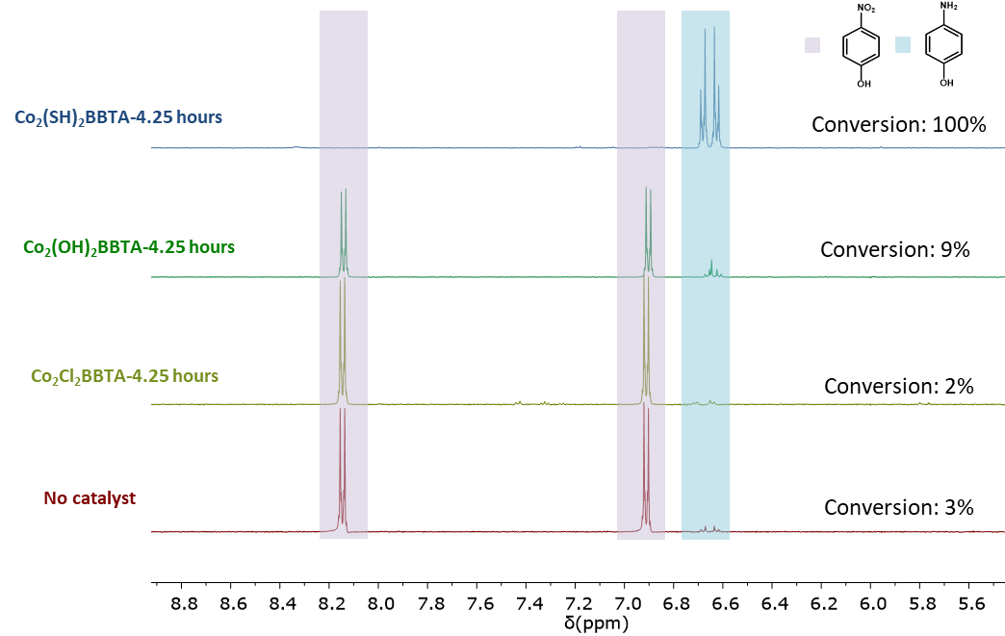
Figure S29. ¹H NMR of hydrogenation of 4-nitrophenol to 4-aminophenol with Co₂X₂BBTA as catalysts, where X = Cl, OH and SH.

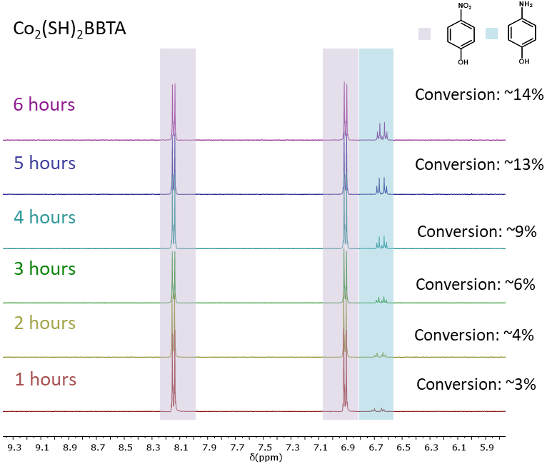
Figure S30. ¹H NMR of hydrogenation of 4-nitrophenol to 4-aminophenol with 1.5 mol% Co₂(SH)₂BBTA
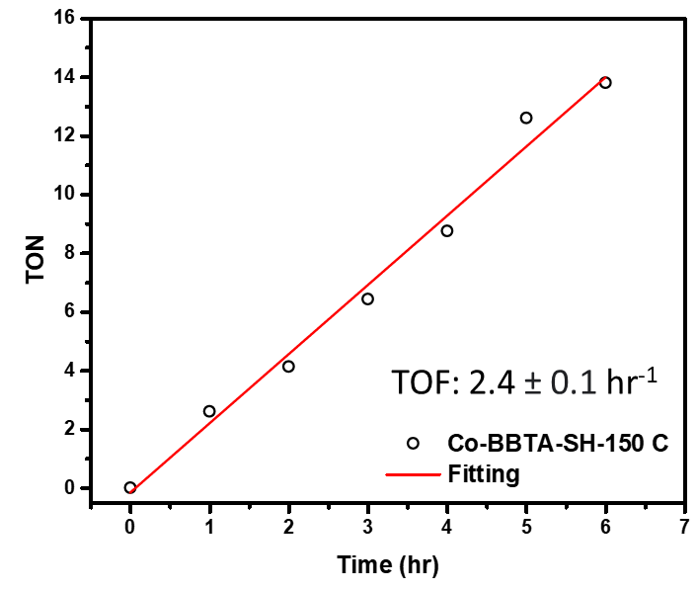
Figure S31. Turnover frequency of hydrogenation of 4-nitrophenol to 4-aminophenol with 1.5 mol% Co₂(SH)₂BBTA

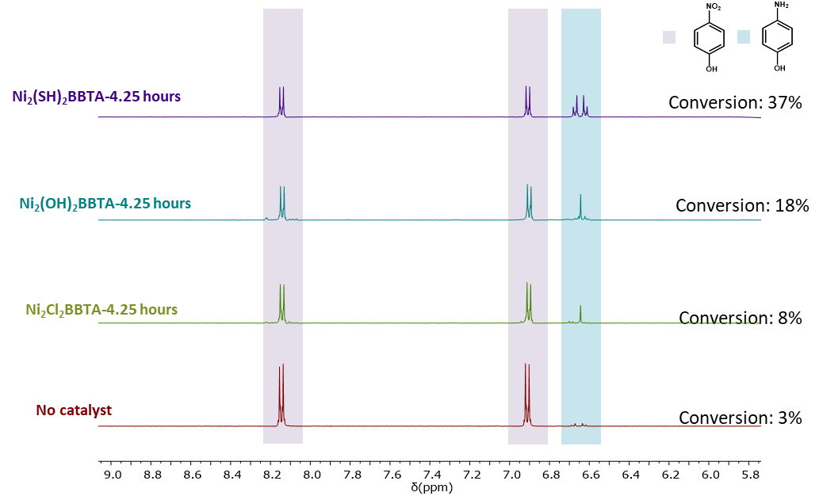
Figure S32. ¹H NMR of hydrogenation of 4-nitrophenol to 4-aminophenol with Ni₂X₂BBTA as catalysts, where X = Cl, OH and SH.
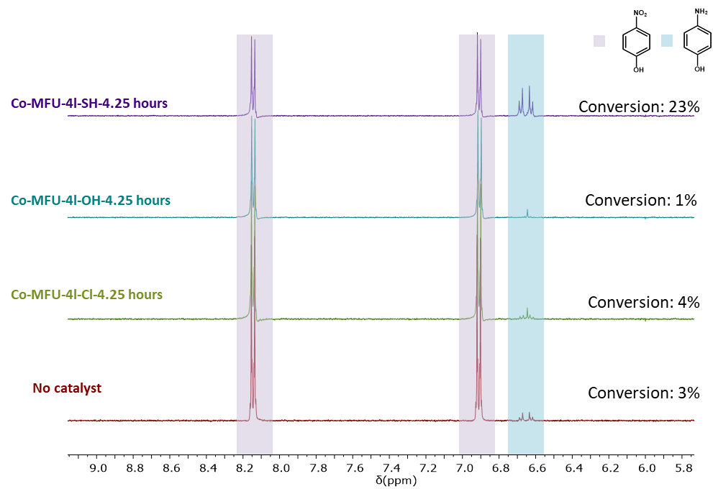
Figure S33. ¹H NMR of hydrogenation of 4-nitrophenol to 4-aminophenol with Co-MFU-4l-X as catalysts, where X = Cl, OH and SH.

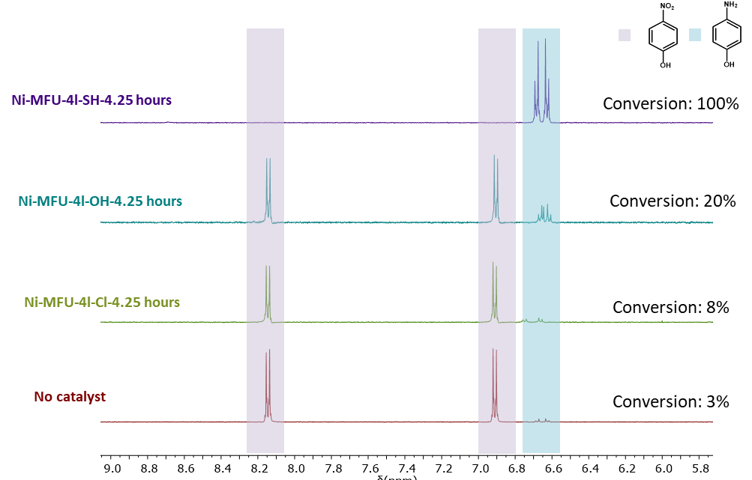
Figure S34. ¹H NMR of hydrogenation of 4-nitrophenol to 4-aminophenol with Ni-MFU-4l-X as catalysts, where X = Cl, OH and SH.
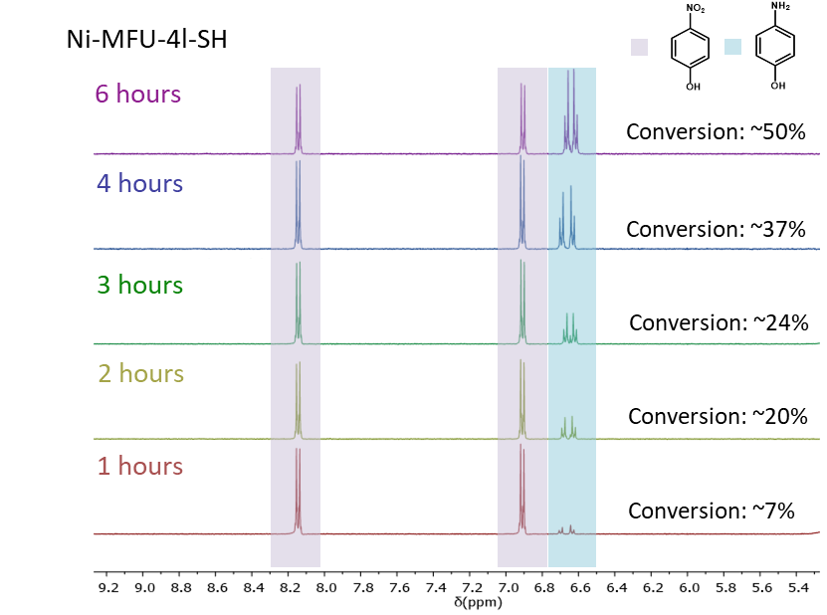
Figure S35. ¹H NMR of hydrogenation of 4-nitrophenol to 4-aminophenol with 5 mol% Ni-MFU-4l-SH

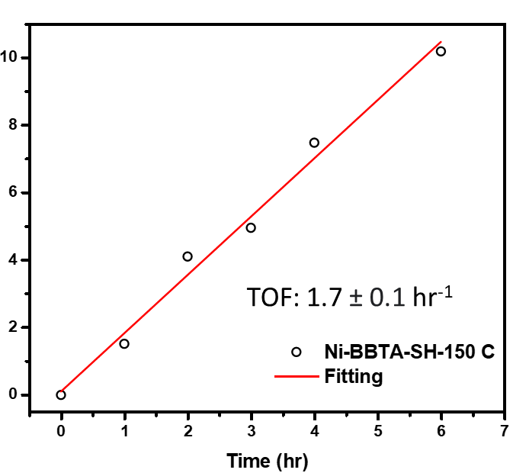
Figure S36. Turnover frequency of hydrogenation of 4-nitrophenol to 4-aminophenol with 5 mol% Ni-MFU-4l-SH

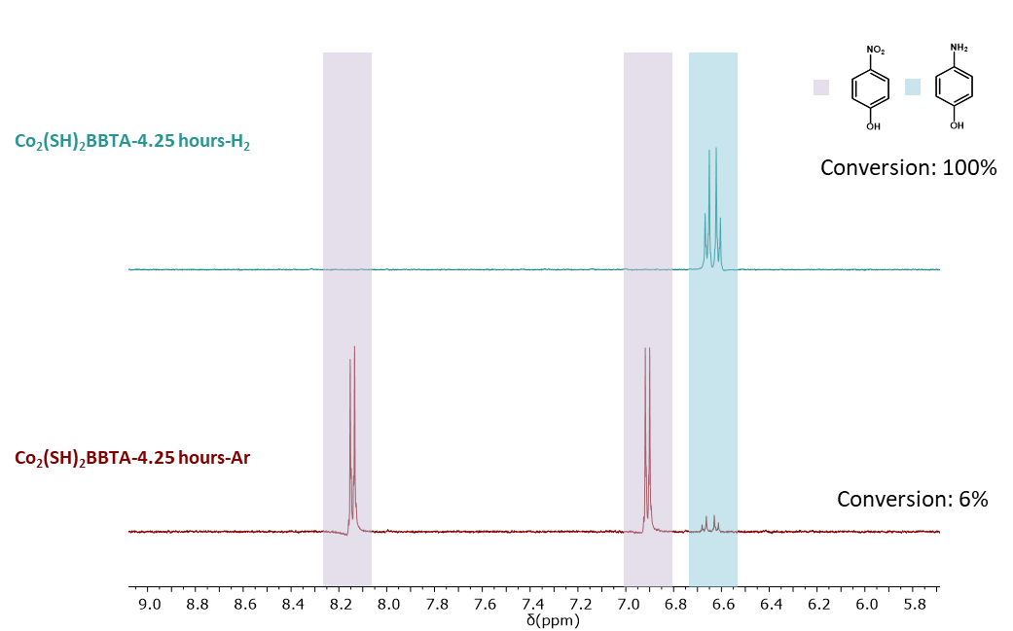
Figure S37. ¹H NMR of hydrogenation of 4-nitrophenol to 4-aminophenol with 10 mol% Co₂(SH)₂BBTA under Ar and H₂

Section H. Computational Analysis

H.1. 3D MFU-4l System: Spin Ladder
Scheme S1. Possible spin configurations for each metal center M (= Co^{II}/Ni^{II}) and their ferromagnetic and antiferromagnetic coupling combinations were explored thoroughly to understand the resting state electronic configuration in these systems. For each spin state, the total spin multiplicity of the node is shown in parenthesis.
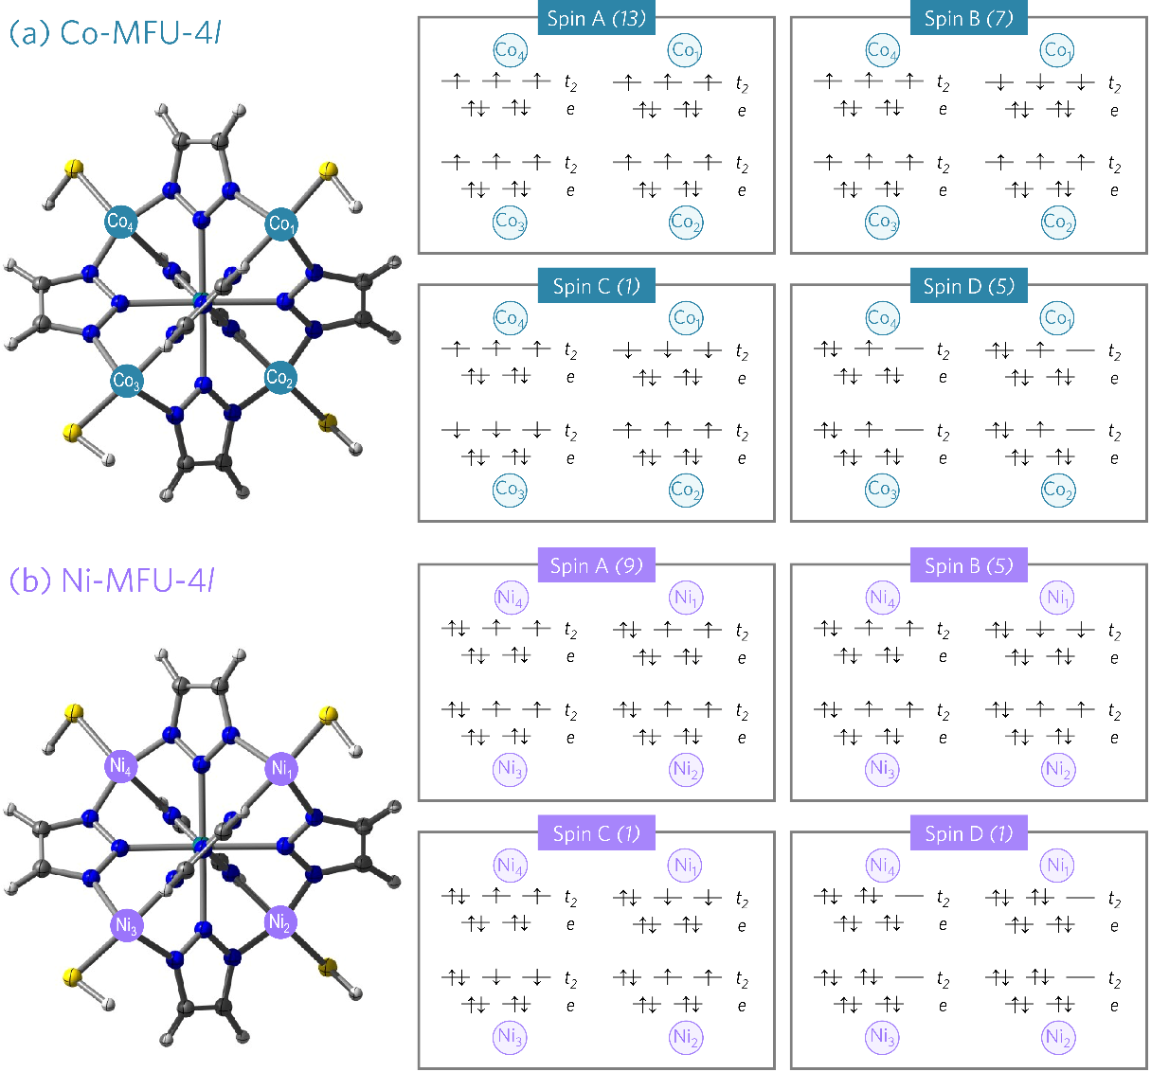
Table S16. Relative energies of the spin isomers presented in Scheme S1. Electronic energies (∆E) are in kcal/mol calculated at the TPSSh-D3(BJ)/basis-II/SMD(MeOH)//TPSSh-D3(BJ)/basis-I level of theory.
System | –X | ∆E (kcal/mol)
System | –X | Spin-A | Spin-B | Spin-C | Spin-D
Co | –Cl | 0 | –0.2 | –0.3 | 99.3
Co | –OH | 0 | –0.2 | –0.3 | 70.2
Co | –SH | 0 | –0.3 | –0.4 | 43.8
Ni | –Cl | 0 | –0.1 | –0.1 | 64.3
Ni | –OH | 0 | –0.2 | –0.3 | 58.6
Ni | –SH | 0 | –0.2 | –0.1 | 58.2

H.2. 3D MFU-4l System: Choice of Density Functional
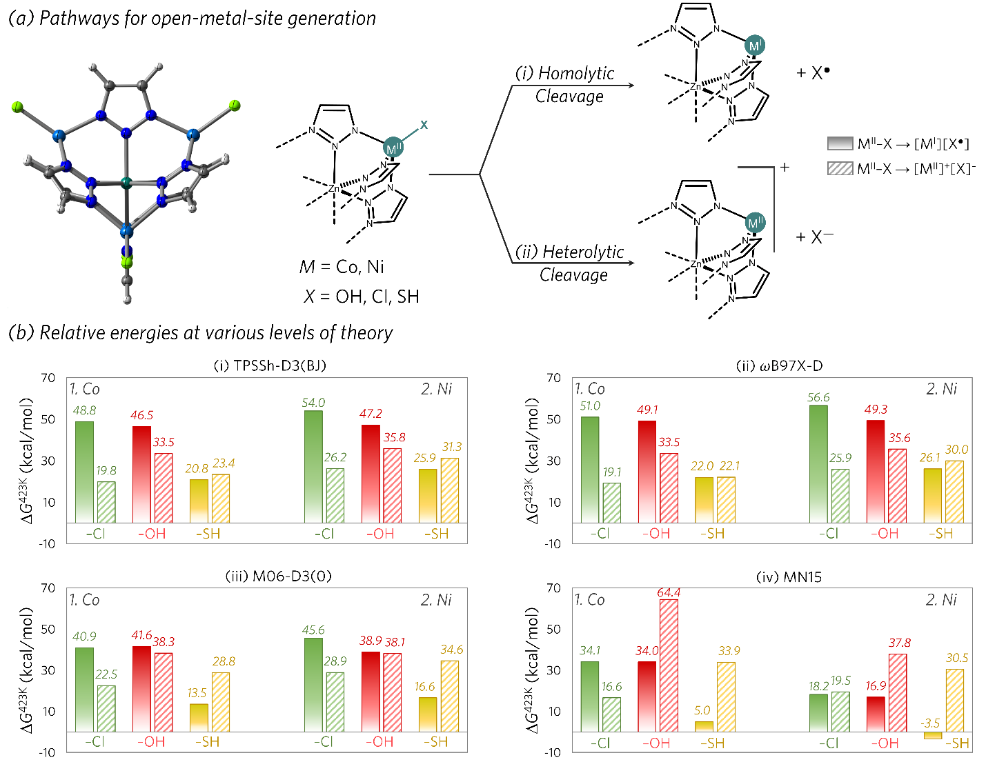
Figure S38. (a) Schematic representation of the two possible pathways for open metal site generation: (i) homolytic cleavage and (ii) heterolytic cleavage of the M–X bond. (b) Influence of the density functional on the computed results. Four density functionals were employed: (i) TPSSh-D3(BJ), (ii) ωB97X-D,²⁵ (iii) M06-D3(0), and (iv) MN-15.²⁶ All methods showed a consistent trend: heterolytic M–X bond cleavage is preferred for X = Cl, OH (depicted by stripe filled bars), while for X = SH homolytic cleavage is preferred (depicted by solid gradient filled bar). For the rest of the study, results obtained using the M06-D3(0) functional will be shown. Gibbs free energies (at 150 °C) are given in kcal/mol.

H.3. Size of 3D Cluster Model: Small vs. Large
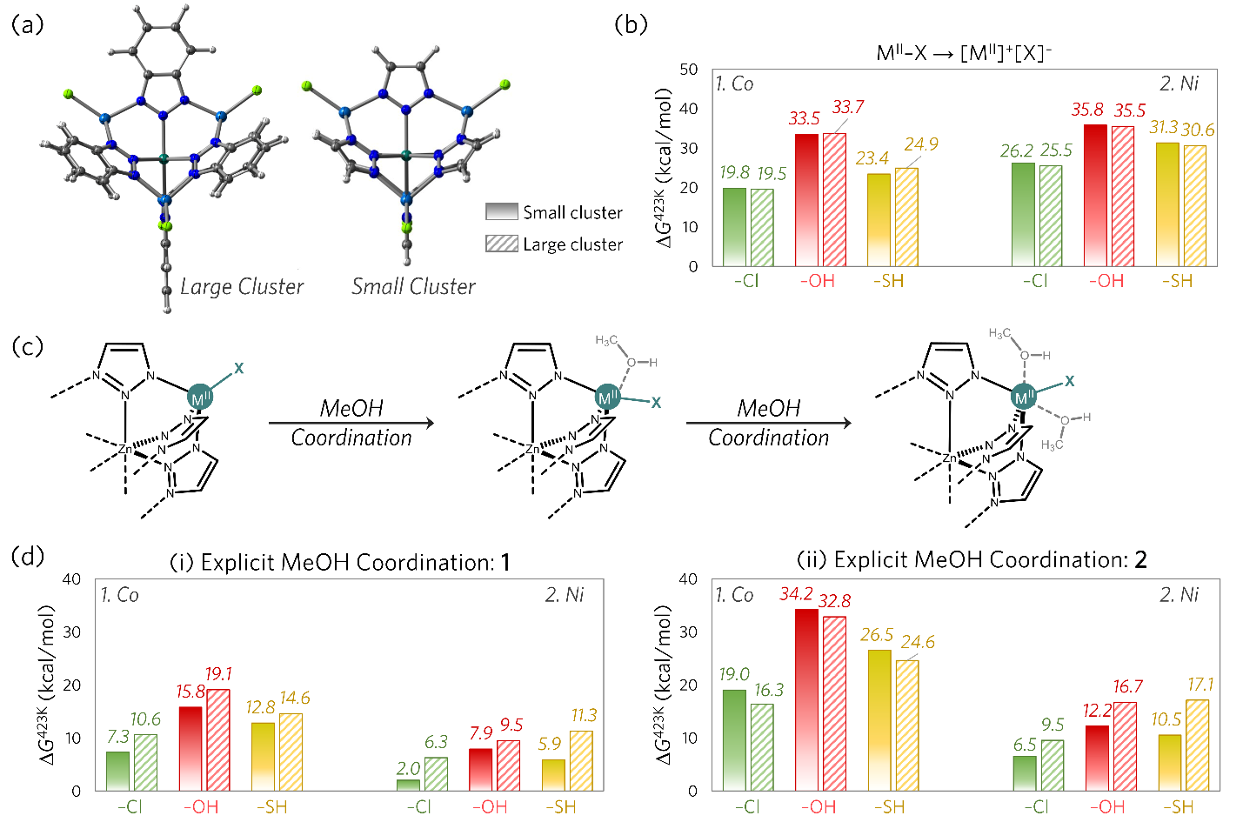
Figure S39. Influence of the size the of the cluster model chosen for the computational study is analyzed. (a) “Large Cluster” (stripe filled bars) includes a benzotriazole ligand, while the “Small Cluster” (solid gradient filled bar) uses a triazole ligand. (b) Energetics of heterolytic M–X bond cleavage (schematically shown in Figure S38(a)) for both cluster models. No significant difference is observed between the models. (c) and (d): Solvent effects were investigated using explicit solvation of the cluster models with methanol: (i) 1 MeOH per metal center and (ii) 2 MeOH per metal center. Panel (d) shows some variation in computed energetics for the larger cluster when compared against the smaller cluster, potentially due to steric hindrance. However, the relative trends for methanol solvation energies (M = Co, Ni; X = Cl, OH, SH) were consistent across both models. Based on these findings, subsequent results will be presented using the smaller cluster model only. Gibbs free energies (at 150 °C) are given in kcal/mol, calculated at the TPSSh-D3(BJ)/ def2-TZVP/SMD(MeOH)//TPSSh-D3(BJ)/def2-SVP level of theory.

H.4. Effect of Systematic Methanol Coordination: 3D MOF Neutral M^{II}–X Species
Scheme S2. Schematic representation of various coordination modes explored for MeOH binding to the neutral M(II)–X species: (A) Two tetrahedral M(II)–X sites (starting structure), (B) Two square pyramidal M(II) sites, (C) Combination of tetrahedral and octahedral M(II) sites, (D) Two square pyramidal M(II) sites with additional hydrogen bonded MeOH units (E) Two octahedral M(II) sites.
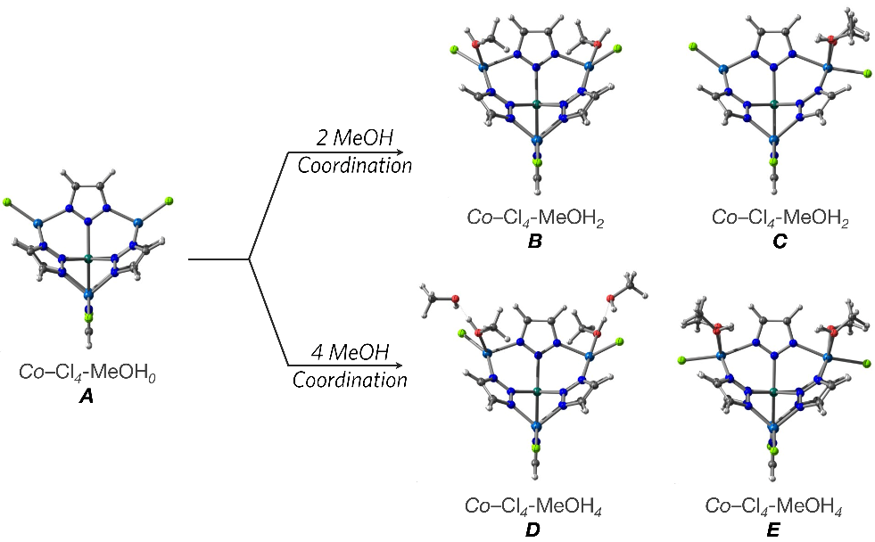
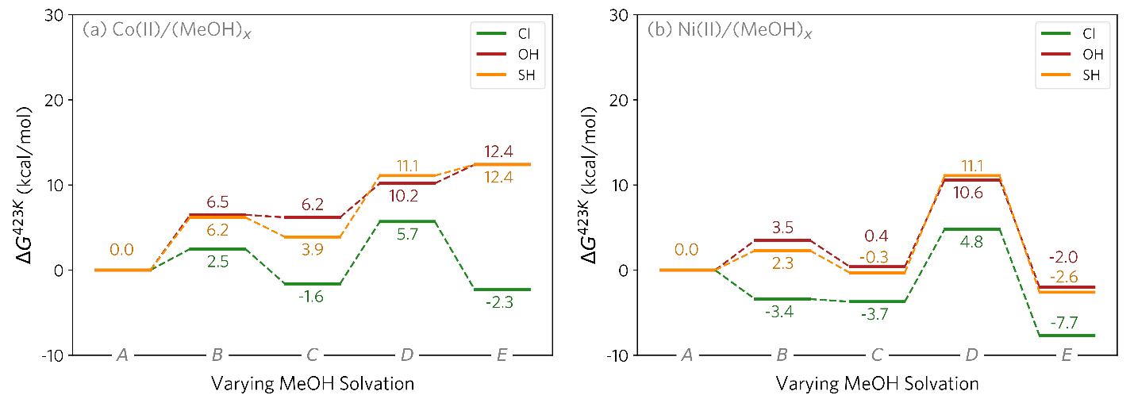
Figure S40. MeOH coordination energetics for Co^{II} (a) and Ni^{II} (b) complexes. Ni consistently shows lower binding energies across all coordination modes. For Co at 423 K, most MeOH coordination modes are endergonic, with only two exceptions involving the Cl ligand (C and E). Thus, the unsolvated system is primarily relevant for neutral Co(II)–X species. In contrast, for Ni(II)–X (X = Cl, OH, SH), the octahedrally coordinated species E is considered the resting state. Gibbs free energies (at 150 °C) are given in kcal/mol, calculated at the M06-D3(0)/def2-TZVP/SMD(MeOH) //TPSSh-D3(BJ)/def2-SVP level of theory.
Scheme S3. Schematic representation of various coordination modes explored for MeOH binding to [M^{I}] sites: tetrahedral M^{II}–X and trigonal [M^{I}] sites (starting structure; A), and various other MeOH coordinated sites (B – G).
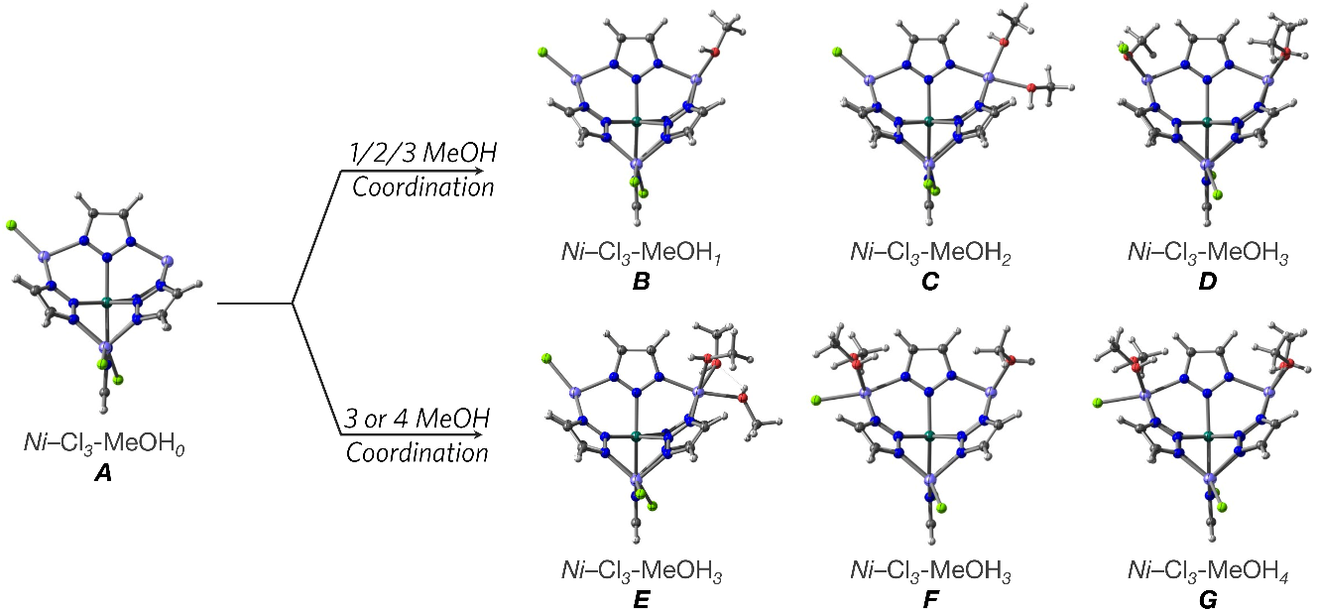
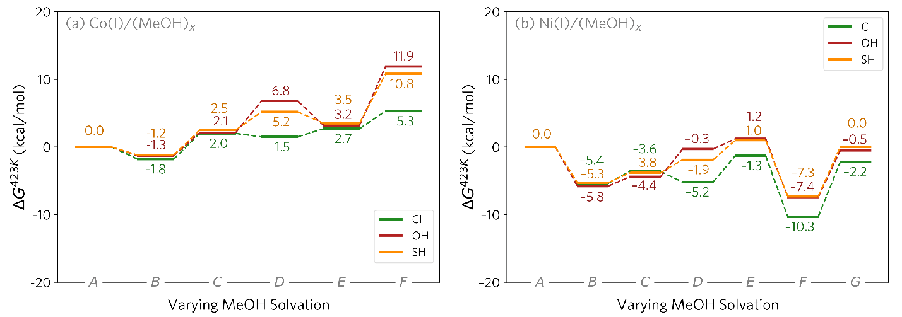
Figure S41. Energetics of MeOH coordination at a [M(I)] species is shown for both Co (a) and Ni (b). Species A – G are demonstrated in Scheme S3. Overall, MeOH solvation at Ni is more favored compared to at Co for all coordination modes. At 423 K, the lowest energy structure for Co(I) is the solvated structure B, having one MeOH coordination at the open-metal site. For Ni(I), it is the solvated structure F that is analogous to B, having one MeOH coordination at the open-metal site, but also the other Ni center octahedrally coordinated by two more MeOH molecules. Gibbs free energies (at 150 °C) are given in kcal/mol, calculated at the M06-D3(0)/def2-TZVP/SMD(MeOH)//TPSSh-D3(BJ)/def2-SVP level of theory.
Scheme S4. Schematic representation of various coordination modes explored for MeOH binding to [M^{II}]⁺ sites: tetrahedral M^{II}–X and trigonal [M^{II}]⁺ sites (starting structure; A), and various other MeOH coordinated sites (B – F).
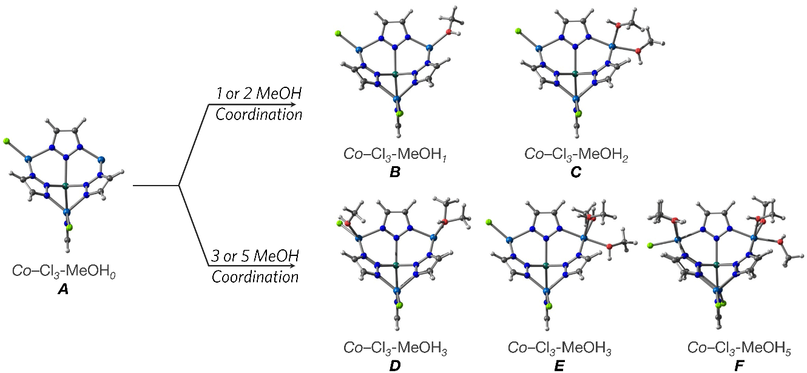

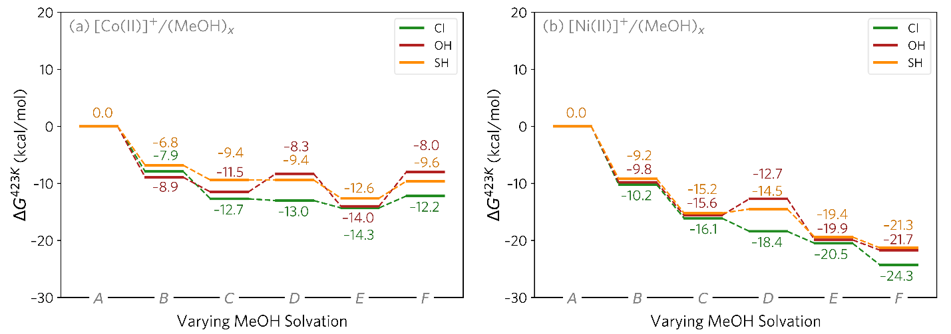
Figure S42. Energetics of MeOH coordination at a [M^{II}]⁺ species is shown for both Co (a) and Ni (b). Species A – F are demonstrated in Scheme S4. Overall, MeOH solvation at Ni is more favored compared to at Co for all coordination modes. At 423 K, the lowest energy structure for [Co^{II}]⁺ is the solvated structure E, having three MeOH coordination at the open-metal site. For [Ni^{II}]⁺, it is the solvated structure F that is analogous to E, having three MeOH coordination at the open-metal site, but also the other Ni center octahedrally coordinated by two more MeOH molecules. Gibbs free energies (at 150 °C) are given in kcal/mol, calculated at the M06-D3(0)/def2-TZVP/SMD(MeOH)//TPSSh-D3(BJ)/def2-SVP level of theory.

H.5. Effect of Systematic Methanol Solvation: H₂ Adsorption on 3D MOF Open Metal Sites [M^{I}] and [M^{II}]⁺
Scheme S5. Schematic representation of various coordination modes explored for MeOH binding to [M^{I}..H₂] sites.
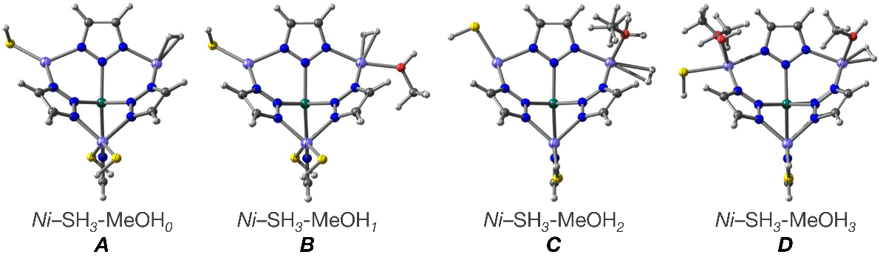

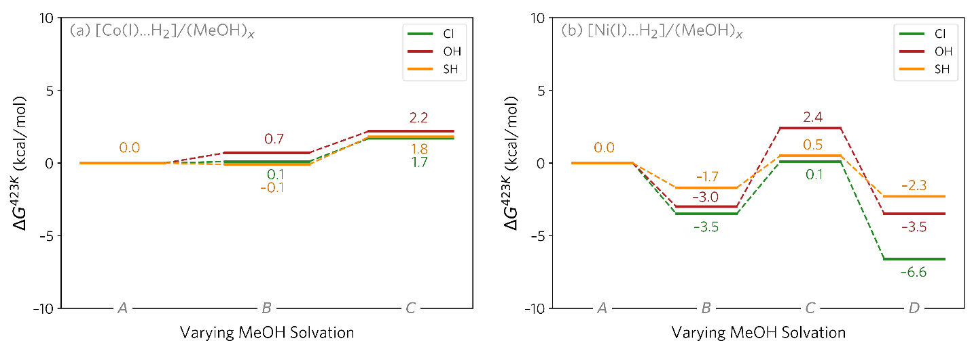
Figure S43. Energetics of MeOH coordination for both Co (a) and Ni (b) at the [M(I)..H₂] site are shown. For Co at 423 K, the unsolvated structure A (Scheme S5) is primarily relevant. In contrast, for Ni, species D (Scheme S5) is the most energetically favored state. Gibbs free energies (at 150 °C) are given in kcal/mol, calculated at the M06-D3(0)/def2-TZVP/SMD(MeOH)//TPSSh-D3(BJ)/def2-SVP level of theory.
Scheme S6. Schematic representation of various coordination modes explored for MeOH binding to [M^{II}..H₂]⁺ sites.
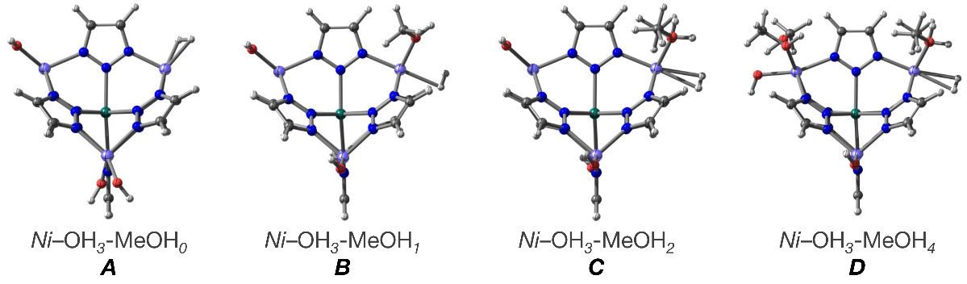
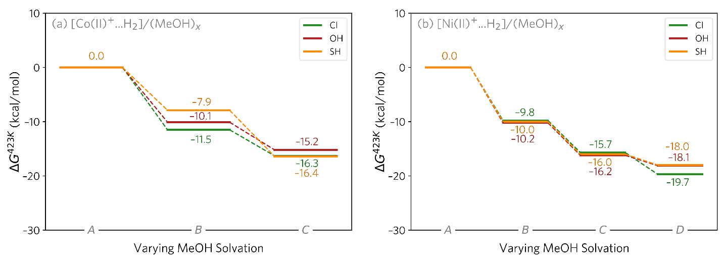
Figure S44. Energetics of MeOH coordination for both Co (a) and Ni (b) at the [M^{II}..H₂]⁺ site are shown. For Co at 423 K, structure C (Scheme S6) is primarily relevant. In contrast, for Ni, species D (Scheme S6) is the most energetically favored state. Gibbs free energies (at 150 °C) are given in kcal/mol, calculated at the M06-D3(0)/def2-TZVP/SMD(MeOH)//TPSSh-D3(BJ)/def2-SVP level of theory.

H.6. Summary of Heterolytic [M^{II}]⁺–Mediated Path 3D MFU-4l catalyst
Scheme S7. Schematic for [M^{II}]⁺–mediated open metal-site generation, hydrogen adsorption and dissociation for subsequent Ar–NO₂ reduction in the MFU-4l catalyst.
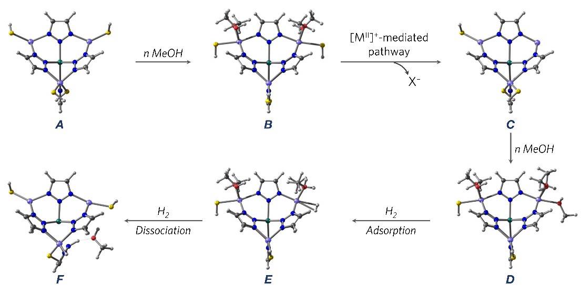
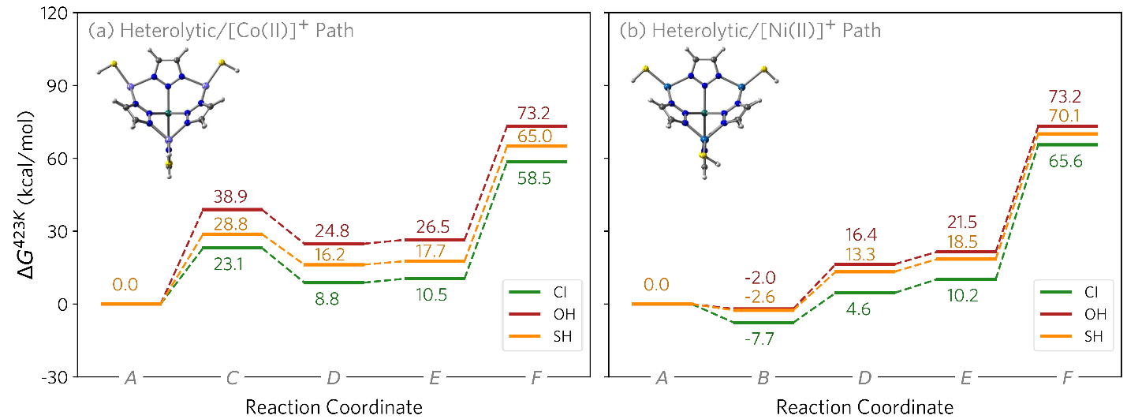
Figure S45. [M^{II}]⁺–mediated pathway for active hydrogen source (F) generation from M-MFU-4l-X catalysts (X = SH (yellow), OH (red), and Cl (green) lines). Gibbs free energies (at 150 °C) are given in kcal/mol, calculated at the M06-D3(0)/def2-TZVP/SMD(MeOH)//TPSSh-D3(BJ)/def2-SVP level of theory.

H.7. 1D BBTA System: Spin Ladder
Table S17. Relative electronic energies (∆E in kcal/mol) of the spin isomers for the 1D system with a four-metal center combination (not considering Zn), analogous to the one shown in Scheme S1. The energies are calculated at the TPSSh-D3(BJ)/def2-TZVP/SMD(MeOH)//TPSSh-D3(BJ)/def2-SVP level of theory.
System | –X | ∆E (kcal/mol)
System | –X | Spin-A | Spin-B | Spin-C | Spin-D
Co | –Cl | 0 | 0 | 13.5 | 48.9
Co | –OH | 0 | –1.1 | –0.4 | 40.6
Co | –SH | 0 | –0.2 | 12.4 | 26.9
Ni | –Cl | 0 | 0.1 | 0.1 | 55.4
Ni | –OH | 0 | 0 | 0 | 49.2
Ni | –SH | 0 | 0.4 | 0.3 | 41.2

H.8. 1D System: Probing the Effect of Explicit MeOH Coordination
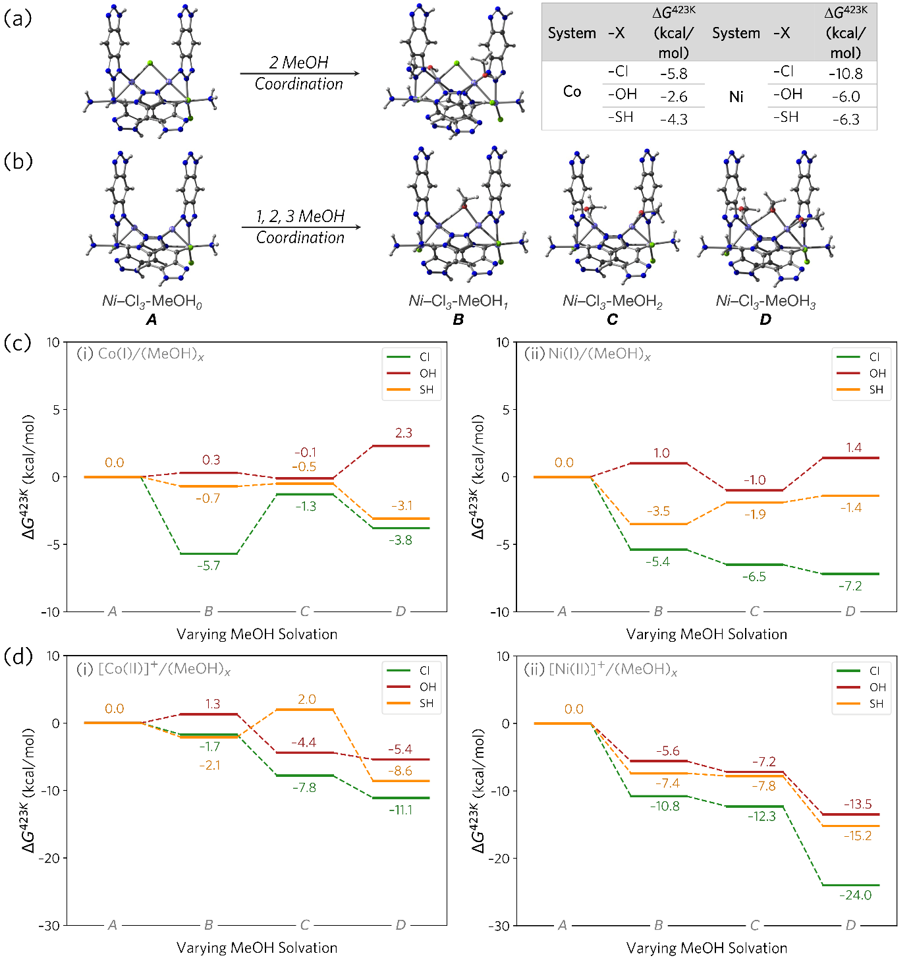
Figure S46. Various MeOH solvated structures explored for the 1D system, analogous to the 3D system. (a) Neutral Co(II) and Ni(II) species. For both metals, the table on the right shows that the coordination of 1 MeOH molecule is favored. (b) Corresponding MeOH coordination at a [M^{I}] or [M^{II}]⁺ species having an open metal site. Energetics for the species shown in panel b, both for the [M^{I}] species (c) and for [M^{II}]⁺ species (d) and both for Co (subpanel i) and Ni (subpanel ii). For [M^{I}] species, a clear trend in MeOH solvated species could not be recognized. 2 MeOH molecule coordinated Species C was used as the resting state for both Co(I) and Ni(I) for consistency. For [M^{II}]⁺ species, however, Species D was clearly found to be the most stable resting state for both metals. Gibbs free energies (at 150 °C) are given in kcal/mol, calculated at the M06-D3(0)/def2-TZVP/SMD(MeOH)//TPSSh-D3(BJ)/def2-SVP level of theory.

H.9. Summary of Homolytic [M^{I}]–and Heterolytic [M^{II}]⁺–Mediated Path 1D Ni-BBTA Catalyst
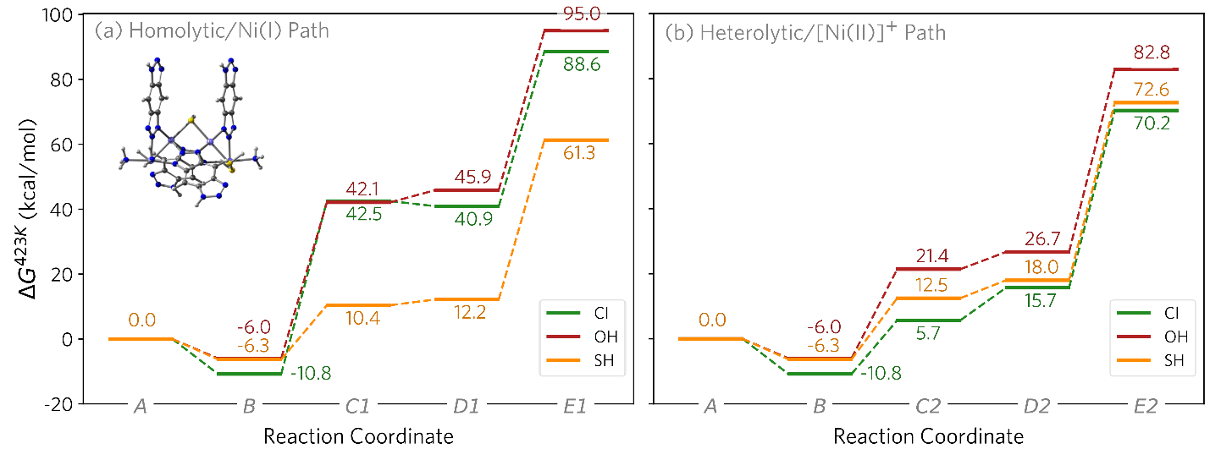
Figure S47. Most likely pathways for active hydrogen source generation (E1 and E2) in the reduction catalysis with Ni-BBTA-X catalysts. Based on calculated energetics, for X = Cl (green) and OH (red), the cation-mediated pathway is energetically favorable. In contrast, for X = SH (yellow), the radical pathway involving an [M^{II}]⁺ species is preferred. Gibbs free energies (at 150 °C) are given in kcal/mol, calculated at the M06-D3(0)/basis-II/SMD(MeOH)//TPSSh-D3(BJ)/basis-I level of theory.

Section I. References
1. Beauvais, M.L., Monserrate, B.A.S., Feng, T.S., Chen, R.K., Liu, P., Chupas, P.J., and Chapman, K.W. (2022). A mixing-flow reactor for time-resolved reaction measurements distributed in space. J. Appl. Crystallogr. 55, 258-264. 10.1107/S1600576722000620.
2. Chupas, P.J., Chapman, K.W., Kurtz, C., Hanson, J.C., Lee, P.L., and Grey, C.P. (2008). A versatile sample-environment cell for non-ambient X-ray scattering experiments. J. Appl. Crystallogr. 41, 822-824. 10.1107/S0021889808020165.
3. Toby, B.H., and Von Dreele, R.B. (2013). GSAS-II: the genesis of a modern open-source all purpose crystallography software package. J. Appl. Crystallogr. 46, 544-549.
4. Yang, X., Juhas, P., Farrow, C.L., and Billinge, S.J. (2014). xPDFsuite: an end-to-end software solution for high throughput pair distribution function transformation, visualization and analysis. arXiv preprint arXiv:1402.3163.
5. Coelho, A.A. (2018). TOPAS and TOPAS-Academic: an optimization program integrating computer algebra and crystallographic objects written in C++. J. Appl. Crystallogr. 51, 210-218.
6. Perdew, J.P., Ruzsinszky, A., Csonka, G.I., Vydrov, O.A., Scuseria, G.E., Constantin, L.A., Zhou, X., and Burke, K. (2008). Restoring the Density-Gradient Expansion for Exchange in Solids and Surfaces. Phys. Rev. Lett. 100, 136406. 10.1103/PhysRevLett.100.136406.
7. Kresse, G., and Furthmüller, J. (1996). Efficient iterative schemes for ab initio total-energy calculations using a plane-wave basis set. Phys. Rev. B 54, 11169-11186. 10.1103/PhysRevB.54.11169.
8. Grimme, S., Antony, J., Ehrlich, S., and Krieg, H. (2010). A consistent and accurate ab initio parametrization of density functional dispersion correction (DFT-D) for the 94 elements H-Pu. J. Chem. Phys. 132. 10.1063/1.3382344.
9. Kresse, G., and Furthmüller, J. (1996). Efficiency of ab-initio total energy calculations for metals and semiconductors using a plane-wave basis set. Comput. Mater. Sci. 6, 15-50. https://doi.org/10.1016/0927-0256(96)00008-0.
10. Kresse, G., and Joubert, D. (1999). From ultrasoft pseudopotentials to the projector augmented-wave method. Phys. Rev. B 59, 1758-1775. 10.1103/PhysRevB.59.1758.
11. Frisch, M.J., Trucks, G.W., Schlegel, H.B., Scuseria, G.E., Robb, M.A., Cheeseman, J.R., Scalmani, G., Barone, V., Petersson, G.A., Nakatsuji, H., et al. (2016). Gaussian 16 Rev. C.01.
12. Staroverov, V.N., Scuseria, G.E., Tao, J., and Perdew, J.P. (2003). Comparative assessment of a new nonempirical density functional: Molecules and hydrogen-bonded complexes. J. Chem. Phys. 119, 12129-12137. 10.1063/1.1626543.
13. Grimme, S., Ehrlich, S., and Goerigk, L. (2011). Effect of the damping function in dispersion corrected density functional theory. J. Comput. Chem. 32, 1456-1465. https://doi.org/10.1002/jcc.21759.
14. Weigend, F., and Ahlrichs, R. (2005). Balanced basis sets of split valence, triple zeta valence and quadruple zeta valence quality for H to Rn: Design and assessment of accuracy. Phys. Chem. Chem. Phys. 7, 3297-3305. 10.1039/B508541A.
15. Andrae, D., Häußermann, U., Dolg, M., Stoll, H., and Preuß, H. (1990). Energy-adjustedab initio pseudopotentials for the second and third row transition elements. Theor. Chim. Acta 77, 123-141. 10.1007/BF01114537.
16. Grimme, S. (2012). Supramolecular Binding Thermodynamics by Dispersion-Corrected Density Functional Theory. Chem. Eur. J. 18, 9955-9964. https://doi.org/10.1002/chem.201200497.
17. Zhao, Y., and Truhlar, D.G. (2008). The M06 suite of density functionals for main group thermochemistry, thermochemical kinetics, noncovalent interactions, excited states, and transition elements: two new functionals and systematic testing of four M06-class functionals and 12 other functionals. Theor. Chem. Acc. 120, 215-241. 10.1007/s00214-007-0310-x.
18. Marenich, A.V., Cramer, C.J., and Truhlar, D.G. (2009). Universal Solvation Model Based on Solute Electron Density and on a Continuum Model of the Solvent Defined by the Bulk Dielectric Constant and Atomic Surface Tensions. J. Phys. Chem. B 113, 6378-6396. 10.1021/jp810292n.
19. Essafi, S., Tomasi, S., Aggarwal, V.K., and Harvey, J.N. (2014). Homologation of Boronic Esters with Organolithium Compounds: A Computational Assessment of Mechanism. J. Org. Chem. 79, 12148-12158. 10.1021/jo502020e.
20. Darù, A., Hu, X., and Harvey, J.N. (2020). Iron-Catalyzed Reductive Coupling of Alkyl Iodides with Alkynes To Yield cis-Olefins: Mechanistic Insights from Computation. ACS Omega 5, 1586-1594. 10.1021/acsomega.9b03578.
21. Syed, Z.H., Mian, M.R., Patel, R., Xie, H., Pengmei, Z., Chen, Z., Son, F.A., Goetjen, T.A., Chapovetsky, A., Fahy, K.M., et al. (2022). Sulfated Zirconium Metal–Organic Frameworks as Well-Defined Supports for Enhancing Organometallic Catalysis. J. Am. Chem. Soc. 144, 16883-16897. 10.1021/jacs.2c05290.
22. Lu, T., and Chen, Q. (2021). Shermo: A general code for calculating molecular thermochemistry properties. Comput. Theor. Chem. 1200, 113249. https://doi.org/10.1016/j.comptc.2021.113249.
23. Rieth, A.J., and Dincă, M. (2018). Controlled Gas Uptake in Metal–Organic Frameworks with Record Ammonia Sorption. J. Am. Chem. Soc. 140, 3461-3466. 10.1021/jacs.8b00313.
24. Mian, M.R., Chen, H., Cao, R., Kirlikovali, K.O., Snurr, R.Q., Islamoglu, T., and Farha, O.K. (2021). Insights into Catalytic Hydrolysis of Organophosphonates at M–OH Sites of Azolate-Based Metal Organic Frameworks. J. Am. Chem. Soc. 143, 9893-9900. 10.1021/jacs.1c03901.
25. Chai, J.-D., and Head-Gordon, M. (2008). Systematic optimization of long-range corrected hybrid density functionals. J. Chem. Phys. 128. 10.1063/1.2834918.
26. Yu, H.S., He, X., Li, S.L., and Truhlar, D.G. (2016). MN15: A Kohn–Sham global-hybrid exchange–correlation density functional with broad accuracy for multi-reference and single-reference systems and noncovalent interactions. Chem. Sci. 7, 5032-5051. 10.1039/C6SC00705H.

