Supplemental Material: Genetic marker type impacts ex situ conservation minimum sample size estimates and their variance
Contents
Methods 1
Results 9

Methods

fastSimcoal simulation parameters
Marker type | Total population size | Number of populations | Migration rate between populations
“MICROSAT” (MSAT)  “DNA” (SNP) | 1,200 individuals  4,800 individuals | 1 population*  4 populations  16 populations | 0.01 (“high”)  0.001 (“low”)
Table S1: Parameters used for fastSimcoal simulations. Each unique combination of simulation parameters is termed a “scenario”.

Allele frequency categories
Very common | Low frequency | Rare
Greater than 10% | Between 1% and 10% | Less than 1%
Table S2: Allele frequency categories used to summarize allele frequency distributions. Allele frequency distributions were used to compare simulated data to empirical data, to ensure the realism of simulation results.

N1200 Datasets
Marker type | Scenario | Average heterozygosity (H_{E}) | Average fixation index (Fst) | Average total alleles | Average allele frequency distribution (>10%; 1%--10%; <1%)
MSAT | 01 pop (mig Low) | 0.701488 | -- | 174.6 | 48.04% ; 35.02% ; 16.61%
MSAT | 01 pop (mig High) | 0.6839992 | -- | 173.8 | 45.35% ; 36.92% ; 17.50%
MSAT | 04 pop (mig Low) | 0.6293966 | 0.14764 | 176 | 49.52% ; 34.39% ; 15.31%
MSAT | 04 pop (mig High) | 0.698623 | 0.01976667 | 177.8 | 48.02% ; 35.57% ; 16.07%
MSAT | 16 pop (mig Low) | 0.6092517 | 0.1645845 | 181.8 | 48.00% ; 36.35% ; 15.54%
MSAT | 16 pop (mig High) | 0.6837737 | 0.020990567 | 174.6 | 48.08% ; 34.70% ; 17.12%
SNP | 01 pop (mig Low) |  | -- | 2902.8 | 49.57% ; 19.10% ; 31.01%
SNP | 01 pop (mig High) | 0.1989577 | -- | 2949 | 49.94% ; 19.42% ; 30.25%
SNP | 04 pop (mig Low) | 0.1888461 | 0.17677 | 3046 | 50.20% ; 19.70% ; 29.69%
SNP | 04 pop (mig High) | 0.1906653 | 0.020166666 | 2957.4 | 49.29% ; 19.22% ; 31.04%
SNP | 16 pop (mig Low) | 0.1859503 | 0.168485 | 3098 | 49.14% ; 20.87% ; 29.54%
SNP | 16 pop (mig High) | 0.1887786 | 0.020517668 | 2924.8 | 49.73% ; 18.97% ; 30.93%
Table S3: Summary statistics for N1200 simulations. The values for each scenario represent averages calculated across 5 simulation replicates. The SNP marker type refers to the “DNA” marker in fastSimcoal. SNP simulation results here were generated using a per base mutation rate of 1e-7; for summary statistics of “low mutation” SNP datasets (1e-8), refer to Table S4. F_{ST} values were only calculated for scenarios with more than 1 population.

N4800 Datasets
Marker type | Scenario | Average heterozygosity (H_{E}) | Average fixation index (Fst) | Average total alleles | Average allele frequency distribution (>10%; 1%--10%; <1%)
MSAT | 01 pop (mig Low) | 0.8295672 | -- | 285 | 35.17% ; 48.41% ; 16.35%
MSAT | 01 pop (mig High) | 0.8258696 | -- | 281 | 35.27% ; 47.08% ; 17.37%
MSAT | 04 pop (mig Low) | 0.807554 | 0.03906667 | 285 | 34.69% ; 48.74% ; 16.42%
MSAT | 04 pop (mig High) | 0.8282144 | 0.00499 | 277.8 | 35.09% ; 47.47% ; 16.48%
MSAT | 16 pop (mig Low) | 0.7947919 | 0.04798533 | 280.8 | 35.85% ; 47.78% ; 16.23%
MSAT | 16 pop (mig High) | 0.8262918 | 0.005345167 | 276.2 | 36.53% ; 47.36% ; 16.11%
SNP | 01 pop (mig Low) | 0.49019906 | -- | 9409.6 | 24.24% ; 23.12% ; 52.54%
SNP | 01 pop (mig High) | 0.49133088 | -- | 9405.6 | 24.17% ; 23.70% ; 51.98%
SNP | 04 pop (mig Low) | 0.47627036 | 0.04929333 | 9547.2 | 23.71% ; 23.99% ; 52.17%
SNP | 04 pop (mig High) | 0.4815281 | 0.00535333 | 9434. | 23.52% ; 23.97% ; 52.39%
SNP | 16 pop (mig Low) | 0.47855684 | 0.04831533 | 9614.2 | 23.83% ; 23.96% ; 52.10%
SNP | 16 pop (mig High) | 0.49518782 | 0.00522167 | 9500. | 24.25% ; 23.34% ; 52.29%
Table S4: Summary statistics for N4800 simulations. The values for each scenario represent averages calculated across 5 simulation replicates. The SNP marker type refers to the “DNA” marker in fastSimcoal. SNP simulation results here were generated using a per base mutation rate of 1e-7; for summary statistics of “low mutation” SNP datasets (1e-8), refer to Table S4. F_{ST} values were only calculated for scenarios with more than 1 population.

Low mutation SNP Datasets
Marker type | Scenario | Average heterozygosity (H_{E}) | Average fixation index (Fst) | Average total alleles | Average allele frequency distribution (>10%; 1%--10%; <1%)
N1200 | 01 pop (mig Low) | 0.0254458 | -- | 1209.6 | 87.36% ; 5.00% ; 7.57%
N1200 | 01 pop (mig High) | 0.0254104 | -- | 1214.4 | 87.14% ; 4.69% ; 8.03%
N1200 | 04 pop (mig Low) | 0.0611521 | 0.18218002 | 1209.8 | 87.46% ; 4.96% ; 7.51%
N1200 | 04 pop (mig High) | 0.0224582 | 0.020256666 | 1190 | 88.19% ; 4.95% ; 6.81%
N1200 | 16 pop (mig Low) | 0.022722 | 0.17317532 | 1221.8 | 86.86% ; 5.87% ; 7.18%
N1200 | 16 pop (mig High) | 0.0235667 | 0.019285166 | 1212.8 | 86.91% ; 5.06% ; 7.90%
N4800 | 01 pop (mig Low) | 0.08748178 | -- | 1925.4 | 62.25% ; 11.48% ; 26.18%
N4800 | 01 pop (mig High) | 0.0879789 | -- | 1913.2 | 62.68% ; 11.99% ; 25.03%
N4800 | 04 pop (mig Low) | 0.08421711 | 0.04603 | 1943.8 | 61.70% ; 12.24% ; 26.00%
N4800 | 04 pop (mig High) | 0.08699781 | 0.00537333 | 1925.6 | 62.35% ; 12.10% ; 25.50%
N4800 | 16 pop (mig Low) | 0.08734501 | 0.051363 | 1963.2 | 61.36% ; 12.18% ; 26.37%
N4800 | 16 pop (mig High) | 0.09032553 | 0.00526133 | 1946.2 | 61.92% ; 12.56% ; 25.47%
Table S5: Summary statistics for low mutation SNP simulations. The values for each scenario represent averages calculated across 5 simulation replicates. The SNP marker type refers to the “DNA” marker in fastSimcoal. SNP simulation results here were generated using a per base mutation rate of 1e-8. F_{ST} values were only calculated for scenarios with more than 1 population.

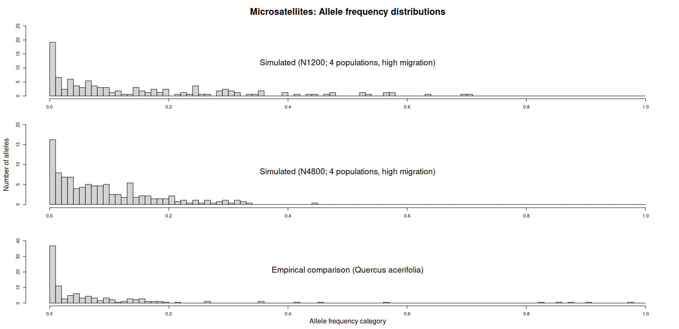
Figure S1: Allele frequency histograms for microsatellite simulated datasets and empirical comparison (Quercus acerifolia). The top graph is using a total number of individuals of 1200, and the middle graph is using a total number of individuals of 4800. The empirical microsatellite dataset was chosen to most closely match the simulation scenario used for comparisons (4 populations, high migration), and was generated from 164 individuals. Note that the scales of the y-axes differ between the plots.
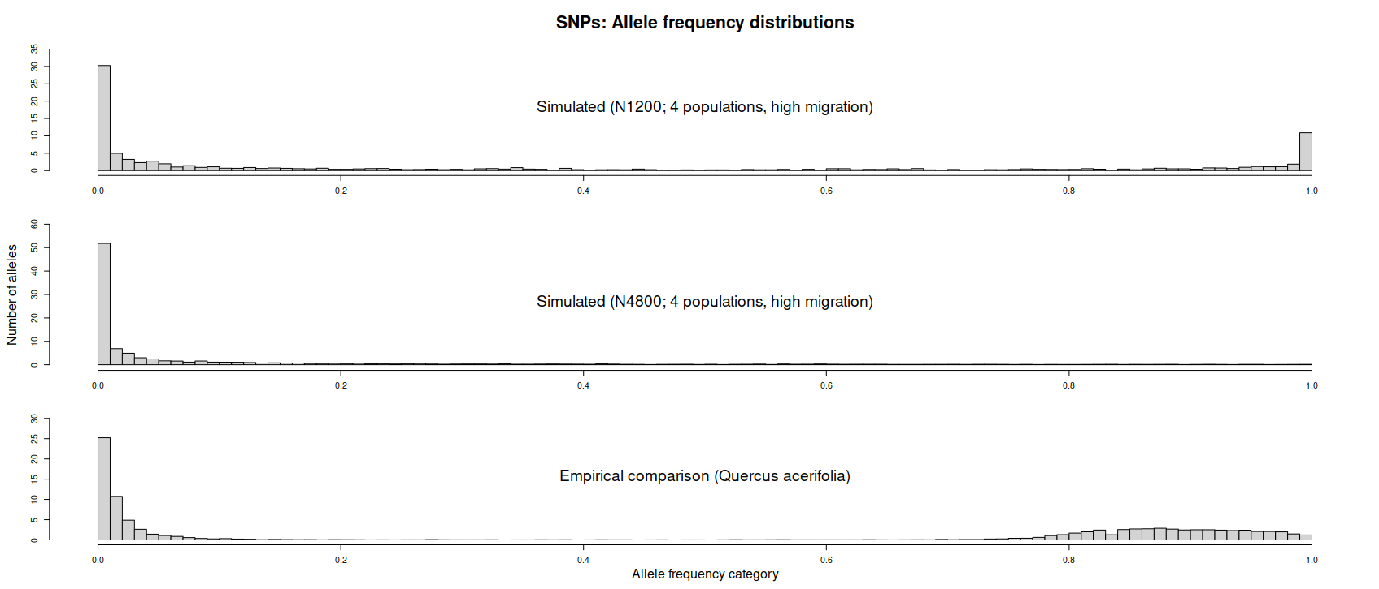
Figure S2: Allele frequency histograms for SNP simulated datasets and empirical comparison (Quercus acerifolia). The top graph is using a total number of individuals of 1200, and the middle graph is using a total number of individuals of 4800. The empirical dataset was chosen to most closely match the simulation scenario used for comparisons (4 populations, high migration). SNPs for simulated datasets utilized a mutation rate of 1e-7 per base; empirical SNPs were filtered for 20% missingness (i.e. loci had to be present in at least 80% of individuals in order to be included), and are derived from 91 individuals. Note that the scales of the y-axes differ between the plots.
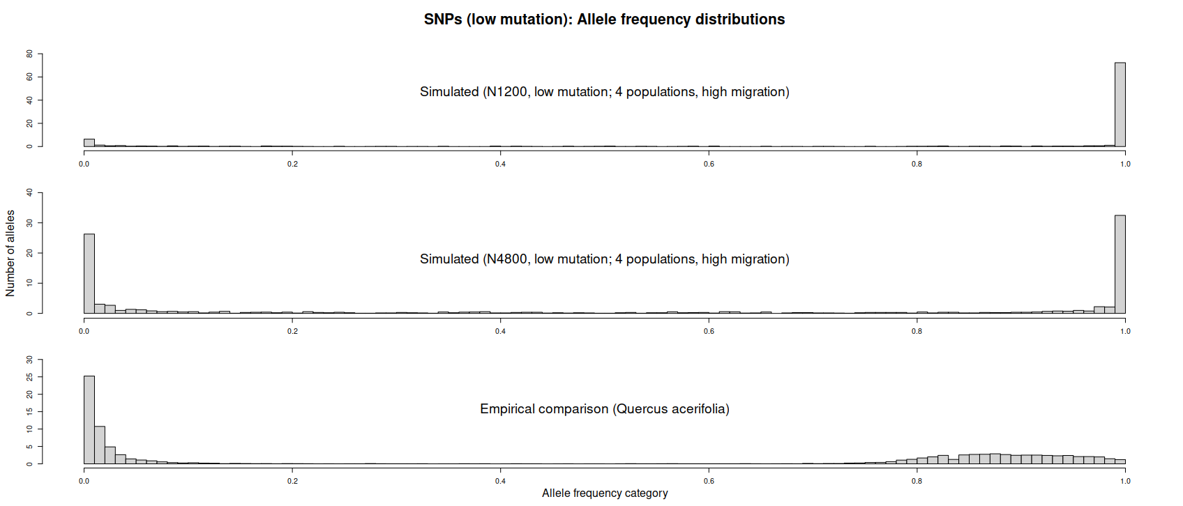
Figure S3: Allele frequency histograms for low mutation SNP simulated datasets and empirical comparison (Quercus acerifolia). The top graph is using a total number of individuals of 1200, and the middle graph is using a total number of individuals of 4800. The empirical dataset was chosen to most closely match the simulation scenario used for comparisons (4 populations, high migration). SNPs for simulated datasets utilized a mutation rate of 1e-8 per base; empirical SNPs were filtered for 20% missingness (i.e. loci had to be present in at least 80% of individuals in order to be included), and are derived from 91 individuals. Note that the scales of the y-axes differ between plots.

Results

Minimum Sample Size Estimates for Representing 95% of Allelic Diversity (Lower–Upper)
 | SNP (Low mutation)
N1200 | 162 (-198.5–523.1)
N4800 | 2,422 (1085.5–3,758.0)
Table S6: 95% minimum sample size estimates and lower and upper prediction intervals for SNP low mutation (1e-8) datasets. Rows indicate different total population sizes, columns different marker types. Values in parentheses indicate the lower and upper prediction intervals bounding 95% estimates. MSSE values are rounded to the next whole number of samples.
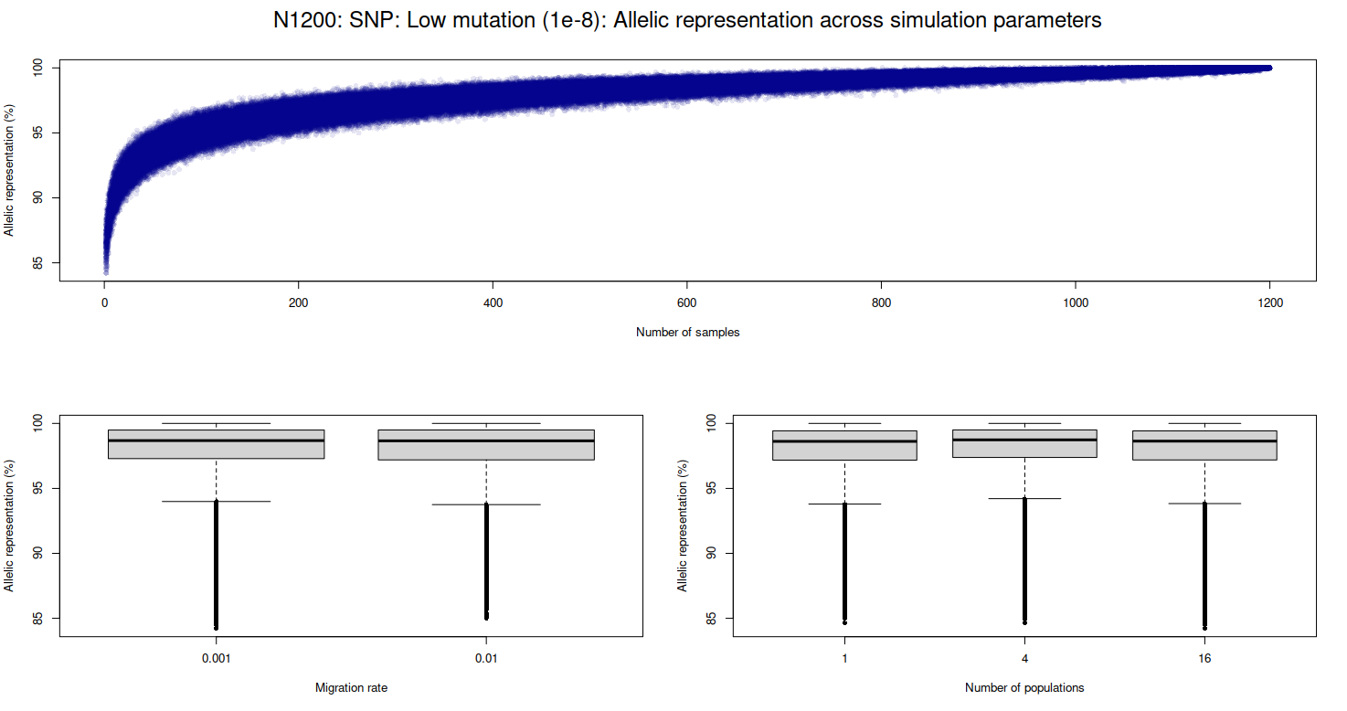
Figure S4: Distribution of allelic representation values across sample sizes and simulation parameters for low mutation SNP markers, N1200 datasets. Allelic representation percentages are on y-axes. Number of samples used for allelic representation calculations are along the x-axis for the top graph; bottom graphs show the different values of simulation parameters: migration rate and number of populations.

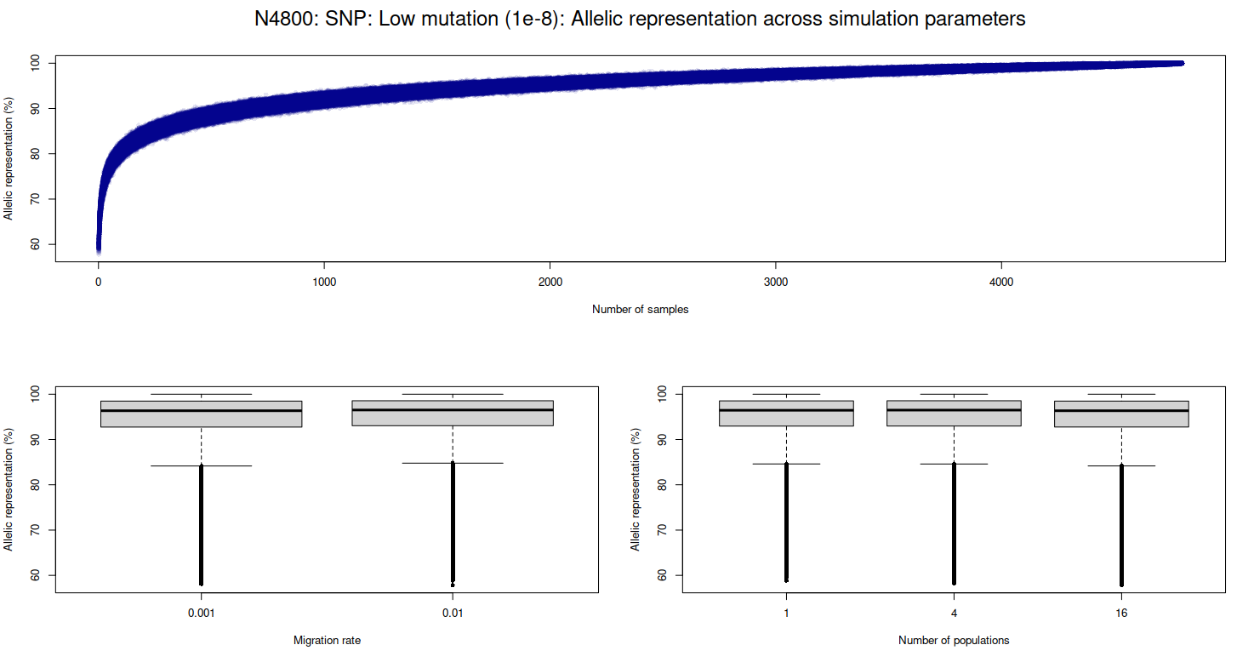
Figure S5: Distribution of allelic representation values across sample sizes and simulation parameters for low mutation SNP markers, N4800 datasets. Allelic representation percentages are on y-axes. Number of samples used for allelic representation calculations are along the x-axis for the top graph; bottom graphs show the different values of simulation parameters: migration rate and number of populations.

