Supplementary Table 1: Overview of included serum proteins and relevant literature
# | Serum protein (abbreviation) | Alternative name | Previous studies
1 | Angiopoietin 2 (ANG2) |  | (1-5)
2 | C-C motif ligand 2 (CCL2) | C-C motif chemokine 2, HC11, Monocyte chemoattractant protein 1, Monocyte chemotactic and activating factor, MCAF, Monocyte chemotactic protein 1, MCP-1, Monocyte secretory protein JE, Small-inducible cytokine A2 | (6-8)
3 | C-C motif ligand 20 (CCL20) | C-C motif chemokine 20, Beta-chemokine exodus-1, CC chemokine LARC, Liver and activation-regulated chemokine, Macrophage inflammatory protein 3 alpha, MIP-3-alpha, Small-inducible cytokine A20, | (6)
4 | C-C motif ligand 8 (CCL8) | C-C motif chemokine 8, HC14, Monocyte chemoattractant protein 2, Monocyte chemotactic protein 2, MCP-2, Small-inducible cytokine A8 | (9)
5 | C-X-C motif ligand 9 (CXCL9) | C-X-C motif chemokine 9, Gamma-interferon-induced monokine, Monokine induced by interferon-gamma, HuMIG, MIG, Small-inducible cytokine B9 | (10, 11)
6 | C-X-C motif ligand 13 (CXCL13) | C-X-C motif chemokine 13, Angie, B cell-attracting chemokine 1, BCA-1, B lymphocyte chemoattractant, CXC chemokine BLC, Small-inducible cytokine B13
7 | C-X-C motif ligand 16 (CXCL16) | C-X-C motif chemokine 16, Scavenger receptor for phosphatidylserine and oxidized low density lipoprotein, SR-PSOX, Small-inducible cytokine B16, Transmembrane chemokine CXCL16
8 | E-Selectin | CD62 antigen-like family member E, Endothelial leukocyte adhesion molecule 1, ELAM-1, Leukocyte-endothelial cell adhesion molecule 2, LECAM2, CD62E | (12)
9 | Intercellular adhesion molecule 1 (ICAM-1) | Major group rhinovirus receptor, CD54 | (12, 13)
10 | Interleukin-5 (IL-5) | B-cell differentiation factor I, Eosinophil differentiation factor, T-cell replacing factor, TRF | (14)
11 | Interleukin-6 (IL-6) | B-cell stimulatory factor 2, BSF-2, CTL differentiation factor, CDF, Hybridoma growth factor, Interferon beta-2, IFN-beta-2 | (8, 14-17)
12 | Interleukin-6 subunit alpha (IL-6Rα) | IL-6 receptor subunit alpha, IL-6R subunit alpha, IL-6R-alpha, IL-6RA, IL-6R 1, Membrane glycoprotein 80, gp80, CD126 | (18)
13 | Interleukin-10 (IL-10) | Cytokine synthesis inhibitory factor, CSIF | (14, 19)
14 | Interleukin-17 (IL-17) | IL-17A, Cytotoxic T-lymphocyte-associated antigen 8, CTLA-8 | (14, 17)
15 | Macrophage migration inhibitory factor (MIF) | 5.3.2.1, Glycosylation-inhibiting factor, GIF, L-dopachrome isomerase, L-dopachrome tautomerase, 5.3.3.12, Phenylpyruvate tautomerase | (20)
16 | Pentraxin-related protein (PTX3) | Pentaxin-related protein PTX3, Tumor necrosis factor alpha-induced protein 5, TNF alpha-induced protein 5, Tumor necrosis factor-inducible gene 14 protein, TSG-14 | (21, 22)
17 | P-Selectin | CD62 antigen-like family member P, Granule membrane protein 140, GMP-140, Leukocyte-endothelial cell adhesion molecule 3, LECAM3, Platelet activation dependent granule-external membrane protein, PADGEM, CD62P | (23)
18 | Receptor for advanced glycosylation end products (RAGE) | Advanced glycosylation end product-specific receptor, AGER
19 | S100 calcium-binding protein A9 (S100A9) | Calgranulin-B, Calprotectin L1H subunit, Leukocyte L1 complex heavy chain, Migration inhibitory factor-related protein 14, MRP-14, p14 | (24)
20 | Soluble interleukin-2 receptor subunit alpha (sIL-2Rα) | IL-2 receptor subunit alpha, IL-2-RA, IL-2R subunit alpha, IL2-RA, TAC antigen, p55, CD25 | (25-35)
21 | Stem cell factor (SCF) | Kit ligand, Mast cell growth factor, MGF, c-Kit ligand | (36)
22 | Suppression of tumorigenicity 2 (ST2) | Interleukin-1 receptor-like 1, 3.2.2.6 | (11, 15, 20, 32, 33, 37-42)
23 | Tissue Factor (TF) | Coagulation Factor III, Thromboplastin, CD142 | (43)
24 | Tumor necrosis factor receptor 1 (TNFR1) | Tumor necrosis factor receptor superfamily member 1A, TNFRSF1A, p55, p60, CD120a | (27, 28, 30-34, 44-47)
25 | Tumor necrosis factor receptor 2 (TNFR2) | Tumor necrosis factor receptor superfamily member 1B, TNFRSF1B, p75, p80 TNF-alpha receptor, CD120b | (47, 48)
26 | Tyrosine kinase with Ig and EGF homology domains-2 (TIE-2) | Angiopoietin-1 receptor, 2.7.10.1, Endothelial tyrosine kinase, Tunica interna endothelial cell kinase, Tyrosine-protein kinase receptor TEK, Tyrosine-protein kinase receptor TIE-2, hTIE2, p140 TEK, CD202b | (49)
27 | Vascular cell adhesion molecule 1 (VCAM-1) | Vascular cell adhesion protein 1, CD106, INCAM-100 | (11, 50)
28 | Vascular endothelial growth factor C (VEGF-C) | Flt4 ligand, Flt4-L, Vascular endothelial growth factor-related protein, VRP | (2, 4)

Supplementary Table 2: Percentages of out of range (OOR) values for each serum protein
Serum protein | In range, N = 21,8001 | OOR <, N = 8221 | OOR >, N = 301
ANG2 | 809 (100%) | 0 (0%) | 0 (0%)
CCL2 | 809 (100%) | 0 (0%) | 0 (0%)
CCL20 | 806 (100%) | 1 (0.1%) | 2 (0.2%)
CCL8 | 672 (83%) | 137 (17%) | 0 (0%)
CXCL13 | 809 (100%) | 0 (0%) | 0 (0%)
CXCL16 | 806 (100%) | 0 (0%) | 3 (0.4%)
CXCL9 | 809 (100%) | 0 (0%) | 0 (0%)
ESELECTIN | 809 (100%) | 0 (0%) | 0 (0%)
ICAM1 | 809 (100%) | 0 (0%) | 0 (0%)
IL10 | 795 (98%) | 13 (1.6%) | 1 (0.1%)
IL17 | 740 (91%) | 69 (8.5%) | 0 (0%)
IL5 | 240 (30%) | 569 (70%) | 0 (0%)
IL6 | 808 (100%) | 1 (0.1%) | 0 (0%)
IL6RA | 809 (100%) | 0 (0%) | 0 (0%)
MIF | 809 (100%) | 0 (0%) | 0 (0%)
PSELECTIN | 809 (100%) | 0 (0%) | 0 (0%)
PTX3 | 808 (100%) | 0 (0%) | 1 (0.1%)
RAGE | 809 (100%) | 0 (0%) | 0 (0%)
S100A9 | 776 (96%) | 31 (3.8%) | 2 (0.2%)
SCF | 809 (100%) | 0 (0%) | 0 (0%)
SIL2RA | 807 (100%) | 0 (0%) | 2 (0.2%)
ST2 | 802 (99%) | 0 (0%) | 7 (0.9%)
TF | 809 (100%) | 0 (0%) | 0 (0%)
TIE2 | 809 (100%) | 0 (0%) | 0 (0%)
TNFR1 | 808 (100%) | 1 (0.1%) | 0 (0%)
TNFR2 | 797 (99%) | 0 (0%) | 12 (1.5%)
VCAM1 | 809 (100%) | 0 (0%) | 0 (0%)
VEGFC | 809 (100%) | 0 (0%) | 0 (0%)

Supplementary Figure 1: Flowchart of patient inclusion
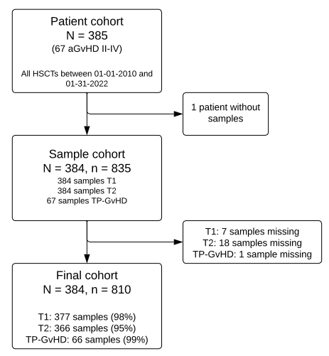
Supplementary Table 3: Main transplant outcomes overall and for each disease subgroup
Outcome | Time  (days) | Overall  N = 384 | Hemoglobinopathy  & other hem. disease  N = 103 | Bone marrow failure  N = 82 | Malignancy  N = 115 | Inborn error of immunity  N = 81
Overall Survival | 100 | 93% | 96.1% | 95.1% | 90.4% | 91.4%
 | 365 | 86.1% | 95.1% | 90.2% | 75.7% | 86.4%
 | 730 | 83.3% | 95.1% | 86.3% | 69.1% | 86.4%
Non relapse mortality | 100 | 8.5% | 3% | 6.4% | 11.9% | 12%
 | 365 | 10.3% | 3% | 9.1% | 14% | 13.5%
 | 730 | 11% | 3% | 12% | 14% | 13.5%
Subsequent transplant | 100 | 4.8% | 5.1% | 9.3% | 1.9% | 4.3%
 | 365 | 9.0% | 12.7% | 9.3% | 4% | 11.6%
 | 730 | 10.7% | 17.7% | 9.3% | 5% | 11.6%
Relapse | 100 | 3.0% | - | - | 10.1% | -
 | 365 | 4.5% | - | - | 15.3% | -
 | 730 | 6.2% | - | - | 20.6% | -
aGvHD | 100 | 16.1% | 11.7% | 9.8% | 23.5% | 18.5%
 | 365 | 17.7% | 13.6% | 11% | 24.4% | 21%
 | 730 | 17.7% | 13.6% | 11% | 24.4% | 21%
SR-aGvHD | 100 | 8.6% | 6.8% | 6.1% | 11.3% | 9.9%
 | 365 | 9.9% | 7.8% | 7.3% | 14% | 9.9%
 | 730 | 9.9% | 7.8% | 7.3% | 14% | 9.9%

Supplementary Figure 2: Volcano plots with cause-specific hazard ratios for aGvHD (A), NRM (B) and OS (C) at T2
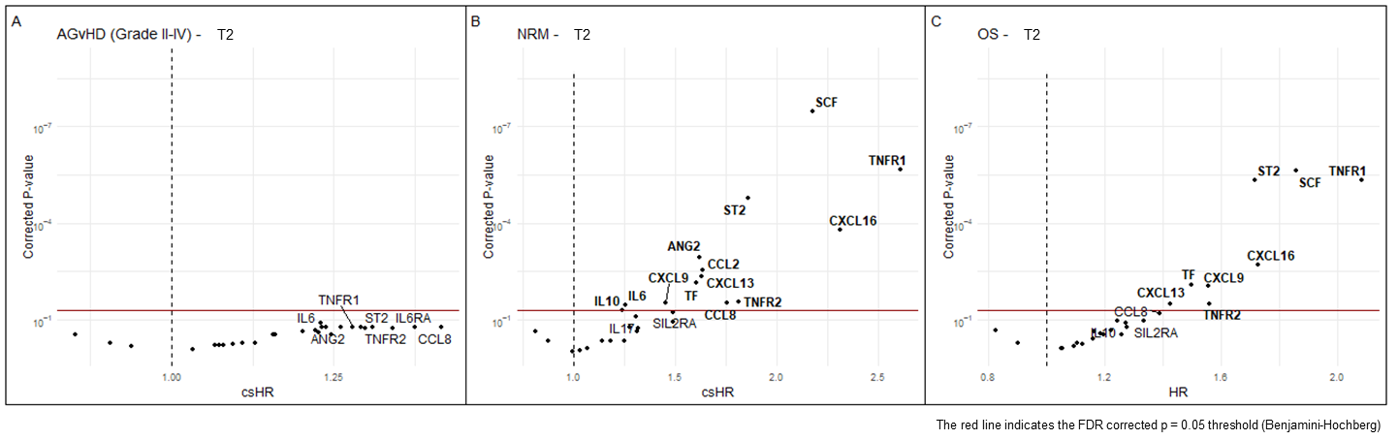
Supplementary Figure 3: Forest plot of (cause-specific) Hazard Ratios for OS, NRM and aGvHD for T1 and T2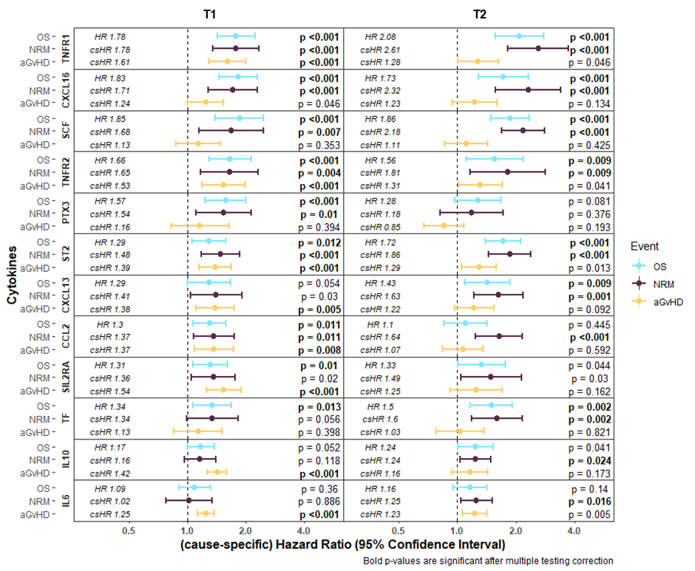

Supplementary Figure 4: Forest plot of cause-specific Hazard Ratios with 95% confidence intervals for OS, NRM and aGvHD at T1 with disease subgroups
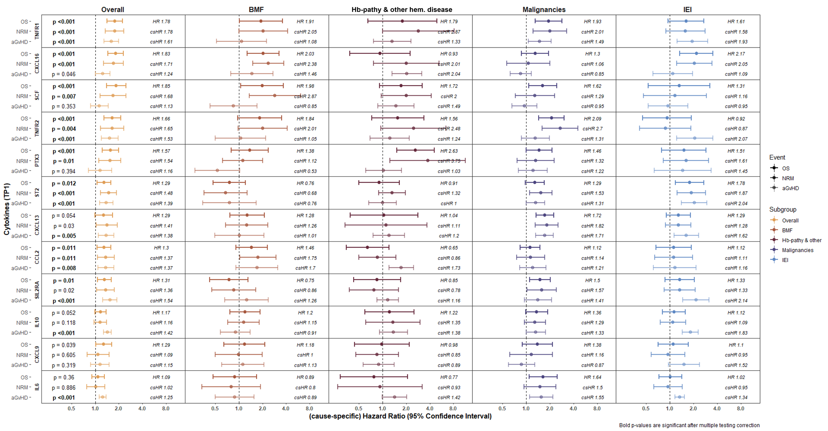

Supplementary Figure 5: Forest plot of cause-specific Hazard Ratios with 95% confidence intervals for OS, NRM and aGvHD at T2 with disease subgroups
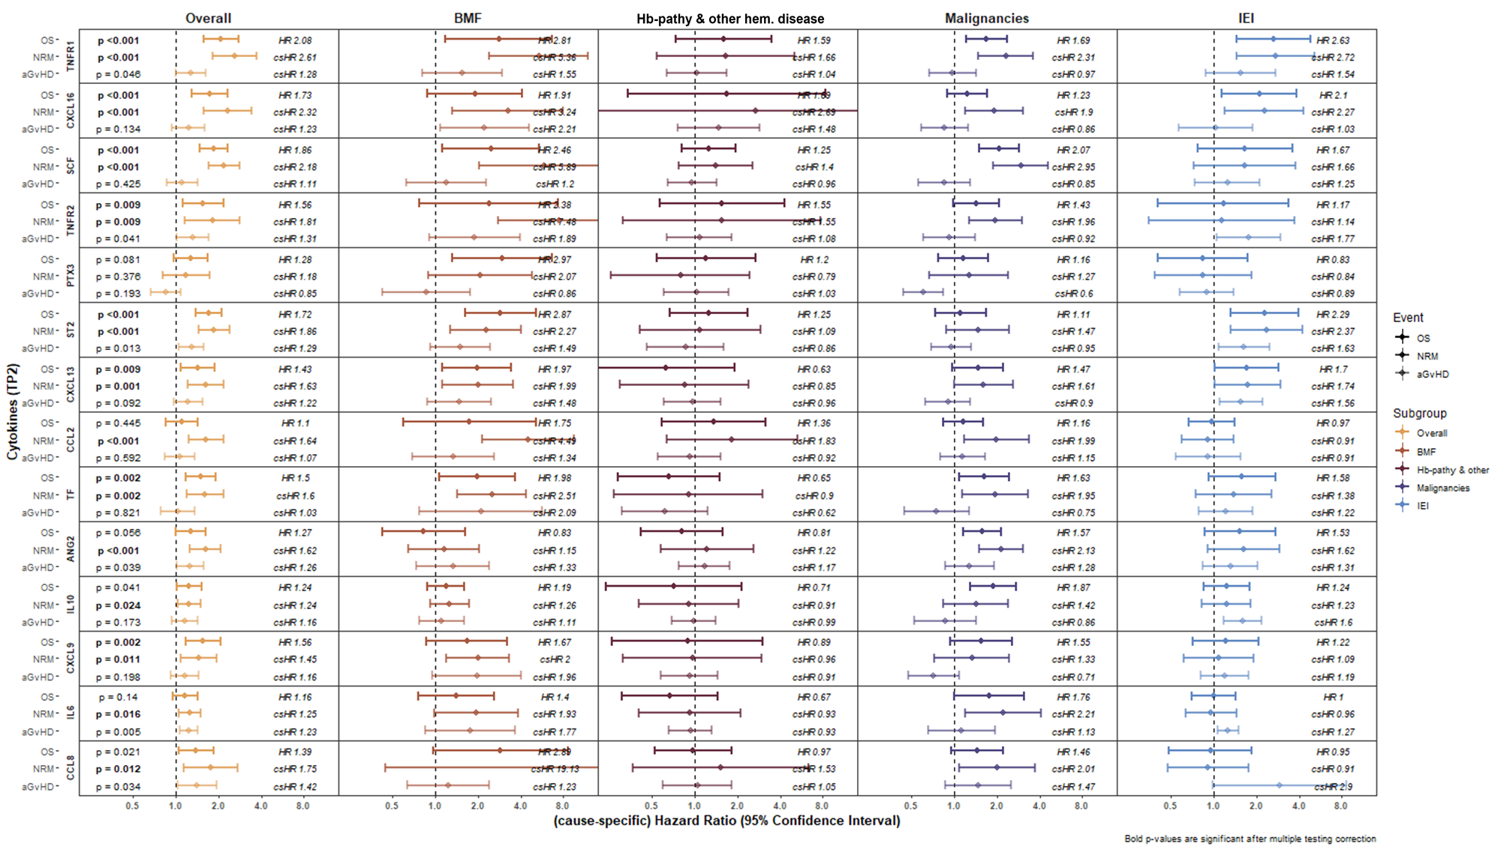
Supplementary Figure 6: Median serum protein levels from T1 to T2 in response to different conditioning regimens (Busulfan vs Treosulfan) for all serum proteins
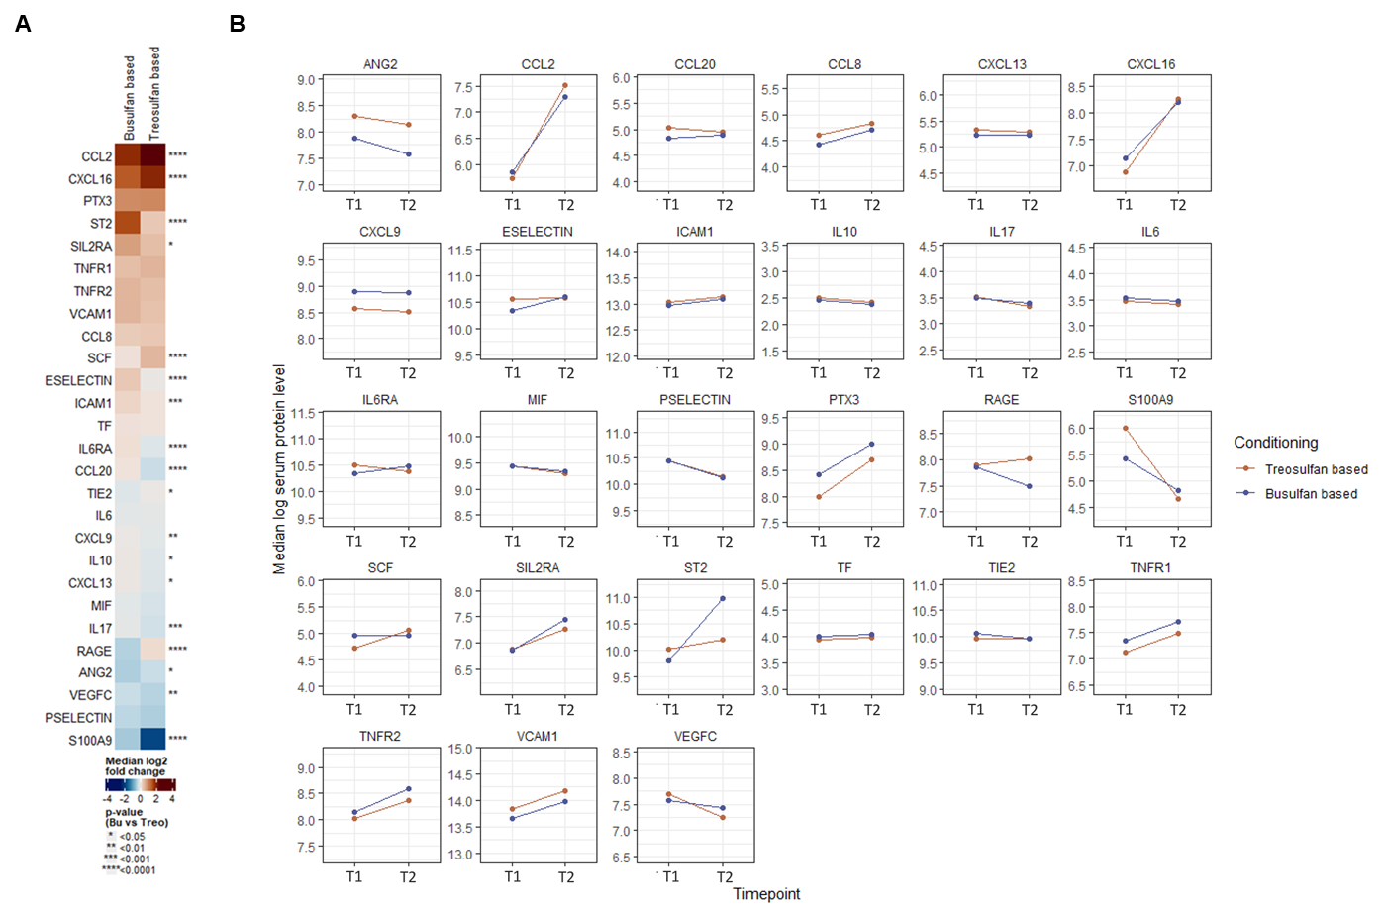
Supplementary Figure 7: serum protein dynamics in terms of log2 fold changes in response to different conditioning regimens (Busulfan vs Treosulfan) for all serum proteins
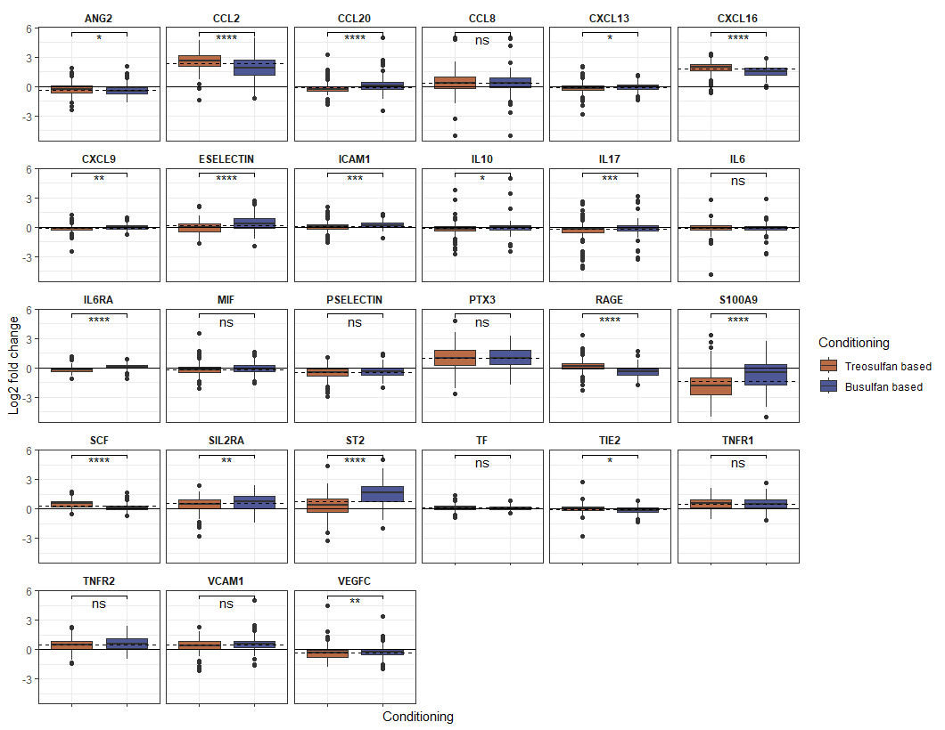
Supplementary Figure 8: Number of patients with specific conditioning regimens with disease subgroups
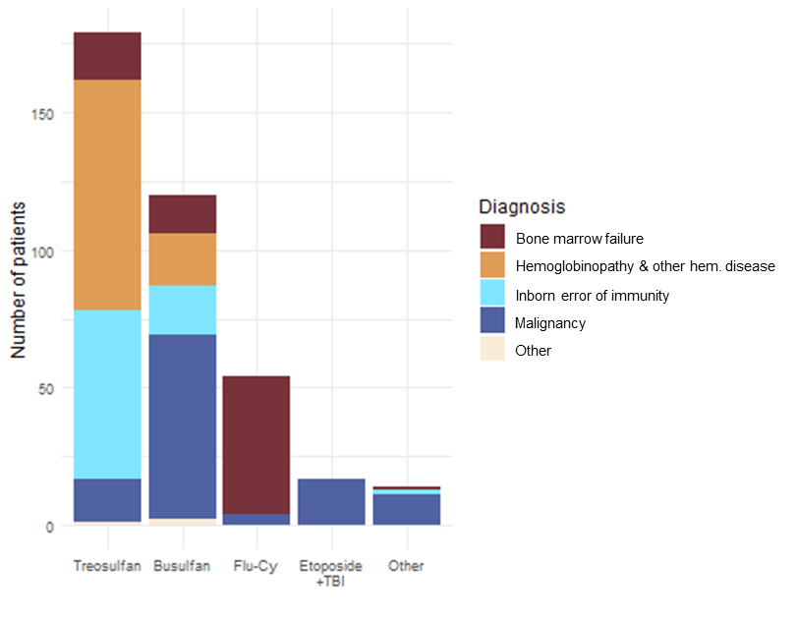

References:
1. Reikvam H, Mosevoll KA, Melve GK, Günther C-C, Sjo M, Bentsen P-T, et al. The Pretransplantation Serum Cytokine Profile in Allogeneic Stem Cell Recipients Differs from Healthy Individuals, and Various Profiles are Associated with Different Risks of Posttransplantation Complications. Biology of Blood and Marrow Transplantation. 2012;18(2):190-9.
2. Politikos I, H TK, Karantanos T, Brown J, McDonough S, Li L, et al. Angiogenic Factors Correlate with T Cell Immune Reconstitution and Clinical Outcomes after Double-Unit Umbilical Cord Blood Transplantation in Adults. Biol Blood Marrow Transplant. 2017;23(1):103-12.
3. Nie DM, Wu QL, Zhu XX, Zhang R, Zheng P, Fang J, et al. Angiogenic factors are associated with development of acute graft-versus-host disease after allogeneic hematopoietic stem cell transplantation. J Huazhong Univ Sci Technolog Med Sci. 2015;35(5):694-9.
4. Porkholm M, Bono P, Saarinen-Pihkala UM, Kivivuori SM. Higher angiopoietin-2 and VEGF levels predict shorter EFS and increased non-relapse mortality after pediatric hematopoietic SCT. Bone Marrow Transplant. 2013;48(1):50-5.
5. Kümpers P, Koenecke C, Hecker H, Hellpap J, Horn R, Verhagen W, et al. Angiopoietin-2 predicts disease-free survival after allogeneic stem cell transplantation in patients with high-risk myeloid malignancies. Blood. 2008;112(5):2139-48.
6. Weber G, Strocchio L, Del Bufalo F, Algeri M, Pagliara D, Arnone CM, et al. Identification of New Soluble Factors Correlated With the Development of Graft Failure After Haploidentical Hematopoietic Stem Cell Transplantation. Front Immunol. 2020;11:613644.
7. DiCarlo J, Agarwal-Hashmi R, Shah A, Kim P, Craveiro L, Killen R, et al. Cytokine and Chemokine Patterns Across 100 Days after Hematopoietic Stem Cell Transplantation in Children. Biology of Blood and Marrow Transplantation. 2014;20(3):361-9.
8. Khandelwal P, Mellor-Heineke S, Rehman N, Lane A, Smiley K, Villanueva J, et al. Cytokine Profile of Engraftment Syndrome in Pediatric Hematopoietic Stem Cell Transplant Recipients. Biology of Blood and Marrow Transplantation. 2016;22(4):690-7.
9. Hori T, Naishiro Y, Sohma H, Suzuki N, Hatakeyama N, Yamamoto M, et al. CCL8 is a potential molecular candidate for the diagnosis of graft-versus-host disease. Blood. 2008;111(8):4403-12.
10. Socie G, Niederwieser D, von Bubnoff N, Mohty M, Szer J, Or R, et al. Prognostic Value of Blood Biomarkers in Steroid-Refractory/Dependent Acute Graft-vs-Host Disease: A REACH2 Analysis. Blood. 2023.
11. Abu Zaid M, Wu J, Wu C, Logan BR, Yu J, Cutler C, et al. Plasma biomarkers of risk for death in a multicenter phase 3 trial with uniform transplant characteristics post-allogeneic HCT. Blood. 2017;129(2):162-70.
12. Shen Z, Ma J, Peng R, Hu B, Zhao Y, Liu S, et al. Biomarkers in Ocular Graft-Versus-Host Disease: Implications for the Involvement of B Cells. Transplant Cell Ther. 2022;28(11):749.e1-.e7.
13. Grimm J, Zeller W, Zander AR. Soluble interleukin-2 receptor serum levels after allogeneic bone marrow transplantation as a marker for GVHD. Bone Marrow Transplant. 1998;21(1):29-32.
14. Li N, Zhao C, Ma R, Lou R, Liu X-J, Zheng F-M, et al. Cytokine profiling during conditioning in haploidentical stem cell transplantation and its prognostic impact on early transplant outcomes. Transplant Immunology. 2023;78:101830.
15. McDonald GB, Tabellini L, Storer BE, Lawler RL, Martin PJ, Hansen JA. Plasma biomarkers of acute GVHD and nonrelapse mortality: predictive value of measurements before GVHD onset and treatment. Blood. 2015;126(1):113-20.
16. Malone FR, Leisenring WM, Storer BE, Lawler R, Stern JM, Aker SN, et al. Prolonged anorexia and elevated plasma cytokine levels following myeloablative allogeneic hematopoietic cell transplant. Bone Marrow Transplant. 2007;40(8):765-72.
17. Han L, Zhang H, Chen S, Zhou L, Li Y, Zhao K, et al. Intestinal Microbiota Can Predict Acute Graft-versus-Host Disease Following Allogeneic Hematopoietic Stem Cell Transplantation. Biology of Blood and Marrow Transplantation. 2019;25(10):1944-55.
18. Khuat LT, Vick LV, Dunai C, Collins CP, More SK, Le CT, et al. Increased efficacy of dual proinflammatory cytokine blockade on acute GVHD while maintaining GVT effects. Blood. 2021;138(24):2583-8.
19. Masetti R, Zama D, Urbini M, Astolfi A, Libri V, Vendemini F, et al. Impact of inflammatory cytokine gene polymorphisms on developing acute graft-versus-host disease in children undergoing allogeneic hematopoietic stem cell transplantation. J Immunol Res. 2015;2015:248264.
20. Vander Lugt MT, Braun TM, Hanash S, Ritz J, Ho VT, Antin JH, et al. ST2 as a Marker for Risk of Therapy-Resistant Graft-versus-Host Disease and Death. New England Journal of Medicine. 2013;369(6):529-39.
21. Dander E, De Lorenzo P, Bottazzi B, Quarello P, Vinci P, Balduzzi A, et al. Pentraxin 3 plasma levels at graft-versus-host disease onset predict disease severity and response to therapy in children given haematopoietic stem cell transplantation. Oncotarget. 2016;7(50):82123-38.
22. Doehn JM, Winkler A, Kuzmina Z, Hladik A, Greinix H, Knapp S, et al. Pentraxin-3 levels in graft-versus-host disease during allogeneic hematopoietic stem cell transplantation. Exp Hematol. 2016;44(10):917-23.
23. Jaing TH, Chen SH, Wen YC, Chang TY, Huang JL, Tsay PK. Assessment of Platelet Activation and Immature Platelet Fraction as Predictors of Platelet Engraftment After Hematopoietic Stem Cell Transplantation. Cell Transplant. 2016;25(7):1259-64.
24. Kim S, Lim S, Kim B, Ritchey J, Vij K, Prior J, et al. S100A9 upregulated by IFNGR signaling blockade functions as a novel GVHD suppressor without compromising GVL in mice. Blood. 2023;141(8):945-50.
25. Shaiegan M, Iravani M, Babaee GR, Ghavamzadeh A. Effect of IL-18 and sIL2R on aGVHD occurrence after hematopoietic stem cell transplantation in some Iranian patients. Transpl Immunol. 2006;15(3):223-7.
26. Visentainer JE, Lieber SR, Persoli LB, Vigorito AC, Aranha FJ, de Brito Eid KA, et al. Serum cytokine levels and acute graft-versus-host disease after HLA-identical hematopoietic stem cell transplantation. Exp Hematol. 2003;31(11):1044-50.
27. Paczesny S, Krijanovski OI, Braun TM, Choi SW, Clouthier SG, Kuick R, et al. A biomarker panel for acute graft-versus-host disease. Blood. 2009;113(2):273-8.
28. August KJ, Chiang KY, Bostick RM, Flanders WD, Waller EK, Langston A, et al. Biomarkers of immune activation to screen for severe, acute GVHD. Bone Marrow Transplant. 2011;46(4):601-4.
29. Xiao B, Wang Y, Li W, Baker M, Guo J, Corbet K, et al. Plasma microRNA signature as a noninvasive biomarker for acute graft-versus-host disease. Blood. 2013;122(19):3365-75.
30. Paczesny S, Braun TM, Levine JE, Hogan J, Crawford J, Coffing B, et al. Elafin Is a Biomarker of Graft-Versus-Host Disease of the Skin. Science Translational Medicine. 2010;2(13):13ra2-ra2.
31. Ferrara JLM, Harris AC, Greenson JK, Braun TM, Holler E, Teshima T, et al. Regenerating islet-derived 3-alpha is a biomarker of gastrointestinal graft-versus-host disease. Blood. 2011;118(25):6702-8.
32. Hartwell MJ, Özbek U, Holler E, Renteria AS, Major-Monfried H, Reddy P, et al. An early-biomarker algorithm predicts lethal graft-versus-host disease and survival. JCI Insight. 2017;2(3):e89798.
33. Levine JE, Braun TM, Harris AC, Holler E, Taylor A, Miller H, et al. A prognostic score for acute graft-versus-host disease based on biomarkers: a multicentre study. The Lancet Haematology. 2015;2(1):e21-e9.
34. Levine JE, Logan BR, Wu J, Alousi AM, Bolaños-Meade J, Ferrara JLM, et al. Acute graft-versus-host disease biomarkers measured during therapy can predict treatment outcomes: a Blood and Marrow Transplant Clinical Trials Network study. Blood. 2012;119(16):3854-60.
35. Berger M, Signorino E, Muraro M, Quarello P, Biasin E, Nesi F, et al. Monitoring of TNFR1, IL-2Rα, HGF, CCL8, IL-8 and IL-12p70 following HSCT and their role as GVHD biomarkers in paediatric patients. Bone Marrow Transplant. 2013;48(9):1230-6.
36. Politikos I, Kim HT, Nikiforow S, Li L, Brown J, Antin JH, et al. IL-7 and SCF Levels Inversely Correlate with T Cell Reconstitution and Clinical Outcomes after Cord Blood Transplantation in Adults. PLoS One. 2015;10(7):e0132564.
37. Reichenbach DK, Schwarze V, Matta BM, Tkachev V, Lieberknecht E, Liu Q, et al. The IL-33/ST2 axis augments effector T-cell responses during acute GVHD. Blood. 2015;125(20):3183-92.
38. Rotz SJ, Dandoy CE, Davies SM. ST2 and Endothelial Injury as a Link between GVHD and Microangiopathy. N Engl J Med. 2017;376(12):1189-90.
39. Ponce DM, Hilden P, Mumaw C, Devlin SM, Lubin M, Giralt S, et al. High day 28 ST2 levels predict for acute graft-versus-host disease and transplant-related mortality after cord blood transplantation. Blood. 2015;125(1):199-205.
40. Major-Monfried H, Renteria AS, Pawarode A, Reddy P, Ayuk F, Holler E, et al. MAGIC biomarkers predict long-term outcomes for steroid-resistant acute GVHD. Blood. 2018;131(25):2846-55.
41. Srinagesh HK, Özbek U, Kapoor U, Ayuk F, Aziz M, Ben-David K, et al. The MAGIC algorithm probability is a validated response biomarker of treatment of acute graft-versus-host disease. Blood Adv. 2019;3(23):4034-42.
42. Qayed M, Kapoor U, Gillespie S, Westbrook A, Aguayo-Hiraldo P, Ayuk FA, et al. A Validated Risk Stratification That Incorporates MAGIC Biomarkers Predicts Long-Term Outcomes in Pediatric Patients with Acute GVHD. Transplant Cell Ther. 2024;30(6):603.e1-.e11.
43. Hao J, Li W, Zou P, Li Q, Xia L, You Y. Expressions of tissue factor and tissue factor pathway inhibitor in patients with acute graft-versus-host disease after allogeneic hematopoietic stem cell transplantation. J Huazhong Univ Sci Technolog Med Sci. 2009;29(6):697-700.
44. Choi SW, Kitko CL, Braun T, Paczesny S, Yanik G, Mineishi S, et al. Change in plasma tumor necrosis factor receptor 1 levels in the first week after myeloablative allogeneic transplantation correlates with severity and incidence of GVHD and survival. Blood. 2008;112(4):1539-42.
45. Willems E, Humblet-Baron S, Dengis O, Seidel L, Beguin Y, Baron F. Elevations of tumor necrosis factor receptor 1 at day 7 and acute graft-versus-host disease after allogeneic hematopoietic cell transplantation with nonmyeloablative conditioning. Bone Marrow Transplant. 2010;45(9):1442-8.
46. Kitko CL, Paczesny S, Yanik G, Braun T, Jones D, Whitfield J, et al. Plasma elevations of tumor necrosis factor-receptor-1 at day 7 postallogeneic transplant correlate with graft-versus-host disease severity and overall survival in pediatric patients. Biol Blood Marrow Transplant. 2008;14(7):759-65.
47. Sakata N, Yasui M, Okamura T, Inoue M, Yumura-Yagi K, Kawa K. Kinetics of plasma cytokines after hematopoietic stem cell transplantation from unrelated donors: the ratio of plasma IL-10/sTNFR level as a potential prognostic marker in severe acute graft-versus-host disease. Bone Marrow Transplant. 2001;27(11):1153-61.
48. Wang W, Hong T, Wang X, Wang R, Du Y, Gao Q, et al. Newly Found Peacekeeper: Potential of CD8+ Tregs for Graft-Versus-Host Disease. Front Immunol. 2021;12:764786.
49. Koenecke C, Kümpers P, Lukasz A, Dammann E, Verhagen W, Göhring G, et al. Shedding of the endothelial receptor tyrosine kinase Tie2 correlates with leukemic blast burden and outcome after allogeneic hematopoietic stem cell transplantation for AML. Ann Hematol. 2010;89(5):459-67.
50. Heo S-K, Noh E-K, Lee YJ, Shin Y, Kim Y, Im H-S, et al. The soluble VCAM-1 level is a potential biomarker predicting severe acute graft versus host disease after allogeneic hematopoietic cell transplantation. BMC Cancer. 2022;22(1):997.

