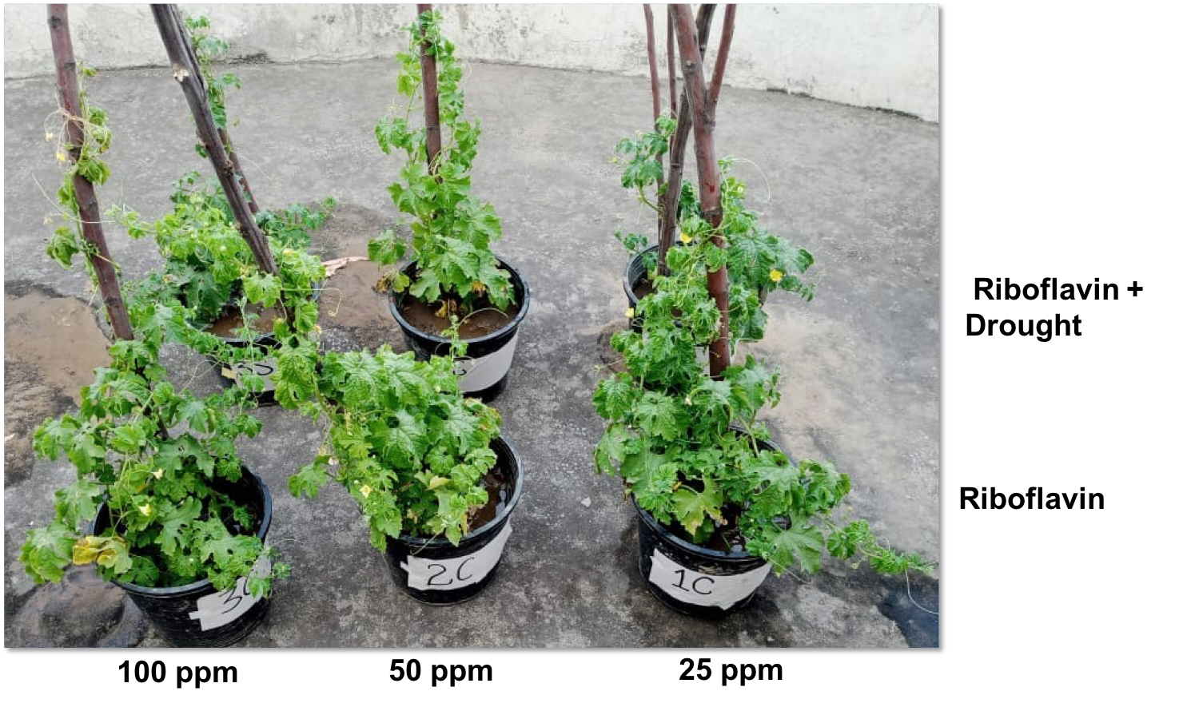
Supplementary figure S1: Effect of Riboflavin foliar application on bittergourd growth and vigor under control and drought conditions.

