Article
Supplementary Information

Part A: Interspecific Eavesdropping on Chemical Communication between Pomegranate, Aphis punicae, Enemies, and Protectors in the Taif Governorate Field using open-loop stripping.

Nour Houda M’sakni^{1,}*,†, Taghreed Alsufyani^{1,}*,†, Noura J. Alotaibi^{2,†}
¹ Department of Chemistry, College of Science, Taif University, P.O. Box 11099, Taif 21944, Saudi Arabia;
² Department of Biology, College of Science, Taif University, P.O. Box 11099, Taif 21944, Saudi Arabia;

* Corresponding authors: Nour Houda M’sakni (nour.h@tu.edu.sa); Taghreed Alsufyani (taghreed.alsufyani@tu.edu.sa).

Supplementary Tables

Supplementary Table 1. Essential and semiessential biomarkers of pattern quadruplet interaction between Aphid infested plant-Ant-Ladybird. The strategy used to identify essential and semiessential biomarkers was explained in our previous study (Alotaibi et al., 2023).

 |  | Triangle: essential biomarkers | Circle: semiessential biomarkers | Intermediar biomarkers
G-1 | PIN24-DVB | Bio5:1-Methyl-3-tert-butylbenzene  Bio6:m-Ethylcumene  Bio11:3-Carene  Bio15:(+)-4-Carene  Bio18:2,2,4-trimethyl-Pentane  Bio22:Unknown alkane-3  Bio27:Caryophyllene | Bio17:alpha-Methylbenzeneacetaldehyde  Bio23:Unknown alkane-4  Bio28:beta-Farnesene | Bio7:2-Methylnaphtalene  Bio16:Benzaldehyde
G-2 | PIN48An24-DVB | Bio9:Methyl methanoate  Bio19:Unknown alkane-1 | - | -
G-3 | PIN48An24Lb24-DVB | Bio8:2-Heptanone | Bio13:Tricyclene | -
G-4 | PIN728An48Lb48-DVB | Bio3:1-Ethyl-3-methylbenzene  Bio4:1,3,5-Trimethylbenzene  Bio10:Methyl Salicylate  Bio12:Sabinene  Bio14:Limonene  Bio20:Unknown alkane-2  Bio24:Pentadecane  Bio25:Heptadecane  Bio26:1-Methyl-1H-imidazole  Bio30:Unknown-1 | Bio29:β-helmiscapene (β-Selinene) | Bio1:o-Xylene  Bio2:p-Xylene  Bio21:Tridecane

Supplementary Figures
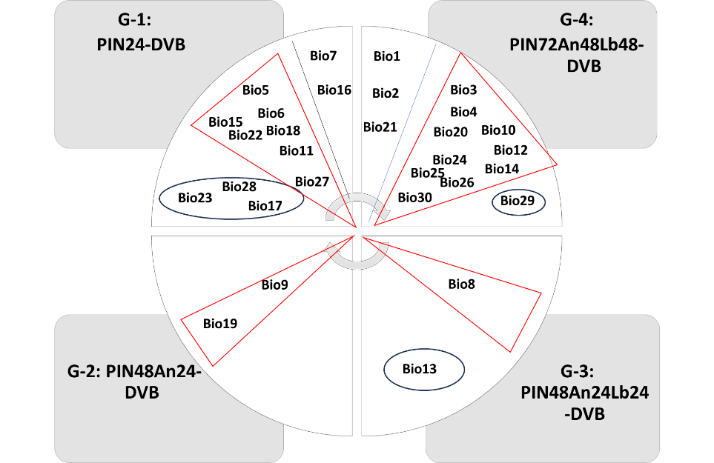

Supplementary Figure 1. Essential (triangle) and semiessential (circle:) biomarkers of pattern quadruplet interaction between Aphid infested plant-Ant-Ladybird. The strategy used to identify essential and semiessential biomarkers was explained in our previous study (Alotaibi et al., 2023).

Supplementary References

Alotaibi, N. J., Alsufyani, T., M’sakni, N. H., Almalki, M. A., Alghamdi, E. M., & Spiteller, D. (2023). Rapid Identification of Aphid Species by Headspace GC-MS and Discriminant Analysis. Insects, 14(7), 589. Retrieved from https://www.mdpi.com/2075-4450/14/7/589

