Supplementary Material for
Proteome-wide assessment of 10,000 plasma proteins with age-related diseases and multi-morbidity in a Chinese population
Derrick A. Bennett, Neil Wright, Pang Yao, et al.
Table S1: ICD-10 codes, number of participants and number of incident cases for specific disease endpoints 2
Table S2: Selected baseline characteristics for participants in the proteomics sub-cohort and the whole CKB study 3
Table S3: Number of proteins significantly associated (FDR-adjusted p<0.05) with incident risk of specific diseases with different adjustments 4
Figure S1: Volcano plots of adjusted HRs for any disease event and all-cause mortality associated with Olink and SomaScan (no ANML) proteins 5
Figure S2: Volcano plots of adjusted HRs for chronic kidney disease, chronic liver disease, ischaemic heart disease and all cancer associated with Olink and SomaScan (no ANML) proteins 6
Figure S3: Volcano plots of adjusted HRs for diabetes, all stroke, respiratory diseases and infectious and parasitic diseases associated with Olink and SomaScan proteins 7
Figure S4: Volcano plots of adjusted HRs for diabetes, all stroke, respiratory diseases and infectious and parasitic diseases associated with Olink and SomaScan (no ANML) proteins 8
Figure S5: Heat map showing the numbers of proteins associated with pairs of disease endpoints 9
Figure S6: Top 40 proteins most strongly associated with two or more disease endpoints 10
Figure S7: Performance of risk prediction models using conventional risk factors and proteins, assessed by (A) C-statistics and Net Reclassification Index and (B) Cumulative incidence of mortality by age-adjusted predicted risk for all-cause mortality, with use of non-normalised SomaScan proteins 11
Figure S8: Calibration of mortality risk prediction models using conventional risk factors and Olink and/or SomaScan proteins 12
Figure S9: Calibration of mortality risk prediction models using conventional risk factors and proteins measured by both Olink and SomaScan platforms 13
Figure S10: Weights of top 40 proteins in risk prediction model of conventional risk factors plus Olink and SomaScan proteins 14
Figure S11: Weights of top 40 proteins in risk prediction model of conventional risk factors plus proteins measured by both Olink and SomaScan platforms 15

Table S1: ICD-10 codes, number of participants and number of incident cases for specific disease endpoints
 |  | Number of participants
 |  | Olink |  | SomaScan
Disease | ICD-10 | Total | Incident disease | Total | Incident disease
All-cause mortality |  | 2,026 | 182 | 2,018 | 182
Chronic kidney disease | E10.2, E11.2, E12.2, E13.2, E14.2, I12.0, I12.9, I13.0-I13.2, I13.9, M10.3, M32.1, N02-N05, N08.3, N11-N13, N15, N18-19, N25-N26, N27.1, N27.9, O10.2, O10.3, R94.4, T86.1, Z94.0 | 2,000 | 36 | 1,992 | 36
Chronic liver disease | B18-B19, B25.1, B58.1, B94.2, K72-K77, Z22.5 | 2,026 | 22 | 2,018 | 22
Ischaemic heart disease | I20-I25 | 2,026 | 212 | 2,018 | 211
All cancer | C00-C97 | 2,013 | 118 | 2,005 | 118
Diabetes | E10-E14 | 1,896 | 83 | 1,888 | 83
All stroke | I60-I61, I63-I64 | 2,026 | 226 | 2,018 | 226
Ischaemic stroke | I63 | 2,026 | 206 | 2,018 | 206
Respiratory diseases | J00-J99 | 1,859 | 218 | 1,851 | 216
Pneumonia | J12-J18 | 1,859 | 105 | 1,851 | 105
Chronic lower respiratory disease + Pulmonary heart disease | J40-J44, I26-I27 | 1,859 | 59 | 1,851 | 59
Broader chronic respiratory disease | A15-A16, G47.3, I27.8, J40, J42-J45, J47 | 1,859 | 70 | 1,851 | 70
Infectious and parasitic diseases | A00-B99 | 2,003 | 63 | 1,995 | 62

Table S2: Selected baseline characteristics for participants in the proteomics sub-cohort and the whole CKB study
Mean (SD) or n (%) | Sub-cohort  (n=2026) | CKB study  (n=512,724)
Age at baseline, years | 51.3 (10.5) | 52.0 (10.7)
Sex
Male | 768 (37.9) | 210,205 (41.0)
Female | 1,258 (62.1) | 302,519 (59.0)
Education
No formal school | 333 (16.4) | 95,179 (18.6)
Primary school | 637 (31.4) | 165,186 (32.2)
Middle school | 594 (29.3) | 144,873 (28.3)
High school or higher | 462 (22.8) | 107,486 (21.0)
Smoking (men)
Never / occasional | 193 (25.1) | 53,917 (25.6)
Ex regular | 90 (11.7) | 27,917 (13.3)
Current smoker | 485 (63.2) | 128,371 (61.1)
Alcohol drinking (men)
Never regular | 141 (18.4) | 42,779 (20.4)
Occasional / monthly | 285 (37.1) | 79,231 (37.7)
Weekly / reduced / ex | 342 (44.5) | 88,195 (42.0)
Total physical activity, MET-hours/day | 21.3 (14.5) | 21.1 (13.9)
BMI, kg/m² | 23.9 (3.4) | 23.7 (3.4)
SBP, mmHg | 130.6 (21.5) | 131.1 (21.3)
Time since last ate, hours | 5.1 (5.0) | 4.9 (4.9)
Ambient temperature, °C | 16.0 (10.5) | 16.1 (10.1)
MET = Metabolic equivalent of task; SBP = Systolic blood pressure; BMI = Body mass index.

Table S3: Number of proteins significantly associated (FDR-adjusted p<0.05) with incident risk of specific diseases with different adjustments
 | Total (inverse) significant associations
 |  |  | Further adjusted for
Disease | Minimally adjusted* | Adjusted for major lifestyle factors† | SBP | Diabetes | BMI | SBP,  Diabetes  & BMI
Olink
Any incident disease event | 424 (2) | 388 (2) | 287 (0) | 237 (0) | 266 (0) | 136 (1)
All-cause mortality | 663 (28) | 610 (30) | 611 (32) | 588 (42) | 630 (26) | 598 (35)
Chronic kidney disease | 1041 (4) | 938 (3) | 847 (4) | 840 (4) | 926 (3) | 797 (4)
Chronic liver disease | 304 (7) | 330 (7) | 308 (7) | 304 (10) | 356 (8) | 300 (10)
Ischaemic heart disease | 256 (2) | 256 (2) | 186 (2) | 249 (2) | 227 (2) | 178 (2)
All cancer | 79 (5) | 51 (4) | 55 (4) | 51 (4) | 64 (6) | 64 (6)
Diabetes | 220 (49) | 238 (55) | 183 (45) | 238 (55) | 18 (7) | 18 (7)
All stroke | 0 (0) | 0 (0) | 0 (0) | 0 (0) | 0 (0) | 0 (0)
Ischaemic stroke | 1 (0) | 1 (0) | 0 (0) | 0 (0) | 0 (0) | 0 (0)
Respiratory diseases | 12 (0) | 4 (0) | 3 (0) | 3 (0) | 3 (0) | 1 (0)
Pneumonia | 0 (0) | 0 (0) | 0 (0) | 0 (0) | 0 (0) | 0 (0)
Chronic lower respiratory disease + Pulmonary heart disease | 2 (0) | 1 (0) | 1 (0) | 1 (0) | 2 (1) | 3 (1)
Broader chronic respiratory disease | 3 (0) | 3 (0) | 3 (0) | 3 (0) | 3 (0) | 3 (0)
Infectious and parasitic diseases | 0 (0) | 0 (0) | 0 (0) | 0 (0) | 0 (0) | 0 (0)
SomaScan
Any incident disease event | 197 (28) | 172 (26) | 134 (11) | 90 (6) | 129 (5) | 81 (5)
All-cause mortality | 660 (172) | 619 (153) | 630 (160) | 640 (181) | 570 (124) | 573 (147)
Chronic kidney disease | 759 (213) | 620 (159) | 637 (188) | 570 (142) | 627 (166) | 599 (171)
Chronic liver disease | 289 (56) | 293 (59) | 284 (59) | 298 (62) | 317 (64) | 299 (65)
Ischaemic heart disease | 94 (16) | 102 (15) | 82 (10) | 103 (15) | 101 (10) | 91 (11)
All cancer | 77 (12) | 53 (8) | 54 (8) | 51 (8) | 65 (11) | 66 (11)
Diabetes | 369 (193) | 385 (199) | 313 (169) | 385 (199) | 42 (21) | 42 (21)
All stroke | 2 (0) | 0 (0) | 0 (0) | 1 (1) | 0 (0) | 0 (0)
Ischaemic stroke | 1 (0) | 1 (0) | 0 (0) | 1 (0) | 1 (0) | 1 (0)
Respiratory diseases | 6 (0) | 3 (0) | 3 (0) | 3 (0) | 3 (0) | 2 (0)
Pneumonia | 1 (0) | 1 (0) | 1 (0) | 1 (0) | 1 (0) | 1 (0)
Chronic lower respiratory disease + Pulmonary heart disease | 6 (2) | 4 (2) | 4 (2) | 4 (2) | 4 (2) | 4 (2)
Broader chronic respiratory disease | 1 (1) | 1 (1) | 1 (1) | 1 (1) | 1 (1) | 1 (1)
Infectious and parasitic diseases | 1 (0) | 2 (0) | 2 (0) | 2 (0) | 2 (0) | 2 (0)
* Adjusted for age, age-squared, sex, region, time since last meal (and its square), ambient temperature (and its square) and education.
† Additionally adjusted for alcohol, smoking and total physical activity.
Significant associations are those with FDR-corrected p < 0.05 (n = 9325 protein measures tested).

Figure S1: Volcano plots of adjusted HRs for any disease event and all-cause mortality associated with Olink and SomaScan (no ANML) proteins
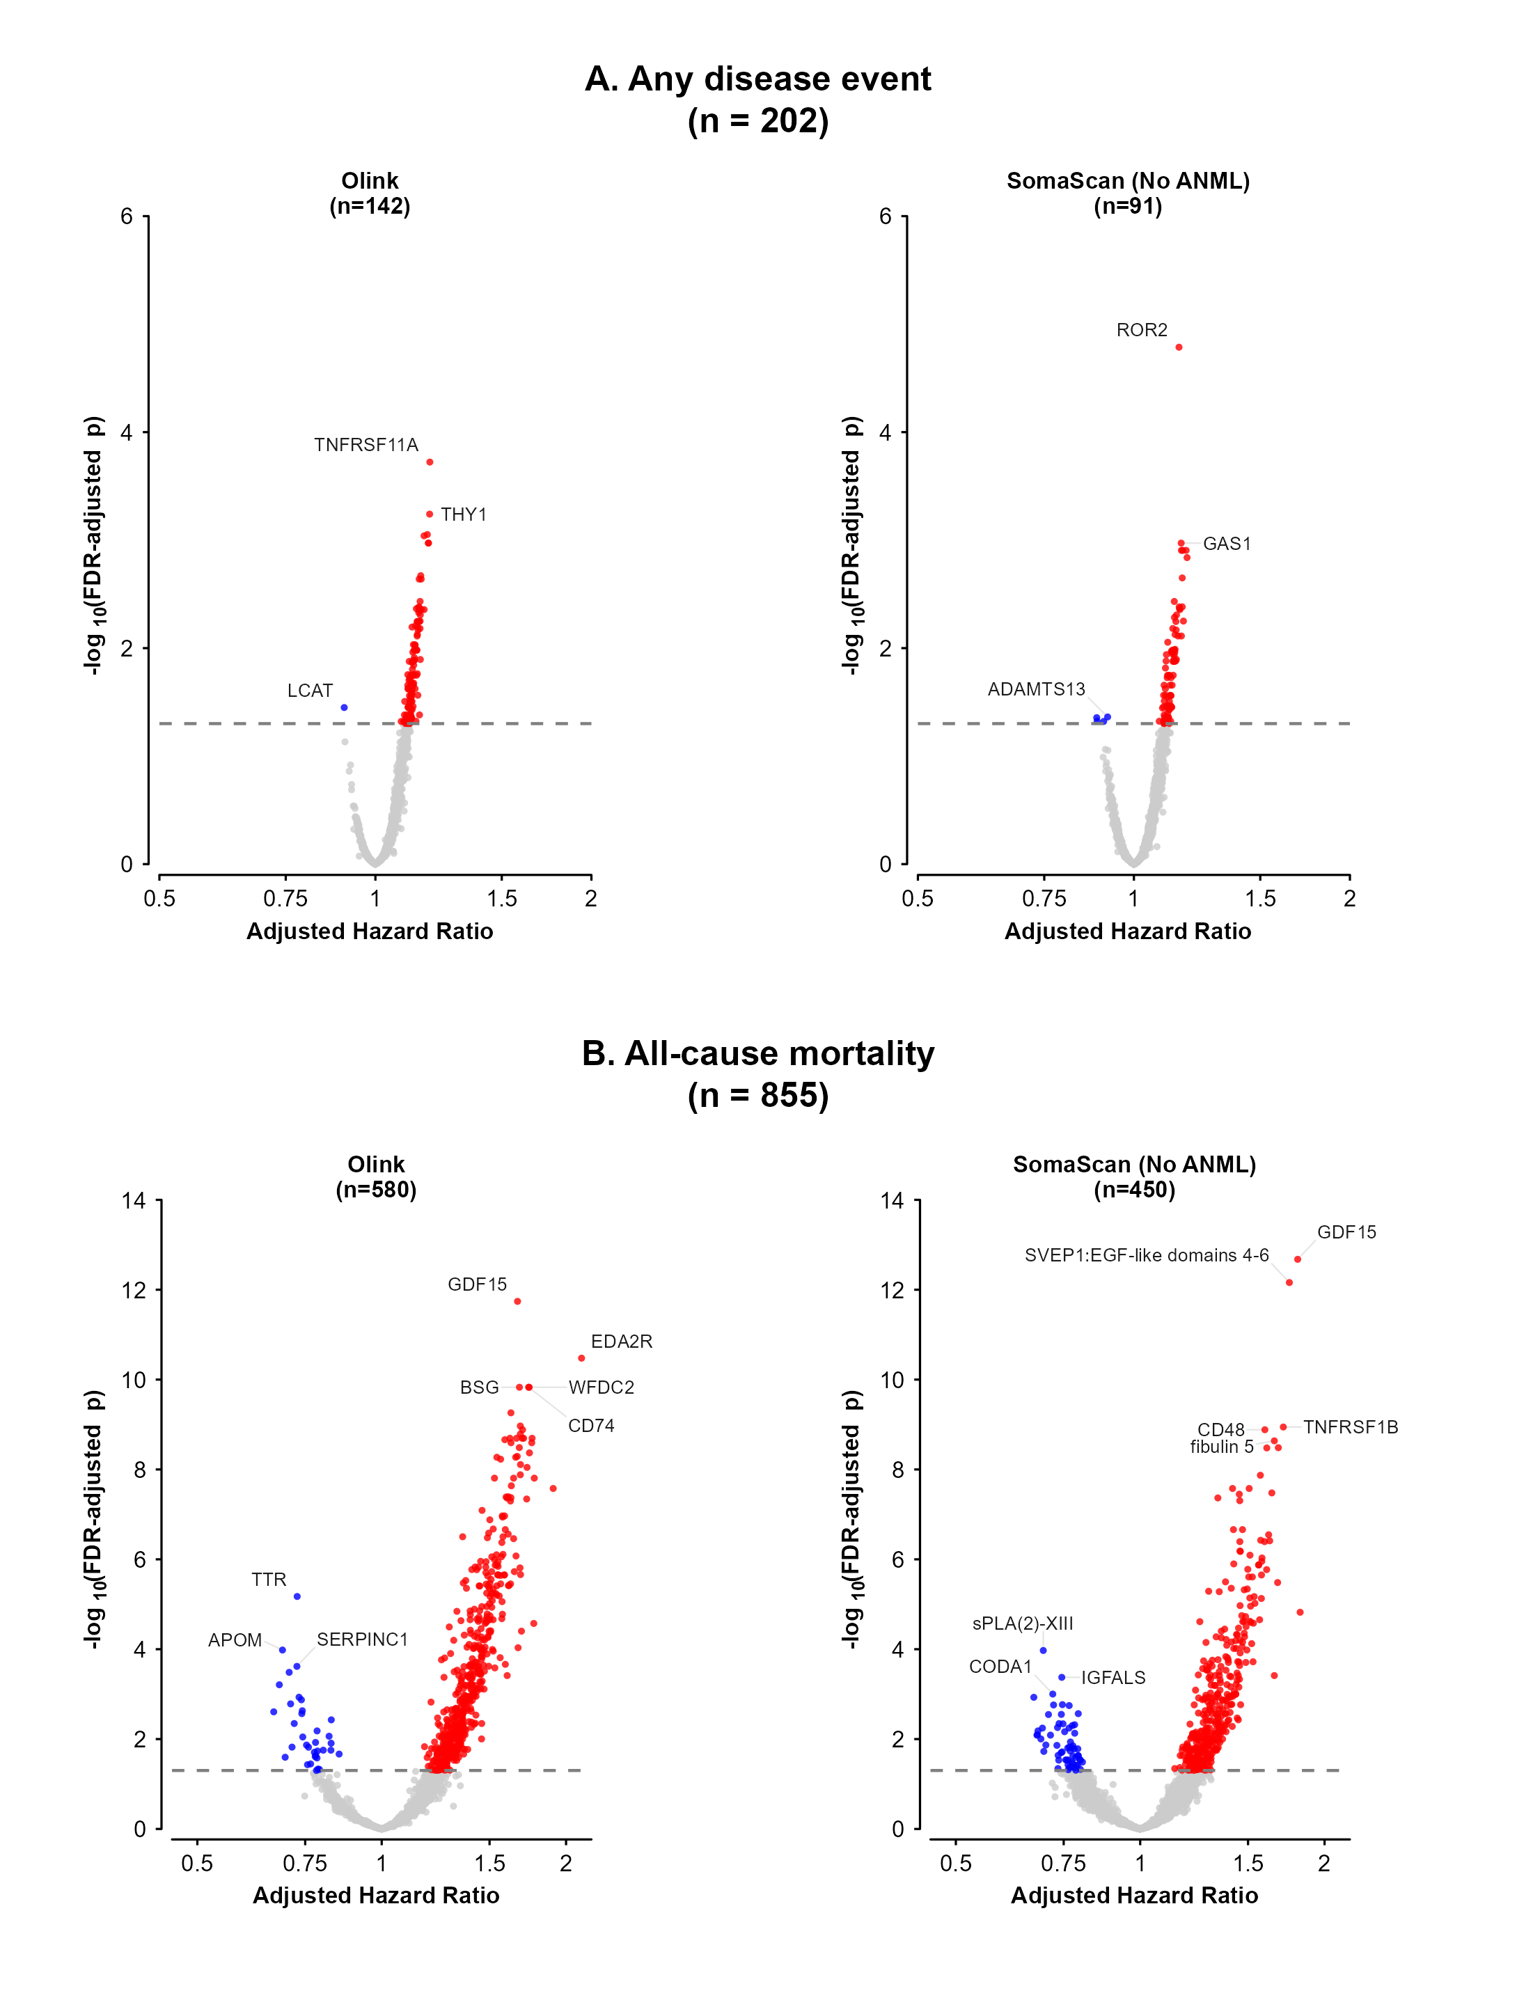
Numbers of proteins significant associated (FDR-adjusted p < 0.05, n = 9325 protein measures tested) with each endpoint shown. For total, proteins measured by both Olink and SomaScan are counted as significant if FDR-adjusted p < 0.05 for either platform.

Figure S2: Volcano plots of adjusted HRs for chronic kidney disease, chronic liver disease, ischaemic heart disease and all cancer associated with Olink and SomaScan (no ANML) proteins
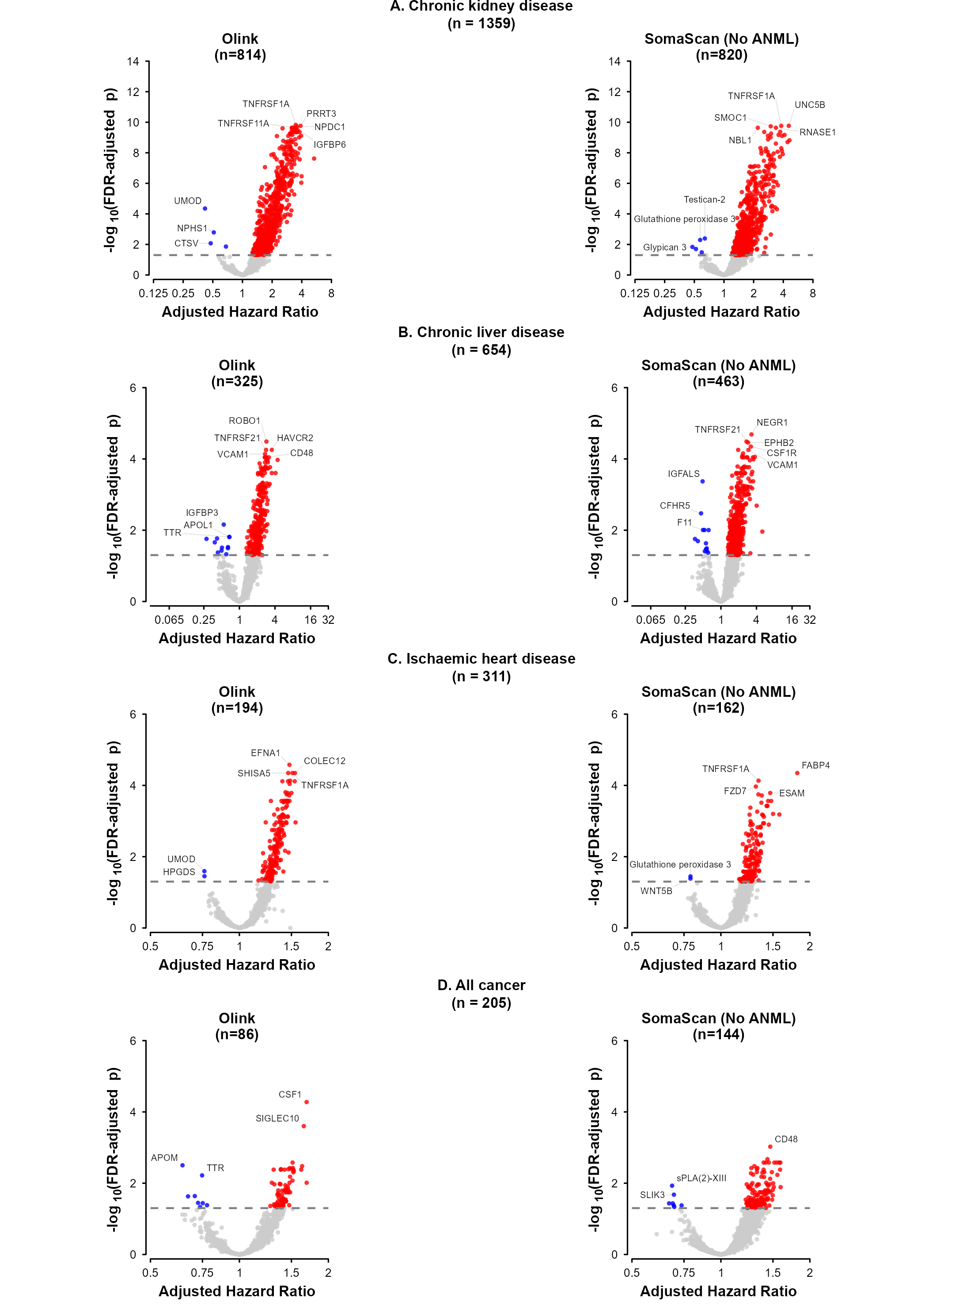
Numbers of proteins significant associated (FDR-adjusted p < 0.05, n = 9325 protein measures tested) with each endpoint shown. For total, proteins measured by both Olink and SomaScan are counted as significant if FDR-adjusted p < 0.05 for either platform.

Figure S3: Volcano plots of adjusted HRs for diabetes, all stroke, respiratory diseases and infectious and parasitic diseases associated with Olink and SomaScan proteins
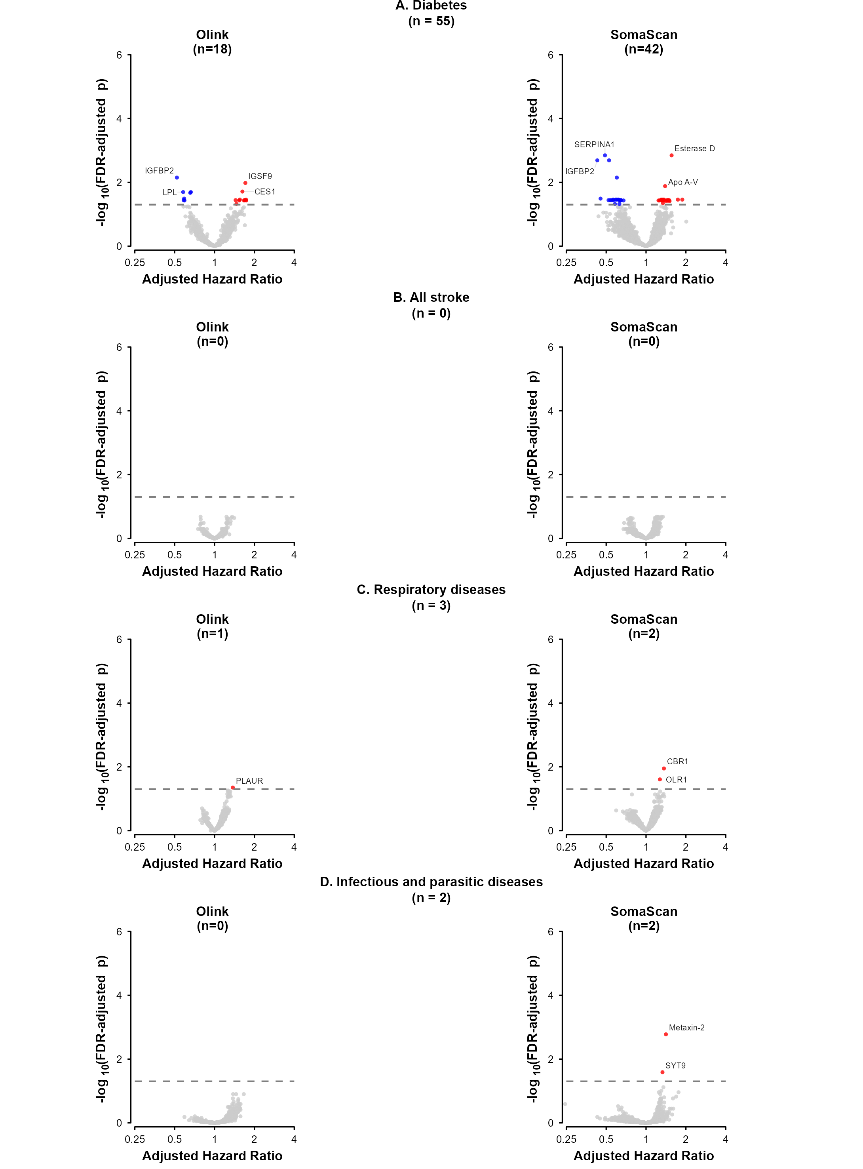
Numbers of proteins significant associated (FDR-adjusted p < 0.05, n = 9325 protein measures tested) with each endpoint shown. For total, proteins measured by both Olink and SomaScan are counted as significant if FDR-adjusted p < 0.05 for either platform.

Figure S4: Volcano plots of adjusted HRs for diabetes, all stroke, respiratory diseases and infectious and parasitic diseases associated with Olink and SomaScan (no ANML) proteins
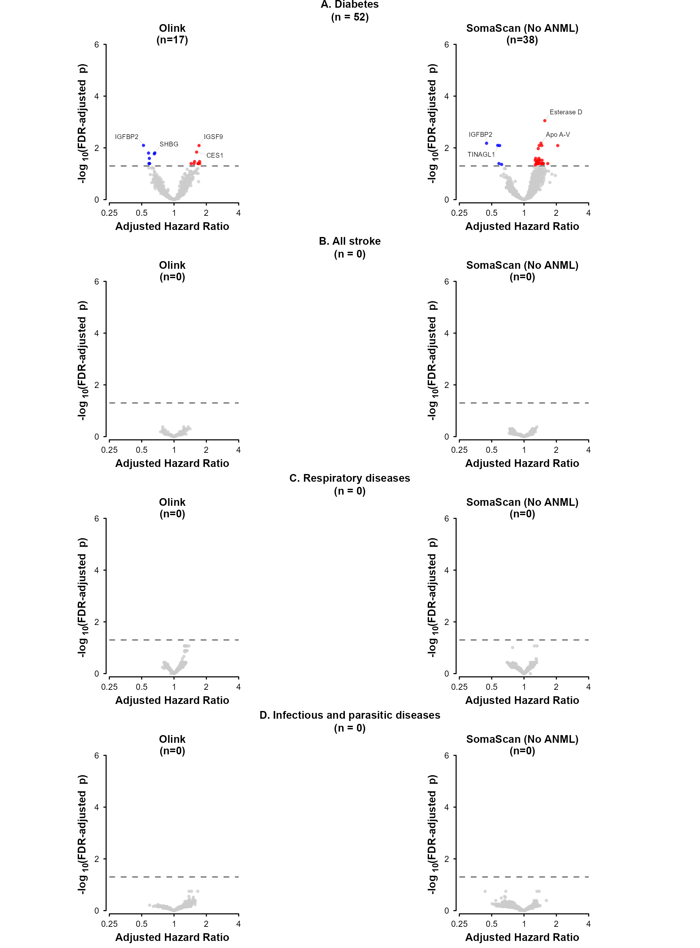
Numbers of proteins significant associated (FDR-adjusted p < 0.05, n = 9325 protein measures tested) with each endpoint shown. For total, proteins measured by both Olink and SomaScan are counted as significant if FDR-adjusted p < 0.05 for either platform.

Figure S5: Heat map showing the numbers of proteins associated with pairs of disease endpoints
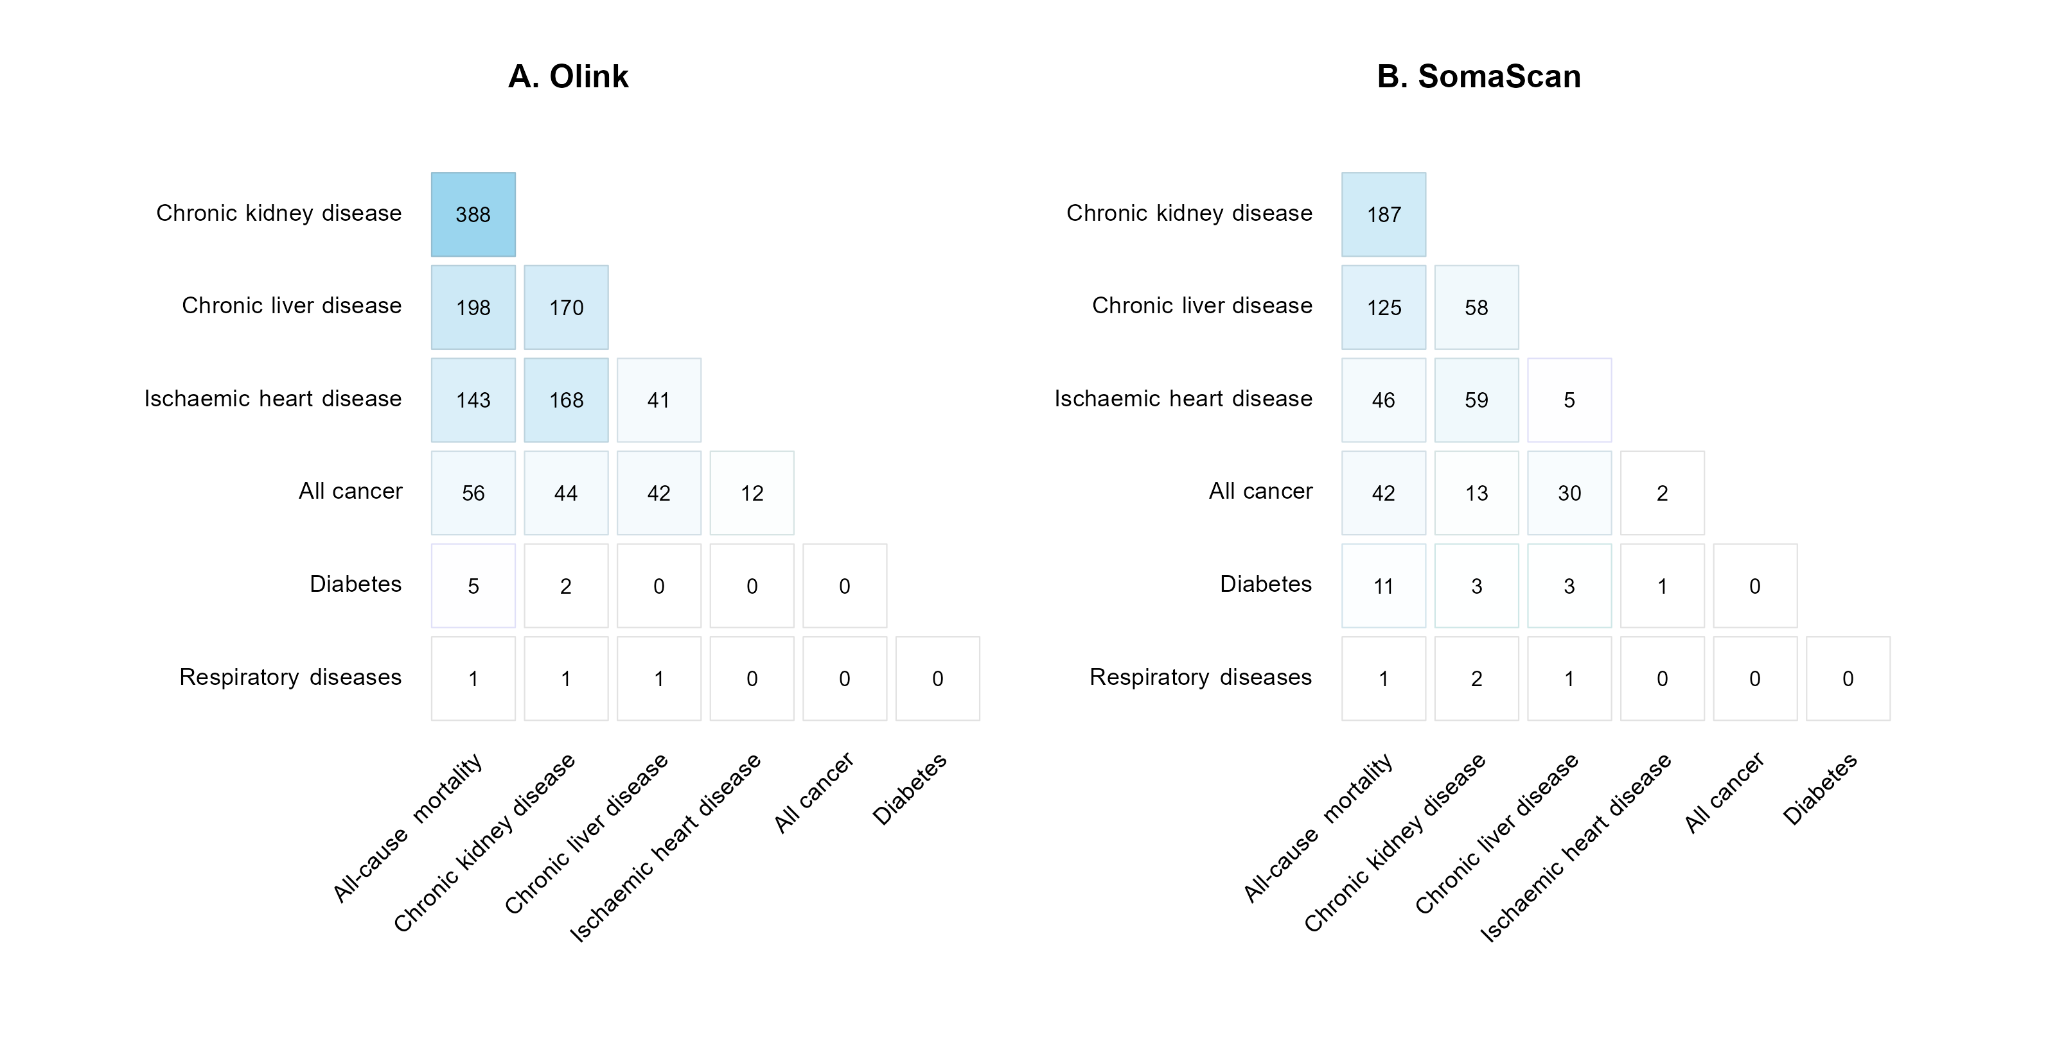

Figure S6: Top 40 proteins most strongly associated with two or more disease endpoints
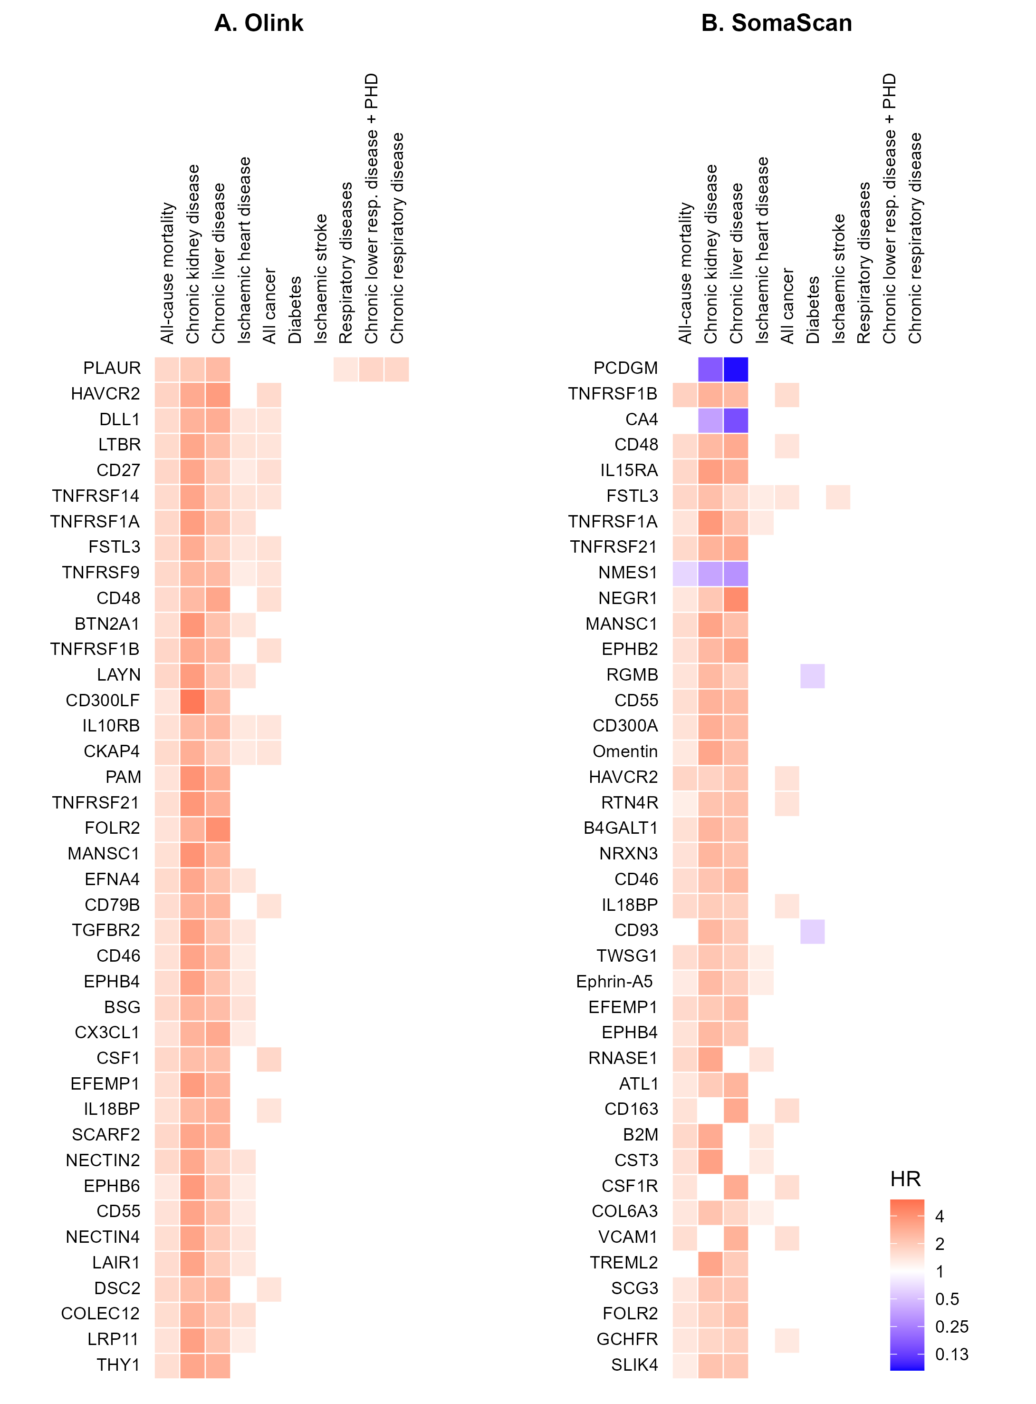 Proteins shown are associated with two or more disease endpoints (FDR-adjusted p < 0.05) and in top 40 for Olink or SomaScan by the sum of effect sizes across those diseases.

Figure S7: Performance of risk prediction models using conventional risk factors and proteins, assessed by (A) C-statistics and Net Reclassification Index and (B) Cumulative incidence of mortality by age-adjusted predicted risk for all-cause mortality, with use of non-normalised SomaScan proteins
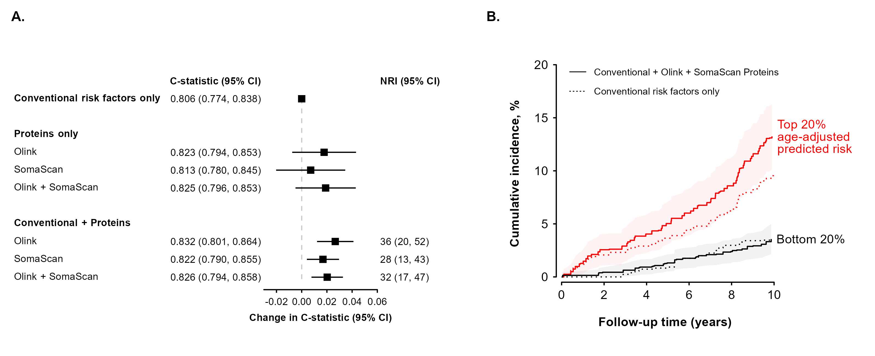

Figure S8: Calibration of mortality risk prediction models using conventional risk factors and Olink and/or SomaScan proteins
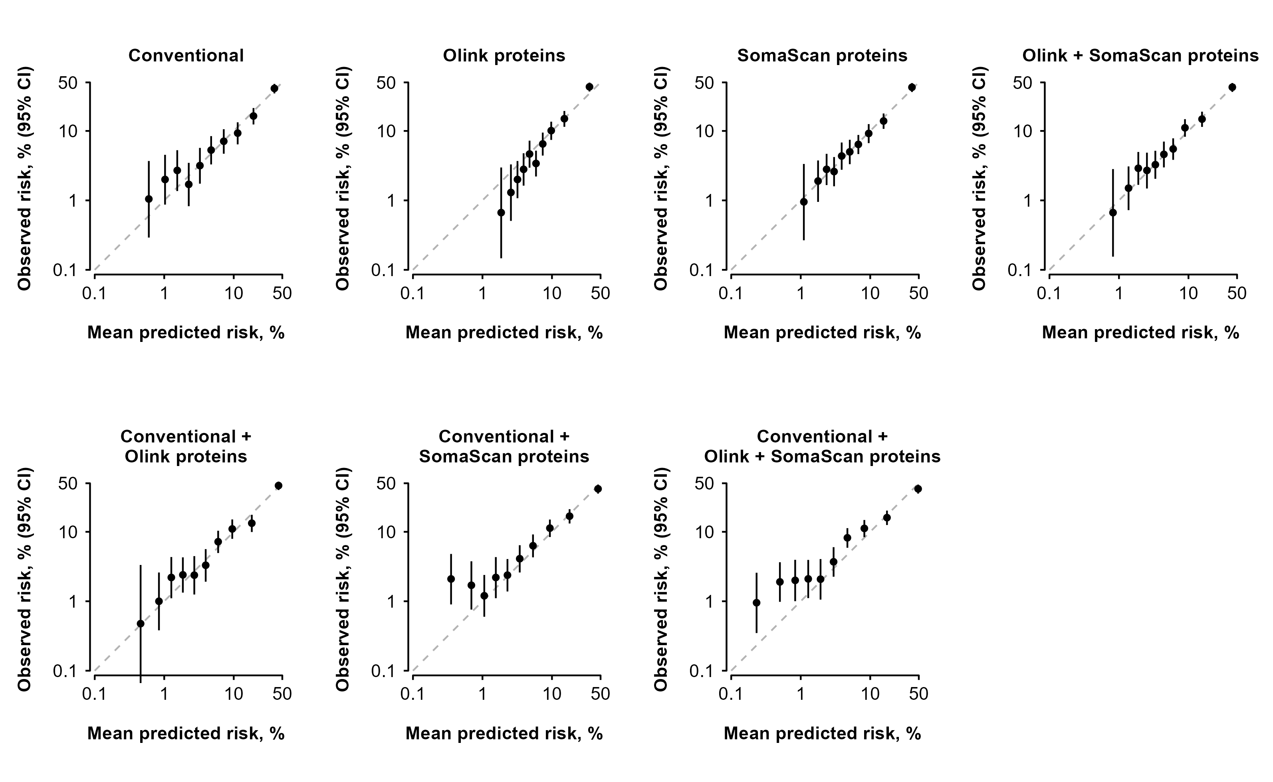

Figure S9: Calibration of mortality risk prediction models using conventional risk factors and proteins measured by both Olink and SomaScan platforms
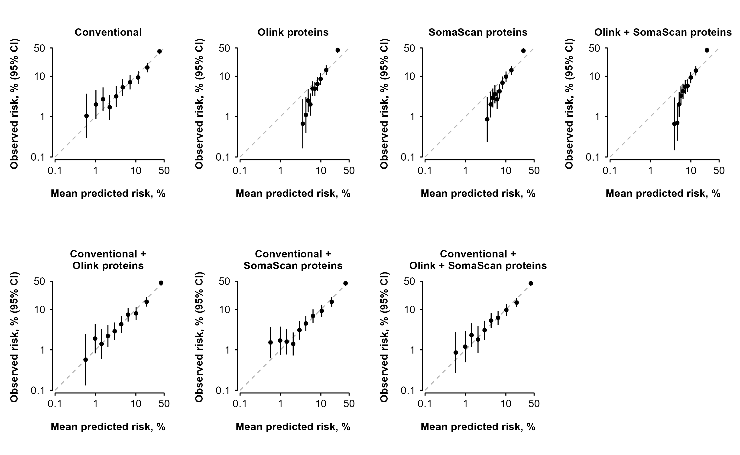

Figure S10: Weights of top 40 proteins in risk prediction model of conventional risk factors plus Olink and SomaScan proteins
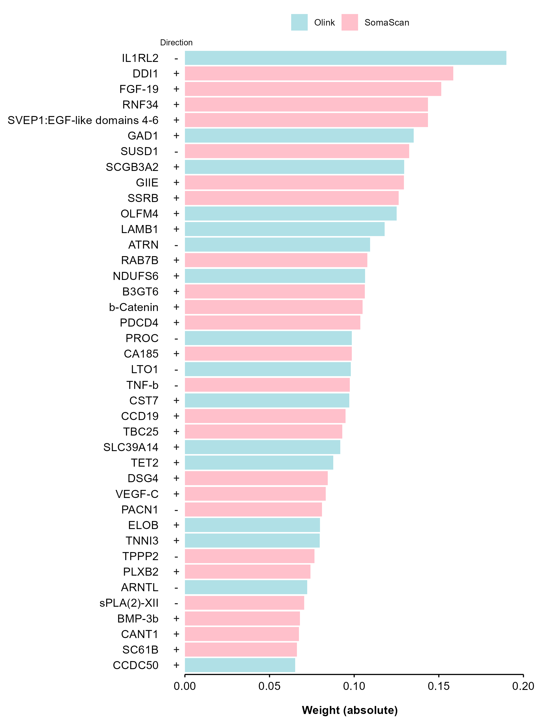

Figure S11: Weights of top 40 proteins in risk prediction model of conventional risk factors plus proteins measured by both Olink and SomaScan platforms
