Supplementary materials

Experimental setup
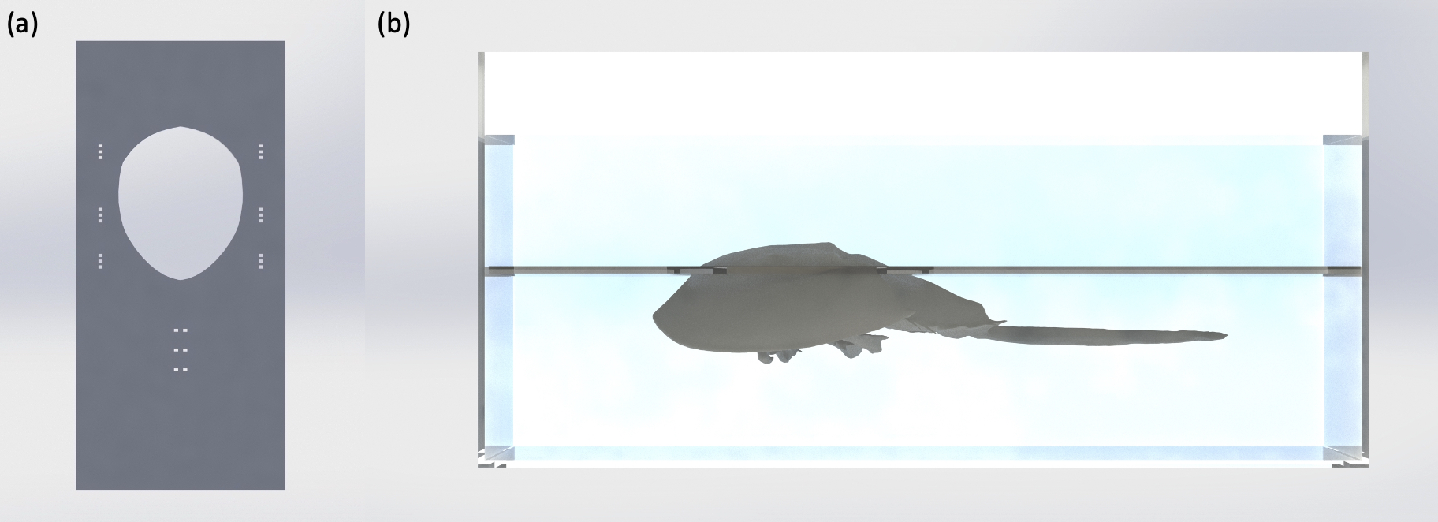Figure S1 Illustrations of the experimental setup for measurements. (a) Illustration of the acrylic frame used to constraint the horseshoe crab during experiment. (b) Illustration of horseshoe crab fastened to the frame and suspended in the water tank during experiment. The frame was supported by the homemade height-adjustable stands on the bottom of the tank.
A custom frame was designed to fit a fully grown male horseshoe crab and constrain its shell from any movement while exposing a large area of the prosoma for measurements (Figure S1 (a)). The small holes around the large opening allow the crab to be tightly mounted onto the frame using zip ties: two around the prosoma, one around the opisthosoma, and two around the tail. This design distributes the forces along the exoskeleton and leaves the delicate organs, such as the mouth and gills, fully exposed to ensure no harm to the organism. In addition, the frame was constructed to fit tightly within the tank where measurements were taken to decouple water motion between the top and the bottom of the shell. Both the frame and the tank were built from 4.4 mm thick transparent acrylic sheets to allow visibility during experiments. The frame’s vertical position within the tank was adjustable with four exchangeable acrylic stands in each corner of the tank on which the frame would rested (shown in Figure S1 (b)). The tank (60 cm × 28 cm × 28 cm) was specifically designed to improve the laser Doppler vibrometry measurements but was also used throughout all measurements.
To obtain the measurements, the horseshoe crab was mounted to the frame and completely immersed in a natural position in the water-filled tank. A 15 minute period before conducting experiments was provided to allow the crab enough to adapt to the environment. This ensured that measurements were taken in a calm natural state of the horseshoe crab. The temperature and salinity levels recorded in the measurement tank were between 18 - 19 °C and 27 - 30 ppt, respectively.

Laser Doppler Vibrometry Measurement Setup
For laser Doppler vibrometer measurements, the horseshoe crab was placed into the measurement setup and the scanning head of the vibrometer (Polytec PSV-500 Scanning Vibrometer) was adjusted using a tripod to direct the laser beam perpendicularly to the surface of interest on the crab’s prosoma. Subsequently, an additional 2D alignment of the surface was performed in the acquisition software (PSV Software). To avoid interference from the water surface, the horseshoe crab was only partially submerged in water (Figure S2). Only the exposed surface of the prosoma was above the water surface, with the rest of the horseshoe crab submerged to maintain regular physiology activities. This would allow for an uninterrupted laser path only through air, without any change in medium, while preserving the environmental conditions for the horseshoe crab. This modified setup provided the highest signal-to-noise ratio.
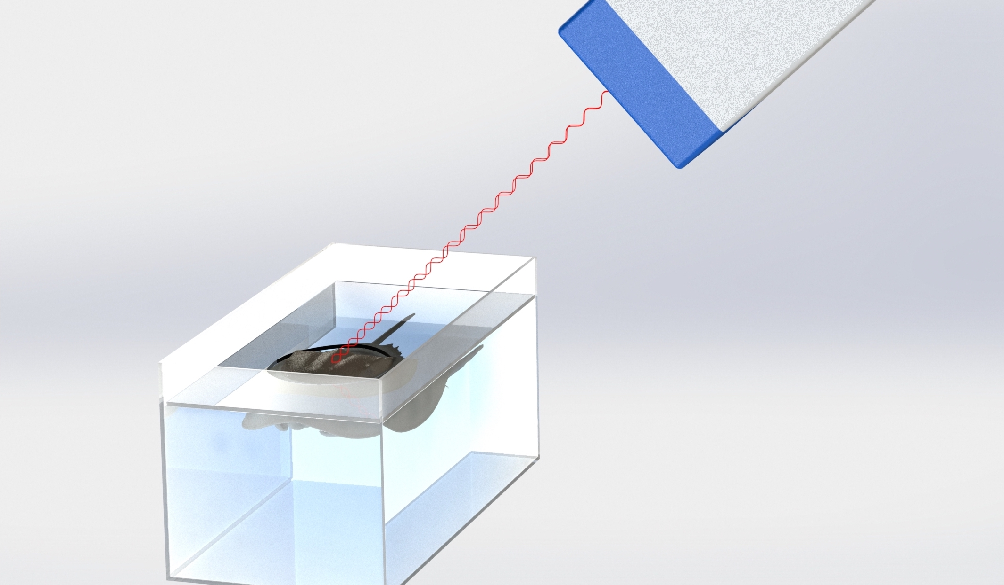Figure S2 Illustration of the vibrometer measurement setup. The scan head of the laser vibrometer was mounted on a tripod and pointing towards the shell.

Hydrophone Measurements Raw Data (Figure 5)
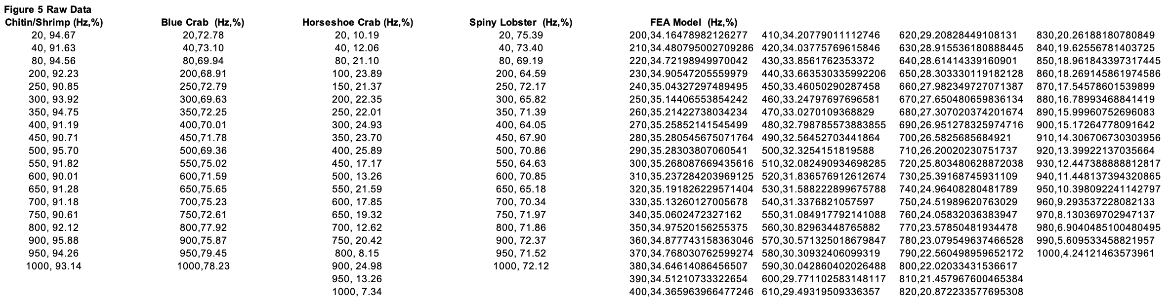

Acoustic fiber measurement on top of the shell
Acoustic fibers were placed directly on top of the shell and fixed using medical tape to ensure sufficient contact and vibration coupling. Various locations on the shell and various orientations of the fiber were explored, as shown in Figure S3. After applying various signal processing techniques such as Fast Fourier Transform (FFT), moving average, and Empirical Mode Decomposition (EMD) to remove the noise, the position highlighted in Figure S3 (third from left to right in the top row) provided the highest correlation between the fiber data and the concurrent heart impedance data.
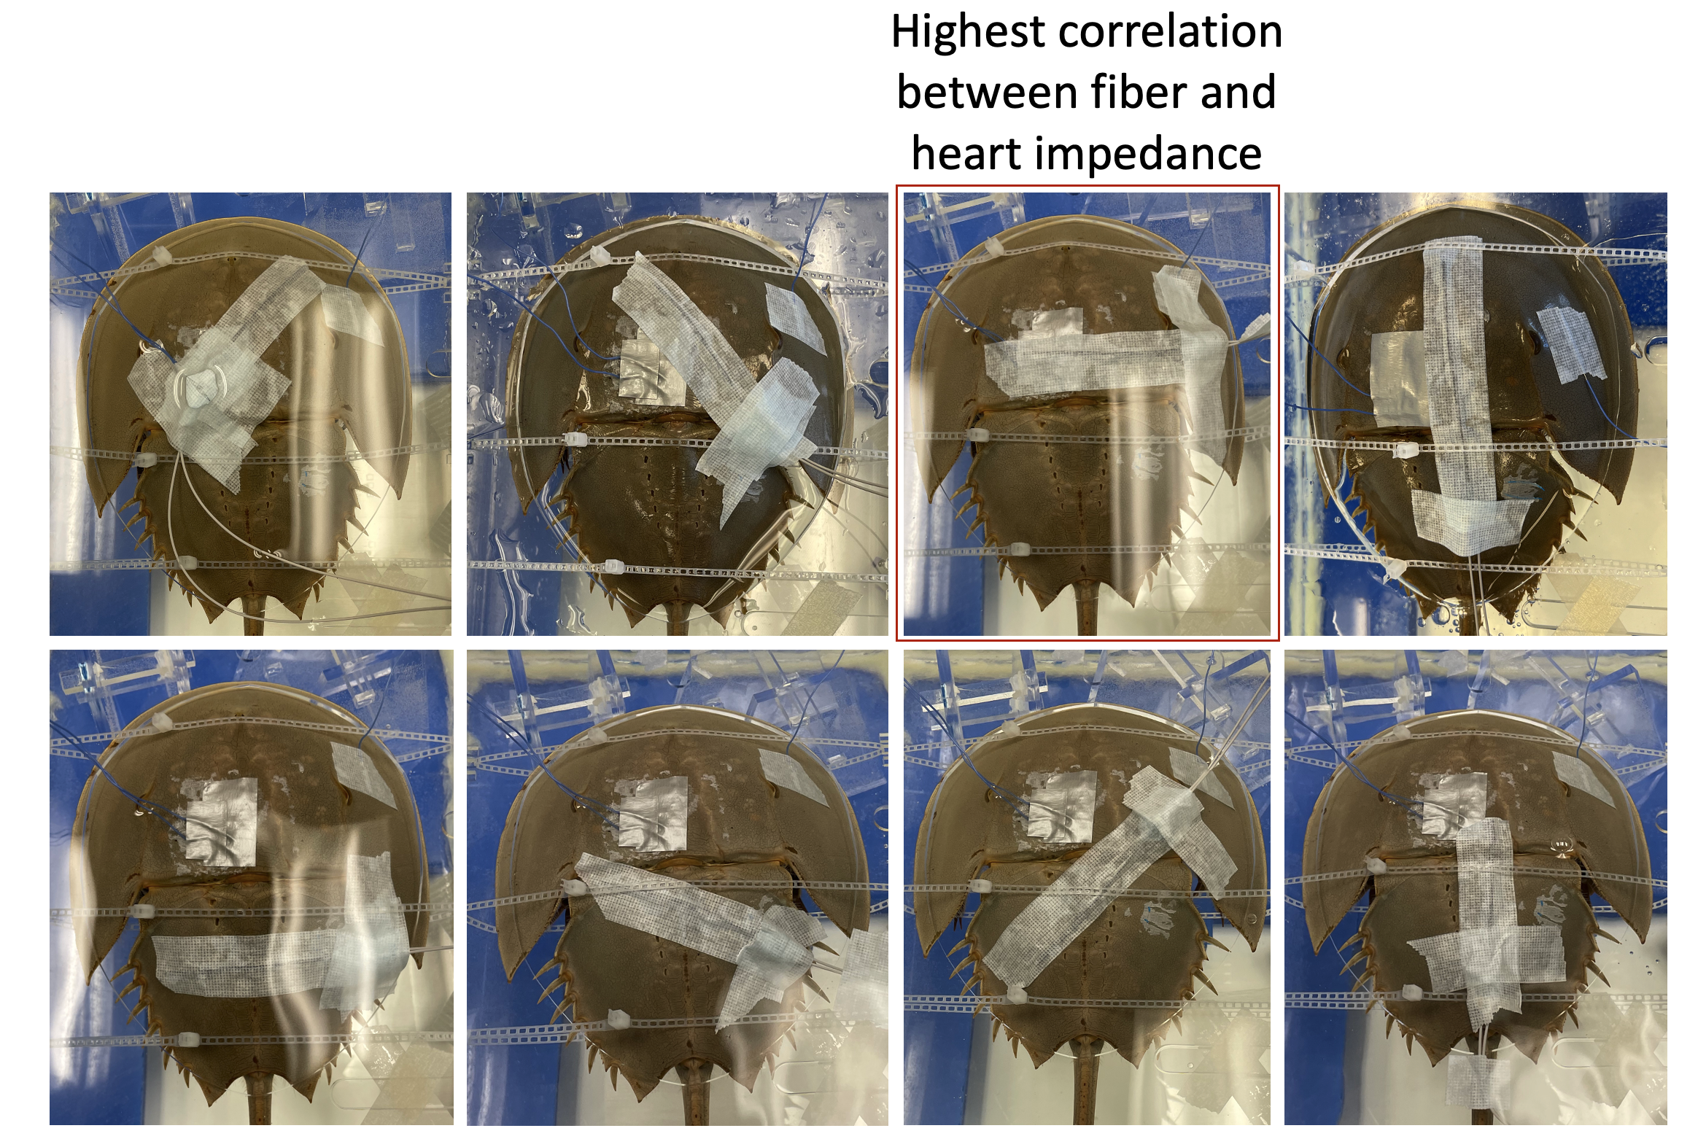
Figure S3. Images demonstrating fiber locations and orientations for measurement. The horizontal fiber on prosoma provided the highest correlation between fiber and concurrent heart impedance data.

Data Corresponding to Acoustic Impedance and Strength Calculations
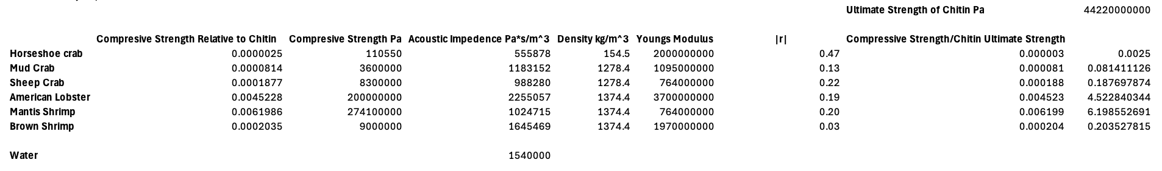
All values corresponding to Figure 1 were estimated using data available in literature. Values corresponding to Young’s Modulus and compressive strength are unique to each species listed in Figure 1. Unfortunately, density values for the Mantis Shrimp, Brown Shrimp and Sheep Crab were unavailable in literature. Thus, density values for the Mantis and Brown Shrimp shell were estimated using the density value for the American Lobster. The Sheep Crab’s shell density was estimated using the Mud Crab’s density value. Error should be considered given these estimates.

FEA simulation
The material property of chitin is listed in Table S1. When there absents of device inserted between the sound source and the measuring point, the sound pressure level field is undisturbed as shown in Figure S4a. The total acoustic pressure measured at the measuring point is shown in Figure S4b. As a reference, when change the porosity of the poroelastic domain to 0.068 (effective density 1.4 g/cm3), the sound pressure level (SPL) of the open field and the total acoustic pressure are shown in Figure S4 c and d, respectively.
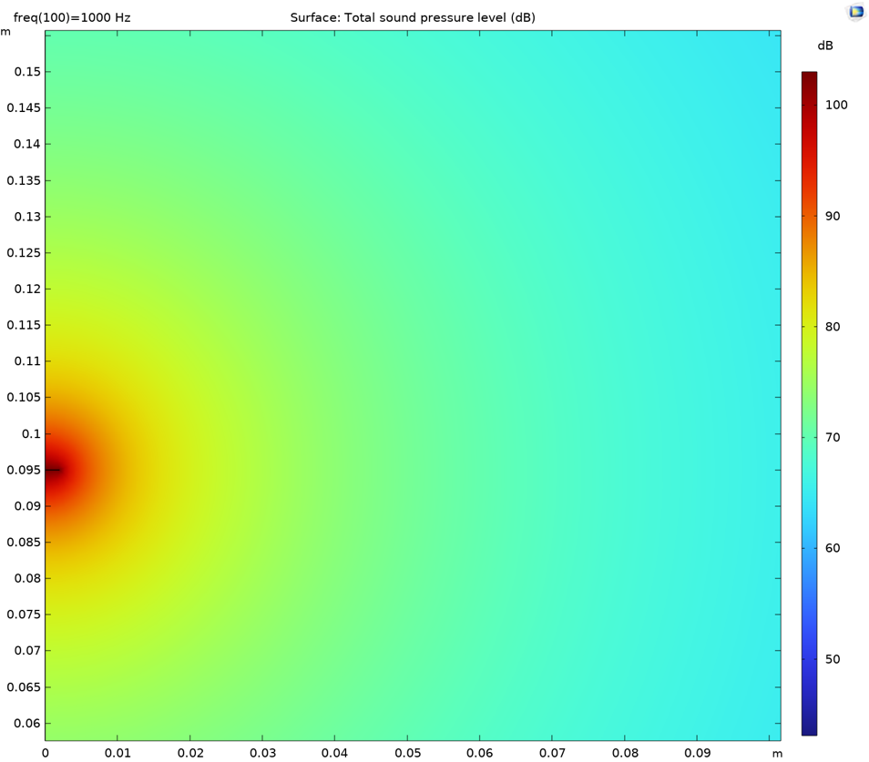
Figure S4 (a) Total SPL (dB) in the open field without the shell (pure water field)
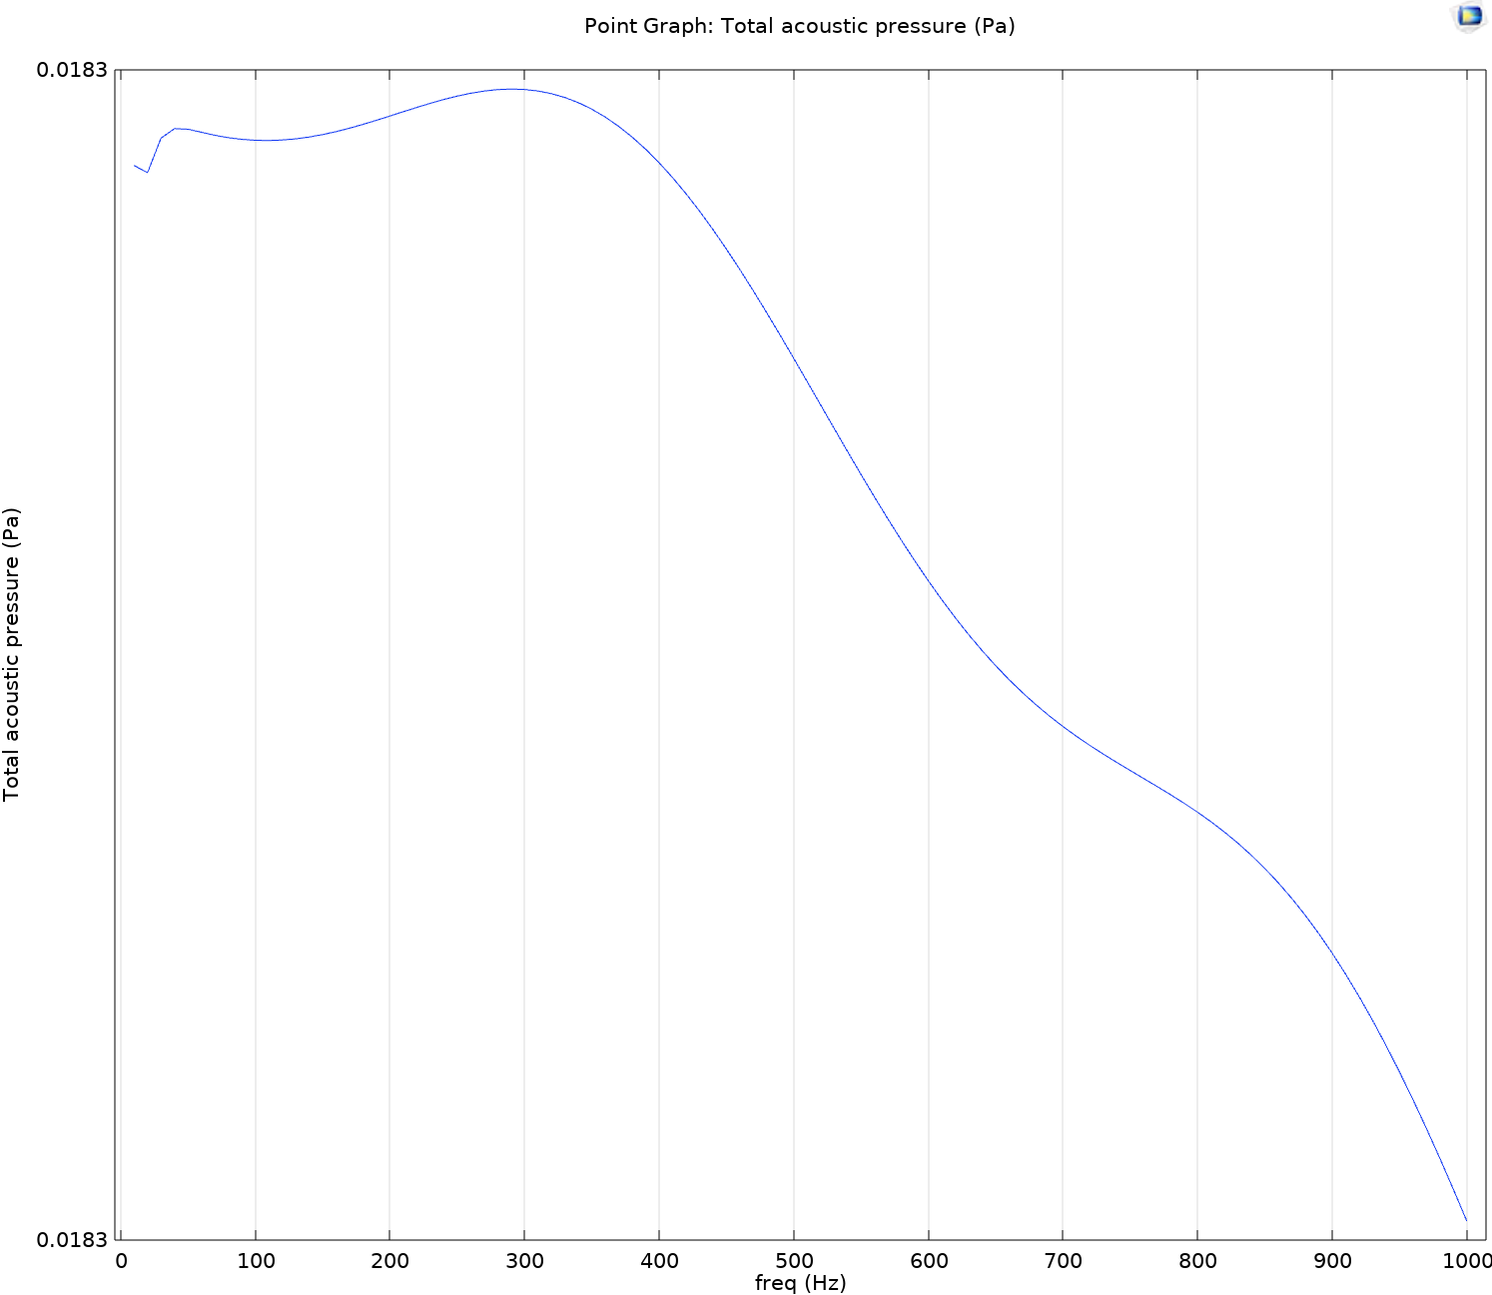
Figure S4 (d) Total acoustic pressure (pa) at the measuring point with respect to varying frequency without the shell inserted.

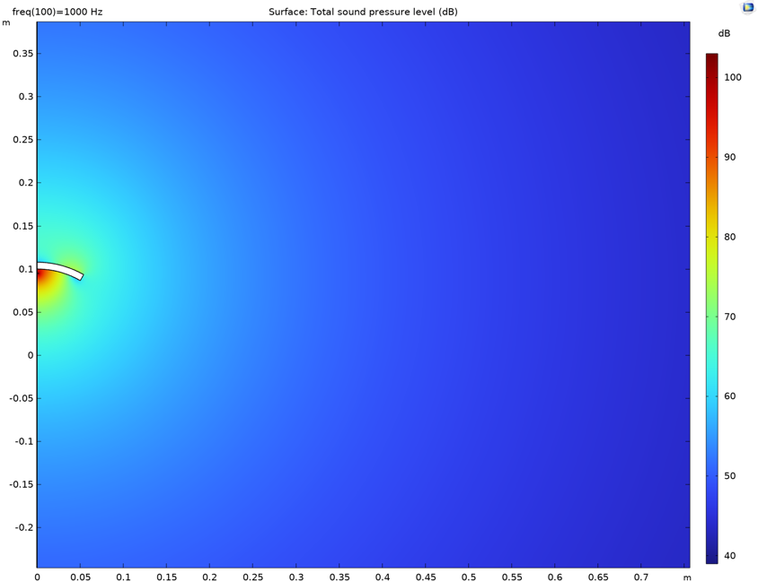
Figure S4 (c) Total SPL (dB) in the open field when shell is inserted (effective density 1.4 g/cm3).
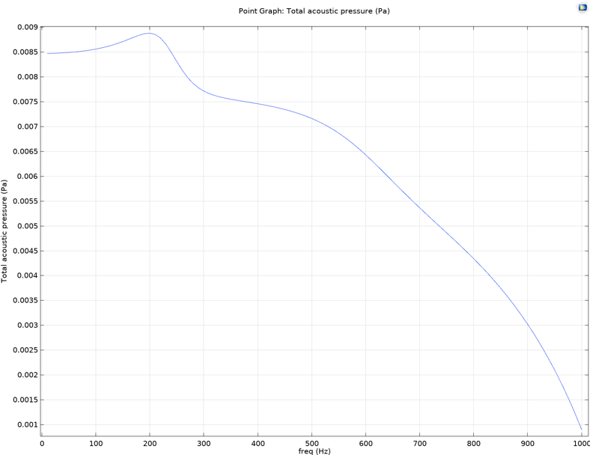
Figure S4 (d) Total acoustic pressure (pa) at the measuring point with respect to varying frequency with shell inserted (effective density 1.4 g/cm3).

Table S1. Chitin properties used in FEA
Property | Young’s modulus | Density | Poisson’s ratio
Value | 2 [GPa] | 1.5 [g/cm3] | 0.4

Table S2. Poroelastic material properties
Property | Isotropic structural loss factor | Flow resistivity | Thermal characteristic length | Viscous characteristic length | Tortuosity factor
Value | 0.01 | 11000 [Pa s/m3] | 142 e-6 [m] | 100e-6 [m] | 20

