Additional Figures and Tables

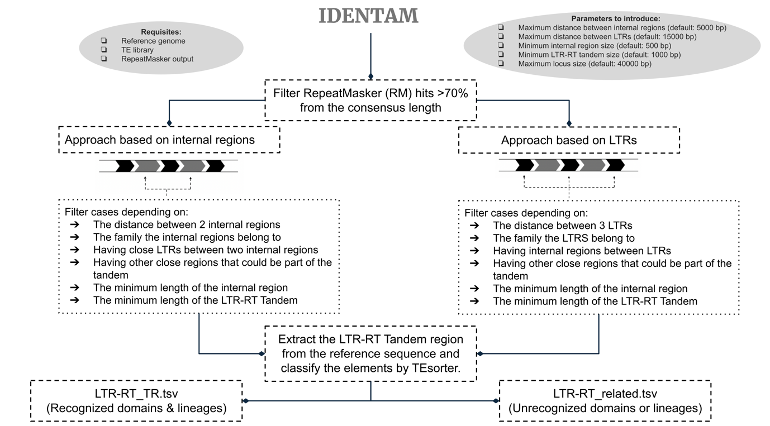Additional figure 1. Pipeline used for identifying LTR-RT Tandems.

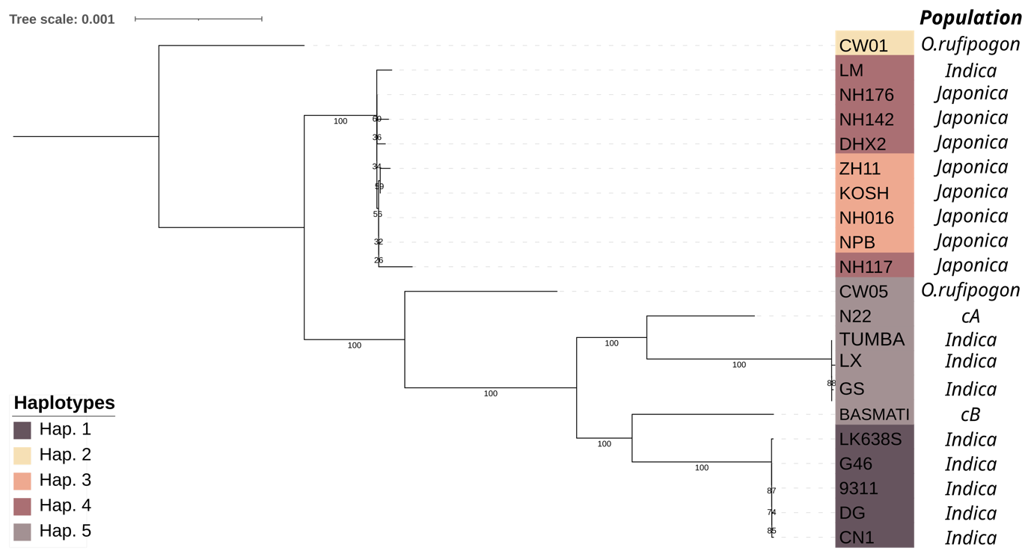Additional Figure 2. Phylogenetic tree based on SNPs located 20Kb upstream and 35Kb downstream of the transposon insertion, rooted to the CW01 (O. rufipogon) accession. Haplotype 1 represents the empty site, haplotype 2 the MULE insertion, haplotype 3 the LTR-RT tandem insertion surrounded by the MULE insertion, haplotype 4 the single LTR-RT insertion surrounded by the MULE and haplotype 5 the 29 bp deletion from the empty site.
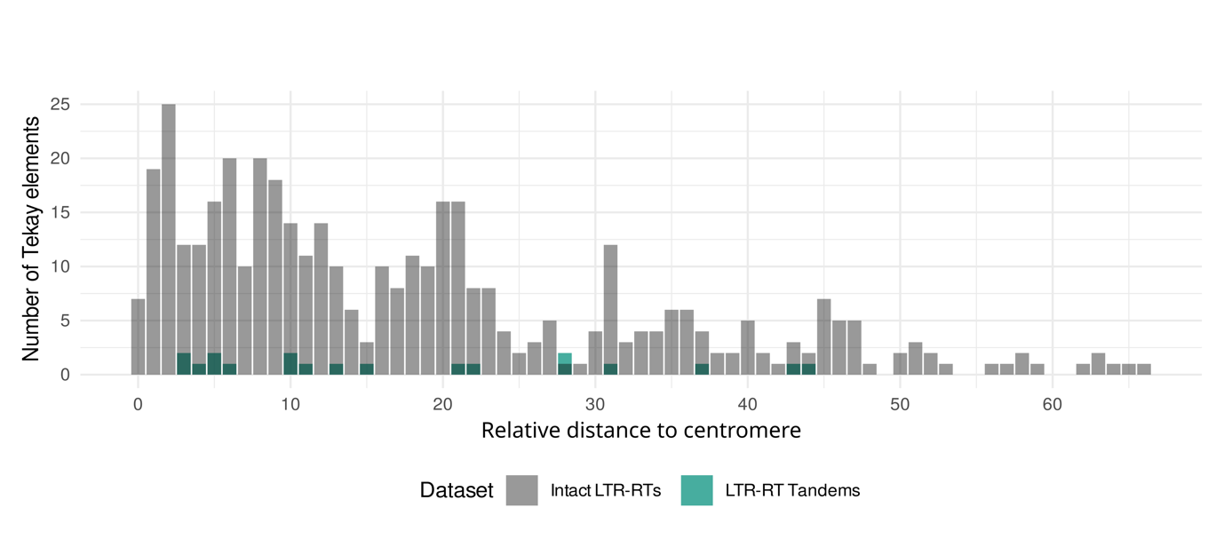Additional Figure 3. Distribution of Tekay transposons relative to the centromere. The graph shows the number of Tekay transposons plotted against their relative distance to the centromere.
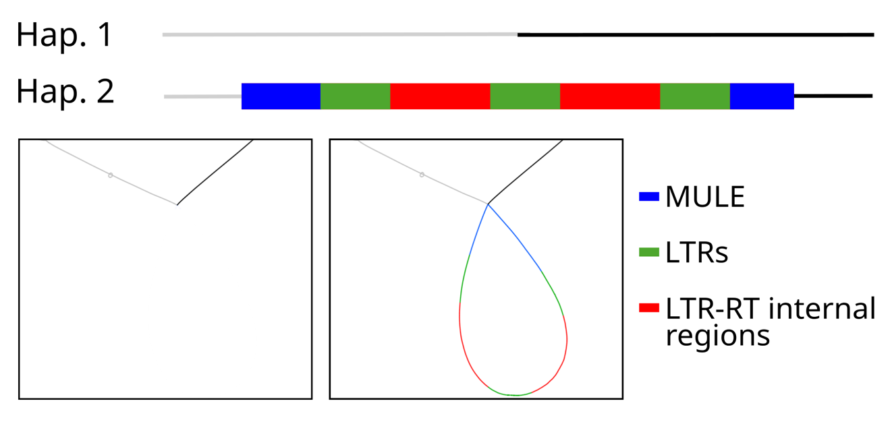

Additional Figure 4. Bandage visualization of the minimap2-SVIM pangenome in Chr02:359587-381449 and scheme of the different haplotypes identified in the graph. The accessions used for the creation of the graph are described in Additional Table 2.

Additional Table 1. Accessions used for pangenome construction using minimap2+SVIM-asm
Additional Table 2. Accessions used for pangenome construction using cactus-minigraph
Additional Table 3. Information on the structure of the TLC2 locus in the genomes of different rice accessions and related species.

Additional Table 4. Selected LTR-RT tandems present in the Nipponbare genome.

