Appendix
Supplementary Table 1. Diagnostic codes used to MACE and operationalize chronic conditions and multimorbidity
Major adverse cardiovascular events (MACE) | International Classification of Diseases, Ninth Revision | The International Classification of Diseases, Tenth Revision, Clinical Modification | International Classification of Primary Care
Acute myocardial infarction (AMI) | 410 | - | -
Stroke | 430,431,432,433,434,436,437,438 | - | -
Cardiovascular death | - | I00 - I02, I05 - I16, I1A, I20 - I28, I30 - I52, I5A, I60 - I89, I95 - I99 | -
Chronic conditions, and multimorbidity
Alcohol misuse | 265.2,291.1,291.2,291.3,291.5,291.6,291.7,291.8,291.9,303.0,303.9,305.0,357.5,425.5,535.3,571.0,571.1,571.2,571.3,980, V11.3 | - | P15
Asthma | 493 | - | R96
Atrial fibrillation | 427.3 | - | K78
Cancer, lymphoma | 200,201,202,203.0,238.6 | - | B72, L71
Cancer, metastatic | 196,197,198,199 | - | B72, B74, D74, D76, D77, L71, N74, S77, T71, U75, U76, U77, W72, X77, Y78
Cancer, non-metastatic (breast, cervical, colorectal, lung, prostate) | 153,154,162,163,174,180,185,230.3,230.4,230.5,230.6,231.2,233.0,233.1,233.4 | - | D75, R84, X75, X76, Y77
Chronic kidney disease | 583,584,585,586,592,593.9 | - | U70, U88, U95
Chronic pain | 307.80,307.89,338.0,338.2,338.4,719.41,719.45,719.46,719.47,719.49,720.0,720.2,720.9,721.0,721.1,721.2,721.3,721.4,721.6,721.8,721.9,722,723.0,723.1,723.3,723.4,723.5,723.6,723.7,723.8,723.9,724.0,724.1,724.2,724.3,724.4,724.5,724.6,724.70,724.79,724.8,724.9,729.0,729.1,729.2,729.4,729.5 | - | L08, L13, L14, L16, L17, L20, L89, L85, L91, L83, L92, L88, L90, L93, L94, L95, L98, N94, L87
Chronic pulmonary disease | 416.8,416.9,490,491,492,494,495,496,497,498,499,500,501,502,503,504,505,506.4,508.1,508.8 | - | R95, K82, R79, R81, R96, R98
Chronic viral hepatitis B | 70.2,70.3 | - | D722, D724
Cirrhosis | 571.2,571.5,571.6,456.0,456.1,456.20,456.21,567.0,567.2,567.21,567.29,567.8,567.9,572.2,572.4,789.5 | - | -
Dementia | 290,294.1,331.2 | - | P70
Depression | 296.2,296.3,296.5,300.4,309,311 | - | P76
Diabetes | 250 | - | T89, T90, T901
Epilepsy | 345 | - | N88
Hypertension | 401,402,403,404,405 | - | K86, K87
Hypothyroidism | 240.9,243,244,246.1,246.8 | - | T86
Inflammatory bowel disease | 555,556 | - | D94
Irritable bowel syndrome | 564.1 | - | D93
Multiple sclerosis | 323,340,341.0,341.9,377.3 | - | N86
Parkinson's disease | 332 | - | N87
Peptic ulcer disease | 531.7,531.9,532.7,532.9,533.7,533.9,534.7,534.9 | - | D86
Peripheral vascular disease | 440.2 | - | K92
Psoriasis | 696.1 | - | S91
Rheumatoid arthritis | 446.5,710.0,710.1,710.2,710.3,710.4,714.0,714.1,714.2,714.8,725 | - | L88
Schizophrenia | 295 | - | P73
Severe constipation | 560.1,560.30,560.39,560.9,564.0,569.83,569.89 | - | D12
retinal vascular occlusion | 362.3 | - | -

Supplementary Table 2. British National Formulary codes for the operationalization of medication use
Medications | British National Formulary code
Antianginal drugs | 2.6
Beta-adrenoceptor blocking drugs | 2.4
Drugs used in diabetes | 6.1
Antiplatelet drugs | 2.9
Antibacterial drugs | 5.1
Corticosteroids (endocrine) | 6.3
Diuretics | 2.2
Drugs used in hypertension and heart failure | 2.5
Antiviral drugs | 5.3
Antidepressant drugs | 4.3
Drugs for genito-urinary disorders | 7.4
Lipid-regulating drugs | 2.12
Anti-arrhythmic drugs | 2.3
Drugs affecting the immune response | 8.2
Anticoagulants and protamine | 2.8
Immunoglobulins  Antiprotozoal drugs  Cough preparations  Cytotoxic drugs | 14.5  5.4  3.9.1  8.1

Supplementary Table 3. Hyperparameters tuning results and the chosen values
Model | Hyperparameters grid search space | Chosen hyperparameters | Measures (survival C-index)
Cox | - | - | 0.779
LASSO | - | - | 0.774
Elastic net | Alpha: 0.05 to 0.95 | Alpha: 0.55 | 0.770
Survival trees | Alpha: 0.01 to 0.05; Minbucket: 5 to 25 | Alpha: 0.01;  Minbucket : 20 | 0.766
RSF | ntree : 200 to 500;  mtry : 5 to 27;  nodesize : 50 to 200 | ntree : 500;  mtry : 5;  nodesize : 125 | 0.792
Cforest | ntree : 500 to 800;  mtry : 200 to 400 | ntree : 500;  mtry : 200 | 0.765
GBM | n.trees : 100 to 500;  interaction.depth : 1 to 5;  n.minobsinnode : 5 to 21;  shrinkage : 0.001 to 0.1 | n.trees : 500;  interaction.depth : 5;  n.minobsinnode : 21;  shrinkage : 0.0505 | 0.798
Deepsurv | num : 1 to 3;  nodes : 5 to 13;  learning_rate : 0 to 0.1;  dropout : 0 to 0.5;  weight_decay : 0 to 0.5 | num : 1;  nodes : 8;  learning_rate : 0.011;  dropout : 0.167;  weight_decay : 0.111 | 0.780
XGBoost | Nrounds : 100 to 500;  max_depth : 1 to 5;  eta : 0.0001 to 1 | nrounds : 500;  max_depth : 2;  eta : 0.3334 | 0.787
Coxboost | Stepno : 1 to 200;  Penalty : -10 to 10 | Stepno : 42;  Penalty : 8.894748 | 0.772

Supplementary Table 4. Machine learning model’s internal validation performance
Tuned models | Survival C-index | Survival calibration score | Right-censored Log Loss
Cox (without hyperparameter tuning) | 0.779 | 0.647 | 0.607
LASSO (without hyperparameter tuning) | 0.774 | 1.303 | 0.611
Elastic net | 0.774 | 1.503 | 0.612
Survival tree | 0.790 | 0.126 | 0.443
RSF | 0.832 | 4.642 | 2.088
Cforest | 0.895 | 49.631 | 0.249
GBM | 0.830 | 777.301 | 0.912
Deepsurv | 0.788 | 1.641 | 0.665
XGBoost | 0.833 | 0.645 | 0.588
CoxBoost | 0.779 | 0.653 | 0.607
Notes: *: Bold font indicates the best-predicted performance among the ten models. The higher the survival C-index and right-censored Log Loss and the lower the survival calibration score, the better the model performance is.
Supplementary Table 5. Cox model’s result
Variables | Exponentiated coefficients | 95% CI (lower bound, upper bound)
Age | 1.05 | 1.05, 1.06
Hypertension
Did not have | Reference
Had | 1.28 | 1.12, 1.46
Chronic kidney disease
Did not have | Reference
Had | 2.34 | 2.03, 2.71
Antibacterial drugs
Unused | Reference
Used | 0.90 | 0.79, 1.03
Antidepressant drugs
Unused | Reference
Used | 0.54 | 0.47, 0.62
Antiplatelet drugs
Unused | Reference
Used | 2.37 | 1.97, 2.84
Haloperidol
Unused | Reference
Used | 1.30 | 1.14, 1.49
Notes: This table only includes the seven most significant factors, and the Cox model violates proportional hazard assumption.

Supplementary Table 6. Antipsychotics and other drugs use time (days) distribution
Other drugs (%) | Training cohort | Testing cohort
Antibacterial drugs
No use | 8,400 (45.7) | 3,630 (46.1)
Less than 90 days | 9,777 (53.1) | 4,152 (52.7)
Longer than 90 days | 222 (1.2) | 91 (1.2)
Drug used in diabetes
No use | 15,129 (82.2) | 6,434 (80.6)
Less than 90 days | 762 (4.2) | 322 (4.2)
Longer than 90 days | 2,509 (13.6) | 1,118 (14.2)
Antidepressant drugs
No use | 11,193 (60.8) | 4,784 (60.8)
Less than 90 days | 3,378 (18.4) | 1,457 (18.5)
Longer than 90 days | 3,829 (20.8) | 1,633 (20.7)
Corticosteroids
No use | 12,888 (70.0) | 5,559 (70.6)
Less than 90 days | 5,068 (27.6) | 2,122 (26.9)
Longer than 90 days | 443 (2.4) | 193 (2.5)
Antiviral drugs
No use | 16,586 (90.1) | 7,143 (90.7)
Less than 90 days | 1,049 (5.7) | 398 (5.1)
Longer than 90 days | 765 (4.2) | 333 (4.2)
β-adrenoceptor blocking drugs
No use | 15,081 (82.0) | 6,438 (81.8)
Less than 90 days | 1,189 (6.4) | 452 (5.7)
Longer than 90 days | 2,509 (13.6) | 984 (12.5)
Antiplatelet drugs
No use | 17,092 (92.9) | 7,330 (93.1)
Less than 90 days | 441 (2.4) | 183 (2.3)
Longer than 90 days | 867 (4.7) | 361 (4.6)
Anti-arrhythmic drugs
No use | 18,000 (97.8) | 7,678 (97.5)
Less than 90 days | 372 (2.0) | 185 (2.4)
Longer than 90 days | 28 (0.2) | 11 (0.1)
Antianginal drugs
No use | 13,719 (74.6) | 5,835 (74.1)
Less than 90 days | 1,273 (6.9) | 577 (7.3)
Longer than 90 days | 3,408 (18.5) | 1,462 (18.6)
Drugs used in hypertension and heart failure
No use | 15,837 (86.1) | 6,745 (85.7)
Less than 90 days | 562 (3.0) | 253 (3.2)
Longer than 90 days | 2,001 (10.9) | 876 (11.1)
Diuretics
No use | 14,799 (80.4) | 6,344 (80.6)
Less than 90 days | 2,339 (12.7) | 991 (12.6)
Longer than 90 days | 1,262 (6.9) | 539 (6.8)
Lipid regulating drugs
No use | 16,075 (87.4) | 6,840 (86.9)
Less than 90 days | 355 (1.9) | 143 (1.8)
Longer than 90 days | 1,970 (10.7) | 891 (11.3)
Anticoagulants and protamine
No use | 18,039 (98.0) | 7,742 (98.4)
Less than 90 days | 204 (1.1) | 66 (0.8)
Longer than 90 days | 157 (0.9) | 66 (0.8)
Drugs affecting the immune response
No use | 18,152 (98.7) | 7,763 (98.6)
Less than 90 days | 111 (0.6) | 56 (0.7)
Longer than 90 days | 137 (0.7) | 54 (0.7)
Immunoglobulins
No use | 18,399 (100.0) | 7,873 (100.0)
Less than 90 days | 1 (0.0) | 1 (0.0)
Longer than 90 days | 0 (0.0) | 0 (0.0)
Cytotoxic drugs
No use | 18,400 (100.0) | 7,873 (100.0)
Less than 90 days | 0 (0.0) | 1 (0.0)
Longer than 90 days | 0 (0.0) | 0 (0.0)
Cough preparations
No use | 18,399 (100.0) | 7,874 (100.0)
Less than 90 days | 1 (0.0) | 0 (0.0)
Longer than 90 days | 0 (0.0) | 0 (0.0)
Antipsychotics (%)
Amisulpride
No use | 18,282 (99.4) | 7,822 (99.3)
Less than 90 days | 111 (0.6) | 49 (0.7)
Longer than 90 days | 7 (0.0) | 3 (0.0)
Aripiprazole
No use | 18,153 (98.7) | 7,769 (98.7)
Less than 90 days | 238 (1.3) | 98 (1.2)
Longer than 90 days | 9 (0.0) | 7 (0.1)
Asenapine
No use | 18,400 (100.0) | 7,874 (100.0)
Less than 90 days | 0 (0.0) | 0 (0.0)
Longer than 90 days | 0 (0.0) | 0 (0.0)
Brexpiprazole
No use | 18,386 (99.9) | 7,866 (99.9)
Less than 90 days | 14 (0.1) | 8 (0.1)
Longer than 90 days | 0 (0.0) | 0 (0.0)
Chlorpromazine
No use | 16,503 (89.7) | 7,040 (89.4)
Less than 90 days | 1,848 (10.0) | 805 (10.2)
Longer than 90 days | 49 (0.3) | 29 (0.4)
Clozapine
No use | 18,390 (100.0) | 7,867 (99.9)
Less than 90 days | 8 (0.0) | 7 (0.1)
Longer than 90 days | 2 (0.0) | 0 (0.0)
Flupenthixol
No use | 18,218 (99.0) | 7,786 (98.9)
Less than 90 days | 174 (1.0) | 82 (1.0)
Longer than 90 days | 8 (0.0) | 6 (0.1)
Fluphenazine
No use | 18,392 (100.0) | 7,873 (100.0)
Less than 90 days | 6 (0.0) | 1 (0.0)
Longer than 90 days | 2 (0.0) | 0 (0.0)
Haloperidol
No use | 8,538 (46.4) | 3,639 (46.2)
Less than 90 days | 9,441 (51.3) | 4,079 (51.8)
Longer than 90 days | 421 (2.3) | 156 (2.0)
Lurasidone
No use | 18,394 (100.0) | 7,871 (100.0)
Less than 90 days | 6 (0.0) | 3 (0.0)
Longer than 90 days | 0 (0.0) | 0 (0.0)
Molindone
No use | 18,400 (100.0) | 7,874 (100.0)
Less than 90 days | 0 (0.0) | 0 (0.0)
Longer than 90 days | 0 (0.0) | 0 (0.0)
Olanzapine
No use | 18,045 (98.1) | 7,732 (98.2)
Less than 90 days | 336 (1.8) | 133 (1.7)
Longer than 90 days | 19 (0.1) | 9 (0.1)
Paliperidone
No use | 18,386 (99.9) | 7,869 (100.0)
Less than 90 days | 13 (0.1) | 4 (0.0)
Longer than 90 days | 1 (0.0) | 1 (0.0)
Pericyazine
No use | 18,379 (99.9) | 7,864 (99.9)
Less than 90 days | 20 (0.1) | 10 (0.1)
Longer than 90 days | 1 (0.0) | 0 (0.0)
Perphenazine
No use | 18,288 (99.4) | 7,833 (99.5)
Less than 90 days | 108 (0.6) | 40 (0.5)
Longer than 90 days | 4 (0.0) | 1 (0.0)
Pimozide
No use | 18,398 (100.0) | 7,873 (100.0)
Less than 90 days | 2 (0.0) | 1 (0.0)
Longer than 90 days | 0 (0.0) | 0 (0.0)
Quetiapine
No use | 15,030 (81.7) | 6,439 (81.8)
Less than 90 days | 3,139 (17.0) | 1,320 (16.7)
Longer than 90 days | 231 (1.3) | 115 (1.5)
Risperidone
No use | 17,157 (93.2) | 7,332 (93.1)
Less than 90 days | 1,209 (6.6) | 527 (6.7)
Longer than 90 days | 34 (0.2) | 15 (0.2)
Sertindole
No use | 18,398 (100.0) | 7,874 (100.0)
Less than 90 days | 2 (0.0) | 0 (0.0)
Longer than 90 days | 0 (0.0) | 0 (0.0)
Sulpiride
No use | 17,615 (95.7) | 7,528 (95.6)
Less than 90 days | 747 (4.1) | 332 (4.2)
Longer than 90 days | 38 (0.2) | 14 (0.2)
Thioridazine
No use | 18,372 (99.8) | 7,866 (99.9)
Less than 90 days | 26 (0.2) | 8 (0.1)
Longer than 90 days | 2 (0.0) | 0 (0.0)
Thiothixene
No use | 18,400 (100.0) | 7,873 (100.0)
Less than 90 days | 0 (0.0) | 1 (0.0)
Longer than 90 days | 0 (0.0) | 0 (0.0)
Trifluoperazine
No use | 18,023 (98.0) | 7,720 (98.0)
Less than 90 days | 367 (1.9) | 149 (1.9)
Longer than 90 days | 10 (0.1) | 5 (0.1)
Ziprasidone
No use | 18,384 (99.9) | 7,873 (100.0)
Less than 90 days | 16 (0.1) | 1 (0.0)
Longer than 90 days | 0 (0.0) | 0 (0.0)
Zuclopenthixol
No use | 18,387 (100.0) | 7,868 (99.9)
Less than 90 days | 13 (0.0) | 6 (0.1)
Longer than 90 days | 0 (0.0) | 0 (0.0)
Note: certain drug use duration is missed.

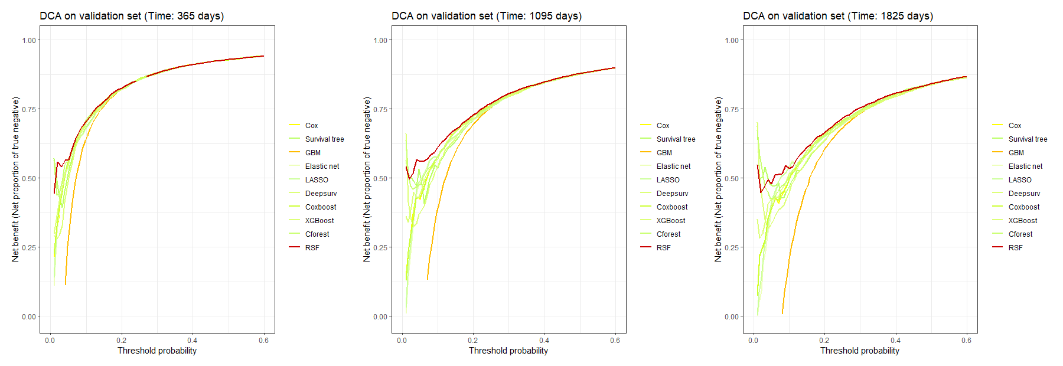
Supplement Figure 1. DCA plot by using the net proportion of true negative as the net benefit.

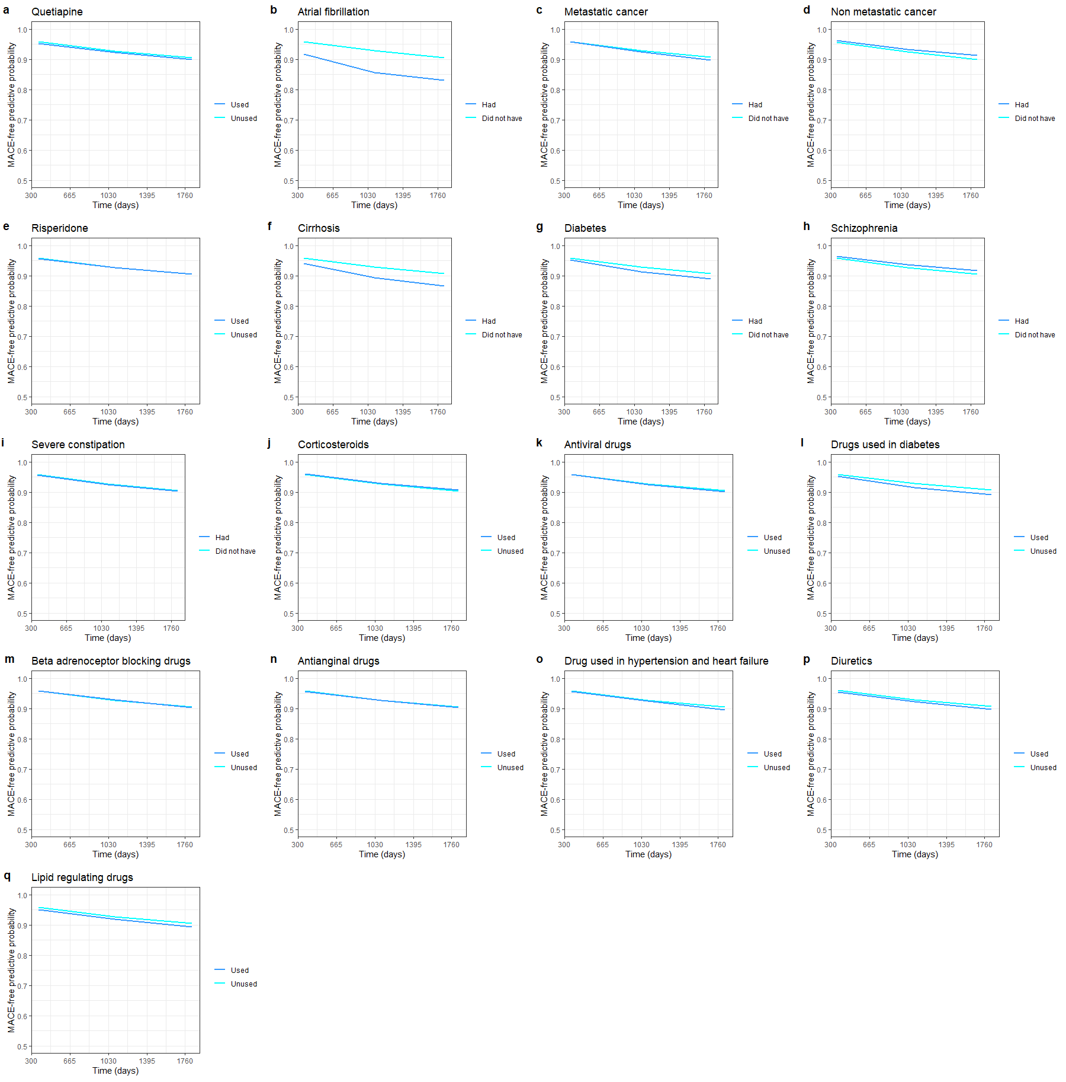
Supplement Figure 2. The rest features time-dependent partial dependence plot.

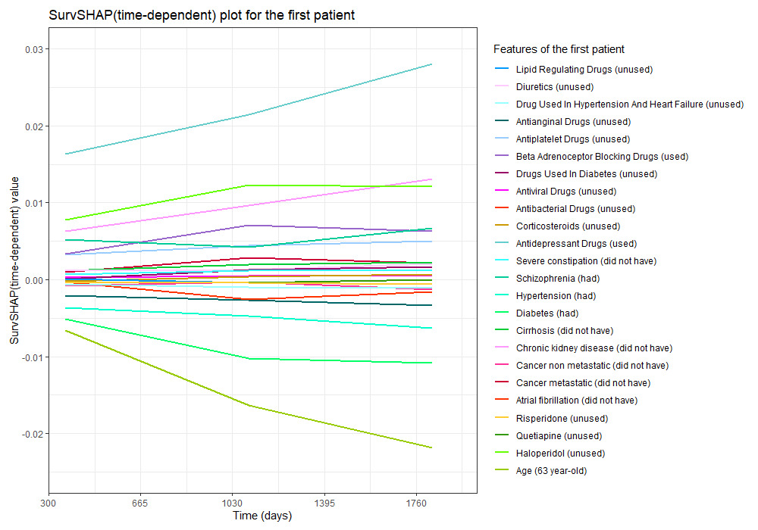
Supplement Figure 3. SurvSHAP plot of the first patient. The positive SurvSHAP value indicates an increased effect on the survival function, and vice versa.

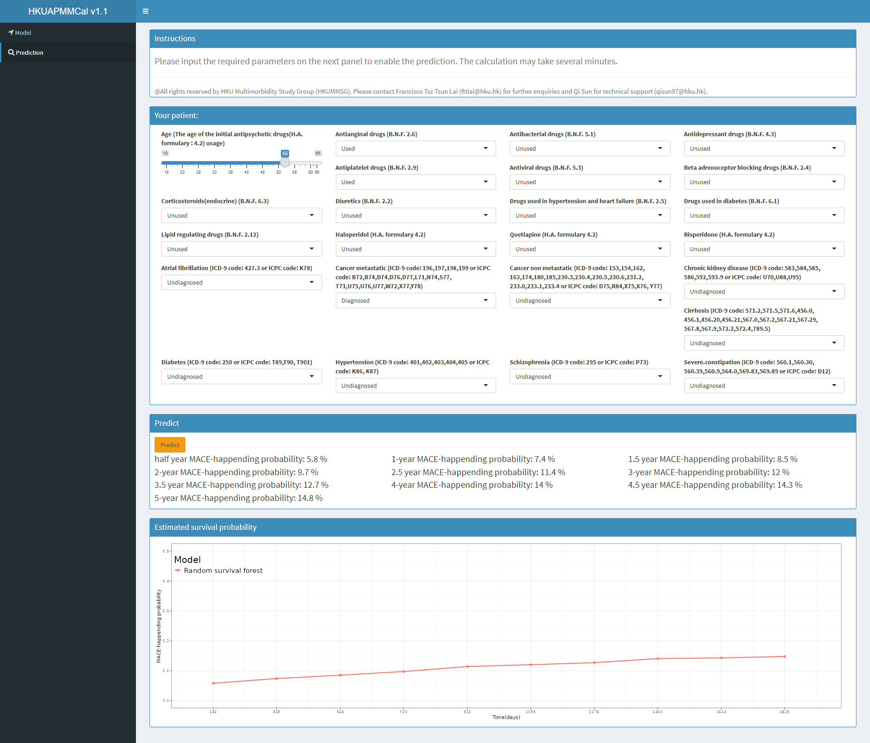
Supplement Figure 4. HKU Antipsychotics Multimorbidity MACE calculator (HKUAPMMCal)

