Supporting Information

Preparation of ultramarine green pigments by recycling of the discarded molecular sieves for green vegetation spectral simulation

Haoyan Zhou^{1,2}, Mei Zu^{1, *}, Xinxuan Tang¹, Yuanxi Chang¹, Shiquan Li¹, Hongrui Yang¹, Chenglong Lv^{2, *}, Haifeng Cheng¹

¹Science and Technology on Advanced Ceramic Fibers and Composites Laboratory, National University of Defense Technology, Changsha 410073, China
²School of Physics and Optoelectronics Engineering, Xiangtan University, Xiangtan 411105, China

Email: zumei2003@163.com (Mei Zu);

These SEM results further demonstrated that discarded molecular sieves contained sodalite structure with a rhombic shape which was confirmed the previous analysis of the crystalline phase^{1,2} (Fig. S1, S2).From the particle size distribution graph, it can be observed that the particle size of all the samples is normally distributed, the smoothness and flatness of a coating is highly dependent on the uniform distribution of pigment particles, The uniformity of the pigment affects the apparent properties of the coating³. It can be observed from Fig. S3 that most of the particle sizes in the samples are below 5 μm and uniformly distributed. Based on the above D50 studies, it can be concluded that the increase in sodium carbonate content results in a larger particle size of the pigment, which is in agreement with SEM results. The SOD structure has excellent thermal stability and is expected to solve the problem of poor weather resistance of hyperspectral materials⁴ (as pretend in Fig. S4). Herein, this green pigment without heavy metals is expected to replace cobalt green, chrome green and other metallic colors in the camouflage pigments from the perspective of the economy and environmental protection.
Fig. S1. SEM images of discarded molecular sieves.

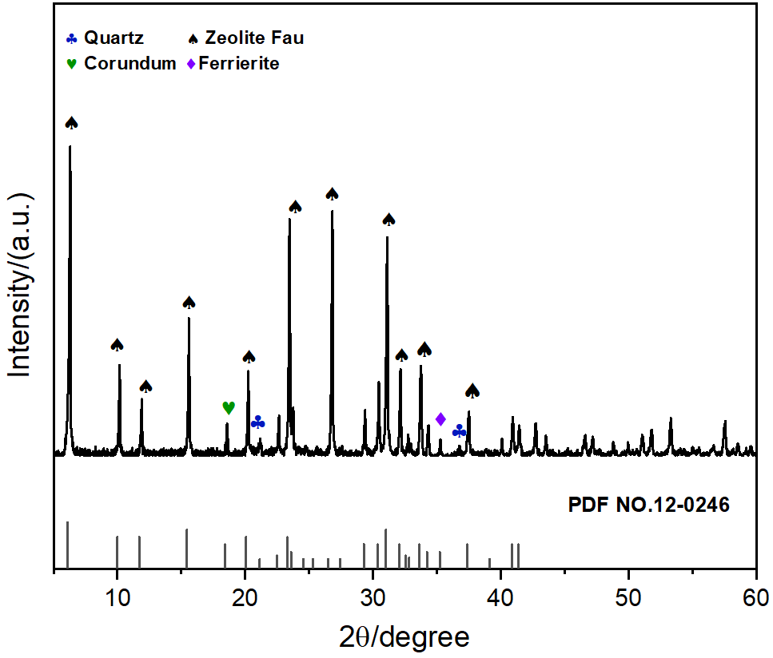
Fig. S2. XRD pattern of discarded molecular sieves.

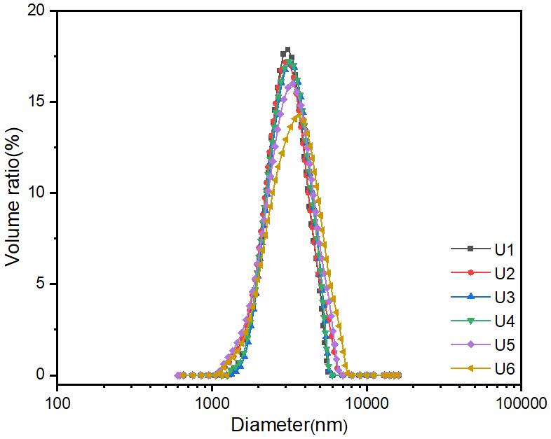
Fig. S3. Particle size analyses of ultramarine.

Fig. S4. TG/DTG curve of U5 sample.

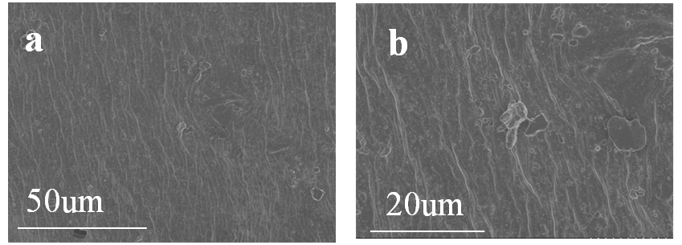
Fig. S5. SEM images of camouflage coating.

References
1 Hsiao, Y.-H., Shen, Y.-H. & Ray, D.-T. Synthesis of Ultramarine from Reservoir Silts. Minerals 7, doi:10.3390/min7050069 (2017).
2 Kowalak, S., Jankowska, A. & Zeidler, S. Ultramarine analogs synthesized from cancrinite. Microporous and Mesoporous Materials 93, 111-118, doi:10.1016/j.micromeso.2006.02.011 (2006).
3 Zhang, M., Feng, L., Zeng, Z., Yang, Y. & Sun, X. Environmentally Friendly High-Near-Infrared Reflectance Blue Pigment YIn0.9–xMn0.1MxO3−δ Based on Li/Zn Doping. ACS Sustainable Chemistry & Engineering 10, 13877-13886, doi:10.1021/acssuschemeng.2c04967 (2022).
4 Škvarlová, A. et al. Preparation and characterization of ultramarine blue pigments from fly ash by using the X-ray photoelectron spectroscopy (XPS) for the determination of chemical states of sulphur in chromophores. Microporous and Mesoporous Materials 284, 283-288, doi:10.1016/j.micromeso.2019.04.039 (2019).

