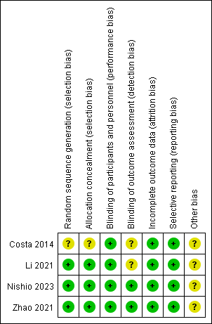
Fig S1. Risk of bias assessments for randomized clinical trials.
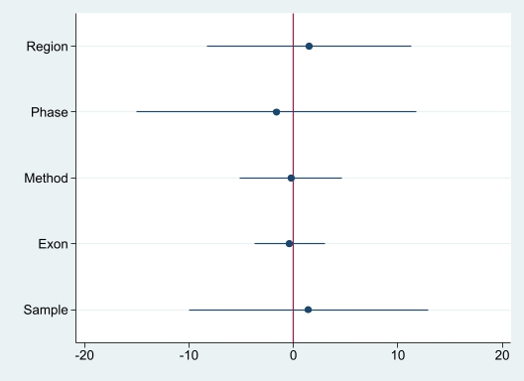
Fig S2. Coefplot of the results of meta-regression.
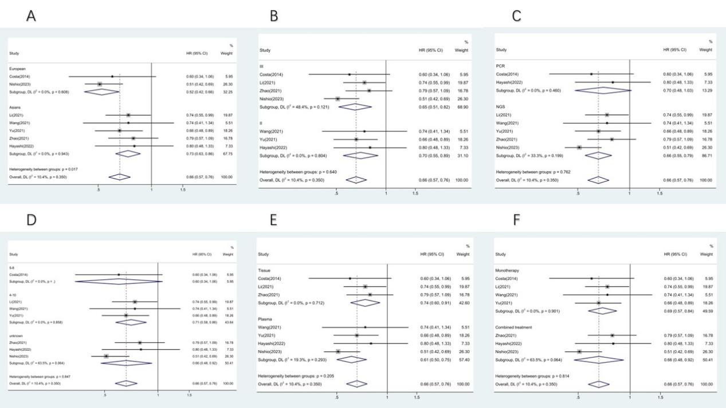
Fig S3. Subgroup analysis of PFS.
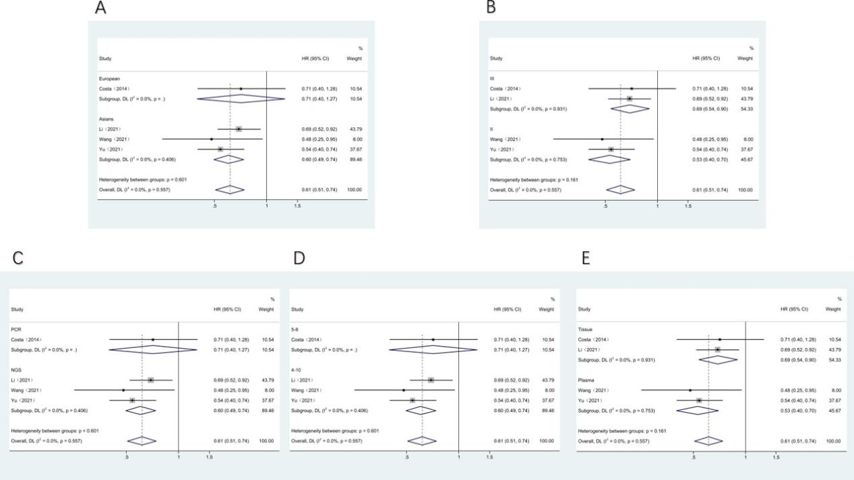
Fig S4. Subgroup analysis of OS.
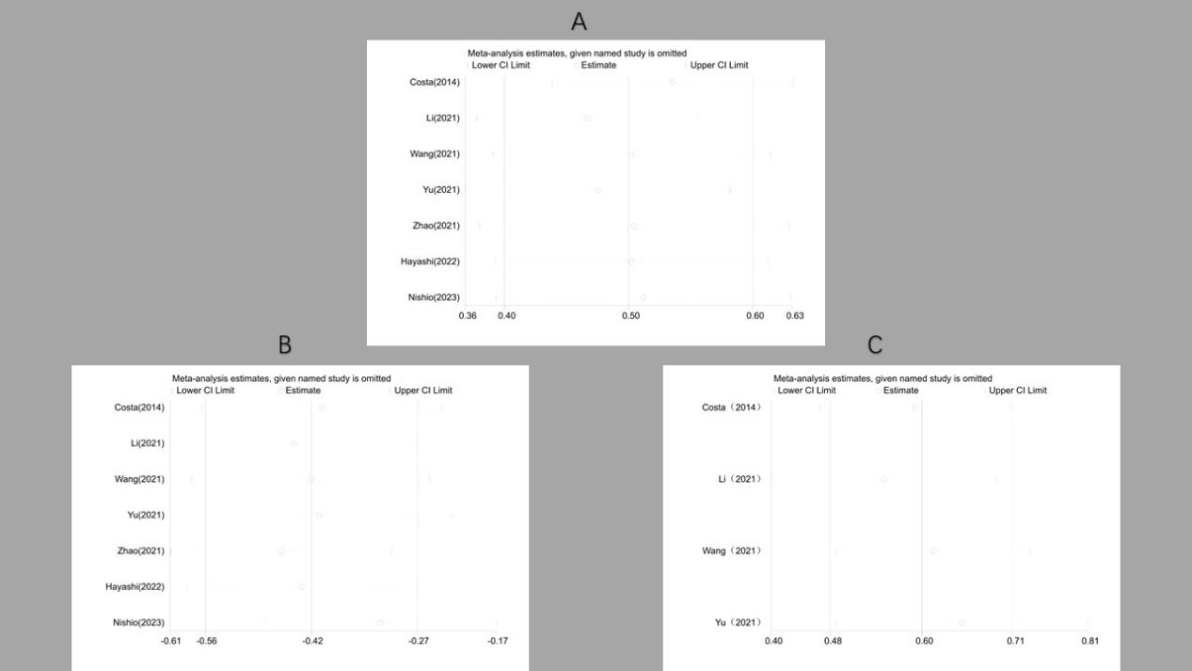
Fig S5.Sensitivity analysis. Sensitivity analysis for incidence (A); Sensitivity analysis for PFS (B); Sensitivity analysis for OS (C).
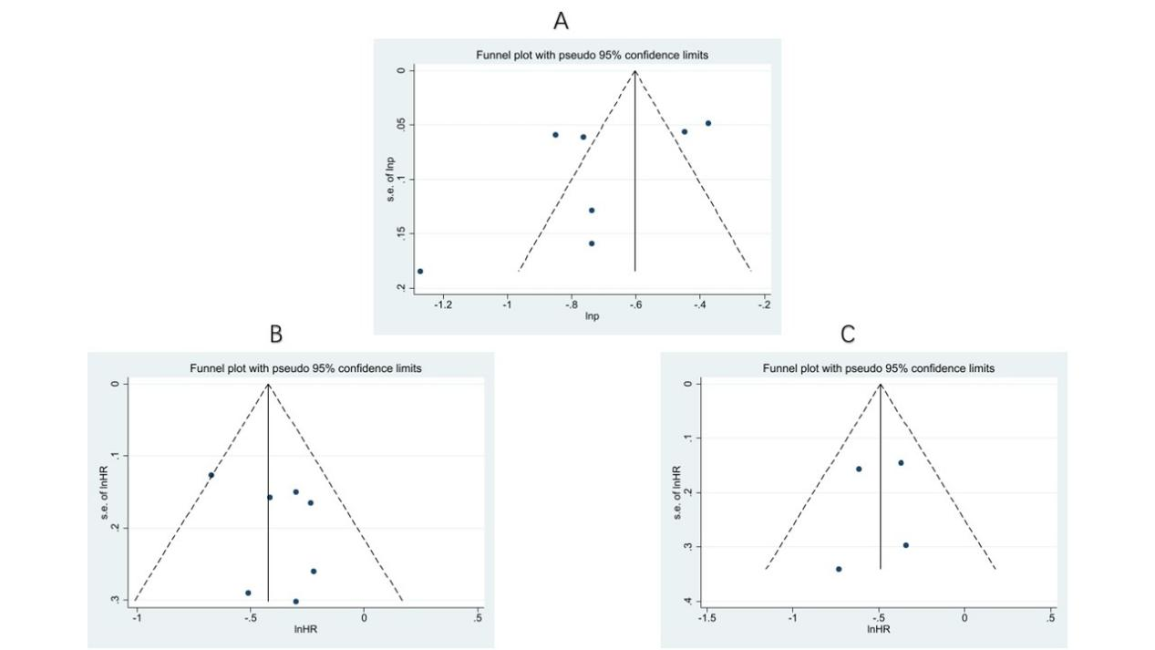
Fig S6.The Funnel graphs of publication bias of incidence (A), PFS (B) and OS (C).
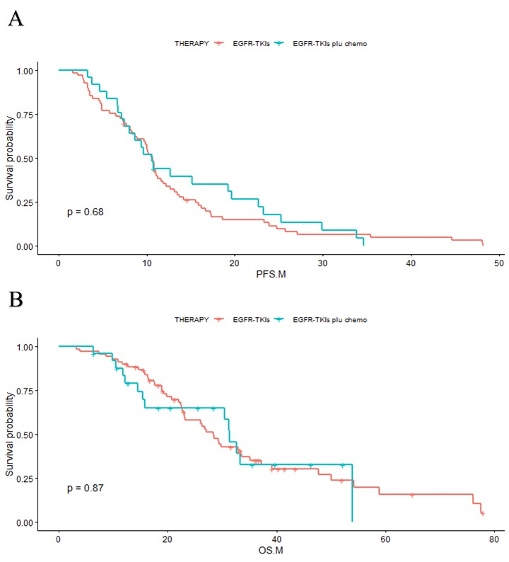
Fig S7.The Kaplan-Meier curves of PFS(A) and OS(B) of each subgroup based on their treatment regiments

Table S1. Search strategy
((((((((((((((Carcinoma, Non-Small-Cell Lung) OR (Carcinoma, Non Small Cell Lung)) OR (Carcinomas, Non-Small-Cell Lung)) OR (Lung Carcinoma, Non-Small-Cell)) OR (Lung Carcinomas, Non-Small-Cell)) OR (Non-Small-Cell Lung Carcinomas)) OR (Non-Small-Cell Lung Carcinoma)) OR (Non Small Cell Lung Carcinoma)) OR (Carcinoma, Non-Small Cell Lung)) OR (Non-Small Cell Lung Carcinoma)) OR (Non-Small Cell Lung Cancer)) OR (Nonsmall Cell Lung Cancer)) OR (NSCLC)) AND ((((((EGFR) OR (Receptors, ErbB)) OR (ErbB Receptor)) OR (Epidermal Growth Factor Receptor)) OR (Epidermal Growth Factor Receptor Kinase)) OR (Epidermal Growth Factor Receptor Protein-Tyrosine Kinase))) AND (((((TP53) OR (Genes, p53)) OR (TP53 Genes)) OR (Genes, TP53)) OR (TP53 Gene))

Table S2. Details of gene alteration in the included studies
Study | Year | Patients | EGFR mutation profile | Methods of TP53 Detected | Exon  of TP53 Detected | Sample  of TP53 Detected | DCR  (TP53 mutation) | ORR  (TP53 mutation)
Costa et al.^{[25]} | 2014 | 82 | Exon 19 deletion  Exon 21 L858R mutation | PCR | 5-8 | Tissue | NR | NR
Li et al.^{[26]} | 2021 | 195 | Exon 19 deletion  Exon 21 L858R mutation | NGS | 2,4-10 | Tissue | 85.8% | 55.2%
Wang et al.^{[27]} | 2021 | 69 | Exon 19 deletion  Exon 21 L858R mutation | NGS | 2,4-10 | Plasma | NR | NR
Yu et al.^{[28]} | 2021 | 180 | Exon 19 deletion  Exon 21 L858R mutation | NGS | 4-10 | Plasma | 67.8% | Error*
Zhao et al.^{[29]} | 2021 | 311 | Exon 19 deletion  Exon 21 L858R mutation | NGS | unknown | Tissue  Plasma | NR | NR
Hayashi et al.^{[30]} | 2022 | 46 | Exon 19 deletion  Exon 21 L858R mutation | PCR | unknown | Plasma | NR | NR
Nishio et al.^{[31]} | 2023 | 386 | Exon 19 deletion  Exon 21 L858R mutation | NGS | unknown | Plasma | 95% | 79%
Note:
NR: No report; PCR: Polymerase Chain Reaction; NGS: Next-Generation Sequencing
Error*: After our review, we considered that the result of this article contained obvious error.

Table S3. Quality assessment of the non-comparative single-arm clinical trials included in the meta-analysis.
Study | Q1 | Q2 | Q3 | Q4 | Q5 | Q6 | Q7 | Q8 | Score†
Wang et al.^{[27]} | 2 | 2 | 2 | 2 | 0 | 2 | 2 | 2 | 14
Yu et al.^{[28]} | 2 | 2 | 2 | 2 | 0 | 2 | 2 | 2 | 14
Hayashi et al.^{[30]} | 2 | 2 | 2 | 2 | 0 | 2 | 2 | 1 | 13
Numbers Q1-Q8 in heading signified:
Q1: A clearly stated aim: the question addressed should be precise and relevant in the light of available literature
Q2: Inclusion of consecutive patients: all patients potentially fit for inclusion (satisfying the criteria for inclusion) have been included in the study during the study period (no exclusion or details about the reasons for exclusion)
Q3: Prospective collection of data: data were collected according to a protocol established before the beginning of the study
Q4: Endpoints appropriate to the aim of the study: unambiguous explanation of the criteria used to evaluate the main outcome which should be in accordance with the question addressed by the study. Also, the endpoints should be assessed on an intention-to-treat basis.
Q5: Unbiased assessment of the study endpoint: blind evaluation of objective endpoints and double-blind evaluation of subjective endpoints. Otherwise the reasons for not blinding should be stated
Q6: Follow-up period appropriate to the aim of the study: the follow-up should be sufficiently long to allow the assessment of the main endpoint and possible adverse events
Q7: Loss to follow up less than 5%: all patients should be included in the follow up. Otherwise, the proportion lost to follow up should not exceed the proportion experiencing the major endpoint
Q8: Prospective calculation of the study size: information of the size of detectable difference of interest with a calculation of 95% confidence interval, according to the expected incidence of the outcome event, and information about the level for statistical significance and estimates of power when comparing the outcomes
†The items are scored 0 (not reported), 1 (reported but inadequate) or 2 (reported and adequate

