Captions for Supplementary Figures S1-S13
Figure S1 | Fluorescence-activated nuclei sorting of midbrain tissue homogenate.
Figure S2 | QC of RNAseq data.
Figure S3 | Variance explained by identified covariates in gene expression of non-neurons
Figure S4 | Enrichment of SCZ-associated genes in brain and non-brain related traits using MAGMA.
Figure S5 | SCZ-associated changes in dopa neurons at FDR 0.10
Figure S6 | Gene expression in BD vs controls in Dopa and non-neurons.
Figure S7 | SCZ-associated transcriptomic changes in the midbrain and two cortical regions.
Figure S8 | Covariate Variance and Differential Gene Regulation by limma and RE2C Analyses.
Figure S9 | Analyzing concordant and discordant genes.
Figure S10 | Enrichment of RE2C genes in brain and non-brain related traits at FDR 0.1.
Figure S11 | QC of HiC dataset.
Figure S12 | CTCF and Histone marks (active and inactive) enrichment at TAD boundaries in Dopa neurons (left) and Non-neurons (right).
Figure S13 | Optimizing TAD calling window size.

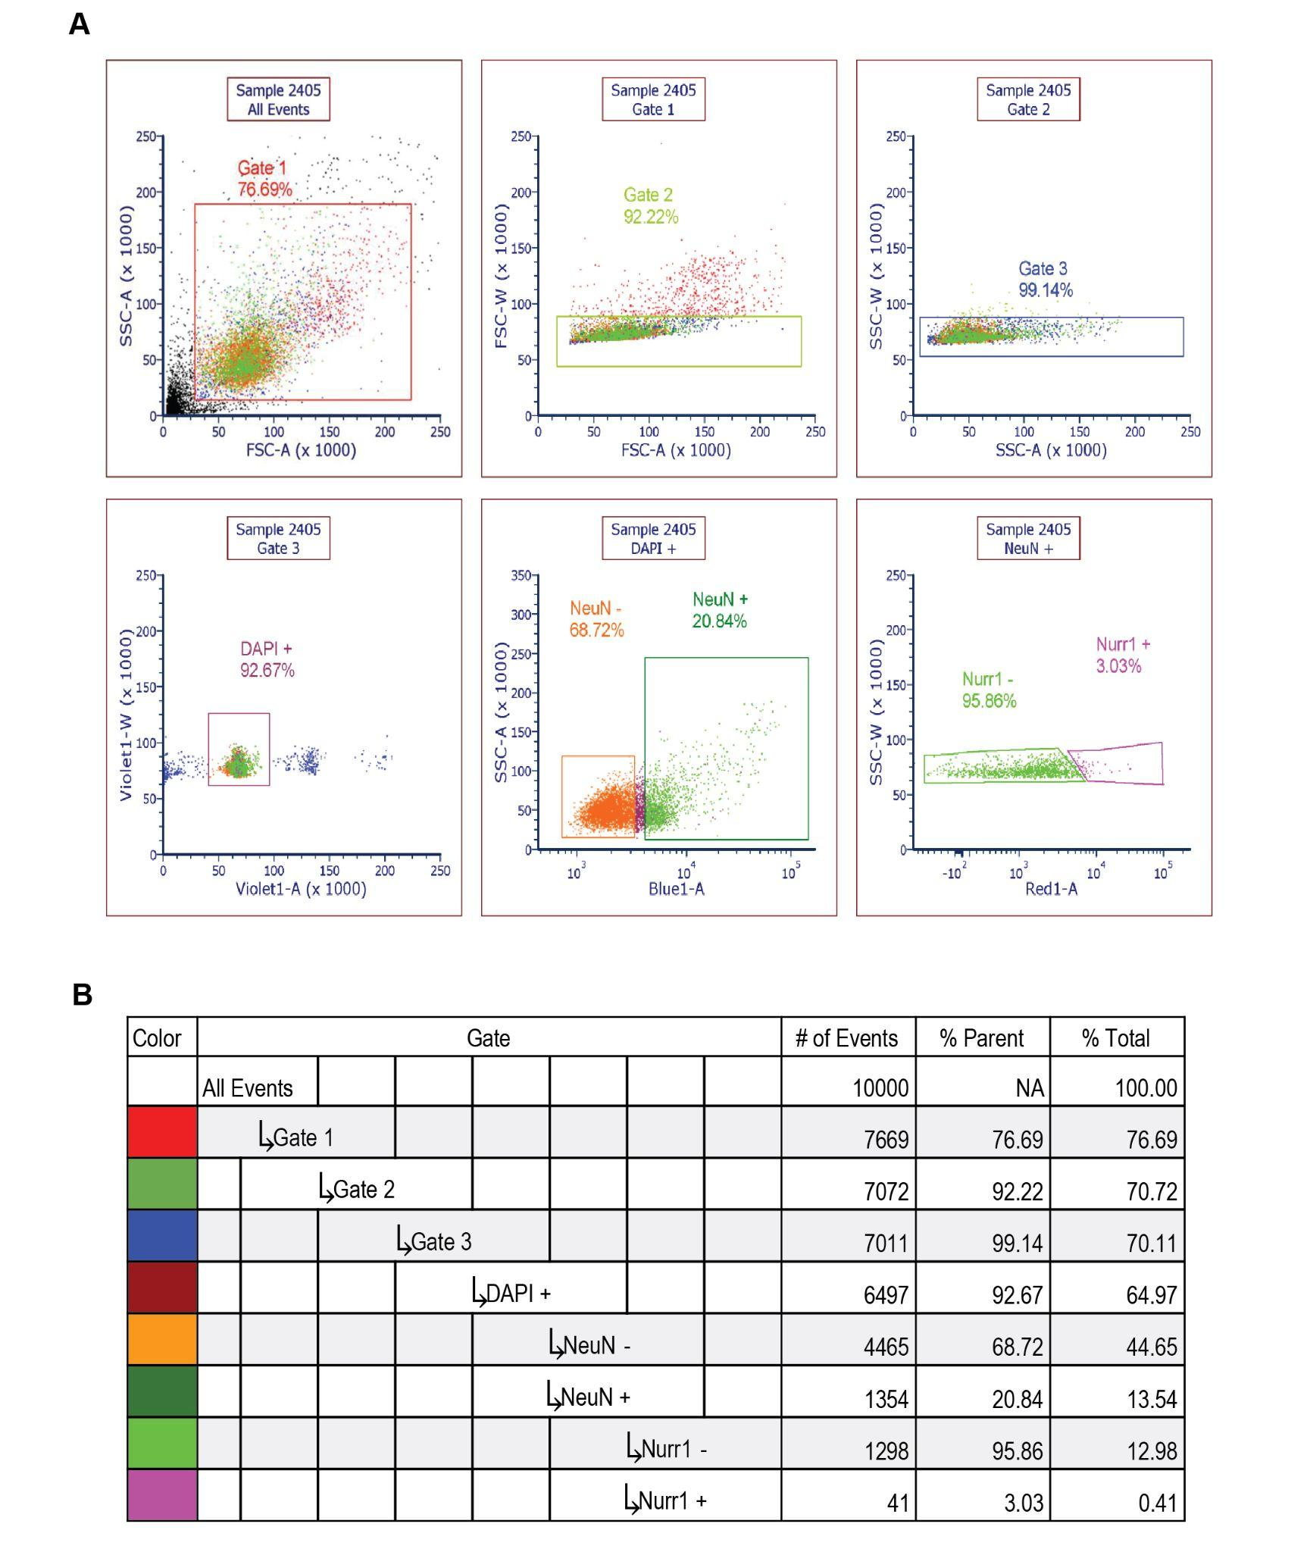

Figure S1 | Fluorescence-activated nuclei sorting of midbrain tissue homogenate. (A) Fluorescence-Activated Nuclei Sorting (FANS) gating strategies on unfixed samples. Each graph is derived from the previous gated population. Gates 1-3 filtered out debris and nuclei doublets; ‘DAPI+’ gate selected for intact nuclei stained with DAPI; ‘NeuN+’ and ‘NeuN-’ gating selected for neuronal and non-neuronal nuclei, respectively, using Alexa 488 staining; ‘Nurr1+’ and ‘Nurr1-’ gating selected for dopa and non-dopa neurons, respectively, using Alexa 647 staining. (B) Gating hierarchy showing population derivatives, number of events, and population percentages of each gated population, relative to the parent gate and relative to the total sample, at a snapshot time point of 10,000 events during the sample run.

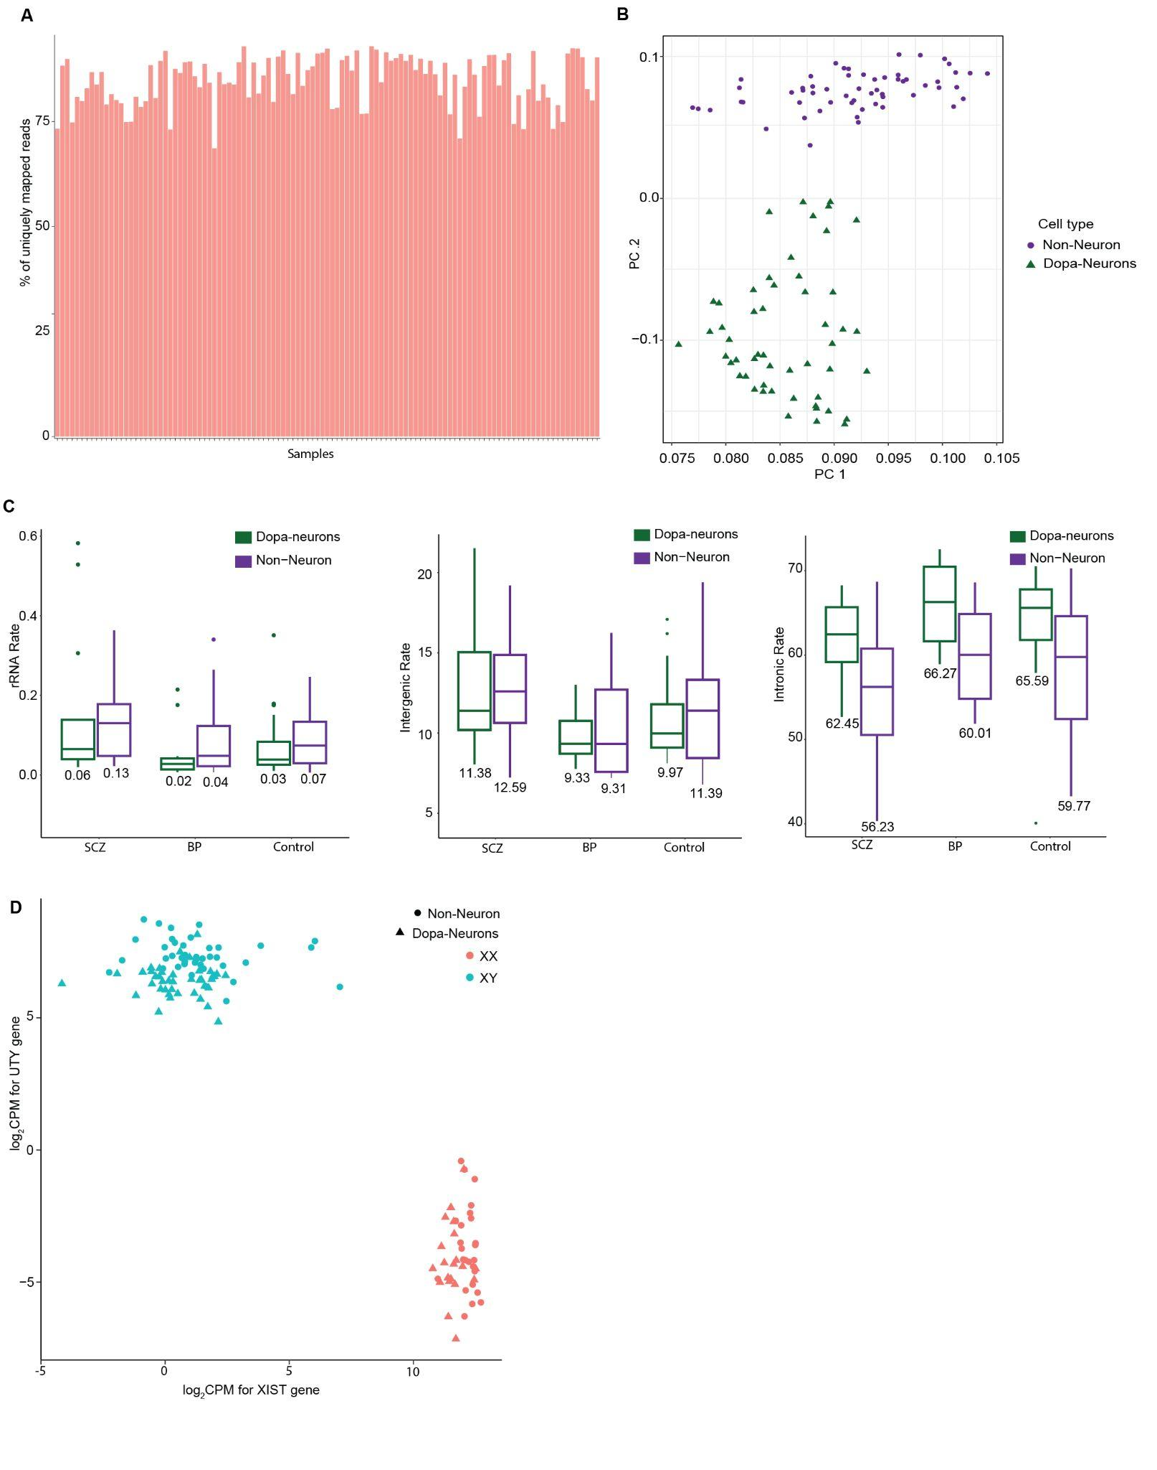

Figure S2 | Quality control metrics of RNAseq data. (A) Percentage of RNA reads aligned to the reference genome. (B) Principal components analysis of log2CPM values from RNA-seq. (C) RNA-seq quality control metrics stratified by disease status. Left plot (rRNA Rate) displays the rRNA rate across different diagnosis groups: SCZ, BD, and Controls. rRNA rate is shown separately for dopa neurons (green) and non-neuronal cells (purple). Middle plot (Intergenic Rate) represents the intergenic rate for SCZ, BP, and Controls. Similar to the left plot, dopa neurons (green) and non-neuronal cells (purple) are compared. Right plot (Intronic Rate) shows the intronic rate by diagnosis for SCZ, BD, and Controls. Dopa neurons (green) tend to have slightly lower intronic rates compared to non-neuronal cells (purple), with median values provided for each group. Box plots are depicted with the center line indicating the median, the box representing the interquartile range (between the 25th and 75th percentiles), and whiskers extending to the lowest and highest values within 1.5 times the interquartile range from the median. (D) The plot of log2CPM expression of UTY gene from chrY against XIST gene from chrX in order to validate reported sex.

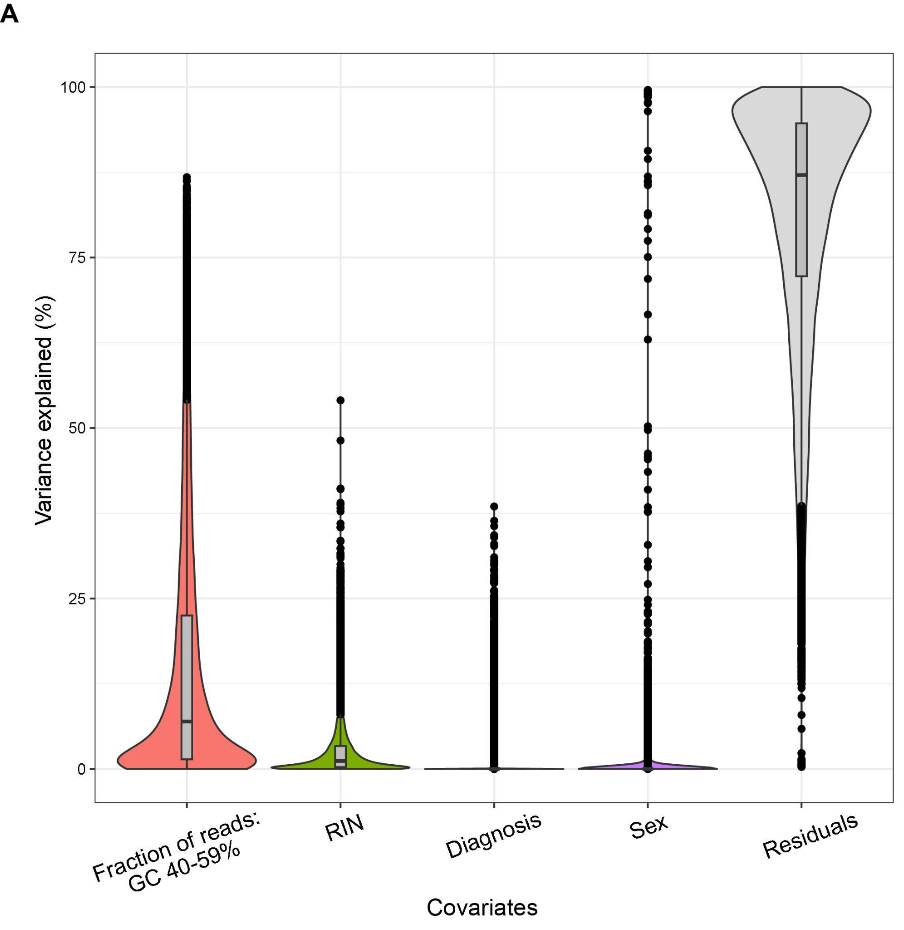

Figure S3 | Variance explained by identified covariates in gene expression of non-neurons. (A) Violin plots to show the distribution of variance in non-neuronal gene expression for biological and technical covariates. Box plots are depicted with the center line indicating the median, the box representing the interquartile range (between the 25th and 75th percentiles), and whiskers extending to the lowest and highest values within 1.5 times the interquartile range from the median. Dots are used to indicate potential outliers beyond this range. RIN (RNA Integrity Number is a measure of RNA quality).

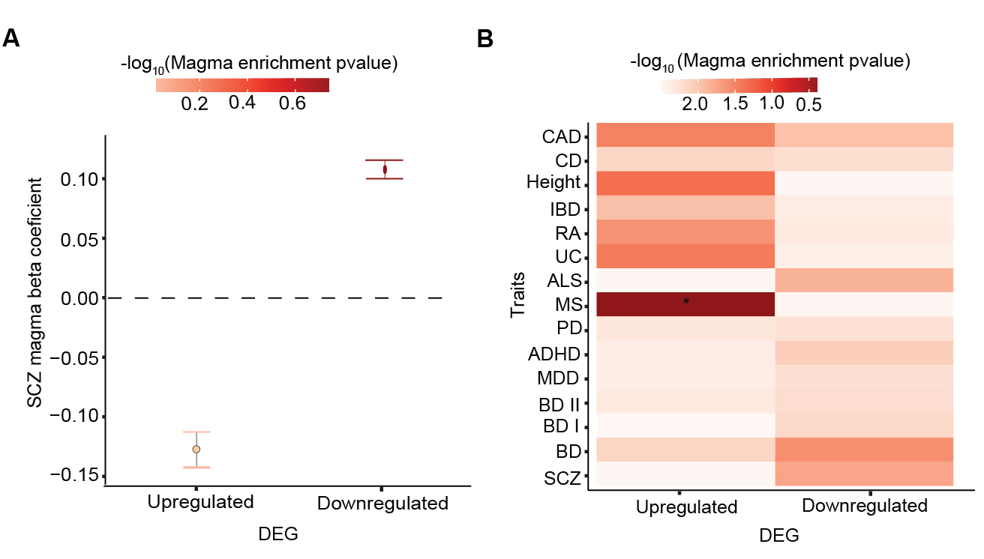
Figure S4 | Enrichment of SCZ-associated genes at FDR<.05 in brain and non-brain related traits using MAGMA (Table 3.F). (A) Coefficient of enrichment of common SCZ risk variants using MAGMA for SCZ-associated genes at FDR 0.05. (B) Heat map of MAGMA enrichment P values of brain-related and non-brain-related GWAS traits at FDR 0.05. ‘#’: significant MAGMA enrichment coefficient after FDR correction of multiple testing across all tests in the plot (Benjamini–Hochberg test); ‘*’: nominally significant for enrichment.

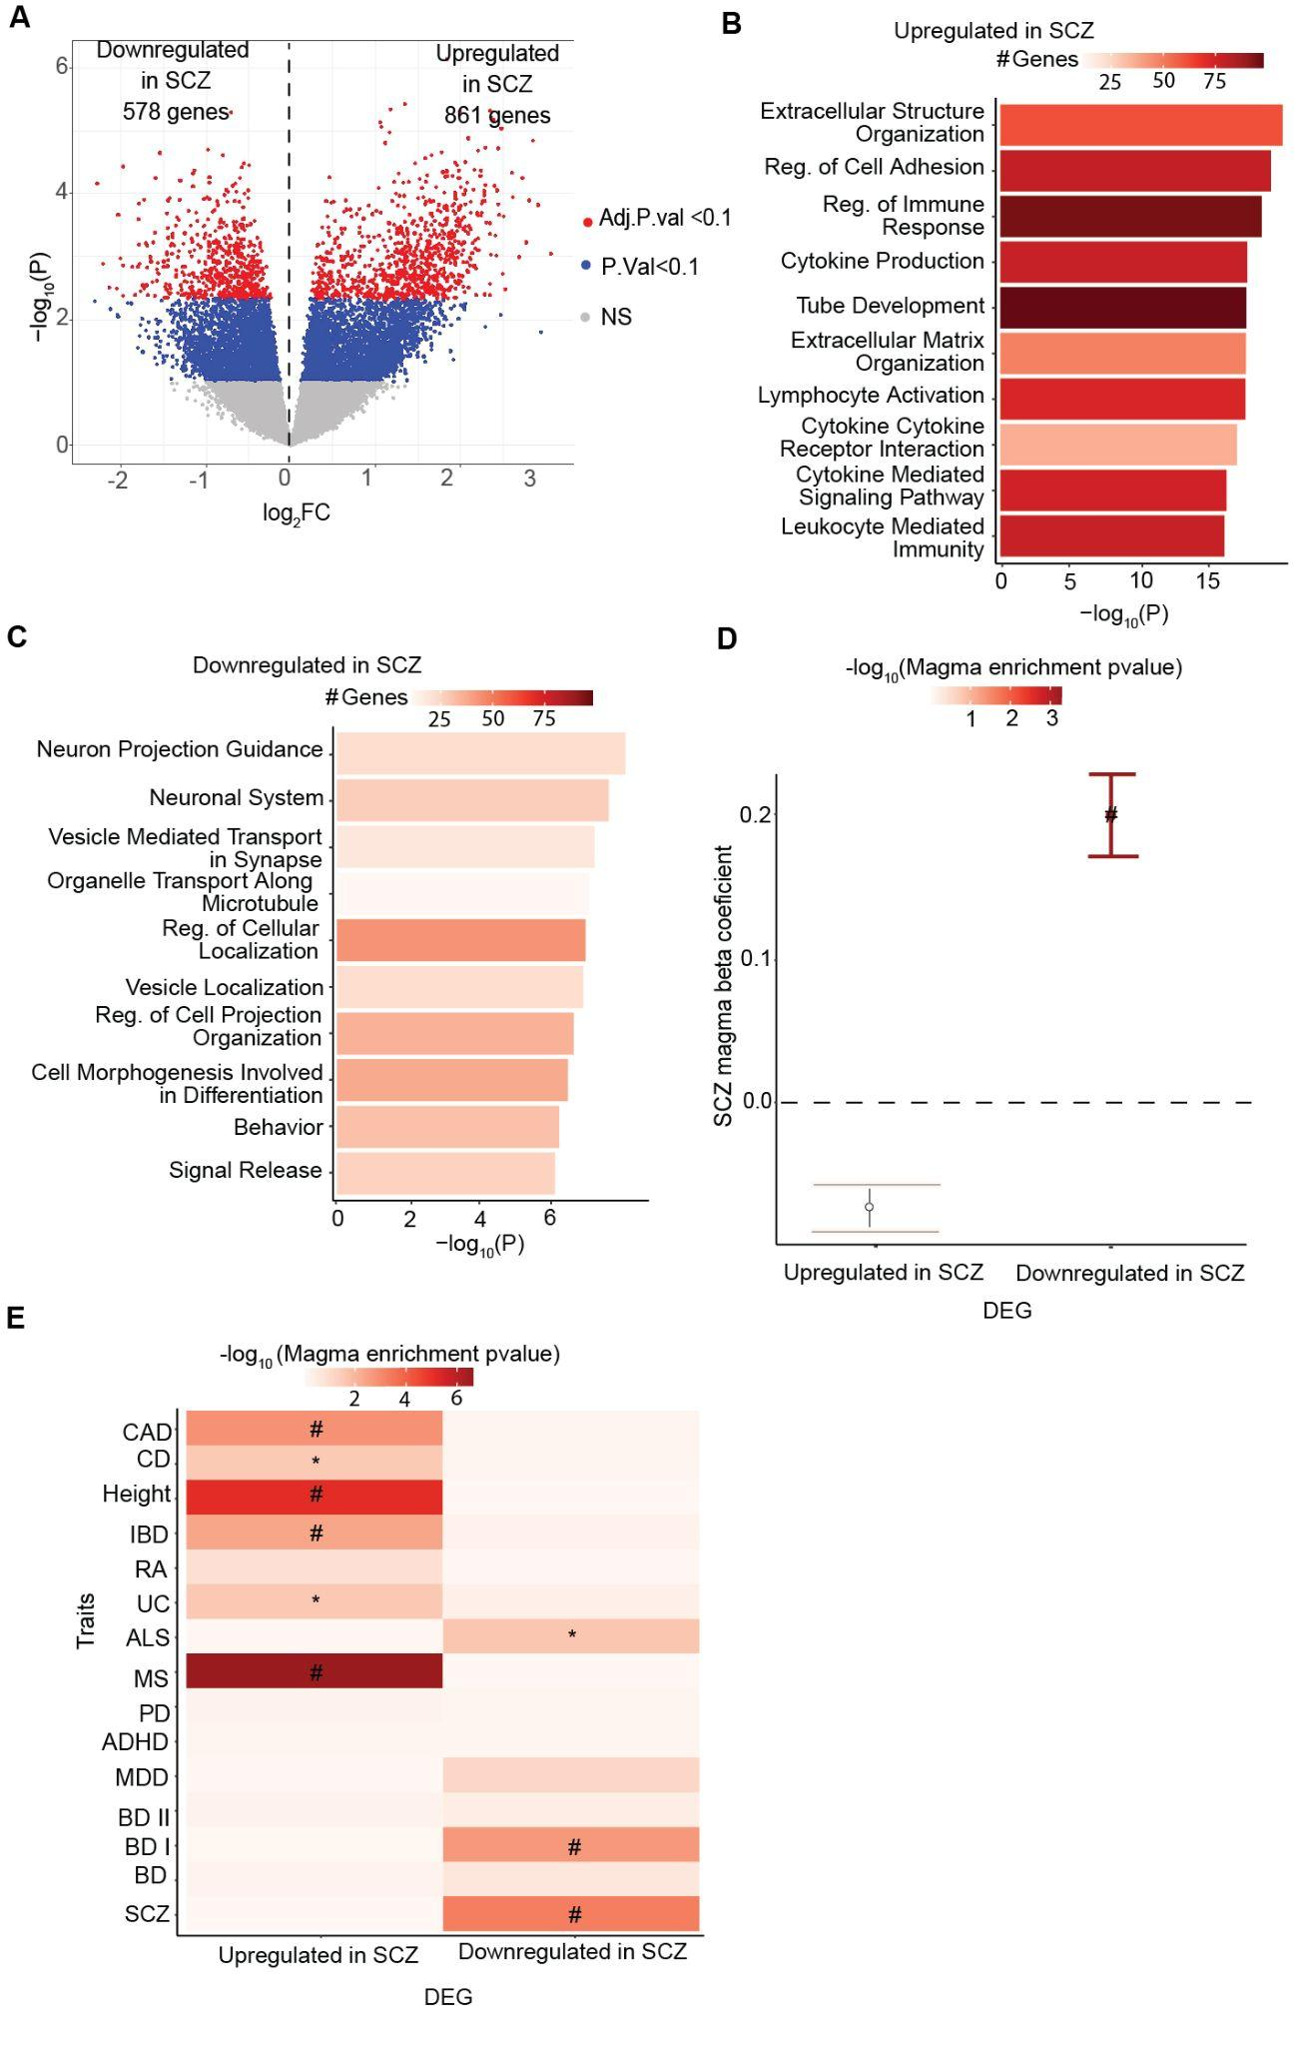

Figure S5 | SCZ-associated changes in dopa neurons at FDR<0.10. (Table 3.H) (A) Volcano plot of -log₁₀P vs. log₂FC (SCZ vs Controls) from limma analysis on 14 SCZ and 28 Controls samples. SCZ-specific genes shown in blue are nominally significant at P < .10 and the ones in red are significant at FDR < .10. (C) Bar plot depicting the enrichment -log₁₀(P) downregulated genes in GO pathways and color of the bar plot showing the number of genes overlapped with each pathway. (D) Coefficient of enrichment of common schizophrenia risk variants using MAGMA for SCZ associated genes. (E) Heat map of MAGMA enrichment P values of brain-related and non-brain-related GWAS traits. ‘#’: significant MAGMA enrichment coefficient after FDR correction of multiple testing across all tests in the plot (Benjamini–Hochberg test); ‘*’: nominally significant for MAGMA enrichment at P < .05 .

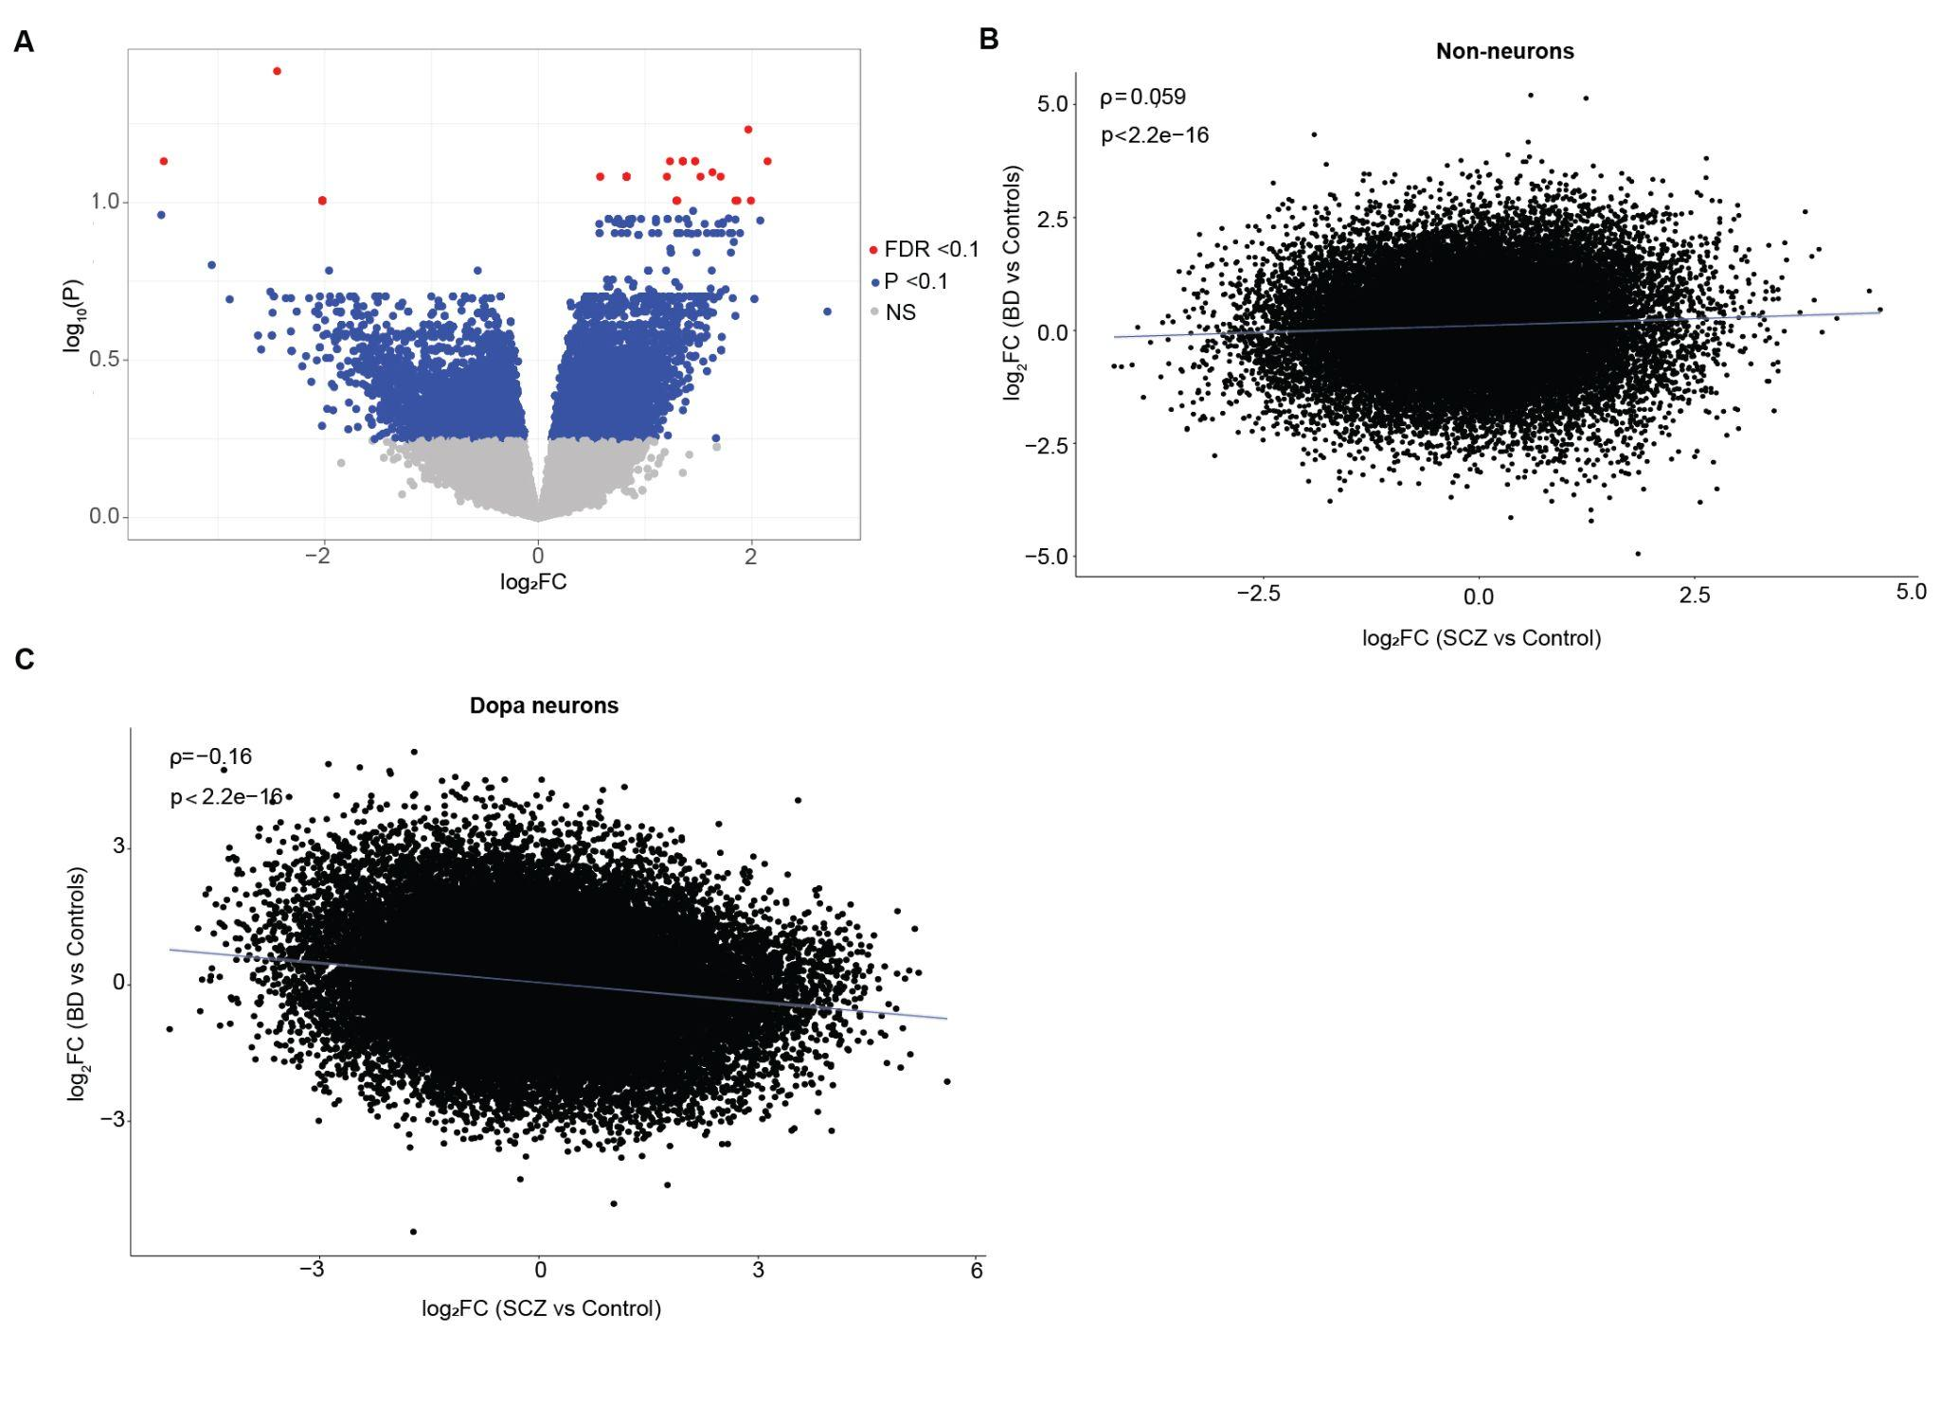

Figure S6 | Concordance of BD specific and SCZ specific changes in dopa neurons and non-neurons. (A) Volcano plot representing log₂FC(BD vs Controls) versus -log₁₀(P) from the DREAM limma analysis. Genes with FDR < 0.1 are highlighted in red, and those with P < 0.1 are shown in blue. Non-significant genes are shown in grey. (B,C) Spearman correlation of log₂FC(SCZ vs Controls) and log₂FC(BD vs Controls) in non-neurons and dopa neurons are shown in B and C respectively.

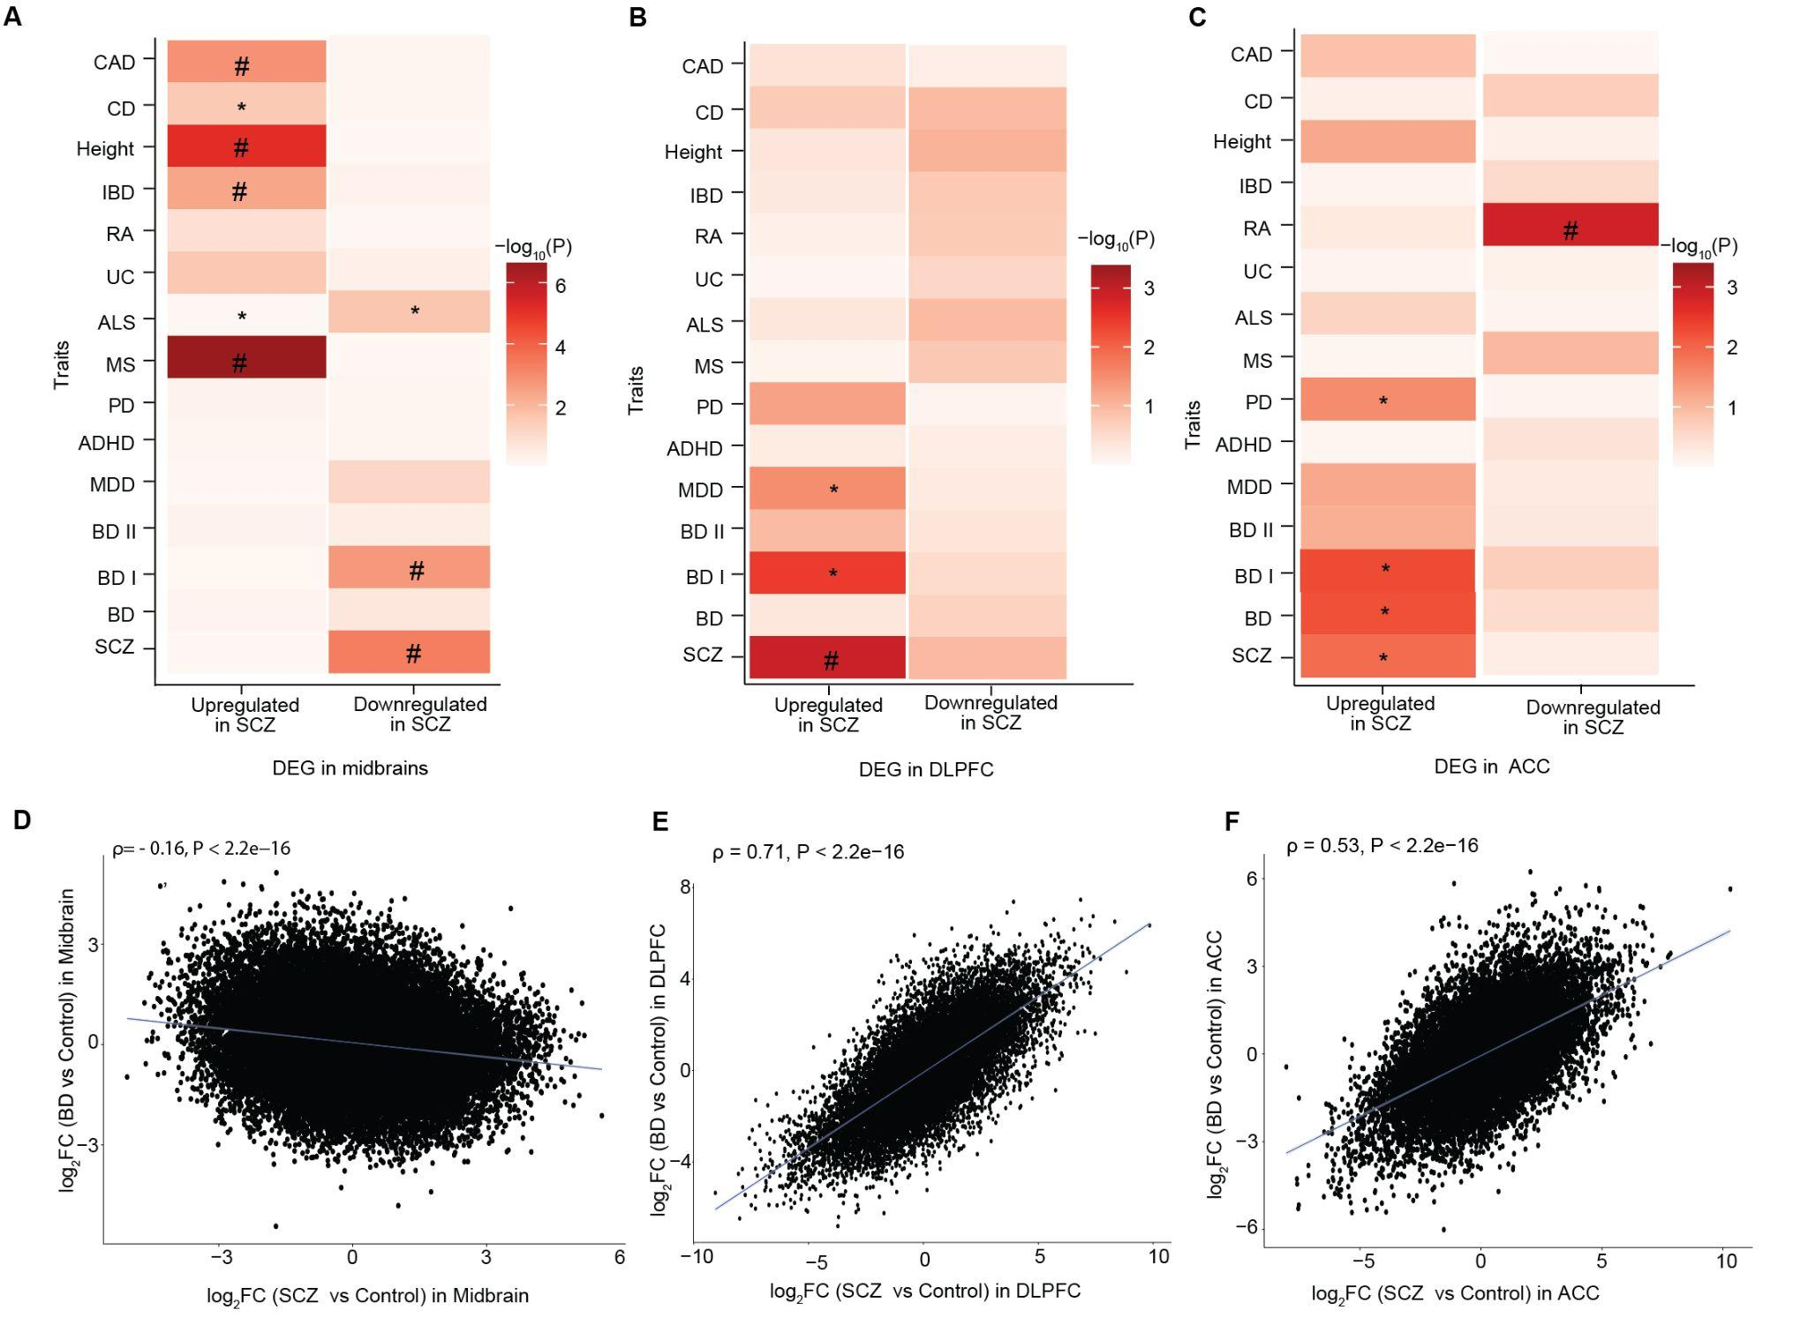

Figure S7 | SCZ-associated transcriptomic changes in the midbrain and two cortical regions (Table S3.I). (A-C) Heatmap of MAGMA enrichment P values of brain-related and non-brain-related GWAS traits for SCZ associated genes in midbrain (FDR<.10), DLPFC(FDR<.05), and ACC(FDR<.05) respectively. Here, ‘#’: significant MAGMA enrichment coefficient after FDR correction of multiple testing across all tests in the plot (Benjamini–Hochberg test); ‘*’: nominally significant for MAGMA enrichment at P<.05. (D-F) Spearman correlation of log₂FC(SCZ vs Controls) and log₂FC(BD vs Controls) in the midbrain, DLPFC, and ACC are shown in D, E and F respectively.

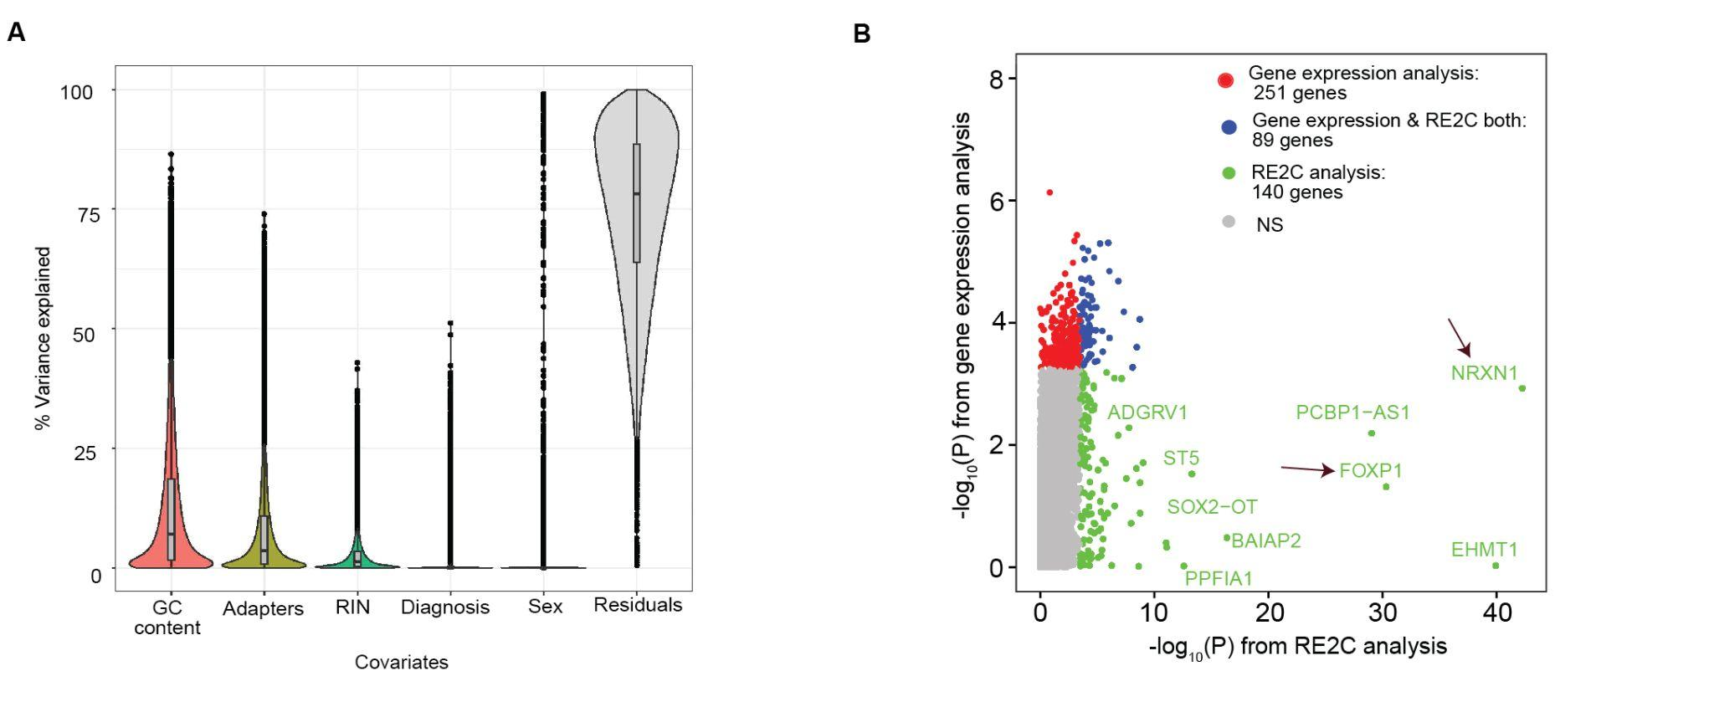

Figure S8 | Covariates in transcript expression and comparison of limma and RE2C statistics. (A) Violin plots to show the distribution of variation in expression of transcripts for biological and technical covariates in dopa neurons. The box represents the interquartile range (between the 25th and 75th percentiles), and whiskers extend to the lowest and highest values within 1.5 times the interquartile range from the median. Dots are used to indicate potential outliers beyond this range. RIN (RNA Integrity Number is a measure of RNA quality). (B) The plot shows a comparison between -log₁₀(P) from a gene expression (limma) analysis and -log₁₀(P) from RE2C analysis. DEGs that were only identified by limma analysis are shown in red, DEGs that were only identified by RE2C analysis are shown in green, and DEGs that were detected by both methods are shown in blue.

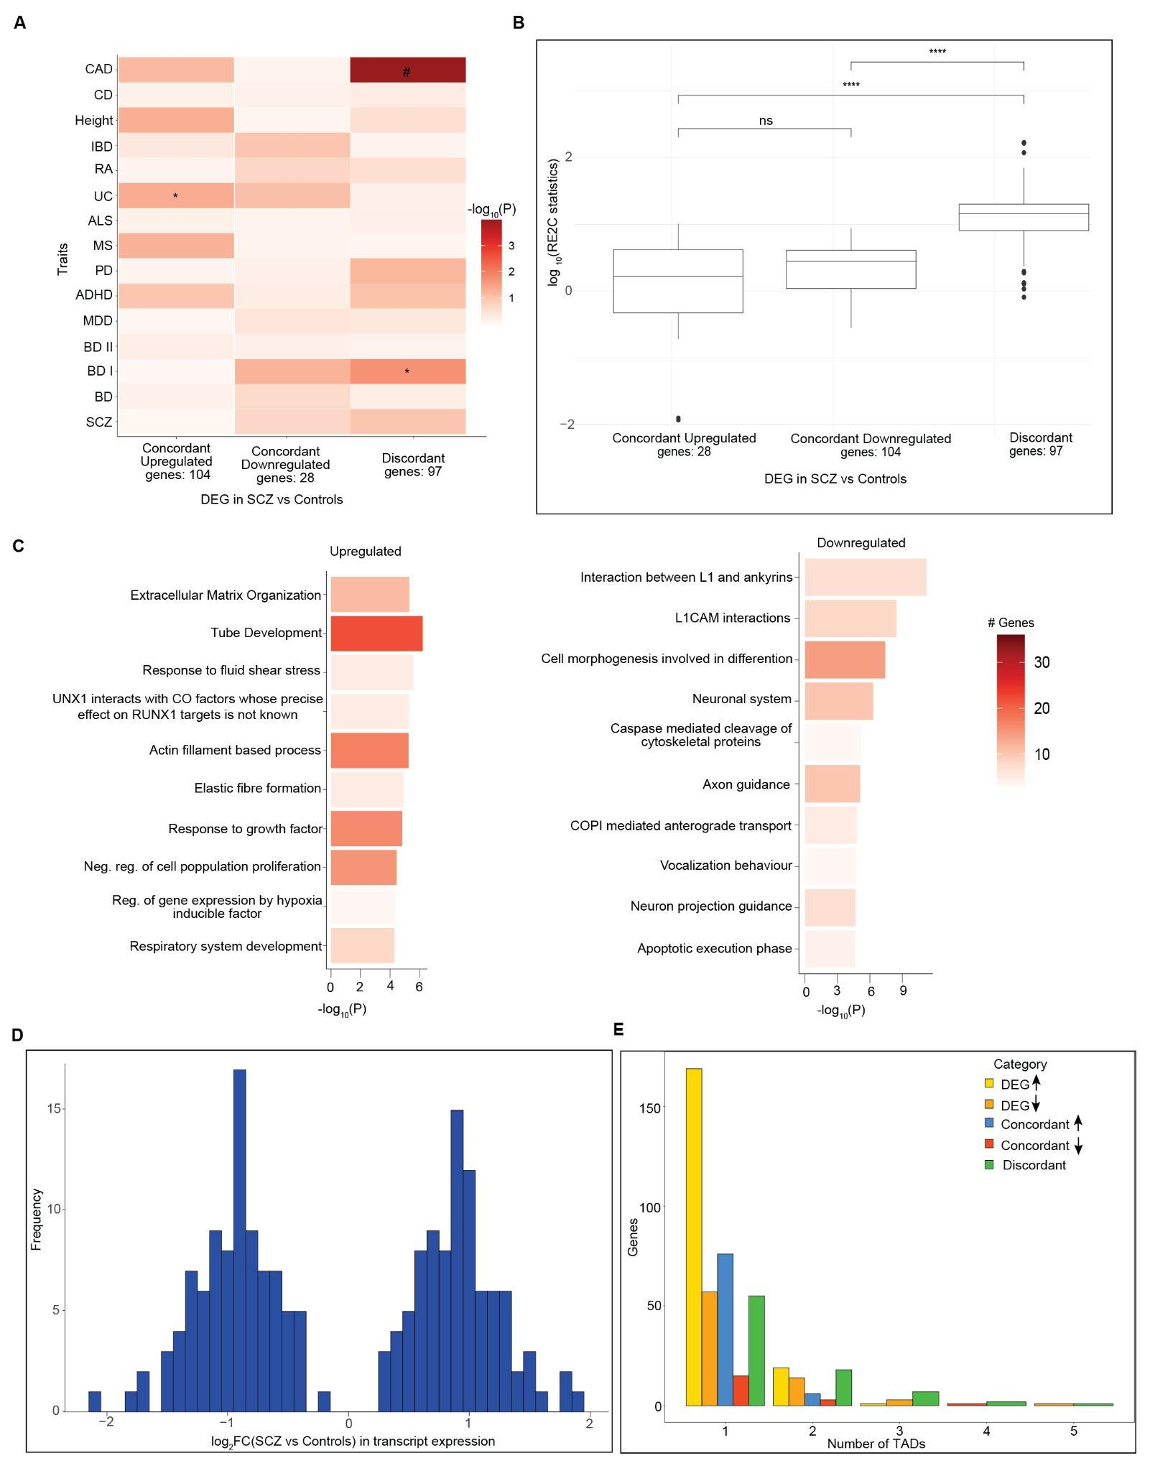

Figure S9 | Analyzing concordant and discordant genes. (A) Heat map of MAGMA enrichment P values of brain-related and non-brain-related GWAS traits in RE2C detected concordant upregulated (n=28), concordant downregulated (n=104), and discordant SCZ-specific genes (n=97) at FDR<.05. ‘#’: significant MAGMA enrichment coefficient after FDR correction of multiple testing across all tests in the plot (Benjamini–Hochberg test); ‘*’: nominally significant for MAGMA enrichment at P < .05. (B) The box plot represents the distribution of the overall mean effect sizes, measured as log₁₀(RE2C statistics), for three categories of genes: concordant upregulated, concordant downregulated, and discordant genes. Statistical significance between the categories is denoted above the box plots: “ns” indicates no significant difference, while **** indicates a high significant difference. (C) Functional analysis of all differentially expressed genes between SCZ vs control identified by RE2C at FDR < 0.05. Bar plot depicting the enrichment -log₁₀(P) upregulated (left) and downregulated(right) genes in GO pathways and the color of the bar plot shows the number of genes overlapped with each pathway. (D) Histogram of log₂FC(SCZ vs. Controls) in transcripts expression obtained from dream-limma analysis for 97 discordant genes. (E) The bar plot shows the number of genes with at least one base pair overlapping with TAD genomic regions on the y-axis while the x-axis represents the number of TADs. The color of the bars shows: DEG upregulated, DEG downregulated, concordant upregulated, concordant downregulated, and discordant.

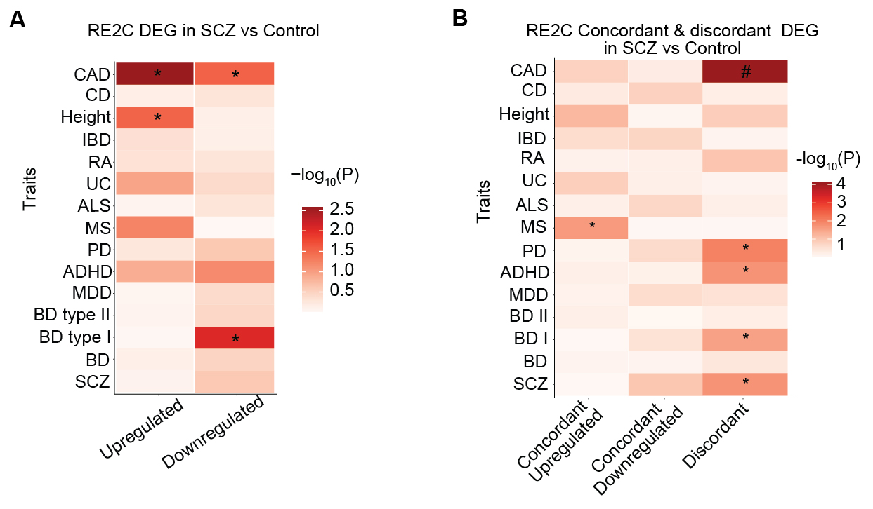

Figure S10 | Enrichment of RE2C genes in brain-related and non-brain-related GWAS traits. A, B) Heatmap of MAGMA enrichment P values of brain-related and non-brain-related GWAS traits of RE2C Up and downregulated genes in SCZ vs control in A and Concordant upregulated, downregulated and discordant genes in B. In A, a total of 228 SCZ-specific RE2C genes were identified and stratified based on effect sizes from a limma-based analysis, resulting in 150 upregulated and 78 downregulated genes. In B, 225 concordant upregulated, 92 downregulated and 159 discordant genes were identified at FDR<0.10. ‘#’: significant MAGMA enrichment coefficient after multiple testing corrections at FDR<.05 across all tests in the plot (Benjamini–Hochberg test); ‘*’: nominally significant for MAGMA enrichment at P < .05.

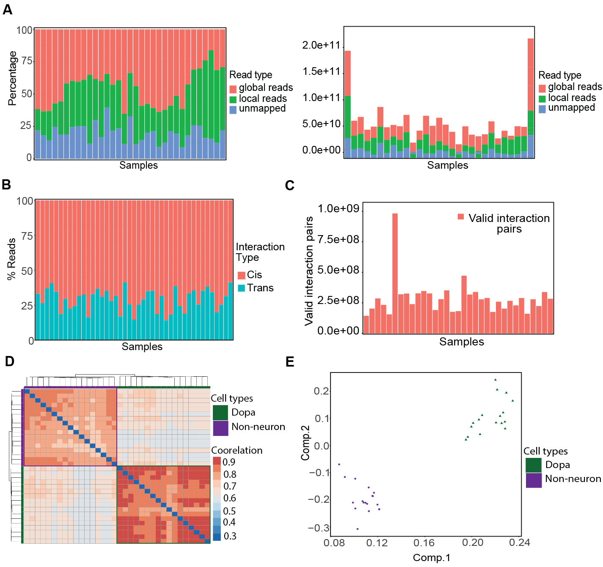

Figure S11 | Quality control of HiC libraries. (A) The left panel displays the percentage of Hi-C reads aligned to the reference genome using HiC-Pro, categorized into global reads (red), local reads (green), and unmapped reads (blue) across individual samples (X-axis). The right panel shows the total number of Hi-C reads aligned to the reference genome using HiC-Pro, with the same classification of read types, across the same set of samples (X-axis) (B) The percentage of cis (intra-chromosomal) and trans (inter-chromosomal) interactions (Y-axis) across individual samples (X-axis). Cis interactions are shown in red, while trans interactions are shown in teal. (C) The total number of valid interaction pairs (Y-axis) identified across individual samples (X-axis). Valid interaction pairs are displayed in red. (D) Heatmap displaying the quality assessment of Hi-C datasets for Dopa neurons,( green) and non-neurons, (purple) cell types using HiCRep. The correlation values between 100kb HiC contact map samples are represented by a color gradient from low (dark blue) to high (dark red), indicating the strength of similarity between sample pairs. The diagonal line represents self-correlations, and the off-diagonal blocks compare inter-group and intra-group correlations, highlighting the similarity within and between the dopa and Non-neuron groups. (E) Principal Component Analysis (PCA) of Hi-C similarity scores between dopa and non-neuronal samples: The scatter plot shows the separation of dopa, green triangles, and non-neuronal, purple circles, cells based on their Hi-C contact map similarity scores. Each point represents a sample, with the first principal component (Comp.1, X-axis) and second principal component (Comp.2, Y-axis) explaining the most variance in the dataset. Notice the complete separation of (green) dopa and (purple) non-neuron datasets in panels D and E.

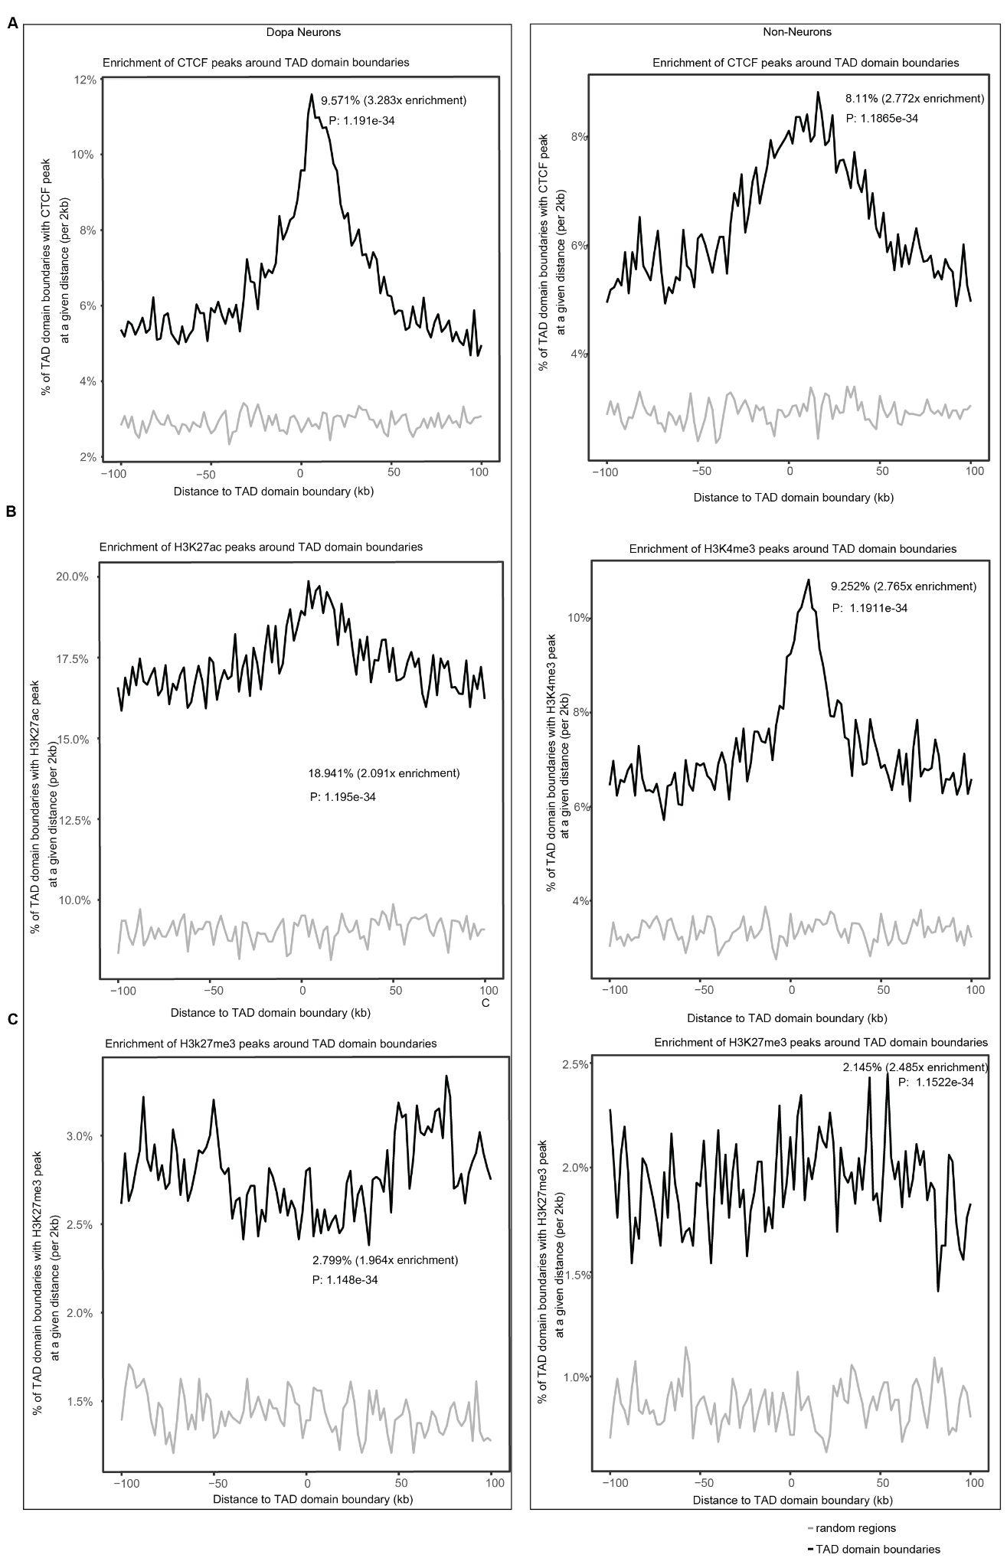

Figure S12 | CTCF and histone marks (active and inactive) enrichment at TAD boundaries. A-C) Enrichment of CTCF chromosomal scaffolding protein binding sites, H3K4me3 and H3K27me3 at TAD boundaries in dopa neurons (left) and Non-neurons (right) shown in A, B, and C respectively.

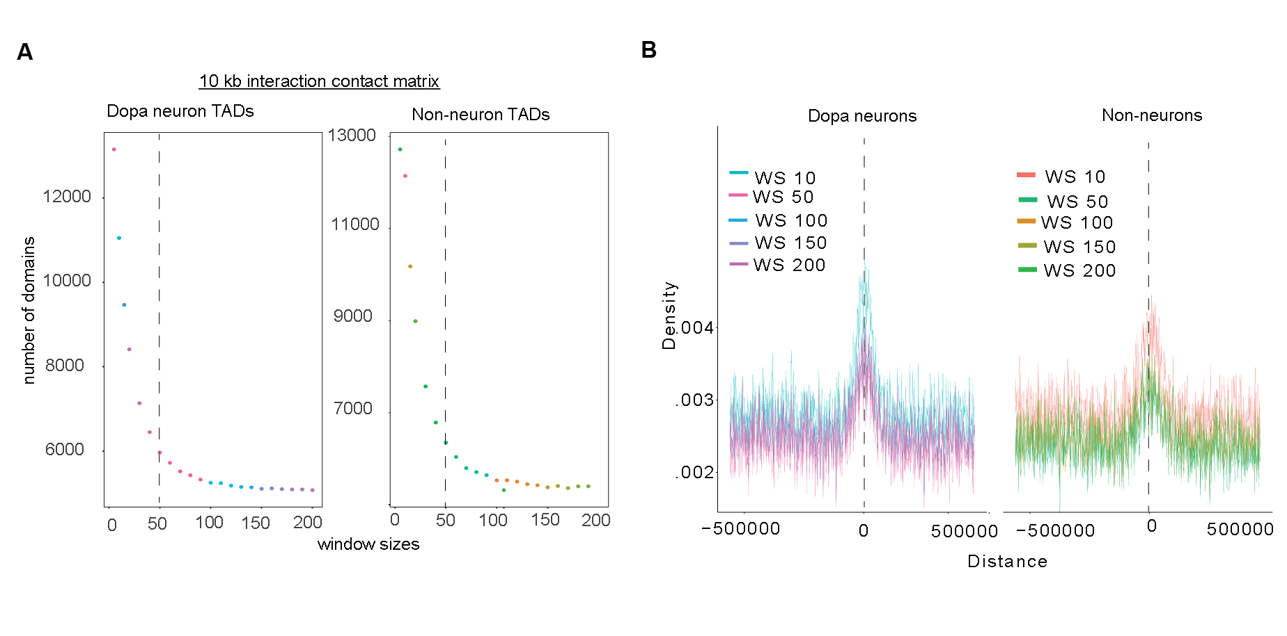

Figure S13 | Optimizing TAD calling window size. A) Plot of window size in 10kb resolution contact matrix vs the number of domains in dopa neurons (left) and non-neuronal TADs (right). The dashed line indicates the elbow point which is the optimal window size for final TADs. B) The figure displays the density plots of CTCF binding enrichment near TAD boundaries, comparing different window sizes (WS) used for TAD calling. The x-axis represents the distance from the TAD boundary (in base pairs), with the boundary positioned at 0, and the y-axis shows the density of CTCF binding. Each colored line corresponds to a different window size (WS 10, 50, 100, 150, and 200 kb). The left panel highlights dopa neurons, while the right panel overlays non-neurons. The peaks near the TAD boundaries indicate strong CTCF enrichment, and the variation in the density curves suggests the optimal window size for capturing CTCF enrichment. This visualization aids in determining the ideal window size that maximizes boundary detection accuracy based on CTCF signals.

Supplementary Tables

Table S1 | Metadata and summary of QC metrics of RNASeq midbrain dopa neurons and non-neurons.

Table S2 | Dopa neurons vs non-neurons differential gene expression results. Sheet A: Summary statistics of differential cell type (Dopa vs Non-neurons) analysis using limma-based dream pipeline; Sheet B: GWAS enrichment of brain traits and non-brain related traits in dopa neurons and non-neuronal cells at FDR < 0.05; Sheet C: Pathway enrichment analysis of dopa neurons and non-neuronal cells at FDR < 0.05.

Table S3 | Disease vs control gene expression analysis results using limma dream pipeline. Sheet A: Summary statistics of differential gene expression analysis in dopa neurons (SCZ vs. control) using the limma-based DREAM pipeline; Sheet B: Summary statistics of differential gene expression analysis in dopa neurons (BD vs. control) using the limma-based DREAM pipeline; Sheet C: Summary statistics of differential gene expression analysis in non-neurons (SCZ vs. control) using the limma-based DREAM pipeline; Sheet D: Summary statistics of differential gene expression analysis in non-neurons (BD vs. control) using the limma-based DREAM pipeline; Sheet E: Pathway analysis of DEG in SCZ vs control dopa neurons at FDR < 0.05; Sheet F: GWAS enrichment of brain traits and non-brain related traits in differentially expressed genes in SCZ vs controls dopa neurons at FDR < 0.1; Sheet G: Pathway analysis of DEG in SCZ vs controls dopa neurons at FDR < 0.05; Sheet H: GWAS enrichment of brain traits and non-brain related traits in differentially expressed genes in SCZ vs control dopa neurons at FDR < 0.1; Sheet I: GWAS enrichment of brain traits and non-brain related traits in differentially expressed genes in SCZ vs control and BD vs control for dopa neurons at FDR < 0.05 in DLPFC and ACC.

Table S4 | Disease vs control transcript-specific analysis results using limma dream pipeline. Sheet A: Summary statistics of differential transcript expression analysis in dopa neurons (SCZ vs. control) using the limma-based DREAM pipeline; Sheet B: Summary statistics of differential transcript expression analysis in non-neurons (SCZ vs. control) using the limma-based DREAM pipeline; Sheet C: Summary statistics of differential transcript expression analysis in dopa neurons (BD vs. control) using the limma-based DREAM pipeline; Sheet D: Summary statistics of differential transcript expression analysis in non-neurons (BD vs. control) using the limma-based DREAM pipeline;

Table S5 | Disease vs control transcript analysis results using RE2C pipeline. Sheet A: Summary statistics of differential transcript expression analysis in dopa neurons (SCZ vs. control) using the RE2C pipeline; Sheet B: Pathway analysis of RE2C detected differentially expressed transcripts in SCZ vs Control dopa neurons at FDR < 0.05; Sheet C: GWAS enrichment of brain traits and non-brain related traits in RE2C detected differentially expressed transcripts in SCZ vs Control dopa neurons FDR < 0.05; Sheet D: Pathway analysis of RE2C detected differentially expressed discordant genes that are inside TADs in SCZ vs controls dopa neurons at FDR < 0.05; Sheet E: Pathway analysis of RE2C detected differentially expressed concordant downregulated genes that are inside TADs in SCZ vs controls dopa neurons at FDR < 0.05; Sheet F: Pathway analysis of RE2C detected differentially expressed concordant upregulated genes that are inside TADs in SCZ vs controls dopa neurons at FDR < 0.05; Sheet G: Count of TADs associated with each discordant gene; Sheet H: Count of TADs associated with each concordant downregulated gene; Sheet I: Count of TADs associated with each concordant upregulated gene; Sheet J: GWAS enrichment of brain traits and non-brain related traits in RE2C detected differentially expressed transcripts in SCZ vs Control dopa neurons FDR < 0.1; Sheet K: GWAS enrichment of brain traits and non-brain related traits in RE2C detected differentially expressed transcripts stratified into concordant and discordant genes in SCZ vs control dopa neurons at FDR < 0.1.
Table S6 | Metadata and summary of QC metrics of HIC libraries from midbrain dopa neurons and non-neurons.

