Table 2 Fe₃O₄@V/TiO₂ as a catalyst for synthesizing 2-(2-chlorophenyl)-benzimidazole
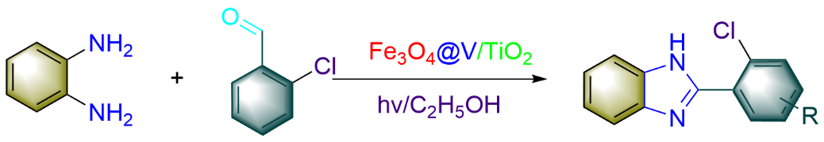
Entry | Catalyst | M(mg) | n_{p}:n_{h} | Solvent | Reaction Condition | Time(h) | Yield(%)
1 | Fe₃O₄@TiO₂ | 150 | 1:1.05 | EtOH | 15W Light | 2 | 89.1
2 | Fe₃O₄@TiO₂ | 150 | 1:1.05 | EtOH | 15W Blue Light | 2 | 83.9
3 | Fe₃O₄@V/TiO₂ (0) | 150 | 1:1.05 | EtOH | 15W Light | 1.5 | 87.5
4 | Fe₃O₄@V/TiO₂ (0.5%) | 150 | 1:1.05 | EtOH | 15W Light | 1.5 | 87.7
5 | Fe₃O₄@V/TiO₂ (1.0%) | 150 | 1:1.05 | EtOH | 15W Light | 1.5 | 92.3
6 | Fe₃O₄@V/TiO₂ (1.5%) | 150 | 1:1.05 | EtOH | 15W Light | 1.5 | 93.1
7 | Fe₃O₄@V/TiO₂ (2.0%) | 150 | 1:1.05 | EtOH | 15W Light | 1.5 | 88.6
8 | Fe₃O₄@V/TiO₂ (2.5%) | 150 | 1:1.05 | EtOH | 15W Light | 1.5 | 86.6
9 | Fe₃O₄@V/TiO₂ (1.5%) | 150 | 1:1.05 | EtOH | 15W Blue Light | 1.5 | 72.1
10 | Fe₃O₄@V/TiO₂ (1.5%) | 150 | 1:1.05 | EtOH | Heat Reflux | 1.5 | 87.0
11 | Fe₃O₄@V/TiO₂ (1.5%) | 150 | 1:1.05 | EtOH | Dark | 1.5 | 41.8
12 | Fe₃O₄@V/TiO₂ (1.5%) | 0 | 1:1.05 | EtOH | 15W Light | 1.5 | 11.3
13 | Fe₃O₄@V/TiO₂ (1.5%) | 50 | 1:1.05 | EtOH | 15W Light | 1.5 | 59.8
14 | Fe₃O₄@V/TiO₂ (1.5%) | 100 | 1:1.05 | EtOH | 15W Light | 1.5 | 72.3
15 | Fe₃O₄@V/TiO₂ (1.5%) | 200 | 1:1.05 | EtOH | 15W Light | 1.5 | 91.4
16 | Fe₃O₄@V/TiO₂ (1.5%) | 250 | 1:1.05 | EtOH | 15W Light | 1.5 | 82.3
17 | Fe₃O₄@V/TiO₂ (1.5%) | 150 | 1:1 | EtOH | 15W Light | 1.5 | 74.1
18 | Fe₃O₄@V/TiO₂ (1.5%) | 150 | 1:1.1 | EtOH | 15W Light | 1.5 | 88.8
19 | Fe₃O₄@V/TiO₂ (1.5%) | 150 | 1:1.05 | CH₃OH | 15W Light | 1.5 | 80.5
20 | Fe₃O₄@V/TiO₂ (1.5%) | 150 | 1:1.05 | CH₂Cl₂ | 15W Light | 1.5 | 41.6
21 | Fe₃O₄@V/TiO₂ (1.5%) | 150 | 1:1.05 | CH₃CN | 15W Light | 1.5 | 58.8
22 | Fe₃O₄@V/TiO₂ (1.5%) | 150 | 1:1.05 | H₂O | 15W Light | 1.5 | 41.2
23 | Fe₃O₄@V/TiO₂ (1.5%) | 150 | 1:1.05 | C₂H₅OAc | 15W Light | 1.5 | 56.6
24 | Fe₃O₄@V/TiO₂ (1.5%) | 150 | 1:1.05 | C₆H₁₂ | 15W Light | 1.5 | 43.6

Table 4 Synthesis of 2-substituted benzimidazole starting from different substituents
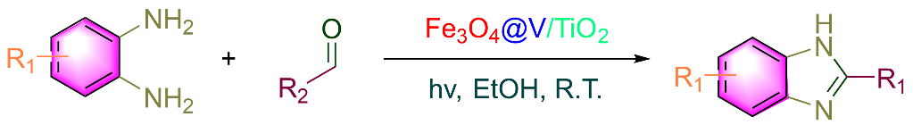
Entry | Codename | Product | Time/h | Yield/% | Melting Point [Reference]/ºC
1 | C1 | 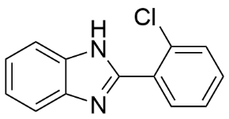 | 1.5 | 93.1 | 236-238[237-238]^{[35]}
2 | C2 | 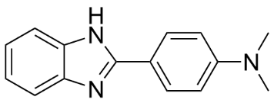 | 4.0 | 84.0 | 227-229[228-229]^{[36]}
3 | C3 | 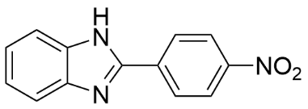 | 4.0 | 87.6 | >300[328-329]^{[37]}
4 | C4 | 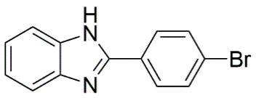 | 2.0 | 92.1 | >300[300]^{[38]}
5 | C5 | 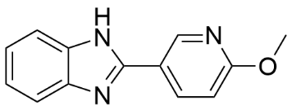 | 4.0 | 90.8 | 213-214[213-214]^{[6]}
6 | C6 | 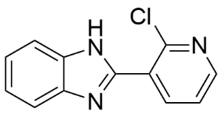 | 3.0 | 83.9 | 197-199[197-199]^{[6]}
7 | C7 | 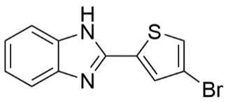 | 3.0 | 64.9 | 160-161[160-161]^{[6]}
8 | C8 | 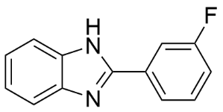 | 2.0 | 94.6 | 220-221[220-222]^{[39]}
9 | C9 | 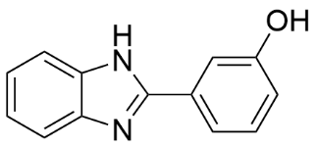 | 3.0 | 92.8 | 271-273[273-274]^{[40]}
10 | C10 | 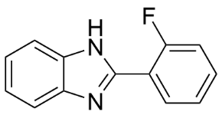 | 2.0 | 68.9 | 223-224[223-225]^{[41]}
11 | C11 | 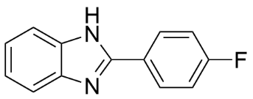 | 2.0 | 80.1 | 246-248[248-250]^{[10]}
12 | C12 | 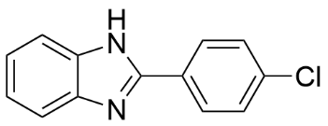 | 2.0 | 93.1 | 290-292[292-294]^{[42]}
13 | C13 | 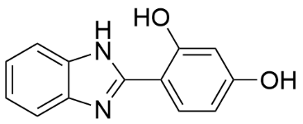 | 4.0 | 89.6 | >300[300]^{[43]}
14 | C14 | 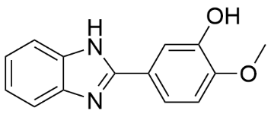 | 4.0 | 43.7 | 238-240[249-251]^{[44]}
15 | C15 | 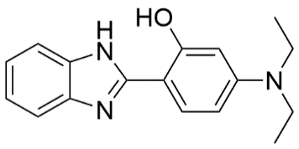 | 4.0 | 80.2 | 68-70^{[a]}
16 | C16 | 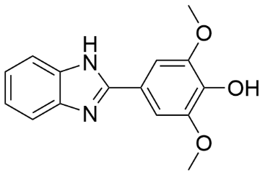 | 4.0 | 40.3 | 236-238^{[a]}
17 | C17 | 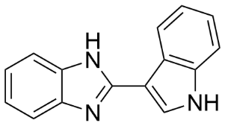 | 4.0 | 57.5 | 228-230[228-229]^{[45]}
18 | C18 | 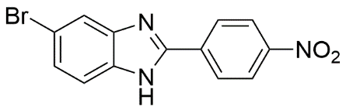 | 4.0 | 75.7 | 224-226^{[a]}
19 | C19 | 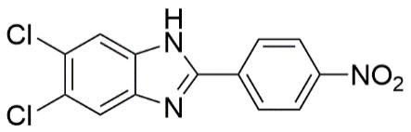 | 4.0 | 70.2 | 214-216^{[a]}
20 | C20 | 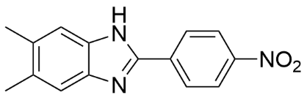 | 4.0 | 75.6 | 170-172^{[a]}
21 | C21 | 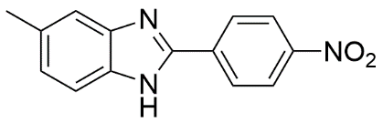 | 4.0 | 78.3 | 126-128^{[a]}
22 | C22 | 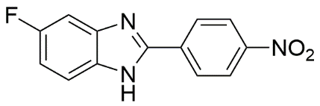 | 4.0 | 46.3 | 152-154^{[a]}
23 | C23 | 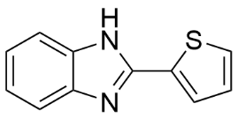 | 4.0 | 72.0 | >300[329-330]^{[10]}
24 | C24 | 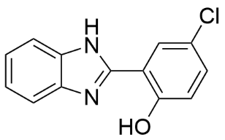 | 4.0 | 93.0 | >300[305-306]^{[46]}
25 | C25 | 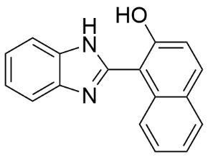 | 4.0 | 91.4 | 260-262[258-260]^{[47]}
Eg: a indicates that the corresponding reference value was not found.

