Luminescence “on-off-on” sensing of acute myocardial infarction biomarker miRNA-208a based on copper nanoclusters-MoS₂ FRET system
Suzhen Zhang ¹, Danling Mei ¹, Hongming Fang ², Quanwei Li ⁴, Xiumei Zhou ¹, Xueqin Zhao ¹*, Zhencang Zheng ³*, Biao Huang ¹*

1 College of Life Sciences and Medicine, Zhejiang Sci-Tech University, Hangzhou 310018, China; suzhenzhang2022@163.com (S.Z.); 2719119394@qq.com (D.M.); zhouxiumei824@163.com (X.Z.)
2 Xiaoshan Hospital, Hangzhou Normal University, Hangzhou 311200, China; 3295988078@qq.com
3 Department of Critical Care Medicine, Taizhou Central Hospital, (Taizhou University Hospital), Taizhou, Zhejiang 318000, China; zhengzc2023@163.com
4 Beijing Institute of Hepatology, You'an Hospital, Capital Medical University, Beijing 100069, China; quanweili@mail.ccmu.edu.cn
* Correspondence:: zhaoxueqin@zstu.edu.cn(X.Z.); zhengzc2023@163.com(Z.Z.); huangbiao@zstu.edu.cn (B.H.)

Table S1. Recovery of the assay of miRNA-208a in 10% human serum.
Sample | Added (nM) | Found (nM) (n=3) | Recovery (%) | RSD (%)
1 | 2.5 | 2.45 | 98.13 | 1.0
2 | 5 | 4.93 | 98.67 | 0.5
3 | 10 | 9.97 | 99.73 | 3.0
4 | 15 | 14.70 | 97.98 | 2.2
5 | 20 | 20.24 | 101.20 | 1.3
Table S2. The sequences of the cDNA probe and miRNA-208a
Nucleic acid | Sequence (5’-3’)
cDNA Probe | TATTCTGCTCGTTTTTCGAACA
miRNA-208a | AUAAGACGAGCAAAAAGCUUGU
Table S3. Mismatch sequence for specific detection
Nucleic acid | Sequence (5’-3’)
Single base mismatch sequence | AUAACACGAGCAAAAAGCUUGU
Double base mismatch sequence | AUUACACGAGCAAAAAGCUUGU
Mismatched sequence | UAGCUUAUCAGACUGAUGUUGA

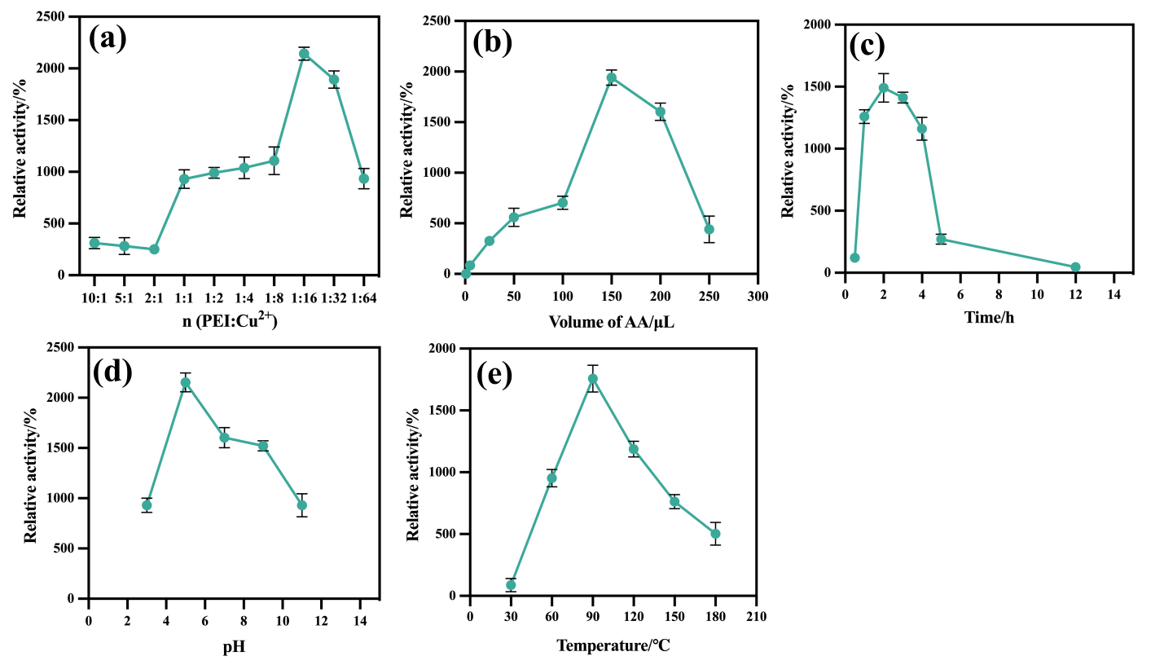
Figure S1. Optimization conditions for synthesis PEI-CuNCs.

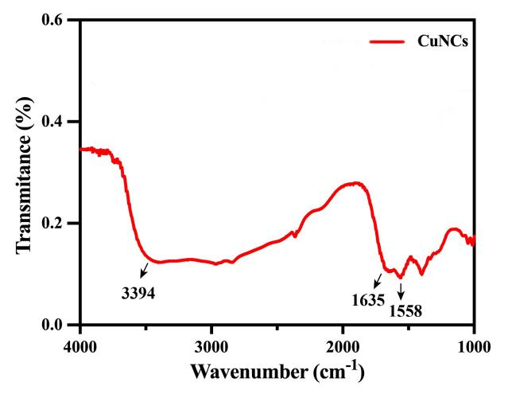

Figure S2. FTIR of CuNCs.
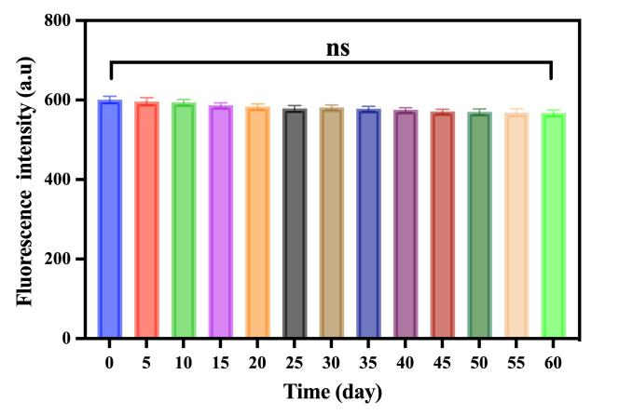

Figure S3. Storage stability of CuNCs.
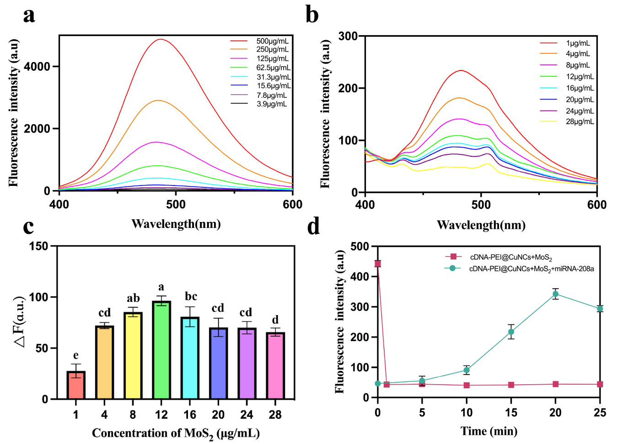
Figure S4. Optimization of the CuNCs-cDNA-MoS₂ sensing strategy. (a) Fluorescence spectra of the CuNCs−DNA with the concentrations of 3.9-500 μg mL⁻¹. (b) Fluorescence spectra of the CuNCs-cDNA-MoS₂ prepared 20 μg mL⁻¹ of CuNCs-cDNA and MoS₂ with the concentrations from 1 to 28 μg mL⁻¹. (c) △F as a function of different concentrations of MoS₂ (△F=F-F0) nanosheets after introducing the target miRNA-208a. (d) FL of CuNCs-cDNA-MoS₂ with time in the absent or present of the target miR-208a.

