Table 2. Results of EUCAST-RAST at 4 hours, 6 hours, and 8 hours
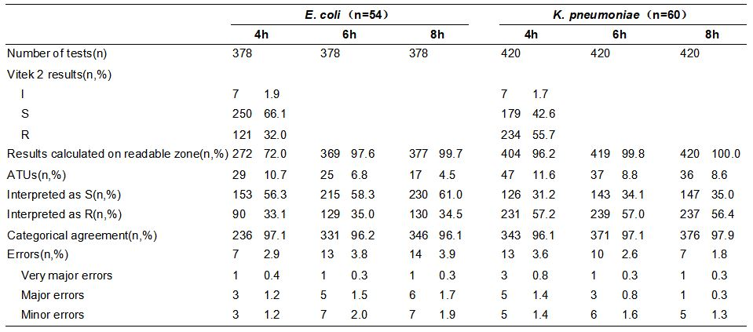

Table 3. EUCAST-RAST result with each antibiotic of E. coli at 4 hours, 6 hours, and 8 hours
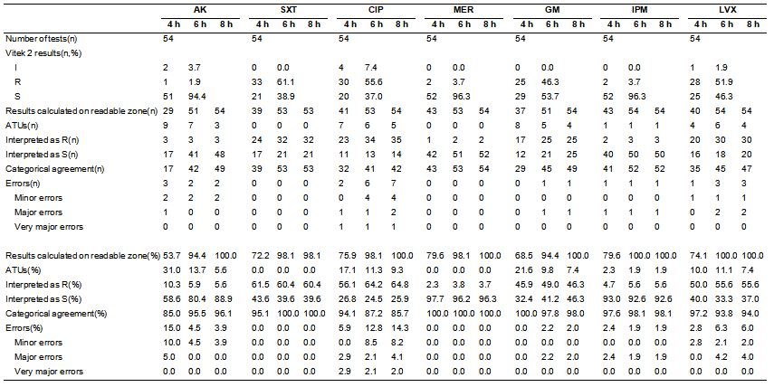

Table 4. EUCAST-RAST result with each antibiotic of K. pneumoniae at 4 hours, 6 hours, and 8 hours
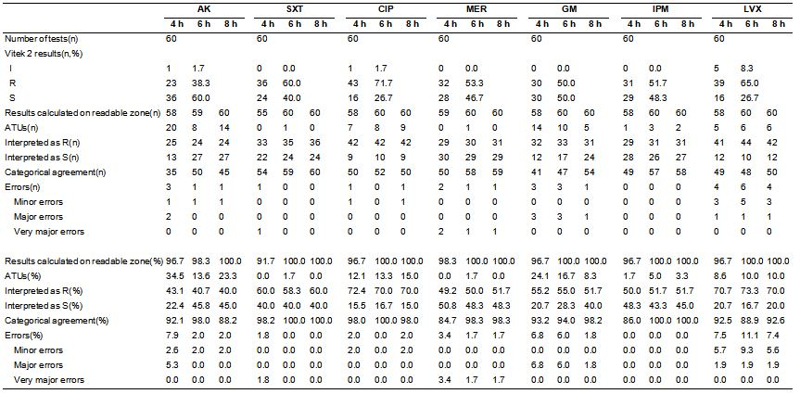

Table 5. The corresponding ATUs, categorical agreement, and errors for the optimal breakpoints of 5 antibiotics for E. coli and K. pneumoniae.
