Supplementary

Wearable sleep recording augmented by artificial intelligence for Alzheimer’s disease screening

Elisabeth R.M. Heremans^{1*}, Astrid Devulder, MD^{2,3∗}, Pascal Borzée⁴, Rik Vandenberghe, MD PhD^{3,5},
François-Laurent De Winter, MD PhD^{6,7}, Mathieu Vandenbulcke, MD PhD^{6,7}, Maarten Van Den Bossche, MD PhD^{6,7}, Bertien Buyse, MD PhD^{4,8}, Dries Testelmans, MD PhD^{4,8}, Wim Van Paesschen, MD PhD^{2,3}, Maarten De Vos, PhD^{1,9}
*First authors contributed equally to this work

Author affiliations:
¹ STADIUS Center for Dynamical Systems, Signal Processing and Data Analytics - Department of Electrical Engineering (ESAT), KU Leuven, Leuven, Belgium
² Laboratory for Epilepsy Research, KU Leuven Biomedical Sciences Group, 3000 Leuven, Belgium
³ Department of Neurology, University Hospitals Leuven, 3000 Leuven, Belgium
⁴ Department of Pulmonary Diseases, University Hospitals Leuven, 3000 Leuven, Belgium
⁵ Laboratory for Cognitive Neurology, KU Leuven Biomedical Sciences Group, 3000 Leuven, Belgium
⁶ Neuropsychiatry, Department of Neurosciences, Leuven Brain Institute, KU Leuven Biomedical Sciences Group, 3000 Leuven, Belgium
⁷ Department of Geriatric Psychiatry, KUL University Psychiatric Center (UPC) KU Leuven, 3000 Leuven, Belgium
⁸ Laboratory of Respiratory Diseases and Thoracic Surgery (BREATHE), KU Leuven Biomedical Sciences Group, 3000 Leuven, Belgium
⁹ Department of Development and Regeneration, KU Leuven, 3000 Leuven, Belgium

Content
Biomarkers of the AD patients 3
Supplementary Table 1: Biomarkers for the AD patients of the Alzheimer’s sleep study. 3
Extended sleep staging results 6
Supplementary Table 2: Sleep staging performance for PSG and wearable data, compared between pre-trained and personalized sleep staging models. 6
Supplementary Figure 1: Comparison of the sleep parameters of different patient subgroups based on ground truth, PSG-based AI and wearable-based AI. 7
Extended classification and feature interpretation results 8
Supplementary Table 3: Performances in detecting patients with AD and the subgroup in the prodromal AD stage based on hypnogram features and physiological features. 8
Supplementary Figure 2: ROC curves showing the performance in detecting AD with and without OSA. 9
Supplementary Figure 3: ROC curves showing the performance in detecting AD in younger and older subjects. 10
Supplementary Figure 4: Correlation between sleep features based on the PSG data and MMSE. 11
Supplementary Figure 5: Most selected physiological features based on ground truth scoring and AI scoring. 12
List of hypnogram features 13
Supplementary Table 4: Hypnogram features and their meaning. 13

Biomarkers of the AD patients

Supplementary Table 1: Biomarkers for the AD patients of the Alzheimer’s sleep study.
Pt | Disease stage | Amyloid-PET | CSF Biomarkers | ¹⁸F- FDG-PET | Brain MRI (or CT)
1 | Dementia | NA | t-tau = 365  p-tau 181 = 52.7  Aβ 1-42 = 501 (a) | Hypometabolism temporoparietal, precuneus and frontal | Normal for age
2 | Dementia | NA | NA | NA | Generalized atrophy. Mild mesial temporal and parietal atrophy
3 | Prodromal | Positive | Aβ 1-42 = 442  Ratio 1-42/1-40 = 0.087  p-tau = 90.4  t-tau = 592 (b) | Mild hypometabolism temporal and parietal bilateral | Normal for age
4 | Dementia | NA | NA | NA | Generalized atrophy. Prominent mesial temporal atrophy.
5 | Dementia | NA | NA | NA | Generalized atrophy, frontotemporal predominance. Prominent mesial temporal atrophy R > L
6 | Prodromal | NA | Ratio 1-42/1-40 = 0.076  Aβ 1-42 = 410  t-tau = 275 (c) | No hypometabolism | Mild generalized atrophy. Moderate vascular white matter lesions.
7 | Dementia | NA | t-tau = 581  p-tau = 80.9  Aβ 1-42 = 695 (a) | Hypometabolism frontal R, bilateral parietal and cuneus R > L | Mild generalized atrophy. Mild vascular white matter lesions. FLAIR hyperintensity frontal right, parietal left and insula (old ischemic lesions).
8 | Dementia | NA | t-tau = 770  p-tau = 107.8  Aβ 1-42 = 332 (a) | Hypometabolism temporoparietal R > L, precuneus and frontal L | Generalized atrophy, parietal and temporal predominance. Prominent mesial temporal atrophy R > L
9 | Prodromal | NA | Aβ 1-42 = 452  Aβ 1-40 = 6765  Ratio 1-42/1-40 = 0.067  t-tau = 425  p-tau = 58 (c) | NA | Frontoparietal atrophy. Mild mesial temporal atrophy
10 | Dementia | NA | NA | NA | Prominent temporoparietal atrophy. Prominent mesial temporal atrophy L > R
11 | Dementia | Positive | NA | NA | Normal for age
12 | Dementia | NA | NA | NA | Generalized atrophy, parietal predominance. Prominent mesial temporal atrophy L > R. Mild to moderate white matter lesions.
13 | Prodromal | NA | NA | NA | Generalized atrophy. Prominent mesial temporal atrophy R > L. Prominent white matter lesions.
14 | Prodromal | Positive | NA | Hypometabolism temporoparietal L > R, frontal L, precuneus L > R | Parietal atrophy. Mild white matter lesions.
15 | Dementia | NA | NA | Mild hypometabolism frontal L | Mild generalized atrophy. Mild to moderate white matter lesions. Old lacunar infarct thalamus L
16 | Dementia | NA | NA | Hypometabolism bilateral parietal and mild temporoparietal L | Generalized atrophy, temporoparietal predominance.
17 | Dementia | NA | NA | Hypometabolism parietotemporal L > R, frontal L and precuneus bilateral | Mild generalized atrophy. Symmetric temporal lobe atrophy.
18 | Prodromal | NA | Aβ 1-42 = 361  Aβ 1-40 = 7026  Ratio 1-42/1-40 = 0.051  t-tau = 715  p-tau = 110 (c) | NA | Generalized atrophy. Prominent mesial temporal atrophy. Moderate vascular white matter lesions. Gliosis frontoparietal right.
19 | Dementia | NA | NA | NA | Prominent mesial temporal atrophy L > R. Periventricular leukoencephalopathy
20 | Dementia | NA | Aβ 1-42 = 388  Aβ 1-40 = 7588  t-tau = 362 (c) | NA | Generalized atrophy, frontoparietal predominance. Prominent mesial temporal atrophy. Mild to moderate white matter lesions.
21 | Prodromal | NA | NA | NA | CT: Mild parietal atrophy.
22 | Dementia | NA | NA | Hypometabolism temporoparietal R > L, precuneus and posterior cingulate bilateral | Generalized atrophy. Moderate mesial temporal atrophy. Mild to moderate white matter lesions.
23 | Dementia | NA | NA | NA | Generalized atrophy. Moderate mesial temporal atrophy. Mild to moderate periventricular white matter lesions.
24 | Dementia | NA | Aβ 1-42 = 309  Aβ 1-40 = 7663  Ratio 1-42/1-40 = 0.040  t-tau = 1034 (c) | NA | Generalized atrophy, frontoparietal predominance. Prominent mesial temporal atrophy. Mild to moderate white matter lesions.
25 | Dementia | NA | NA | NA | Generalized atrophy. Prominent mesial temporal atrophy L > R. Mild to moderate white matter lesions.
26 | Prodromal | NA | Aβ 1-42 = 667  Aβ 1-40 = 8838  t-tau = 674 (c) | Hypometabolism parietotemporal bilateral, frontal bilateral, precuneus and posterior cingulate. | Mild generalized atrophy. Prominent parietal atrophy. Mild mesial temporal atrophy L > R. Mild vascular lesions (Fazekas 1).
27 | Prodromal | NA | Aβ 1-42 = 362  Aβ 1-40 = 5050  Ratio 1-42/1-40 = 0.072  t-tau = 314 (c) | Mild hypometabolism precuneus and posterior cingulate. | Mild mesial temporal atrophy
28 | Prodromal | NA | NA | NA | Generalized atrophy. Prominent mesial temporal atrophy L > R. Mild white matter lesions.
29 | Dementia | NA | NA | Hypometabolism temporoparietal L > R, precuneus bilateral | Generalized atrophy, parietal predominance. Mesial temporal atrophy L > R. Mild white matter lesions
30 | Dementia | NA | Aβ 1-42 = 629  Aβ 1-40 = 10246  Ratio 1-42/1-40 = 0.061  t-tau = 526 (c) | Hypometabolism temporoparietal L > R and mild frontal L | CT: No significant changes
31 | Dementia | Positive | NA | Hypometabolism temporoparietal (L > R), frontal (L > R), precuneus and posterior cingulate, secondary visual cortex left | Generalized atrophy. Hemosiderin depositions cortico-subcortical. Mild to moderate white matter lesions
32 | Prodromal | NA | Aβ 1-42 = 370  Aβ 1-40 = 6088  Ratio 1-42/1-40 = 0.061  t-tau = 389  p-tau = 54 (c ) | Mild hypometabolism posterior cingulate. | Generalized atrophy, parieto-occipital predominance. Prominent mesial temporal atrophy. Prominent white matter lesions.
33 | Dementia | NA | NA | NA | Mild generalized atrophy. Mild mesial temporal atrophy.
34 | Dementia | Positive | NA | Hypometabolism parieto-temporal L > R, precuneus and posterior cingulate | Mild generalized atrophy. Mild white matter lesions.
35 | Prodromal | NA | Aβ 1-42 = 439  Aβ1-40 = 9506  Ratio 1-42/1-40 = 0.046  t-tau = 1173 (c) | Mild hypometabolism parietotemporal, bilateral precuneus and posterior cingulate. | Mild generalized atrophy. Mild parietal atrophy. Mild mesial temporal atrophy.
ª Values supporting a diagnosis of Alzheimer’s disease are t-tau level > 367 pg/mL, p-tau > 80 pg/mL, Aβ 1-42 < 500 pg/mL.
^{b} Values supporting a diagnosis of Alzheimer’s disease are p-tau > 57pg/mL, t-tau > 501 pg/mL, ratio 1-42/1-40 < 0.12, Aβ 1-42 < 775 pg/mL.
^{c} Values supporting a diagnosis of Alzheimer’s disease are ratio 1-42/1-40 < 0.096, t-tau > 545 pg/mL.
Amyloid PET was performed with ¹¹C-Pittsburgh compound B, except for pt 11 with ¹⁸F-NAV4694.

Abbreviations: AD, Alzheimer’s disease; Aβ, Amyloid-beta; CSF, Cerebrospinal fluid; CT, computed tomography; L, left; MRI, magnetic resonance imaging; NA, not available; pt, patient; p-tau, tau phosphorylated at threonine 181; R, right; t-tau, total tau.

Extended sleep staging results
The sleep staging performance of the pre-trained model and fine-tuned, personalized model is shown in Supplementary Table 3. The personalized model’s performance is shown on the different patient subgroups as well. All performance metrics are with respect to manually scored PSG as the ground truth. For both PSG and wearable, the personalized model achieved a 4% - 5% higher accuracy compared to the pre-trained model, because it was better adapted to the individual subjects. The personalized model achieved best performance for the CIE subgroup without OSA, followed by the CIE subgroup with OSA and AD patients with OSA, which had similar sleep staging performances. The lowest sleep staging performance was observed in the group of patients with AD without OSA. Compared to the PSG-based model, the accuracy of the wearable-based model was around 10% lower.

Supplementary Table 2: Sleep staging performance for PSG and wearable data, compared between pre-trained and personalized sleep staging models.
 |  | Accuracy | κ | wF1
Sleep staging on PSG
Pre-trained | All subjects | 0.769 ± 0.011 | 0.665 ± 0.015 | 0.743 ± 0.012
Personalized | All subjects | 0.808± 0.009 | 0.724 ± 0.014 | 0.801 ± 0.010
Personalized | CIE - no OSA | 0.857 ± 0.010 | 0.799 ± 0.015 | 0.854 ± 0.011
Personalized | CIE - OSA | 0.789 ± 0.017 | 0.699 ± 0.025 | 0.775 ± 0.019
Personalized | AD - no OSA | 0.732 ± 0.024 | 0.607 ± 0.037 | 0.727 ± 0.025
Personalized | AD - OSA | 0.826 ± 0.011 | 0.747 ± 0.018 | 0.823 ± 0.011
Sleep staging on wearable
Pre-trained | All subjects | 0.655 ± 0.014 | 0.498 ± 0.019 | 0.616 ± 0.015
Personalized | All subjects | 0.703 ± 0.013 | 0.577 ± 0.019 | 0.690 ± 0.014
Personalized | CIE - no OSA | 0.755 ± 0.020 | 0.659 ± 0.027 | 0.745 ± 0.020
Personalized | CIE - OSA | 0.692 ± 0.025 | 0.568 ± 0.033 | 0.673 ± 0.025
Personalized | AD - no OSA | 0.631 ± 0.032 | 0.463 ± 0.046 | 0.625 ± 0.033
Personalized | AD - OSA | 0.694 ± 0.029 | 0.555 ± 0.044 | 0.681 ± 0.030
Performances are reported as mean ± standard error.
Abbreviations: AD, Alzheimer’s disease; CIE, cognitively intact elderly; OSA, obstructive sleep apnea (patients with apnea-hypopnea scores ≥ 15); PSG, polysomnography; wF1, weighted F1-score; κ, Cohen’s kappa score.

Supplementary Figure 1 shows a few of the main clinically important sleep staging parameters in the four subgroups, derived from the manual PSG scoring and the personalized sleep staging model for the PSG and wearable. The estimations of the sleep parameters by the PSG-based AI model were highly similar to the ground truth parameters, with three out of four significant differences between the patient subgroups reproduced. The parameters estimated by the wearable-based model differed slightly more from the ground truth, with only two overlapping significant differences. The AI’s parameters based on PSG and wearable also exhibited additional significant differences.

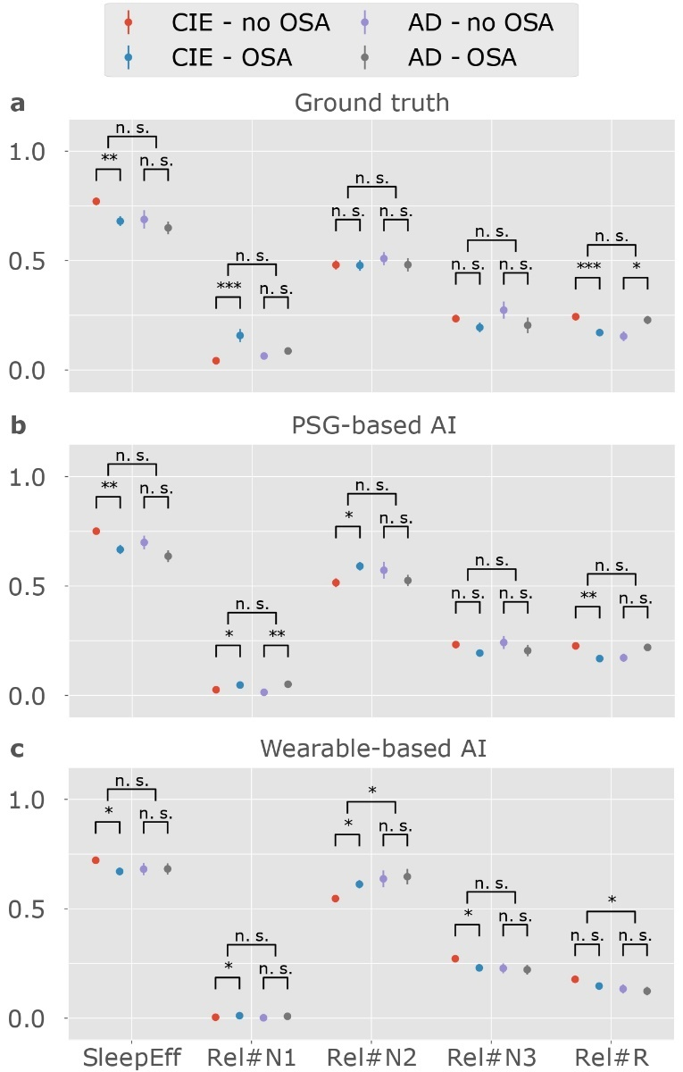

Supplementary Figure 1: Comparison of the sleep parameters of different patient subgroups based on ground truth, PSG-based AI and wearable-based AI.
The four different-colored dots each represent a patient subgroup. (a) Sleep parameters based on manually annotated PSG, considered as ground truth. (b) The AI model-extracted sleep parameters based on PSG. (c) The AI model extracted sleep parameters based on the wearable. Significant differences according to an independent two-sample t-test are indicated with * (p < 0.05), ** (p < 0.005), etc. The statistical test is performed between CIE subjects with and without OSA, between AD patients with and without OSA, and between all CIE participants and all patients with AD. The PSG-based AI and wearable-based AI agree on some of the significant differences that are found in the ground truth, but they also find additional significant differences.
Abbreviations: AD, Alzheimer’s disease; CIE, cognitively intact elderly; N.S., non-significant; OSA, obstructive sleep apnea; PSG, polysomnography; SleepEff, sleep efficiency; Rel#X, relative time in sleep stage X (divided by total sleep time).

Extended classification and feature interpretation results

Supplementary Table 3: Performances in detecting patients with AD and the subgroup in the prodromal AD stage based on hypnogram features and physiological features.
For the hypnogram features, we compared the ground truth hypnogram features against the hypnogram features obtained from the machine learning-scored PSG, and the machine learning-scored wearable data. The physiological features were based on both the raw data and the sleep stage labels. Therefore, both the type of data and the way that it was scored needs to be specified. The physiological features derived from the PSG data scored with ground truth sleep stages is taken as the baseline. It is compared to the features from the PSG data scored by the machine learning algorithm, and the features from the wearable data scored by the machine learning algorithm. For each feature set, three results are shown. The first line, annotated with ‘AD’, shows how well a machine learning model can discriminate AD patients, including those in the prodromal disease stage. ‘AD dementia’ are results of the previous model, but only includes patients in the dementia stage for performance testing. ‘Prodromal’ shows the performance when training a model to classify the prodromal AD patients from cognitively intact elderly.
 |  | Accuracy | κ | Precision | Recall
Hypnogram features
Ground truth | AD | 0.636 ± 0.024 | 0.167 ± 0.060 | 0.465 ± 0.041 | 0.406 ± 0.065
 | AD dementia | 0.684 ± 0.026 | 0.217 ± 0.066 | 0.400 ± 0.043 | 0.474 ± 0.074
 | Prodromal | 0.785 ± 0.023 | -0.022 ± 0.060 | 0.131 ± 0.069 | 0.067 ± 0.033
PSG-based AI | AD | 0.644 ± 0.014 | 0.165 ± 0.038 | 0.475 ± 0.026 | 0.369 ± 0.043
 | AD dementia | 0.711 ± 0.016 | 0.265 ± 0.045 | 0.440 ± 0.027 | 0.487 ± 0.058
 | Prodromal | 0.781 ± 0.020 | -0.101 ± 0.024 | 0.000 ± 0.000 | 0.000 ± 0.000
Wearable-based AI | AD | 0.664 ± 0.034 | 0.216 ± 0.077 | 0.514 ± 0.062 | 0.409 ± 0.054
 | AD dementia | 0.711 ± 0.035 | 0.254 ± 0.083 | 0.441 ± 0.063 | 0.461 ± 0.065
 | Prodromal | 0.830 ± 0.028 | 0.162 ± 0.056 | 0.439 ± 0.167 | 0.175 ± 0.025
Physiological features
Ground truth (PSG) | AD | 0.857 ± 0.023 | 0.676 ± 0.051 | 0.818 ± 0.040 | 0.751 ± 0.036
 | AD dementia | 0.897 ± 0.024 | 0.738 ± 0.060 | 0.770 ± 0.049 | 0.852 ± 0.048
 | Prodromal | 0.847 ± 0.013 | 0.339 ± 0.052 | 0.502 ± 0.059 | 0.375 ± 0.067
PSG-based AI | AD | 0.822 ± 0.021 | 0.588 ± 0.048 | 0.788 ± 0.037 | 0.657 ± 0.038
 | AD dementia | 0.881 ± 0.019 | 0.695 ± 0.046 | 0.750 ± 0.040 | 0.804 ± 0.035
 | Prodromal | 0.846 ± 0.024 | 0.328 ± 0.089 | 0.497 ± 0.104 | 0.358 ± 0.065
Wearable-based AI | AD | 0.797 ± 0.022 | 0.544 ± 0.049 | 0.717 ± 0.035 | 0.677 ± 0.048
 | AD dementia | 0.832 ± 0.023 | 0.581 ± 0.054 | 0.650 ± 0.042 | 0.752 ± 0.052
 | Prodromal | 0.832 ± 0.018 | 0.234 ± 0.060 | 0.427 ± 0.083 | 0.267 ± 0.050
The results are reported as mean ± standard deviation.
Abbreviations: AD, Alzheimer’s disease; AI, artificial intelligence; κ, Cohen’s kappa score; PSG, polysomnography.

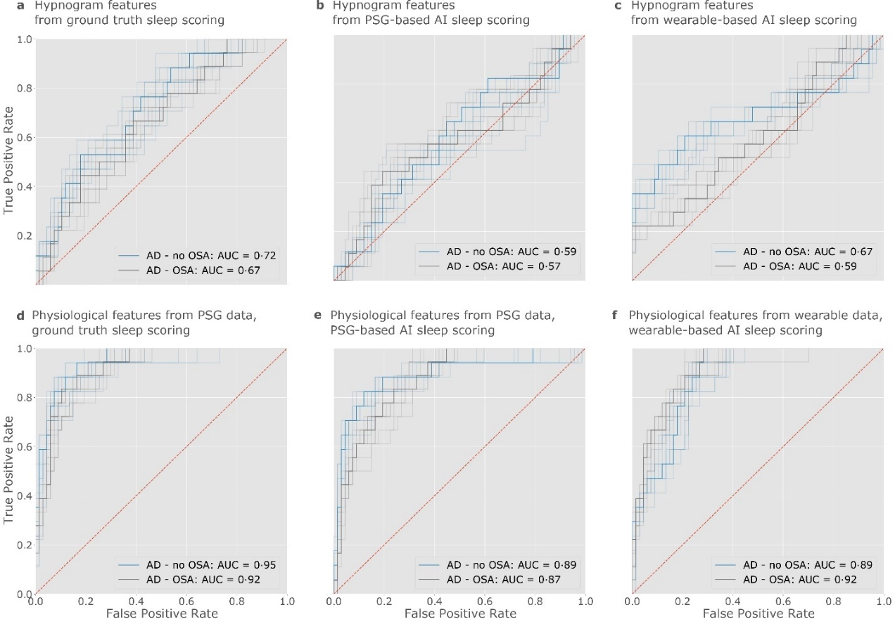

Supplementary Figure 2: ROC curves showing the performance in detecting AD with and without OSA.
The transparent lines represent the ROC curves of all ten classifiers trained for each prediction task, while the non-transparent lines represent the ROC curves obtained using the mean predictions with ten repeats. Their AUC is reported in the legend. The curves labeled with ‘AD - no OSA’ show the performance when testing how well the AD detection model could detect AD patients without OSA (AHI ≥ 15), and the curves labeled with ‘AD - OSA’ show the performance when testing how well AD patients with OSA were discriminated. Both results were computed with the same trained models, with only the test data differing. The upper row shows the performances using hypnogram features, calculated based on (a) the manually labeled PSG which is taken as a ground truth, (b) the AI-labeled PSG, (c) the AI-labeled wearable data. The lower row shows the performances using the physiological features, calculated based on both the raw data and sleep stage labels. In (d), the raw PSG data was used with its manual labels, in (e), the raw PSG data was used with its AI-based labels, and in (f), the wearable data was used with its AI-based labels. The ROC curves show that the discrimination power for AD patients with OSA and those without was not very different in most cases.

Abbreviations: AD, Alzheimer’s disease; AHI, apnea-hypopnea-index; AI, artificial intelligence; AUC, area under the curve; OSA, obstructive sleep apnea; PSG, polysomnography; ROC, receiver operating characteristic.

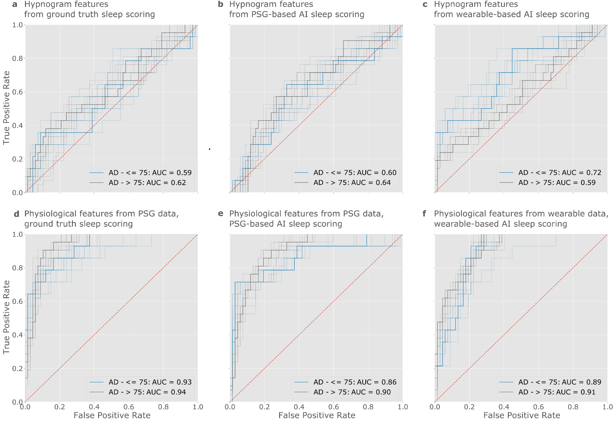

Supplementary Figure 3: ROC curves showing the performance in detecting AD in younger and older subjects.
The transparent lines represent the ROC curves of all ten classifiers trained for each prediction task, while the non-transparent lines represent the ROC curves obtained using the mean predictions with ten repeats. Their AUC is reported in the legend. The curves labeled with ‘AD - ≤ 75’ show the performance when testing how well the AD detection model could detect AD patients up to 75 years old (n = 14, mean age = 68.4), and the curves labeled with ‘AD - >75’ show the performance when testing how well AD patients older than 75 were discriminated (n = 21, mean age = 78.8). In both cases, the negative group consists of all 67 non-AD subjects. Both results were computed with the same trained models, with only the test data differing. The upper row shows the performances using hypnogram features, calculated based on (a) the manually labeled PSG which is taken as a ground truth, (b) the AI-labeled PSG, (c) the AI-labeled wearable data. The lower row shows the performances using the physiological features, calculated based on both the raw data and sleep stage labels. In (d), the raw PSG data was used with its manual labels, in (e), the raw PSG data was used with its AI-based labels, and in (f), the wearable data was used with its AI-based labels. The ROC curves show that the discrimination power for AD patients with older age usually distinguished slightly better, but that the performance for both age groups was not very different in most cases.

Abbreviations: AD, Alzheimer’s disease; AHI, apnea-hypopnea-index; AI, artificial intelligence; AUC, area under the curve; PSG, polysomnography; ROC, receiver operating characteristic.

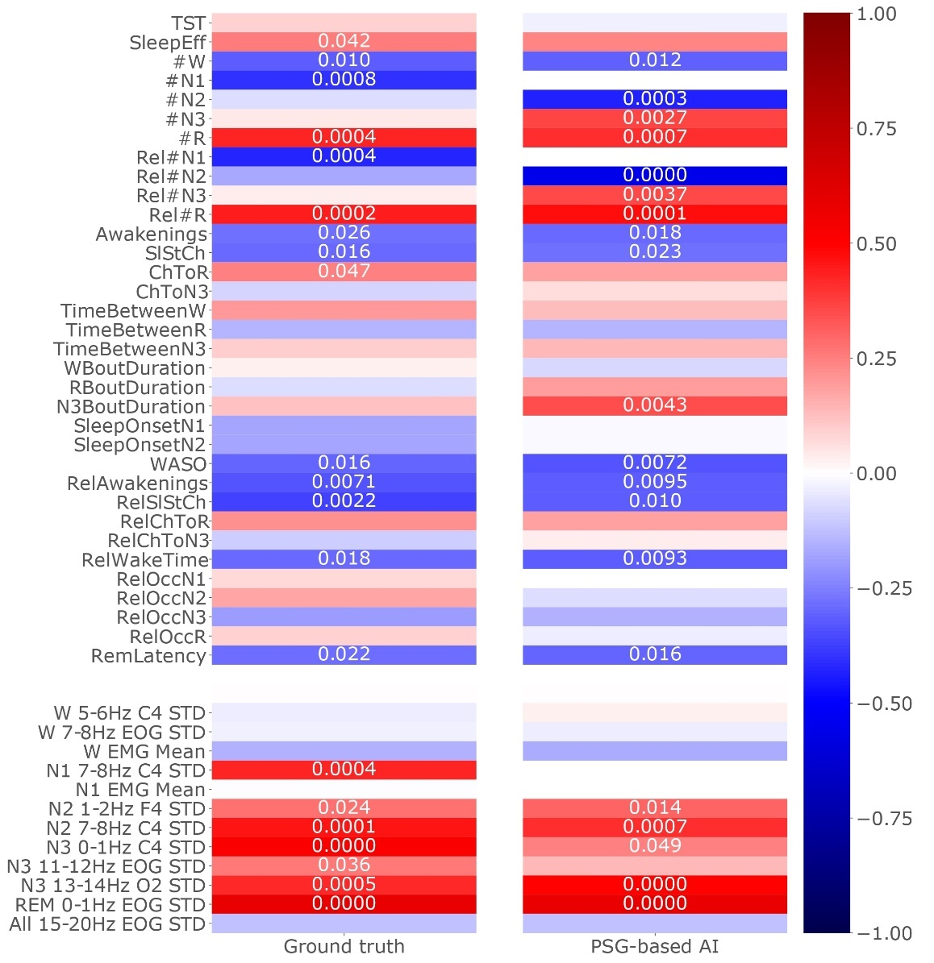

Supplementary Figure 4: Correlation between sleep features based on the PSG data and MMSE.
The hypnogram features are shown in the upper part of the figure, and a few selected physiological features are shown in the lower part. The first column shows the ground truth sleep features based on PSG data with manual scoring, and the second column shows sleep features based on PSG data scored by AI. Pearson’s correlation test was performed with the subjects as samples. The MMSE score was not recorded in the patients from the senior sleep dataset, so the correlations were only computed for the 65 patients of the Alzheimer’s sleep dataset (see Table 3). Correlations are shown through the colors, with p values below 0.05 reported as numbers to indicate the significance of the correlations. The PSG-based AI agrees on most significant correlations that are found in the ground truth, with an agreement of 73.5% for the hypnogram features and 88.8% for the physiological features.

Abbreviations: AI, artificial intelligence; All, all sleep stages; EEG, electroencephalography; EOG, electrooculography; EMG, electromyography; MMSE, Mini-Mental State Examination; STD, standard deviation. Abbreviations for hypnogram features are explained in Supplementary Table S.1.

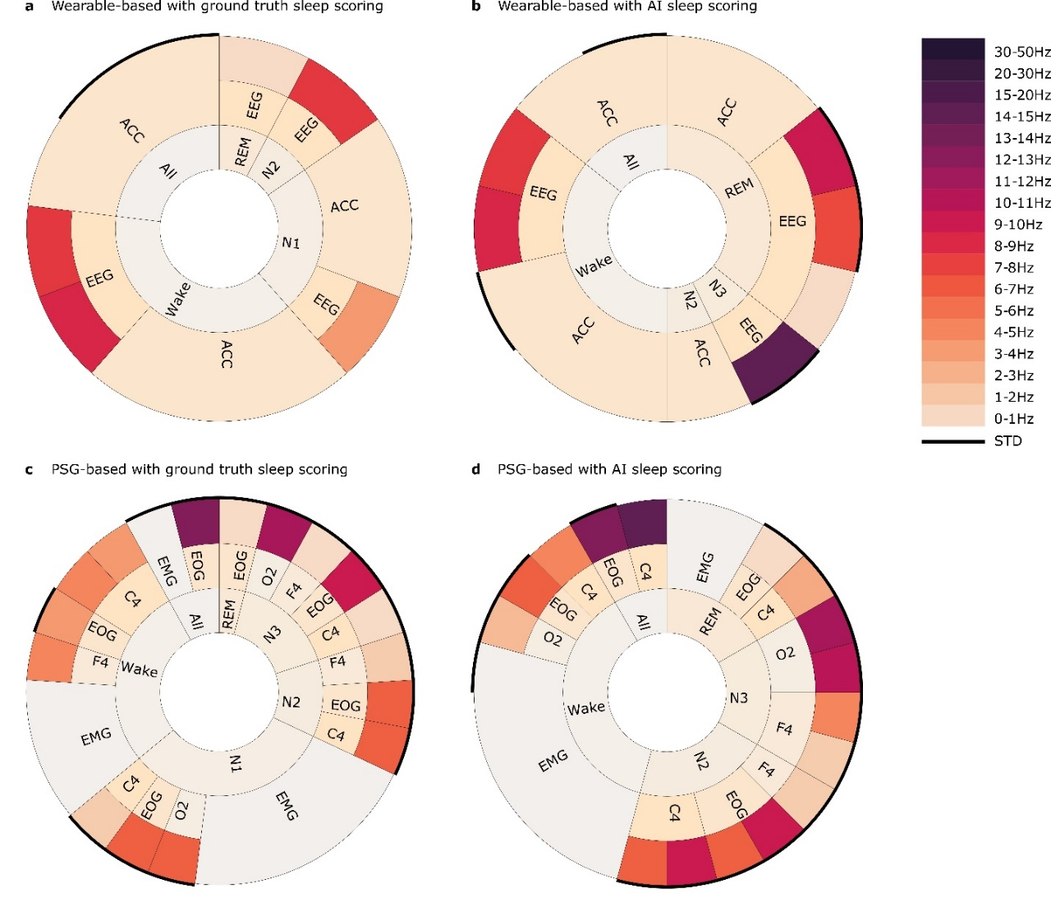

Supplementary Figure 5: Most selected physiological features based on ground truth scoring and AI scoring.
The physiological features that were selected more than 85% of the time by (a) the wearable-based AD detection model using ground truth sleep scoring, (b) the wearable-based AD detection model using AI sleep scoring, (c) the PSG-based AD detection model using ground truth sleep scoring, (d) the PSG-based AD detection model using AI sleep scoring. Features are visualized using three rings showing to which (1) sleep stage, (2) channel, and (3) frequency range each feature corresponded. The frequency range is only shown for the EEG and EOG channels due to the limited interpretability of the EMG and ACM frequencies. The discrete color bar shows the interpretation of the frequency range. The surrounding black ring shows which features were computed using STD, with the remaining calculated using the mean. The width of each segment indicates how many features of that type were selected more than 85% of times. This width should not be mistaken for overall importance of a channel or sleep stage: information may be more spread out over multiple frequency bands for some channels or sleep stages than for others. Rather, this figure shows which channels were important in which sleep stages, and which frequencies were decisive in each channel. The imperfections in sleep staging are apparent when comparing (a) to (b), and (c) to (d), especially for the wearable features. For instance, frequency bands that were important in N2 and N1 according to ground truth scoring (a) appear important in REM when scored by AI (b). Nonetheless, this analysis also demonstrated that despite imperfect sleep staging by AI, the important features remained identifiable and valuable for AD detection.

Abbreviations: ACM, accelerometry; AD, Alzheimer’s disease; AI, artificial intelligence; All, features computed over the whole recording; EEG, electroencephalography; EOG, electrooculography; EMG, electromyography; PSG, polysomnography; STD, standard deviation.

List of hypnogram features

Supplementary Table 4: Hypnogram features and their meaning.
Abbreviation | Meaning
TST | Total sleep time (hours)
SleepEff | Sleep efficiency: TST/ time in bed
#W | Amount of time in Wake (hours)
#N1 | Amount of time in N1 (hours)
#N2 | Amount of time in N2 (hours)
#N3 | Amount of time in N3 (hours)
#R | Amount of time in REM (hours)
Rel#N1 | Relative time in N1: #N1 /TST
Rel#N2 | Relative time in N2: #N2 /TST
Rel#N3 | Relative time in N3: #N3 /TST
Rel#R | Relative time in REM: #R /TST
Awakenings | Total number of awakenings, i.e. transitions to Wake
SlStCh | Total number of sleep stage changes
ChToR | Total number of transitions to REM
ChToN3 | Total number of transitions to N3
TimeBetweenW | Average time between Wake bouts (hours)
TimeBetweenR | Average time between REM bouts (hours)
TimeBetweenN3 | Average time between N3 bouts (hours)
WBoutDuration | Average Wake bout duration (hours)
RBoutDuration | Average REM bout duration (hours)
N3BoutDuration | Average N3 bout duration (hours)
SleepOnsetN1 | Sleep onset as time until first N1 epoch (hours)
SleepOnsetN2 | Sleep onset as time until first N2 epoch (hours)
WASO | Wake after sleep onset: time in Wake between sleep onset and final awakening
RelAwakenings | Relative number of awakenings: awakenings/TST (/hour)
RelSlStCh | Relative number of sleep stage changes: SlStCh/TST (/hour)
RelChToR | Relative number of transitions to REM: ChToR/TST (/hour)
RelChToN3 | Relative number of transitions to N3: ChToN3/TST (/hour)
RelWakeTime | Relative time spent awake after sleep onset: WASO/TST
RelOccN1 | Average timing of N1 sleep relative to sleep onset and final awakening
RelOccN2 | Average timing of N2 sleep relative to sleep onset and final awakening
RelOccN3 | Average timing of N3 sleep relative to sleep onset and final awakening
RelOccR | Average timing of REM sleep relative to sleep onset and final awakening
RemLatency | Time until first REM epoch after sleep onset (hours)

