Supplementary Information

Antitumor activity of Lactococcus lactis cell-free supernatant on human glioblastoma cell lines.

De Chiara I¹, Feola A², Della Gala M¹, Marasco R¹, Nielsen MS³, Porcellini A², Grieco M.¹, Gentile MT^{1*}, Muscariello L^{1*}
1. Department of Environmental, Biological and Pharmaceutical Sciences and Technologies (DiSTABiF), University of Campania Luigi Vanvitelli, Caserta, Italy
2. Department of Biology, University of Naples “Federico II”, Laboratory of General and Clinical Pathology, Naples, Italy
3. Department of Biomedicine, Faculty of Health, Aarhus University, 8000 Aarhus C, Denmark
*corresponding: lidia.muscariello@unicampania.it; mariateresa.gentile@unicampania.it

Figure S1. CFSs from L. lactis strains inhibit proliferation of U87MG cell line. (a) MTT assay. Dose (0.5-5-50 mg/mL) and time (24-48-72 hours) -dependent effect of the CFSs from L. lactis (A3-A5-B1-D1-D3-I1-I4-I7) strains on the viability of U87MG. No differences were detected 24 hours after treatment as compared to untreated cells for none of the CFSs on U87MG. A decrease in cell viability was observed 48 and 72 hours after CFSs administration as compared to the untreated cancer cells. Among the CFSs produced by L. lactis tested, D1, I4, and I7 were selected for further analyses, as they appeared to exert a more cytostatic rather than cytotoxic effect. Untreated cells (NT) were used as positive control. Error bars are representative of the SD of three independent experiments performed in triplicates. Significance of the data obtained was tested by 2way Anova with Sidak’s multiple comparisons (**** p < 0.0001, ** p < 0.05, *p= 0.02) compared to untreated cells; ns: not significant).

Figure S2. FACS flow cytometry cell cycle analysis of U87MG and U251 cell lines. (a) Flow cytometry histogram shows the percentage of cell cycle accumulation during treatments with CFS from L. lactis D1, I4, I7 after 24 hours in U87MG and U251 cell lines. Error bars are representative of SD of the three independent experiments performed in triplicates. The significance of data obtained was tested by the 2way ANOVA with Dunnett’s multiple comparisons (**** p < 0.0001, ***p < 0.001, ** p < 0,005, ns: non significant compared to untreated cells, NT). (b) Percentage of U87MG and U251 cell lines treated with CFS of L. lactis D1, I4, I7 for 24 hours in the different cell cycle phases.

Figure S3. Apoptosis by Annexin V-FITC/PI assay. (a) U251 cells treated with CFS of L. lactis D1-I4-I7 for 48h. Staining with Annexin V or PI resulted in matching fractions of vital cells, early/late apoptosis, and necrotic cells. Cells in region Q4 represent living cells, cells in Q3 early apoptotic cells, cells in Q2 late apoptotic cells, and cells in Q1 those with a damaged membrane only. Each panel corresponds to a representative analysis of the indicated treatments. At least three separate experiments were done. No significant differences in the percentage of apoptotic cells between treatments were seen. (b) U87MG cells treated with CFS of L. lactis D1-I4-I7 for 48h. Staining with Annexin V or PI resulted in matching fractions of vital cells, early/late apoptosis, and necrotic cells. Cells in region Q4 represent living cells, cells in Q3 early apoptotic cells, cells in Q2 late apoptotic cells, and cells in Q1 those with a damaged membrane only. Each panel corresponds to a representative analysis of the indicated treatments. At least three separate experiments were done. No significant differences in the percentage of apoptotic cells between treatments were seen.

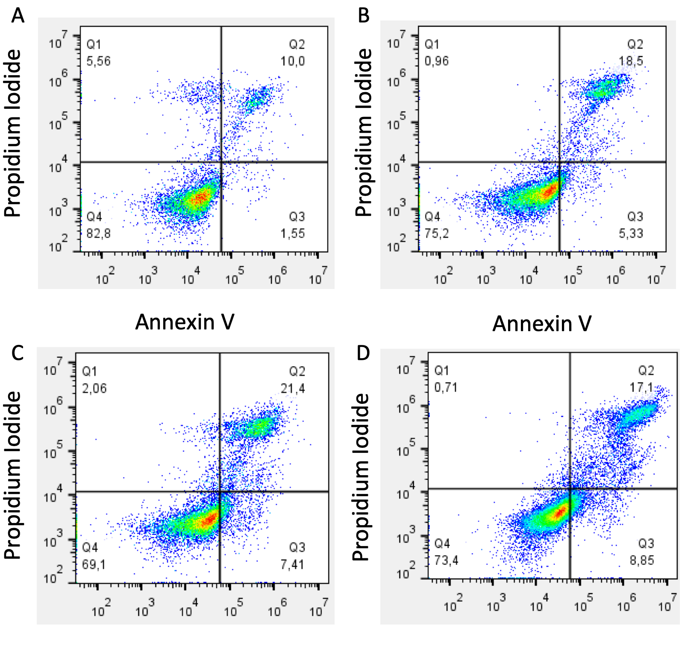

Figure S4. Apoptosis by Annexin V-FITC/PI assay. NIH3T3 cells treated with Cisplatin 60uM for 6h (B), 12h (C), 24h (D) or untreated. Staining with Annexin V or PI resulted in matching fractions of vital cells, early/late apoptosis, and necrotic cells. Cells in region Q4 represent living cells, cells in Q3 early apoptotic cells, cells in Q2 late apoptotic cells, and cells in Q1 those with a damaged membrane only. Each panel corresponds to a representative analysis of the indicated treatments. At least three separate experiments were done. A time-dependent increase in the percentage of apoptotic cells was seen.

