Supporting Information

A Quantum Chemical, Biological, and Experimental Analysis of Newly Synthesized Schiff-based PEI CA/N-GQDs Nanomaterials: Evaluation of Anticancer Potential in Human Neuroblastoma Cell
Murat Kilic^{1,*}, Buket Altinok Gunes¹, Omer Faruk Kirlangic^{1,2}, Aysenur Aslan¹, Didem Ketenoglu³, Fatma Zeynep Kirlangic⁴, Pinar Mualla Elci⁵, Faruk Mert⁶, Neslihan Demir⁷, Bahadir Boyacioglu¹, Huseyin Unver⁸, Ashok Chaterjee⁹, Mustafa Yildiz^{10,*}
¹Vocational School of Health Services, Ankara University, 06290-Ankara, Türkiye
²Department of Medical Biochemistry, Faculty of Medicine, Gazi University, 06500-Ankara, Türkiye
³Department of Physics Engineering, Faculty of Engineering, Ankara University, 06100-Ankara, Türkiye
⁴Department of Pathology, Faculty of Medicine, Amasya University, 05100-Amasya, Türkiye
⁵Gülhane Institute of Health Sciences, University of Health Sciences, Ankara, Türkiye
⁶Vocational School of Technical Sciences, Ankara Yıldırım Beyazıt University, 06760-Ankara, Türkiye
⁷Department of Biology, Faculty of Science, Çanakkale Onsekiz Mart University, 17020-Çanakkale, Türkiye
⁸Department of Physics, Faculty of Science, Ankara University, 06100-Ankara, Türkiye
⁹ Department of Physics, GITAM University, Hyderabad 500046, India
¹⁰Department of Chemistry, Faculty of Science, Çanakkale Onsekiz Mart University, 17020-Çanakkale, Türkiye

*Corresponding Author(s): muratkilic_genetic@yahoo.com (M. KILIC),

myildiz@comu.edu.tr (M. YILDIZ)

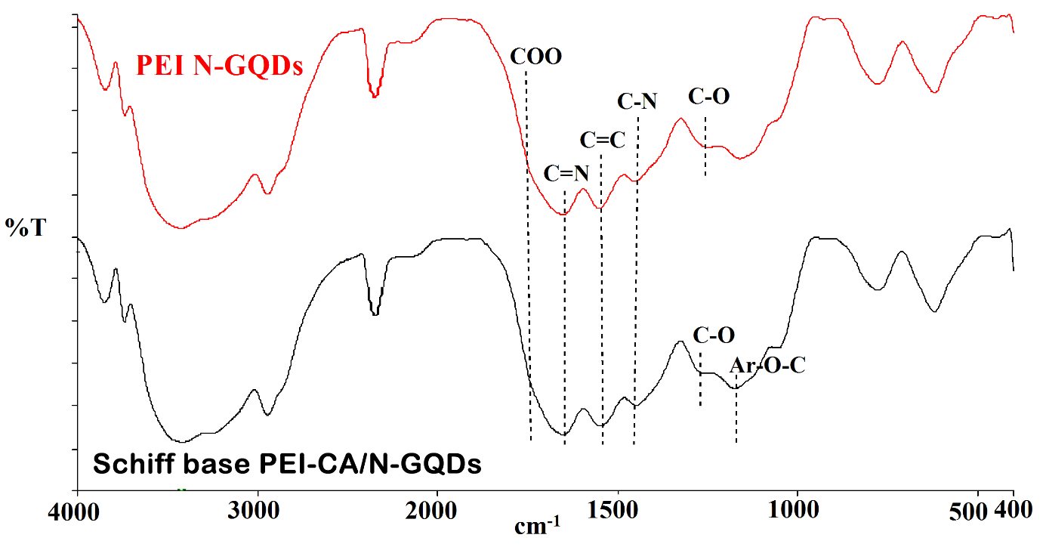
Figure S1. The experimental FTIR specta of PEI N-GQDs^{[1]} and Schiff base PEI-CA/N-GQDs nanocomposites

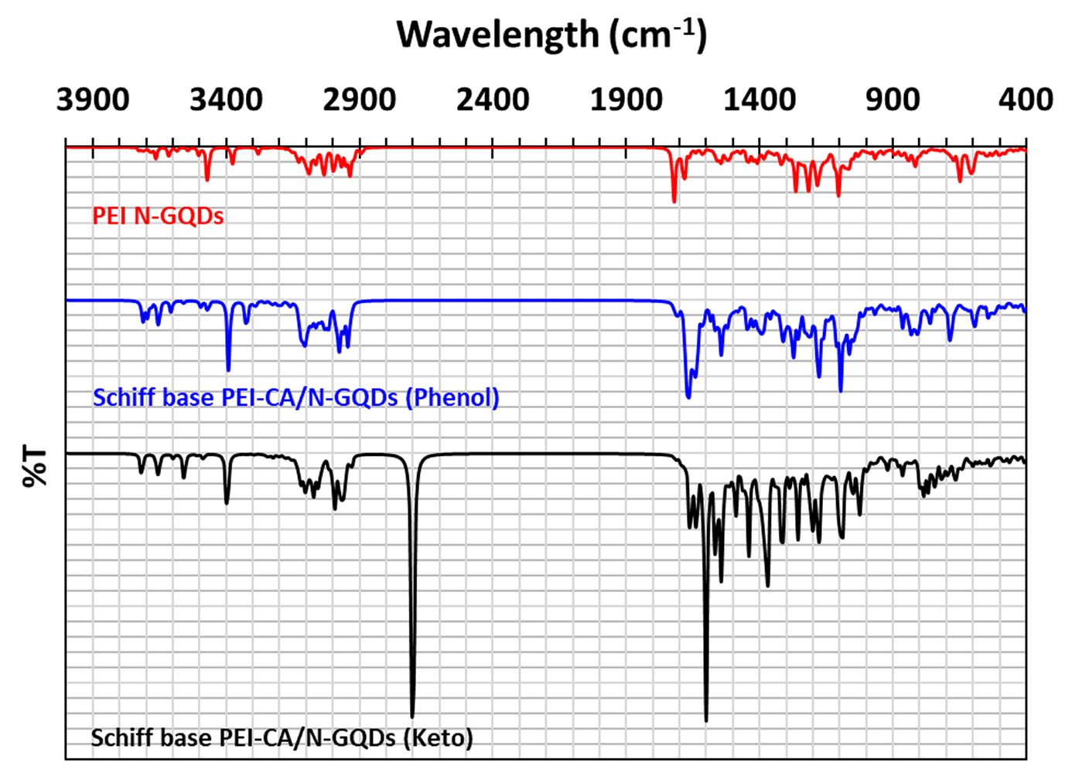
Figure S2. The theoretical FTIR specta of PEI N-GQDs^{[1]} and Schiff base PEI-CA/N-GQDs (for the phenol-imine and keto-amine forms) materials

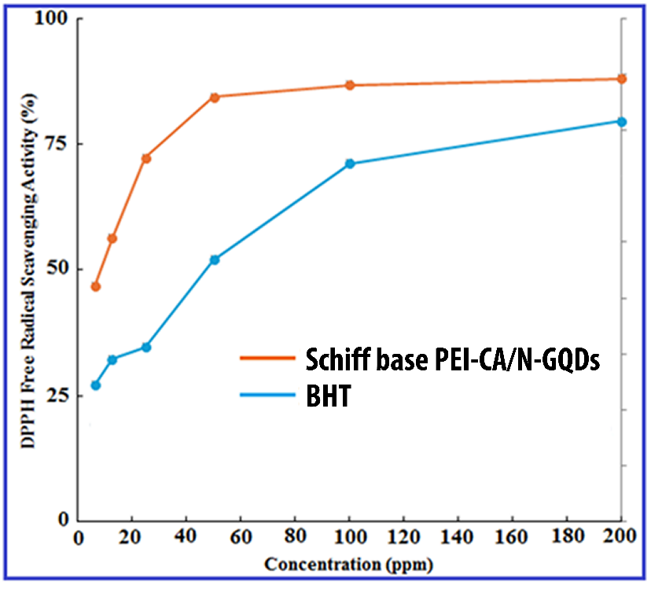
Figure S3. The antioxidant activity of Schiff base PEI-CA/N-GQDs.

References
[1] B.A. Gunes, O.F. Kirlangic, M. Kilic, A. Sunguroglu, T. Ozgurtas, E.K. Sezginer, B. Boyacioglu, H. Unver, M. Yildiz, Palladium Metal Nanocomposites Based on PEI-Functionalized Nitrogen-Doped Graphene Quantum Dots: Synthesis, Characterization, Density Functional Theory Modeling, and Cell Cycle Arrest Effects on Human Ovarian Cancer Cells, Acs Omega, 9 (2024) 13342-13358.

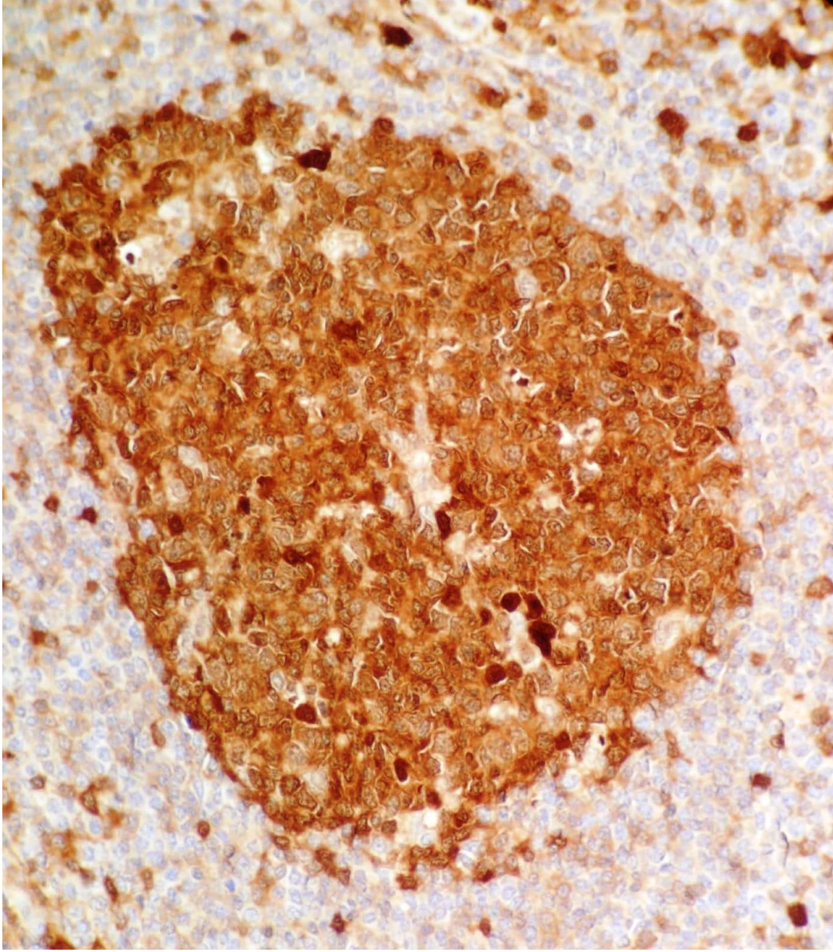
Figure S4. Positive control staining of CASPASE-3 protein in lymphoid tissue (clone EP410 cod. AC-0364RUO, Cell Marque, USA) (400X). Stained by Fatma Zeynep Kirlangic using the Leica Bond-Max automated staining system.

Figure S5. Positive control staining of Bcl-2 protein in lymphoid tissue (clone EP410 cod. AC-0364RUO, Cell Marque, USA) (400X). Stained by Fatma Zeynep Kirlangic using the Leica Bond-Max automated staining system.

