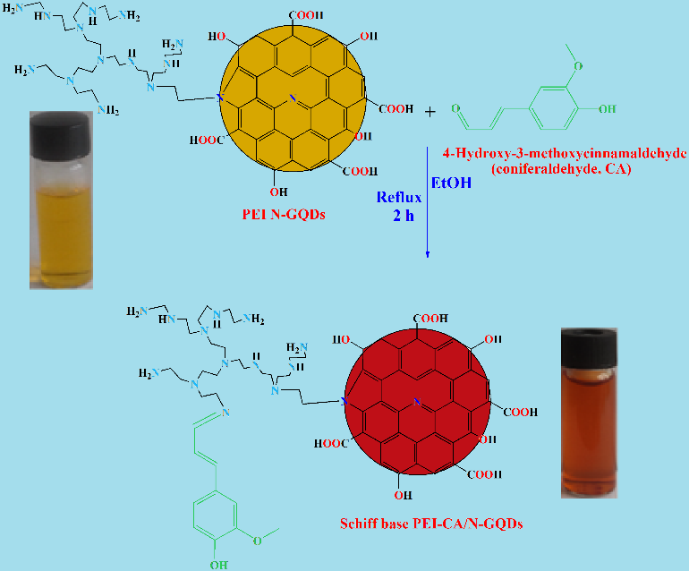
Scheme 1. Synthesis of Schiff base PEI-CA/N-GQDs

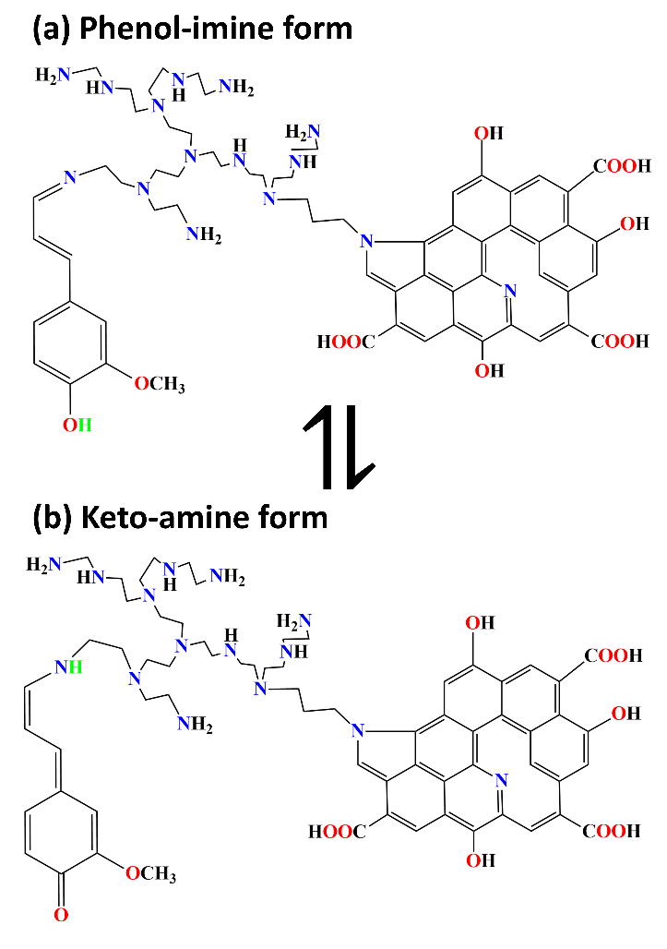
Scheme 2. Schematic representation of Schiff base PEI-CA/N-GQDs for both phenol-imine (a) and keto-amine (b) forms.

