Population Pharmacokinetics of Brexpiprazole in Japanese Healthy Subjects and Patients with Schizophrenia

Supplementary material

Table S1. Dosing regimen and PK sampling schedule of trials included in the population PK analysis
Trial identifier | Brexpiprazole dosing regimen | PK sampling schedule
331-07-002 | Single dose of 0.2, 0.5, 1, 2, 4, and 6 mg | Pre-dose, then at 0.5, 1, 1.5, 2, 3, 4, 6, 8, 10, 12, 24, 36, 48, 60, 72, 96, 120, 144, and 168 hours post-dose, and at discontinuation
331-10-001 | Multiple QD doses of 1, 4, and 6 mg | Day 1: pre-dose, then at 1, 2, 4, 6, 8, 12, and 24 hours post-dose (before dosing on Day 2)  Days 10, 11, 12, and 13: pre-dose  Day 14: pre-dose, then at 1, 2, 4, 6, 8, 12, 24 (Day 15), 48 (Day 16), 72 (Day 17), 96 (Day 18), 120 (Day 19), 144 (Day 20), and 168 (Day 21) hours post-dose  At discontinuation: feasible time on the discontinuation day
331-10-002 | Multiple QD doses of 1, 2, and 4 mg | Week 3: at 0.5 to 6 hours, 6 to 12 hours, and 12 to 24 hours (prior to brexpiprazole administration the following day) post-dose  Week 6/end of treatment: at a feasible time (1 timepoint)
PK, pharmacokinetic; QD, once daily.

Table S2. Percentiles of age and eGFR and impact on apparent clearance
 | Percentiles
 | 5% | 25% | 50% | 75% | 95%
Age (years) | 22 | 31 | 42 | 53 | 63
Difference in typical CL/F at given age percentileª (%) | 21 | 9.40 | Reference | -6.60 | -11.3
Difference in AUC at given age percentileª (%) | -17.4 | -8.59 | Reference | 7.07 | 12.7
eGFR (mL/min) | 65.5 | 78 | 88.4 | 100.1 | 119.7
Difference in typical CL/F at given eGFR percentileª (%) | -11.4 | -4.93 | Reference | 5.15 | 13.0
Difference in AUC at given eGFR percentileª (%) | 12.9 | 5.19 | Reference | -4.90 | -11.5

ªValues for intermediate CYP2D6 metabolisers.
AUC, area under the curve; CL/F, apparent clearance in the central compartment; CYP, cytochrome P450; eGFR, estimated glomerular filtration rate.

Table S3. Impact of CYP2D6 metabolic status on brexpiprazole CL/F and AUC
 | N | % of subjects | CL/F effect | AUC effect
Extensive CYP2D6 metaboliserª | 202 | 50.8 | Referenceª | Referenceª
Missing/inconclusiveª | 128 | 32.2 | Referenceª | Referenceª
Intermediate CYP2D6 metaboliser | 68 | 17.1 | -35.9% | 56%

ªExtensive and missing/inconclusive metabolisers were combined.

Figure S1. Graphical exploration of initial data exploration
(A) Dose-normalised brexpiprazole plasma concentration vs time after last dose plot for the two Phase 1 studies on a semi-log (left) and linear scale (right)
(Solid lines represent the median of the observations within the study)
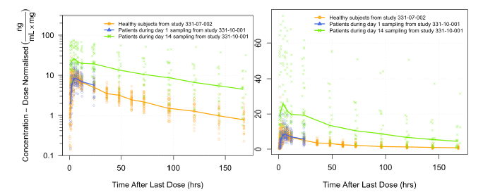

(B) Median of dose-normalised brexpiprazole plasma concentrations for each inferred metabolic status vs time after last dose plot for healthy volunteers and patients across Day 1 for the Phase 1 studies on a semi-log (left) and linear scale (right)
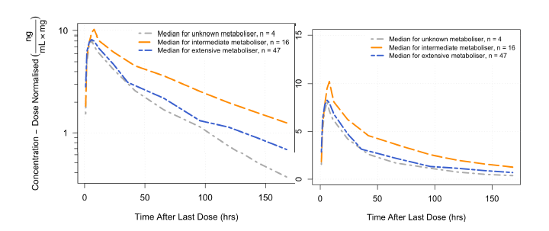
(C) Phase 1 trough samples, multiple daily dosing in patients
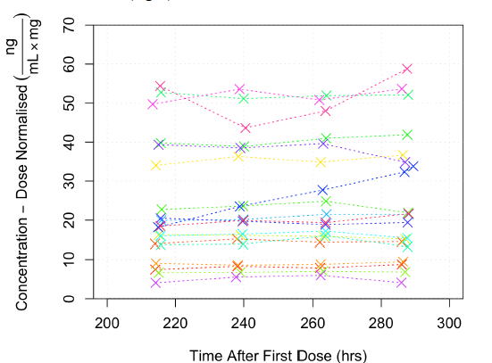

(D) Dose-normalised brexpiprazole plasma concentration vs actual time since last dose plot for the patient data from combined Phase 1 and Phase 2/3 studies semi-log (left) and on a linear scale (right)
(The solid red line and the dashed blue line represent the median of Phase 1 and Phase 2/3 patient data, respectively)
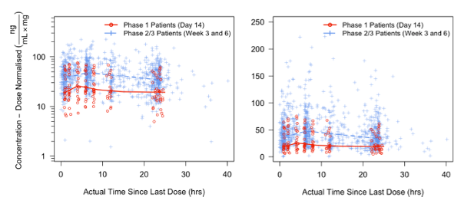
CL/F, apparent clearance; hrs, hours.

Figure S2. KTR plotted per dose group with KTR values predicted by the final base model using a power function
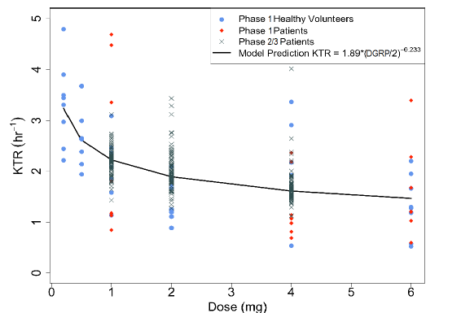
KTR, absorption transit rate constant.

Figure S3. ETA on CL/F and Vc/F plotted data from Phase 1 and Phase 2/3 studies separately
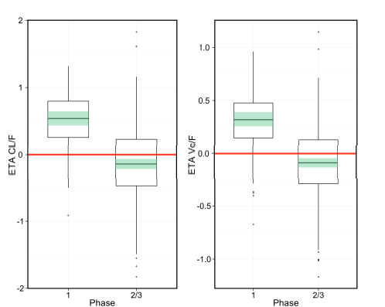
The red line represents zero; the box represents the range between lower and upper quartile for η; the centre line shows the median; the green shading represents the 95% CI for the median and circles show the outliers (1.5*IQR).
CI, confidence interval; CL/F, apparent clearance; IQR, inter-quartile range; Vc/F, apparent central volume of distribution.

Figure S4. General goodness-of-fit for the final population PK model
(Loess smoothing line in red, identity line in blue, dashed orange line represents LOQ = 0.5 ng/mL)
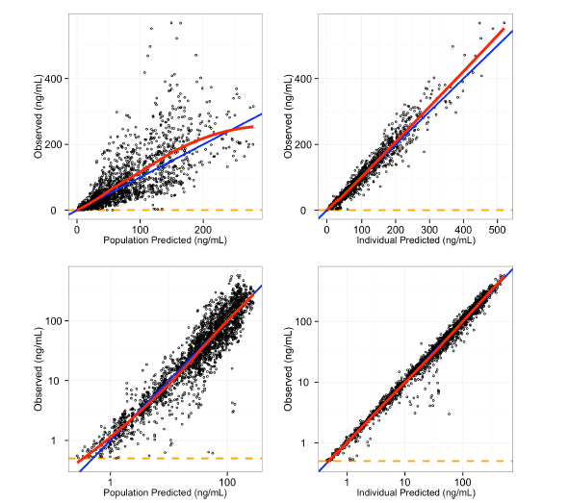
LOQ, limit of quantification; PK, pharmacokinetic.

Figure S5. Residual goodness-of-fit for the final population PK model
(Loess smoothing line in red, zero line or unity in blue)
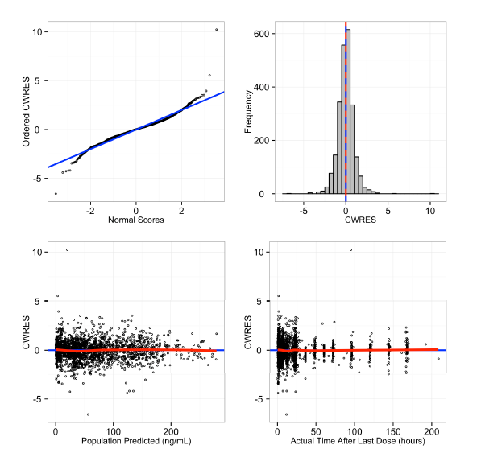
CWRES, conditional weighted residuals; PK, pharmacokinetic.

Figure S6. Distribution and shrinkage of the ETAs of the final population PK model
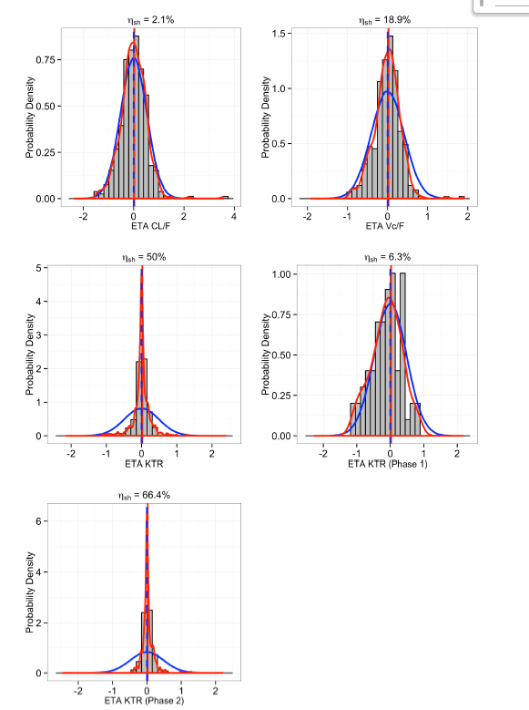
The curved blue lines show the expected trend of the data; curved red lines the observed trend; vertical blue lines show the expected mean of zero; and the vertical red lines show the mean of the data. ETA shrinkage is shown at the top of each plot.
CL/F, apparent clearance; KTR, absorption transit rate constant; PK, pharmacokinetic; Vc/F, apparent central volume of distribution.

