Table S1͵ Procedures and complications
Variable | AFPHF-CA | AF-CA | P
All pulmonary veins isolated — no. (%) | 187（100） | 196（100） | 1.00
Additional left atrial linear ablation — no. (%) | 98（52.41） | 92（46.94） | 0.26
Total duration of radiofrequency ablation — min | 85.1±22.6 | 82.6±22.3 | 0.46
Total duration of fluoroscopy — min | 6.9±3.2 | 6.1±2.3 | 0.32
Total duration of procedure — min | 138.6±37.6 | 137.5±32.8 | 0.78
Serious complications — no. (%)
Tamponade | 2（1.07%） | 2（1.02%） | 0.37
stroke | 0（0%） | 0（0%） | 1.00
death | 0（0%） | 0（0%） | 1.00
Repeat operations — no. (%) | 13（6.95） | 17 (8.67） | 0.26

Table S2͵ Univariate and multivariate analyses for predictors of incidence of survival and stoke in AFPHA patients
Variable | survival |  |  |  | stroke
Variable | Univariate analysis |  | Multivariable analysis |  | Univariate analysis |  | Multivariable analysis
Variable | OR (95%CI) | P- value | OR (95%CI) | P-value | OR (95%CI) | P-value | OR (95%CI) | P-value
Age, year | 1.32 (1.15-1.52) | <0.001 | 1.32 (1.12-1.55) | .001 | 1.21 (1.09-1.33) | <.001 | 1.20 (1.03-1.41) | .023
eGFR, ml/min |  |  |  |  | 0.96 (0.93-0.99) | .013
Long-stand of AF, N |  |  |  |  | 4.11 (1.01-16.75) | 0.048 | 9.90 (1.26-78.09) | .029
BNP, pg/mL |  |  |  |  | 1.0(1.00-1.00) | 0.049
Diabetes mellitus, N |  |  |  |  | 4.75 (1.64-13.73) | 0.004
CHA2DS2-VASC | 1.97 (1.40-2.76) | <.001 |  |  | 1.81 (1.33-2.47) | <.001
Hypertension, N |  |  |  |  | 4.17 (1.15-15.21) | 0.030
Stroke before CA, N | 4.25 (1.30-13.95) | .017 |  |  | 3.61 (1.13-11.58) | 0.031
Posterior wall thickness, mm |  |  |  |  | 2.13 (1.28-3.55) | 0.004 | 2.86 (1.23-6.65) | .015
LV mass index, gm/m | 1.03 (1.01-1.05) | .017 |  |  | 1.02 (1.00-1.05) | 0.033
LA volume index, ml/m2 | 1.13 (1.01-1.27) | .038
SR maintenance, N | 6.66 (1.45-30.64) | .015 | 1.53 (0.18-12.89) | .010 | 4.97 (1.36-18.11) | 0.015 | 0.87 (0.17-4.55) | 0.007
Abbreviation: AF, atrial fibrillation; BMI, body mass index; eGFR, estimated glomerular filtration rate; CHA2DS2-VASc, congestive heart failure, hypertension, age ≥75 (doubled), diabetes, stroke (doubled), vascular disease, age 65–74, and sex category (female);; BNP, brain natriuretic peptide; CA, catheter ablation.

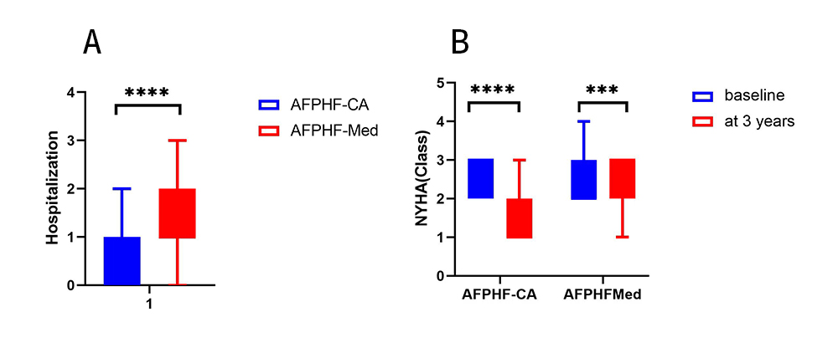
FigureS1. A, HF hospitalization during the follow up between AFPHF-CA and AFPHF-Med, ****P < .001; B, Improvements of New York Heart Function Classification between baseline and after 36-month follow up, ****P < .001, ***P < .005.

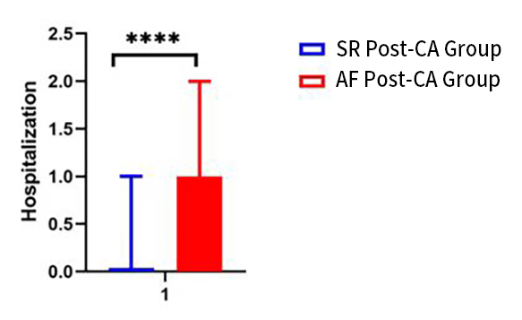
FigureS2. HF hospitalization during the follow up between SR Post-CA Group and AF Post-CA Group, ****P < .001

