Supplement Table 1
Factors associated with serum phosphate in multivariate linear regression
 | Coefficient | 95% confidence interval | p value
Male Gender | -0.72 | -0.263~-0.66 | 0.01
Age | -0.199 | -0.20~-0.13 | <0.001
BMI | -0.003 | 0.889~-0.11 | 0.889
Smoking (n, %) | -0.022 | -0.127~0.35 | 0.267
Dyslipidemia (n, %) | 0.023 | -0.033~0.126 | 0.253
Diabetes (n, %) | 0.024 | -0.035~0.147 | 0.231
Hypertension (n, %) | 0.020 | -0.040~0.123 | 0.314
Heart failure (n, %) | 0.031 | -0.19~0.176 | 0.113
Stroke (n, %) | 0.043 | 0.021~0.294 | 0.024
CKD (n, %) | 0.061 | 0.065~0.321 | 0.003
ACS | 0.024 | -0.030~0.127 | 0.223
eGFR | -0.185 | -0.008~-0.005 | <0.001
HGB | -0.098 | -0.069~-0.024 | <0.001
UA | 0.098 | 0.029~0.068 | <0.001
CA | 0.114 | 0.109~0.220 | <0.001
HDLC | 0.018 | -0.002~0.005 | 0.353
LDLC | 0.031 | 0.000~0.002 | 0.116
Beta blockers | -0.004 | -0.134~0.035 | 0.253
ACEI/ARB | -0.025 | -0.134~0.035 | 0.253
Statins | -0.023 | -0.132~0.041 | 0.298
BMI=body mass index, CKD=chronic kidney disease, ACS=acute coronary syndrome, HGB=hemoglobin, UA=uric acid, CA=calcium, HDLC=high density lipoprotein cholesterol, LDLC=low density lipoprotein cholesterol, ACEI/ARB= angiotensin converting enzyme inhibitor/ angiotensin receptor blockers
Supplement Figure 1.
eGFR (ml/min/1.73m²)
Serum phosphate(mg/dL)

Supplement Figure 2.
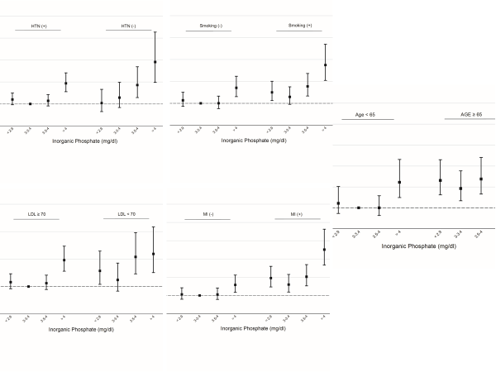

Supplement Figure 1: Relationship between serum phosphate and renal
function. Box–and–whisker plots of changes in serum phosphate
level according to the severity of renal dysfunction. The line within the
box denotes the median and the box spans the interquartile range
(25th to 75th percentiles). Whiskers extend from the 5th to 95th percentiles.

Supplement Figure 2: Prespecified subgroup analysis showing the relationship between serum phosphate quartile and the probability of the primary endpoint in different subgroups. HTN=hypertension, LDL=low density lipoprotein cholesterol, MI=presented as acute coronary syndrome.

Authors’ contribution:

Tsung-Ying Tsai MD. ^{1,2,3,6}, Pai-Feng Hsu MD.PhD. ^{2.4.5.8}, Cheng-Hsueh Wu MD. ^{4,7,8}, Ya-Ling Yang MD. ^{7,8},Su-Chan Chen MD. ^{7,8}, Shao-Sung Huang MD. ^{4,7,8}, Wan Leong Chan MD. ^{4,5}, Shing-Jong Lin MD. ^{4,5}, Jaw-Wen Chen MD. ^{4,5}, Ju-Pin Pan MD. ^{4,5,7}, Min-Ji Charng MD. ^{4,5,7}, Ying-Hwa Chen MD. ^{7,8}, Tao-Cheng Wu MD. ^{7,8}, Tse-Min Lu MD.^{7,8}, Po-Hsun Huang MD. ^{7,8}, Hao-Min Cheng MD. ^{4,7,8}, Chin-Chou Huang MD. ^{4,7,8}, Shih-Hsien Sung MD.^{7,8}, Yenn-Jiang Lin MD. ⁵, and Hsin-Bang Leu MD. ^{1,2,4,5,7,8}

Concept/design¹,

Data analysis/interpretation²,

Drafting article³,

revision of article⁴,

Approval of article⁵,

Statistics⁶,

Data collection⁷,
Other(logistic)⁸

