Supplementary material
- Supplemental Brief introduction of the Cohort 2
- Supplemental Table 1 The Bayesian Information Criterion for models with varying group number groups (two to five clusters). 4
- Supplemental Table 2 Reclassification and discrimination of different models for TyG index and cardiovascular disease risk in PLWH 5
- Supplementary Table 3 Sensitivity analysis of the threshold effect of TyG index on cardiovascular disease risk in PLWH excluding people with less than first year of follow-up 6
- Supplemental Fig. 1 Trajectory groups of TyG index over time in PLWH (two to five groups), identified using Group-Based Trajectory Modeling 7
- Supplemental Fig. 2 Multivariable adjusted spline curves for associations of the TyG index with cardiovascular disease in PLWH excluding people with less than first year of follow-up 8

Supplemental Brief introduction of the Cohort
This study is based on a cohort study at the Third People’s Hospital of Shenzhen, the only designated hospital for HIV care in Shenzhen, China. The hospital managed approximately 17,000 people living with HIV (PLWH) from 2010 to 2021. Antiretroviral therapy (ART) is provided free-of-charge according to national HIV treatment guidelines. PLWH visit the hospital every three months for continuous ART prescriptions and health monitoring. Before starting ART, comprehensive baseline assessments are conducted, including HIV viral load, T-cell subsets, common opportunistic infections, complete blood count, liver and kidney function, thyroid function, electrocardiogram, bone density, and co-infections (e.g., CMV, HBV, HCV, syphilis, HPV). Detailed patient histories and lifestyle information are also collected. After initiating ART, patients are regularly followed up every three months with routine HIV viral load and T-cell subset testing, and additional tests as needed. The high reimbursement rate of Shenzhen’s health insurance policies contributes to a low loss-to-follow-up rate, providing a stable cohort and valuable clinical data for research

The following are some studies we have conducted based on this cohort：
1. Li T, Sun L, He Y, et al. Increasing trends of overweight and obesity in treatment-naive people living with HIV in Shenzhen from 2014 to 2020: an emerging health concern. Front Public Health 2023; 11:1186838.
2. Sun L, He Y, Xu L, et al. Higher Risk of Dyslipidemia With Coformulated Elvitegravir, Cobicistat, Emtricitabine, and Tenofovir Alafenamide than Efavirenz, Lamivudine, and Tenofovir Disoproxil Fumarate Among Antiretroviral-Naive People Living With HIV in China. J Acquir Immune Defic Syndr 2022; 91: S8-S15.
3. Liu J, Hou Y, Sun L, et al. High population-attributable fractions of traditional risk factors for non-AIDS-defining diseases among people living with HIV in China: a cohort study. Emerging Microbes & Infections 2021; 10:416-423.
4. Liu J, Sun L, Hou Y, et al. Barriers to early diagnosis and treatment of persistently high burden of severely immunosuppressed patients with HIV-1: a quantitative and qualitative study. HIV Medicine 2020; 21:708-717.
5. Sun LQ, Liu JY, He Y, et al. Evolution of blood lipids and risk factors of dyslipidemia among people living with human immunodeficiency virus who had received first-line antiretroviral regimens for 3 years in Shenzhen. Chin Med J 2020; 133:2808-2815.
Supplementary Table 1 The Bayesian Information Criterion for models with varying group number groups (two to five clusters).
Number of trajectory group | Order of the trajectory polynomials | BIC | AIC | No. of patients classified into group | patients classified into group (%) | AvePP
2 | (3, 3) | -208076.5 | -208038.2 | 10095 | 63.6 | 0.979
 |  |  |  | 5784 | 36.4 | 0.970
3 | (3, 3, 3) | -182361.6 | -182304.0 | 6447 | 40.6 | 0.960
 |  |  |  | 6860 | 43.2 | 0.943
 |  |  |  | 2572 | 16.2 | 0.965
4 | (3, 3, 3, 3) | -170256.5 | -170179.8 | 4144 | 26.1 | 0.938
 |  |  |  | 6098 | 38.4 | 0.914
 |  |  |  | 4129 | 26.2 | 0.936
 |  |  |  | 1508 | 9.3 | 0.963
5 | (3, 3, 3, 3, 3) | -164011.0 | -163915.1 | 3382 | 21.3 | 0.926
 |  |  |  | 5446 | 34.3 | 0.895
 |  |  |  | 4240 | 26.7 | 0.904
 |  |  |  | 2255 | 14.2 | 0.933
 |  |  |  | 556 | 3.5 | 0.956
According to the likelihood ratio test, the final model is a four-group model. Order: 0= zero-order (intercept), 1=linear; 2= quadratic; 3=cubic. BIC= Bayesian Information Criterion; AIC= Akaike’s Information Criterion; AvePP= Average Posterior Probability
Supplemental Table 2 Reclassification and discrimination of different models for TyG index and cardiovascular disease risk in PLWH
 | C statistic |  |  | NRI (continuous) |  |  | NRI (categorical) |  |  | IDI
 | Estimate (95% Cl) | P Value |  | Estimate  (95% Cl), % | P Value |  | Estimate  (95% Cl), % | P Value |  | Estimate (95%Cl), % | P Value
Conventional model | 0.836 (0.810, 0.862) |  |  | Reference |  |  | Reference |  |  | Reference
Conventional model + TyG | 0.847 (0.821, 0.873) | <0.001 |  | 37.47 (24.05, 50.89) | <0.001 |  | 1.71 (1.48, 1.94) | <0.001 |  | 0.13 (-0.24, 0.50) | 0.481
TyG, triglyceride-glucose; Cl, confidence interval; PLWH, people living with HIV; NRI, net reclassification improvement; IDI, integrated discrimination index
Conventional model included sex, age, body mass index, marital status, smoking, drinking, high-density lipoprotein cholesterol, low-density lipoprotein cholesterol, total cholesterol, hypertension, CD4 count, HIV transmission route, ART treatment regimen
Supplemental Table 3 Sensitivity analysis of the threshold effect of TyG index on cardiovascular disease risk in PLWH excluding people with less than first year of follow-up
 | Adjusted HR (95% CI) | P value
TyG index on cardiovascular disease
Fitting by the standard Cox proportional risk model | 1.55 (1.21, 1.97) | <0.001
Fitting by the two-piecewise Cox proportional risk model
Infection point | 8.479
TyG index < 8.479 | 3.61 (1.08, 12.11) | 0.038
TyG index ≥ 8.479 | 1.39 (1.01, 1.91) | 0.042
P for Log-likelihood ratio | <0.001
TyG, triglyceride-glucose; HR, hazard ratio; CI, confidence interval; PLWH, people living with HIV
Cox proportional hazard models were used to estimate HR and 95% CI
Adjusted for sex, age, body mass index, marital status, smoking, drinking, high-density lipoprotein cholesterol, low-density lipoprotein cholesterol, total cholesterol, hypertension, CD4 count, HIV transmission route, ART treatment regimen

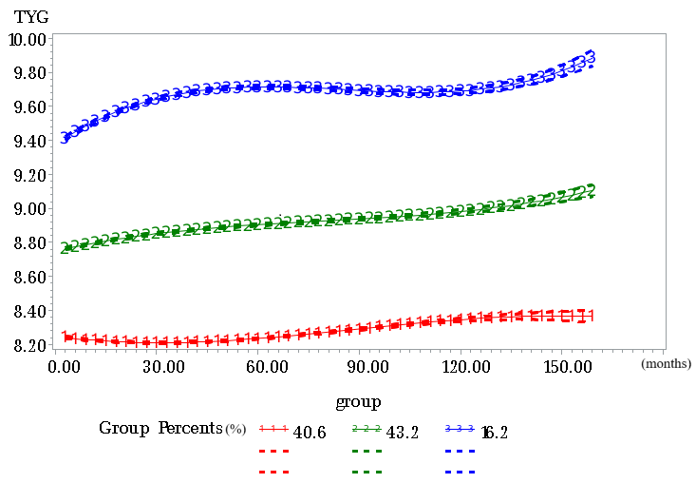
Supplemental Fig. 1 Trajectory groups of TyG index over time in PLWH (two to five groups), identified using Group-Based Trajectory Modeling
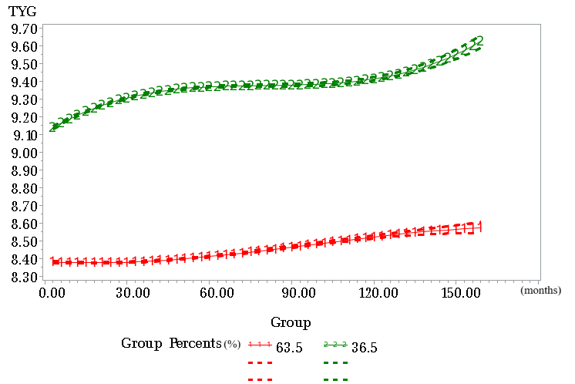

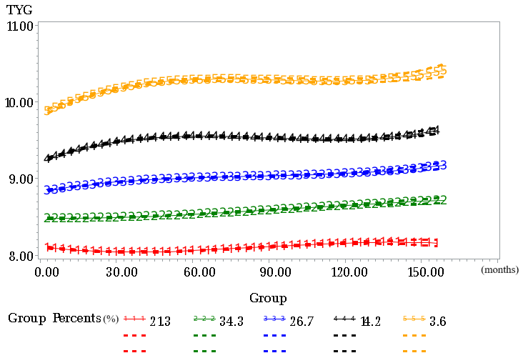
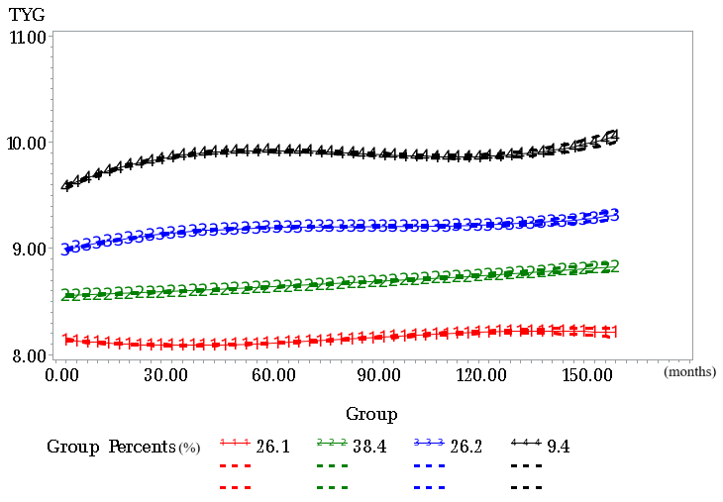

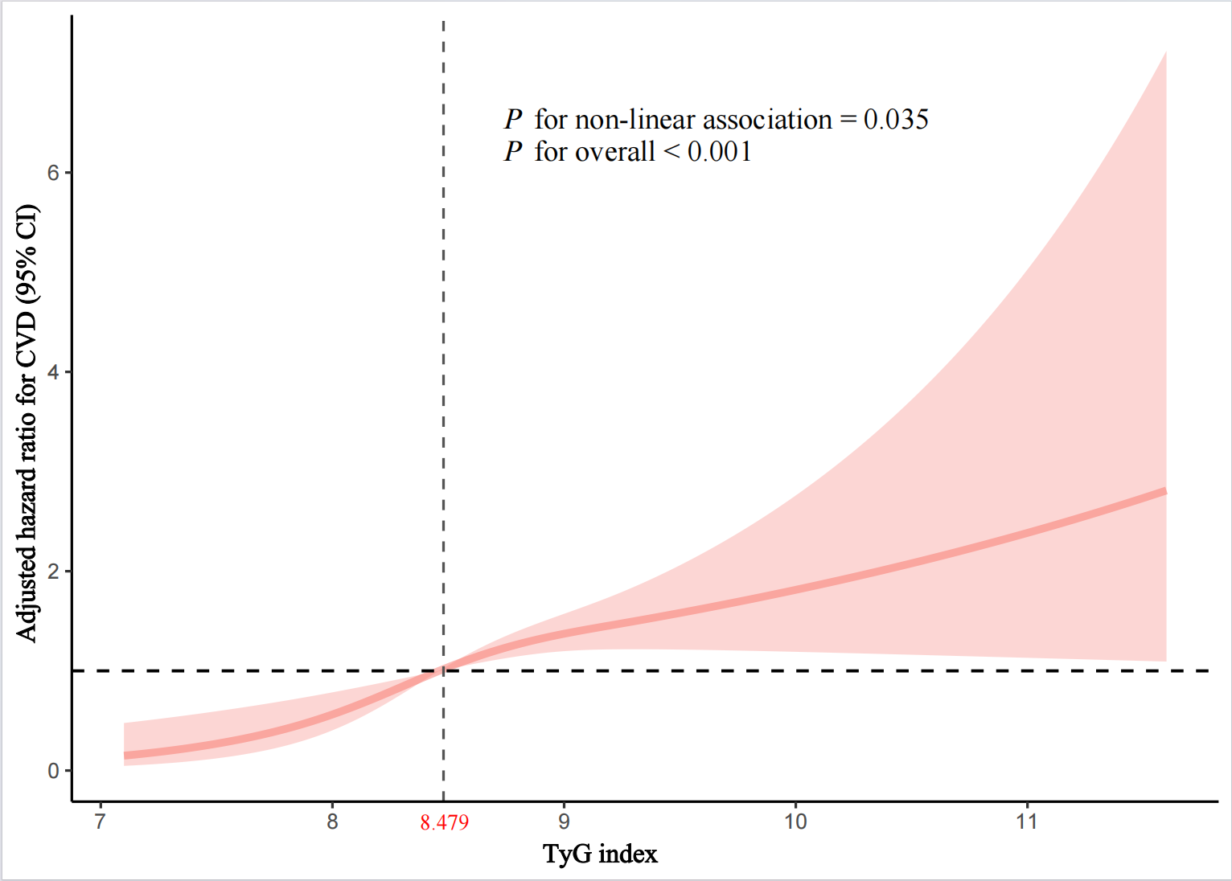
Supplemental Fig. 2 Multivariable adjusted spline curves for associations of the TyG index with cardiovascular disease in PLWH excluding people with less than first year of follow-up

Hazard ratios adjusted for sex, age, BMI, marital status, smoking, drinking, HDL-C, LDL-C, TC, hypertension, CD4 count, HIV transmission route, ART treatment regimen. The solid line and red area represent the estimated values and their corresponding 95% CI. TyG, triglyceride–glucose; CVD, cardiovascular diseases; PLWH, people living with HIV; HR, hazard ratio; CI, confidence interval; BMI, body mass index; HDL-C, high-density lipoprotein cholesterol; LDL-C, low-density lipoprotein cholesterol; TC, total cholesterol; ART, antiretroviral therapy

