Supporting Information for
Complex Influences of Tropical Indian and Atlantic Oceans on ENSO Prediction

Ke Jiangª, Jiye Wuª*, Jing-Jia Luoª*

ª Institute of Climate Application Research (ICAR)/School of Future Technology/CIC-FEMD/KLME/ILCEC, Nanjing University of Information Science and Technology, Nanjing 210044, China.

Contents of this file
Figures S1 to S6
Tables S1
Introduction
Figure S1 shows the anomaly correlation coefficient (ACC) skill differences between the Obs and Cli experiments of the AO, IO, and AO+IO groups in predicting the sea surface temperature anomalies (SSTA) at different lead times. Figures S2 and S3 exhibit the composited differences in SST, precipitation, and 10m wind anomalies between the prediction of AO and IO groups initialized on 1st Feb during the developing years of La Niña and El Niño. Figure S4 shows the ACC skills of six experiments during two periods. Figures S5 and S6 exhibit the composited differences in SST, precipitation, and 10m wind anomalies between the prediction of AO and IO groups initialized on 1st Feb of El Niño events during pre-2000 and post-2000. Table S1 introduces the detailed model information from the North American Multi-Model Ensemble (NMME) used for analysis.

Figures S1 - S6
Fig. S1 The ACC skill differences between the Obs and Cli experiment of the AO group (left panel), IO group (middle panel), and AO+IO group (right panel) in predicting SST anomalies at lead times of 2 (1st row), 4 (2nd row), 6 (3rd row), 8 (4th row), 10 (5th row), and 12 (6th row) months. Stippled areas in (a-r) represent that the differences in two sets of ACCs are significant at the 95% confidence level.

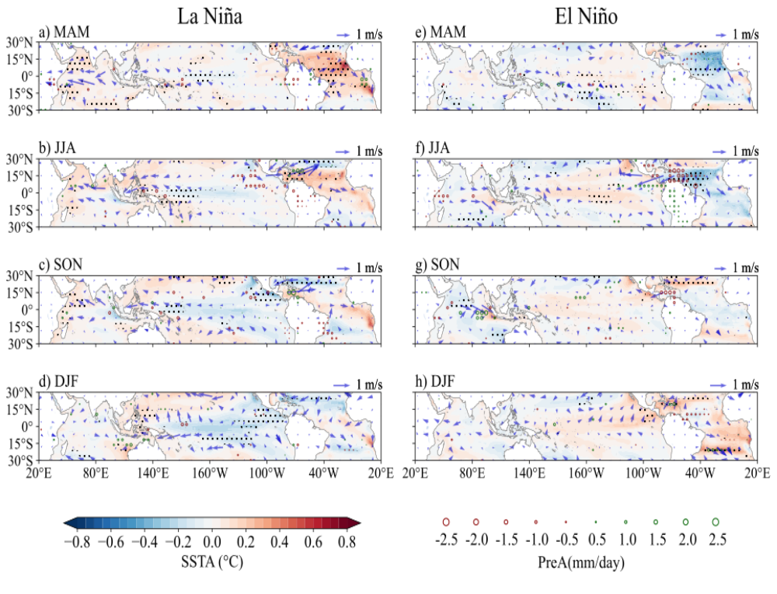
Fig. S2 The composited difference in SST (shading, °C) and 10m winds (vectors, m·s⁻¹) anomalies between the prediction of Obs_AO and Cli_AO experiment (AO group) initialized on 1st Feb during the developing years of La Niña (left column) and El Niño (right column). The composited differences in SST (shading, °C) and 10m winds (vectors, m·s⁻¹) anomalies between the prediction of Obs and Cli experiment initialized on 1st Feb during the developing years of La Niña (left column) and El Niño (right column). Stippled areas and bold vectors indicate that the differences of SST and winds exceeding the 95% confidence level, respectively. Hollow circles denote the difference of precipitation (mm·day⁻¹) exceeding the 95% confidence level.

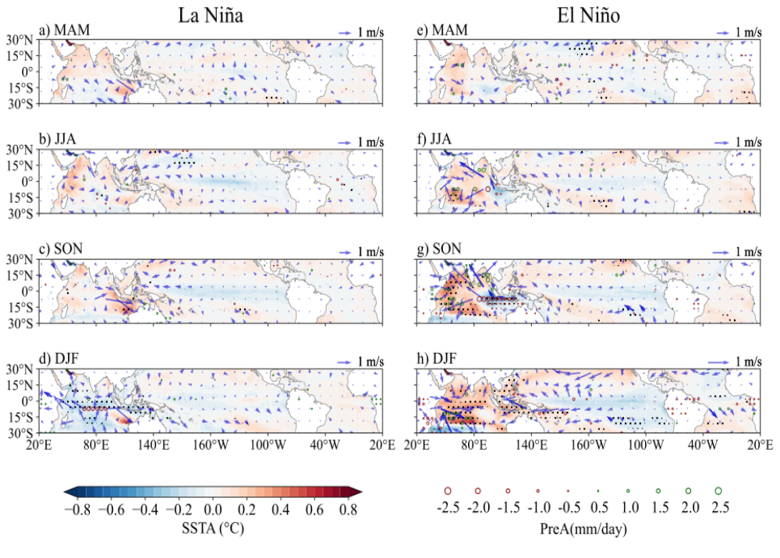
Fig. S3 As in Figure S2, but for differences between the prediction of Obs_IO and Cli_IO experiment.

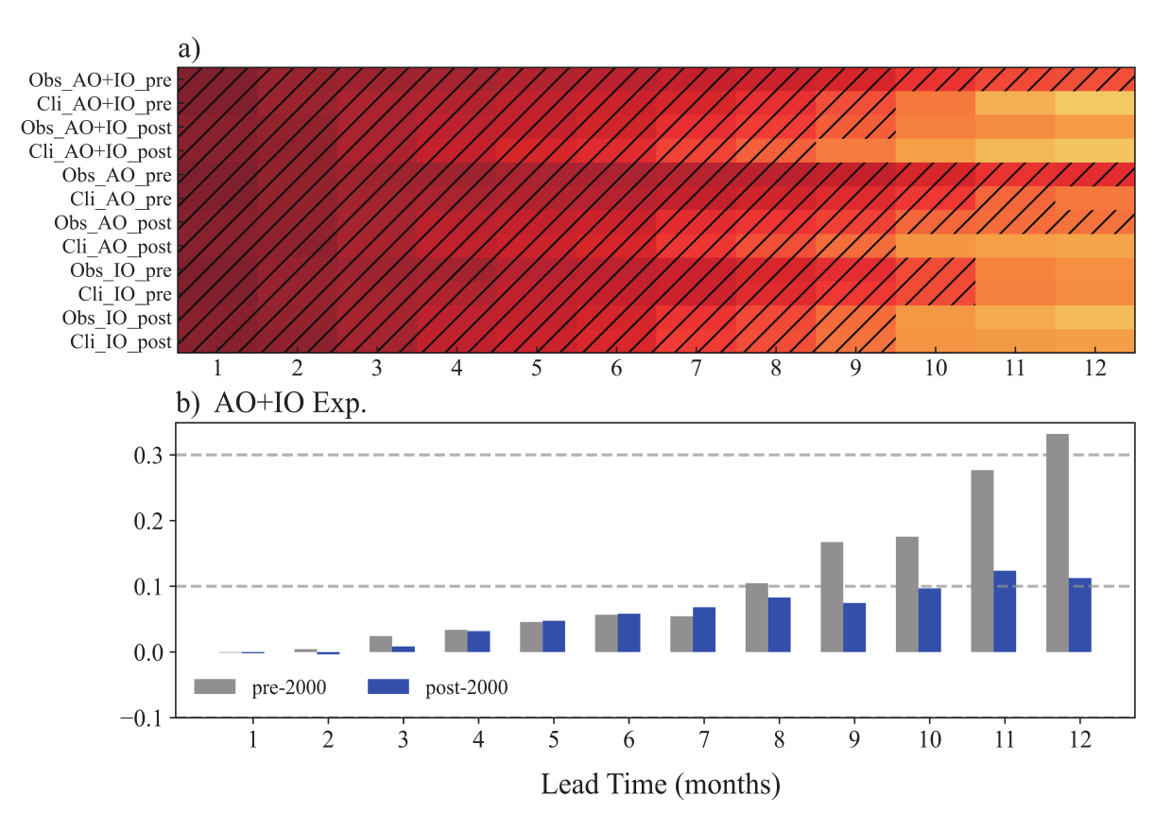
Fig. S4 (a) The ACC skill in predicting the Nino 3.4 index based on the six experiments of AO+IO, AO, and IO groups during the two decadal periods (i.e., pre-2000 and post-2000). Hatched areas denote that the ACC is greater than 0.5. (b) The difference in the ACC skill of the Nino 3.4 index between Obs_AO+IO and Cli_AO+IO experiments during the two decadal periods.
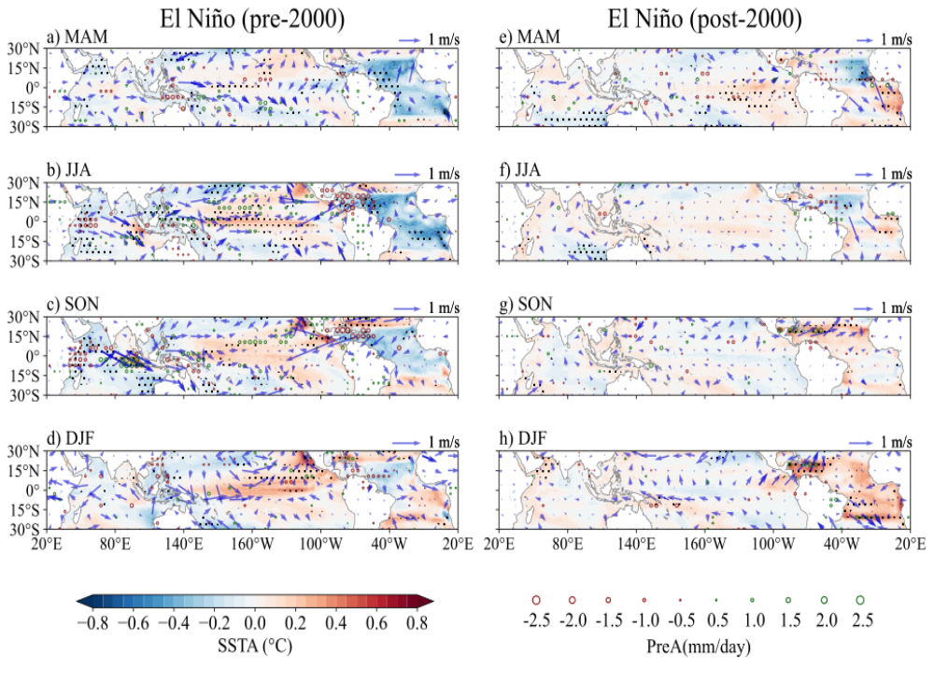
Fig. S5 The composited differences in SST (shading, °C) and 10m winds (vectors, m·s⁻¹) anomalies between the prediction of Obs_AO and Cli AO experiment initialized on 1st Feb of the developing years of El Niño events during 1983-2000 (left column) and 2001-2018 (right column). Stippled areas and bold vectors indicate that the differences of SST and winds exceeding the 95% confidence level, respectively. Hollow circles denote the difference of precipitation (mm·day⁻¹) exceeding the 95% confidence level.
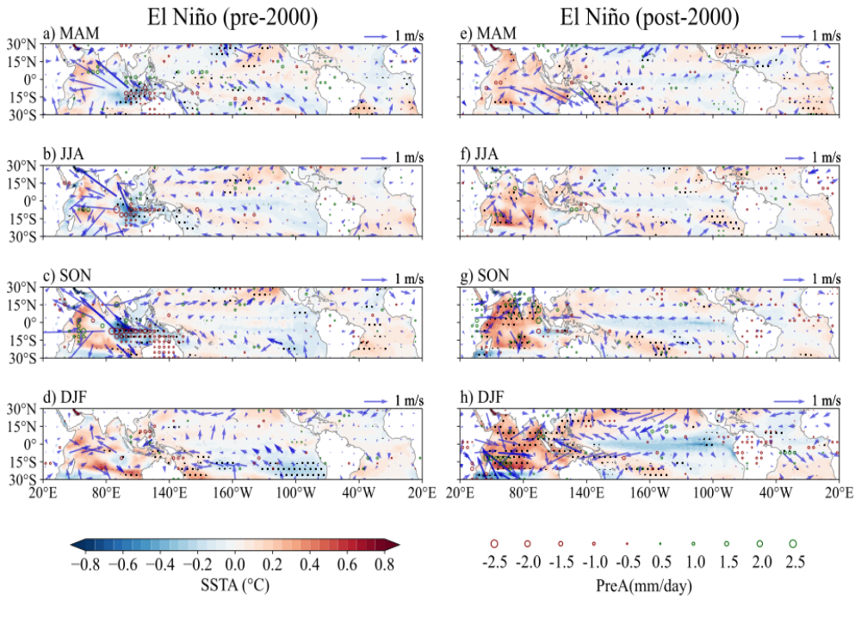
Fig. S6 The composited differences in SST (shading, °C) and 10m winds (vectors, m·s⁻¹) anomalies between the prediction of Obs_ IO and Cli_IO experiment initialized on 1st Feb of the developing years of El Niño events during 1983-2000 (left column) and 2001-2018 (right column). Stippled areas and bold vectors indicate that the differences of SST and winds exceeding the 95% confidence level, respectively. Hollow circles denote the difference of precipitation (mm·day⁻¹) exceeding the 95% confidence level.

Tables S1
Table S1 Six models from the North American Multi-Model Ensemble (NMME) and the hindcasts of NUIST-CFS1.0 used for analysis.

Source ID | Member | Integration Time
CanCM4i | 10 | 1983 to 2018 | Initialized from 1st day of February (12 months of continuous integration)
CMC1-CanCM3 | 10 | 1983 to 2010
CMC2-CanCM4 | 10 | 1983 to 2010
GEM-NEMO | 10 | 1983 to 2018
GFDL-SPEAR | 15 | 1991 to 2018
NCAR-CESM1 | 10 | 1983 to 2010
NUIST-CFS1.0 | 9 | 1983 to 2018

