Supplementary Materials

Supplementary Table 1. Performance for screening ADHD

Supplementary Table 2. Performance for screening of ADHD

Supplementary Figure 1. Detailed information of computerized comprehensive attention test
Supplementary Figure 2. Overview of the study

Supplementary Figure 3. Study dataset flow diagram

Supplementary Figure 4. Performance for predicting severity using the Korean ADHD Rating Scale based on retinal features

Supplementary Table 1. Performance for screening of ADHD
Feature | ADHD | TD | p-value
Disc_height | 93169 (10498) | 101023 (16945) | <0·001
Disc_width | 84432 (10245) | 89663 (13295) | <0·001
Cup_height | 41777 (10366) | 54834 (18131) | <0·001
Cup_width | 40661 (9963) | 50571 (13986) | <0·001
CDR_vertical | 0·44 (0·08) | 0·534 (0·104) | <0·001
CDR_horizontal | 0·48 (0·08) | 0·558 (0·092) | <0·001
Fractal_dimension | 1·5 (0·03) | 1·519 (0·036) | <0·001
Vessel_density | 0·08 (0·01) | 0·078 (0·011) | <0·001
Average_width | 3451 (251) | 3333 (425) | <0·001
Distance_tortuosity | 3·2 (1·0) | 2·838 (0·801) | <0·001
Squared_curvature_tortuosity | 19·1 (17·1) | 15·081 (12·324) | <0·001
Tortuosity_density | 0·7 (0·03) | 0·686 (0·032) | 0·51
Artery_fractal_dimension | 1·3 (0·04) | 1·316 (0·048) | <0·001
Artery_vessel_density | 0·034 (0·005) | 0·037 (0·007) | <0·001
Artery_average_width | 3688 (309) | 3706 (484) | 0·48
Artery_distance_tortuosity | 4·8 (2·9) | 3·900 (2·077) | <0·001
Artery_squared_curvature_tortuosity | 51 (79) | 35·886 (68·134) | <0·001
Artery_tortuosity_density | 0·7 (0·05) | 0·725 (0·052) | <0·001
Vein_fractal_dimension | 1·33 (0·037) | 1·341 (0·048) | 0·004
Vein_vessel_density | 0·043 (0·006) | 0·042 (0·009) | 0·004
Vein_average_width | 3814 (294) | 3853 (486) | 0·108
Vein_distance_tortuosity | 3·4 (1·4) | 2·876 (1·150) | <0·001
Vein_squared_curvature_tortuosity | 22 (21·8) | 16 (16·9) | <0·001
Vein_tortuosity_density | 0·7 (0·04) | 0·74 (0·04) | 0·578
Artery_fractal_dimension_zone_B | 1·01 (0·055) | 0·99 (0·059) | <0·001
Artery_vessel_density_zone_B | 0·005 (0·001) | 0·004 (0·001) | <0·001
Artery_average_width_zone_B | 3997 (456) | 4384 (754) | <0·001
Artery_distance_tortuosity_zone_B | 2·61 (2·07) | 2·52 (2·42) | 0·53
Artery_squared_curvature_tortuosity_zone_B | 9·23 (14·05) | 8·81 (22·45) | 0·71
Artery_tortuosity_density_zone_B | 0·69 (0·11) | 0·71 (0·11) | 0·009
CRAE_Hubbard_zone_B | 8938 (1286) | 9278 (2539) | 0·005
CRAE_Knudtson_zone_B | 7933 (1159) | 8221 (2266) | 0·008
Vein_fractal_dimension_zone_B | 1·03 (0·05) | 1·02 (0·05) | <0·001
Vein_vessel_density_zone_B | 0·006 (0·001) | 0·005 (0·001) | <0·001
Vein_average_width_zone_B | 4344 (464) | 4591 (701) | <0·001
Vein_distance_tortuosity_zone_B | 2·61 (1·94) | 2·503 (2·044) | 0·373
Vein_squared_curvature_tortuosity_zone_B | 8·98 (14·2) | 8·740 (17·398) | 0·802
Vein_tortuosity_density_zone_B | 0·66 (0·097) | 0·667 (0·101) | 0·186
CRVE_Hubbard_zone_B | 10551 (1067) | 10971 (2217) | <0·001
CRVE_Knudtson_zone_B | 11675 (1220) | 12118 (2495) | <0·001
AVR_Hubbard_zone_B | -13 (333) | -68 (731) | 0·109
AVR_Knudtson_zone_B | -11 (294) | -59 (631) | 0·113
Artery_fractal_dimension_zone_C | 1·14 (0·046) | 1·152 (0·056) | <0·001
Artery_vessel_density_zone_C | 0·014 (0·003) | 0·013 (0·003) | <0·001
Artery_average_width_zone_C | 3944 (384) | 4195 (665) | <0·001
Artery_distance_tortuosity_zone_C | 3·89 (2·95) | 3·688 (3·084) | 0·276
Artery_squared_curvature_tortuosity_zone_C | 29 (48) | 28·765 (75·434) | 0·903
Artery_tortuosity_density_zone_C | 0·73 (0·075) | 0·735 (0·077) | 0·625
CRAE_Hubbard_zone_C | 10017 (1047) | 10744 (1824) | <0·001
CRAE_Knudtson_zone_C | 8951 (949) | 9603 (1649) | <0·001
Vein_fractal_dimension_zone_C | 1·17 (0·044) | 1·182 (0·054) | <0·001
Vein_vessel_density_zone_C | 0·016 (0·003) | 0·015 (0·004) | <0·001
Vein_average_width_zone_C | 4218 (368) | 4330 (585) | <0·001
Vein_distance_tortuosity_zone_C | 3·3 (2·02) | 2·8 (1·71) | <0·001
Vein_squared_curvature_tortuosity_zone_C | 20 (32) | 14 (23) | 0·002
Vein_tortuosity_density_zone_C | 0·714 (0·063) | 0·711 (0·062) | 0·462
CRVE_Hubbard_zone_c | 12000 (964) | 12730 (1933) | <0·001
CRVE_Knudtson_zone_c | 13401 (1083) | 14221 (2181) | <0·001
AVR_Hubbard_zone_c | 0·837 (0·087) | 0·846 (0·091) | 0·09
AVR_Knudtson_zone_c | 0·67 (0·07) | 0·68 (0·08) | 0·082

Supplementary Table 2. Performance for screening of ADHD

Model | AUROC | Sensitivity | Specificity | PPV | NPV | F1-Score | NLL | Brier score
Random forest classifier | 95·5% (94·6%–96·5%) | 87·6% (85·4%–90·0%) | 89·2% (87·1%–91·4%) | 88·3% (86·6%–90·0%) | 89·0% (86·8%–91·4%) | 87·8% (85·6%– 90·2%) | 0·37 (0·35–0·38) | 0·11 (0·10–0·11)
XGBoost | 96·9% (96·2%–97·7%) | 91·6% (89·7%–93·7%) | 92% (90·1%–93·9%) | 91·8% (90·5%–93·2%) | 91·9% (90·1%–93·9%) | 91·7% (89·8%–93·6%) | 0·24 (0·2–0·27) | 0·07 (0·06–0·07)
Extra trees classifier | 96·4% (95·6%–97·2%) | 90·7% (88·8%–92·8%) | 89·2% (87·2%–91·4%) | 90% (88·5%–91·6%) | 89·3% (87·3%–91·6%) | 90·6% (88·6%–92·8%) | 0·38 (0·36–0·39) | 0·11 (0·10–0·12)
Logistic regression | 96·5% (95·7% –97·4%) | 91·3% (89·3%–93·4%) | 90·4% (88·4%–92·7%) | 90·9% (89·4%–92·4%) | 90·5% (88·5%–92·7%) | 91·2% (89·2%–93·3%) | 0·25 (0·22–0·29) | 0·07 (0·06–0·08)
AUROC, area under the receiver operating characteristic curve; PPV, positive predictive value; NPV, negative predictive value; NLL: negative log-likelihood, XGBoost, extreme gradient boosting classifier
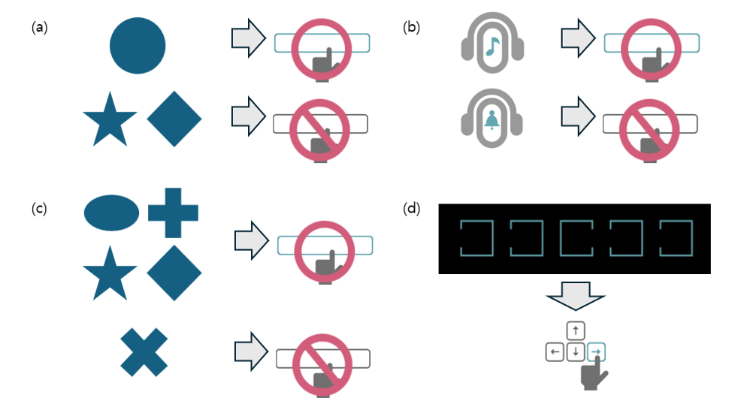
Supplementary Figure 1. Detailed information of computerized comprehensive attention test
The computerized CAT is a computer-based continuous performance test (CPT) for individuals aged 4–49 years. The CAT has four subsets: visual selective attention (VSA), auditory selective attention (ASA), sustained attention to response task (SART), and Flanker task (FT). Each visual or auditory stimuli was presented on a black screen at 2-s intervals. (a) In the VSA test, participants were instructed to press a button as quickly as possible whenever a circle appeared while ignoring other shapes. In total, 150 stimuli were presented, of which 75 were circles. (b) In the ASA test, participants were instructed to press a button as quickly as possible upon hearing a specific bell sound while ignoring other auditory stimuli. In total, 150 stimuli were presented, of which 75 were the target sounds. (c) In the SART, participants were instructed to ignore only the X shapes and press the button as quickly as possible for all other shapes. In total, 300 stimuli were presented, of which 75 were X shapes. (d) In the FT, participants were instructed to press the arrow key (left or right) corresponding to the direction of the open side of the middle box as quickly as possible when five boxes with one open side appeared on the screen. In total, 150 stimuli were presented. Each subset exhibits four indicators: omission errors (OE) for the number of missed responses, commission errors (CE) for the number of wrong responses, mean reaction time (RT) for the average response time to the stimuli, and standard deviation of reaction time (RTSD) for response time variability. These measurements, 16 in total, were normalized to obtain an attention quotient (AQ), adjusting for sex and age, with an average value of 100 and a standard deviation of 15.

Supplementary Figure 2. Overview of the study

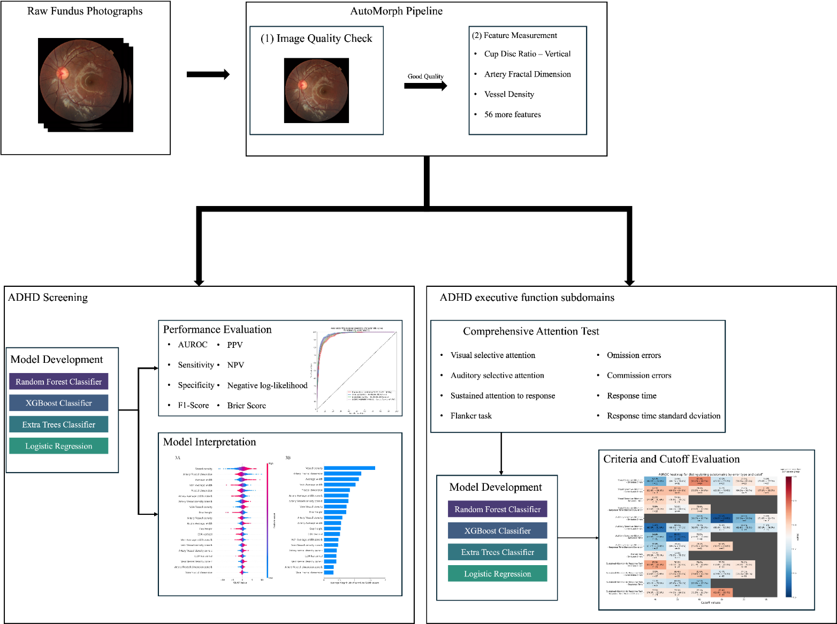

Supplementary Figure 3. Study dataset flow diagram

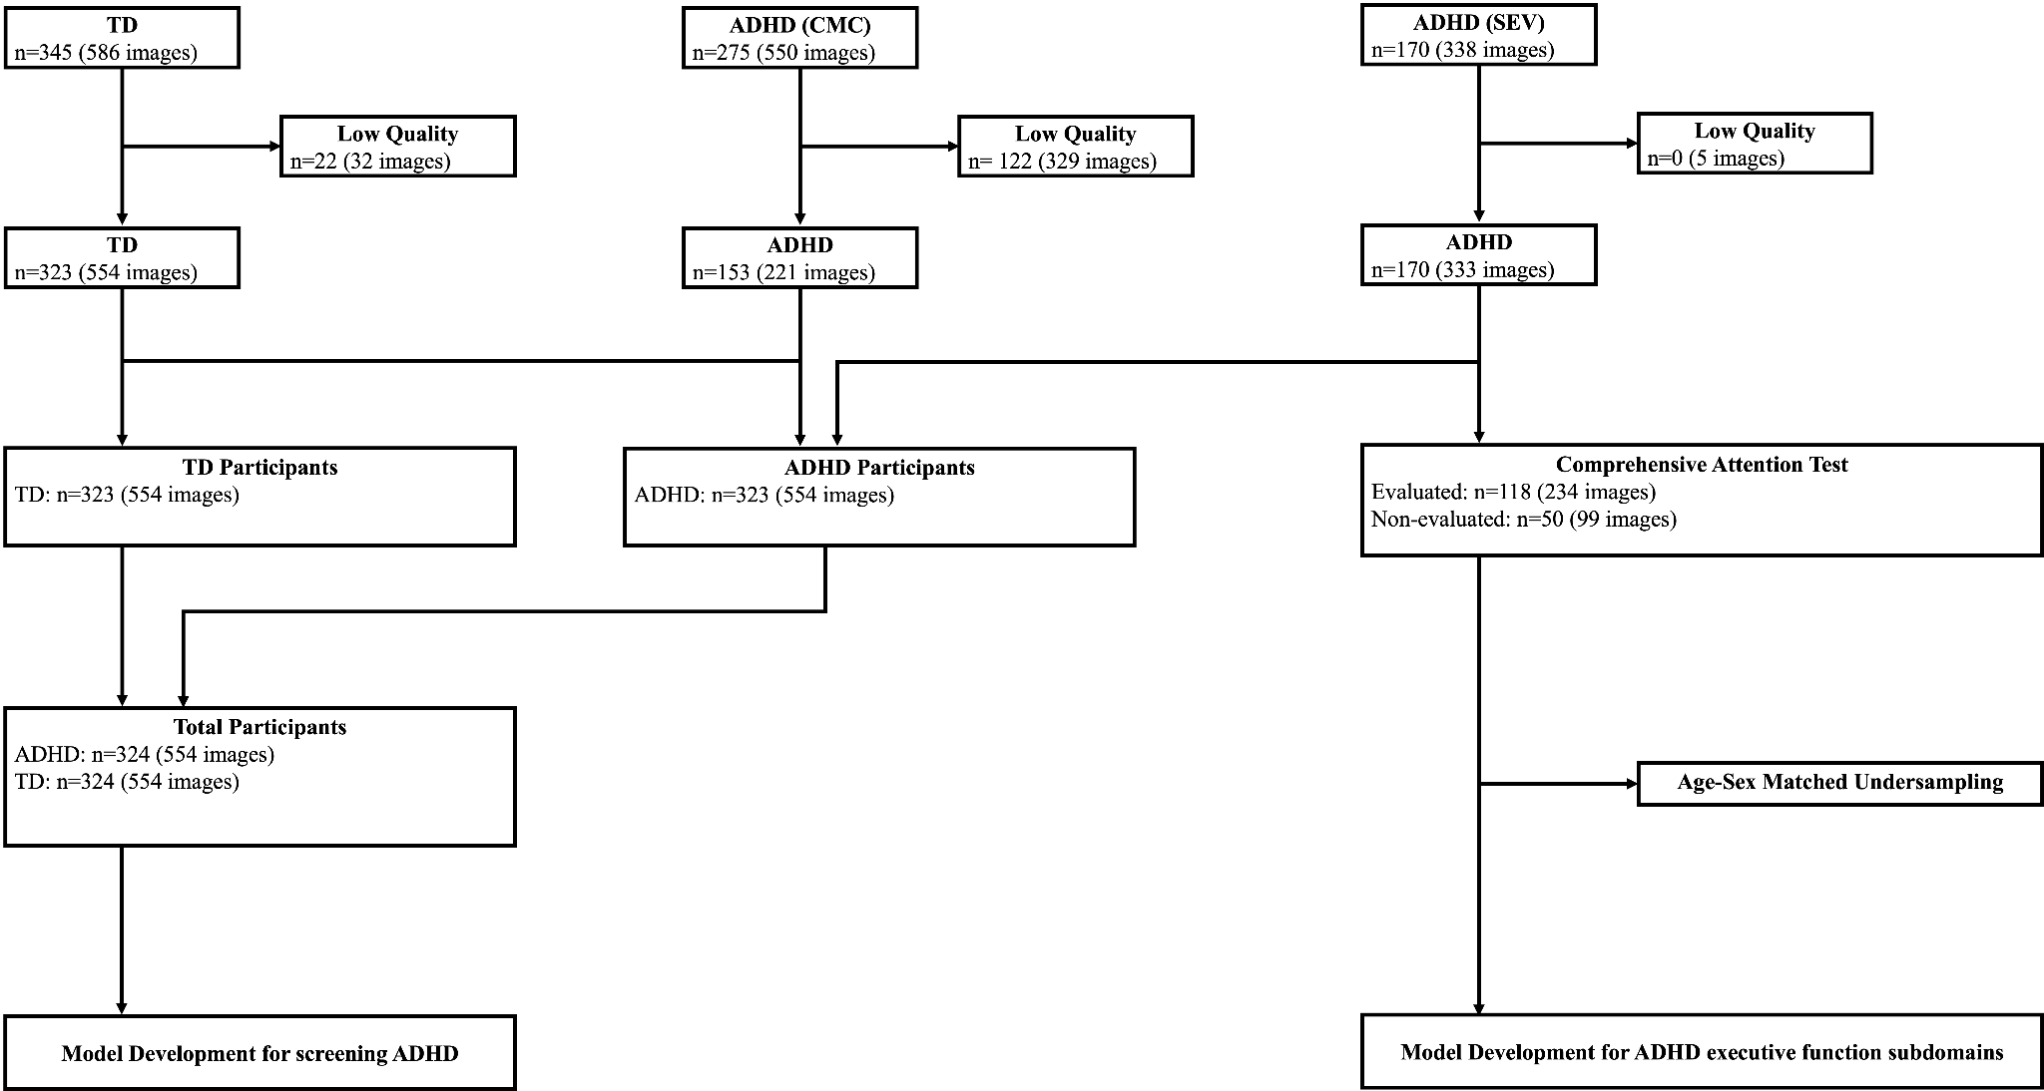

eFigure 4. Performance for predicting severity using the Korean ADHD Rating Scale based on retinal features
