Supplementary Data

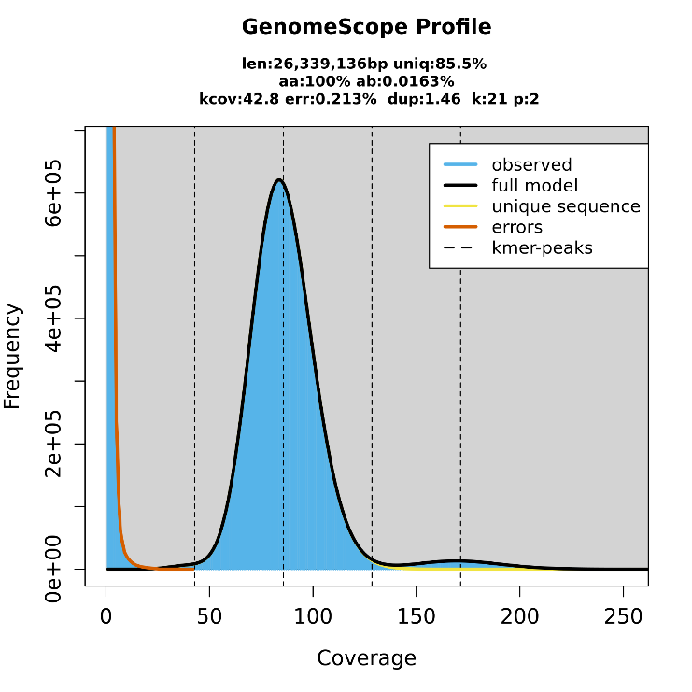
Supplementary Figure 1. The k-mer distribution (k = 21) of the genome. The 21-mer distribution was calculated by GenomeScope based on Illumina short-reads data. K-mer coverages (x axis) were plotted against the value of coverage multiplying frequency (y axis). The size estimation obtained by GenomeScope is 26,339,136 bp, with a uniqueness of 85.5% and duplication 1.46%.

