Highlights
- Acetone extracts of clove, turmeric, and ginger demonstrated strong antimicrobial effects against various uropathogens.
- The extracts effectively reduced the formation of biofilms, a key factor in persistent UTIs.
- The study revealed a significant decrease in EPS production by plant extracts, indicating a potential mechanism for the observed antimicrobial and antibiofilm effects.
- The results suggest that these plant-based extracts could be developed into alternative treatments for UTIs, particularly in the face of increasing antibiotic resistance.

List of figures

- Fig.3.1 Antimicrobial activity of acetone extract of clove at different concentrations (a) S. aureus (b) E. coli (c) P. aeruginosa (d) K. pneumoniae
- Fig.3.2 Antimicrobial activity of acetone extract of turmeric at different concentrations (a) S. aureus (b) E. coli (c) P. aeruginosa (d) K. pneumoniae
- Fig.3.3 Antimicrobial activity of acetone extract of ginger at different concentrations (a) S. aureus (b) E. coli (c) P. aeruginosa (d) K. pneumoniae
- Fig. 3.4 (A) Graphical representation of the antimicrobial activity of acetone extract of Clove at different concentrations against isolated Uropathogens. (B) Graphical representation of the antimicrobial activity of acetone extract of Turmeric at different concentrations against isolated Uropathogens. (C) Graphical representation of the antimicrobial activity of acetone extract of Ginger at different concentrations against isolated Uropathogens.
- Fig. 3.5 MIC of acetone plant extract against E. coli, P. aeruginosa
E. coli – Lane A (acetone clove extract), Lane B (acetone turmeric extract), Lane C (acetone ginger extract)
P. aeruginosa - Lane E (acetone clove extract), Lane F (acetone turmeric extract), Lane G (acetone ginger extract) +=Positive control, - =Negative control
- Fig. 3.6 MIC of acetone plant extract against E. coli, P. aeruginosa
E. coli – Lane A (acetone clove extract), Lane B (acetone turmeric extract), Lane C (acetone ginger extract)
P. aeruginosa - Lane E (acetone clove extract), Lane F (acetone turmeric extract), Lane G (acetone ginger extract) +=Positive control, - =Negative control
- Fig. 3.7 (A) Peak (days-2) old biofilm in the presence of different plant extracts against S. aureus, E. coli, K. pneumoniae and P. aeruginosa in comparison to untreated control (B) Peak (days-4) old biofilm in the presence of different plant extracts against S. aureus, E. coli, K. pneumoniae and P. aeruginosa in comparison to untreated control.
- Fig. 3.8 Microscopic view of S. aureus 48-hour-old biofilm formed a) untreated control b) clove c) ginger d) turmeric
- Fig. 3.9 Microscopic view of E. coli 48-hour-old biofilm formed a) untreated control b) clove c) ginger d) turmeric
- Fig. 3.10 Microscopic view of K. pneumoniae 48-hour-old biofilm formed a) untreated control b) clove c) ginger d) turmeric
- Fig. 3.11 Microscopic view of P. aeruginosa 48-hour-old biofilm formed a) untreated control b) clove c) ginger d) turmeric
- Fig. 3.12 (A) EPS quantification of E. coli biofilm after treatment with acetone extracts of clove, turmeric and ginger. (B) EPS quantification of P. aeruginosa biofilm after treatment with acetone extracts of clove, turmeric and ginger. (C) EPS quantification of S. aureus biofilm after treatment with acetone extracts of clove, turmeric and ginger. (D) EPS quantification of K. pneumoniae biofilm after treatment with acetone extracts of clove, turmeric and ginger.
- Fig. 3.13 (A) Graphical representation of the effect of extracts on the susceptibility of S. aureus to serum. (B) Graphical representation of the effect of extracts on the susceptibility of E. coli to serum. (C) Graphical representation of the effect of extracts on the susceptibility of K. pneumoniae to serum. (D) Graphical representation of the effect of extracts on the susceptibility of P. aeruginosa to serum.

ABBREVIATIONS AND SYMBOLS

et al., Coworkers
g Gram
mg Microgram
% Percent
μL Microliters
°C Degree Celsius
mL Millilitres
nm Nanometre
rpm Rotation per minute
CFU Colony forming unit
mg/ml Milligram per millilitre
MIC Minimum Inhibitory Concentration
LB Luria Bertani
NA Nutrient agar
NB Nutrient broth
MHA Muller Hilton agar
DMSO Dimethyl sulfoxide
Hrs Hours
Fig Figure
µg/ml Microgram/ Milliliters
OD Optical density
Conc. Concentration

Supplementary data
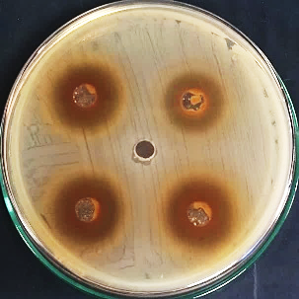
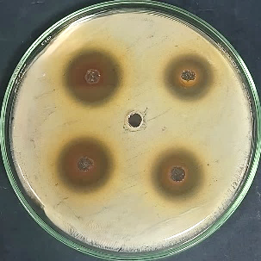
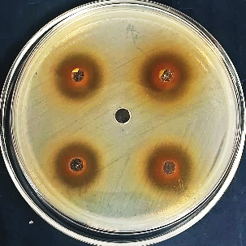
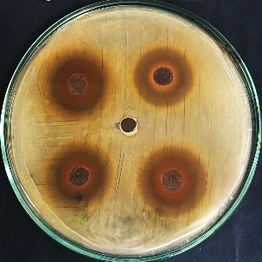
d
c
b
a

Fig.3.1 Antimicrobial activity of acetone extract of clove at different concentrations (a) S. aureus (b) E. coli (c) P. aeruginosa (d) K. pneumoniae

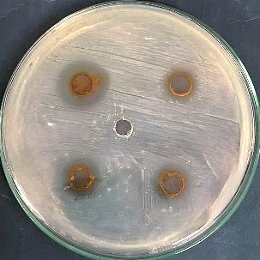
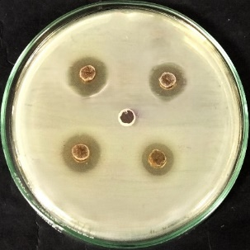
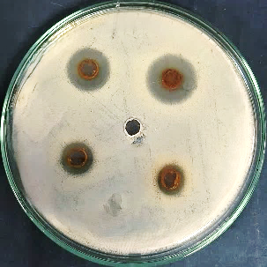
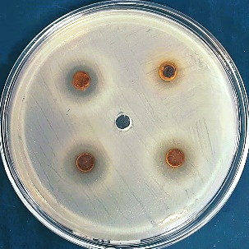
d
c
b
a

Fig.3.2 Antimicrobial activity of acetone extract of turmeric at different concentrations (a) S. aureus (b) E. coli (c) P. aeruginosa (d) K. pneumoniae

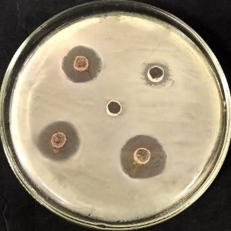
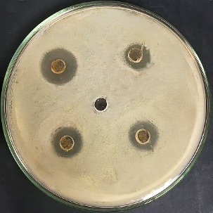
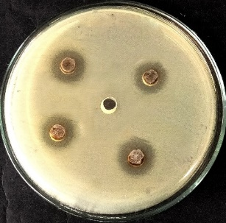
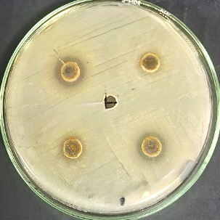
d
c
b
a

Fig.3.3 Antimicrobial activity of acetone extract of ginger at different concentrations (a) S. aureus (b) E. coli (c) P. aeruginosa (d) K. pneumoniae

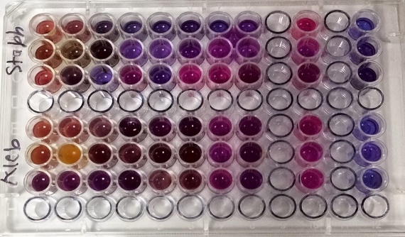
-ve
+ve
ABCDEFGHA
B
C
D
E
F
G
H
S. aureus

K. pneumoniae

Fig. 3.5 MIC of acetone plant extract against E. coli, P. aeruginosa
E. coli – Lane A (acetone clove extract), Lane B (acetone turmeric extract), Lane C (acetone ginger extract)
P. aeruginosa - Lane E (acetone clove extract), Lane F (acetone turmeric extract), Lane G (acetone ginger extract)
+=Positive control, - =Negative control

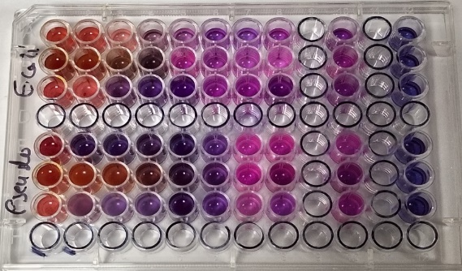
ABCDEFGHA
B
C
D
E
F
G
H
-ve
+ve
E. coli
P. aeruginosa

Fig. 3.6 MIC of acetone plant extract against E. coli, P. aeruginosa
E. coli – Lane A (acetone clove extract), Lane B (acetone turmeric extract), Lane C (acetone ginger extract)
P. aeruginosa - Lane E (acetone clove extract), Lane F (acetone turmeric extract), Lane G (acetone ginger extract)
+=Positive control, - =Negative control

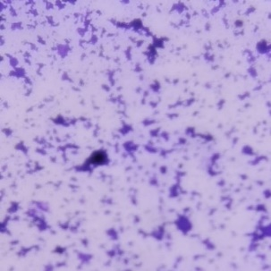
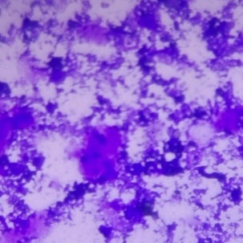
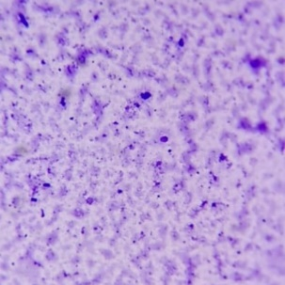
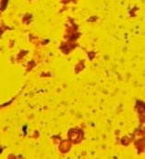
d
c
b
a

Fig. 3.8 Microscopic view of S. aureus 48-hour-old biofilm formed a) untreated control b) clove c) ginger d) turmeric

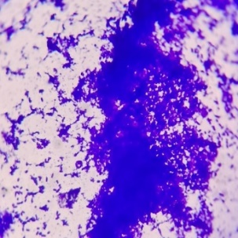
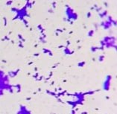
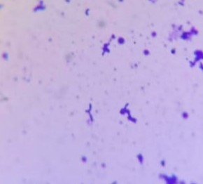
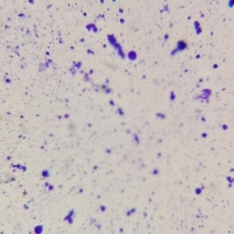
d
c
b
a

Fig. 3.9 Microscopic view of E. coli 48-hour-old biofilm formed a) untreated control b) clove c) ginger d) turmeric
FFF

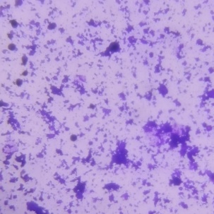
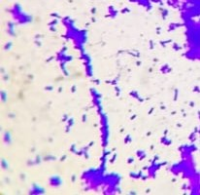
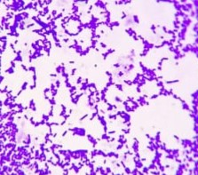
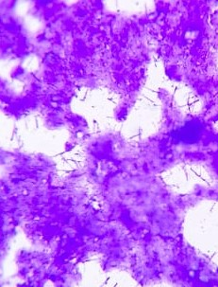
d
c
b
a

Fig. 3.10 Microscopic view of K. pneumoniae 48-hour-old biofilm formed a) untreated control b) clove c) ginger d) turmeric

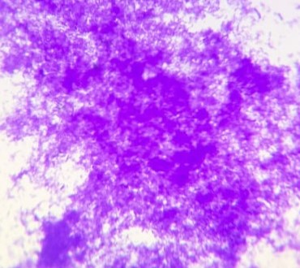
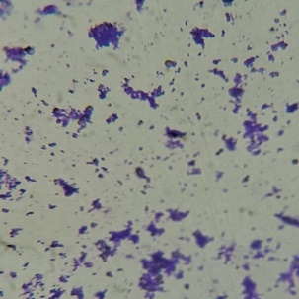
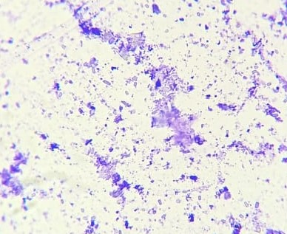
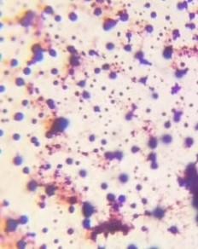
d
c
b
a

Fig. 3.11 Microscopic view of P. aeruginosa 48-hour-old biofilm formed a) untreated control b) clove c) ginger d) turmeric

