Supplementary Table S1. ﻿ Baseline characteristics of the healthy individuals and patients with MI.
Categorical Variable | Healthy (n=24) | Patients (n=24) | P-value
Categorical Variable | Healthy (n=24) | Patients (n=24) | Fisher Exact test
Male/Female, n (%) | 14 (58%) / 10 (42%) | 14 (58%) / 10 (42%) | 0.9999
Current smoker, n (%) | 0 | 4 (16%) | 0.1092
Alcohol, n (%) | 0 | 5 (20%) | 0.0496*
﻿﻿Known diabetes n (%) | 0 | 3 (12%) | 0.2340
Blood type distribution A/B/AB/O | 9/4/10/1 | 9/4/9/2 | -----
﻿Quantitative Variables | Healthy (n=24) | Patient (n=24) | p-value
﻿Quantitative Variables | Healthy (n=24) | Patient (n=24) | t Test or Mann-Whitney
Age (Year) | 29.0 ± 7.7 | 65.04 ± 10.89 | 0.0001**
Body Mass Index ﻿(kg/cm²) | 20.85 ± 2.17 | 25.86 ± 4.38 | 0.0001**
Systolic blood pressure (mmHg) | 113.12 ± 10.07 | 128.08 ± 22.45 | 0.0012*
﻿Diastolic blood pressure (mmHg) | 76.91 ± 6.5 | 75.91 ± 13.88 | 0.9470
Hypertension, n (%) | 1 (4%) | 8 (33%) | 0.0102*
﻿Low-density Lipoprotein (mmol/L) | 2.39 ± 0.52 | 6.74 ± 19.02 | 0.0160*
﻿High-density Lipoprotein (mmol/L) | 1.38 ± 0.27 | 1.22 ± 0.63 | 0.0010*
﻿Total Cholestrole (mmol/L) | 4.33 ± 0.59 | 4.11 ± 0.99 | 0.2162
﻿TG (mmol/L) | 0.94 ± 0.44 | 1.83 ± 0.82 | 0.0001**
﻿FBG (mmol/L) | 5.14 ± 1.10 | 6.05 ± 2.10 | 0.0089*
﻿C-reactive protein (mg/L) | 0.45 ± 0.90 | 17.48 ± 24.56 | 0.0001**
﻿Uric acid (UA) (µmol/L) | 309.87 ± 85.99 | 322.22 ± 107.29 | 0.4803
White blood cell (10⁹/L) | 5.32 ± 1.46 | 8.25 ± 2.92 | 0.0001**
﻿Red blood cell (10¹²/L) | 4.73 ± 0.50 | 4.97 ± 0.62 | 0.0431*
﻿Platelets ﻿(10⁹/L) | 220.61 ± 62.04 | 213.20 ± 33.64 | 0.3540
﻿Hemoglobin (g/L) | 140.87 ± 16.81 | 145.58 ± 24.47 | 0.1114
Neutrophils | 58.56 ± 8.85 | 67.96 ± 9.25 | 0.0015*
Serum creatinine (µmol/L) | 59.71 ± 10.84 | 65.00 ± 9.51 | 0.0638
PH | 6.63 ± 0.45 | 6.31 ± 0.67 | 0.1226
The values are shown as mean ± SD, percentage (%), and number (n). Every P-value comes from a Mann-Whitney analysis. A p-value of less than 0.05 was deemed significant. **p < = 0.001, *p < 0.05. Measurements: Kilogram (Kg); Centimeter (cm); Millimoles Per Liter, (mmol/L); Micromole per Liter, (µmol/L); Grams per Liter, (g/L); Milligrams per Liter, (mg/L); Standard deviation, (± SD); Grams per Liter, (g/L); Liter, (L).
Supplementary Table S2. Gut, and oral microbiome-based functional prediction pathways between healthy and MI groups using PICRUST2.
Metabolic pathways | Healthy | MI Patients | P-value
Gut microbiome functional prediction pathways
Carbohydrate metabolism | 10.06 ± 0.52 | 10.21 ± 0.71 | 0.84
Lipid metabolism | 1.97 ± 0.07 | 1.99 ± 0.09 | 0.84
Metabolism of cofactors and vitamins | 4.15 ± 0.12 | 4.05 ± 0.22 | 1.47
Energy metabolism | 4.04 ± 0.11 | 4.07 ± 0.22 | 0.85
Amino acid metabolism | 6.56 ± 0.17 | 6.49 ± 0.30 | 0.77
Nucleotide metabolism | 3.76 ± 0.13 | 3.72 ± 0.20 | 0.82
Biosynthesis of other secondary metabolites | 1.03 ± 0.12 | 1.01 ± 0.12 | 0.86
Metabolism of terpenoids and polyketides | 1.03 ± 0.04 | 1.05 ± 0.06 | 0.77
Xenobiotics biodegradation and metabolism | 0.77 ± 0.12 | 0.85 ± 0.19 | 1.39
Metabolism of other amino acids | 1.32 ± 0.10 | 1.36 ± 0.09 | 0.84
Oral microbiome functional prediction pathways
Carbohydrate metabolism | 9.12 ± 0.25 | 9.22 ± 0.35 | 0.70
Lipid metabolism | 1.87 ± 0.10 | 1.93 ± 0.10 | 0.30
Metabolism of cofactors and vitamins | 4.54 ± 1.87 | 4.37 ± 0.20 | 0.22
Energy metabolism | 4.10 ± 0.12 | 4.03 ± 0.19 | 0.51
Amino acid metabolism | 6.12 ± 0.23 | 6.13 ± 0.15 | 0.93
Nucleotide metabolism | 4.31 ± 0.19 | 4.35 ± 0.16 | 0.64
Biosynthesis of other secondary metabolites | 0.89 ± 0.03 | 0.88 ± 0.04 | 0.84
Metabolism of terpenoids and polyketides | 1.11 ± 0.37 | 1.13 ± 0.02 | 0.36
Xenobiotics biodegradation and metabolism | 0.75 ± 0.07 | 0.80 ± 0.07 | 0.24
Metabolism of other amino acids | 1.38 ± 0.02 | 1.39 ± 0.03 | 0.94

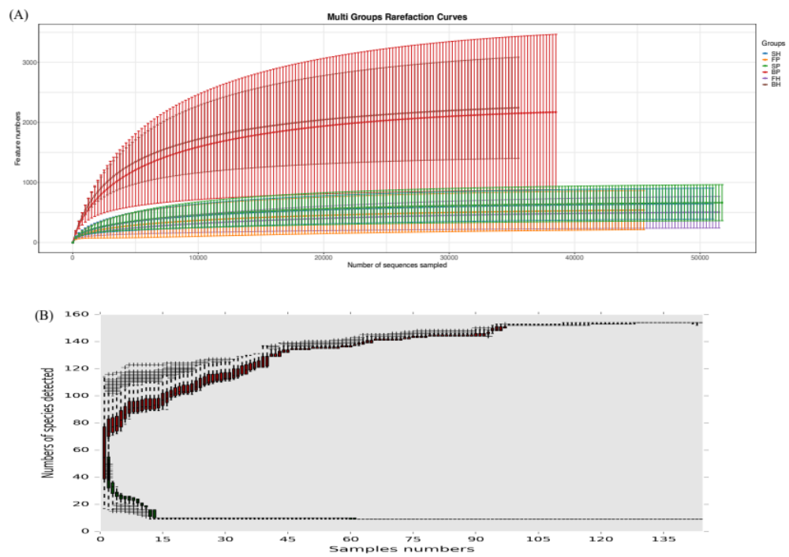
Supplementary Fig. S1 (A). Rarefaction curve of microbiotas from blood, fecal, and saliva samples. (B) The species accumulation curve of blood, fecal, and salivary microbiota in MI and control subjects.

