Endeavoring the First Lanthanide-Carbon Triple-Bond in Fullerene Cage
Hongjie Jiang^{1†}, Jing Zhao^{2,3†}, Qingyu Meng¹, Xiao-Kun Zhao², Min Guo¹, Han-Shi Hu³, Jun Li^{2,3,4}*, Ning Chen¹*
Affiliations
¹College of Chemistry, Chemical Engineering and Materials Science & State Key Laboratory of Radiation Medicine and Protection, Soochow University, Suzhou 215123, China.
²Department of Chemistry and Guangdong Provincial Key Laboratory of Catalytic Chemistry, Southern University of Science and Technology, Shenzhen 518055, China.
³Department of Chemistry and Engineering Research Center of Advanced Rare-Earth Materials of the Ministry of Education, Tsinghua University, Beijing 100084, China.
⁴Fundamental Science Center of Rare Earths, Ganjiang Innovation Academy, Chinese Academy of Sciences, Ganzhou 341000, China

†These authors contributed equally to this work.
*Corresponding author email: chenning@suda.edu.cn (N. C.); junli@tsinghua.edu.cn (J. L.)

Supplementary Figures
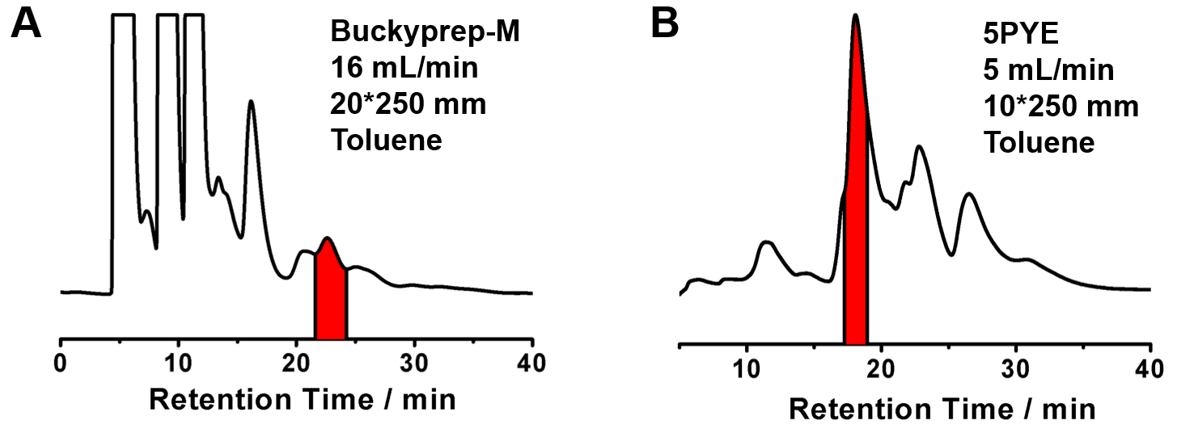
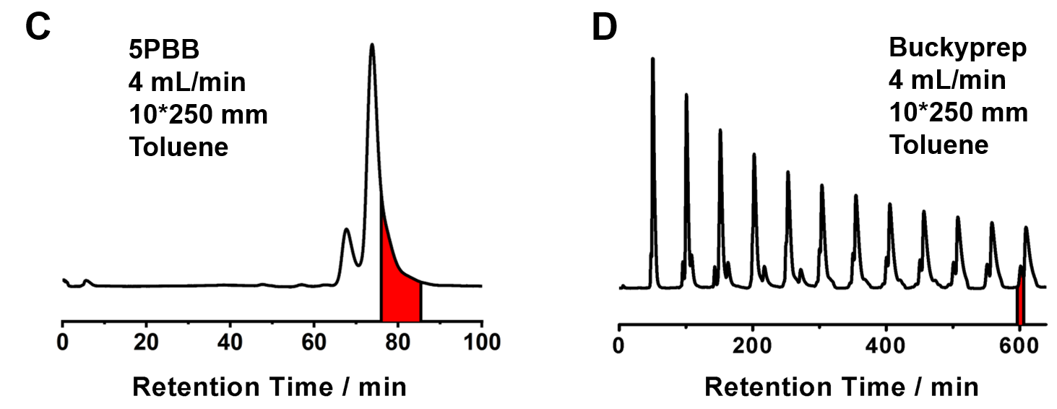
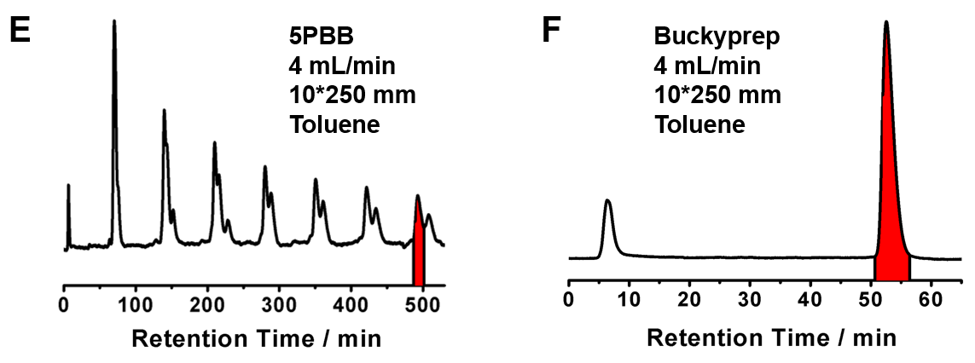
Supplementary Figure 1. HPLC isolation scheme of CeSc₂C@C₈₀. (A) The first-step HPLC chromatogram of the extracted fullerene mixture containing CeSc₂C@C₈₀. (condition: 20×250 mm semi-preparative Buckyprep-M column; flow rate 4.0 mL/min; toluene as eluent); (B) The second-step HPLC chromatogram of the collected fraction (21.5-24.5 min, highlighted as red) from the first step (condition: 10×250 mm semi-preparative 5PYE column; flow rate 5.0 mL/min; toluene as eluent); (C) The third-step HPLC chromatogram of the collected fraction (17.5-19.5 min, highlighted as red) from the second step (condition: 10×250 mm semi-preparative 5PBB column; flow rate 4.0 mL/min; toluene as eluent); (D) The fourth-step HPLC chromatogram of the collected fraction (76-85 min, highlighted as red) from the third step (condition: 10×250 mm semi-preparative Buckyprep column; flow rate 4.0 mL/min; toluene as eluent). (E) The fifth-step HPLC chromatogram in recycling mode of the collected fraction (595-620 min, highlighted as red) from the fourth step (condition: 10×250 mm semi-preparative 5PBB column; flow rate 4.0 mL/min; toluene as eluent). (F) The final-step HPLC chromatogram of the collected fraction (483-502 min, highlighted as red) from the fifth step (condition: 10×250 mm semi-preparative Buckyprep column; flow rate 4.0 mL/min; toluene as eluent). The highlighted single peak containing isolated CeSc₂C@C₈₀ was collected.
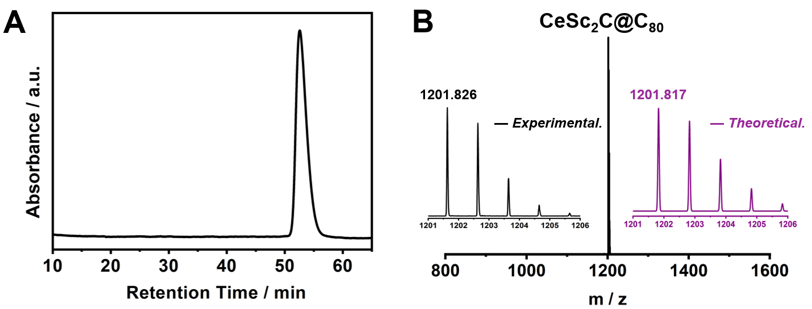
Supplementary Figure 2. HPLC chromatograms and mass spectra of purified CeCSc₂@C₈₀. (A) HPLC chromatograms of purified CeCSc₂@C₈₀ on a 10×250 mm semi-preparative Buckyprep column with a 4 mL/min flow rate using toluene as the eluent. (B) Positive-ion mode MALDI-TOF mass spectrum of purified CeCSc₂@C₈₀. The inserts show the corresponding experimental and theoretical isotopic distributions, both in good agreement.

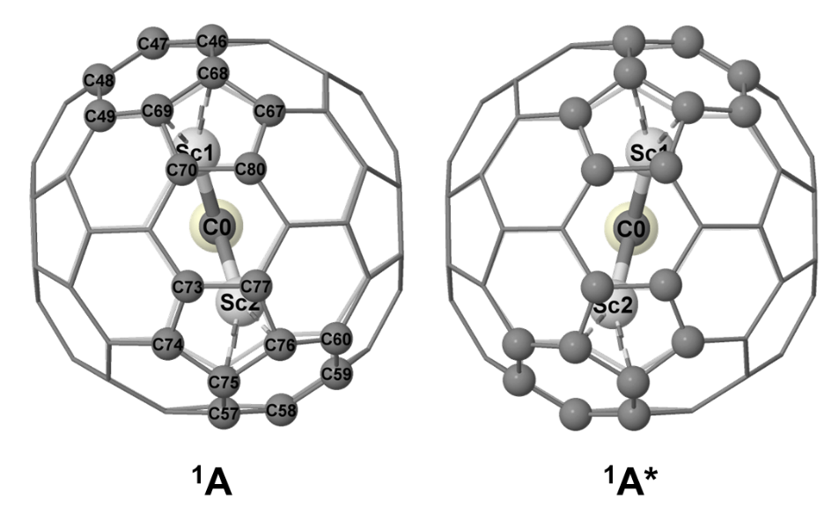
Supplementary Figure 3. The view from Sc1–C–Sc2 of ¹A CeCSc₂@C₈₀ which is consistent with experimental observations, along with its symmetrical counterpart ¹A*.

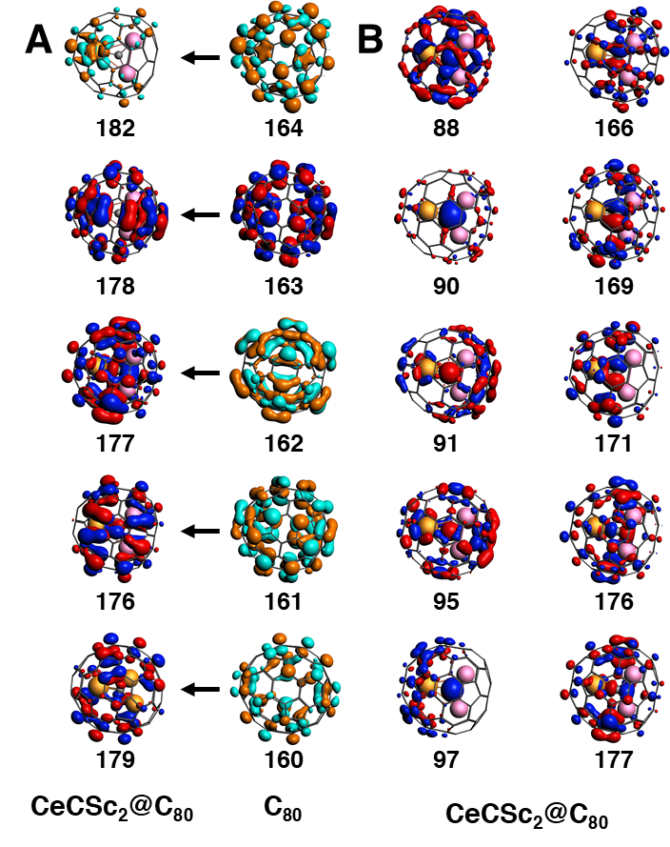
Supplementary Figure 4. Canonical molecular orbitals of CeCSc₂@C₈₀ at the PBE level; Occupied orbitals are indicated with blue and red colors, while unoccupied orbitals are marked with orange and cyan colors. (a) MOs related to LUMO and HOMOs of fullerene C₈₀ (isosurface: 0.02 a.u.); (b) Other MOs with larger contributions from the central CeCSc₂ cluster (isosurface: 0.03 a.u.).
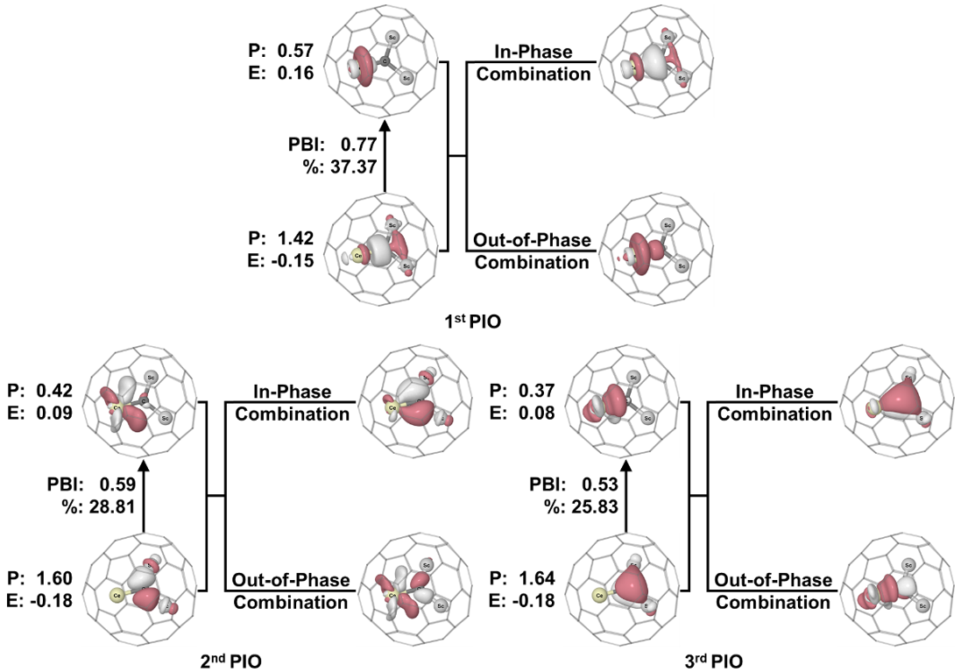
Supplementary Figure 5. PIO pair and PIMO pairs of PIO analysis on CeCSc₂@C₈₀: Ce and CSc₂ as two fragments based on the calculations at B3LYP/6-31G*+SDD level. The orbital energies and populations (occupation numbers) are given as E and P, respectively, near each PIO. Given between each PIO pair are the PIO-based bond indices (abbreviated as PBI) and its contribution (as %) to the total interactions between two fragments (the contributions of all PIOs sum up to 100%). Isovalue: 0.05 a.u. for all orbitals.

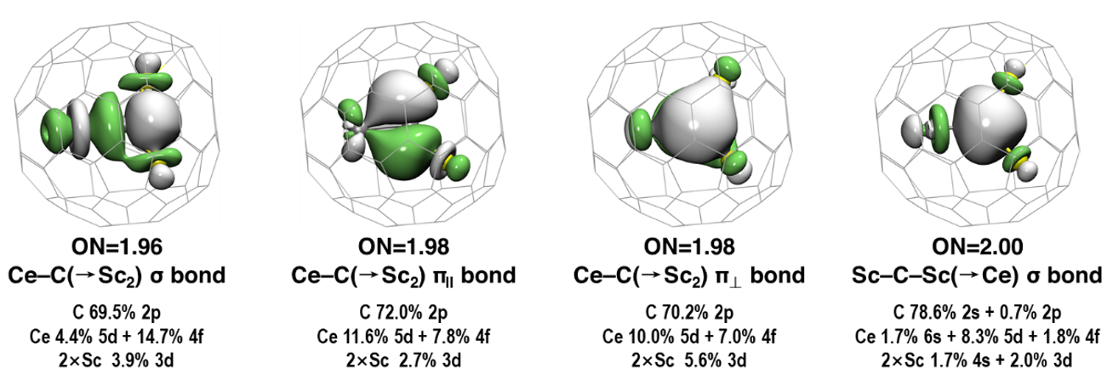
Supplementary Figure 6. AdNDP analysis of the four 4-center 2-electron (4c-2e) bonds of CeCSc₂@C₈₀ at B3LYP/6-31G*+SDD.

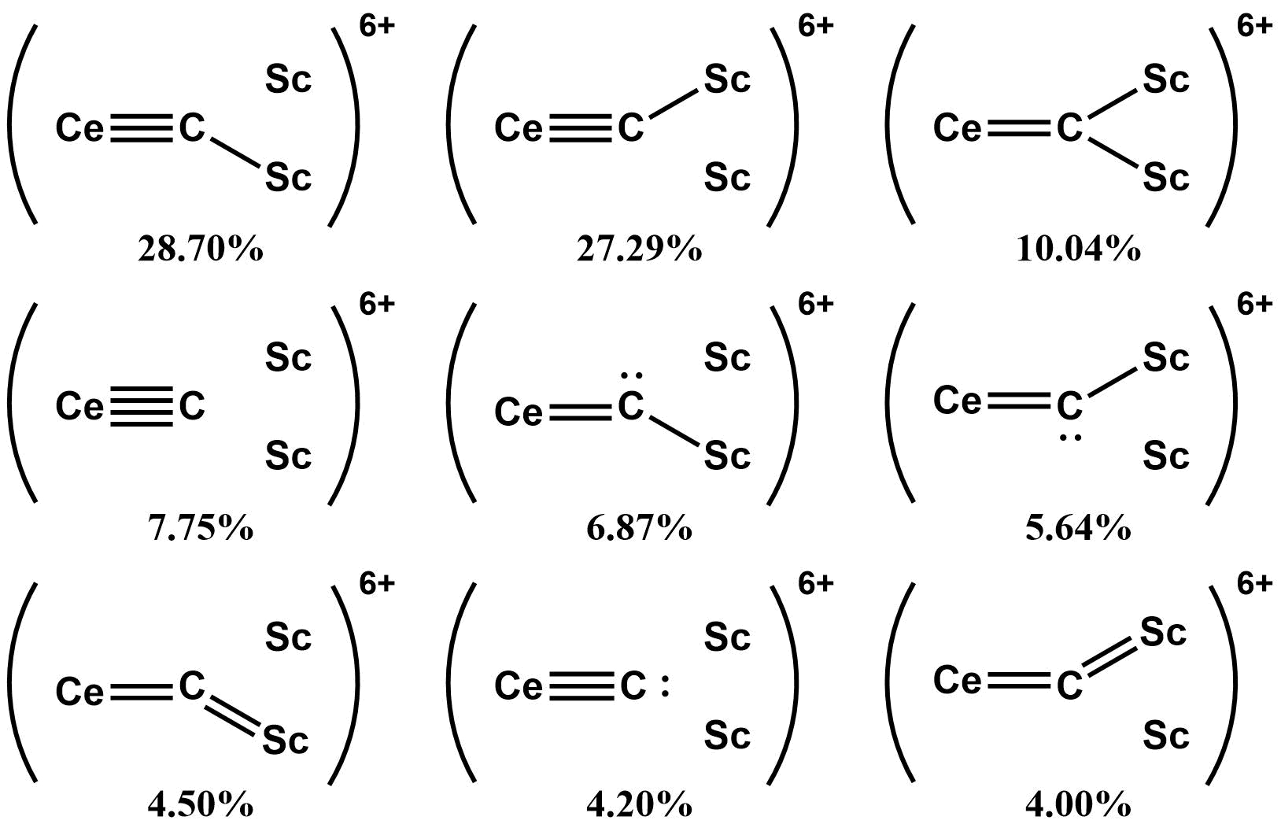
Supplementary Figure 7. Natural resonance analysis results of CeCSc₂ with contributions greater than 1% in CeSc₂C@C₈₀ at B3LYP/6-31G*+SDD level.

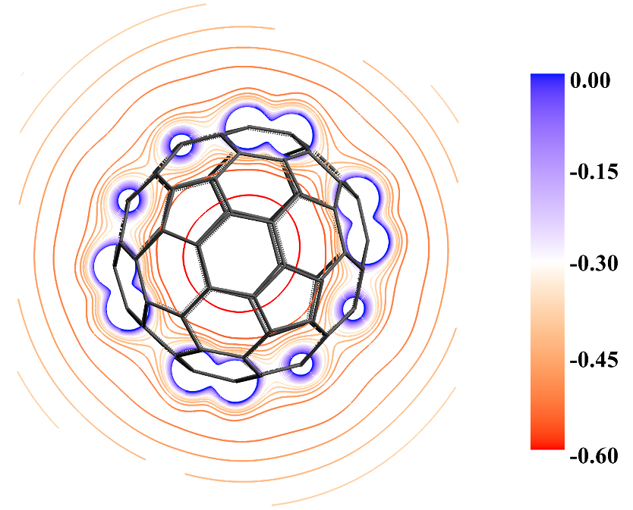
Supplementary Figure 8. Contour lines of electrostatic potential of [C₈₀]⁶⁻ on the symmetric plane defined by C15, C16 and C47 at PBE level.

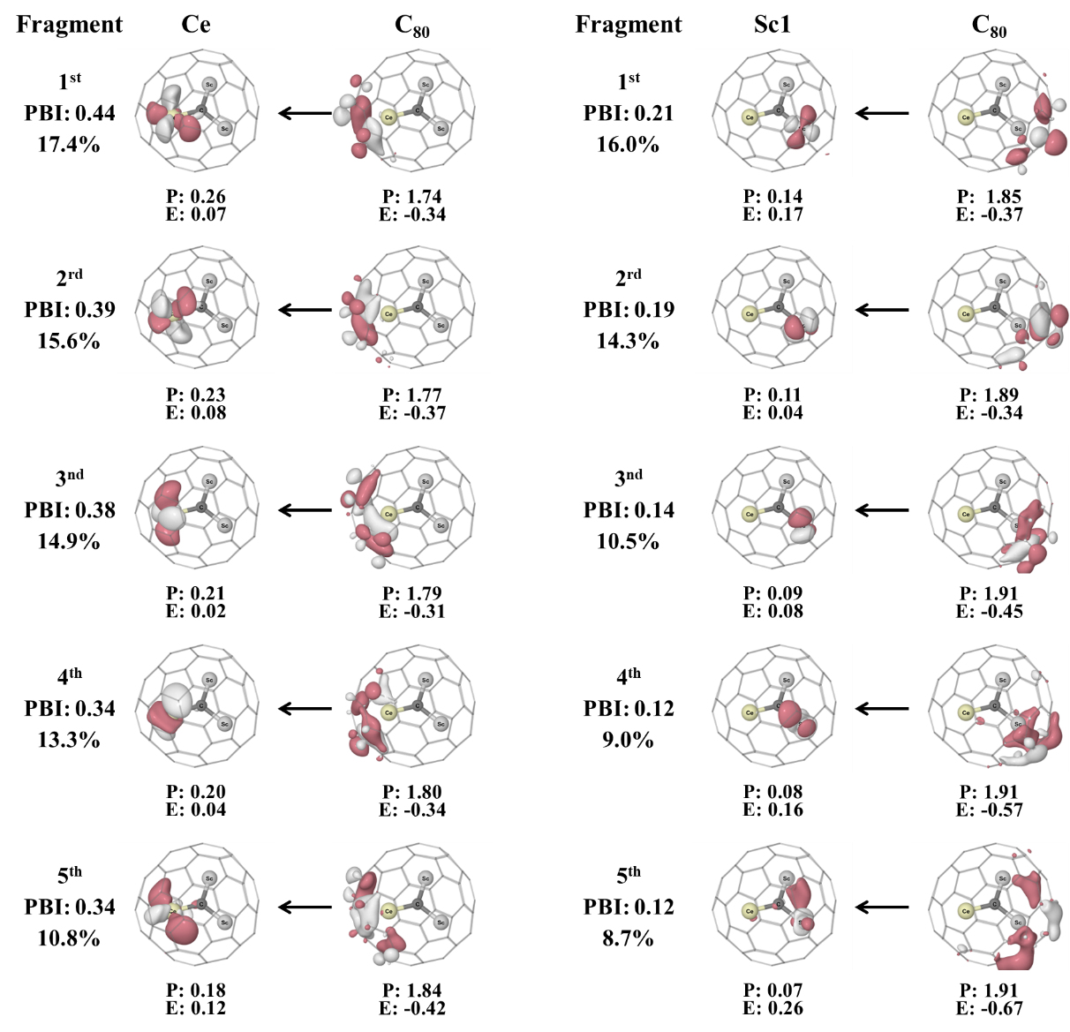
Supplementary Figure 9. Principal interacting orbitals (PIOs) of CeCSc₂@C₈₀ between the metal atoms and the C₈₀ cage. The PIO bond indices (PBI) and contribution (in %) are obtained from Kohn-Sham B3LYP calculations. The energies (in a.u.) and populations (occupation numbers) of the PIOs (isovalues: ±0.05 a.u.) are abbreviated as E and P, respectively. Since the positions of the two Sc atoms are symmetrical, for simplicity, only the interaction analysis between one Sc atom and C₈₀ was performed. Only the first five major interactions are listed in the figure.

Supplementary Figure 10. Radial distribution function D(r) = r²R(r)² of Ce 4f/5d, Sc 3d, and C 2s/2p AOs at the experimental bond length (Ce–C = 1.98 Å; Sc–C = 2.00 Å) from the calculation at PBE/TZ2P level.
Supplementary Figure 11. ORTEP-style illustration with probability ellipsoids for CeCSc₂@I_{h}(7)-C₈₀.

Supplementary Tables
Supplementary Table 1. Crystallographic information of CeSc₂C@I_{h}(7)-C₈₀ cocrystals.
Crystal | CeSc₂C@I_{h}(7)-C₈₀·  [Ni^{II}(OEP)]·2C₆H₆ | Z | 4
Formula | C129 H56 Ce N4 Ni Sc2 | ρ, g cm⁻³ | 1.732
Formula weight | 1950.52 | θ, deg | 2.25 –74.58
F(000) | 3944 | μ(GaK) (mm⁻¹) | 6.940
Crystal size, mm³ | 0.12 × 0.08 × 0.03 | T, K | 120(2)
Bravais lattice | monoclinic | Radiation (λ, mm⁻¹) | 1.54178
Space group | C2/m (No. 12) | R₁(all data) | 0.1006
a, Å | 25.2433(6) | wR₂(all data) | 0.2530
b, Å | 15.0739(4) | Parameters | 974
c, Å | 19.7436(5) | reflections (I > 2.0σ(I)) | 1051
α, deg | 90 | R₁ (observed data) | 0.0936
β, deg | 95.3560(10) | wR₂(observed data) | 0.2468
γ, deg | 90 | Goodness-of-fit indicator | 1.071
Volume, Å³ | 7479.9(3) | Maximum residual electron density, e Å⁻³ | 1.778

Supplementary Table 2. Occupancies of different metal atoms in the cluster.
Metal Sites | Sc1/Sc1A | Sc2/Sc2A | Sc3/Sc3A | Sc4/Sc4A
Occupancy | 0.435(4) | 0.324(7) | 0.176(7) | 0.065(4)
Metal Sites | Ce1/Ce1A | Ce2/Ce2A | Ce3/Ce3A | /
Occupancy | 0.4035(15) | 0.0379(10) | 0.0585(10) | /

Supplementary Table 3. Comparison of geometric parameters between the central cluster and fullerene of CeCSc₂@C₈₀ from PBE/TZ2P+DZP calculations and experiments.
Distance | Exp. | Cal. | Distance | Exp. | Cal. | Distance | Exp. | Cal.
C2–Ce | 2.478 | 2.569 | C68–Sc1 | 2.166 | 2.229 | C75–Sc2 | 2.205 | 2.230
C1–Ce | 2.492 | 2.576 | C46–Sc1 | 2.251 | 2.363 | C76–Sc2 | 2.278 | 2.238
C3–Ce | 2.560 | 2.571 | C69–Sc1 | 2.279 | 2.239 | C57–Sc2 | 2.357 | 2.364
C6–Ce | 2.574 | 2.572 | C47–Sc1 | 2.441 | 2.518 | C60–Sc2 | 2.460 | 2.382
C5–Ce | 2.585 | 2.572 | C67–Sc1 | 2.469 | 2.488 | C74–Sc2 | 2.484 | 2.493
C4–Ce | 2.619 | 2.576 | C49–Sc1 | 2.491 | 2.386 | C58–Sc2 | 2.546 | 2.503
 |  |  | C48–Sc1 | 2.540 | 2.528 | C77–Sc2 | 2.565 | 2.515
 |  |  | C70–Sc1 | 2.619 | 2.503 | C59–Sc2 | 2.568 | 2.524
Average | 2.551 | 2.573 | Average | 2.407 | 2.407 | Average | 2.433 | 2.406

Supplementary Table 4. Comparisons of the central cluster CeCSc₂ structure between the experimental data and optimized results of CeSc₂C@C₈₀ using PBE with different spin multiplicities at PBE/TZ2P+DZP level.
 |  | Exp | ¹A | ¹A*ª | ³A | ⁵A | ⁷A
ΔE/kcal·mol⁻¹ |  | / | -0- | -0- | 26.65 | 63.56 | 105.03
Distances/Å | Ce–C | 1.978 | 2.084 | 2.084 | 2.143 | 2.126 | 2.147
Distances/Å | Sc1–C | 2.010 | 2.002 | 2.002 | 1.996 | 2.042 | 2.098
Distances/Å | Sc2–C | 2.035 | 2.003 | 2.003 | 1.994 | 2.043 | 2.079
Angles/° | Ce–C–Sc1 | 127.7 | 125.0 | 124.7 | 122.1 | 124.8 | 116.8
Angles/° | Ce–C–Sc2 | 121.9 | 124.8 | 124.9 | 124.5 | 124.9 | 121.7
Angles/° | Sc1–C–Sc2 | 109.9 | 110.2 | 110.3 | 109.7 | 102.5 | 100.9
Dihedral Angle/° | Sc1–C–Sc2–Ce | 172.4 | 179.7 | 179.7 | -159.0 | 150.1 | 131.2
^{a 1}A* is the chiral isomer of ¹A structure due to approximate C₂ symmetry of CeSc₂C@C₈₀.
Supplementary Table 5. Relative energy differences (kcal/mol) between singlet and triplet state of CeCSc₂@C₈₀ obtained through PBE, B3LYP and PBE0 optimizations.
State | PBE | B3LYP | PBE0
¹A | -0- | -0- | -0-
¹A* | -0- | -0- | -0-
³A | 26.58 | 13.91 | 12.65

Supplementary Table 6. The contribution (%) of corresponding valence atomic orbital from the central cluster [CeCSc₂]⁶⁺ to the Kohn-Sham canonical MOs at the PBE/TZ2P+DZP level.
No. | C 2s | C 2p | Sc 3d | Sc 4s | Ce 4f | Ce 5d | Ce 6s
88 | 7.12 |  |  | 2.37
90 | 36.01 |  |  | 9.48 |  | 2.26 | 1.63
91 | 7.71 |  |  |  |  |  | 2.99
95 | 4.45 |  |  |  |  |  | 1.18
97 | 11.54 | 1.96 |  |  |  | 4.36
166 |  | 7.07 | 6.52 |  | 1.11
169 |  | 13.96 | 5.15 |  |  | 1.92
171 |  | 6.99 |  |  | 2.53 | 1.36
172 |  | 49.06 | 8.29 |  | 7.22 | 6.03
173 |  | 16.21 | 1.33 |  | 4.43
175 |  | 21.57 | 8.67 |  | 4.71 | 3.63
176 |  | 6.36 | 1.34 |  | 4.34
177 |  | 6.53

Supplementary Table 7. Different types of bond order results for [CeCSc₂]⁶⁺ cluster in CeCSc₂@C_{80.}
Bond | PBE/TZ2P+DZP |  |  |  | B3LYP/6-31G*+SDD
Bond | Distance/Å | Mayer | G-J | N-M(3) | Distance /Å | WBI | NRTª
C–Ce | 2.08 | 1.50 | 1.74 | 1.99 | 2.05 | 1.84 | 2.73 (1.49)
C–Sc1 | 2.00 | 0.83 | 0.92 | 1.00 | 2.01 | 0.56 | 0.51 (0.45)
C–Sc2 | 2.00 | 0.83 | 0.92 | 1.00 | 2.01 | 0.56 | 0.55 (0.48)
ª Ionic contributions are in parentheses.

Supplementary Table 8. The experimental bond length R(Å), electron density ρ, Laplace electron density ∇²ρ, electron energy density H (H = kinetic energy density G + potential energy density V), eta index η, ellipticity ε and delocalization index DI (all are atomic unit) of Ce≡C bond in CeCSc₂@C₈₀ from the QTAIM analysis at B3LYP/6-31G*+SDD and other reported Ce–C bonds.
 | R | ρ | ∇²ρ | G | V | H | η | ε | DI
CeCSc₂@C₈₀ | 1.978 | 0.160 | 0.078 | 0.111 | -0.202 | -0.091 | 0.44 | 0.12 | 1.55
Ce(BIPM^{TMS})₂ ¹⁵ | 2.385  2.399 | 0.086  0.086 | / | / | / | / | / | 0.40  0.41 | 0.62  0.61
Ce(BIPM^{TMS})(ODipp)₂ ¹² | 2.442 | 0.074 | 0.155 | 0.046 | −0.054 | −0.008 | / | 0.32 | /
[BrCe(CDP)₂]²⁺ ⁵² | 2.574  2.597 | 0.062  0.062 | 0.095  0.097 | 0.038  0.038 | −0.052  −0.053 | −0.014  −0.015 | / | 0.19  0.18 | /
Br₃Ce(CDP)(THF)⁵² | 2.597 | 0.057 | 0.097 | 0.035 | −0.045 | −0.010 | / | 0.11 | /

Supplementary Table 9. Energy decomposition analysis of CeCSc₂@C₈₀ by using singlet [CeCSC₂]⁶⁺ and [C₈₀]⁶⁻ as interacting fragment at the PBE/TZ2P+DZP level. Energy values are given in kcal/mol. The value in parentheses gives the percentage contribution to the total attractive interactions ΔE_{elstat} + ΔE_{orb}.
Fragment | [CeCSc₂]⁶⁺ (singlet)  [C₈₀]⁶⁻ (singlet)
ΔE_{int} | −3056.95
ΔE_{Pauli} | 518.79
ΔE_{elstat} | −2432.08 (68.0%)
ΔE_{orb} | −1143.67 (32.0%)

Supplementary Table 10. Optimization results of different molecules at B3LYP/6-31G+SDD level.
Molecular | CeCSc₂@C₈₀ | ECP46ª | 1^{b} | 2^{b} | 3^{b} | 4^{b}
R_{Ce–C}/Å | 2.049 | 2.112 | 1.992 | 1.968 | 2.077 | 2.084
R_{Sc–C}/Å | 2.015  2.016 | 1.997  1.997 | 2.201  2.095 | 2.170  2.128 | 2.115  2.113 | 2.111  2.111
Sc1–C–Sc2–Ce/° | 176.9 | 179.68 | 165.9 | 173.2 | 179.9 | 179.9
ªIn the optimization of CeCSc₂@C₈₀, the pseudopotential used for Ce is ECP46MWB with its corresponding valence basis; ^{b}(C₅H₅)CeC[Sc1(C₇H₇)][Sc2(C₈H₈)] (1), (C₅H₅)CeC[Sc(C₈H₈)]₂⁺ (2), (C₈H₈)CeC[Sc(C₈H₈)]₂ (3), and (C₅H₅)₂CeC[Sc(C₈H₈)]₂ (4), respectively.

Supplementary Table 11. Different atomic charge analyses of CeCSc₂@C₈₀ at PBE/TZ2P+DZP level. Charge analyses include Hirshfeld charge, Voronoi deformation density (VDD) charges, multipole-derived charges reconstructed up to quadrupoles (MDC-q), and Mulliken charge.
Atom | Hirshfeld | VDD | MDC-q | Mulliken
Ce | 0.48 | 0.33 | 1.22 | 4.02
C | -0.55 | -0.70 | -0.92 | -1.14
Sc1 | 0.42 | 0.42 | 0.95 | 2.28
Sc2 | 0.42 | 0.42 | 0.95 | 2.28

Supplementary Table 12. The atomic orbital overlap integrals of Ce or Sc atom and C atom in M-C diatoms at the experimental bond lengths (Ce–C = 1.98 Å; Sc–C = 2.00 Å)^{a,b}.
Atoms (distance from carbon) | Atomic orbitals | C 2s | C 2p_{z} | C 2p_{x} | C 2p_{y}
Ce (1.98 Å) | 4f_{z3} | 0.082 | 0.042
Ce (1.98 Å) | 4f_{z2x} |  |  | 0.091
Ce (1.98 Å) | 4f_{z2y} |  |  |  | 0.091
Ce (1.98 Å) | 5d_{z2} | 0.396 | 0.092
Ce (1.98 Å) | 5d_{zx} |  |  | 0.352
Ce (1.98 Å) | 5d_{zy} |  |  |  | 0.352
Sc (2.00 Å) | 3d_{z2} | 0.260 | 0.105
Sc (2.00 Å) | 3d_{zx} |  |  | 0.225
Sc (2.00 Å) | 3d_{zy} |  |  |  | 0.225
ªThe M-C bond axis is used as the z-direction. For Ce-C =1.98 Å, the σ-orbital overlap integrals <4f_{z3}|2s> : <5d_{z2}|2s> = 20.7% ~ 1/5; <4f_{z3}|2p_{z}> : <5d_{z2}|2p_{z} > = 45.7% ~ 2/5; The π-orbital overlap integrals <4f_{z2x}|2p_{x}> : <5d_{xz}|2p_{x} > = 26.0% ~ 1/4. ^{b}The calculated Mulliken bond order is 0.24 for Ce4f-C2s/2p and 0.55 for Ce5d-C2s/2p.

