Comparing Pixel-and Object-Based Approaches for Classifying Benthic Habitats
Henry O. J. Simmons¹, Oli Dalby¹, Daniel Ierodiaconou¹, *Mary A. Young¹
¹Faculty of Science Engineering and Built Environment/School of Life and Environmental Sciences/Centre for Marine Science, Princes Hwy, Warrnambool VIC 3280, Victoria, Australia.
*Corresponding author(s).
E-mail(s): mary.young@deakin.edu.au
Telephone: +61 3 556 33097

Table.S1. The CBiCS hierarchical system showing the biotopes found within the study site and classified within this stud.

BC2 – Broad Habitat | BC3 – Habitat Complex | BC4 – Biotope Complex | Detailed Description
Circalittoral rock and other hard substrata | High energy open coast circalittoral rock | Sandy low profile reef wave surge communities | Deep communities on low profile, flat or sandy veneer reef adjacent to or affected by sand inundation and resuspension. Considerable sand trapped around the base of sponge colonies and clumps.
 |  | High energy circalittoral rock with seabed covering sponges | Moderate to high complexity circalittoral rock, including ramp /slope geoforms, with a predominance of seabed covering sponges and other cushion fauna. Erect forms may be common but mostly low in height, less than 40 cm. There is often trapped sand amongst the sponges but does not form veneer patches.
 |  | Moderate to high complexity circalittoral rock with prominent sea plumes, sea tulips and hydroid fans | Assemblages on moderate to high complexity circalittoral rock with prominence of sea tulips such as Pyura spinifera, sea plumes such as Pteronisis and hydroid fans such as Solanderia fuscus and Clathrozoan wilsoni. Sponges are the predominant substratum cover.
 |  | Low complexity circalittoral rock with non-crowded erect sponges | Low complexity circalittoral rock with predominant covering of small colonies < 10 cm and occasional to prominent but well-spaced or non- crowded erect sponges. Larger seabed covering sponges mostly absent.
Infralittoral rock and other hard substrata | High energy infralittoral rock | High energy Ecklonia-Phyllospora  communities | Mixed Ecklonia radiata and Phyllospora comosa dominated communities where both species have an appreciable proportion of the canopy structure but varying in relative dominance. Occurs in less than extremely exposed conditions. Often associated with sand-affected reef and behind surf breaks. Note: Ecklonia radiata may be a minor component in the Phyllospora biotope complex.
 |  | High energy lower infralittoral zone | Red algal dominated communities ranging from Ecklonia park to mixed red and browns to mixed reds and sessile invertebrates.
 |  | High energy Durvillaea  communities | Durvillaea dominated communities, usually associated with highly scoured substrata colonised by crustose coralline algae or intertidal biota if occurring in the swash zone.
Sublittoral sediment | Sublittoral seaweed on sediment | Thallose red algae on sand with ground surge | Scattered thalli of predominantly red algae in tidal sediment channels, attached to objects in or on the sediment. Biotopes are differentiated by the nature of the sediments, including presence of coarse sand, fine  sand, shelly sand, sandy shell, burrows, species of seaweed, and associated presence of sea pens, bivalves, sponges, and corals. Occasional presence of Caulerpa and/or seagrass species.
 | Sublittoral sand and muddy sand | Circalittoral fine sand | Clean fine sands with less than 5% silt/clay in deeper water, either on the open coast or in tide-swept channels of marine inlets in depths of over 15-20 m. The habitat may also extend offshore and is characterised by a wide range of echinoderms, polychaetes, bivalves, and occasional beds of rhodoliths. This habitat is generally more stable than shallower, infralittoral sands and consequently supports a more diverse community.
 | Sublittoral coarse sediment | Infralittoral shell and shell mixes | Surface layer of shell sand (contains 5 to 30 % shell with sand comprising 90 % or more of the remaining sand-mud mix) or sandy shell (30-80 % shell).

Table.S2. Comparison of habitat types, sample sizes, and total number of cells between pixel based and OBIA methodologies for BC4.

Habitat type | Number of Ground Truth Points
Habitat type | PB | OBIA
Circalittoral fine sand | 119 | 35 | 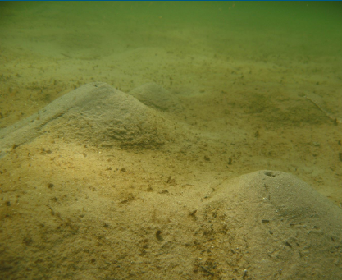
High energy circalittoral rock with seabed covering sponges | 341 | 147 | 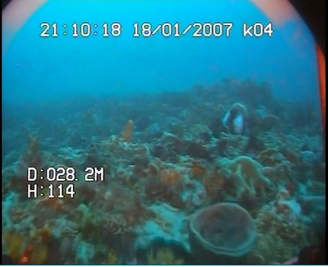
High energy Durvillaea communities | 7 | 0 | 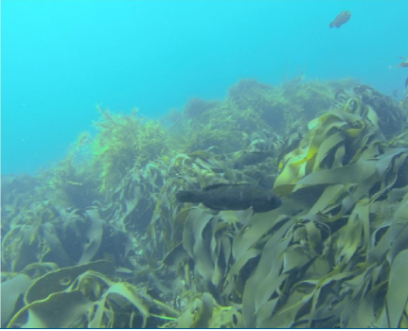
High energy Ecklonia-Phyllospora communities | 89 | 11 | 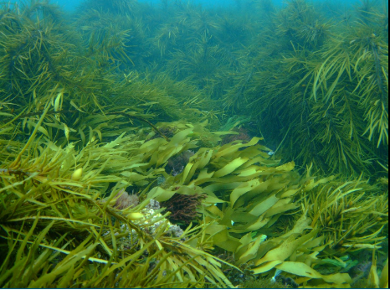
Low complexity circalittoral rock with non-crowded erect sponges | 374 | 158 | 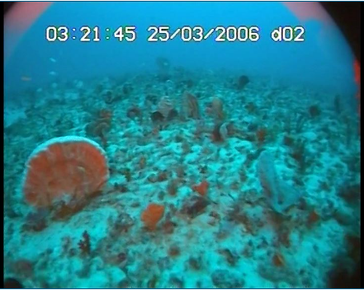
High energy lower infralittoral zone | 61 | 7 | 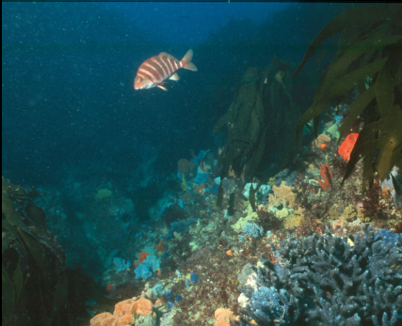
Moderate to high complexity circalittoral rock with prominent sea plumes, sea tulips and hydroid fans | 41 | 7 | 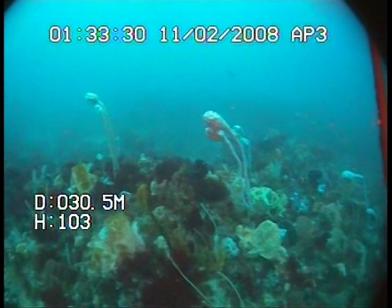
Thallose red algae on sand with ground surge | 22 | 3 | 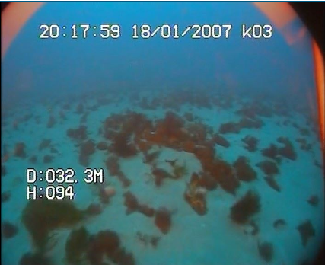
Sandy low profile reef wave surge communities | 151 | 17 | 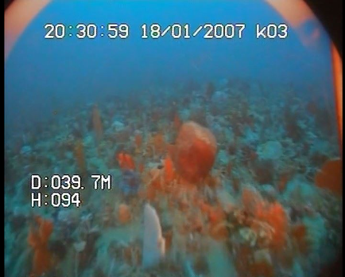
Infralittoral shell and shell mixes | 1546 | 556 | 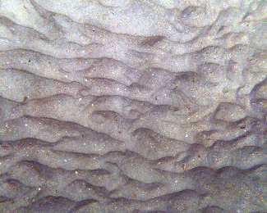
Total | 2751 | 941
Train split (70%) | 1926 | 659
Test split (30%) | 825 | 282
Total number of cells | 37461677 | 700411

Table.S3 BC2 class confusion matrix

 | OBIA |  |  | Pixel based
 | Circalittoral rock and other hard substrate | Infralittoral rock and other hard substrate | Sublittoral sediment | Circalittoral rock and other hard substrate | Infralittoral rock and other hard substrate | Sublittoral sediment
Sensitivity | 0.7653 | 1.0000 | 0.8686 | 0.8561 | 0.9575 | 0.8399
Specificity | 0.8778 | 0.9890 | 0.7961 | 0.8517 | 0.9987 | 0.8774
Pos Pred Value | 0.7732 | 0.6250 | 0.8786 | 0.7389 | 0.9783 | 0.9159
Neg Pred Value | 0.8729 | 1.0000 | 0.7810 | 0.9235 | 0.9974 | 0.7750
Prevalence | 0.3525 | 0.0180 | 0.6295 | 0.3289 | 0.0570 | 0.6141
Detection Rate | 0.2698 | 0.0179 | 0.5468 | 0.2816 | 0.0546 | 0.5158
Detection Prevalence | 0.3489 | 0.0288 | 0.6223 | 0.3811 | 0.0558 | 0.5631
Balanced Accuracy | 0.8215 | 0.9945 | 0.8323 | 0.8539 | 0.9781 | 0.8586
Precision | 0.7732 | 0.6250 | 0.8786 | 0.7389 | 0.9783 | 0.9159
Recall | 0.7653 | 1.0000 | 0.8686 | 0.8561 | 0.9575 | 0.8399
F1-Score | 0.7698 | 0.7692 | 0.8239 | 0.7389 | 0.9677 | 0.8777
Accuracy | 0.8350 |  |  | 0.8500

Table.S4 BC3 class confusion matrix | Pixel-based BC3 | OBIA BC3
Sublittoral coarse sediment
Sensitivity | 0.9179 | 0.9581
Specificity | 0.9721 | 0.9273
Precision | 0.9770 | 0.9524
Recall | 0.9179 | 0.9581
F1-score | 0.9471 | 0.9649
High energy open coast circalittoral rock
Sensitivity | 0.9371 | 0.9286
Specificity | 0.9192 | 0.9553
Precision | 0.8708 | 0.9192
Recall | 0.9371 | 0.9286
F1-score | 0.9036 | 0.9236
High energy infralittoral rock
Sensitivity | 0.9375 | 1.0000
Specificity | 0.9963 | 0.9963
Precision | 0.8333 | 0.8333
Recall | 0.9375 | 1.0000
F1-score | 0.8810 | 0.9091
Sublittoral sand and muddy sand
Sensitivity | 0.9143 | 0.5714
Specificity | 0.9924 | 1.0000
Precision | 0.8421 | 1.0000
Recall | 0.9143 | 0.5714
F1-score | 0.8772 | 0.7273
Sublittoral seaweed on sediment
Sensitivity | 0.3333 | NA
Specificity | 0.9951 | 1.0000
Precision | 0.3333 | NA
Recall | 0.3333 | NA
F1-score | 0.3333 | NA
Average Precision | 0.7894 | 0.9262
Average Recall | 0.9158 | 0.8645
Average F1-score | 0.8176 | 0.8756
Accuracy | 0.9200 | 0.9340

Biotope | Metric | Pixel-based BC4  Table.S5 BC4 class confusion matrix | OBIA BC4
Circalittoral fine sand | Sensitivity | 0.97727 | 1.00000
 | Specificity | 0.99616 | 1.00000
 | Precision | 0.93478 | 1.00000
 | Recall | 0.97727 | 1.00000
 | F1-score | 0.95529 | 1.00000
High energy circalittoral rock with seabed covering sponges | Sensitivity | 0.83721 | 0.54545
 | Specificity | 0.90257 | 0.92672
 | Precision | 0.50000 | 0.58537
 | Recall | 0.83721 | 0.54545
 | F1-score | 0.64109 | 0.56440
High energy Durvillaea communities | Sensitivity | 0.33333 | NA
 | Specificity | 1.00000 | NA
 | Precision | 1.00000 | NA
 | Recall | 0.33333 | NA
 | F1-score | 0.50000 | NA
High energy Ecklonia-Phyllospora communities | Sensitivity | 0.79310 | 1.00000
 | Specificity | 0.99623 | 1.00000
 | Precision | 0.88462 | 1.00000
 | Recall | 0.79310 | 1.00000
 | F1-score | 0.83516 | 1.00000
Low complexity circalittoral rock with non-crowded erect sponges | Sensitivity | 0.62393 | 0.68090
 | Specificity | 0.93079 | 0.89080
 | Precision | 0.59836 | 0.56140
 | Recall | 0.62393 | 0.68090
 | F1-score | 0.61171 | 0.67045
High energy lower infralittoral zone | Sensitivity | 0.93333 | 1.00000
 | Specificity | 0.99259 | 0.99635
 | Precision | 0.70000 | 0.66667
 | Recall | 0.93333 | 1.00000
 | F1-score | 0.80282 | 0.80000
Moderate to high complexity circalittoral rock with prominent sea plumes, sea tulips and hydroid fans | Sensitivity | 0.71429 | 0.50000
 | Specificity | 1.00000 | 0.99635
 | Precision | 1.00000 | 0.50000
 | Recall | 0.71429 | 0.50000
 | F1-score | 0.83333 | 0.50000
Thallose red algae on sand with ground surge | Sensitivity | 0.33333 | 0.20000
 | Specificity | 0.99756 | 0.99262
 | Precision | 0.50000 | 0.33333
 | Recall | 0.33333 | 0.20000
 | F1-score | 0.40000 | 0.25000
Sandy low profile reef wave surge communities | Sensitivity | 0.64000 | 0.20000
 | Specificity | 0.99871 | 0.99262
 | Precision | 0.96970 | 0.33333
 | Recall | 0.64000 | 0.20000
 | F1-score | 0.76923 | 0.25000
Infralittoral shell and sand mixes | Sensitivity | 0.89800 | 0.95780
 | Specificity | 0.98630 | 0.99090
 | Precision | 0.98810 | 0.99380
 | Recall | 0.89800 | 0.95780
 | F1-score | 0.94188 | 0.97581
Average | Sensitivity | 0.72448 | 0.67942
 | Specificity | 0.97815 | 0.98129
 | Precision | 0.74242 | 0.69479
 | Recall | 0.72448 | 0.67942
 | F1-score | 0.72957 | 0.68169

 | OBIA BC2 | Importance | OBIA BC3 | Importance | OBIA BC4  Table.S6. Top ten important variables for each hierarchical level of the OBIA approach. | Importance
1 | Bathymetry | 100.000 | predicted_BC2 | 100.000 | predicted_BC3 | 100.00
2 | X9x9_elv | 95.964 | X51x51_l | 39.457 | predicted_BC2 | 98.29
3 | X5x5_elv | 92.757 | X9x9_elv | 35.051 | X3x3_elv | 74.63
4 | X3x3_elv | 92.675 | X21x21_l | 30.970 | X9x9_elv | 72.66
5 | X21x21_l | 88.405 | Bathymetry | 30.392 | Bathymetry | 66.48
6 | X51x51_l | 77.256 | X3x3_elv | 29.056 | X21x21_l | 64.85
7 | X51x51_d | 28.116 | X5x5_elv | 26.271 | X51x51_l | 63.94
8 | X9x9_djs | 25.492 | X51x51_d | 14.373 | X5x5_elv | 62.12
9 | X21x21_d | 16.305 | Backscatter | 10.058 | Backscatter | 36.14
10 | X51x51_qst | 15.238 | X21x21_d | 8.395 | X21x21_d | 29.82

Table.S7. Top ten important variables for each hierarchical level of the PB approach.

Rank | PB BC2 | Importance | PB BC3 | Importance | PB BC4 | Importance
1 | x51_elev | 100.0000 | predicted_habitats_bc3 | 100.000 | predicted_habitats_bc3 | 100.000
2 | x21_elev | 41.5101 | x51_elev | 42.665 | x51_elev | 42.665
3 | x5_elev | 37.5251 | predicted_habitats_bc2 | 40.231 | predicted_habitats_bc2 | 40.231
4 | x3_elev | 37.0605 | x21_elev | 33.711 | x21_elev | 33.711
5 | Bathymetry | 36.3198 | x9_elev | 27.100 | x9_elev | 27.100
6 | x9_elev | 28.1284 | x5_elev | 24.538 | x5_elev | 24.538
7 | x21_adjsd | 18.9323 | Bathymetry | 20.709 | Bathymetry | 20.709
8 | x51_adjsd | 18.0554 | x3_elev | 20.406 | x3_elev | 20.406
9 | Backscatter | 15.2115 | x21_adjsd | 15.687 | x21_adjsd | 15.687
10 | x51_qnorthness | 5.7229 | x51_qaspect | 14.348 | x51_qaspect | 14.348

Table.S8. Biotope coverage at the BC3 level.
 | BC2 Biotope Coverage (km²)
 | PB | OBIA
Circalittoral rock | 44.314416 | 48.592377
Infralittoral rock | 10.368999 | 12.688299
Sublittoral sediment | 282.471678 | 275.299965

Table.S9. Biotope coverage at the BC2 level.
 | BC3 Biotope Coverage (km²)
 | PB | OBIA
Sublittoral sediment | 222.811119 | 219.035601
High energy open coast circalittoral rock | 50.106528 | 50.293881
High energy infralittoral rock | 2.663028 | 10.471113
Sublittoral sand and muddy sand | 60.634107 | 56.57427
Sublittoral seaweed on sediment | 0.940311 | 0.205776

Table.S10. Biotope coverage at BC4. | BC4 Biotope Coverage (km²)
Table.S10. Biotope coverage at BC4. | PB | OBIA
Circalittoral fine sand | 55.118043 | 57.373866
High energy circalittoral rock with seabed covering sponges | 20.94984 | 21.694509
High energy Durvillaea communities | 0.102303 | NA
High energy Ecklonia-Phyllospora communities | 8.473275 | 6.635961
Low complexity circalittoral rock with non-crowded sponges | 29.496969 | 19.340712
High energy lower infralittoral zone | 2.556666 | 3.826377
Moderate to high complexity circalittoral rock with prominent sea plumes, sea tulips and hydroid fans | 0.694377 | 1.486836
Thallose red algae on sand with ground surge | 0.891306 | 0.206037
Sandy low profile reef wave surge communities | 7.560441 | 7.063902
Infralittoral shell and sand mixes | 211.311873 | 218.952441

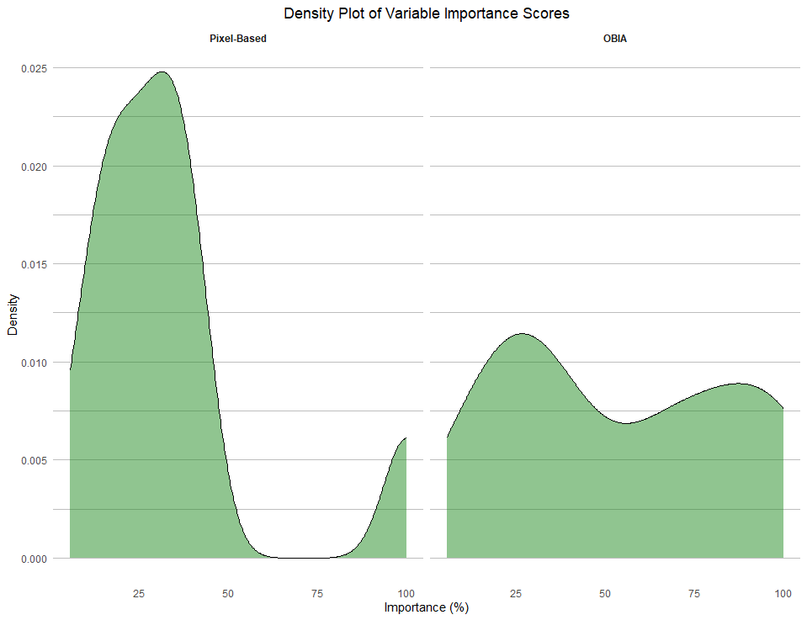
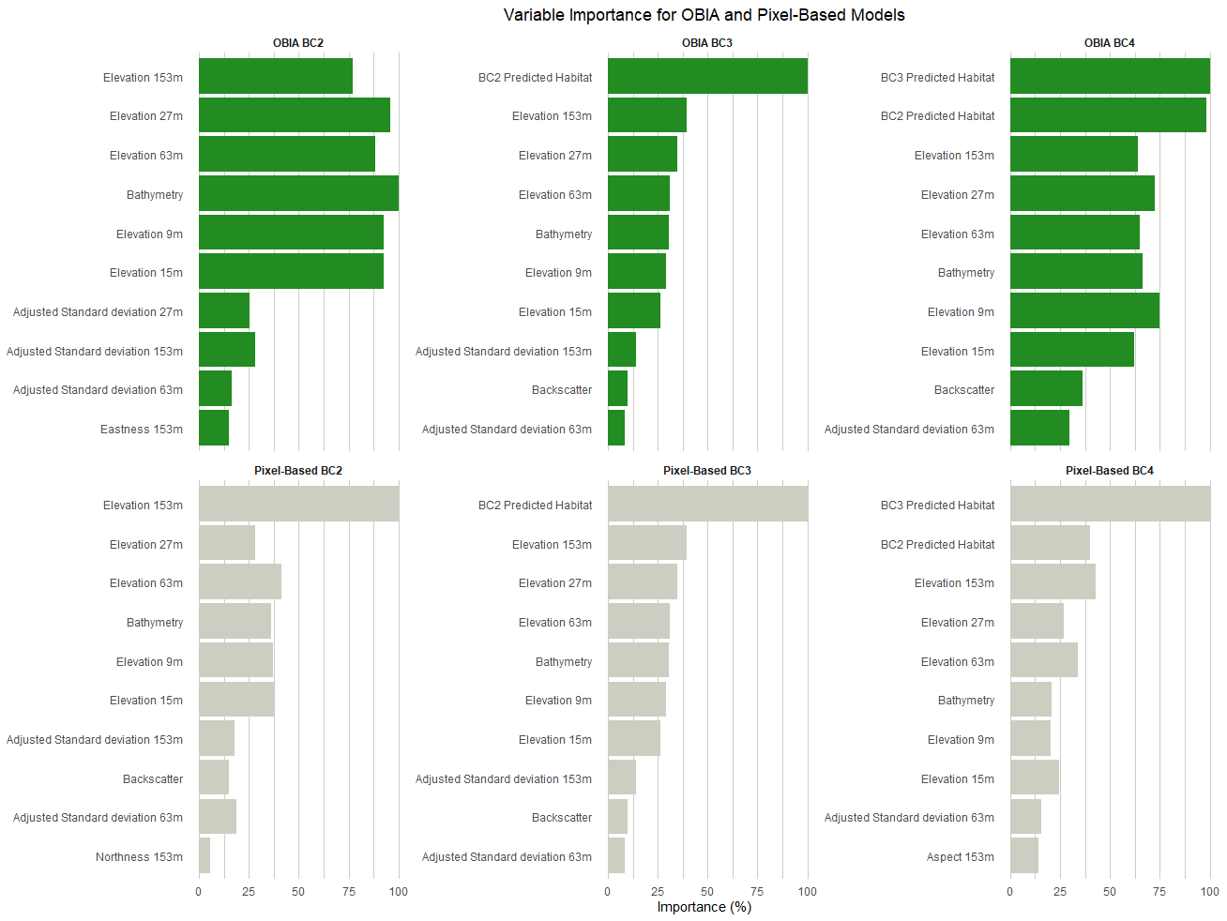
Fig. S2. A density plot for variable importance for both approaches.
Fig. S1. The ten most important variables for both pixel-based and OBIA approaches at each hierarchical level of classification.
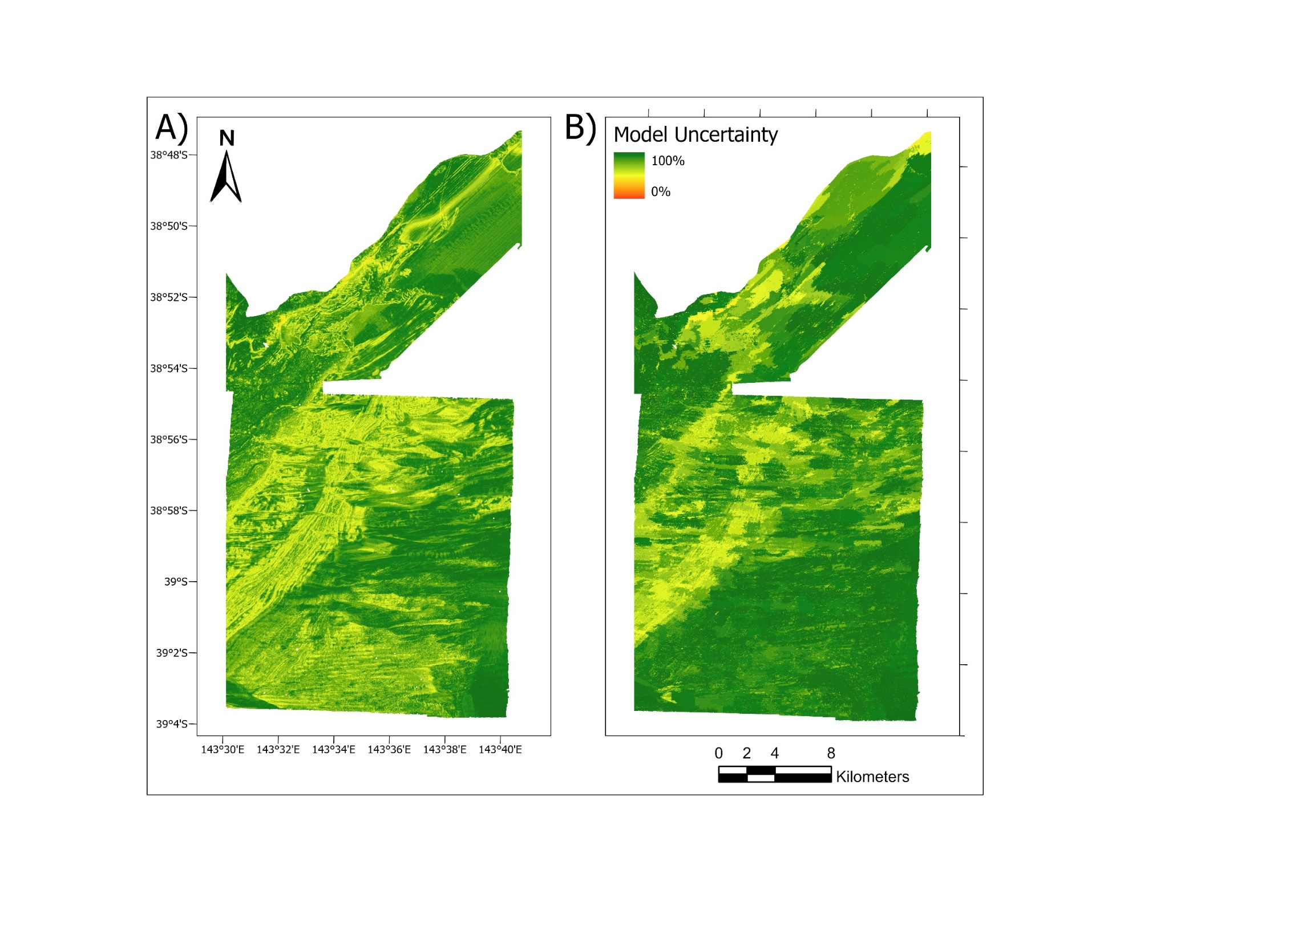
Fig.S3 Biotope classification model uncertainty map for the BC2 level of classification.

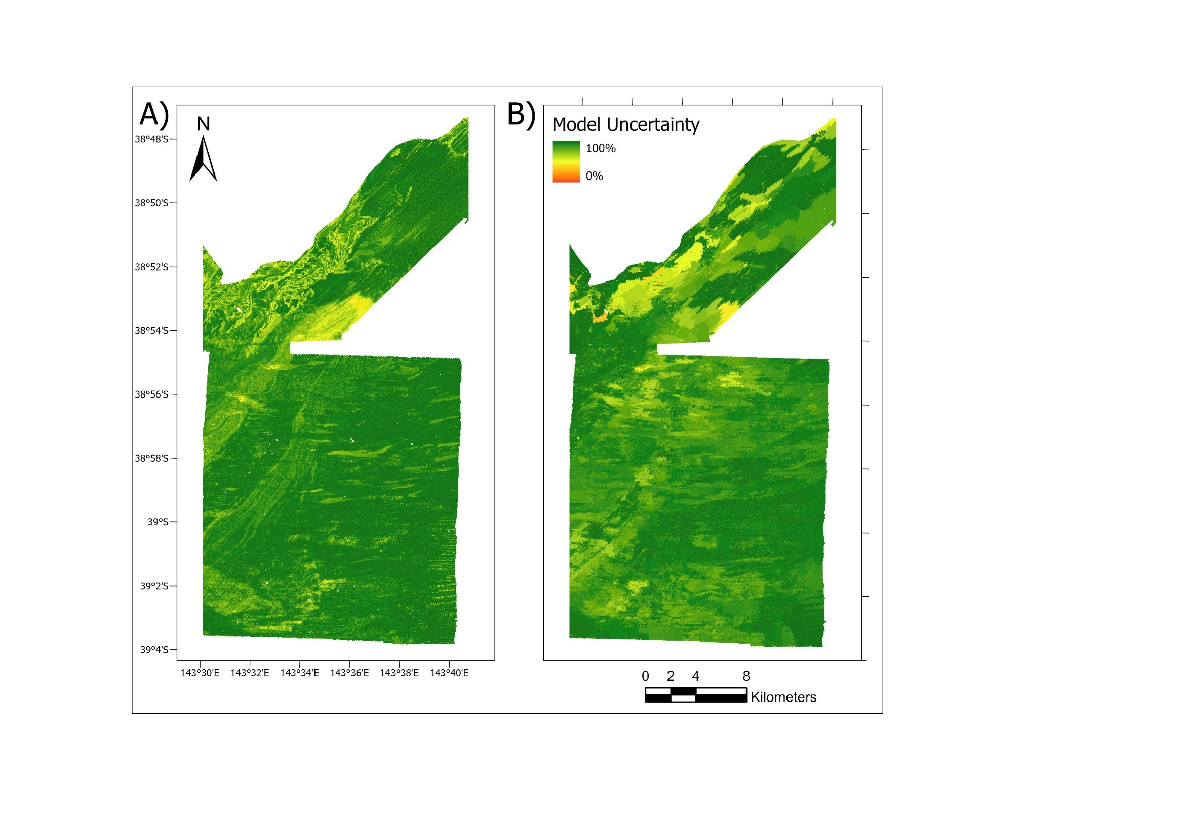
Fig.S4 Biotope classification model uncertainty map for the BC3 level of classification.
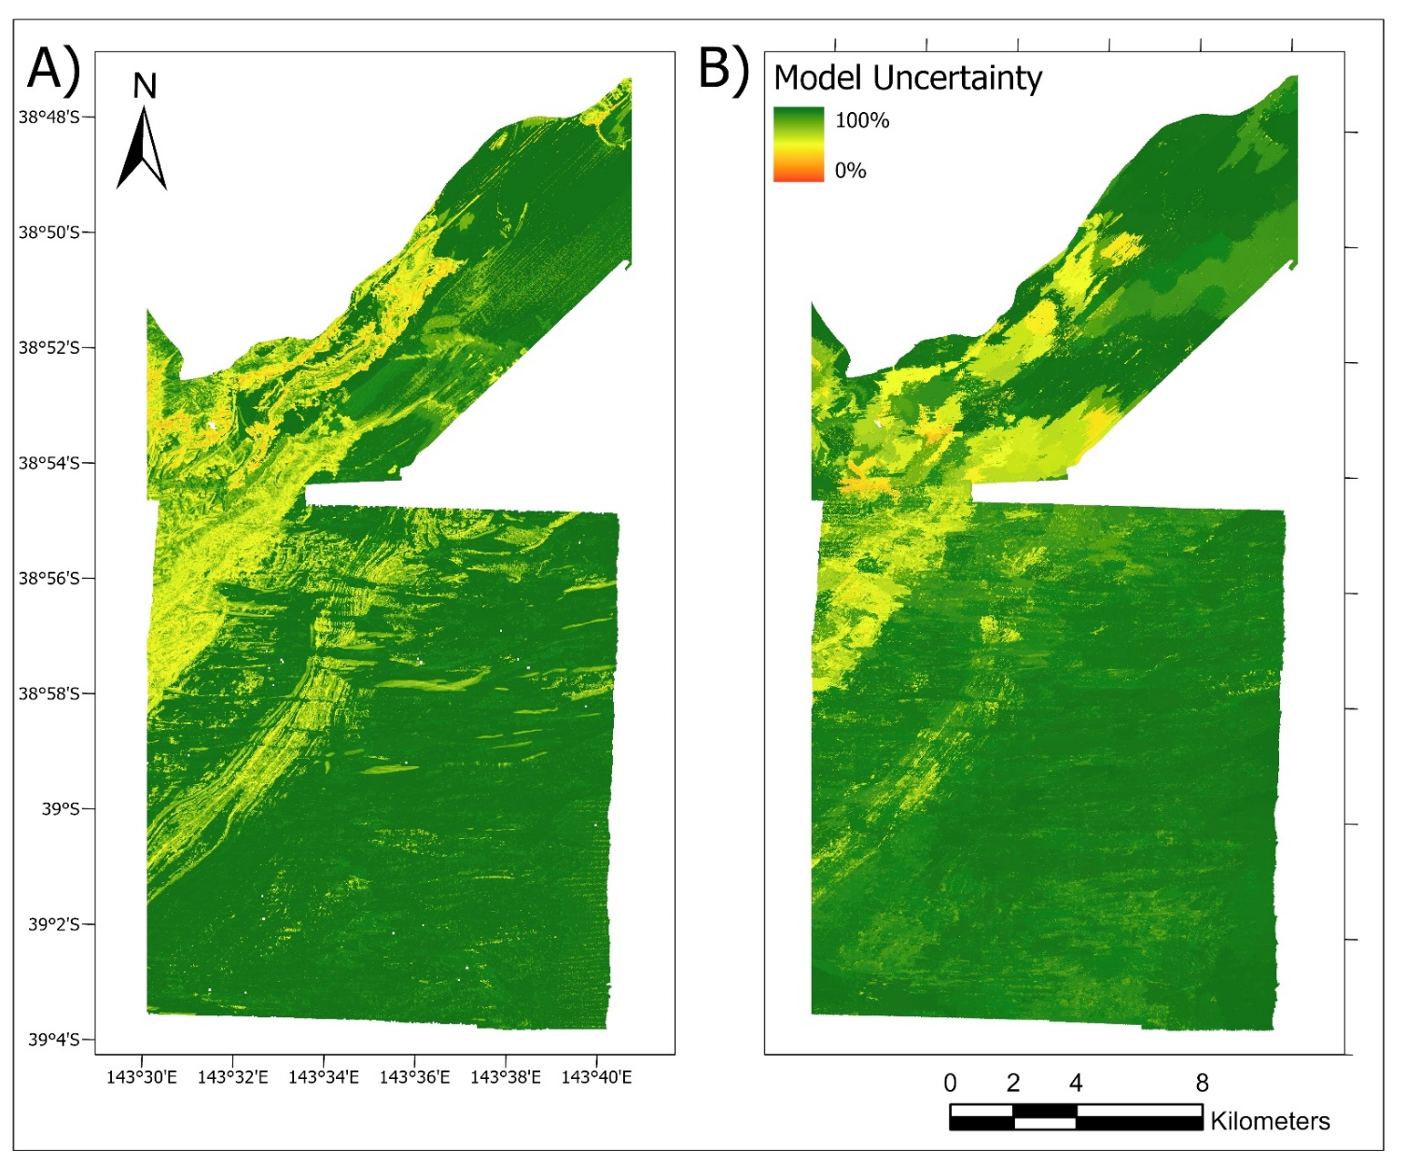
Fig.S5 Biotope classification model uncertainty map for the BC4 level of classification.

