Spillover effects of upstream irrigation expansion on downstream water stress in transboundary river basins

Supplemental Information

Table of Contents
1. Uncertainty estimates of irrigation water stress index (IWSI)
2. Comparison of IWSI patterns with exiting water scarcity maps
3. Multiple regression models of irrigation water withdrawal
4. Supplementary Tables and Figures

Uncertainty estimates of irrigation water stress index (IWSI)
To assess the uncertainty in the IWSI calculations, we compute the interquartile range (IQR) for each sub-basin's IWSI. The IQR represents the range between the third quartile (Q3) and the first quartile (Q1), providing a robust measure of data dispersion that is less sensitive to outliers. The indicators for irrigation, domestic, and industrial water withdrawal, as well as discharge data obtained from the four GHMs and four GCMs, are validated in previous studies (Table S7). Due to the variation in indicator definitions across models, we exclude models with significant discrepancies, resulting in 16 combinations for discharge and irrigation water withdrawal, 12 combinations for domestic water withdrawal, and 8 combinations for industrial water withdrawal (Table S6). We use the median values from these combinations to calculate the IWSI and determine the IQR for each indicator separately. By comparing the magnitudes of the IQRs, we assess the uncertainty in the calculations and identify the most significant sources of variability.
The result shows that 56.4% of sub-basins have IQR below 0.1 in the 2000s, while the sub-basins with IQR above 0.2 are primarily located in Asia and North America. This indicates that while the uncertainty in IWSI calculations remains relatively robust (Fig. S1A-D). The sub-basins, where discharge is the primary source of uncertainty, are the largest, accounting for 87.2%, 79.8%, and 75.6% in the 1900s, 1950s, and 2000s, respectively (Fig. S1E-H). Sub-basins, where irrigation water withdrawal is a major factor of uncertainty, are mainly in Asia, such as China in the upper Amur Basin, India in the middle Ganges-Brahmaputra-Meghna Basin, and India and Pakistan in the Rann of Kutch Basin. Sub-basins where industrial and domestic water withdrawal are major factors of uncertainty are mainly in Europe, including Russia downstream of the Vuoksa Basin, Germany downstream of the Elbe Basin, and Poland downstream of the Vistula/Wista Basin.

Comparison of IWSI patterns with exiting water scarcity maps
We compare the IWSI results with existing water stress maps. Rosa et al.¹ defines blue water scarcity (BWS) as local supply fails to meet irrigation demands. The BWS map for the period 1996-2005 indicates the number of months each pixel experiences BWS. The spatial distribution patterns of the average number of months with BWS across various sub-basins closely align with the IWSI (Fig. S4). A confusion matrix analysis using the IWSI, with the BWS map treated as a reference, reveals an overall accuracy of 0.83 for sub-basin identification of water stress. However, some sub-basins experiencing BWS are misclassified as not facing irrigation water stress, resulting in a user accuracy of 0.49 (Table S8). Because only a few pixels within a large-scale sub-basin exhibit months of BWS, the average for the sub-basin is not zero, leading to its classification as having a water stress situation, as seen in the downstream section of the Ob Basin.
Munia et al.² defines water scarcity as local flow fails to meet water demand. The water scarcity index (WSI) map from the 1970s exhibits a distribution pattern consistent with the IWSI map (Fig. S5), and the identification of water stress areas is verified against this map, yielding an overall accuracy of 0.91 (Table S9). However, the number of sub-basins identified as water-stressed by Munia is relatively lower than those identified by the IWSI. This difference may primarily arise from variations in the datasets used; we employ updated indicators derived from the ISIMIP 2b protocol, while WSI map utilizes the abandoned ISIMIP FAST TRACK protocol.

Multiple regression models of irrigation water withdrawal
We conduct multiple regression models (MRMs) to analyze downstream IWS attribution using decadal averages from the 20th century. The variables considered include upstream irrigation water withdrawal, industrial water withdrawal, residential water withdrawal, water availability from the same years, and downstream-upstream IWSI differences from the previous year. The results show that downstream IWSI increases by 0.61 ± 0.04% following one percentage point of previous year’s downstream-upstream IWSI differences, while upstream irrigation water withdrawal is also an important driver, specifically, each percentage point increase in upstream irrigation water withdrawal leads to a 0.44 ± 0.1% increase in downstream IWSI (Table S10). Downstream IWSI is significantly negatively correlated with upstream domestic water withdrawal (p value<0.001), approximately double the positive impact of industrial water withdrawal: -0.279 vs. 0.141. Upstream water availability has the least effect, accounting for just -0.064% of downstream IWSI.

Supplementary Tables

Table S1. Estimates of the direct path effect of indicator 2 on the role of indicator 1 in structural equation model (SEM) during 1901-2005.
Indicator1 |  | Indicator2 | Estimate | S.E.
IWSI_{down} | <--- | IWSI_{dif} | 1.107*** | 0.012
IWSI_{down} | <--- | IWSI_{up} | 0.936*** | 0.01
IWSI_{down} | <--- | irrWW_{down} | 0.043** | 0.002
IWSI_{down} | <--- | irrArea_{up} | 0.037*** | 0
IWSI_{down} | <--- | domWW_{down} | -0.025 | 0.031
IWSI_{down} | <--- | discharge_{down} | -0.011 | 0
IWSI_{down} | <--- | indWW_{down} | 0.005 | 0.005
IWSI_{up} | <--- | irrWW_{up} | 0.843*** | 0.014
IWSI_{up} | <--- | domWW_{up} | -0.804*** | 0.182
IWSI_{up} | <--- | IWSI_{dif} | -0.622*** | 0.025
IWSI_{up} | <--- | indWW_{up} | 0.323*** | 0.032
IWSI_{up} | <--- | irrArea_{down} | 0.307*** | 0
IWSI_{up} | <--- | discharge_{up} | -0.062** | 0
irrWW_{up} | <--- | irrArea_{up} | 0.992*** | 0
irrWW_{up} | <--- | indWW_{down} | -0.013* | 0.008
irrWW_{down} | <--- | irrArea_{down} | 0.953*** | 0
irrWW_{down} | <--- | indWW_{down} | -0.063*** | 0.017
irrWW_{down} | <--- | irrArea_{up} | 0.053*** | 0
discharge_{up} | <--- | domWW_{up} | 0.327*** | 13.03
discharge_{up} | <--- | irrWW_{up} | -0.264*** | 0.97
discharge_{up} | <--- | indWW_{up} | 0.069 | 2.243
discharge_{down} | <--- | discharge_{up} | 0.506*** | 0.029
discharge_{down} | <--- | domWW_{up} | 0.387*** | 12.449
discharge_{down} | <--- | irrWW_{up} | -0.212*** | 0.916
discharge_{down} | <--- | indWW_{up} | -0.201*** | 2.28
discharge_{down} | <--- | domWW_{down} | 0.056 | 6.655
discharge_{down} | <--- | irrWW_{down} | -0.018 | 0.372
discharge_{down} | <--- | indWW_{down} | -0.009 | 0.995
Asterisks denote the statistical significance based on P values: *P< 0.05, **P< 0.01, ***P< 0.001. IWSI_{dif} indicates the previous year's downstream irrigation water stress index (IWSI) minus upstream IWSI difference. The subscripts "up" and "down" denote upstream and downstream, respectively. irrArea denotes the area under irrigation cropland. irrWW, domWW, and indWW represent water withdrawals from irrigation, domestic, and industrial sector, respectively. Discharge refers to the flow in the sub-basin after accounting for the removal of the environmental flow requirement (EFR), i.e., water availability.

Table S2. Direct and indirect effects of indicators on downstream irrigation water stress (IWS) in structural equation model (SEM) from 1901 to 2005.
 |  | Direct effect | Indirect effect | Total effect
IWSI_{up} | Effect | 0.936 | 0 | 0.936
 | Ratio | 100% | 0%
irrArea_{up} | Effect | 0.037 | 0.803 | 0.841
 | Ratio | 4.405% | 95.595%
irrWW_{up} | Effect | 0 | 0.808 | 0.808
 | Ratio | 0% | 100%
domWW_{up} | Effect | 0 | -0.777 | -0.777
 | Ratio | 0% | 100%
IWSI_{dif} | Effect | 1.107 | -0.582 | 0.524
 | Ratio | 65.542% | 34.458%
irrArea_{down} | Effect | 0 | 0.329 | 0.329
 | Ratio | 0% | 100%
indWW_{up} | Effect | 0 | 0.3 | 0.3
 | Ratio | 0% | 100%
discharge_{up} | Effect | 0 | -0.063 | -0.063
 | Ratio | 0% | 100%
irrWW_{down} | Effect | 0.043 | 0 | 0.043
 | Ratio | 100% | 0%
domWW_{down} | Effect | -0.025 | -0.001 | -0.026
 | Ratio | 96.154% | 3.846%
discharge_{down} | Effect | -0.011 | 0 | -0.011
 | Ratio | 100% | 0%
indWW_{down} | Effect | 0.005 | -0.013 | -0.008
 | Ratio | 27.778% | 72.222%
Direct effects were derived from the standardized path coefficients of each indicator on downstream IWS. Indirect effects were calculated as the product of all effects along a single path. Total effects represent the sum of all direct and indirect effects. The ratio is the absolute value of direct or indirect effects divided by the sum of the absolute values of all effects.

Table S3. Basins with current water conflict hotspots.
Basin name | Downstream  country | Upstream  country | IWSI_{down} | IWSI_{up} | irrArea_{down}（km²） | irrArea_{up}（km²） | IWSI_{dif}
Asia
Rann of Kutch | Pakistan | India | 7.8 | 36.05 | 295.68 | 753.1 | -12.95
Indus | Pakistan | India, Afghanistan, Antigua and Barb. | 9.4 | 2.72 | 1295.87 | 237.66 | 6.72
Ganges-Brahmaputra-Meghna | Bangladesh | India,  Nepal,  Bhutan | 0.19 | 6.39 | 374.52 | 2822.61 | -4.83
Tigris-Euphrates/Shatt al Arab | Iraq | Syria | 2.12 | 0.58 | 363.85 | 79.72 | 1.25
Tigris-Euphrates/Shatt al Arab | Syria | Iran, Turkey, Iraq | 0.58 | 1.94 | 79.72 | 246.08 | -1.17
Aral Sea | Shared zone | Kazakhstan, Uzbekistan, Tajikistan, Turkmenistan, Shared zone | 0.25 | 5.35 | 44.43 | 512.64 | -5.73
Aral Sea | Kazakhstan, Uzbekistan, Tajikistan, Turkmenistan, Shared zone | Afghanistan, Tajikistan, Uzbekistan, Kyrgyzstan | 5.35 | 4.90 | 512.64 | 166.59 | 1.23
Ili/Yili He | China | Kazakhstan | 2.01 | 0.00 | 51.39 | 0.14 | 1.13
Hari/Harirud | Turkmenistan | Afghanistan | 1.29 | 0.75 | 98.50 | 26.01 | 0.86
Hari/Harirud | Afghanistan | Iran | 1.29 | 1.69 | 26.01 | 33.92 | -0.80
Alakol | Kazakhstan | China | 0.65 | 1.22 | 9.95 | 26.95 | 0.12
North America
Rio Grande | Shared zone | Mexico, United States | 0.36 | 4.48 | 58.95 | 91.25 | -3.45
Colorado | Mexico | United States | 0.10 | 2.15 | 18.82 | 111.10 | -1.15
Africa
Limpopo | Zimbabwe, Botswana, Shared zone | South Africa, Botswana, Zimbabwe | 0.03 | 3.16 | 1.58 | 38.42 | -2.02
Europe
Guadiana | Portugal | Spain | 0.04 | 1.16 | 6.98 | 46.29 | -0.93
Sourth America
La Plata | Uruguay | Brazil, Argentina | 0.09 | 0.50 | 10.43 | 27.36 | -0.34
IWSI_{down}, IWSI_{up}, irrArea_{down}, and irrArea_{up} are all from the 2000s while IWSI_{dif} is from the 1990s. IWSI_{dif} is the irrigation water stress index (IWSI) difference between downstream and upstream (or, in basins with a middle stream, the difference between downstream and middle stream, and middle stream and upstream). IWSI represents the value of IWSI for the subbasin and irrArea the area of irrigated cropland within the sub-basin. If there are multiple sub-basins in the middle or upper reaches, then the sum is used as the value.

Table S4. Changes in upstream and downstream irrigation water stress index (IWSI) and irrigation area in typical river basins in five continents during the 20th century.
 | Ganges-Brahmaputra-Meghna Basin in Asia | Rio Grande Basin in North America | Limpopo Basin in Africa | La Plata Basin in South America | Guadiana in Europe
irrArea_{up} | 0.990** | 0.405 | 0.806** | 0.908** | 0.892**
irrWW_{up} | 0.802** | 0.642* | 0.759** | 0.909** | 0.932**
IWSI_{dif} | 0.981* | 0.455 | 0.778** | 0.898** | 0.913**
domWW_{up} | 0.983* | 0.619 | 0.687** | 0.859** | 0.825**
indWW_{up} | 0.886* | 0.551 | 0.757** | 0.859** | 0.792**
discharge_{up} | -0.598 | -0.667* | -0.919** | 0.349 | -0.868**
The asterisks denote the statistical significance based on P values: *P< 0.05, **P< 0.01, two-tailed. IWSI_{dif} indicates the previous year's downstream IWSI minus upstream IWSI difference. The subscripts "_{up}" denote upstream. irrArea denotes the area under irrigation cropland. irrWW, domWW, and indWW represent water withdrawals from irrigation, domestic, and industrial sector, respectively. Discharge refers to the flow in the sub-basin after accounting for the removal of the environmental flow requirement (EFR), i.e., water availability.

Table S5. Basins with potential water conflict hotspots in the future. IWSI_{down} and IWSI_{dif} represents Sen's trend fits to the irrigation water stress index (IWSI) for the period 1901-2099 under the RCP6.0 scenario. irrArea_{up} is the Sen's trend fits to the upstream irrigated areas for the period 1901-2005. The terms downstream and upstream are relative. In the presence of midstream regions, the table reflects downstream-midstream or midstream-upstream relationships.
Basin name | Downstream  country | Upstream  country | IWSI_{down} | irrArea_{up} | IWSI_{dif}
Asia
Indus | Pakistan | India | 0.44 | 1819.36 | 0.32
Tigris-Euphrates/Shatt al Arab | Iraq | Syria | 0.07 | 598.12 | 0.05
Tigris-Euphrates/Shatt al Arab | Syria | Iran, Turkey, Iraq, Saudi, Arabia | 0.01 | 2214 | -0.14
Alakol | Kazakhstan | China | 0.05 | 223.51 | -0.05
Ili/Yili He | Kazakhstan | China | 0.04 | 389.01 | -0.08
Kura-Araks | Azerbaijan | Georgia,  Shared zone,  Iran | 0.02 | 867.54 | -0.07
Kura-Araks | Georgia,  Shared zone,  Iran | Turkey, Armenia, Azerbaijan | 0.01 | 327.89 | 0.03
Ganges-Brahmaputra-Meghna | Bangladesh | India  Nepal  Bhutan | 0.01 | 22177.58 | -0.3
Ganges-Brahmaputra-Meghna | India,  Nepal,  Bhutan, | India,  China | 0.32 | 252.52 | 0.31
Irrawaddy | Myanmar | China,  India | 0.03 | 161.15 | 0.02
Aral Sea | Kazakhstan,  Uzbekistan,  Tajikistan,  Turkmenistan,  Shared zone | Uzbekistan,  Kyrgyzstan,  Uzbekistan,  Tajikistan,  Afghanistan | 0.23 | 1563.77 | 0.07
Rann of Kutch | Pakistan | India | 0.15 | 5765.30 | -1.02
Europe
Don | Russia | Ukraine | 0.03 | 189.27 | 0.03
South America
La Plata | Argentina, Bolivia,  Brazil,  Paraguay,  Shared zone, | Bolivia,  Brazil | 0.03 | 852.04 | -0.06
La Plata | Uruguay | Brazil,  Argentina | 0.01 | 329.19 | -0.04

Table S6. Parameters used in global hydrological models for indicators required for irrigation water stress calculations
Indicators for calculating irrigation water stress | Global Hydrological Model | Output Variable | Temporal resolution | Climate related forcing | Direct human forcing
Irrigation water withdrawal | H08 | airrww | monthly | historical, rcp26, rcp60 | histsoc, rcp26soc, rcp60soc
Irrigation water withdrawal | CWatM
Irrigation water withdrawal | LPJmL
Irrigation water withdrawal | PCR-GLOBWB | airrww | monthly | historical, rcp26, rcp60 | 2005soc, rcp26soc, rcp60soc
Domestic water withdrawal | H08 | adomww | monthly | historical, rcp26, rcp60 | histsoc, rcp26soc, rcp60soc
Domestic water withdrawal | LPJmL | admeluse | annual | historical, rcp26, rcp60 | histsoc, rcp26soc, rcp60soc
Domestic water withdrawal | PCR-GLOBWB | adomww | annual | historical, rcp26, rcp60 | 2005soc, rcp26soc, rcp60soc
Industrial water withdrawal | H08 | aindww | monthly | historical, rcp26, rcp60 | histsoc, rcp26soc, rcp60soc
Industrial water withdrawal | PCR-GLOBWB | aindww | monthly | historical, rcp26, rcp60 | 2005soc, rcp26soc, rcp60soc
River Discharge | H08 | dis | daily | historical, rcp26, rcp60 | histsoc, rcp26soc, rcp60soc
River Discharge | CWatM
River Discharge | LPJmL
River Discharge | PCR-GLOBWB | dis | daily | historical, rcp26, rcp60 | 2005soc, rcp26soc, rcp60soc

Table S7. Validation of indicators needed for irrigation water stress calculations in global hydrological models
Indicators for calculating irrigation water stress | Global Hydrological Model | Model Validation
Water withdrawal | H08 | Agreed well with previously published Siebert, et al.³, Döll, et al.⁴, Wada, et al.⁵, and Pokhrel, et al.⁶and IGRAC⁷ report.⁸
Water withdrawal | CWatM | Actual water withdrawals have been extensively validated⁵ and are estimated based on water demand and available water resources.⁹
Water withdrawal | LPJmL | Agreed well with previously published^{4,10-14}.¹⁵
Water withdrawal | PCR-GLOBWB | Water withdrawal data for many countries were sourced from FAO's AQUASTAT database¹⁶, typically reported every five years. Simulated water withdrawal per sector and water source (surface water and groundwater) were compared with reported values per country and reporting period whenever available.¹⁷
River discharge | H08 | Validated simulated river discharge at major gauging stations in six heavily human-affected basins using observation records from the Global Runoff Data Centre (GRDC,www.bafg.de/GRDC/EN/Home/homepage_node.html).⁸
River discharge | CWatM | Used daily discharge simulations (0.5° resolution) for the 1971–2010 period to compare against observed discharge from the GRDC. The approach and dataset of Zhao, et al.¹⁸ were utilized to select suitable daily discharge time series.¹⁹
River discharge | LPJmL | Observed discharge data from the GRDC were used to compare with simulated discharge.²⁰
River discharge | PCR-GLOBWB | Discharge stations from the GRDC, totaling 3,597 locations with an average time series length of 36 years, were used to compare simulated discharge with monthly reported discharge.¹⁷

Table S8. Confusion matrix for accuracy assessment based on the blue water scarcity map from Rosa et al.¹ during 1996-2005.
Class | No stress | Stress | User’s Accuracy | Producer’s Accuracy | F1-score | Overall Accuracy
No stress | 600 | 9 | 0.99 | 0.81 | 0.89 | 0.83
Stress | 141 | 136 | 0.49 | 0.94 | 0.64 | 0.83

Table S9. Confusion matrix for accuracy assessment based on the water stress map from Munia et al.² during 1971-1980.
Class | No stress | Stress | User’s Accuracy | Producer’s Accuracy | F1-score | Overall Accuracy
No stress | 753 | 53 | 0.93 | 0.97 | 0.95 | 0.91
Stress | 27 | 53 | 0.66 | 0.50 | 0.57 | 0.91

Table S10. Multiple linear regression model determining the effect of indicators to downstream irrigation water stress (IWS) from 1901 to 2005
 | Coefficient | s.e. | P values | 95% Confidence Interval.
irrWW_{up} | 0.436*** | 0.051 | 0.000 | 0.100
IWSI_{dif} | 0.608*** | 0.022 | 0.000 | 0.043
domWW_{up} | -0.279*** | 0.061 | 0.000 | 0.120
indWW_{up} | 0.141*** | 0.034 | 0.000 | 0.067
discharge_{up} | -0.064** | 0.022 | 0.003 | 0.042
Adjusted R² | 0.36
P values | 0.000
The asterisks denote the level of statistical significance based on P values: *P< 0.05, **P< 0.01, ***P< 0.001. IWSI_{dif} indicates the previous year's downstream irrigation water stress index (IWSI) minus upstream IWSI difference. The subscripts "_{up}" denote upstream. irrWW, domWW, and indWW represent water withdrawal from irrigation, domestic, and industrial sector, respectively. Discharge refers to the flow in the sub-basin after accounting for the removal of the environmental flow requirement (EFR), i.e., water availability.

Supplementary Figures
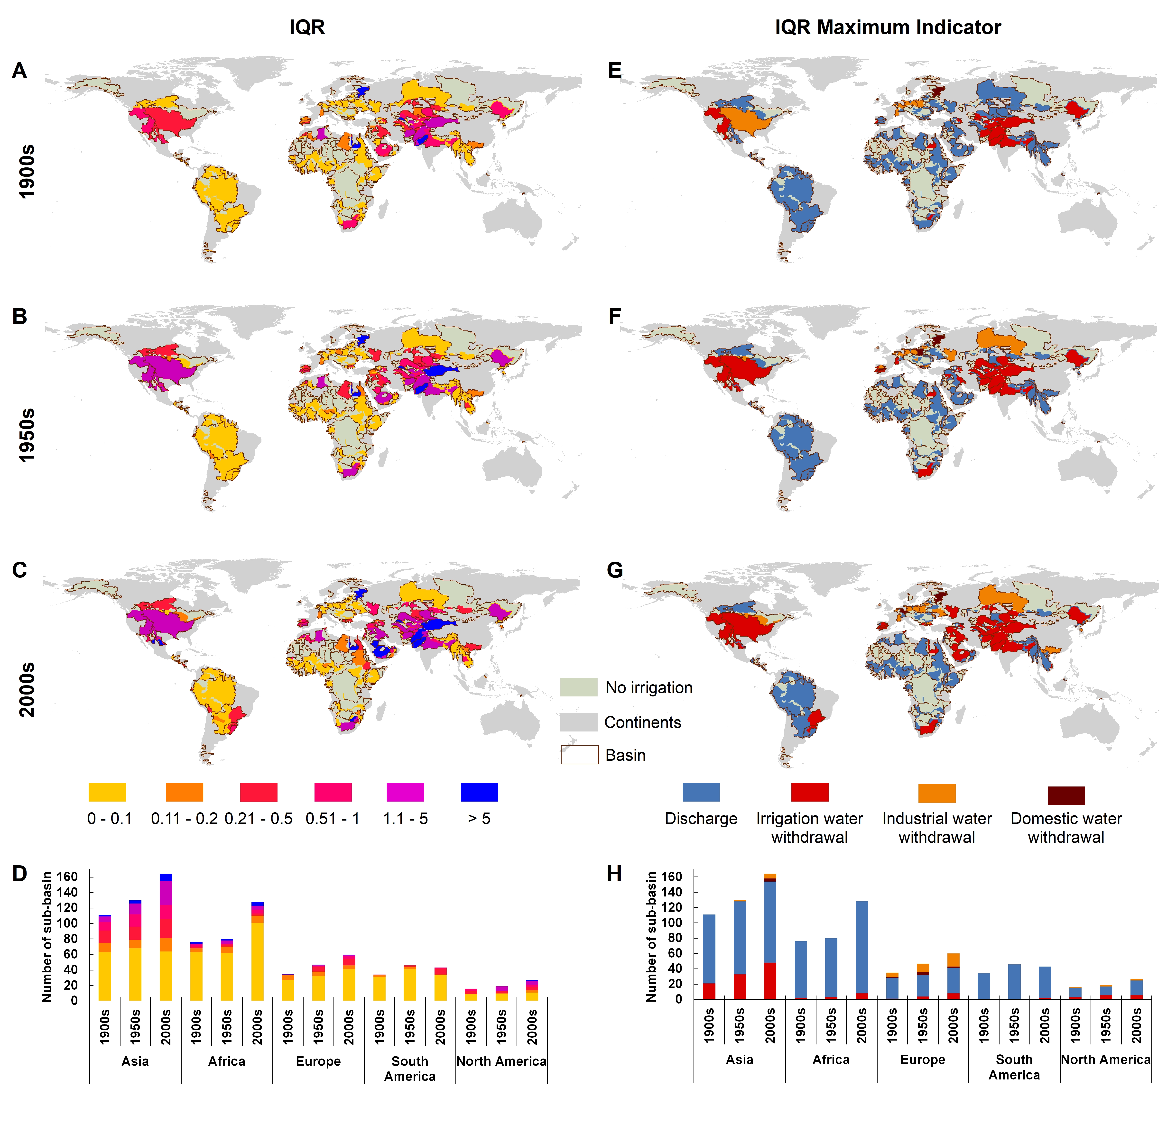

Figure S1. The interquartile range (IQR, range between the third quartile and the first quartile) of each sub-basin IWSI and the maximum IQR indicator in the 1900s, 1950s, and 2000s. (A-C) IQR of the IWSI in sub-basin areas categorized into six levels. (D) Distribution of sub-basins across continents for different IQR categories. (E-G) the maximum IQR indicator of the four indicators (irrigation, industrial and domestic water withdrawal and discharge) used to calculate IWSI in the sub-basin. (H) Distribution of sub-basins across continents for different categories of the maximum IQR indicator.
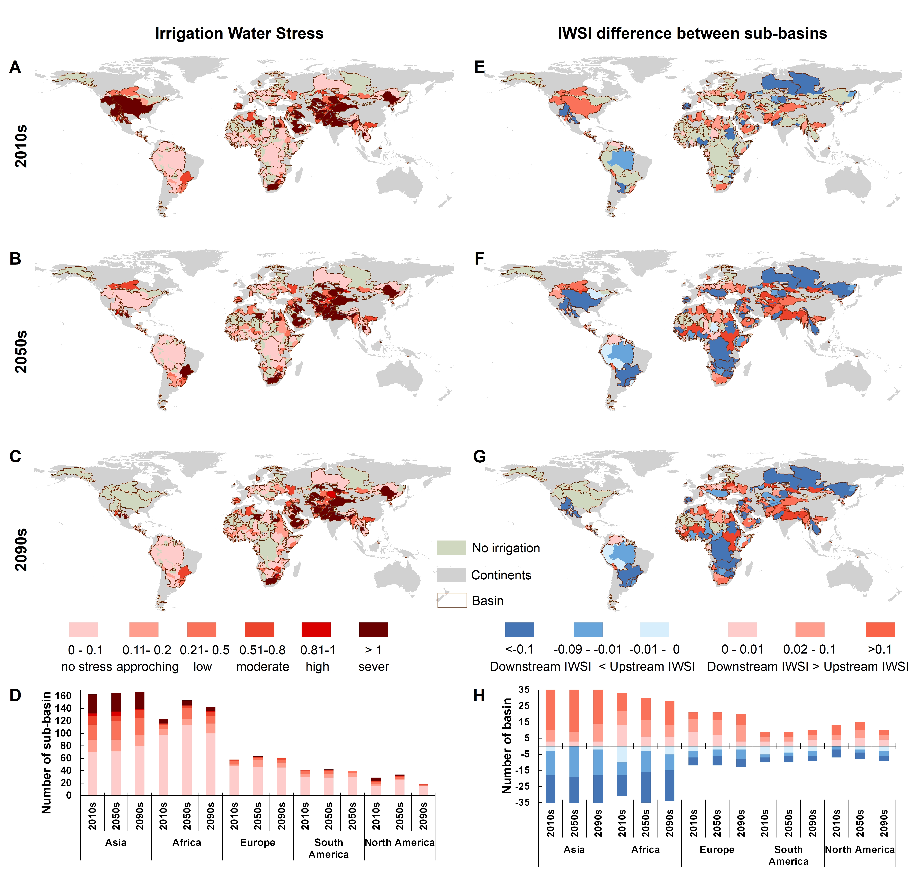

Figure S2. IWSI and sub-basin differences in the 2010s, 2050s, and 2090s under future scenario RCP2.6. (A-C) IWSI in sub-basin areas categorized into six levels, where values greater than 0.2 indicate water scarcity. (D) Distribution of sub-basins across continents for different IWSI categories. (E-G) Variation in IWSI between upstream and downstream sub-basins. Negative values indicate lower downstream IWSI compared to upstream, while positive values indicate higher downstream IWSI. (H) Distribution of sub-basins across continents for different categories of IWSI difference. Irrigation expansion led to an increase in the number of basins with IWSI differences across the three periods, resulting in varying total numbers of basins in each period: 217, 221, and 208, respectively.

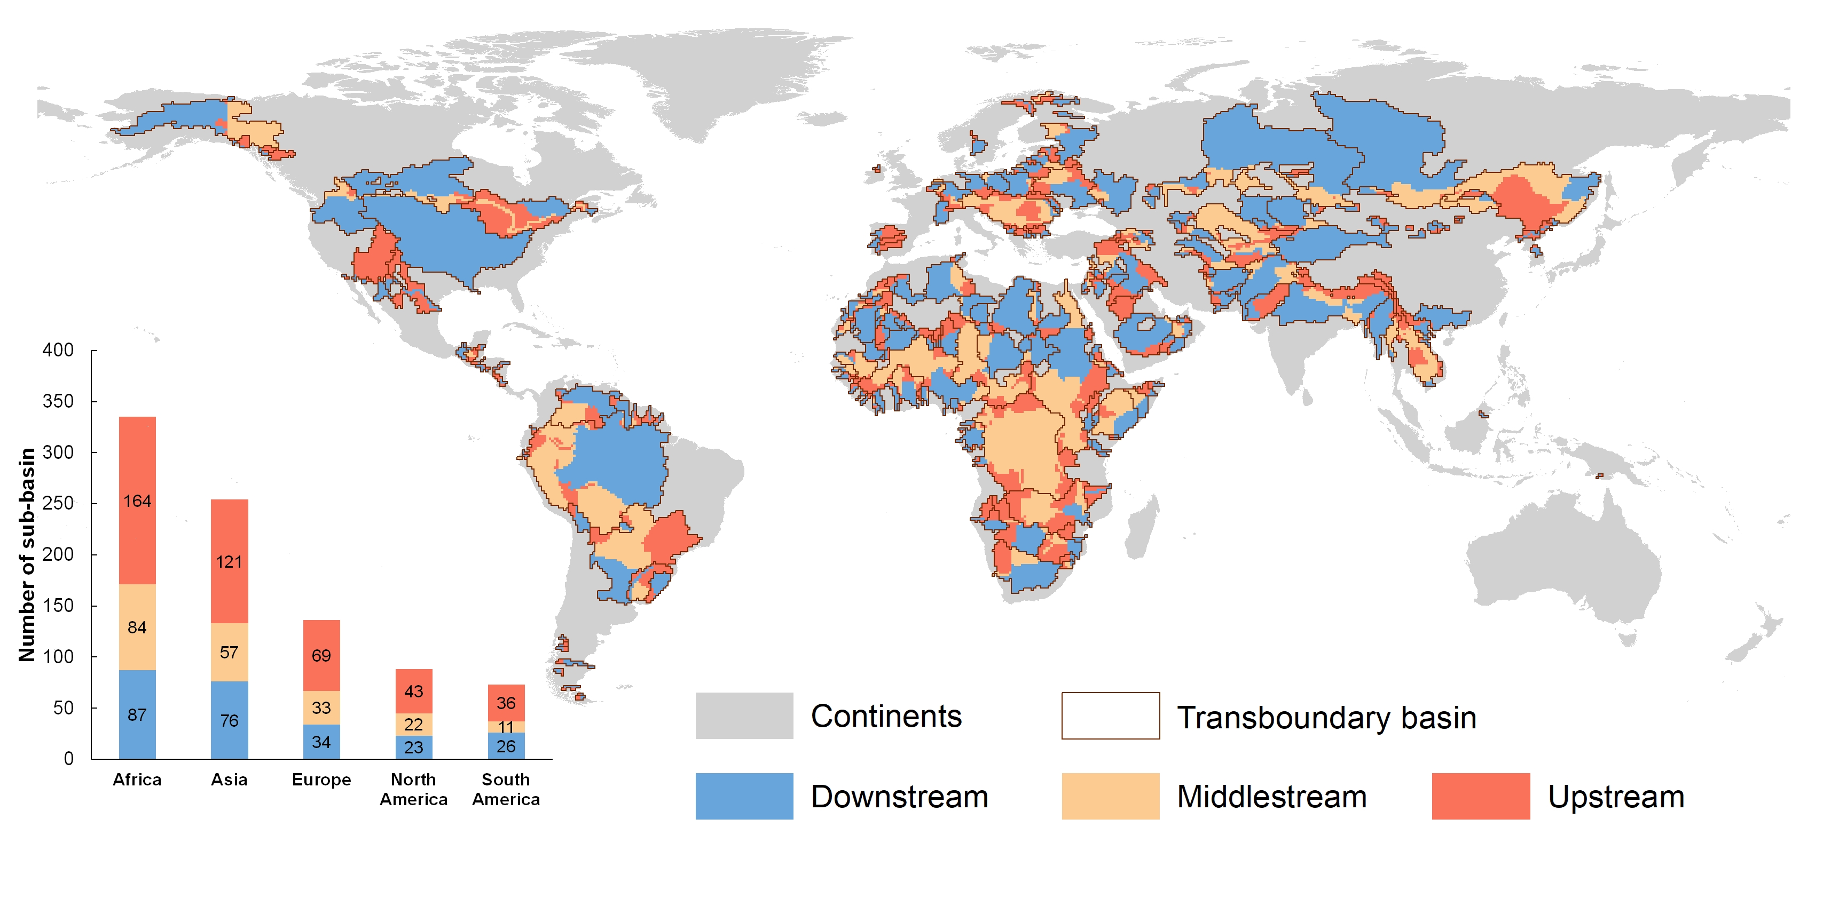

Figure S3. Global upstream, middle stream and downstream distribution of transboundary river basins. The bar chart shows statistics on the number of upstream, middle stream and downstream sub-basins for the five continents. In this chart, the number of downstream basins is equivalent to the total number of basins on that continent, as each basin consists of one downstream and one or more middle stream and upstream sub-basins. The basin delineation is adopted from Munia et al.²¹.

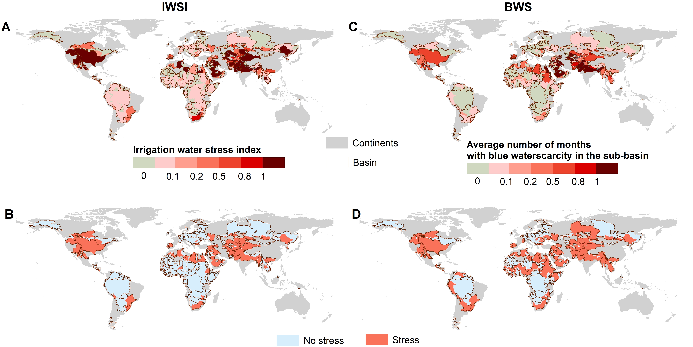

Figure S4. Comparison between irrigation water stress index (IWSI) and blue water scarcity (BWS)¹ maps during 1996-2005. (A) is the decade average of the IWSI; the value above 0.1 indicates the sub-basin experiencing water stress (B). (C) is the average number of months experiencing BWS in the sub-basin; the value above 0 indicates the water stress situation (D).

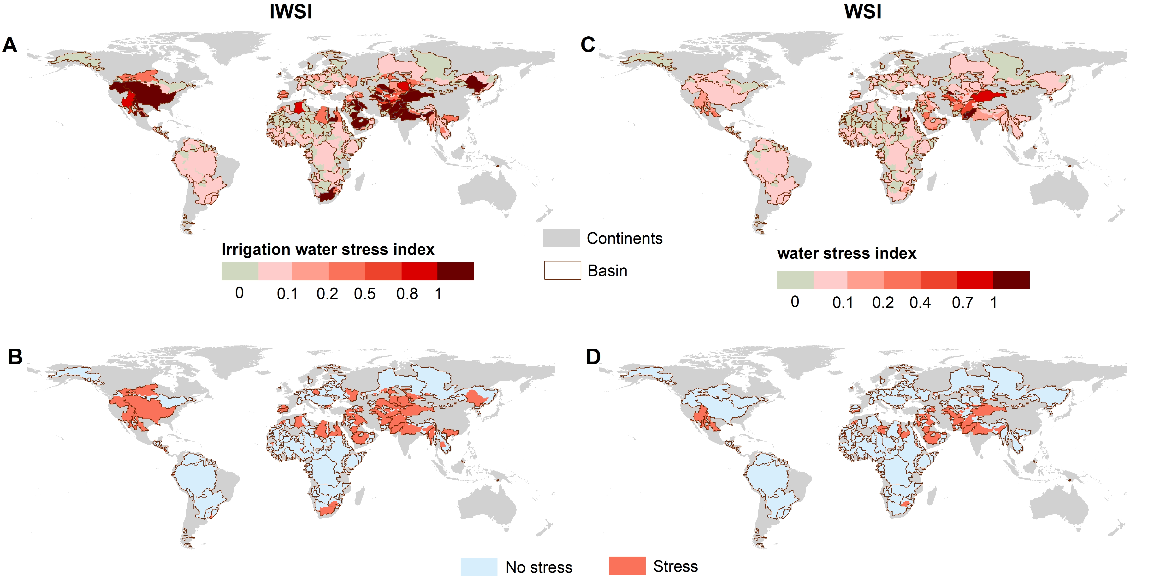

Figure S5. Comparison between irrigation water stress index (IWSI) and water stress index (WSI)² maps during 1971-1980. (A) is the decade average of the IWSI; the value above 0.1 indicates the sub-basin experiencing water stress (B). (C) is the decade average of the WSI; the value above 0.1 indicates the sub-basin experiencing water stress (D).

References
1 Rosa, L., Chiarelli, D. D., Rulli, M. C., Dell’Angelo, J. & D’Odorico, P. Global agricultural economic water scarcity. Sci. Adv. 6, eaaz6031 (2020).
2 Munia, H. A. et al. Future transboundary water stress and its drivers under climate change: a global study. Earth's Future 8, e2019EF001321 (2020).
3 Siebert, S. et al. Groundwater use for irrigation–a global inventory. Hydrol. Earth Syst. Sci. 14, 1863-1880 (2010).
4 Döll, P., Müller Schmied, H., Schuh, C., Portmann, F. T. & Eicker, A. Global‐scale assessment of groundwater depletion and related groundwater abstractions: Combining hydrological modeling with information from well observations and GRACE satellites. Water Resour. Res. 50, 5698-5720 (2014).
5 Wada, Y., Wisser, D. & Bierkens, M. F. Global modeling of withdrawal, allocation and consumptive use of surface water and groundwater resources. Earth Syst. Dyn. 5, 15-40 (2014).
6 Pokhrel, Y. N. et al. Incorporation of groundwater pumping in a global L and S urface M odel with the representation of human impacts. Water Resour. Res. 51, 78-96 (2015).
7 KUKURIC, N. & VAN DER GUN, J. in Hydroinformatics: (In 2 Volumes, with CD-ROM) 1979-1986 (World Scientific, 2004).
8 Hanasaki, N., Yoshikawa, S., Pokhrel, Y. & Kanae, S. A global hydrological simulation to specify the sources of water used by humans. Hydrol. Earth Syst. Sci. 22, 789-817 (2018).
9 Greve, P. et al. Low flow sensitivity to water withdrawals in Central and Southwestern Europe under 2 K global warming. Environ. Res. Lett. 18, 094020 (2023).
10 Wada, Y. & Bierkens, M. F. Sustainability of global water use: past reconstruction and future projections. Environ. Res. Lett. 9, 104003 (2014).
11 Siebert, S. & Döll, P. Quantifying blue and green virtual water contents in global crop production as well as potential production losses without irrigation. J. Hydrol. 384, 198-217 (2010).
12 Wada, Y. et al. Global monthly water stress: 2. Water demand and severity of water stress. Water Resour. Res. 47 (2011).
13 Alexandratos, N. & Bruinsma, J. World agriculture towards 2030/2050: the 2012 revision. (2012).
14 Döll, P. et al. Impact of water withdrawals from groundwater and surface water on continental water storage variations. J. Geodyn. 59, 143-156 (2012).
15 Jägermeyr, J. et al. Water savings potentials of irrigation systems: global simulation of processes and linkages. Hydrol. Earth Syst. Sci. 19, 3073-3091 (2015).
16 Food and Agriculture Organization of the United Nations, F. AQUASTAT database of water-related data, <http: //www.fao.org/nr/water/aquastat/main/index.stm> (2016).
17 Sutanudjaja, E. H. et al. PCR-GLOBWB 2: a 5 arcmin global hydrological and water resources model. Geosci. Model Dev. 11, 2429-2453 (2018).
18 Zhao, F. et al. The critical role of the routing scheme in simulating peak river discharge in global hydrological models. Environ. Res. Lett. 12, 075003 (2017).
19 Burek, P. et al. Development of the Community Water Model (CWatM v1. 04)–a high-resolution hydrological model for global and regional assessment of integrated water resources management. Geosci. Model Dev. 13, 3267-3298 (2020).
20 Biemans, H. et al. Impact of reservoirs on river discharge and irrigation water supply during the 20th century. Water Resour. Res. 47 (2011).
21 Munia, H. A., Guillaume, J. H. A., Mirumachi, N., Wada, Y. & Kummu, M. How downstream sub-basins depend on upstream inflows to avoid scarcity: typology and global analysis of transboundary rivers. Hydrol. Earth Syst. Sci. 22, 2795-2809, doi:10.5194/hess-22-2795-2018 (2018).

