Supplementary information
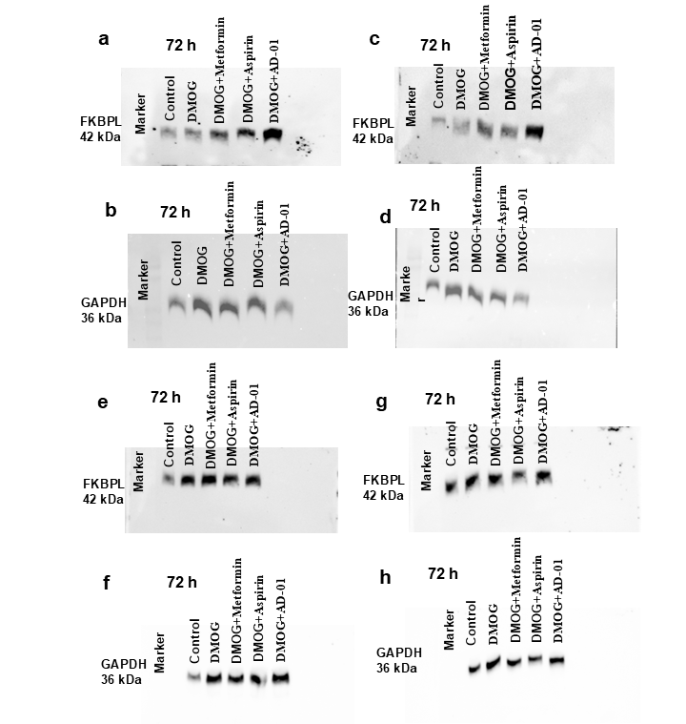
Supplementary Figure S 1: Hypoxia induced trend towards reduced expression of FKBPL in trophoblast cells which is restored by aspirin and AD-01. (a-h) The full blots of ACH-3Ps protein lysate expression of FKBPL. ACH-3Ps exposed to hypoxia (DMOG 1mM) and treated with metformin (0.5 mM) or aspirin (0.5 mM) or AD-01 (100 nM) for 72h. Control, untreated. GAPDH, loading control.

