Table 2. Comparison of change in secondary outcomes from baseline to 12 weeks in both groups
(Empagliflozin; n=19, Sitagliptin; n=14)

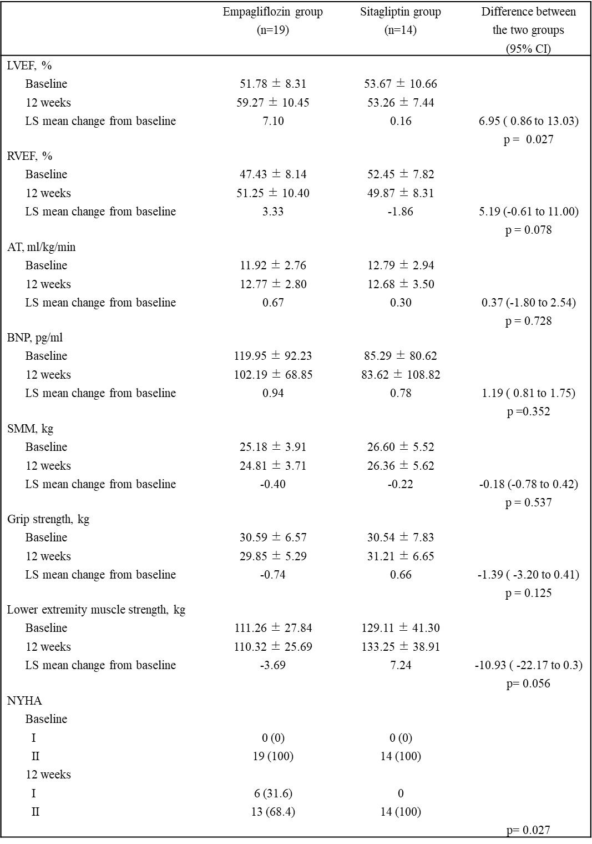
Data are shown as the mean ± standard deviation or n (%). Only the AT was analyzed with 18 patients in the empagliflozin group. An analysis of covariance was performed using baseline values and randomization factor as covariates to test for differences between the two groups. The difference in BNP concentrations between the groups is shown as a “ratio of change.” The group differences and their 95% CIs obtained by analysis of covariance were calculated. Comparison of NYHA classification between the two groups at 12 weeks was performed using Fisher’s exact test.
Abbreviations: CI, confidence interval; LVEF, left ventricular ejection fraction; LS, least squares; RVEF, right ventricular ejection fraction; AT, anoxic threshold; BNP, brain natriuretic peptide; SMM, skeletal muscle mass; NYHA, New York Heart Association.

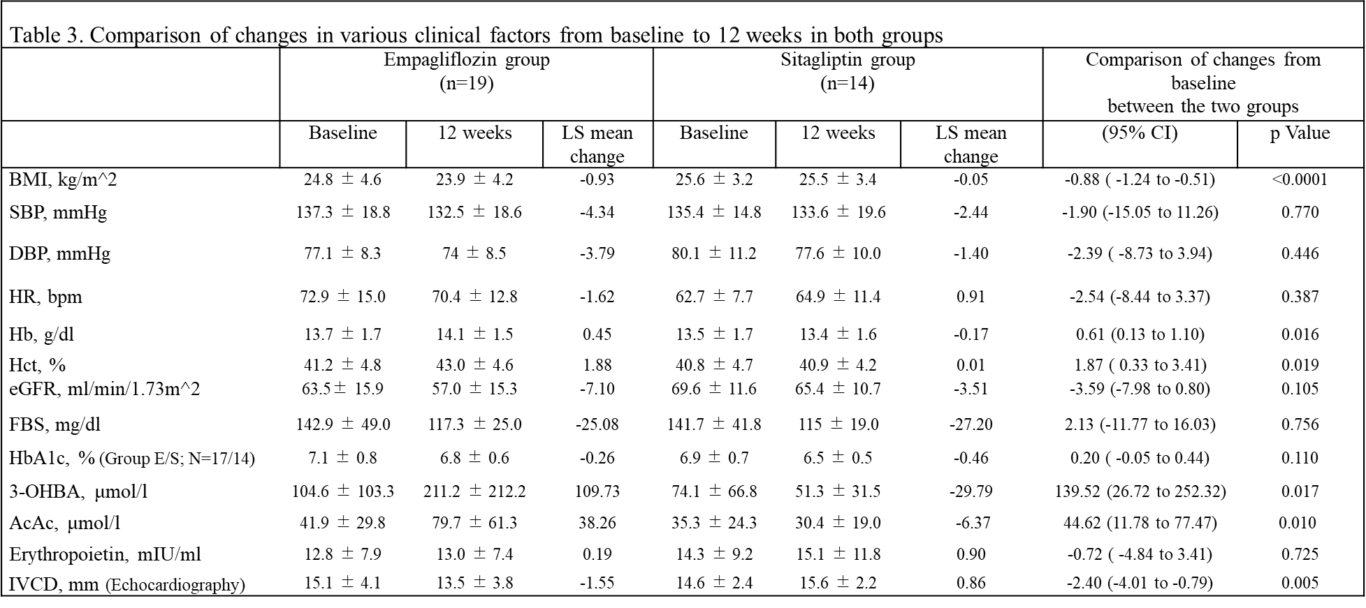

Data are shown as the mean ± standard deviation. An analysis of covariance was performed using baseline values and randomization factor as covariates to test for differences between the two groups. The group differences and their 95% CIs obtained by analysis of covariance were calculated.
Abbreviations: LS, least squares; CI, confidence interval; BMI, body mass index; SBP, systolic blood pressure; DBP, diastolic blood pressure; HR, heart rate; Hb, hemoglobin; Hct, hematocrit; eGFR, estimated glomerular filtration rate; FBS, fasting blood sugar; HbA1c, hemoglobin A1c; 3-OHBA, 3-hydroxybutyric acid; AcAc, acetoacetic acid; IVCD, inferior vena cava dimension.

