Table 1, Radiomics Feature Extraction Settings
Setting | Determination
Bin Method | FBN
Bin Amount | 5
Method | SitkNearestNeighbor
Resample Filter | 1
Resample Spacing X | 3mm
Resample Spacing Y | 3mm
Resample Spacing Z | 3mm

FBN,fixed bin number

Table 2, Diagnosis Results of Sarcopenia Patients in Training Set
 | Sarcopenia | Non-sarcopenia
Male | 37 | 22
Female | 7 | 5
Male TPI (mm²/m²) | 433.59±72.88 | 629.37±69.40
Female TPI(mm²/m²) | 295.07±68.69 | 431.63±46.69
TPI, total psoas index.

Table 3, Diagnosis Results of Sarcopenia Patients in Validation Set
 | Sarcopenia | Non-sarcopenia
Male | 9 | 20
Female | 2 | 3
Male TPI (mm²/m²) | 407.41±59.90 | 703.04±74.05
Female TPI(mm²/m²) | 330.66±50.17 | 411.39±10.63
TPI, total psoas index.

Table 4, Clinical Baseline Statistics of Patients in Training Set
Characteristic variable | Patients with Sarcopinea | Not with sarcopinea | z-value / t-value / chi-square value |  |  | P-value
Sex(Male：Female) | 37:7 | 22:5 |  | 0ª | 1
Age(years) | 62.93±9.34 | 66(13) |  | -1.103^{c} | 0.273
Body height(cm) | 165.73±7.67 | 166.037±6.25 |  | -0.177^{b} | 0.86
Body weight(kg) | 58(15) | 60.93±8.61 |  | -1.328^{c} | 0.186
BMI | 20.66(4.05) | 22.09±2.83 |  | -1.202^{c} | 0.232
Length of hospital stay(day) | 15(6.75) | 17(6) |  | -1.10^{c} | 0.275
Duration of surgery(min) | 218.7±72.59 | 155(83) |  | -2.307^{c} | 0.021
Laparoscopic surgery:open surgery | 28:16 | 22:5 |  | 2.558ª | 0.180
T-stage |  |  |  | 0.937ª | 0.8*
T0 | 0 | 0
T1 | 4 | 3
T2 | 7 | 6
T3 | 22 | 11
T4 | 11 | 7
N-stage |  |  |  | 2.532ª | 0.496*
N0 | 19 | 10
N1 | 5 | 7
N2 | 9 | 5
N3 | 11 | 5
M-stage |  |  |  | - | 0.522*
M0 | 42 | 27
M1 | 2 | 0
a, chi-square value; b, t-value; c, z-value; d, Continuous data are expressed as mean ± standard deviation for those that fit the normal distribution and median (quartiles) for those that do not; *, P-value from Fisher's exact probability method; BMI,body mass index.

Table 5, Clinical Baseline Statistics of Patients in Validation Set
Characteristic variable | Patients with Sarcopinea | Not with sarcopinea | z-value / t-value / chi-square value |  |  | P-value
Sex(Male：Female) | 9:2 | 20:3 |  | - | 1*
Age(years) | 66.18±7.77 | 67.08±7.19 |  | -0.335ª | 0.74
Body height(cm) | 165.8±7.62 | 169.39±6.09 |  | -1.457ª | 0.150
Body weight(kg) | 55.18±7.48 | 59.76±9.23 |  | -1.432ª | 0.162
BMI | 20.05±2.22 | 20.78±2.7 |  | -0.778ª | 0.422
Length of hospital stay(day) | 15.72±4 | 16.69±3.75 |  | -0.689ª | 0.496
Duration of surgery(min) | 176.81±54.23 | 139.78±36.07 |  | 2.372ª | 0.024
Laparoscopic surgery:open surgery | 9:2 | 22:1 |  | - | 0.239*
M-stage |  |  |  | - | 0.363*
M0 | 8 | 20
M1 | 3 | 3
a, t-value; b, Continuous data are expressed as mean ± standard deviation for those that fit the normal distribution and median (quartiles) for those that do not; *, P-value from Fisher's exact probability method; BMI,body mass index.

Table 6, Collinearity Diagnostics Results
Variable | P | VIF
Age | .023 | 1.121
Weight | .492 | 4.938
BMI | .098 | 4.749
T-stage | .322 | 1.330
N-stage | .258 | 1.359
M-stage | .005 | 1.040
BMI,body mass index;VIF,variance inflation factor.

Table 7, Univariate Cox Regression Results
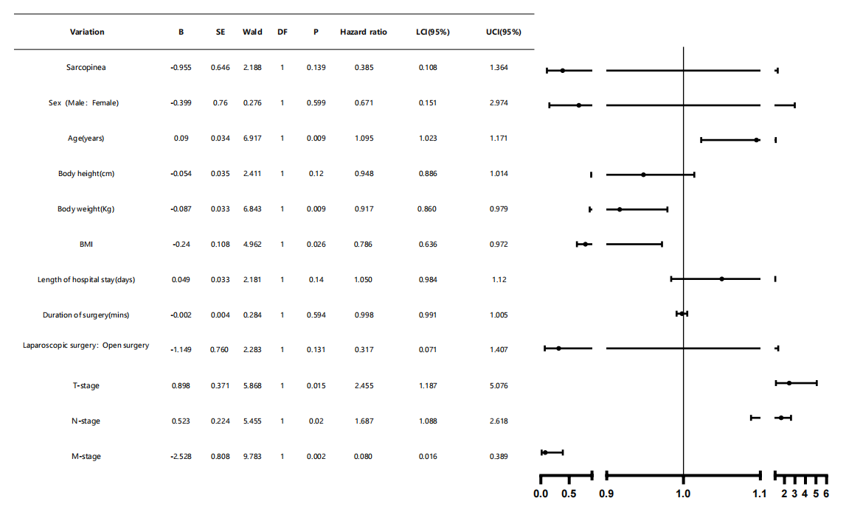
BMI, body mass index;UCI, upper confidence limit;LCI, lower confidence limit;SE, standard error;DF, degrees of freedom.
UCI  (95%) | 1.364 | 2.974 | 1.171 | 1.014 | 0.979 | 0.972 | 1.12 | 1.005 | 1.407 | 5.076 | 2.618 | 0.389
LCI  (95%) | 0.108 | 0.151 | 1.023 | 0.886 | 0.860 | 0.636 | 0.984 | 0.991 | 0.071 | 1.187 | 1.088 | 0.016
Hazard  ratio | 0.385 | 0.671 | 1.095 | 0.948 | 0.917 | 0.786 | 1.050 | 0.998 | 0.317 | 2.455 | 1.687 | 0.080
P | 0.139 | 0.599 | 0.009 | 0.12 | 0.009 | 0.026 | 0.14 | 0.594 | 0.131 | 0.015 | 0.02 | 0.002
DF | 1 | 1 | 1 | 1 | 1 | 1 | 1 | 1 | 1 | 1 | 1 | 1
Wald | 2.188 | 0.276 | 6.917 | 2.411 | 6.843 | 4.962 | 2.181 | 0.284 | 2.283 | 5.868 | 5.455 | 9.783
SE | 0.646 | 0.76 | 0.034 | 0.035 | 0.033 | 0.108 | 0.033 | 0.004 | 0.760 | 0.371 | 0.224 | 0.808
B | -0.955 | -0.399 | 0.09 | -0.054 | -0.087 | -0.24 | 0.049 | -0.002 | -1.149 | 0.898 | 0.523 | -2.528
Variation | Sarcopinea | Sex（Male：Female） | Age(years) | Body height(cm) | Body weight(Kg) | BMI | Length of hospital  stay(days) | Duration of  surgery(mins) | Laparoscopic surgery:  Open surgery | T-stage | N-stage | M-stage

Table 8, Multivariate Cox Regression Results
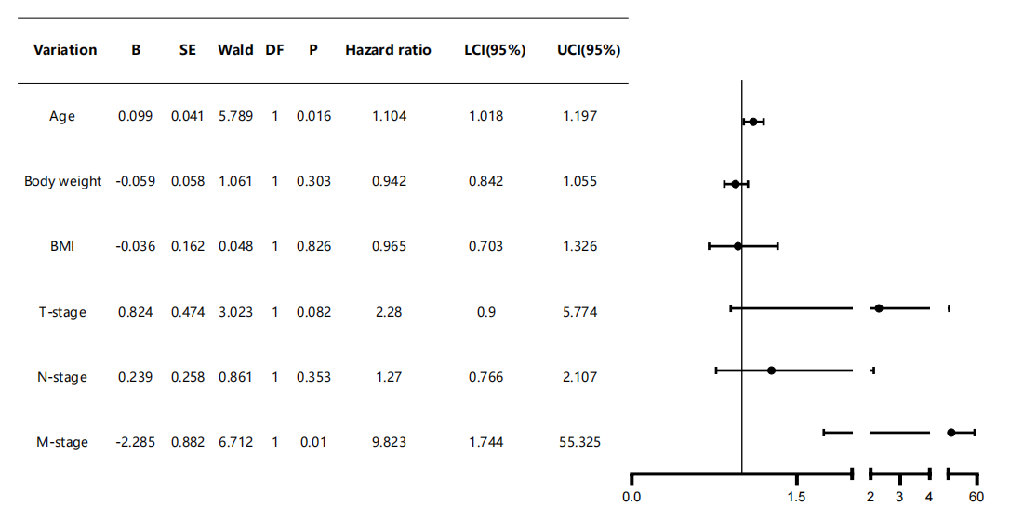
BMI, body mass index;UCI, upper confidence limit;LCI, lower confidence limit;SE, standard error;DF, degrees of freedom.
UCI(95%) | 1.197 | 1.055 | 1.326 | 5.774 | 2.107 | 55.325
LCI(95%) | 1.018 | 0.842 | 0.703 | 0.9 | 0.766 | 1.744
Hazard ratio | 1.104 | 0.942 | 0.965 | 2.28 | 1.27 | 9.823
P | 0.016 | 0.303 | 0.826 | 0.082 | 0.353 | 0.01
DF | 1 | 1 | 1 | 1 | 1 | 1
Wald | 5.789 | 1.061 | 0.048 | 3.023 | 0.861 | 6.712
SE | 0.041 | 0.058 | 0.162 | 0.474 | 0.258 | 0.882
B | 0.099 | -0.059 | -0.036 | 0.824 | 0.239 | -2.285
Variation | Age | Body weight | BMI | T-stage | N-stage | M-stage

Table 9, Post Hoc Power Analysis
 | Efficiency^{b} | N1 | Standard deviation | N2 | Standard deviation | Mean value difference | P-value
Average difference testª | 0.834 | 27 | 16.8 | 44 | 20.8 | 13.4 | 0.05
a,Bilateral test. b,Based on a non-central T-distribution.
Table 10, Multi-omics Model Accuracy and AUC
model_name | Task | Accuracy | AUC | 95%CI
LR | Training | 0.70 | 0.82 | 0.7006-0.9357
 | Internal validation | 0.67 | 0.72 | 0.4419-0.9981
 | External validation | 0.77 | 0.69 | 0.4806-0.8944
NaiveBayes | Training | 0.75 | 0.84 | 0.7247-0.9457
 | Internal validation | 0.60 | 0.74 | 0.4607-1.0000
 | External validation | 0.29 | 0.43 | 0.2098-0.6402
SVM | Training | 0.84 | 0.95 | 0.8958-1.0000
 | Internal validation | 0.73 | 0.76 | 0.4956-1.0000
 | External validation | 0.71 | 0.73 | 0.5348-0.9235
KNN | Training | 0.21 | 0.89 | 0.8014-0.9770
 | Internal validation | 0.33 | 0.83 | 0.6410-1.0000
 | External validation | 0.29 | 0.66 | 0.4818-0.8432
RandomForest | Training | 0.98 | 1.00 | 1.0000-1.0000
 | Internal validation | 0.73 | 0.82 | 0.5926-1.0000
 | External validation | 0.62 | 0.86 | 0.7361-0.9847
ExtraTrees | Training | 0.91 | 0.99 | 0.9691-1.0000
 | Internal validation | 0.73 | 0.80 | 0.5582-1.0000
 | External validation | 0.56 | 0.74 | 0.5724-0.9026
XGBoost | Training | 0.93 | 0.99 | 0.9676-1.0000
 | Internal validation | 0.67 | 0.78 | 0.5311-1.0000
 | External validation | 0.74 | 0.74 | 0.5436-0.9314
LightGBM | Training | 0.66 | 0.84 | 0.7359-0.9440
 | Internal validation | 0.53 | 0.78 | 0.5285-1.0000
 | External validation | 0.71 | 0.73 | 0.5542-0.8999
GradientBoosting | Training | 0.96 | 0.99 | 0.9818-1.0000
 | Internal validation | 0.33 | 0.50 | 0.1867-0.8133
 | External validation | 0.74 | 0.77 | 0.5534-0.9882
AdaBoost | Training | 0.88 | 0.99 | 0.9762-1.0000
 | Internal validation | 0.73 | 0.93 | 0.7950-1.0000
 | External validation | 0.68 | 0.52 | 0.2629-0.7788
MLP | Training | 0.77 | 0.87 | 0.7679-0.9669
 | Internal validation | 0.60 | 0.74 | 0.4764-1.0000
 | External validation | 0.74 | 0.57 | 0.3482-0.7935

The accuracy, AUC (Area Under the Curve), and 95% confidence intervals of 11 machine learning algorithms for predicting the 5-year survival status of patients based on the integration of clinical and radiomic features：LR, logistic regression; NaiveBayes, naive bayes classifier; SVM, support vector machine; KNN, k-nearest neighbors; ExtraTrees, extremely randomized trees; XGBoost, extreme gradient boosting; LightGBM, light gradient boosting machine; AdaBoost, adaptive boosting; MLP,multi-layer perceptron.

Table 11, Accuracy and AUC of LR model and Confusion LR model
model_name | Task | Accuracy | AUC | 95%CI
LR | Training | 0.7 | 0.82 | 0.7006-0.9357
 | Internal validation | 0.67 | 0.72 | 0.4419-0.9981
 | External validation | 0.77 | 0.69 | 0.4806-0.8944
Confusion LR | Training | 0.804 | 0.826 | 0.6948 - 0.9567
 | Internal validation | 0.733 | 0.9 | 0.7373 - 1.0000
 | External validation | 0.618 | 0.675 | 0.4760 - 0.8740

