Supplementary Figure
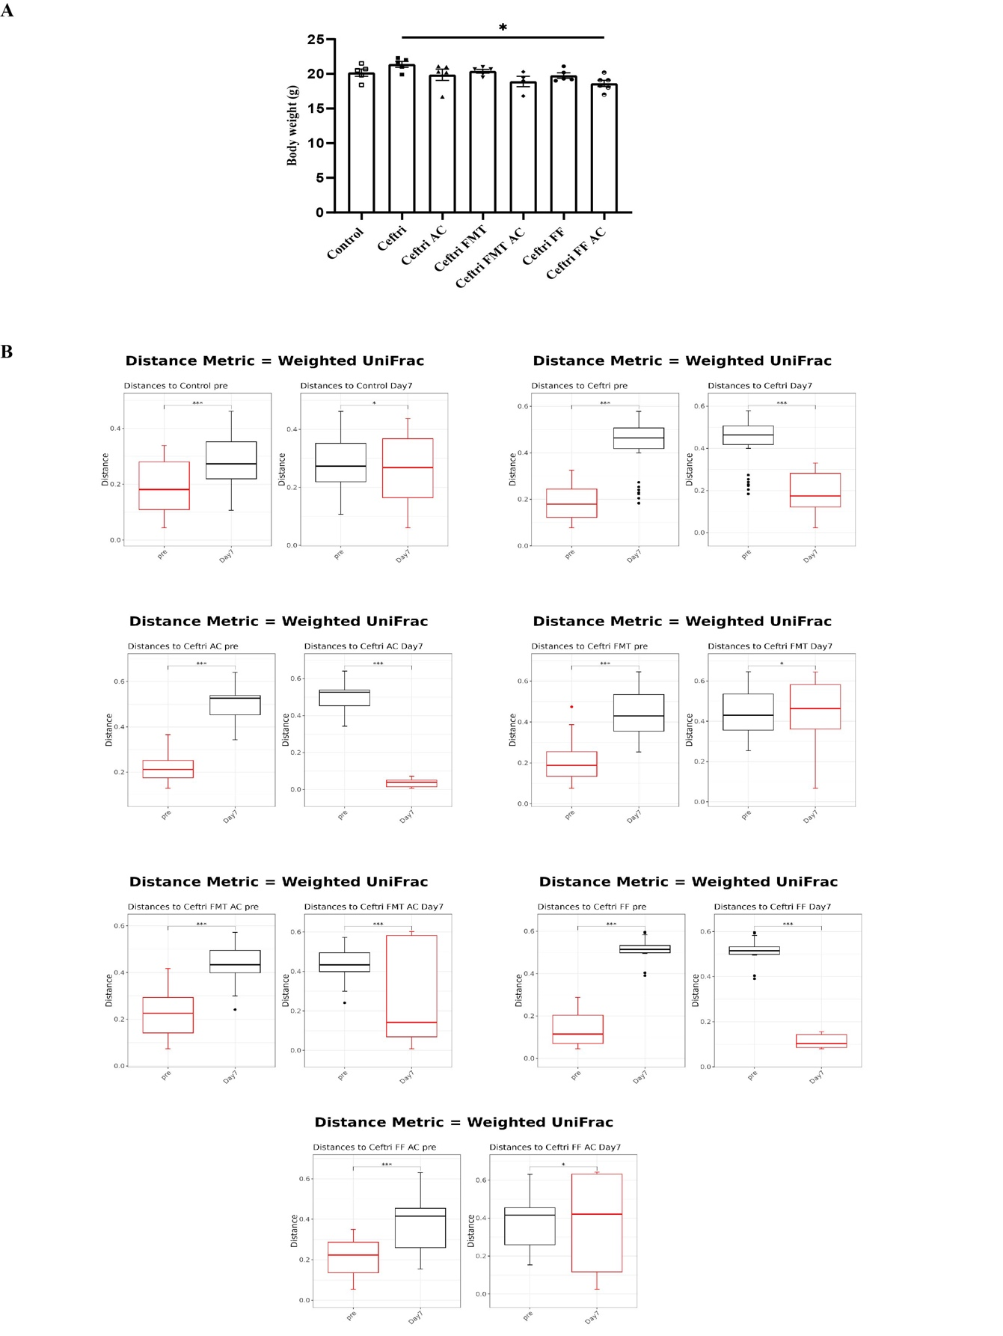
Supplementary Figure 1. The body weight changes and distance metric pairwise in the dysbiosis mouse model.
A Mean body weight on day 7 (n = 4-6 per group). B Distance metric pairwise on weighted UniFrac using the Bray Curtis method of sequenced 16S rRNA gene in the feces from different experimental treatment groups at day 7 (n = 4-6 per group). All experimental data are representative of two independent experiments. Statistics were done using one-way ANOVA Welch's test (A), and the Kruskal-Wallis test (B). *p < 0.05, **p < 0.01, ***p< 0.001.

