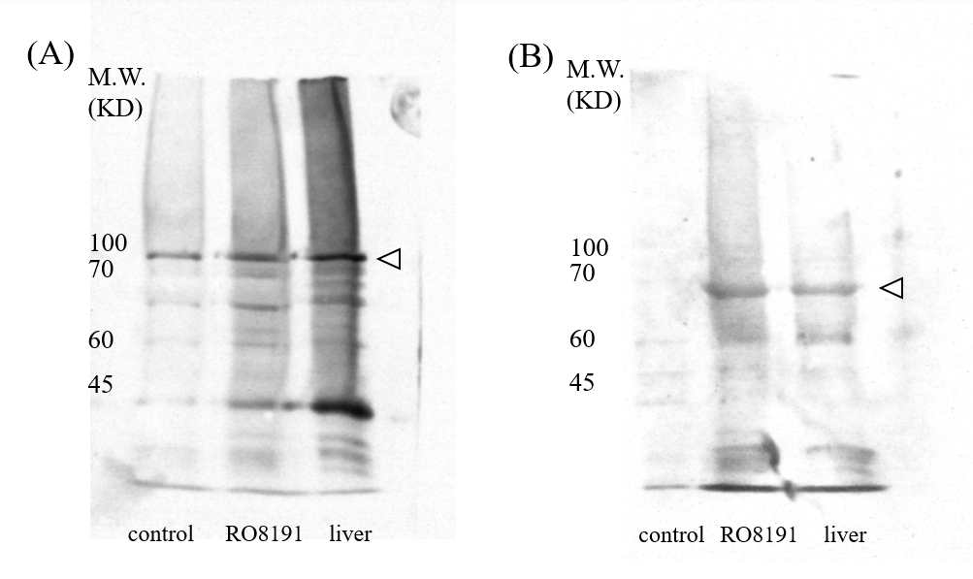
Supplementary Figure 1. Full-length blots presented in Figures 2.
(A) Western blot in Figures 2, upper panel (Stat3). (B) Western blot in Figures 2, lower panel (p-Stat3). White arrowheads indicate the position of the target protein.

