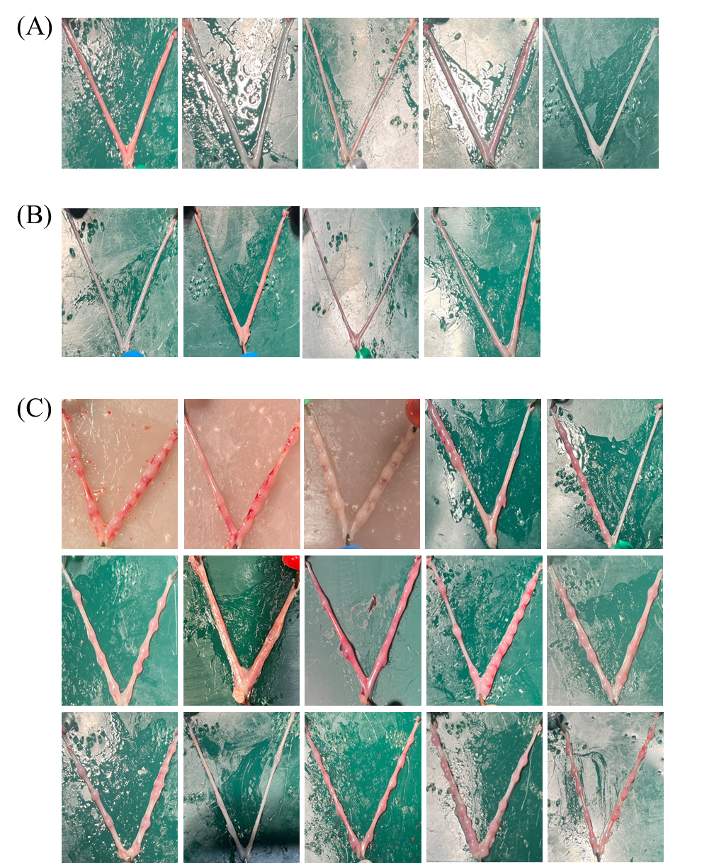
Supplementary Figure 2. Uterine morphology of delayed implantation (DI) model mice after the injection of oil or RO8191. All data used in this study.
(A) Images of the gross uterine morphology from the oil-treated DI mice on D10. (B,C) Images of the gross uterine morphology from the RO8191-treated DI mice on D10.
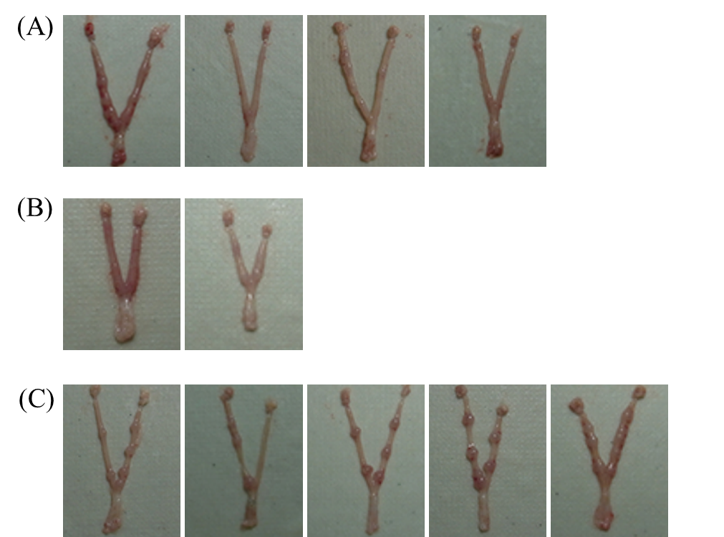
Supplementary Figure 3. Uterine morphology of Stat3 cKO mice after the injection of oil or RO8191. All data used in this study.
(A) Images of the gross uterine morphology from the RO8191-treated Stat3 cKO mice on D7. (B) Images of the gross uterine morphology from the oil-treated Stat3 cKO mice on D7. (C) Images of the gross uterine morphology from the oil-treated Stat3^{f/f} mice on D7.

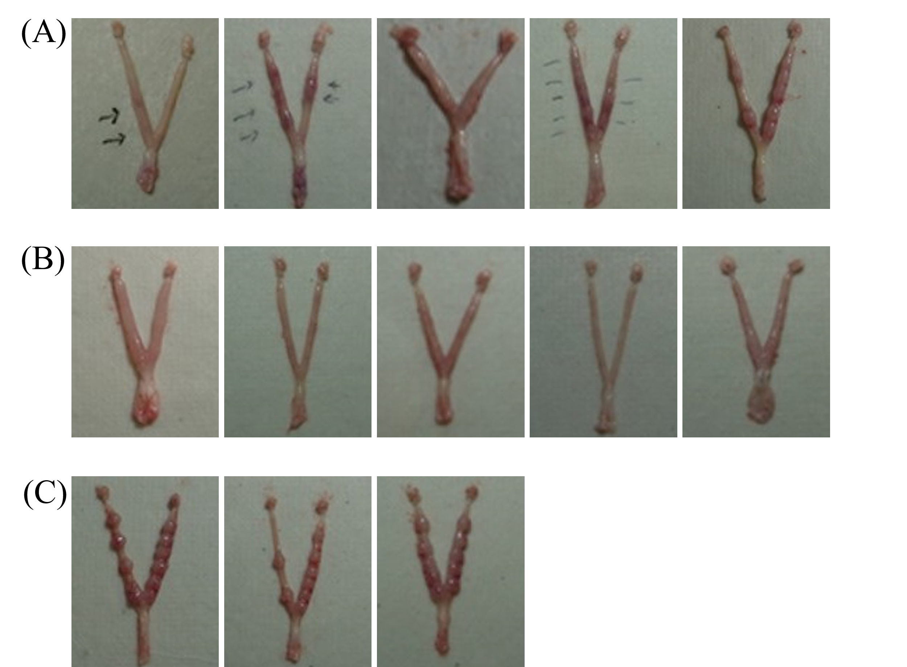
Supplementary Figure 4. Uterine morphology of Gp130 cKO mice after the injection of oil or RO8191. All data used in this study.
(A) Images of the gross uterine morphology from the RO8191-treated Gp130 cKO mice on D7. (B) Images of the gross uterine morphology from the oil-treated Gp130 cKO mice on D7. (C) Images of the gross uterine morphology from the oil-treated Gp130^{f/f} mice on D7.

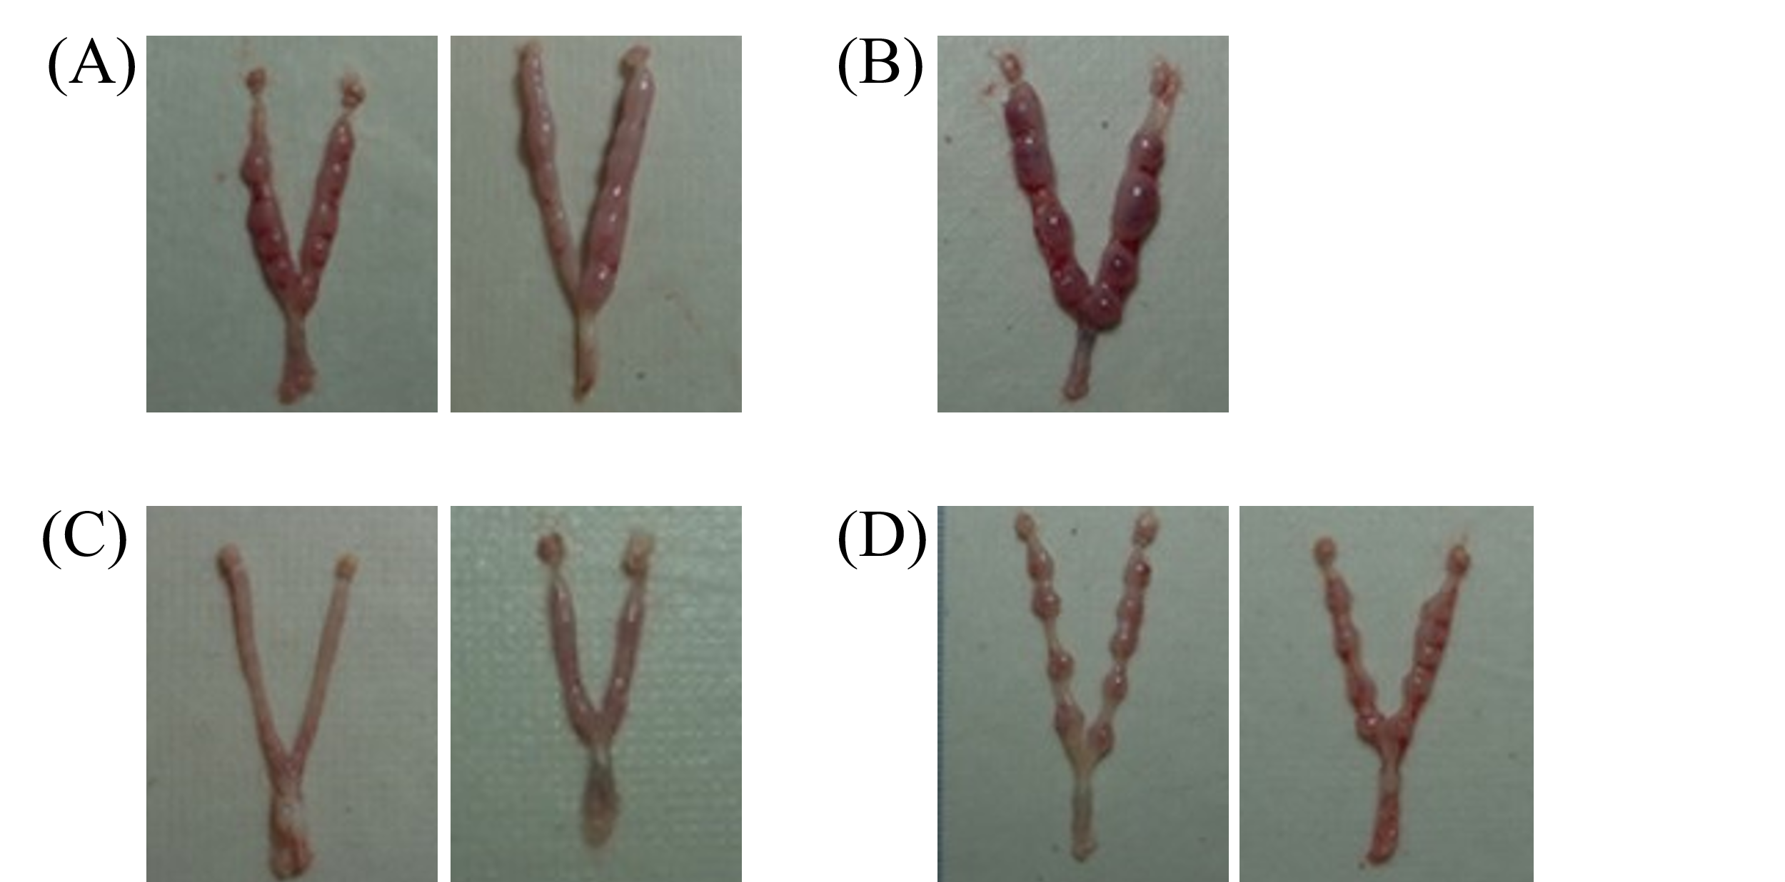
Supplementary Figure 5. Uterine morphology of Lifr cKO mice after the injection of oil or RO8191. All data used in this study.
(A) Images of the gross uterine morphology from the RO8191-treated Lifr cKO mice on D7. (B) Images of the gross uterine morphology from the RO8191-treated Lifr cKO mice on D8. (C) Images of the gross uterine morphology from the oil-treated Lifr cKO mice on D7. (D) Images of the gross uterine morphology from the oil-treated Lifr ^{f/f} mice on D7.

