Supplementary Information
Sub-Femtomolar Drug Monitoring via Co-Calibration Mechanism with Nanoconfined DNA Probes
Yonghuan Chen, Xiuying Li, Xinru Yue, Weihua Yu, Yuesen Shi, Zilong He, Yuanfeng Wang, Yu Huang,* Fan Xia, and Fengyu Li*
[1] Y. Chen, X. Li, X. Yue, W. Yu, Z. He, and Prof. F. Li
College of Chemistry and Materials Science, Guangdong Provincial Key Laboratory of Functional Supramolecular Coordination Materials and Applications, Su Bingtian Center for Speed Research and Training, Jinan University, Guangzhou 510632 (P. R. China)
[2] Prof. Y. Huang, and Prof. F. Xia
State Key Laboratory of Biogeology and Environmental Geology, Engineering Research Center of Nano-Geomaterials of Ministry of Education, Faculty of Material Science and Chemistry, China University of Geosciences, Wuhan 430074 (P. R. China)
[3] Dr. Y. Shi
Anti-Drug Technology Center of Guangdong Province, Guangdong Province Key Laboratory of Psychoactive Substances Monitoring and Safety, Guangzhou 510230, China.
[4] Prof. Y. Wang
Key Laboratory of Evidence Science, China University of Political Science and Law, Beijing 100088, China.
[5] Prof. F. Li
College of Chemistry, Zhengzhou University, Zhengzhou 450001 (P. R. China)
* Corresponding Authors: Fengyu Li, E-mail: lifengyu@jnu.edu.cn
Yu Huang, E-mail: yuhuang@cug.edu.cn

CONTENTS
1. Materials and Reagents 2
2. Apparatus: Characterization and Measurements 4
3. Circular Dichroism (CD) Spectrum Tests 5
4. Molecular Docking 5
5. Data Analysis 6
6. Preparation of Functionalized N_{C}B_{S} (CBA@AAO) 7
7. Ultra-high Resolution Scanning Electron Microscope (SEM) 10
8. Energy Dispersive Spectromete (EDS) 18
9. X-ray Photoelectron Spectroscopy (XPS) 19
10. Contact Angle (CA) 23
11. Electrochemical Measurements 24
12. The Potential of Biosensor for Multivariate Discrimination Analysis 37
13. Co-Calibration Strategy of CBA&C4@AAO. 40
14. Research Progress on Cathinone Detection 44
15. References 45

Materials and Reagents
Anodic aluminum oxide (AAO) nanochannel membranes with five different pore size distributions (20 ~ 30 nm, 40 ~ 70 nm, 80 ~ 100 nm, 110 ~ 150 nm, and 200 ~ 300 nm) were procured from Hefei PuYuan Nano Technology Co., Ltd (Hefei, China). The cathinone-specific binding DNA probe (CBA) and the pH-responsive probe C4 DNA were purchased from Sangon Biotech Co., Ltd (Shanghai, China). The sequences of all single-stranded DNAs used in this work are detailed in Table S1. Tris-HCl buffer (C₄H₁₁NO₃, > 99.9%) solutions at concentrations of 1.0 M with pH 7.4 and 8.0 were obtained from Biosharp. The 1.0 M Tris-HCl buffer solution was diluted to 0.01 M and supplemented with 0.5 M NaCl and 0.001 M MgCl₂ to prepare different concentrations of DNA solutions. NaCl (99.5%) and MgCl₂ (hexahydrate, 98%) were purchased from Shanghai Macklin Biochemical Co., Ltd. Additionally, 25% glutaraldehyde (GA) aqueous solution, isopropanol (≥ 95%), and sucrose (Sul, 99%) were also obtained from Macklin. (3-aminopropyl)trimethoxysilane (APTES, > 98%), Lactose (Lac, D-(+)-Lactose), and mannitol (Man, D-Mannitol) were acquired from Aladdin (Shanghai, China). Hydrochloric acid (HCl, 36.0% ~ 38.0%) was supplied by Guangzhou Chemical Reagent Factory.

Table S1. The sequences of all single-stranded DNA oligonucleotides involved in the probe-based N_{C}B_{S} are detailed. CBA, PolyA, and C4 DNA serve as the functionalizing probe DNAs for the N_{C}B_{S}, while CBA I, PolyA I, and C4 DNA I are the probe DNAs used for circular dichroism (CD) spectroscopy analysis.
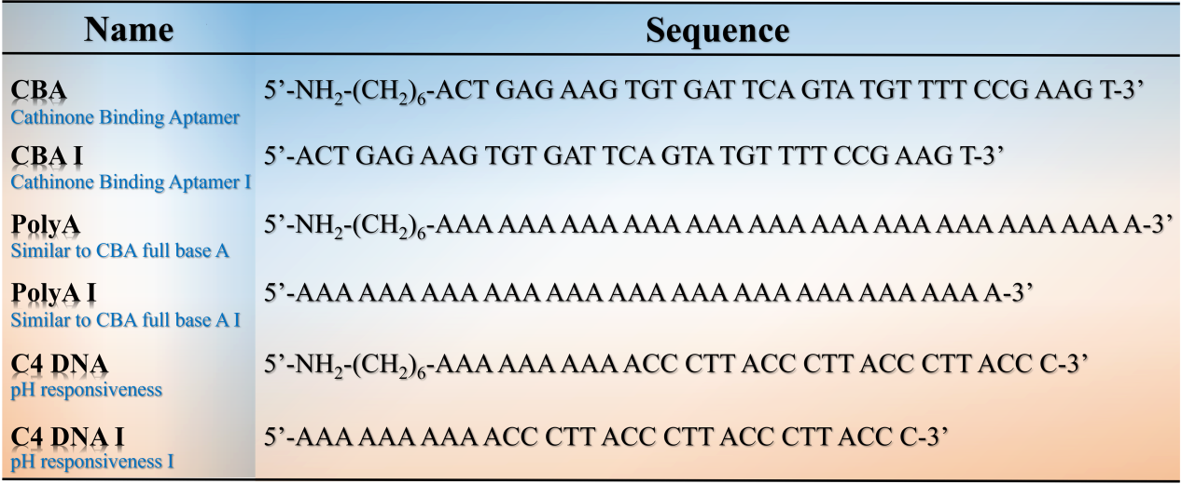

The stock solutions of drugs (1.0 mg·mL⁻¹), including cathinone (Cat), methcathinone (Met), ethcathinone (Eth), norketamine (Nor), ketamine (Ket), amphetamine (Amp), (±)-3,4-methylenedioxy-methamphetamine (MDMA), phenacetin (Phe), cocaine (Coc), heroin (Her), caffeine (Caf), procaine (Pro), paracetamol (Par), and (+)-pseudoephedrine ((+)-PSE), were legally provided by criminal evidence samples of the institute of evidence laboratory at China University of Political Science and Law (CUPL) and Guangdong Province Key Laboratory of Psychoactive Substances Monitoring and Safety. The analytical samples were prepared by diluting the stock solutions in either 0.01 M Tris-HCl buffer or artificial sweat. Artificial sweat (pH 7.3) was purchased from YuanYe Biotechnology Co., Ltd (Shanghai, China). Unless otherwise specified, all chemical reagents were of analytical grade and used without further purification. All solutions were prepared using ultrapure water produced by a Millipore Milli-Q system (18.2 MΩ·cm).

Apparatus: Characterization and Measurements

2.1 Material Characterization
Ultra-high-resolution scanning electron microscopy (SEM) was performed using the Zeiss GeminiSEM 360, operating at an accelerating voltage of 5.00 kV (at magnifications of 50,000x and 100,000x), to characterize the surface morphology of the nanochannels. Contact angle (CA) measurements were conducted using the contact angle measurement instrument SDC-350 from Shengding Precision Instrument Co., Ltd. (Dongguan, China). For each measurement, 4 μL of ultrapure water (18.2 MΩ·cm) was dropped onto the membranes surface at room temperature for investigation. Energy-dispersive X-ray spectroscopy (EDS mapping) was performed using a Hitachi/SU1000 high-resolution SEM to qualitatively analyze the distribution of carbon (C), nitrogen (N), oxygen (O), and silicon (Si) elements on the membranes surface before and after nanochannel functionalization (CBA@AAO). Subsequently, X-ray photoelectron spectroscopy (XPS) was employed on a Thermo ScientificTM K-Alpha^{TM+} spectrometer to quantitatively test the C, N, and O elements on the membranes surface before and after nanochannel functionalization. The testing software used was Thermo Avantage v5,9921.

2.2 Electrical Measurements
All measurements of electrical signals were conducted on customized poly(methyl methacrylate) (PMMA) electrochemical cells, with functionalized nanochannel AAO membranes sandwiched between two electrolyte chambers. Using a Keithley 6487 picoammeter (Keithley Instruments, Cleveland), current-voltage (I-V) curves were recorded in electrolyte solutions with varying pH (0.01 M Tris-HCl) to evaluate the transmembrane ion transport characteristics of the nanochannels before and after modification. The electrochemical testing setup employed a two-electrode system, with homemade Ag/AgCl electrodes applied on both sides of the nanochannel membrane to apply a transmembrane potential. Scan voltages ranged from -2.0 ~ +2.0 V with a step voltage of 0.1 V for I-V measurements. Additionally, real-time current (I-T) measurements were conducted at a constant voltage of +2 V for 60 s. All measurements, unless specified otherwise, were performed at room temperature, with each test conducted at least three times in parallel to obtain an average value.

Circular Dichroism (CD) Spectrum Tests
Circular dichroism (CD) spectra were acquired using a Chirascan Plus spectropolarimeter (Applied Photophysics, UK) over the wavelength range of 200 ~ 340 nm, employing 10 mm path length quartz cuvettes. The test samples comprised 1 μM CBA I with varying concentrations (1, 5, 10, 50, 100, and 1000 μM) of cathinone, 1 μM PolyA I with different concentrations (1, 5, 10, 50, and 100 μM) of cathinone, 1 μM CBA I and PolyA I with varying concentrations (10 and 100 μM) of cathinone, methcathinone, and ethcathinone, and C4 DNA I incubated for 2 hours in 0.01 M Tris-HCl solutions at different pH levels (3.5, 4.5, 5.5, and 7.5). Additionally, a blank group was prepared by mixing 1 μM CBA I with 100 μM methcathinone, ethcathinone, and norketamine respectively, followed by the addition of varying concentrations (1, 5, 10, 50, and 100 μM) of cathinone and incubation for at least 2 hours to investigate the response to cathinone in complex systems. Background scans of 0.01 M Tris-HCl (pH 7.4) buffer were initially conducted, and the blank background was subtracted from the sample spectra after each collection. All tests were conducted at RT.

Molecular Docking
Referring to our previous work, computational-assisted compound docking was conducted using the Maestro interface within the Schrödinger 2021-3 software package.^{[S1]} The structure of Cat bound to the appropriate DNA (CBA) was constructed using RNAComposer (http://rnacomposer.cs.put.poznan.pl/), while the ligand (cathinone) was designed using ChemDraw. Further refinement was performed using the PyMOL Molecular Graphics System 3.0 (The PyMOL Molecular Graphics System, Version 3.0 Schrödinger, LLC.) for docking computations. Prior to docking, the LipPrep module was employed to compute the charge state and optimal structure for the binding free energy of cathinone under physiological conditions. The receptor grid generation module in Maestro was utilized to generate grid files defining the docking interface, with the center of the CBA chain centroid chosen as the center of the active pocket, and a grid file with dimensions of 40 × 40 × 40 Å³ was generated. Finally, the ligand was docked to the receptor using Glide in SP mode.

Data Analysis
SEM images and contact angle (CA) measurements were processed using Adobe Photoshop 22.1.1. For nanochannel pore size and distribution statistics of the AAO membranes, Nano Measurer 1.2 software from the Surface Chemistry and Catalysis Laboratory at Fudan University was employed. Pore density statistics and CA measurements utilized Image J 1.51j8 (Wayne Rasband, National Institutes of Health, USA). And Data plotting was performed with Origin 2024 (OriginLab Co., Northampton, USA). Thermo ScientificTM Avantage v6.6.0 was utilized for charge correction in XPS data, setting the standard value for external carbon contamination at 284.8 eV for the C1s peak. Principal component analysis (PCA) was conducted using SYSTAT 13 (Systat Software Inc., Chicago, IL, USA), and hierarchical cluster analysis (HCA) was executed with Minitab 19 (Minitab Inc., State College, PA). Quantitative identification of caspofungin involved a limit of detection (LOD) calculation of LOD = (3.3 × δ) / S, where δ represents the standard deviation of response values from multiple measurements of the blank group, and S is the slope of the standard curve. All data were obtained from at least three parallel experiments, and error bars indicate one standard deviation (SD).

Preparation of Functionalized N_{C}B_{S} CBA@AAO
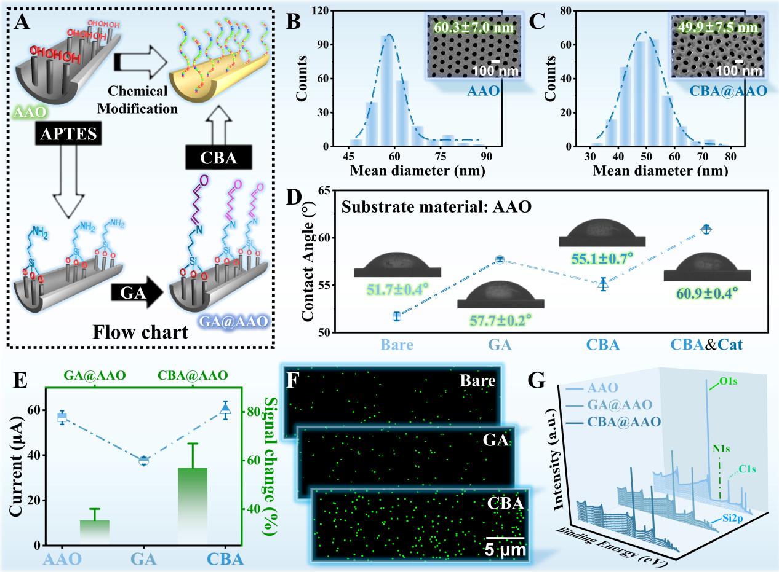
Figure S1. Preparation of the Solid-state N_{C}B_{S} Functionalized with DNA Probes. (A) Schematic illustration of the preparation process for the functionalized nanochannel CBA@AAO. SEM images and corresponding pore diameter distribution of the AAO nanochannel membrane before (B) and after (C) CBA functionalization. (D) Contact angles (CA) of the AAO membranes at each subsequent experimental step, with data obtained from three independent measurements. Insets show corresponding photographs of water droplet shapes on the membranes. (E) Current values at +2 V during I-V characteristic tests and changes in current signals before and after modification. Experimental data are from at least three parallel experiments. EDS mapping (F) and XPS spectra (G) of the AAO, GA@AAO, and CBA@AAO membranes.

The design strategy for the solid-state N_{C}B_{S} functionalized with DNA probes is shown in Figure S1A. The anodic aluminum oxide (AAO) nanochannel membrane surface was modified to an aldehyde group (GA@AAO) through a two-step chemical reaction. Subsequently, a 5'-amino-modified Cat-specific binding DNA probe (CBA) was grafted onto the AAO membrane surface via a Schiff base reaction, thus functionalizing it (CBA@AAO). The SEM images of the nanochannel membrane illustrate the changes in effective pore diameter before and after functionalization (Figure S4). The bare AAO membrane exhibits an orderly channel structure with a pore diameter distribution of 60.3 ± 7.0 nm, whereas the surface-functionalized CBA@AAO shows a disordered surface and a reduced effective pore diameter of 49.9 ± 7.5 nm (Figures S1B, C). To confirm the successful grafting of CBA and its response to Cat, CA measurements were used to characterize the surface of the modified AAO membrane. The CA values of the AAO membrane in its original state, GA@AAO, CBA@AAO, and CBA@AAO bound to Cat were 51.7 ± 0.4°, 57.7 ± 0.2°, 55.1 ± 0.7°, and 60.9 ± 0.4°, respectively (Figures S1D, S8). All these changes in wettability of the AAO membrane correspond to changes in chemical composition.
The successful fabrication of CBA@AAO can be corroborated by measuring the changes in ionic current through the nanochannels before and after modification, which reflect changes in effective diameter and surface wettability. As shown in Figure S1E, the AAO membrane exhibits a higher transmembrane current due to the synergistic effect of its effective size and surface wettability. In contrast, GA@AAO shows a corresponding decrease in current due to the reduced effective diameter and increased surface hydrophobicity, with a signal change of approximately 35%. Although the effective diameter of CBA@AAO significantly decreases, its porosity increases compared to GA@AAO (Table S2), and the introduction of the DNA probe enhances the hydrophilicity of the membrane surface. The combined competitive effects of surface wettability and size result in an increase in current, with a significant signal change of approximately 57%. Figure S1F shows the EDS mapping of CBA@AAO before and after fabrication, qualitatively confirming N_{C}B_{S} functionalization through changes in nitrogen content (Figure S6). Additionally, to further validate the successful grafting of CBA onto the AAO membrane surface, XPS was used to quantitatively characterize the changes in nitrogen content before and after modification (Tables S18-S23, Figure S7). Unlike the unmodified membrane, the GA@AAO and CBA@AAO show characteristic N1s XPS peaks at approximately 400 eV, indicating the successful immobilization of the probe on the membrane surface (Figure S1G). The nitrogen content before and after modification was 1.03%, 4.49%, and 5.50%, respectively. These results provide substantial evidence for the successful binding of the Cat-specific probe to the AAO membrane surface.

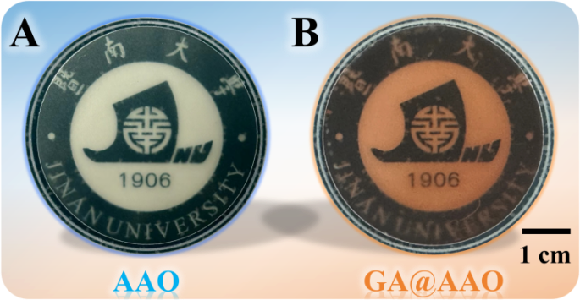
Figure S2. The color change of anodized aluminum oxide (AAO) nanochannel membrane before and after the modification of aldehyde group (-CHO).

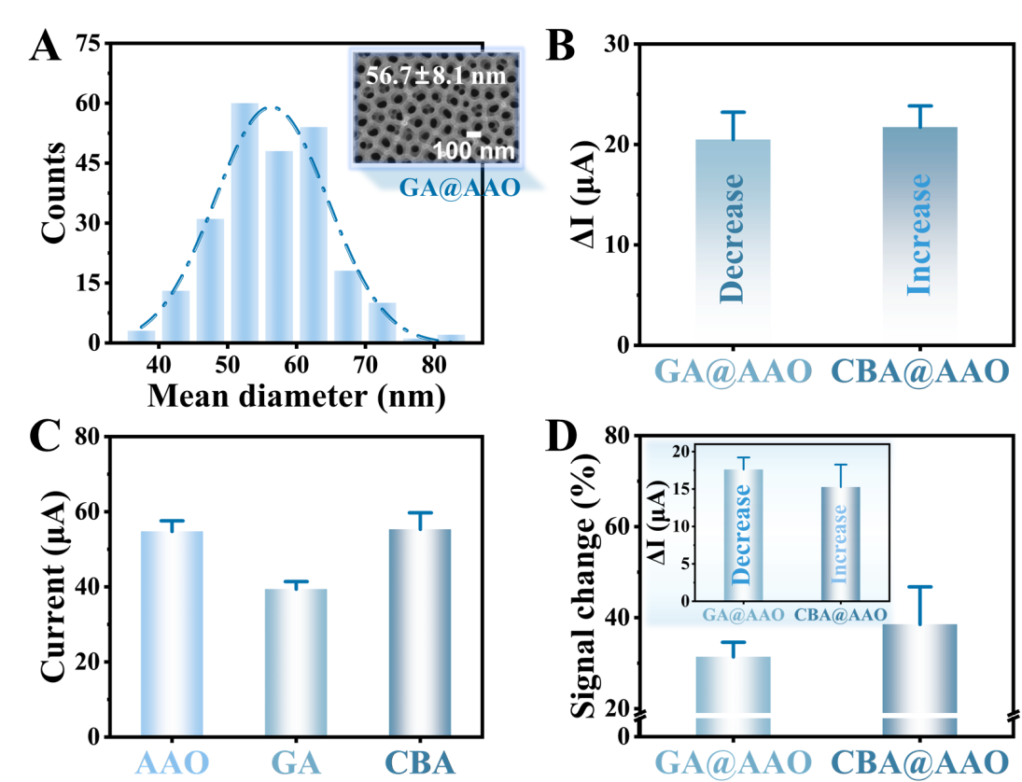
Figure S3. (A) SEM images and corresponding pore size distribution statistics of -CHO modified nanochannels (GA@AAO). (B) Changes in transmembrane ionic current magnitude (based on I-V characteristics at +2 V) before and after the preparation of GA@AAO and CBA@AAO. (C) Steady-state ionic currents passing through nanochannels at three stages (AAO, GA@AAO, and CBA@AAO) within 60 s under an applied voltage of +2 V. (D) Rate of change in current signals before and after preparation of GA@AAO and CBA@AAO based on I-T characteristics. Insets illustrate changes in transmembrane ionic current magnitude corresponding to the two stages.

- Ultra-high Resolution Scanning Electron Microscope (SEM)
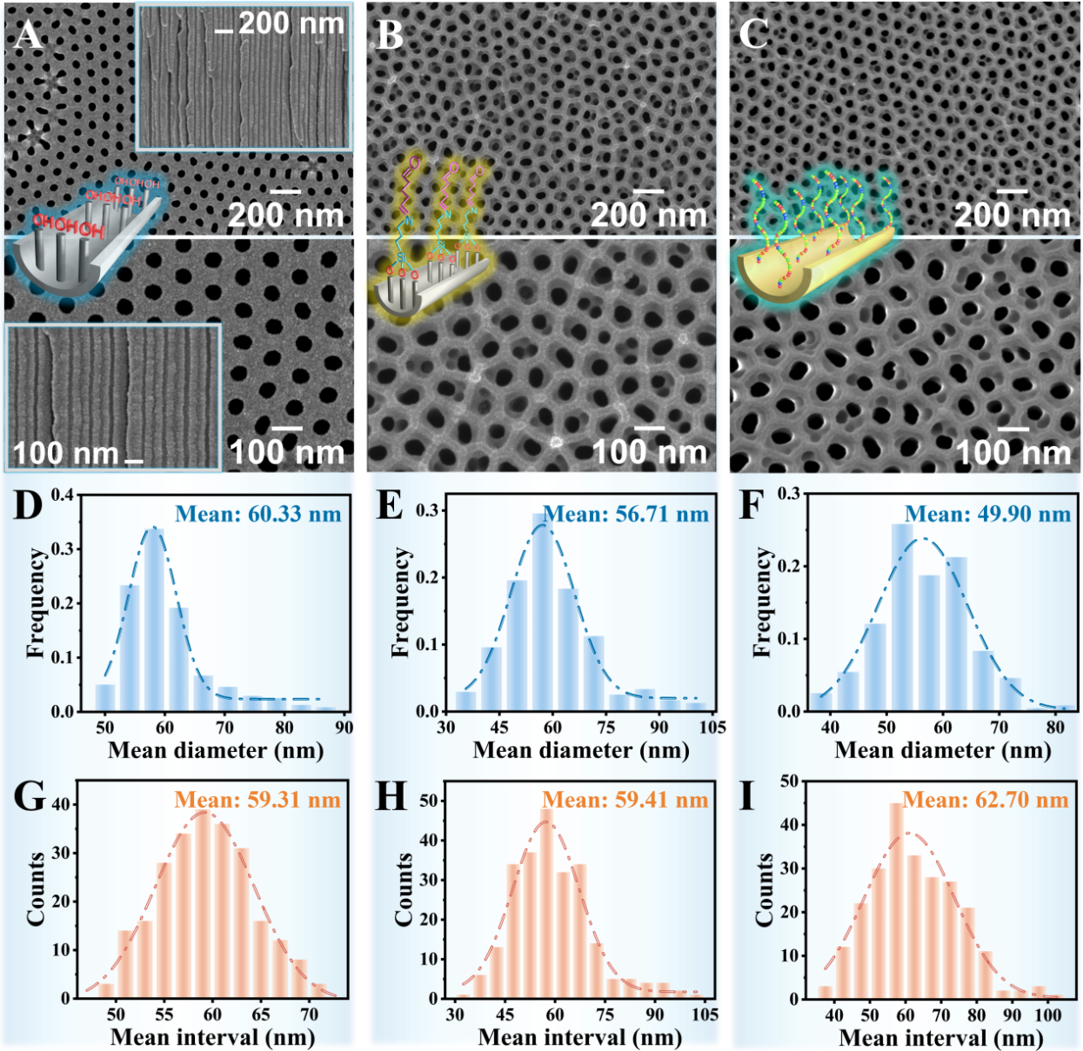
Figure S4. (A) SEM images of the surface and cross-section of bare AAO membranes. SEM images of the surfaces of GA@AAO (B) and CBA@AAO (C), respectively. Pore size distribution statistics for the three membrane states: AAO (D), GA@AAO (E), and CBA@AAO (F), respectively. And pore spacing distribution statistics between adjacent pores in nanochannels before and after functionalization of AAO membranes for the three states: AAO (G), GA@AAO (H), and CBA@AAO (I).

Table S2. The actual pore diameter, pore density, and porosity for AAO, GA@AAO, and CBA@AAO.
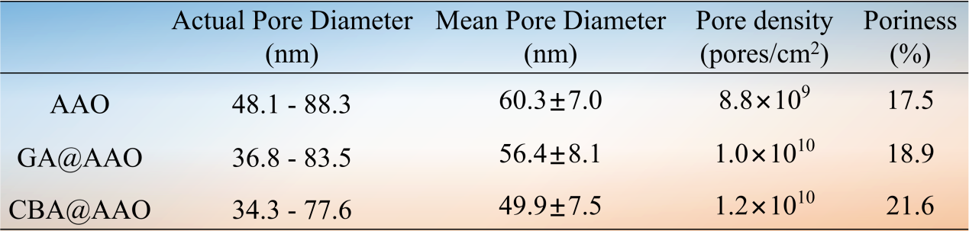

To confirm the successful fabrication of the functionalized nanochannels (CBA@AAO), we conducted a detailed study of the surface morphology of AAO, GA@AAO, and CBA@AAO using ultra-high resolution scanning electron microscopy (SEM) (Table S2). The purchased AAO nanochannel membranes had a pore size distribution ranging from 40 to 70 nm. Statistical analysis revealed that the actual pore size distribution ranged from 48.1 to 88.3 nm, with an average pore size of 60.3 ± 7.0 nm and a porosity of 17.5%. Compared to the bare AAO membrane, the pore size of the aldehyde-functionalized nanochannels (GA@AAO) decreased, with a distribution between 36.8 and 83.5 nm, an average pore size of 56.4 ± 8.1 nm, and a porosity of 18.9%. Notably, after introducing cathinone-specific single-stranded DNA (CBA), the pore size further decreased compared to GA@AAO, with an average pore size reduced to 49.9 ± 7.5 nm, ranging from 34.3 to 77.6 nm, and the porosity increased to 21.6%. Detailed statistical data on the pore size distribution and pore spacing of the three nanochannel states (AAO, GA@AAO, and CBA@AAO) can be found in Tables S3-S8.

Table S3. Statistics of pore size distribution of AAO bare membrane.
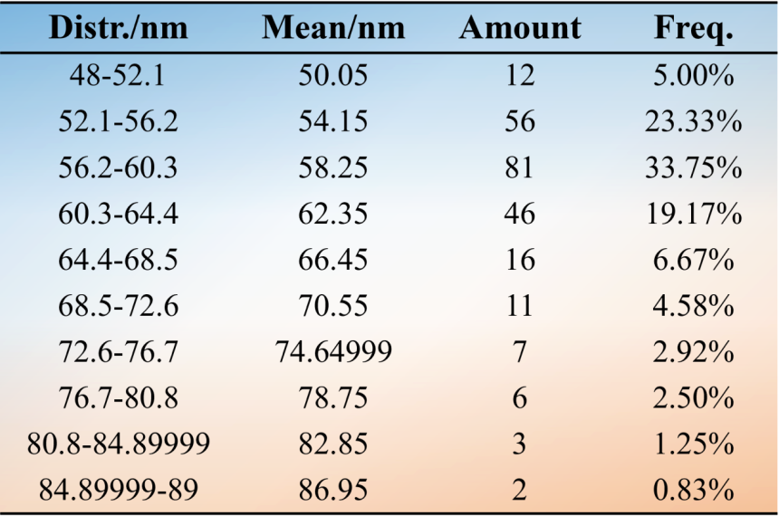

Table S4. The pore gap size distribution statistics between adjacent pores of AAO bare membrane.
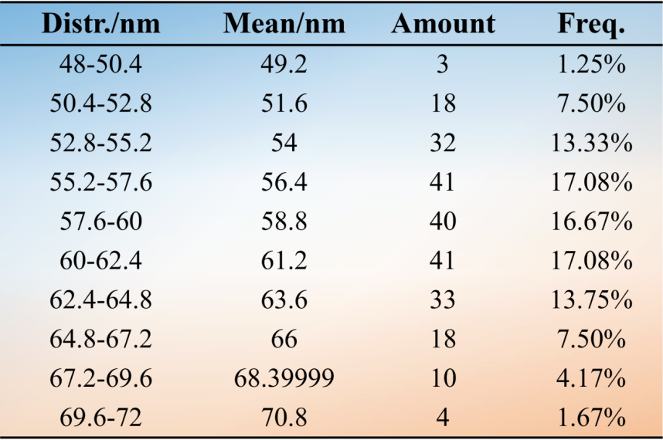

Table S5. The pore diameter distribution statistics of GA@AAO.
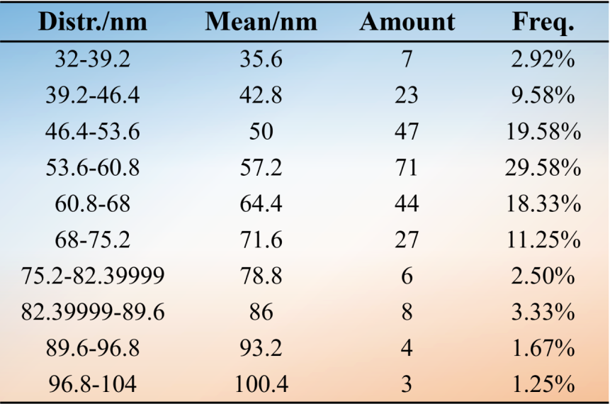

Table S6. The gap distribution statistics of two adjacent holes of GA@AAO.
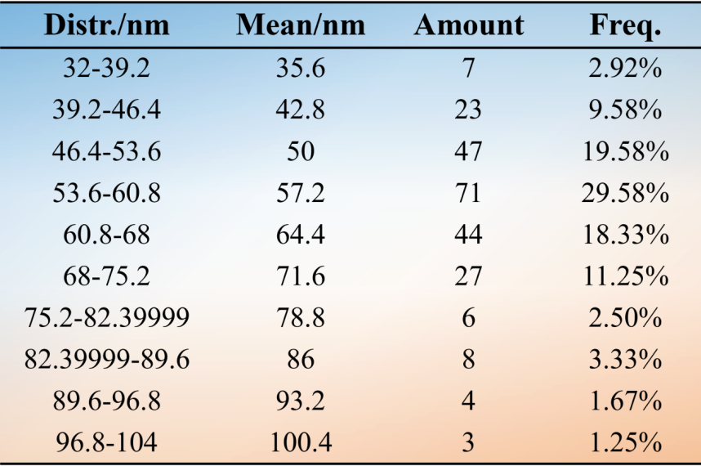

Table S7. The pore diameter distribution statistics of CBA@AAO.
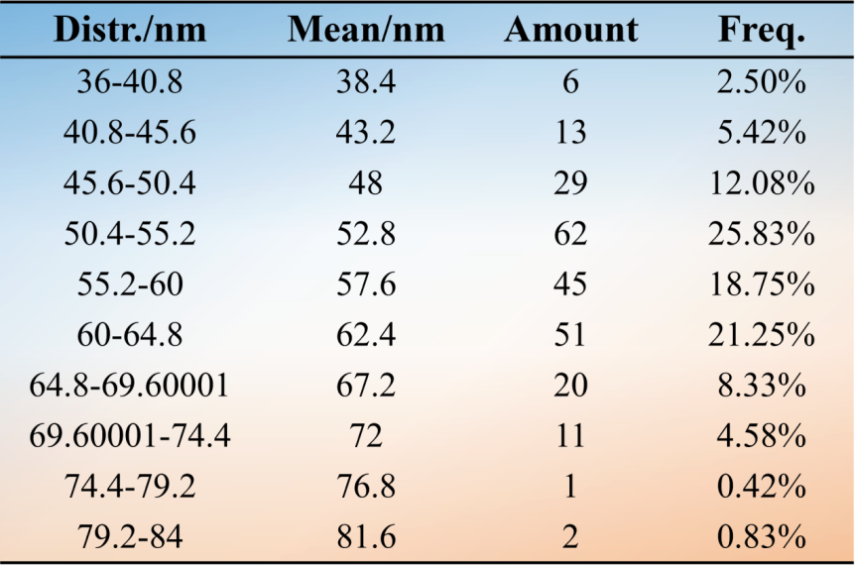

Table S8. The gap distribution statistics of two adjacent holes of CBA@AAO.
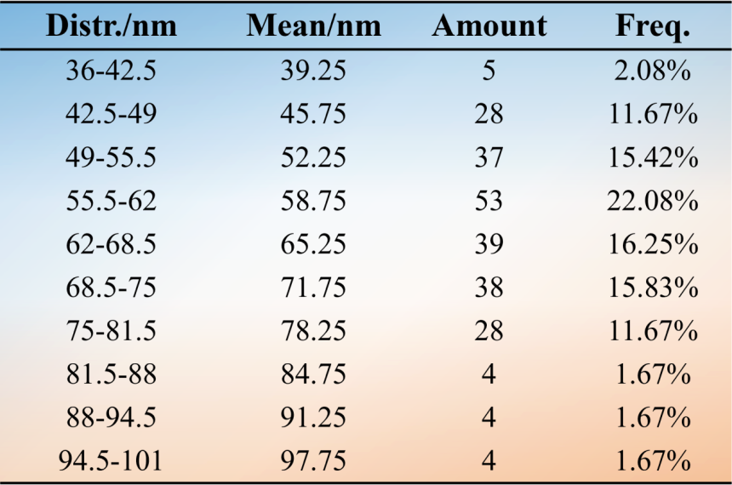

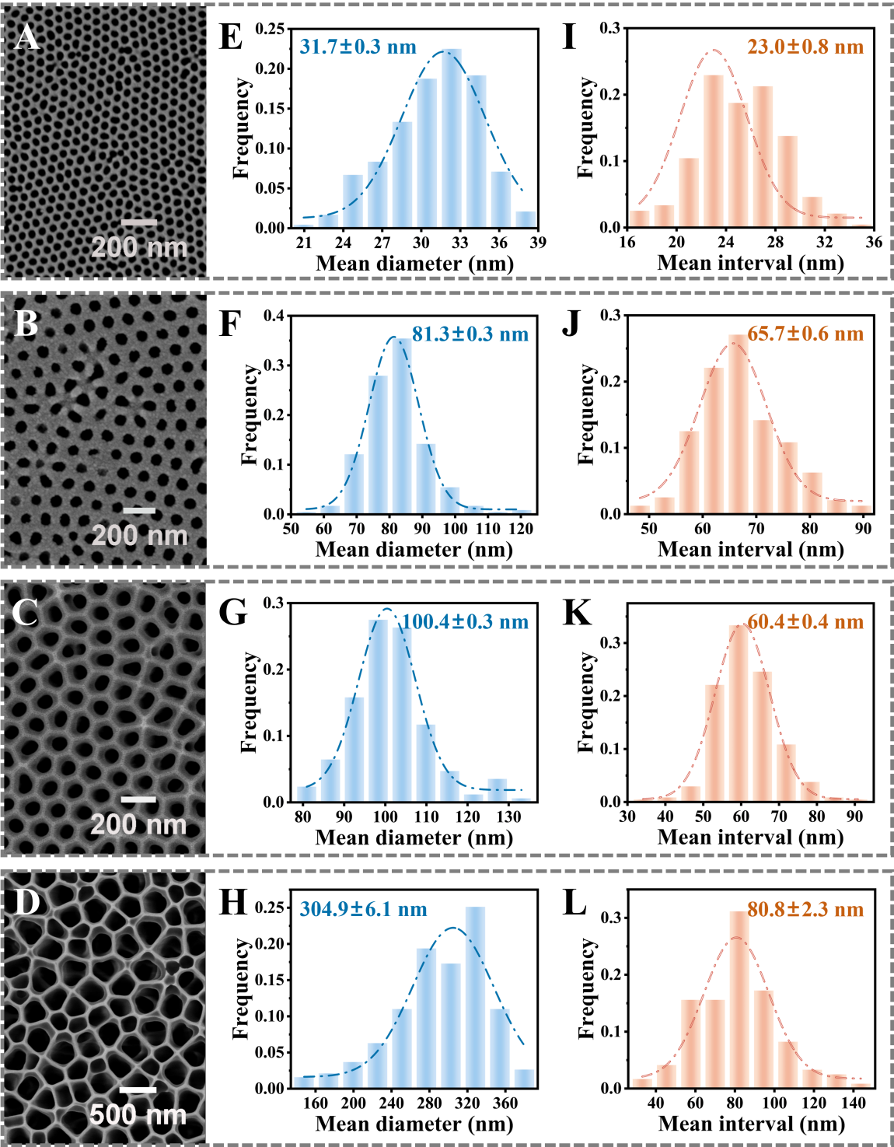
Figure S5. Four different sizes of AAO nanochannel membranes. (A) AAO with aperture distribution of 20 ~ 30 nm. (E) and (I) are the corresponding pore distribution and pore gap size statistics of adjacent holes, respectively. (B) AAO with aperture distribution of 80 ~ 100 nm. (F) and (J) are the corresponding pore distribution and pore gap size statistics of adjacent holes respectively. (C) AAO with aperture distribution of 110 ~ 150 nm. (G) and (K) are the corresponding pore distribution and pore gap size statistics of adjacent holes, respectively. (D) AAO with aperture distribution of 200 ~ 300 nm. (H) and (L) are the corresponding pore distribution and pore gap size statistics of adjacent holes, respectively.

Table S9. The actual pore diameter, pore density and porosity of five AAO nanochannel membranes with different pore sizes.
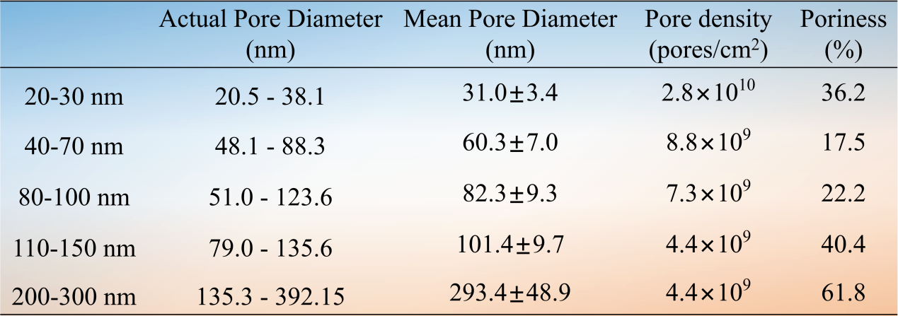

Table S10. The pore size distribution statistics of 20 ~ 30 nm AAO.
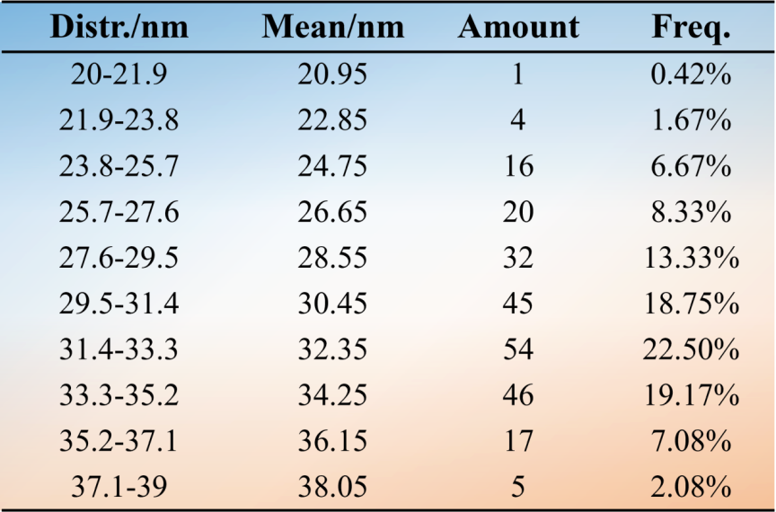

Table S11. The gap distribution statistics of two adjacent holes of 20 ~ 30 nm AAO.
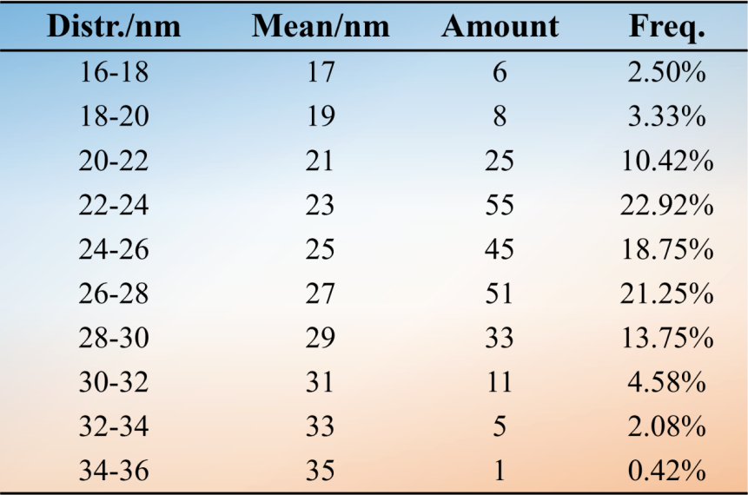

Table S12. The pore size distribution statistics of 80 ~ 100 nm AAO.
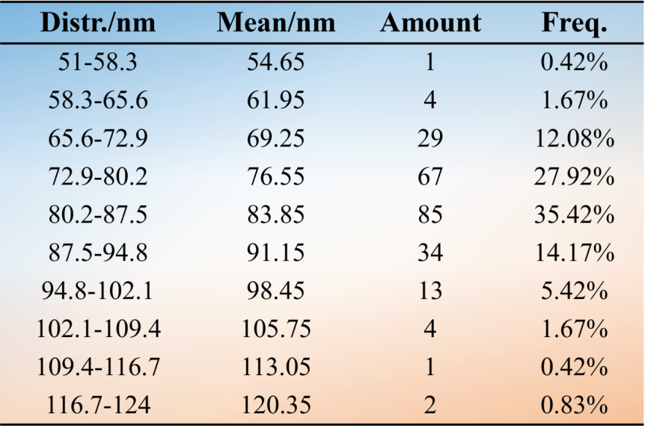

Table S13. The gap distribution statistics of two adjacent holes of 80 ~ 100 nm AAO.
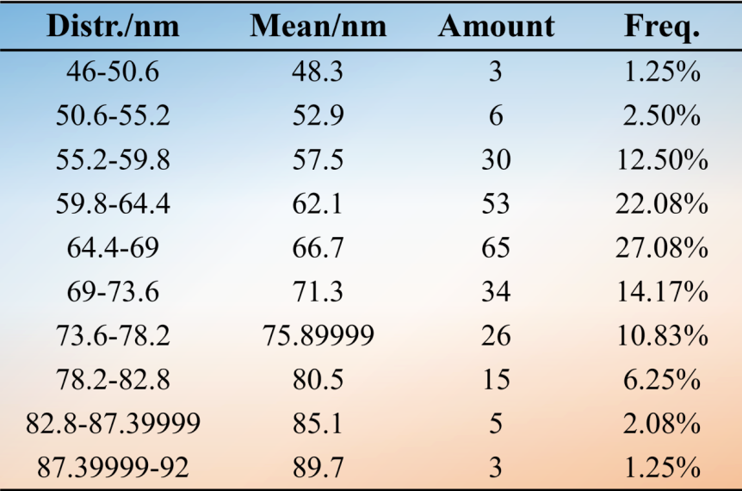

Table S14. The pore size distribution statistics of 110 ~ 150 nm AAO.
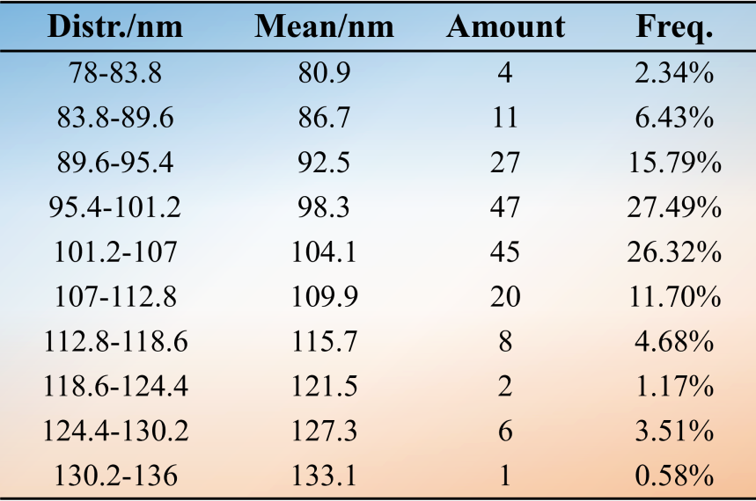

Table S15. The gap distribution statistics of two adjacent holes of 110 ~ 150 nm AAO.
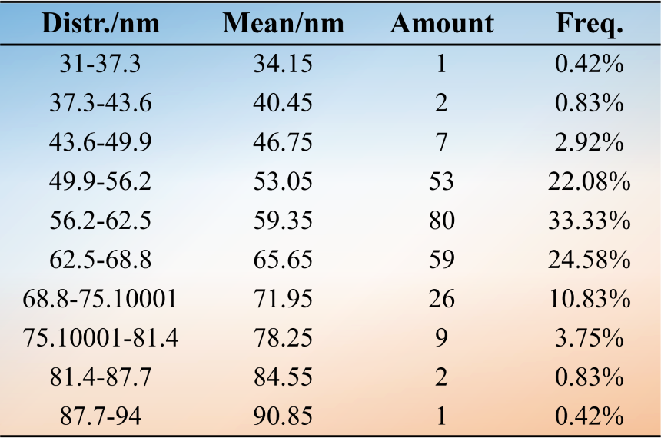

Table S16. The pore size distribution statistics of 200 ~ 300 nm AAO.
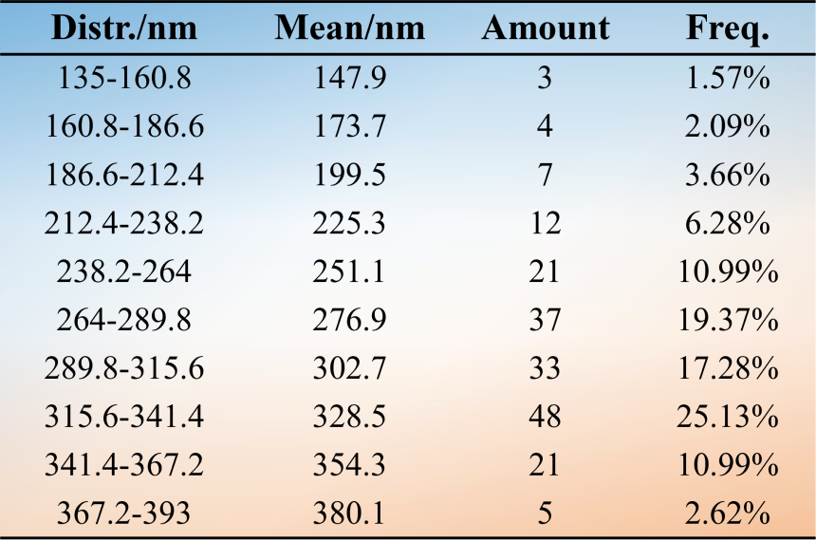

Table S17. The gap distribution statistics of two adjacent holes of 200 ~ 300 nm AAO.
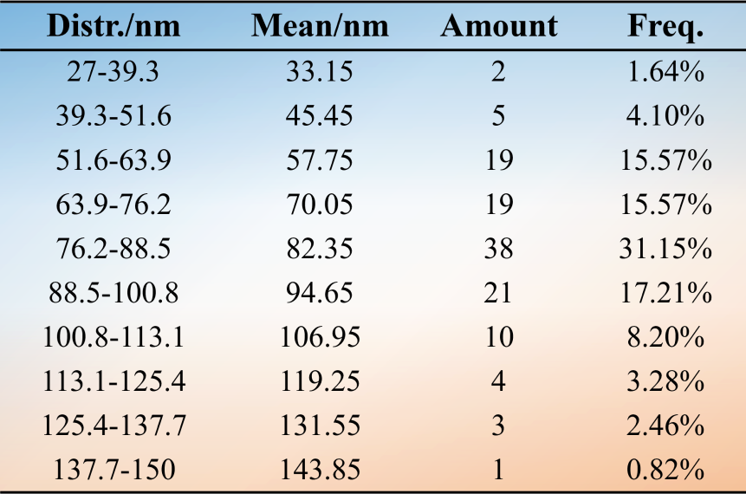

Energy Dispersive Spectromete (EDS)
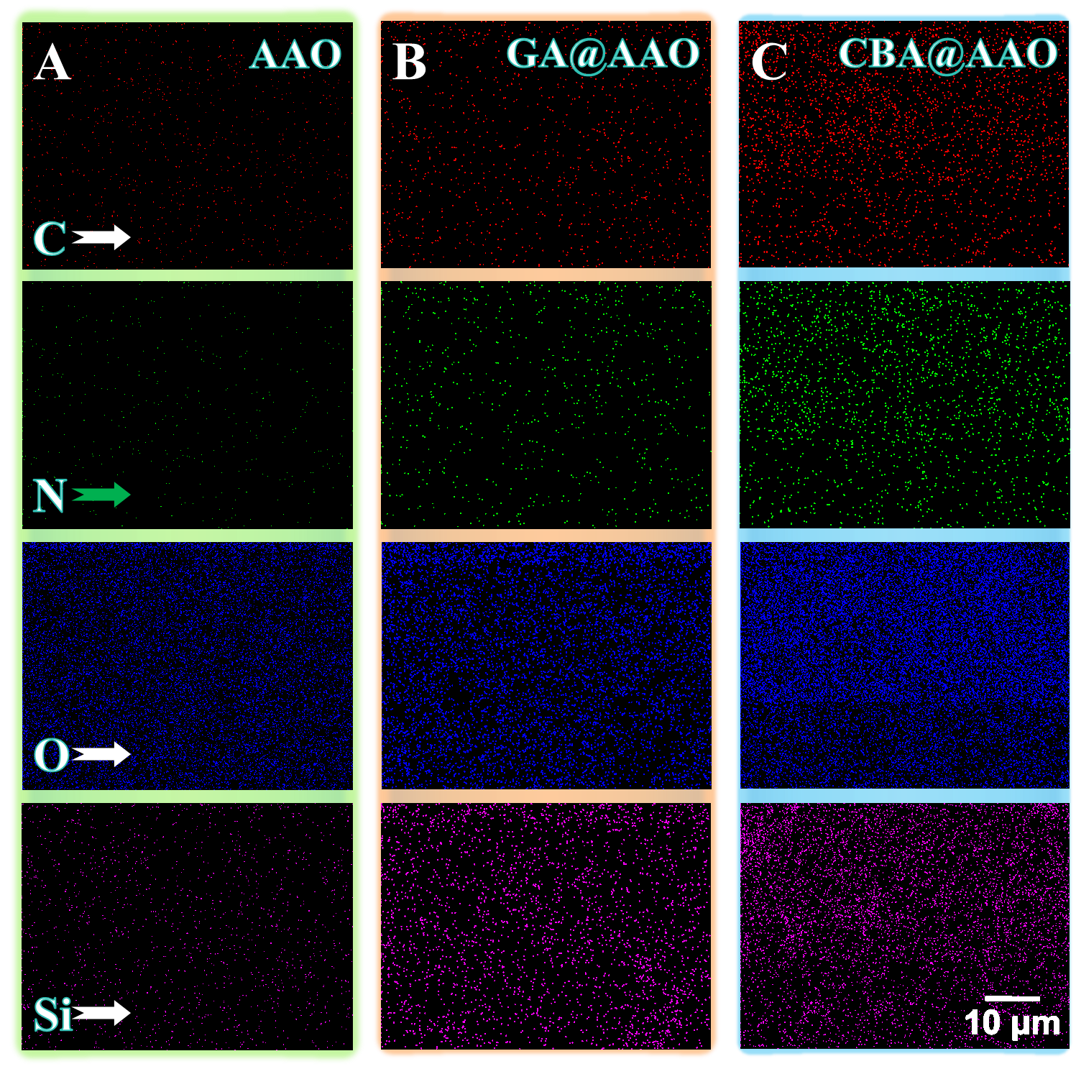
Figure S6. (A), (B) and (C) are EDS mapping images of the surface of nanochannel films in AAO, GA@AAO and CBA@AAO states, respectively. Qualitative analysis of C, N, O and Si elements on the membrane surface.

GA@AAO Compared with AAO, nitrogen and silicon on the membrane surface increase directly due to the introduction of APTES. With the continuous grafting of APTES and GA to the AAO membrane surface, the oxygen element on the surface is covered and slightly reduced. The successful preparation of CBA@AAO indicates that the content of nitrogen and carbon increases after the introduction of CBA (5’-terminal amination) to GA@AAO. Therefore, the changes of C, N, O and Si elements on AAO, GA@AAO and CBA@AAO membrane surfaces were observed by EDS mapping, which can roughly reflect the modification process.

X-ray Photoelectron Spectroscopy (XPS)

9.1 Surface elements (C1s, N1s, O1s, Al2p and Si2p) analysis of CBA@AAO films at various stages of preparation.
Table S18. The XPS date of the AAO film before modification (AAO).
Name | Start BE | Peak BE | End BE | Height CPS | FWHM eV | Area (P)  CPS.eV | At. %
C1s | 294.08 | 283.40 | 277.08 | 127616.90 | 3.10 | 510649.06 | 25.42
N1s | 408.58 | 398.32 | 390.08 | 5846.15 | 3.43 | 32158.38 | 1.03
O1s | 536.08 | 530.16 | 523.08 | 677307.87 | 3.26 | 2378535.57 | 48.95
Al2p | 79.08 | 73.03 | 65.08 | 103110.6 | 2.79 | 313553.52 | 24.6

Table S19. The XPS date of the AAO membrane after GA modification (GA@AAO).
Name | Start BE | Peak BE | End BE | Height CPS | FWHM eV | Area (P)  CPS.eV | At. %
C1s | 291.80 | 283.41 | 276.30 | 272310.03 | 3.19 | 974194.17 | 56.87
N1s | 409.30 | 398.02 | 389.30 | 24776.90 | 4.21 | 119385.47 | 4.49
O1s | 535.30 | 530.16 | 522.30 | 332384.34 | 3.03 | 1099010.59 | 26.53
Al2p | 77.80 | 72.78 | 62.30 | 23439.81 | 2.75 | 80614.35 | 7.42
Si2p | 107.30 | 100.23 | 92.30 | 24242.76 | 2.66 | 80815.28 | 4.7

Table S20. The XPS date of the AAO membrane after CBA modification (CBA@AAO).
Name | Start BE | Peak BE | End BE | Height CPS | FWHM eV | Area (P)  CPS.eV | At. %
C1s | 289.60 | 283.03 | 275.60 | 258702.37 | 3.39 | 960756.46 | 56.25
N1s | 407.60 | 397.36 | 391.60 | 34176.57 | 3.99 | 145850.64 | 5.50
O1s | 535.60 | 529.74 | 521.60 | 326336.15 | 3.16 | 1136821.12 | 27.52
Al2p | 78.10 | 72.06 | 62.10 | 20826.09 | 2.91 | 70055.77 | 6.46
Si2p | 107.10 | 99.87 | 91.60 | 22137.09 | 2.92 | 73290.88 | 4.27

X-ray photoelectron spectroscopy (XPS) analysis was utilized to detect the content of nitrogen in order to confirm the DNA immobilized on AAO surface treated by Tris solution after modification (pH = 7.4, 23 ℃) . XPS was conducted on a Thermo ScientificTM K-Alpha^{TM+} spectrometer equipped with a monochromatic Al Kα X-ray source (1486.6 eV) operating at 100 W. Samples were analyzed under vacuum (P < 10⁻⁸ mbar) with a pass energy of 150 eV (survey scans) or 50 eV (high-resolution scans). All peaks would be calibrated with C1s peak binding energy at 284.8 eV for adventitious carbon.
In this work, due to the abundant hydroxyl group (-OH) on the surface of AAO membrane, APTES can be grafted to the surface of AAO membrane by silanization through a two-step chemical modification method. The surface of the membrane was modified to an amino group (-NH₂), and then the surface functional group was changed to an aldehyde group (-CHO) by Schiff base reaction with glutaraldehyde (GA). Subsequently, the 5'-amino modified CBA and GA@AAO were functionalized into the nanochannel by Schiff base reaction again. In order to verify the successful grafting of DNA probes onto AAO nanochannel membranes as specific sensing probes, the elemental compositions of AAO, GA@AAO and CBA@AAO membranes were analyzed by XPS.
Similar to the EDS analysis results, the relative content of nitrogen in GA@AAO nanochannels increased from 1.03% to 4.49%. After the successful grafting of CBA onto the AAO nanochannel membrane, the nitrogen content further increased to 5.50% (Tables S18-S20). As shown in Figure S7A, the N1s peak is significantly pronounced and shows an increasing trend. After functionalizing the AAO nanochannel membrane with CBA, the intensities of the C1s (284.8 eV) and N1s (~ 398 eV) peaks increased significantly, indicating an increase in the content of C and N elements (Figures S7B, C). The content of O elements showed an overall decreasing trend, particularly during the transition from AAO to GA@AAO. This decrease is due to the introduction of APTES and GA onto the nanochannel membrane, leading to the coverage of oxygen elements originally present on the AAO membrane (Figure S7D). These XPS results further confirm the successful preparation of CBA@AAO.

9.2 The narrow spectra (C1s, N1s and O1s) analysis of CBA@AAO films at various stages of preparation.
Table S21. The XPS narrow spectra date of the AAO film.
Name | Start BE | Peak BE | End BE | Height CPS | FWHM eV | Area (P)  CPS.eV | At. %
Metal carbide | 297.30 | 283.17 | 278.50 | 34286.23 | 1.68 | 62568.93 | 22.71
C-C | 297.30 | 284.80 | 278.50 | 7978.49 | 1.04 | 8978.56 | 3.26
O-C=O | 297.30 | 287.00 | 278.50 | 5236.68 | 3.50 | 19861.85 | 7.23
Si₃N₄ | 409.30 | 398.19 | 391.50 | 1388.27 | 1.74 | 2615.38 | 0.61
Al₂O₃ | 544.30 | 530.08 | 524.50 | 155890.40 | 2.58 | 435576.75 | 65.39
Mental oxides | 544.30 | 529.18 | 524.50 | 5908.22 | 0.83 | 5294.4 | 0.79

Table S22. The XPS narrow spectra date of the GA@AAO film.
Name | Start BE | Peak BE | End BE | Height CPS | FWHM eV | Area (P)  CPS.eV | At. %
Metal carbide | 297.20 | 283.08 | 278.40 | 69104.11 | 2.01 | 150168.07 | 53.71
C-C | 297.20 | 284.80 | 278.40 | 14266.21 | 1.17 | 18135.54 | 6.49
C-O-C | 297.20 | 285.90 | 278.40 | 9145.69 | 1.23 | 12197.99 | 4.37
O-C=O | 297.20 | 287.10 | 278.40 | 2023.69 | 1.15 | 2530.39 | 0.91
Metal nitrides | 409.20 | 397.37 | 391.40 | 6698.10 | 1.90 | 13811.86 | 3.18
C-N | 409.20 | 400.38 | 391.40 | 3323.03 | 1.37 | 4916.82 | 1.14
Si₃N₄ | 409.20 | 398.78 | 391.40 | 1154.71 | 1.06 | 1323.51 | 0.31
Al₂O₃ | 544.20 | 530.26 | 524.40 | 82500.41 | 2.09 | 186939.43 | 27.66
Mental oxides | 544.20 | 528.68 | 524.40 | 10425.38 | 1.29 | 14556.56 | 2.15
C=O | 544.20 | 532.88 | 524.40 | 805.77 | 0.64 | 554.14 | 0.08

Table S23. The XPS narrow spectra date of the CBA@AAO film.
Name | Start BE | Peak BE | End BE | Height CPS | FWHM eV | Area (P)  CPS.eV | At. %
Metal carbide | 296.50 | 282.51 | 277.70 | 63874.19 | 2.33 | 161172.13 | 54.77
C-C | 296.50 | 284.80 | 277.70 | 12752.22 | 2.14 | 29498.56 | 10.04
Metal nitrides | 408.50 | 396.91 | 390.70 | 8098.19 | 2.19 | 19198.38 | 4.20
C-N | 408.50 | 399.58 | 390.70 | 3192.99 | 1.60 | 5522.91 | 1.21
Si₃N₄ | 408.50 | 398.38 | 390.70 | 726.76 | 0.45 | 348.35 | 0.08
Al₂O₃ | 543.50 | 529.66 | 523.70 | 84237.38 | 2.16 | 196764.28 | 27.65
Mental oxides | 543.50 | 527.88 | 523.70 | 10488.53 | 1.29 | 14644.74 | 2.06

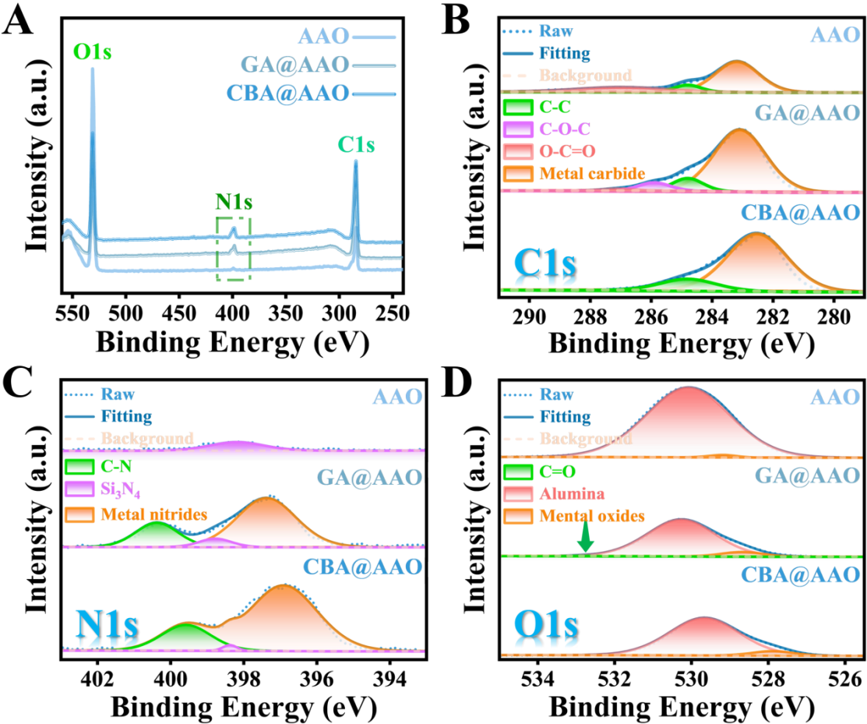
Figure S7. X-ray Photoelectron Spectroscopy (XPS) of the Surfaces of AAO, GA@AAO and CBA@AAO Nanochannel Films. (A) Full XPS spectra of the surface of the nanochannel films in three states before and after functionalization. (B-D) Narrow XPS spectrum near C1s, N1s and O1s peaks on the surface of each nanochannel film. The XPS results showed that CBA was successfully functionalized on AAO membrane, and CBA@AAO biosensor was prepared.

Contact Angle (CA)
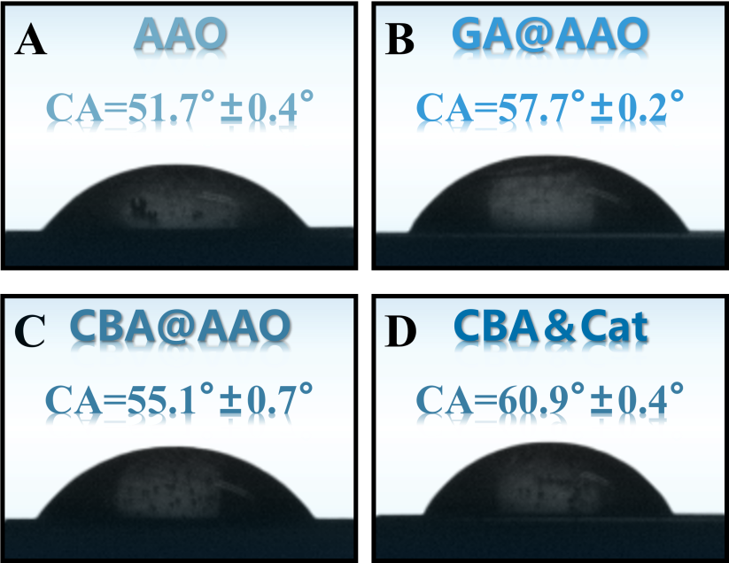
Figure S8. Contact Angle (CA) Test after Successful Preparation of Functionalized N_{C}B_{S} and Response to Target Cathinone. (A) AAO bare film. (B) GA@AAO nanochannel membrane modified by -CHO. (C) Cathinone responsive nanochannel membrane (CBA@AAO). (D) CA after CBA@AAO interaction with cathinone.

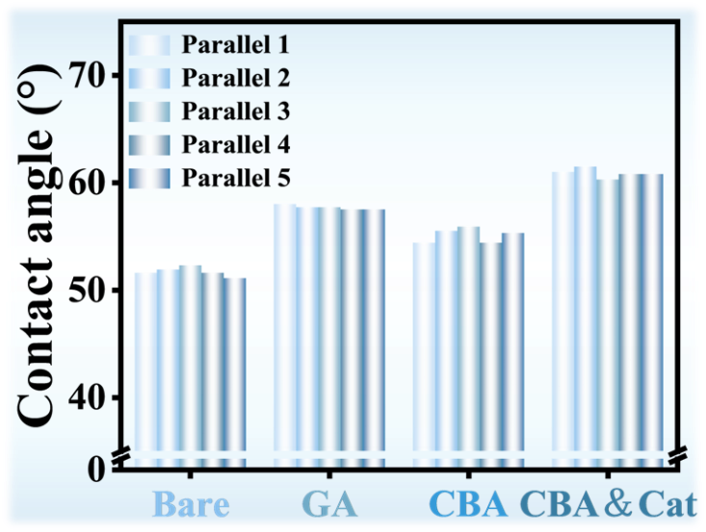
Figure S9. Parallel experiments of five groups of CA measurements before and after functionalization of N_{C}B_{S} and after interaction with cathinone.

Electrochemical Measurements
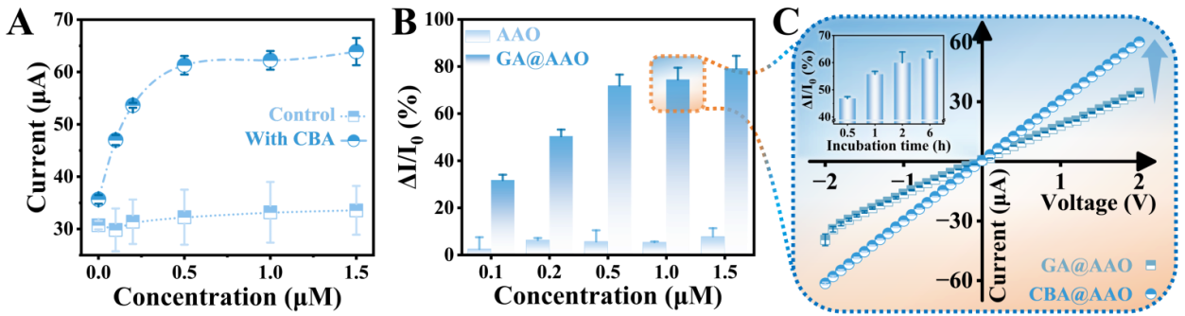
Figure S10. (A) Current changes of rapid response I-V (+2 V) after 2 h incubation of GA@AAO in Tris-HCl (10 mM pH 7.4, 0.5 M NaCl, 1 mM MgCl₂) solutions with different concentrations of CBA. The control group was incubated in Tris-HCl without CBA to exclude environmental factors and solvent effects. (B) Rate of current change of rapid response I-V (+2 V) after 2 h incubation of AAO and GA@AAO in Tris-HCl solutions containing different concentrations of CBA. Non-specific adsorption of CBA was excluded. (C) Current-voltage (I-V) characteristics of CBA@AAO prepared with GA@AAO and 1 µM CBA. The inset shows the time-dependent incubation of GA@AAO and 1 µM CBA.

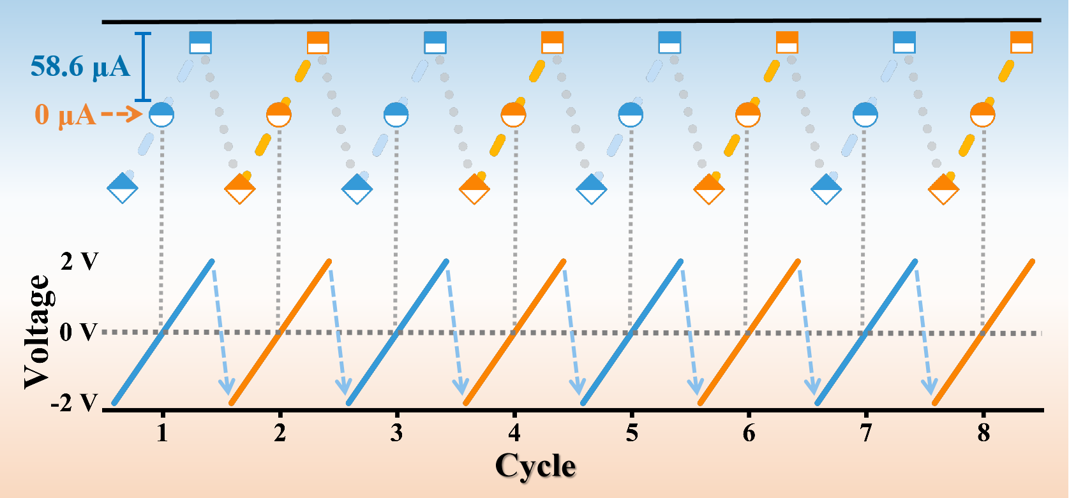
Figure S11. Cycling stability of CBA@AAO sensor for direct detection of 1 pM Cat.

11.1 CBA@AAO Optimization of sensor preparation
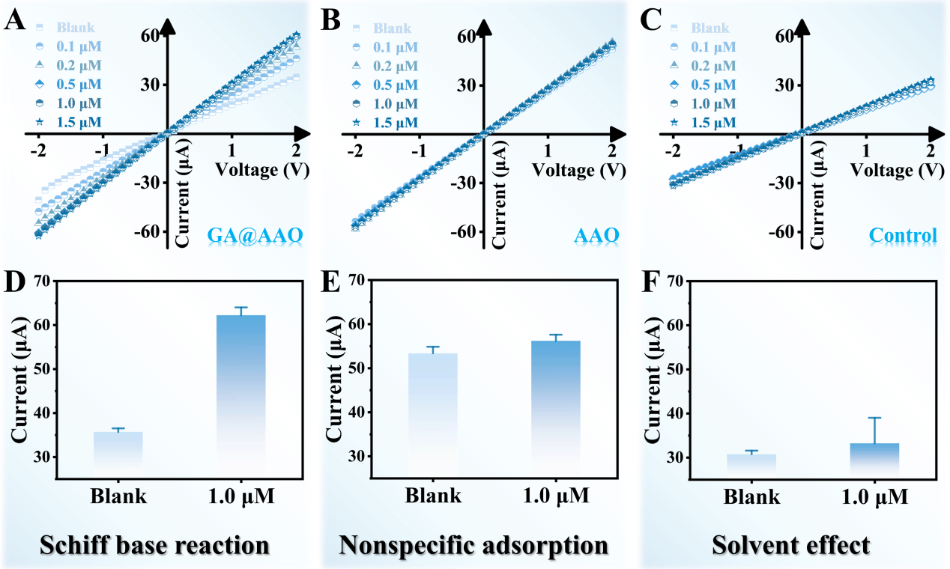
Figure S12. (A) I-V characteristics of GA@AAO incubated with different concentrations (0.1, 0.2, 0.5, 1.0 and 1.5 μM) of CBA for 30 min. (B) I-V characteristics of AAO incubated with different concentrations of CBA for 30 min. (C) GA@AAO I-V characteristics after incubation for 30 min without different concentrations of CBA. (D) Current signal before and after incubation of GA@AAO with 1.0 μM CBA. (E) Current signal before and after incubation of AAO with 1.0 μM CBA. (F) GA@AAO current signals before and after soaking in 10 mM Tris-HCl (pH 7.4) solution for 2 h.

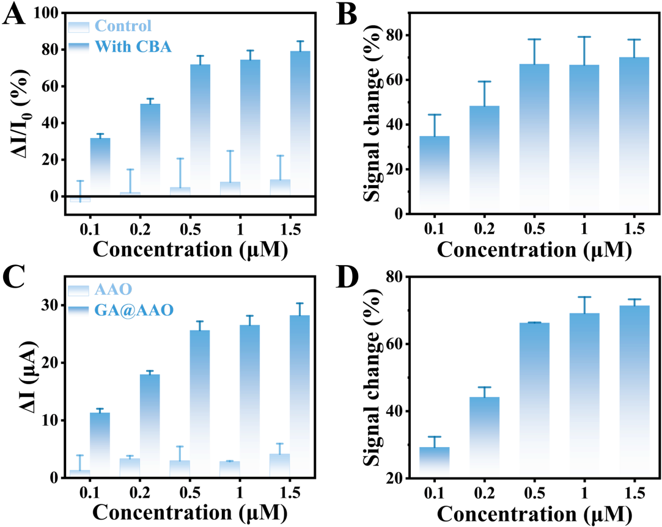
Figure S13. (A) Changes in the current signal (ΔI/I₀) after incubating GA@AAO with different concentrations (0.1, 0.2, 0.5, 1.0, and 1.5 μM) of CBA. The control group involves incubating GA@AAO in Tris-HCl (0.01 M, pH 7.4) without CBA for the same duration as the CBA treatments to eliminate environmental influences, including the solvent (Tris-HCl) interference with the current signal of CBA@AAO. (B) Changes in ionic current signal (ΔI/I₀) of CBA@AAO prepared by incubating GA@AAO with different concentrations of CBA, after subtracting the interference current signal caused by environmental influences. (C) Net increase in current changes after incubating AAO and GA@AAO with different concentrations of CBA, eliminating the non-specific adsorption of CBA on the nanochannel membrane, which instead is covalently grafted into the nanochannels through Schiff base reactions. (D) Ionic current signal of CBA@AAO prepared by incubating GA@AAO with CBA (covalently grafted through Schiff base reactions) after subtracting the signal changes caused by the interaction of AAO with different concentrations of CBA (non-specific adsorption).

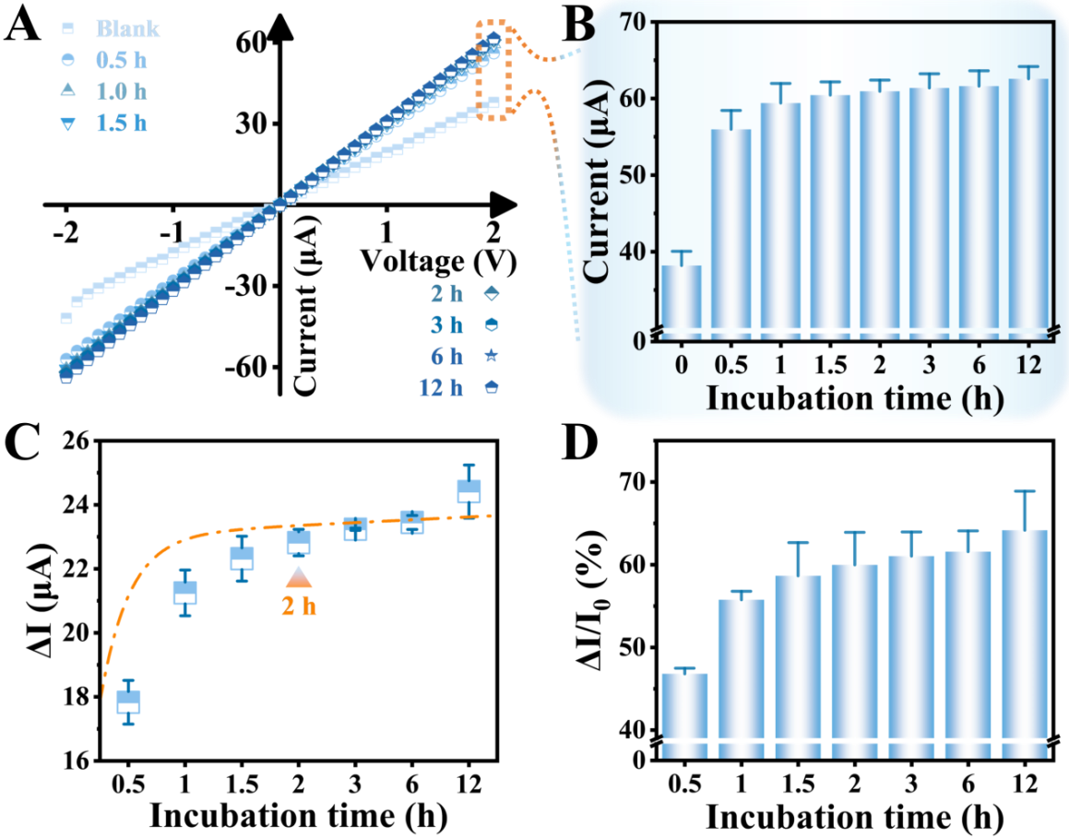
Figure S14. Optimization of CBA Incubation Time. (A) I-V curves of GA@AAO incubated with 1 μM CBA for different times (0.5, 1.0, 1.5, 2, 3, 6, and 12 h). (B) Transmembrane ionic current at +2 V through CBA@AAO functionalized for different times based on the I-V characteristics. (C) Current changes (ΔI) at +2 V before and after functionalizing CBA@AAO for different times. The optimal incubation time is shown to be 2h. (D) Changes in ionic current signal (ΔI/I₀) of CBA@AAO prepared with different incubation times.

11.2 CBA@AAO Sensor response performance to target cathinone
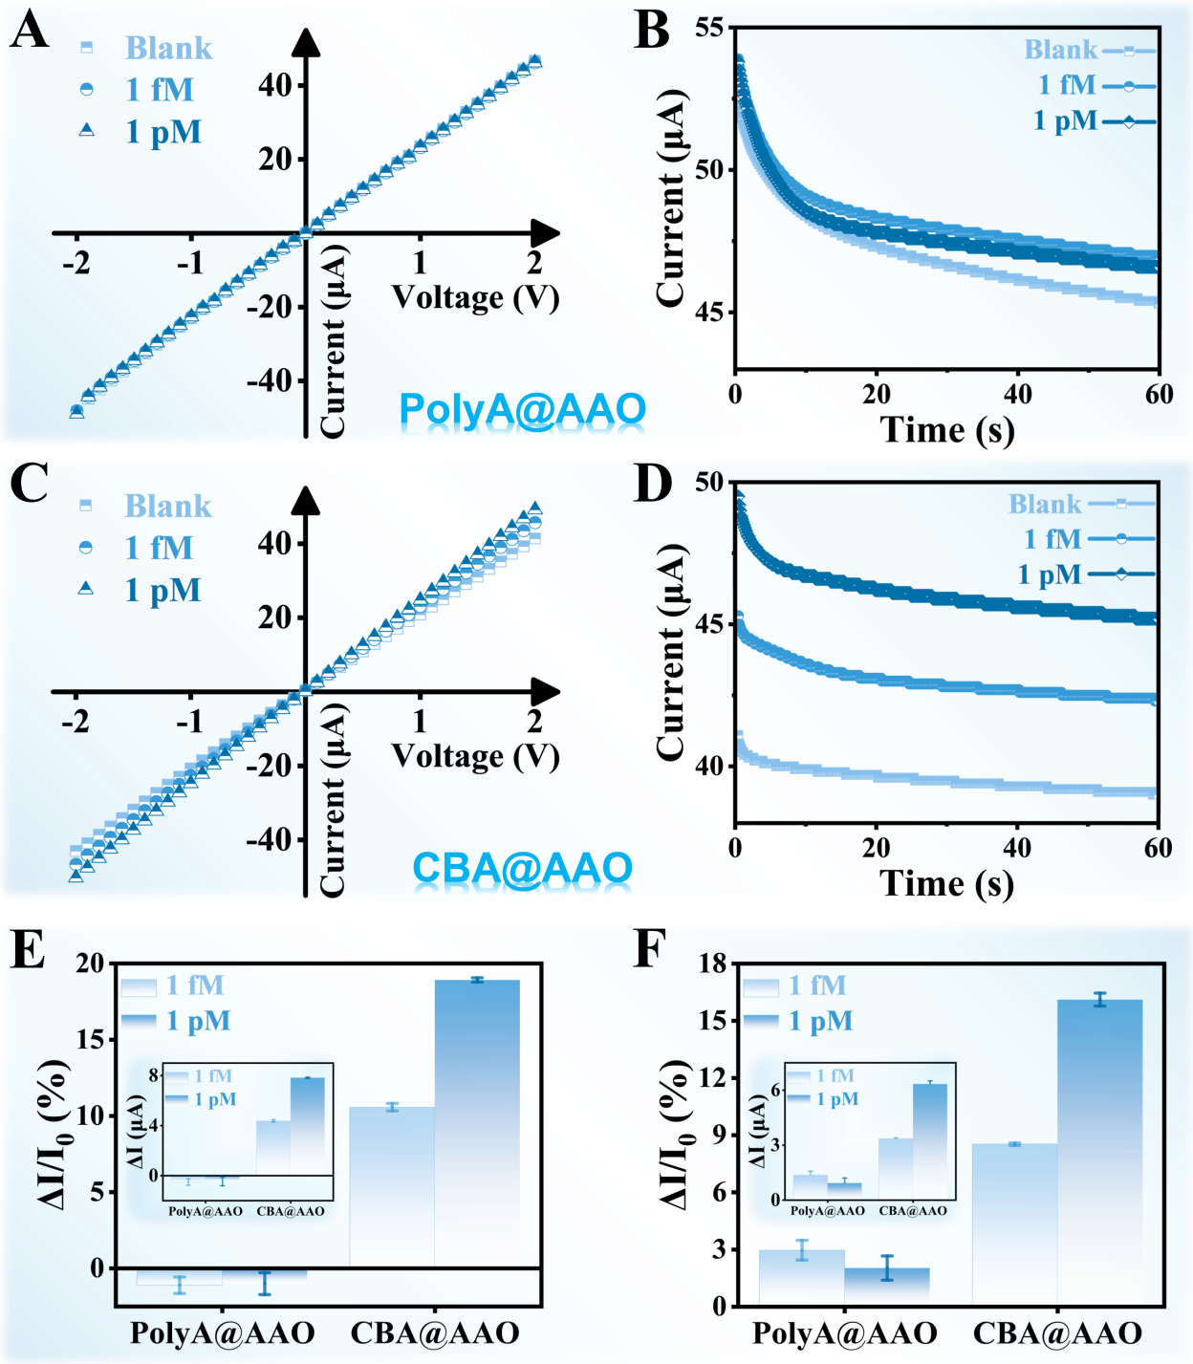
Figure S15. PolyA@AAO and CBA@AAO sensitivity of sensors to different concentrations of cathinone. PolyA@AAO (A) and CBA@AAO (C) I-V characteristics before and after interaction with 1 fM and 1 pM cathinone, respectively. The I-T characteristics of PolyA@AAO (B) and CBA@AAO (D) before and after interaction with 1 fM and 1 pM cathinone, respectively, with a period of 60 s. (E) and (F) are the changes of ionic current signals (ΔI/I₀) before and after the recognition of two different concentrations of cathinone by the two sensors under the applied voltage +2 V in the I-V and I-T characteristics, respectively. The illustrations show the change of current magnitude (ΔI) before and after the action of the target object.

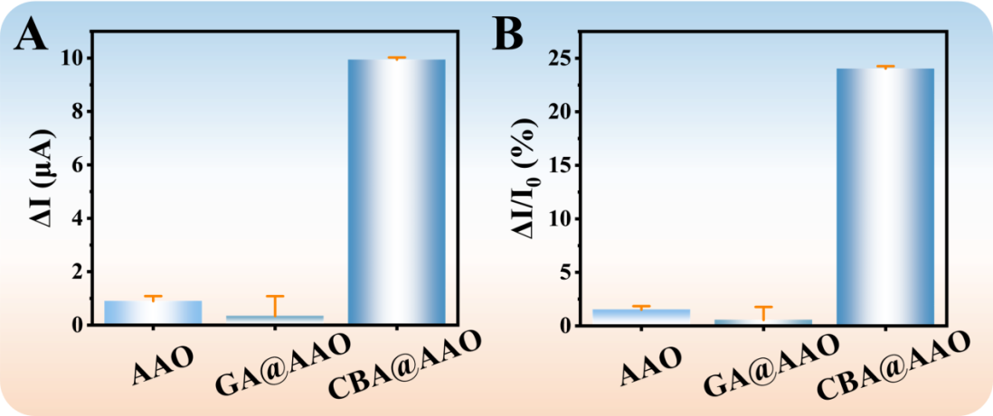
Figure S16. AAO, GA@AAO and CBA@AAO investigated the changes of current magnitude (A) and ionic current signal (B) before and after the identification of 1 nM cathinone, respectively.

11.3 Linear response of the sensor (CBA@AAO) to cathinone
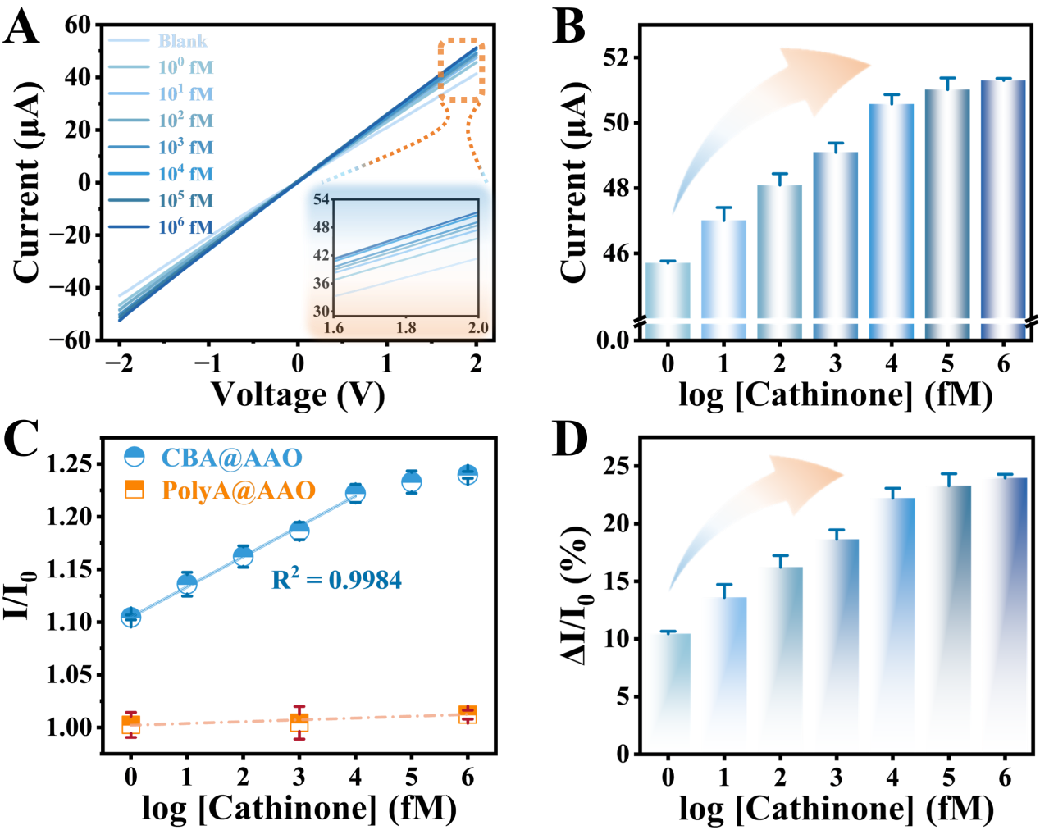
Figure S17. (A) I-V characteristics of CBA@AAO in response to different concentrations of cathinone. The illustration is a partial enlargement of the current size at an applied voltage of 1.6 ~ 2.0 V. (B) Ionic current at +2 V at the I-V characteristic of CBA@AAO sensor in response to different concentrations of catinone. (C) The ionic current ratio (I/I₀) before and after the sensor recognizes the target at different concentrations, and the linear response range to the target. Compared with PolyA@AAO sensor, CBA@AAO has remarkable sensitivity. (D) Transmembrane ionic current signal changes (ΔI/I₀) of CBA@AAO after recognizing different concentrations of cathinone.

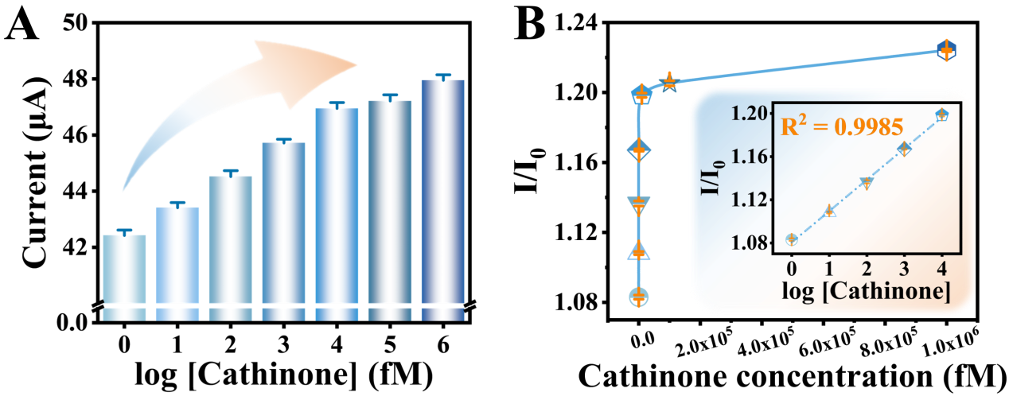
Figure S18. (A) Real-time current recordings at an applied voltage of +2 V over a period of 60 s. Ionic current response of the CBA@AAO sensor to different concentrations of cathinone. (B) Current ratio (I/I₀) recorded at +2 V for different target concentrations of cathinone based on I-T characteristics. The inset shows the linear response of CBA@AAO to cathinone concentrations ranging from 1 to 10⁴ fM, with R² = 0.9985.

11.4 Specific recognition of cathinone by the CBA@AAO sensor

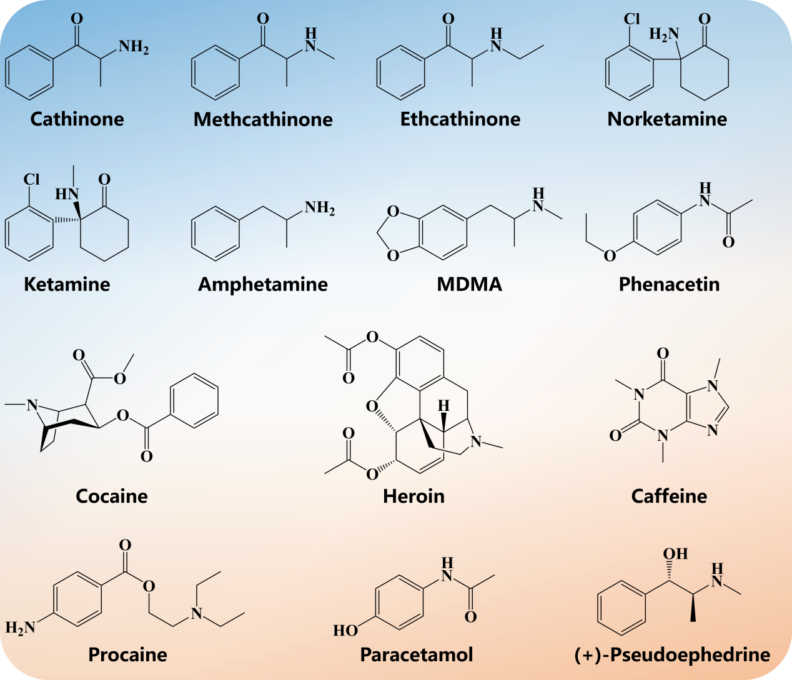
Figure S19. Structures of the Target Analyte Cathinone and 13 Psychoactive Drugs. (Cathinone: Cat, Methcathinone: Met, Ethcathinone: Eth, Norketamine: Nor, Ketamine: Ket, Amphetamine: Amp, 3,4-Methylenedioxymethamphetamine: MDMA, Phenacetin: Phe, Cocaine: Coc, Heroin: Her, Caffeine: Caf, Procaine: Pro, Paracetamol: Par, (+)-Pseudoephedrine: PSE.)

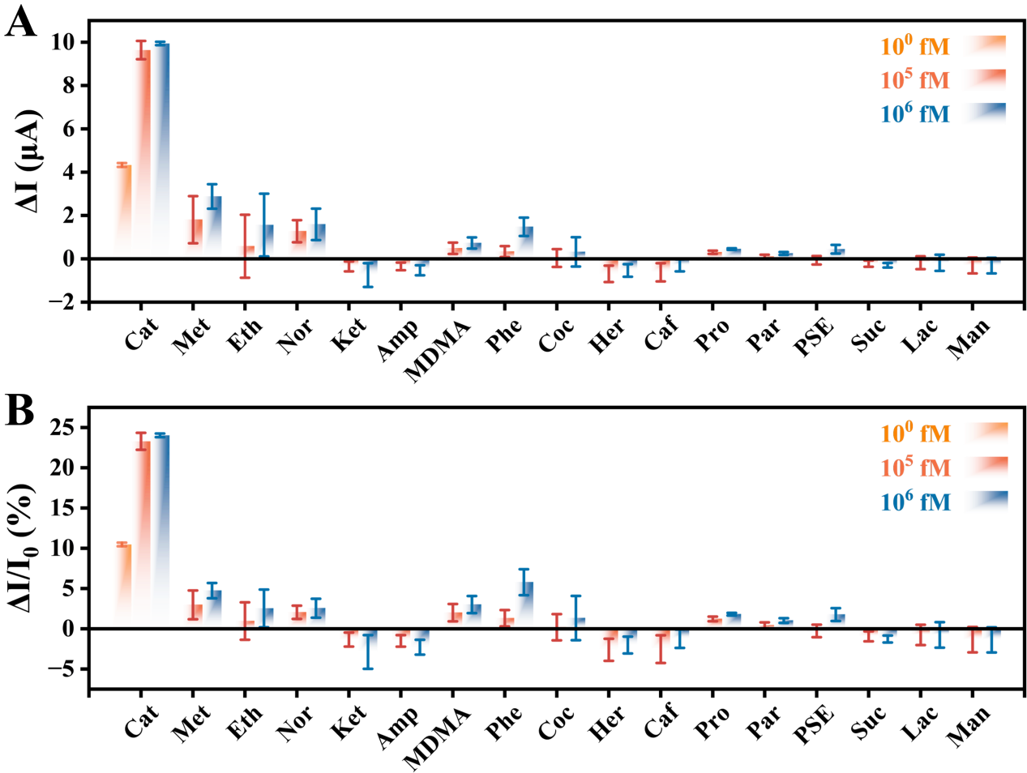
Figure S20. Selectivity of the Probe-N_{C}B_{S}. Comparison of 13 psychoactive drugs and 3 interfering substances, based on changes in current magnitude before and after recognition at +2 V from I-V characteristics (A) and changes in ionic current signals (B). The concentration of cathinone was 1, 10⁵, and 10⁶ fM, while the concentrations of other interfering substances were 10⁵ and 10⁶ fM.

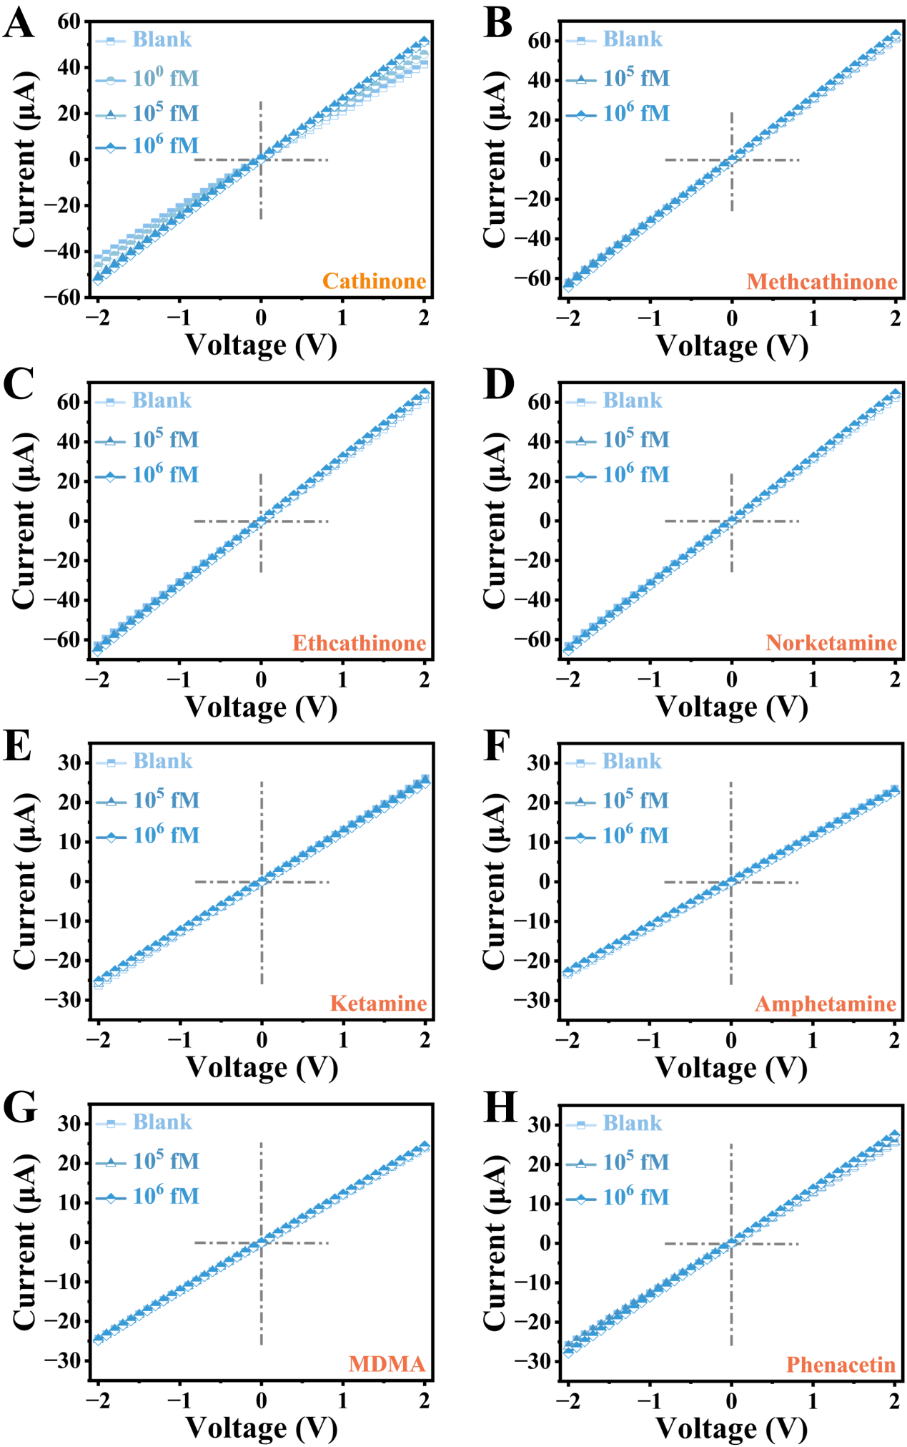

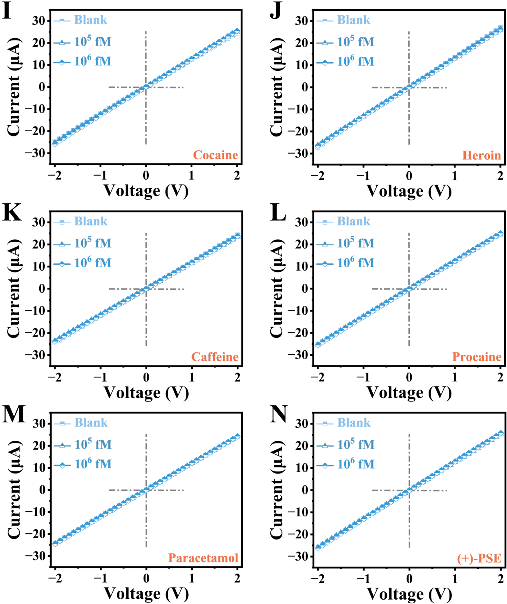
Figure S21. I-V characteristics of CBA@AAO in response to the target cathinone and 13 psychoactive drugs.

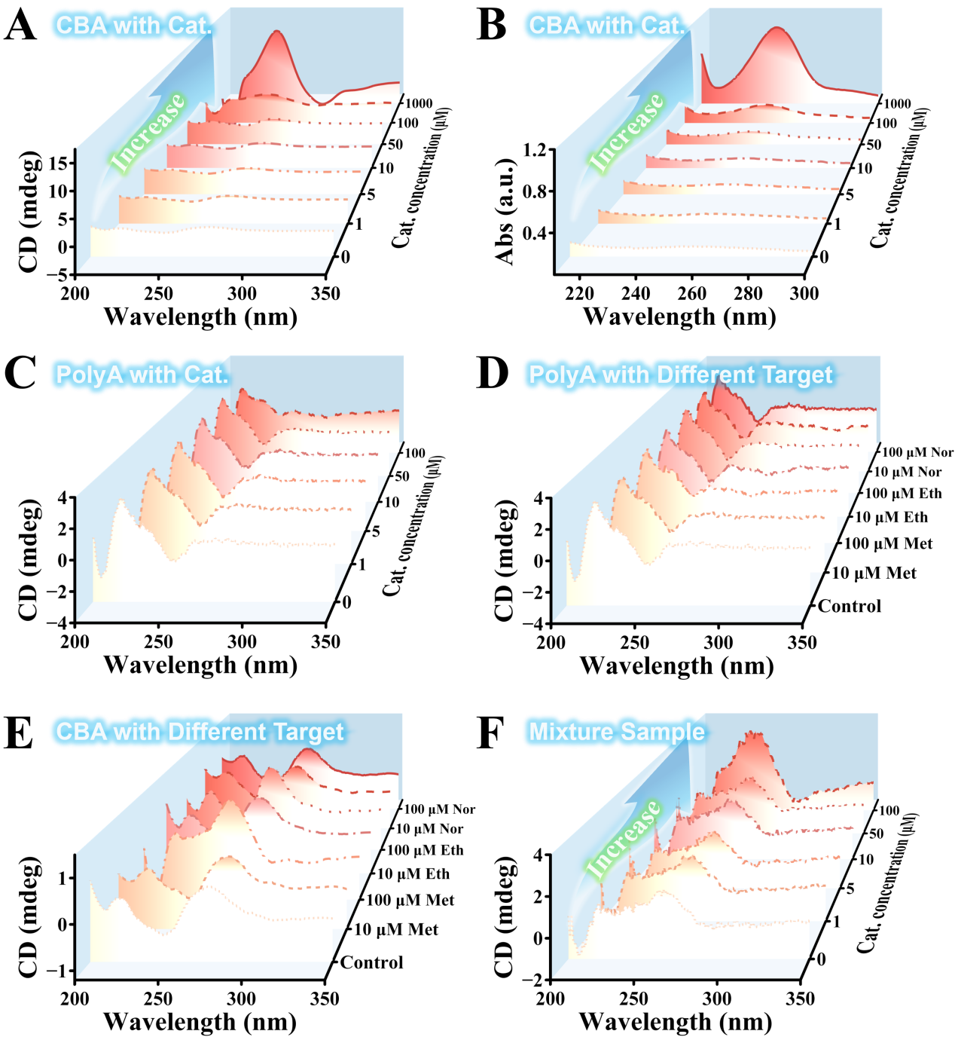
Figure S22. (A) Changes in circular dichroism (CD) spectral signals of CBA after interaction with different concentrations of cathinone. (B) UV absorption changes of CBA after binding to different concentrations of cathinone. (C) CD signal changes of PolyA after interaction with different concentrations of cathinone. (D) CD signal changes of PolyA after interaction with 10 and 100 μM of methcathinone, ethcathinone, and norketamine. (E) CD signal changes of CBA after interaction with 10 and 100 μM of methcathinone, ethcathinone, and norketamine. (F) CD response signals of CBA to different concentrations of target cathinone in a mixed sample, where the mixed sample (blank group) consists of 1 μM CBA and 100 μM of methcathinone, ethcathinone, and norketamine.

The Potential of Biosensor for Multivariate Discrimination Analysis
12.1 Multivariate discrimination analysis of CBA@AAO
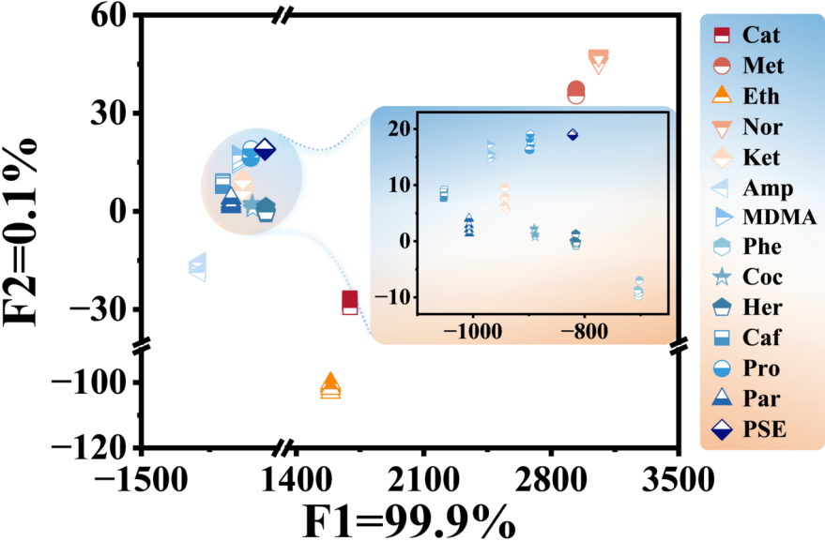
Figure S23. Principal Component Analysis (PCA) score plot was utilized to differentiate 14 different drug analytes (all at 1 nM), achieving a classification accuracy of 100%.

Table S24. Jackknifed classification matrix based on CBA@AAO sensors was employed to differentiate 14 types of drugs at identical concentrations.
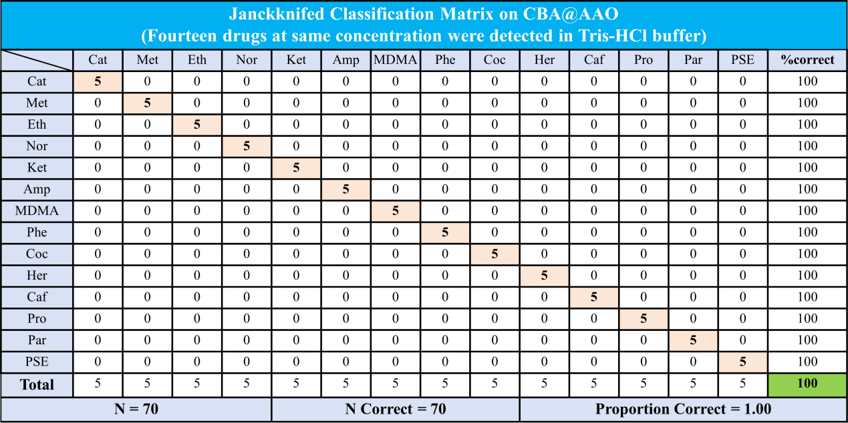

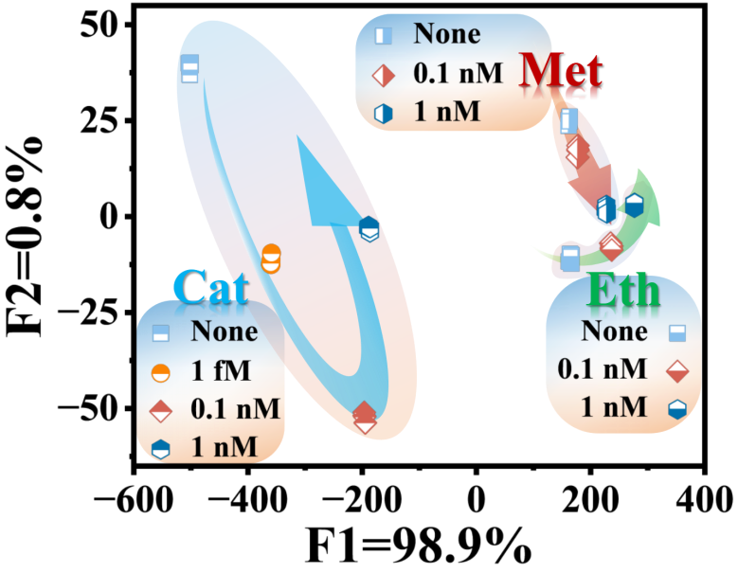
Figure S24. Principal component analysis (PCA) score plot for distinguishing different concentrations of Cat, Met, and Eth. The clusters are dispersed along the direction of increasing concentration indicated by arrows, with an accuracy of 94%.

Table S25. Based on DNA probe-N_{C}B_{S}, a jackknifed classification matrix was employed to differentiate different concentrations of cathinone, methcathinone and ethcathinone.
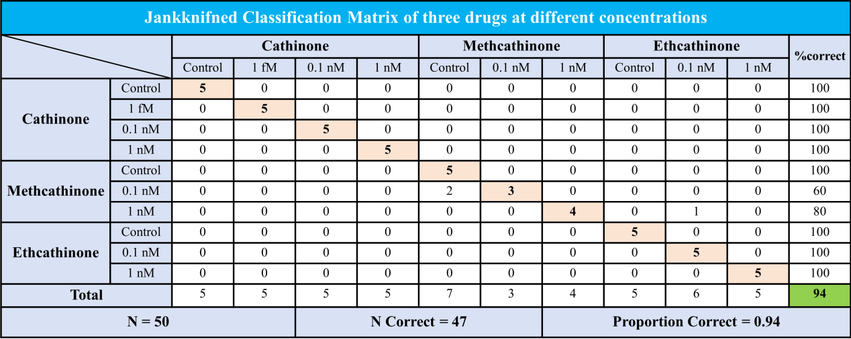

12.1 Multivariate discrimination analysis of CBA&C4@AAO

Table S26. Based on the double-calibration strategy, four drugs and two common sweat markers in artificial sweat were classified by jackknife classification matrix.
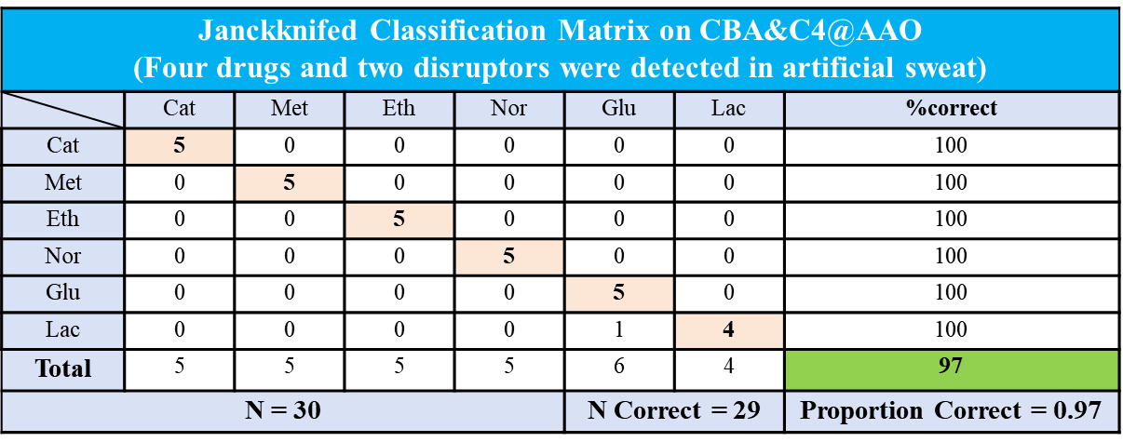

Co-Calibration Strategy of CBA&C4@AAO.
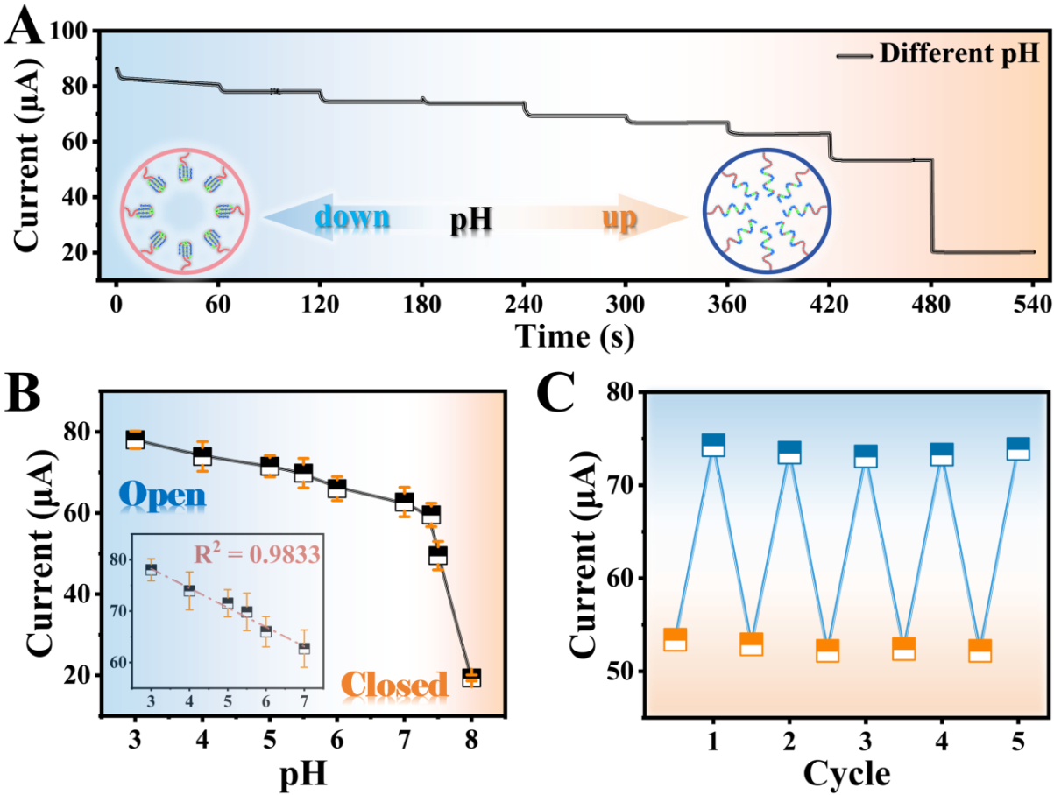
Figure S25. pH-responsive Functionalized Nanochannel C4@AAO. (A) I-T response of C4@AAO to different pH values (3, 4, 5, 5.5, 6, 7, 7.4, 7.5 and 8) under an applied voltage of +2 V, with each pH response cycle lasting for 60 s. Inset shows the reversible change in effective pore diameter of C4@AAO with pH variation. (B) Transmembrane ionic current magnitude of C4@AAO sensor in response to different pH values under +2 V. Inset displays the linear fitting of the sensor within the pH range of 3 ~ 7, with R² = 0.9833. Directly correlates to the opening of the functionalized nanochannel, leading to an increase in effective pore diameter at low pH values. As pH increases, the C4@AAO nanochannel gradually closes, resulting in a decrease in ionic current. (C) Cycling stability of C4@AAO under two pH states (pH 5.5 and 7.5), based on I-T characteristics under an applied voltage of +2 V.

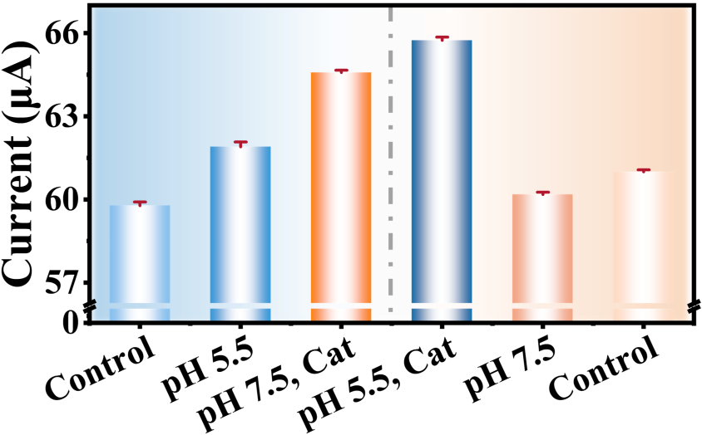
Figure S26. Transmembrane ionic current variation of CBA&C4@AAO sensor under four different conditions.

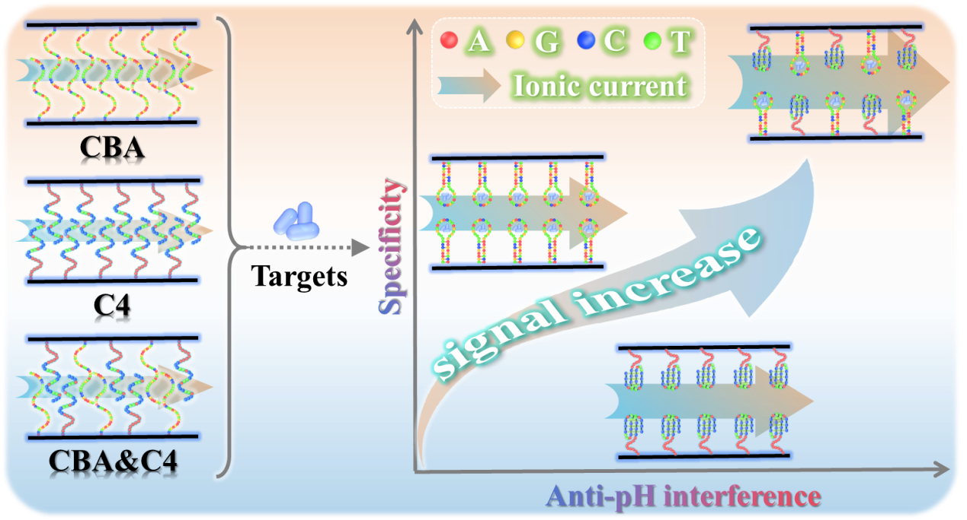
Figure S27. Schematic diagram of co-calibration of Cat and pH with dual-DNA probes N_{C}B_{S}.

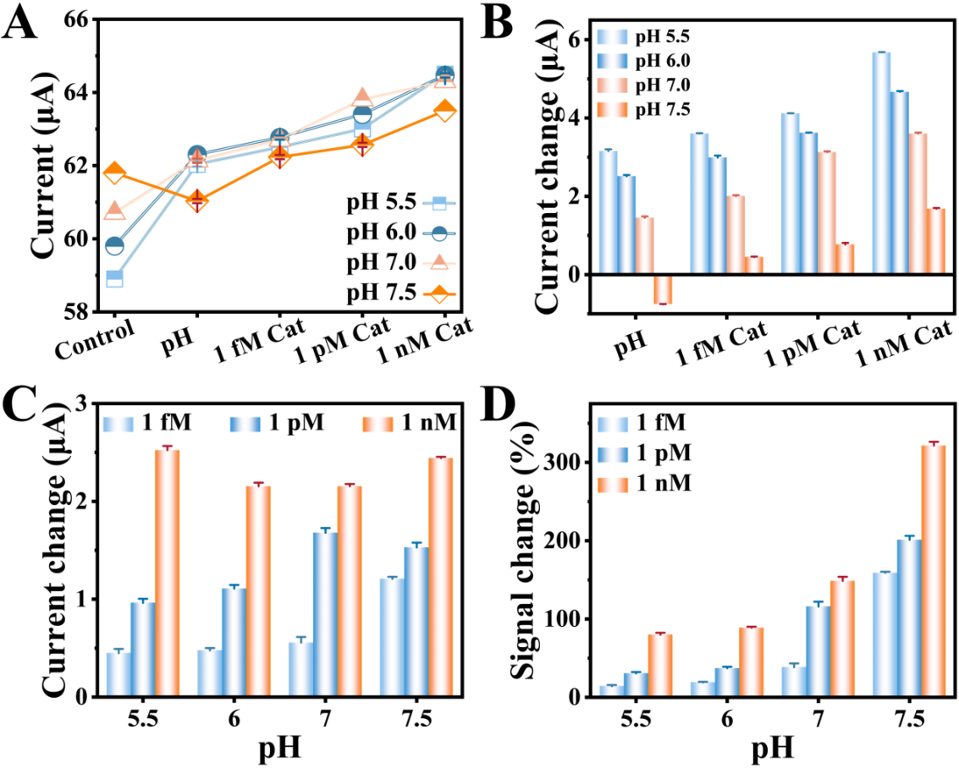
Figure S28. (A) Based on the I-V characteristics, transmembrane ionic current response of CBA&C4@AAO sensor under an applied voltage of +2 V for four different conditions. The control group is Tris-HCl (0.01 M) at pH 7.4. (B) Current changes of the sensor after recognition of target substances under four different conditions. (C) Current changes of the sensor after cathinone recognition at different concentrations (1 fM, 1 pM, and 1 nM) under four different pH values. (D) Signal changes of CBA&C4@AAO sensor after cathinone recognition at different concentrations under different pH conditions.

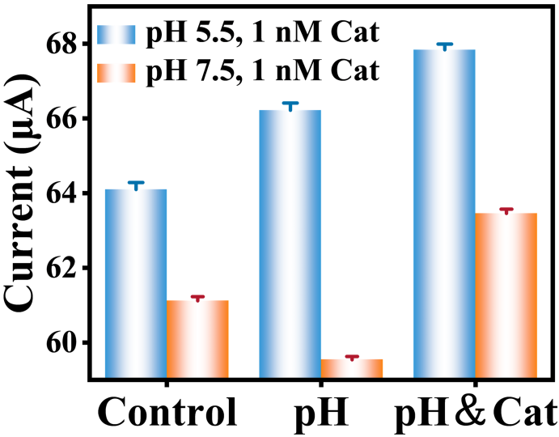
Figure S29. Orthogonal responsiveness of CBA&C4@AAO sensor towards the target substance cathinone and pH under four different conditions. These conditions include pH 5.5, pH 7.5, pH 5.5 with 1 nM cathinone, and pH 7.5 with 1 nM cathinone. The control group is the transmembrane electrical signal in a test environment with pH 7.4. The sensor was prepared based on asymmetric solution modification.

Research Progress on Cathinone Detection
Table S27. Different methods for detecting cathinone in recent years.
Detection method | Linear range | LOD  (ng/mL) | Ref.
Electrochemical | 1 - 104 nM | 0.027 | S1
LC-MS/MS | 0.22 - 2.31 ng/mL | 0.07 - 0.69 | S2
MIP | 2.0 - 12.0 μM | 4.76 | S3
HPLC-MS/MS | 7.46 - 149 ng/mL | 0.002 | S4
AIE-MIP | 2 - 12 μM | 7.74 | S5
EKS-CE | 15 - 250 ng/mL | 4 - 8 | S6
CE | 25 - 1000 ng/mL | 15 - 45 | S7
GC-MS | 2 - 50 ng/mL | 1 - 10 | S8
MIF-SPE | 1.5 × 10-5 - 1.1×10-2 μg/mL | 8.9×10-3 | S9
LC-QQQ-MS/MS | 1-10 ng/mL | 0.01 | S10
CBA@AAO | 1 - 104 fM | 5.93×10-8 | This work
CBA&C4@AAO | 0.1 - 107 fM | 1.87×10-7 | This work
CBA&C4@AAO (In artificial sweat) | 103 - 108 fM | 5.34×10-7 | This work

References
[S1] Zhang, X., Tang, Y., Wu, H. et al. Anal. Chem 94, 22, 7936-7943 (2022).
[S2] Hong, C., Yan, Y., Tu, T. et al. Efficient flat membrane based liquid phase microextraction of cathinones from environmental water and biological samples. Talanta Open 7, 100232 (2023).
[S3] Hu, R., Yan, Y., Jiang, L. et al. Determination of total cathinones with a single molecularly imprinted fluorescent sensor assisted by electromembrane microextraction. Microchim Acta 189, 324 (2022).
[S4] Han, C., Tan, D., Wang, Y. et al. Selective extraction of synthetic cathinones new psychoactive substances from wastewater, urine and cocktail using dummy molecularly imprinted polymers. J. Pharm. Biomed. Anal 215, 114765 (2022).
[S5] Yan, Y., Jiang, L., Zhang, S. et al. Specific “light-up” sensor made easy: An aggregation induced emission monomer for molecular imprinting. Biosens. Bioelectron 205, 114113 (2022).
[S6] Pérez-Alcaraz, A., Borrull, F., Aguilar, C. et al. An electrokinetic supercharging approach for the enantiodetermination of cathinones in urine samples by capillary electrophoresis. Microchem. J 158, 105300 (2020).
[S7] Pérez-Alcaraz, A., Borrull, F., Calull, M. et al. Field-amplified sample injection combined with CE for the enantiodetermination of cathinones in urine samples. J Sep Sci 43: 2914-2924 (2020).
[S8] Mercieca, G., Odoardi, S., Cassar, M. et al. Rapid and simple procedure for the determination of cathinones, amphetamine-like stimulants and other new psychoactive substances in blood and urine by GC-MS. J. Pharm. Biomed. Anal 149, 494-501 (2018).
[S9] Zang, D., Yan, M., Ge, S. et al. A disposable simultaneous electrochemical sensor array based on a molecularly imprinted film at a NH₂-graphene modified screen-printed electrode for determination of psychotropic drugs. Analyst 138, 2704 (2013).
[S10] Swortwood, M.J., Boland, D.M., & DeCaprio, A.P. Determination of 32 cathinone derivatives and other designer drugs in serum by comprehensive LC-QQQ-MS/MS analysis. Anal Bioanal Chem 405, 1383-1397 (2013).

