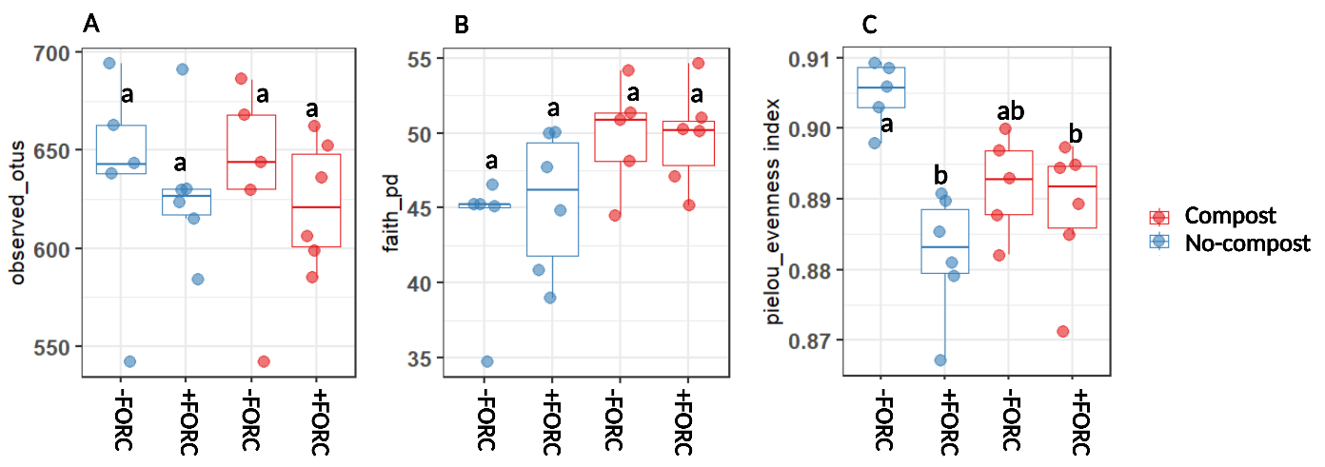

Figure S1. Alpha diversity (observed OTUs) (A), Faith’s phylogenetic diversity (B) and Pielou evenness index (C) of bacterial 16s rRNA communities in the rhizosphere of compost amended and non-amended plants with and without FORC inoculation. Different letters indicate statistically significant differences obtained by multiple comparison of all pairs of means (Tukey HSD test, P < 0.05).

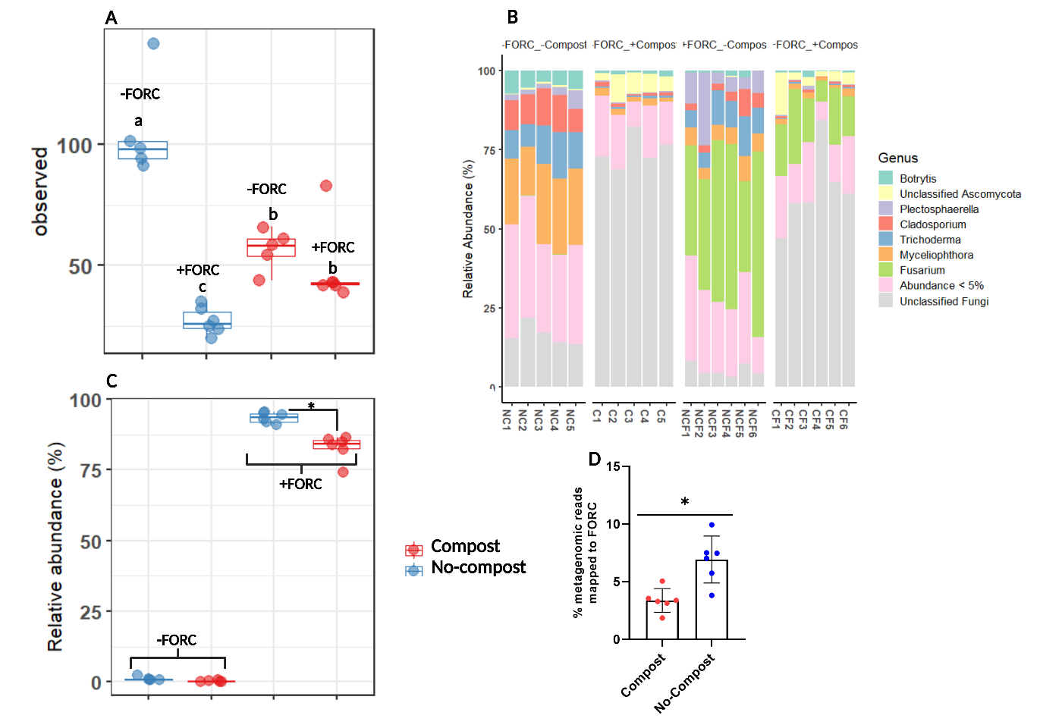
Figure S2. (A) Alpha diversity (observed OTUs) of fungal communities in the rhizosphere of compost amended and non-amended plants with and without FORC inoculation. Different letters indicate statistically significant differences obtained by multiple comparison of all pairs of means (Tukey HSD test, P < 0.05). (B) relative abundance of fungal ITS ASVs taxonomically classified to genus level, (C) relative abundance of ITS ASV taxonomically classified as Fusarium genus and most abundant in FORC-inoculated samples with and without compost, (D) percentage of shotgun metagenomics reads mapped to the genome of F. oxysporum f. sp. radicis-cucumerinum (FORC) (Student’s t-test, P < 0.05).

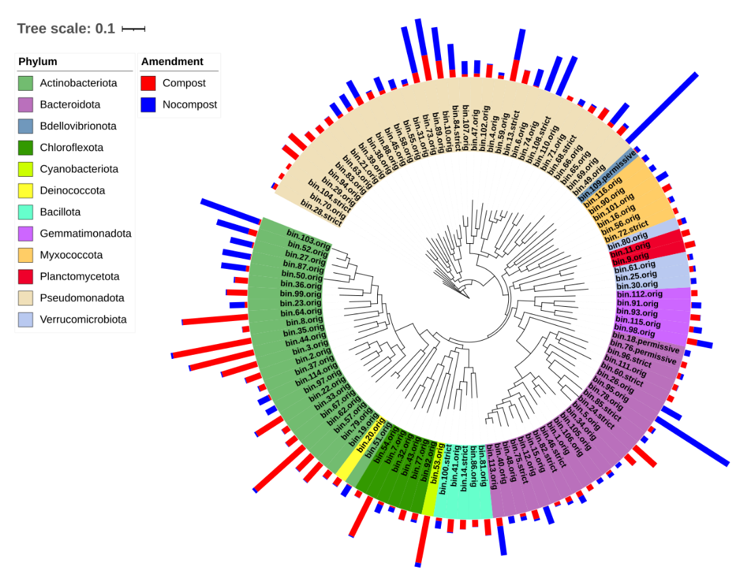
Figure S3. Abundance of bins assembled from FORC-inoculated, compost amended and non-amended samples. Abundances are expressed as genome copies per million reads (determined by Quant_bins module of the metaWrap pipeline. For amendment group, abundance represents an average of 6 samples in each group. The phylogenetic tree was constructed using PhyloPhlAn 3.0 (Asnicar et al., 2020) and visualized using iTOL (Letunic & Bork, 2024).

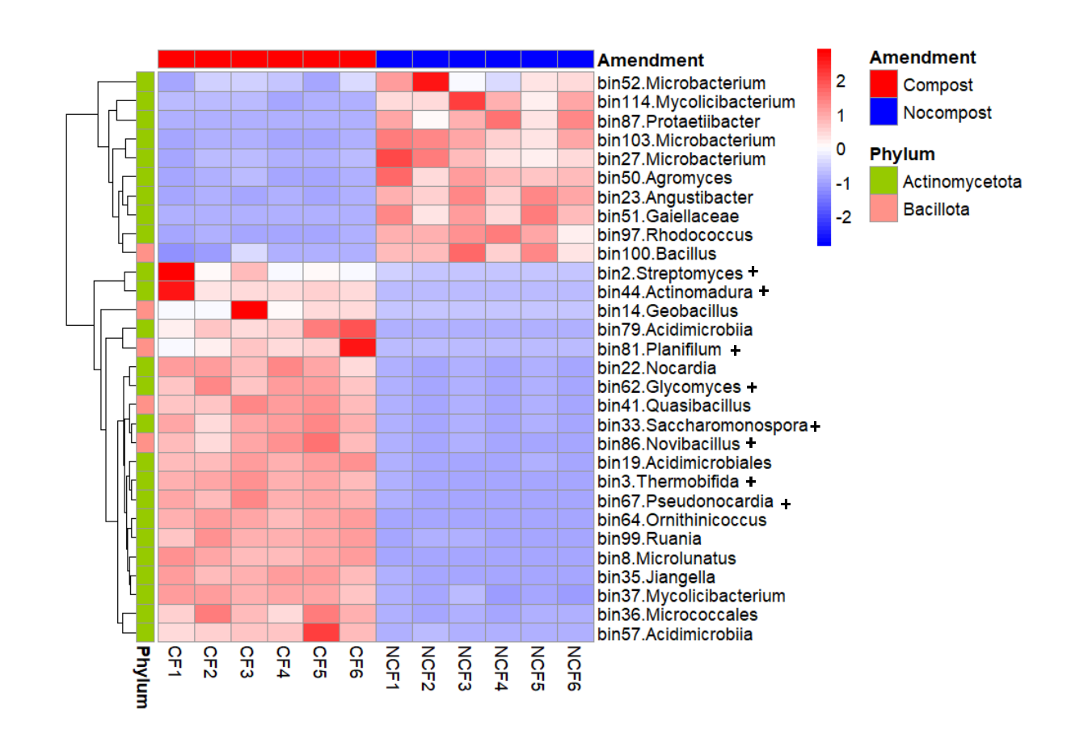
Figure S4. Z-score normalized abundance of Actinomycetota and Bacillota associated MAGs assembled from FORC-inoculated, compost amended and non-amended samples and classified to genus level using GTDB-Tk classify workflow (A). Abundances are expressed as genome copies per million reads (determined by Quant_bins module of the metaWrap pipeline.

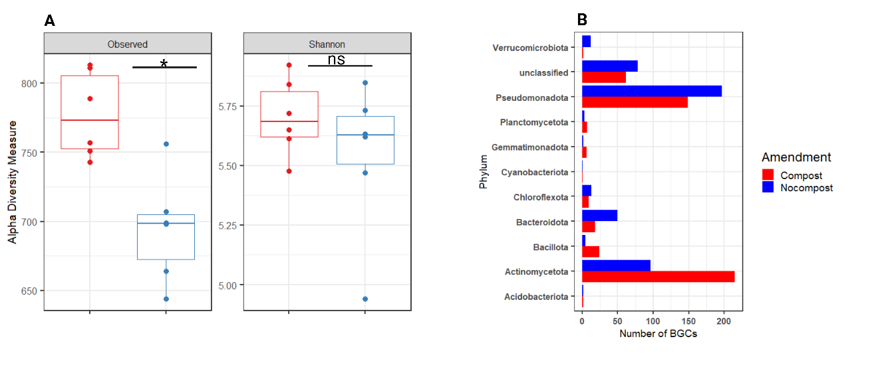
Figure S5. Alpha diversity (observed and shannon) (A) of BGCs identified in the rhizosphere metagenomes of FORC-inoculated compost amended and non-amended plants. * = significant, BH (Benjamini–Hochberg) adjusted P < 0.05 (Wilcoxon test). Phylum-level taxonomy of identified (by antiSMASH-V6.0) secondary metabolite-encoding biosynthetic gene clusters (BGCs) based on analysis of shotgun metagenome contigs (>5kbp) from compost-amended and non-amended FORC-inoculated cucumber rhizosphere samples (B).

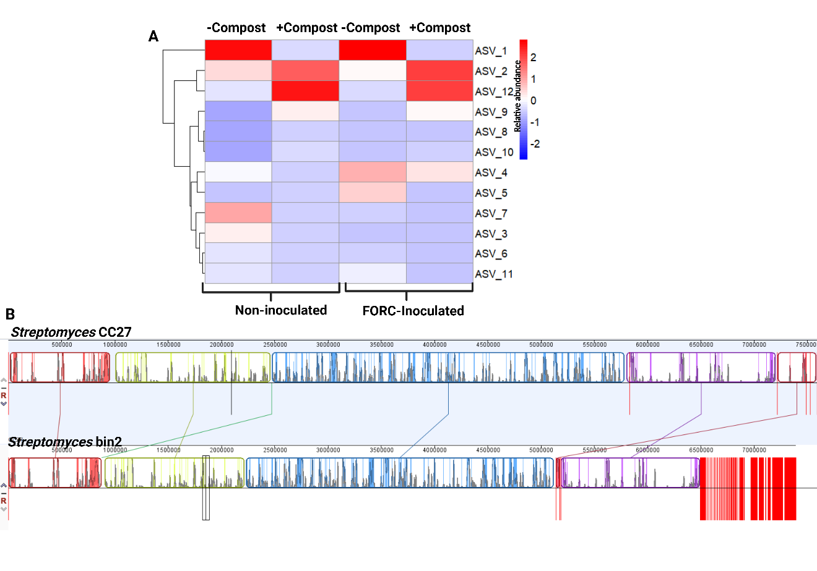
Figure S6. (A) Relative abundance(z-score normalized) of 16S rRNA gene amplicon ASVs classified as Streptomyces. Relative abundance is based on 16S rRNA gene amplicon count table for all samples. (B) Mauve Contig Mover (MCM) alignment of the Streptomyces CC7 genome and the Streptomyces bin2. Contigs are reordered using the Streptomyces CC7 genome as the reference.

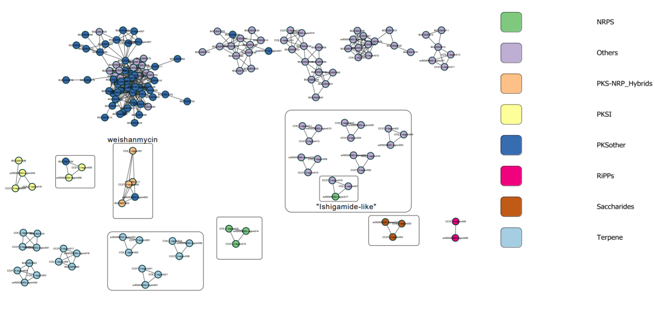
Figure S7. BiG-SCAPE network of BGCs identified in Streptomyces isolates (CC6 and CC27) and bin2 genomes in comparison to the known BGCs in the MiBIG database. BiG-SCAPE cutoff = 0.5.

