S.1 Technical information of sensors utilised
Table S1: Type and specifications of the reference instruments employed at the Nicosia traffic air quality monitoring station.
 | CO | NO_{y} | O₃ | PM
Model | Ecotech Serinus 30 | Ecotech Serinus 40 | Thermo Scientific 49i | TEOM Model: 1405-DF
Method | infrared spectroscopy | Chemiluminescence | ultraviolet photometry | TEOM Model: 1405-DF
Sample flow rate | 1.0 slpm | 0.3 slpm (0.6 slpm total flow for the NO and NOX flow path) | 1–3 LPM | PM_{2.5} : 3 LPM,  PM_{coarse} : 1.67 LPM, Bypass flow rate: 12 LPM
Precision | 20 ppb or 0.1% of reading, whichever is greater | 0.4 ppb otherwise 0.5% of reading, whichever is greater | – | ±2.0 μg/m³ (1-hour avg)
Linearity | Better than ±1% of full scale (0-50 ppm); ±2% of full scale (0-200 ppm), from best straight-line fit | ±1% of full scale | ± 1% of full-scale
Response time | 60 seconds to 95% | 15 seconds to 90% | 20 seconds (10 seconds lag time)
Lower detectable limit | 40 ppb | 0.4 ppb | 1.0 ppb | <5 μg/m³

Table S2: Type and specifications of the reference instruments employed at CyI CAO air quality monitoring station.
 | CO | NO₂ | O₃ | PM
Model  Method | Teledyne Model T300, Gas Filter Correlation | Teledyne Model T500U, Cavity Attenuated Phase Shift (CAPS) | Teledyne Model T400  UV absorption | TEOM Model: 1405-DF
Sample flow rate | 800 cc/min ±10% | 900 cc​/min ±10% | 800 cc/min ±10% | PM_{2.5} : 3 LPM,  PM_{coarse} : 1.67 LPM, Bypass flow rate: 12 LPM
Precision | 0.5% of reading above 5 ppm | 0.5% of reading above 5 ppb | 0.5% of reading above 100 ppb | ±2.0 μg/m³ (1-hour avg)
Linearity | 1% of full scale | 1% of full scale | 1% of full scale
Response time | < 70 seconds to 95% | < 40 seconds to 95% | < 30 seconds to 95%
Lower detectable limit | < 0.04 ppm | < 40 ppt | < 0.4 ppb with 80 Sample Digital Filter​ | <5 μg/m³

S.2 Data processing:
Reference gas measurements from TRS which are originally provided in μg/m³ units, are converted into ppb units using:
$$C_{gas_ppb}= C_{gas_μg/m^{3} }* (273.2 + T))/(12.187*M);$$
where $C_{gas_ppb}$ is the concentration in ppb units, $C_{gas_μg/m^{3} }$is the gas concentration in μg/m3 units, T is the temperature in °C and M is the molecular weight in g/mol units of each gas. No further processing is applied on the data.
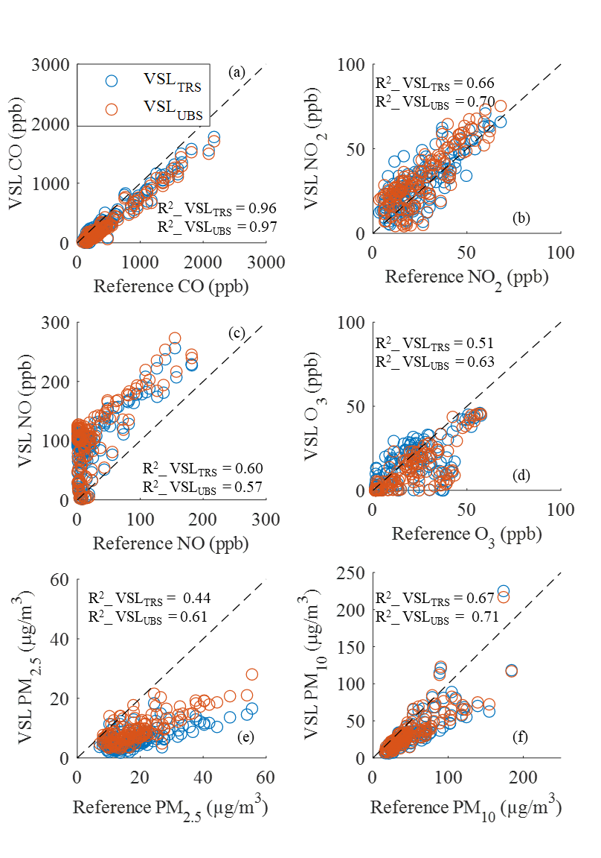
Figure S1: Correlation between hourly averaged measurements recorded by the VSL_{TRS} (blue color) and VSL_{UBS} (orange color) and those provided by the respective reference instruments during the co-location week. The black dashed lines indicate the 1:1 line.

S.3 Overall performance
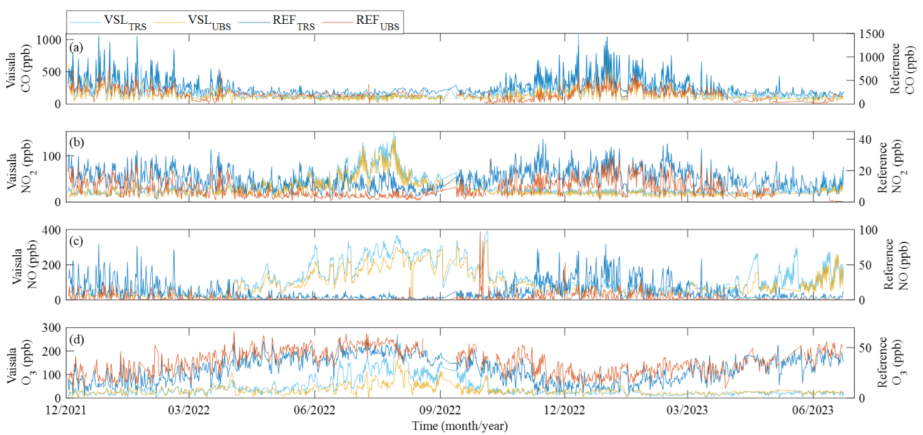
Figure S2: Time series of 12-hours averaged concentrations measured by the VSL_{TRS} and VSL_{UBS} gas sensors for CO (a), NO₂ (b), NO (c) and O₃ (d) for the whole measurement period. The VSL_{TRS} and VSL_{UBS} measurements are plotted on the left y-axis while the ones from the reference instruments (i.e. REF_{TRS}, REF_{UBS}) are plotted on the right y-axis.
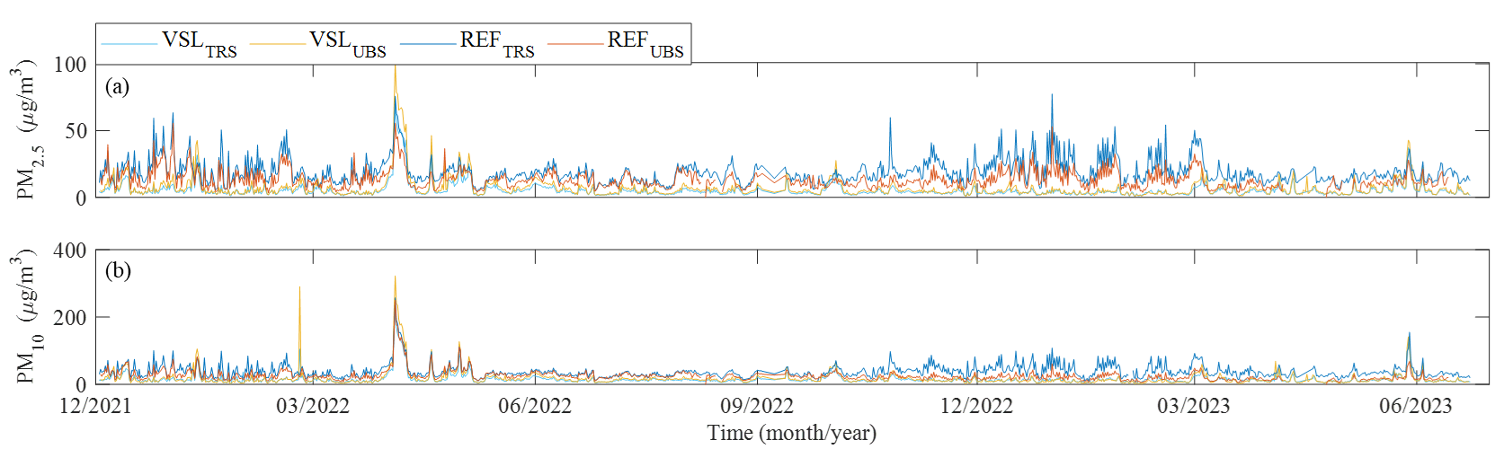
Figure S3: Time series of 12-hours averaged concentrations measured by the VSL_{TRS} and VSL_{UBS} PM sensors for PM_{2.5} (a), PM₁₀ (b) mass fractions for the whole measurement period.
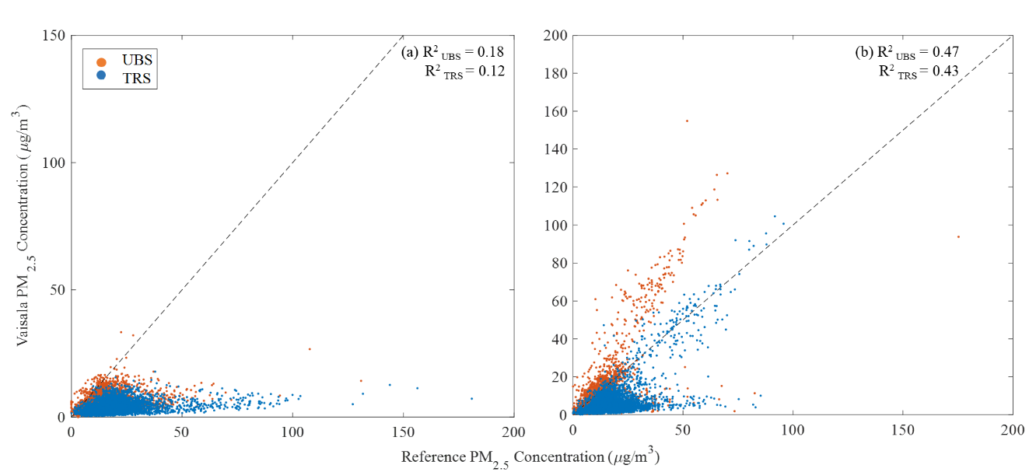
Figure S4: Correlation between hourly averaged PM_{2.5} measurements recorded by the AQTs at the two stations and those provided by the respective reference instruments during the (a) non-dust periods (i.e. summer and winter) and (b) dust periods (i.e. spring and autumn). The black dashed lines indicate the 1:1 line.
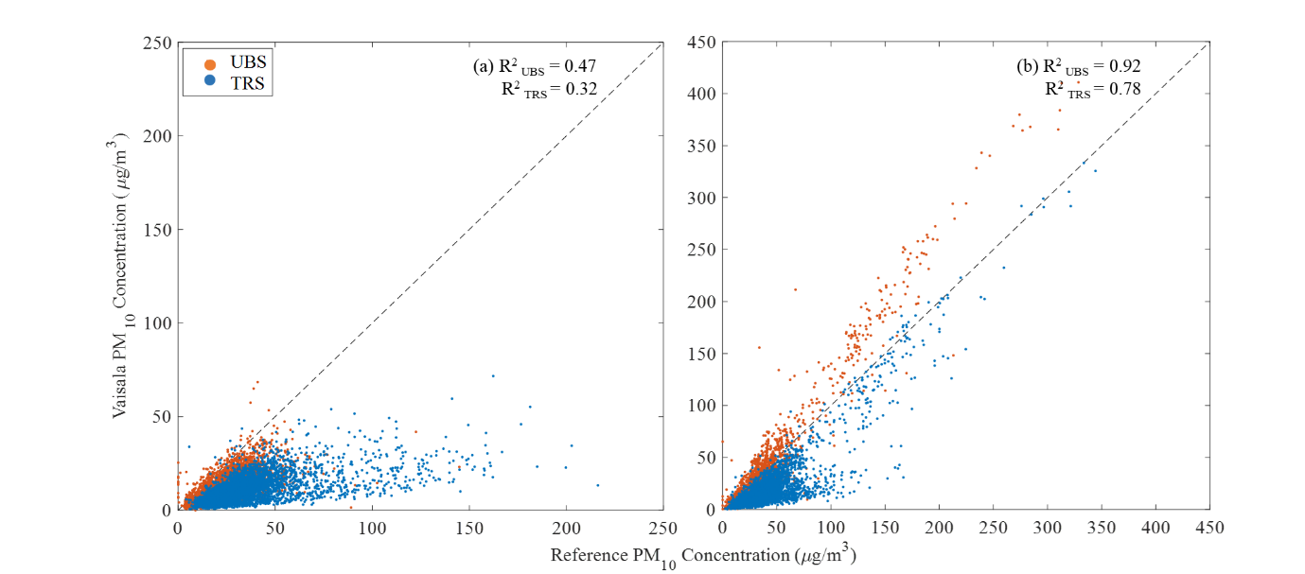
Figure S5: Correlation between hourly averaged PM₁₀ measurements recorded by the AQTs at the two stations and those provided by the respective reference instruments during the (a) non-dust periods (i.e. summer and winter) and (b) dust periods (i.e. spring and autumn). The black dashed lines indicate the 1:1 line.
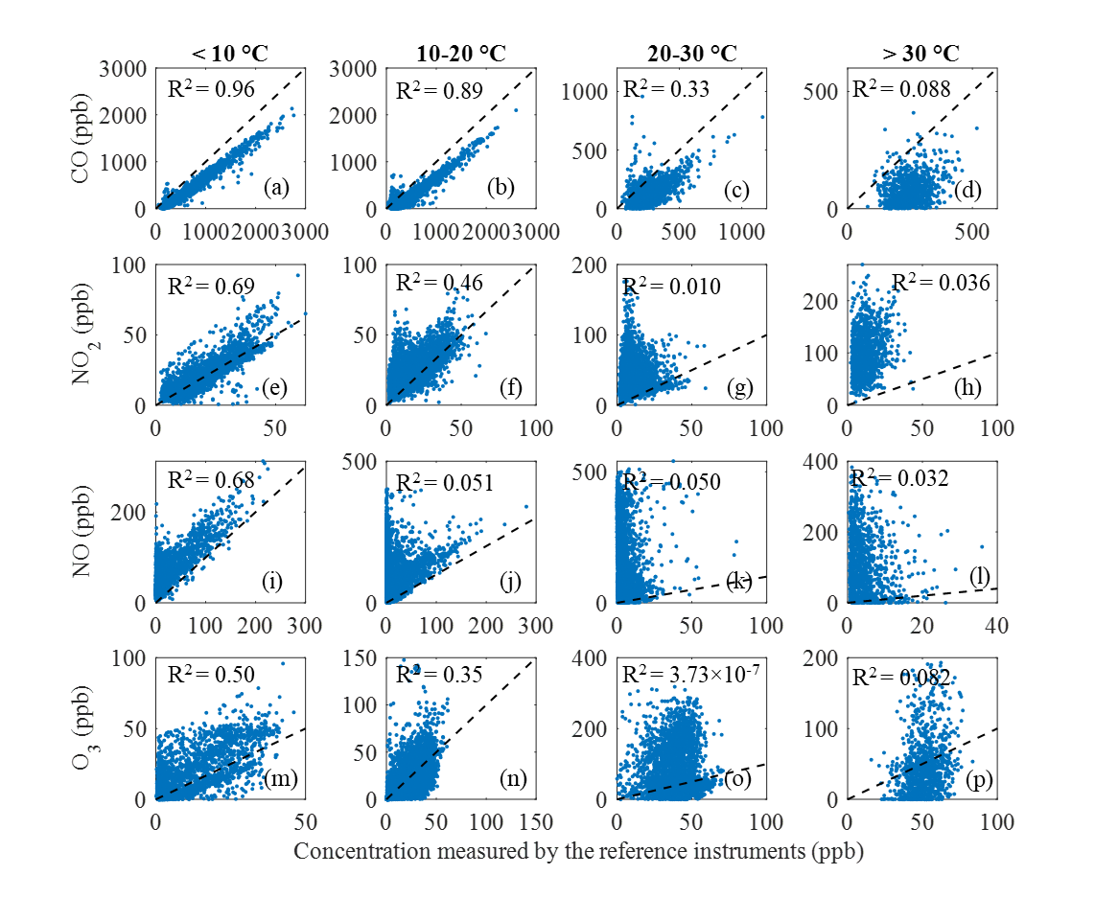
Figure S6: Correlation between the measurements recorded by the VSL_{TRS} gas sensors, and those provided by the respective reference instruments at four different temperature ranges. The 1:1 lines for each subplot are depicted as dashed lines.
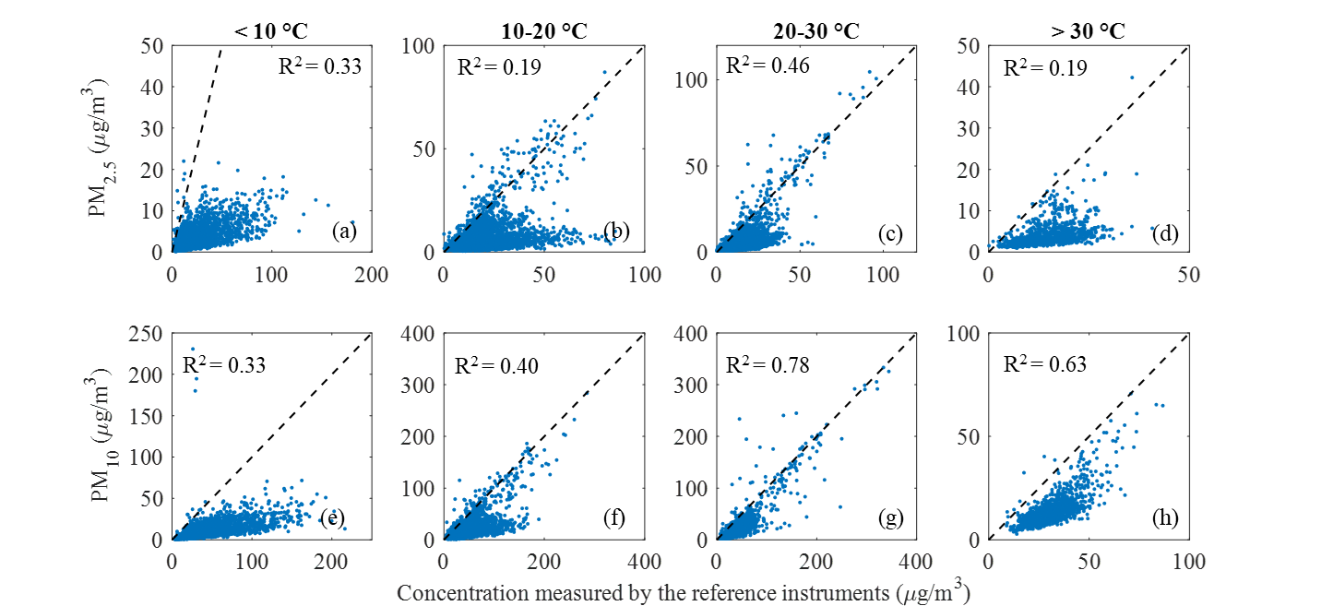
Figure S7: Correlation between the mass concentration measurements recorded by the VSL_{TRS} particle sensor, and those provided by the respective reference instruments at four different temperature ranges. The 1:1 lines for each subplot are depicted as dashed lines.

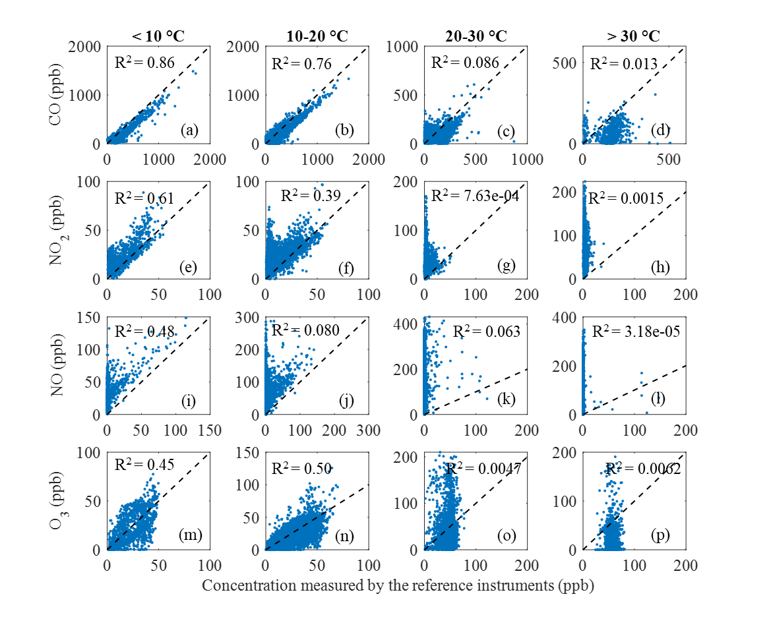
Figure S8: Correlation between the measurements recorded by the VSL_{UBS} gas sensors, and those provided by the respective reference instruments at four different temperature ranges. The 1:1 lines for each subplot are depicted as dashed lines.
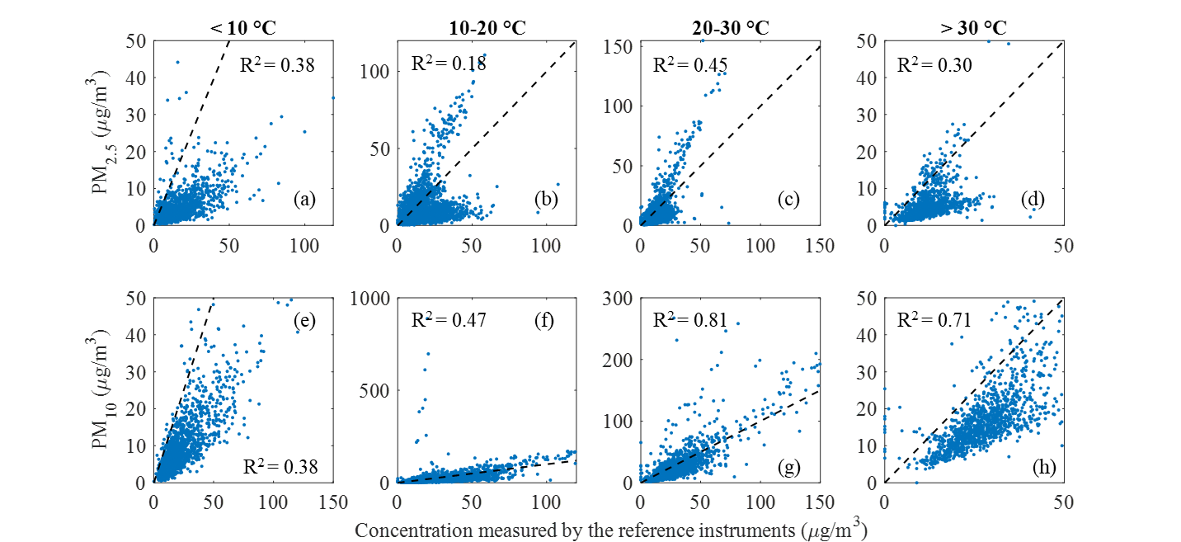
Figure S9: Correlation between the mass concentration measurements recorded by the VSL_{UBS} particle sensor, and those provided by the respective reference instruments at four different temperature ranges. The 1:1 lines for each subplot are depicted as dashed lines.

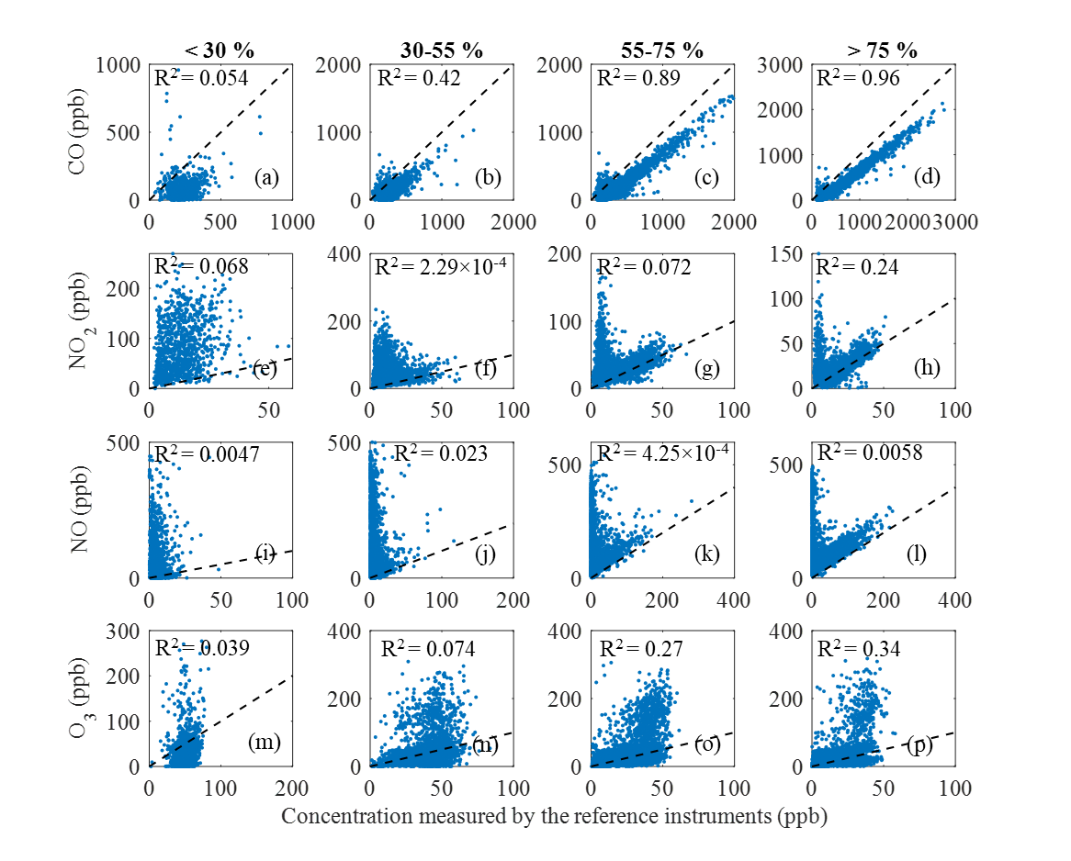
Figure S10: Correlation between the measurements recorded by the VSL_{TRS} gas sensors and those provided by the respective reference instruments at four different RH ranges. The 1:1 lines for each subplot are depicted as dashed lines.
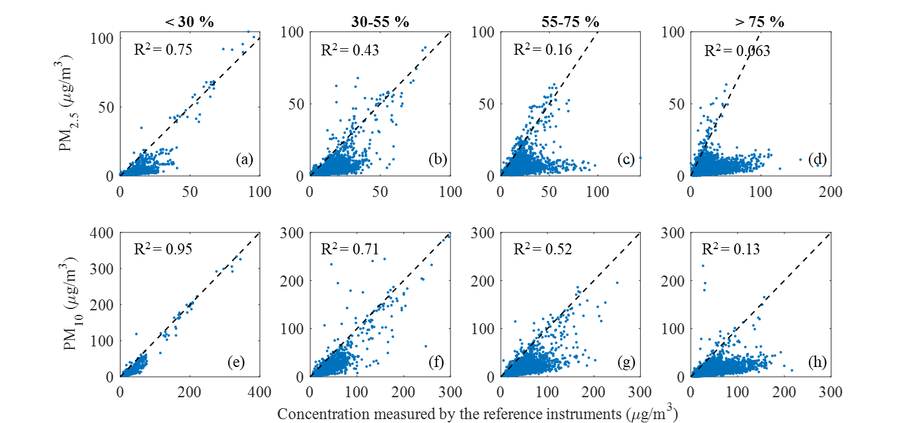
Figure S11: Correlation between the mass concentration measurements recorded by the VSL_{TRS} particle sensor, and those provided by the respective reference instruments at four different RH ranges. The 1:1 lines for each subplot are depicted as dashed lines.

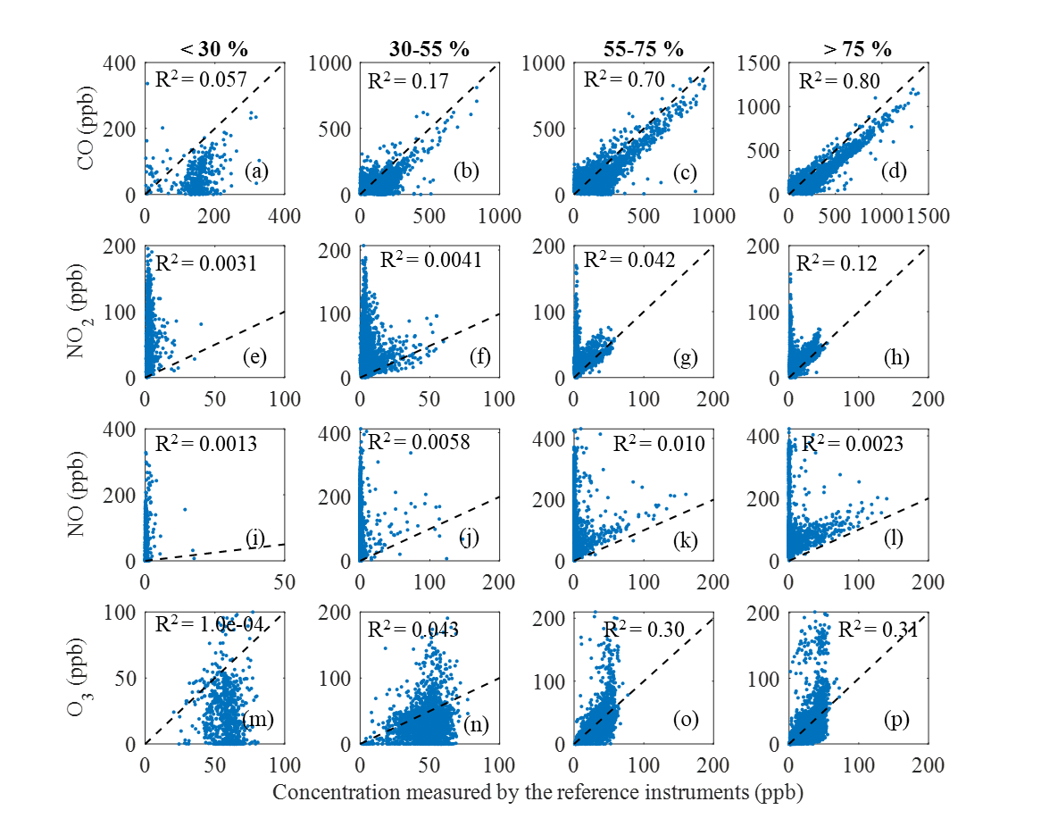
Figure S12: Correlation between the measurements recorded by the VSL_{UBS} gas sensors and those provided by the respective reference instruments at four different RH ranges. The 1:1 lines for each subplot are depicted as dashed lines.
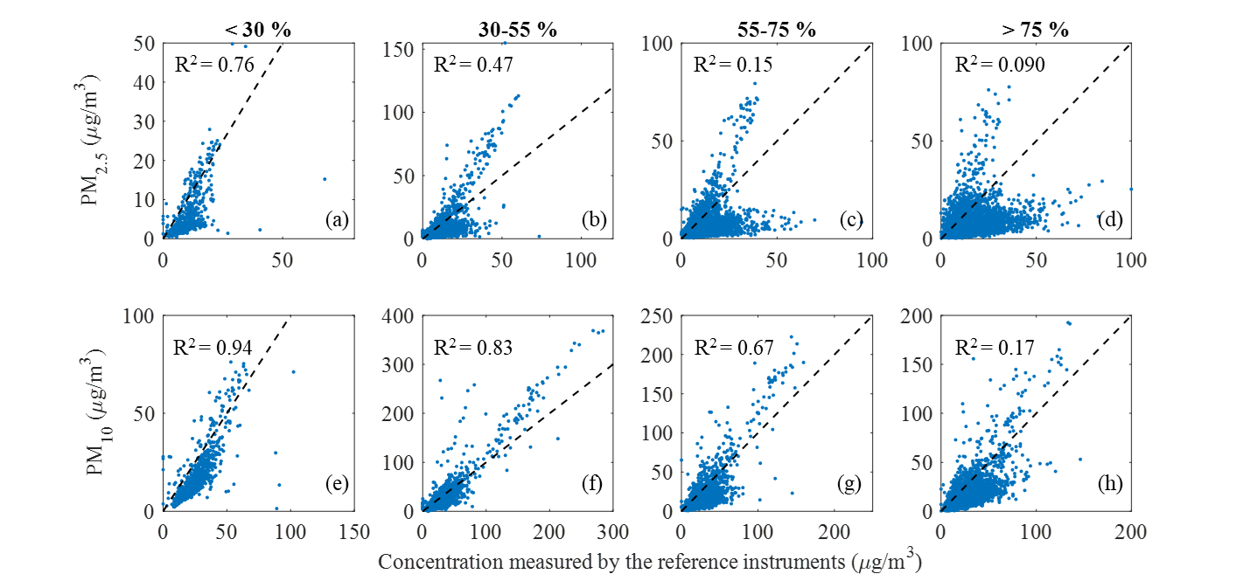
Figure S13: Correlation between the mass concentration measurements recorded by the VSL_{UBS} particle sensor and those provided by the respective reference instruments at four different RH ranges. The 1:1 lines for each subplot are depicted as dashed lines.

S.4 Significance of the difference between observations of the two stations
The Wilcoxon rank sum test method is a non-parametric test for two paired populations (x,y) assuming they are randomly and independently distributed. It returns the p-value for the null hypothesis that data in x and y are samples from continuous distributions with equal medians, against the alternative that they are not. The Wilcoxon rank sum test relies on the z-statistic defined as:
$$z=\frac{W-\frac{n(n+1)}{4}}{\sqrt{\frac{n(n+1)(2n+1)}{24}}},$$
where n is the sample size of the difference (x–y) and W is calculated using the following procedure: (1) Calculate the absolute difference between the two measurements ($\left|D_{i}\right|$), (2) Assign ranks from 1 to n to each $\left|D_{i}\right|$ such that the smallest absolute difference score gets rank 1 and the largest gets rank n, (3) Reassign the symbol "+" or "–" to each of the n ranks, depending on whether Di was originally positive or negative, (4) Calculate the sum of the positive ranks (W+) and the sum of the negative ranks (W-). W is the smaller value of W+ and W-. The calculated z value is then compared against a critical z value obtained from the so-called z-table. If the calculated z is less or equal to z-critical then the null hypothesis is rejected implying significant difference between the two populations (p<0.05).

Entire period
Table S3: Wilcoxon rank sum test results. Orange-coloured cells indicate p values >0.05, indicative of rejecting the null hypothesis of the test.
 | Reference measurements |  |  | AQT measurements
 | p value | Significant difference  (P<0.05) | p value |  | Significant difference  (P<0.05)
CO | 0 | true | $$9.9×{10}^{-142}$$ |  | true
NO₂ | 0 | true | $$3.8×{10}^{-99}$$ |  | true
NO | 0 | true | $$3.3×{10}^{-68}$$ |  | true
O₃ | $$8.3×{10}^{-316}$$ | true | $$7.0×{10}^{-12}$$ |  | true
PM_{2.5} | 0 | true | $$7.9×{10}^{-117}$$ |  | true
PM₁₀ | 0 | true | $$2.0×{10}^{-14}$$ |  | true

Monthly variabilities
Table S4: CO Wilcoxon rank sum test results. Orange-coloured cells indicate p values >0.05, indicative of rejecting the null hypothesis of the test.
 | Reference measurements |  |  | AQT measurements
 | p value | Significant difference  (P<0.05) | p value |  | Significant difference  (P<0.05)
Dec. 2021 | $$1.1×{10}^{-17}$$ | true | $$3.2×{10}^{-07}$$ |  | true
Jan. 2022 | $$1.9×{10}^{-36}$$ | true | $$1.9×{10}^{-11}$$ |  | true
Feb. 2022 | $$4.1×{10}^{-68}$$ | true | $$1.8×{10}^{-10}$$ |  | true
Mar. 2022 | $$2.2×{10}^{-96}$$ | true | $$1.6×{10}^{-12}$$ |  | true
Apr. 2022 | $$3.2×{10}^{-52}$$ | true | $$1.0×{10}^{-06}$$ |  | true
May 2022 | $$1.3×{10}^{-57}$$ | true | $$4.4×{10}^{-05}$$ |  | true
Jun. 2022 | $$1.3×{10}^{-26}$$ | true | $$3.2×{10}^{-04}$$ |  | true
Jul. 2022 | $$1.6×{10}^{-30}$$ | true | $$5.2×{10}^{-01}$$ |  | false
Aug. 2022 | $$5.5×{10}^{-89}$$ | true | $$6.8×{10}^{-01}$$ |  | false
Sept. 2022 | $$1.3×{10}^{-84}$$ | true | $$6.7×{10}^{-05}$$ |  | true
Oct. 2022 | $$2.6×{10}^{-142}$$ | true | $$3.5×{10}^{-11}$$ |  | true
Nov. 2022 | $$4.4×{10}^{-126}$$ | true | $$1.0×{10}^{-19}$$ |  | true
Dec. 2022 | $$1.1×{10}^{-44}$$ | true | $$1.8×{10}^{-16}$$ |  | true
Jan. 2023 | $$3.0×{10}^{-48}$$ | true | $$3.1×{10}^{-15}$$ |  | true
Feb. 2023 | $$3.3×{10}^{-73}$$ | true | $$8.3×{10}^{-25}$$ |  | true
Mar. 2023 | $$1.3×{10}^{-17}$$ | true | $$9.3×{10}^{-14}$$ |  | true
Apr. 2023 | $$1.1×{10}^{-163}$$ | true | $$5.2×{10}^{-14}$$ |  | true
May 2023 | $$1.9×{10}^{-121}$$ | true | $$1.0×{10}^{-17}$$ |  | true
Jun. 2023 | $$1.4×{10}^{-92}$$ | true | $$2.5×{10}^{-12}$$ |  | true

Table S5: PM₁₀ Wilcoxon rank sum test results. Orange-coloured cells indicate p values >0.05, indicative of rejecting the null hypothesis of the test.
 | Reference measurements |  |  | AQT measurements
 | p value | Significant difference  (P<0.05) | p value |  | Significant difference  (P<0.05)
Dec. 2021 | $$5.6×{10}^{-14}$$ | true | $$4.2×{10}^{-01}$$ |  | false
Jan. 2022 | $$3.5×{10}^{-18}$$ | true | $$7.2×{10}^{-02}$$ |  | true
Feb. 2022 | $$3.8×{10}^{-29}$$ | true | $$7.0×{10}^{-01}$$ |  | false
Mar. 2022 | $$1.2×{10}^{-35}$$ | true | $$3.1×{10}^{-01}$$ |  | false
Apr. 2022 | $$2.8×{10}^{-06}$$ | true | $$1.0×{10}^{-07}$$ |  | true
May 2022 | $$1.4×{10}^{-06}$$ | true | $$3.3×{10}^{-15}$$ |  | true
Jun. 2022 | $$5.2×{10}^{-09}$$ | true | $$1.0×{10}^{-14}$$ |  | true
Jul. 2022 | $$8.8×{10}^{-05}$$ | true | $$4.0×{10}^{-29}$$ |  | true
Aug. 2022 | $$1.2×{10}^{-31}$$ | true | $$4.4×{10}^{-34}$$ |  | true
Sept. 2022 | $$1.5×{10}^{-36}$$ | true | $$3.2×{10}^{-07}$$ |  | true
Oct. 2022 | $$2.8×{10}^{-77}$$ | true | $$1.5×{10}^{-06}$$ |  | true
Nov. 2022 | $$2.8×{10}^{-133}$$ | true | $$7.2×{10}^{-02}$$ |  | false
Dec. 2022 | $$2.3×{10}^{-121}$$ | true | $$1.4×{10}^{-03}$$ |  | true
Jan. 2023 | $$1.2×{10}^{-69}$$ | true | $$4.6×{10}^{-03}$$ |  | true
Feb. 2023 | $$6.3×{10}^{-98}$$ | true | $$3.4×{10}^{-09}$$ |  | true
Mar. 2023 | $$2.4×{10}^{-132}$$ | true | $$4.3×{10}^{-01}$$ |  | false
Apr. 2023 | $$1.6×{10}^{-87}$$ | true | $$3.7×{10}^{-01}$$ |  | false
May 2023 | $$4.2×{10}^{-129}$$ | true | $$6.2×{10}^{-01}$$ |  | false
Jun. 2023 | $$9.1×{10}^{-64}$$ | true | $$1.5×{10}^{-04}$$ |  | true

Hour-of-the-day (diurnal) variabilities
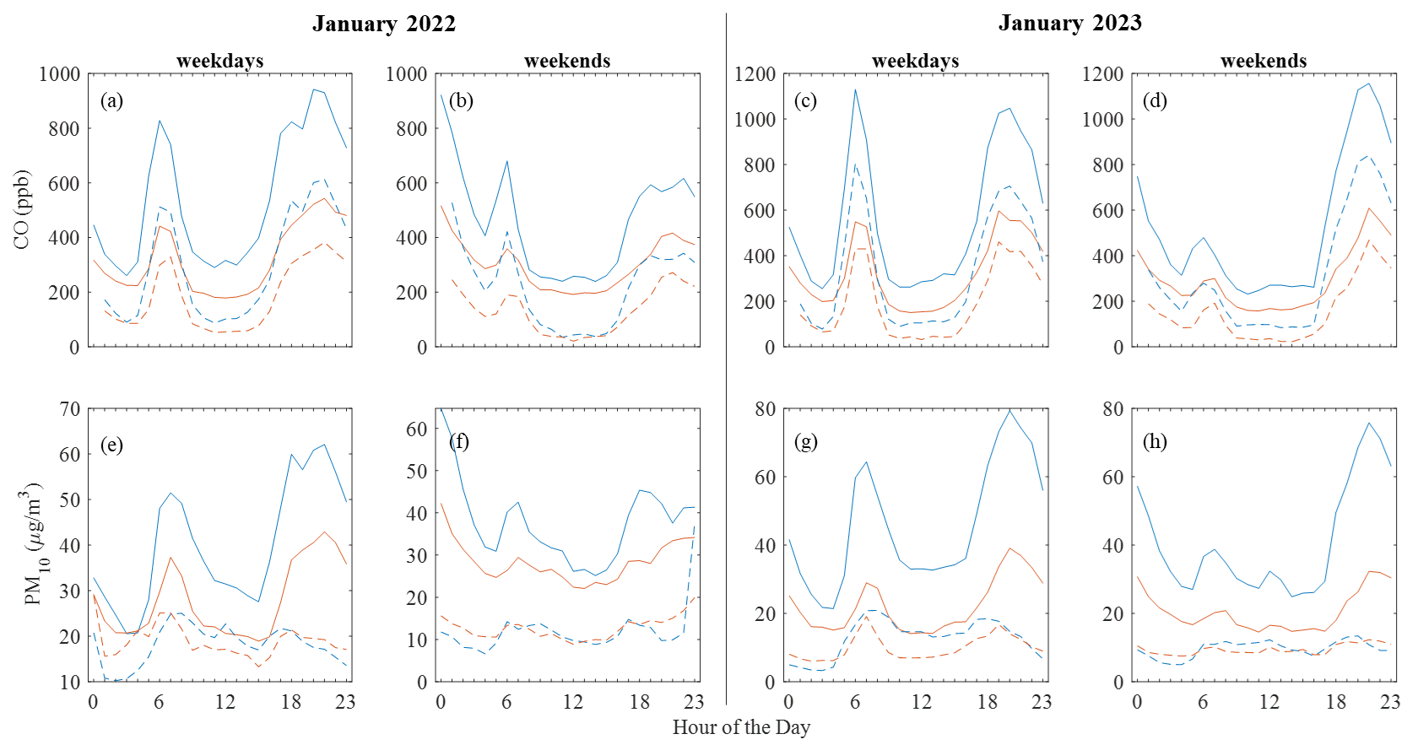
Figure S14: Diurnal variability of CO (a-d) and PM₁₀ (e-h), for January 2022 (left column) and January 2023 (right column) measurements determined by the reference instrument (solid lines) and Vaisala AQT sensor (dashed lines) at the two stations. The plots show the mean for each hour of the day. The blue and orange lines correspond to measurements at TRS and UBS stations respectively.
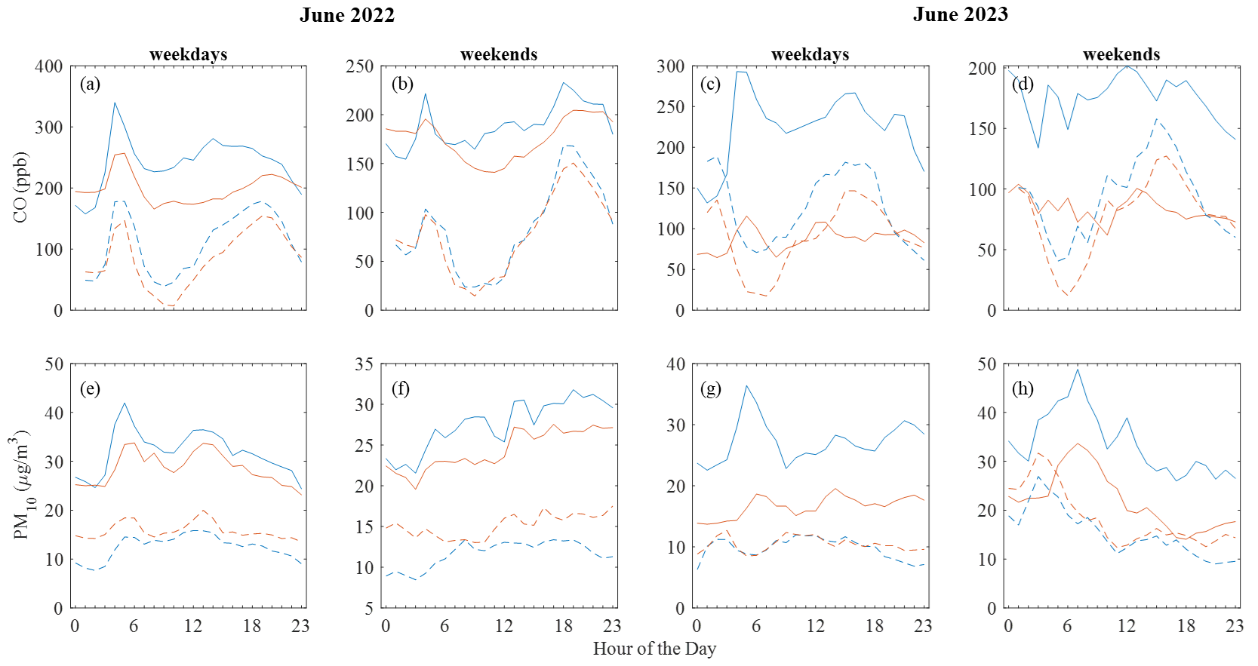
Figure S15: Diurnal variability of CO (a-d) and PM₁₀ (e-h) for June 2022 (left column) and June 2023 (right column) measurements determined by the reference instrument (solid lines) and Vaisala AQT sensor (dashed lines) at the two stations. The plots show the mean for each hour of the day. The blue and orange lines correspond to measurements at TRS and UBS stations respectively.

Table S6: CO Wilcoxon rank sum test results. Orange-coloured cells indicate p values >0.05, indicative of rejecting the null hypothesis of the test.
 | Reference measurements |  |  |  | AQT measurements
 | June 2022 - 2023 |  | January 2022 - 2023 |  | June 2022 - 2023 |  |  | January 2022 - 2023
 | p value |  | p value |  | p value |  |  | p value
Hour | workdays | weekends | workdays | weekends | workdays | weekends | workdays |  | weekends
0 | $$5.6×{10}^{-01}$$ | $$7.3×{10}^{-01}$$ | $$2.1×{10}^{-02}$$ | $$9.6×{10}^{-02}$$ | $$2.3×{10}^{-01}$$ | $$3.5×{10}^{-01}$$ | $$3.0×{10}^{-01}$$ |  | $$1.9×{10}^{-01}$$
1 | $$9.7×{10}^{-02}$$ | $$8.7×{10}^{-01}$$ | $$1.6×{10}^{-01}$$ | $$1.2×{10}^{-01}$$ | $$6.9×{10}^{-01}$$ | $$8.4×{10}^{-01}$$ | $$4.9×{10}^{-01}$$ |  | $$1.9×{10}^{-01}$$
2 | $$4.6×{10}^{-01}$$ | $$9.5×{10}^{-01}$$ | $$5.2×{10}^{-02}$$ | $$1.4×{10}^{-01}$$ | $$4.9×{10}^{-01}$$ | $$6.6×{10}^{-01}$$ | $$8.5×{10}^{-01}$$ |  | $$3.2×{10}^{-01}$$
3 | $$2.1×{10}^{-02}$$ | $$7.7×{10}^{-01}$$ | $$1.3×{10}^{-02}$$ | $$3.7×{10}^{-01}$$ | $$1.2×{10}^{-02}$$ | $$6.6×{10}^{-01}$$ | $$8.5×{10}^{-01}$$ |  | $$1.9×{10}^{-01}$$
4 | $$4.8×{10}^{-07}$$ | $$3.5×{10}^{-01}$$ | $$2.0×{10}^{-06}$$ | $$9.0×{10}^{-02}$$ | $$1.7×{10}^{-03}$$ | $$8.9×{10}^{-01}$$ | $$2.5×{10}^{-03}$$ |  | $$1.5×{10}^{-01}$$
5 | $$2.5×{10}^{-06}$$ | $$4.8×{10}^{-01}$$ | $$1.9×{10}^{-09}$$ | $$7.1×{10}^{-04}$$ | $$2.5×{10}^{-02}$$ | $$5.1×{10}^{-01}$$ | $$9.9×{10}^{-07}$$ |  | $$1.3×{10}^{-03}$$
6 | $$3.9×{10}^{-06}$$ | $$8.3×{10}^{-01}$$ | $$5.9×{10}^{-07}$$ | $$2.2×{10}^{-03}$$ | $$8.8×{10}^{-06}$$ | $$8.9×{10}^{-03}$$ | $$1.4×{10}^{-04}$$ |  | $$2.9×{10}^{-03}$$
7 | $$1.5×{10}^{-08}$$ | $$1.0×{10}^{-01}$$ | $$7.9×{10}^{-05}$$ | $$3.3×{10}^{-02}$$ | $$9.9×{10}^{-08}$$ | $$1.0×{10}^{-02}$$ | $$1.1×{10}^{-02}$$ |  | $$4.1×{10}^{-02}$$
8 | $$1.6×{10}^{-10}$$ | $$6.9×{10}^{-02}$$ | $$2.1×{10}^{-06}$$ | $$5.8×{10}^{-02}$$ | $$6.4×{10}^{-04}$$ | $$8.5×{10}^{-01}$$ | $$5.3×{10}^{-04}$$ |  | $$3.3×{10}^{-02}$$
9 | $$5.0×{10}^{-08}$$ | $$1.3×{10}^{-01}$$ | $$1.8×{10}^{-10}$$ | $$1.7×{10}^{-02}$$ | $$1.9×{10}^{-02}$$ | $$5.7×{10}^{-01}$$ | $$7.5×{10}^{-07}$$ |  | $$9.4×{10}^{-03}$$
10 | $$3.4×{10}^{-08}$$ | $$3.3×{10}^{-02}$$ | $$1.6×{10}^{-10}$$ | $$1.5×{10}^{-02}$$ | $$1.0×{10}^{-01}$$ | $$7.5×{10}^{-01}$$ | $$1.4×{10}^{-03}$$ |  | $$7.9×{10}^{-03}$$
11 | $$7.7×{10}^{-08}$$ | $$2.4×{10}^{-03}$$ | $$8.3×{10}^{-12}$$ | $$4.2×{10}^{-03}$$ | $$4.5×{10}^{-03}$$ | $$8.9×{10}^{-01}$$ | $$1.1×{10}^{-03}$$ |  | $$2.5×{10}^{-01}$$
12 | $$3.7×{10}^{-07}$$ | $$2.4×{10}^{-03}$$ | $$7.7×{10}^{-12}$$ | $$1.5×{10}^{-04}$$ | $$7.1×{10}^{-03}$$ | $$8.2×{10}^{-01}$$ | $$1.2×{10}^{-04}$$ |  | $$2.9×{10}^{-02}$$
13 | $$8.5×{10}^{-07}$$ | $$6.1×{10}^{-03}$$ | $$4.5×{10}^{-11}$$ | $$2.1×{10}^{-04}$$ | $$3.5×{10}^{-03}$$ | $$1.3×{10}^{-01}$$ | $$1.0×{10}^{-04}$$ |  | $$6.5×{10}^{-02}$$
14 | $$2.0×{10}^{-07}$$ | $$1.9×{10}^{-02}$$ | $$2.2×{10}^{-10}$$ | $$4.6×{10}^{-04}$$ | $$7.1×{10}^{-04}$$ | $$4.0×{10}^{-01}$$ | $$8.6×{10}^{-05}$$ |  | $$3.9×{10}^{-02}$$
15 | $$5.0×{10}^{-09}$$ | $$1.4×{10}^{-01}$$ | $$8.6×{10}^{-08}$$ | $$2.4×{10}^{-03}$$ | $$4.1×{10}^{-04}$$ | $$3.2×{10}^{-01}$$ | $$8.2×{10}^{-06}$$ |  | $$6.2×{10}^{-02}$$
16 | $$1.6×{10}^{-09}$$ | $$1.6×{10}^{-02}$$ | $$5.8×{10}^{-07}$$ | $$3.7×{10}^{-04}$$ | $$5.8×{10}^{-04}$$ | $$5.1×{10}^{-01}$$ | $$8.2×{10}^{-05}$$ |  | $$1.6×{10}^{-02}$$
17 | $$6.2×{10}^{-09}$$ | $$5.3×{10}^{-03}$$ | $$2.7×{10}^{-05}$$ | $$9.1×{10}^{-05}$$ | $$2.2×{10}^{-04}$$ | $$2.4×{10}^{-01}$$ | $$5.2×{10}^{-04}$$ |  | $$1.3×{10}^{-03}$$
18 | $$1.5×{10}^{-08}$$ | $$1.2×{10}^{-02}$$ | $$9.9×{10}^{-05}$$ | $$5.1×{10}^{-03}$$ | $$6.0×{10}^{-04}$$ | $$2.6×{10}^{-01}$$ | $$2.5×{10}^{-03}$$ |  | $$2.1×{10}^{-02}$$
19 | $$6.8×{10}^{-05}$$ | $$2.1×{10}^{-01}$$ | $$4.5×{10}^{-03}$$ | $$1.0×{10}^{-02}$$ | $$7.4×{10}^{-02}$$ | $$3.7×{10}^{-01}$$ | $$8.6×{10}^{-02}$$ |  | $$6.4×{10}^{-02}$$
20 | $$9.6×{10}^{-05}$$ | $$3.0×{10}^{-01}$$ | $$2.5×{10}^{-04}$$ | $$2.0×{10}^{-02}$$ | $$4.7×{10}^{-01}$$ | $$8.0×{10}^{-01}$$ | $$1.1×{10}^{-02}$$ |  | $$7.5×{10}^{-02}$$
21 | $$3.9×{10}^{-03}$$ | $$4.8×{10}^{-01}$$ | $$2.2×{10}^{-03}$$ | $$3.8×{10}^{-02}$$ | $$8.9×{10}^{-01}$$ | $$5.8×{10}^{-01}$$ | $$3.3×{10}^{-02}$$ |  | $$1.7×{10}^{-01}$$
22 | $$5.3×{10}^{-02}$$ | $$6.6×{10}^{-01}$$ | $$7.3×{10}^{-04}$$ | $$8.5×{10}^{-02}$$ | $$6.8×{10}^{-01}$$ | $$7.0×{10}^{-01}$$ | $$1.5×{10}^{-02}$$ |  | $$2.4×{10}^{-01}$$
23 | $$6.7×{10}^{-01}$$ | $$8.0×{10}^{-01}$$ | $$9.5×{10}^{-03}$$ | $$1.1×{10}^{-01}$$ | $$5.8×{10}^{-02}$$ | $$7.5×{10}^{-01}$$ | $$1.5×{10}^{-01}$$ |  | $$2.8×{10}^{-01}$$

Table S7: PM₁₀ Wilcoxon rank sum test results. Orange-coloured cells indicate p values >0.05, indicative of rejecting the null hypothesis of the test.
 | Reference measurements |  |  |  | AQT measurements
 | June 2022 - 2023 |  | January 2022 - 2023 |  | June 2022 - 2023 |  |  | January 2022 - 2023
 | p value |  | p value |  | p value |  |  | p value
Hour | workdays | weekends | workdays | weekends | workdays | weekends | workdays |  | weekends
0 | $$3.7×{10}^{-02}$$ | $$2.1×{10}^{-01}$$ | $$3.0×{10}^{-02}$$ | $$2.3×{10}^{-02}$$ | $$3.9×{10}^{-03}$$ | $$9.4×{10}^{-02}$$ | $$5.7×{10}^{-02}$$ |  | $$4.1×{10}^{-01}$$
1 | $$1.0×{10}^{-01}$$ | $$2.7×{10}^{-01}$$ | $$1.3×{10}^{-02}$$ | $$2.9×{10}^{-02}$$ | $$2.6×{10}^{-02}$$ | $$1.5×{10}^{-01}$$ | $$5.1×{10}^{-03}$$ |  | $$6.4×{10}^{-01}$$
2 | $$1.6×{10}^{-01}$$ | $$1.6×{10}^{-01}$$ | $$7.6×{10}^{-03}$$ | $$8.5×{10}^{-02}$$ | $$4.1×{10}^{-03}$$ | $$1.2×{10}^{-01}$$ | $$5.6×{10}^{-04}$$ |  | $$5.0×{10}^{-02}$$
3 | $$1.5×{10}^{-02}$$ | $$1.4×{10}^{-01}$$ | $$8.1×{10}^{-02}$$ | $$1.7×{10}^{-01}$$ | $$2.2×{10}^{-03}$$ | $$9.4×{10}^{-02}$$ | $$1.4×{10}^{-03}$$ |  | $$4.7×{10}^{-02}$$
4 | $$1.7×{10}^{-04}$$ | $$1.2×{10}^{-01}$$ | $$3.4×{10}^{-02}$$ | $$1.6×{10}^{-01}$$ | $$7.0×{10}^{-02}$$ | $$1.2×{10}^{-01}$$ | $$3.5×{10}^{-02}$$ |  | $$7.0×{10}^{-02}$$
5 | $$1.1×{10}^{-04}$$ | $$1.1×{10}^{-01}$$ | $$2.9×{10}^{-04}$$ | $$9.6×{10}^{-02}$$ | $$3.8×{10}^{-01}$$ | $$3.2×{10}^{-01}$$ | $$1.3×{10}^{-01}$$ |  | $$3.4×{10}^{-01}$$
6 | $$5.5×{10}^{-03}$$ | $$2.3×{10}^{-01}$$ | $$4.3×{10}^{-06}$$ | $$3.8×{10}^{-03}$$ | $$1.4×{10}^{-01}$$ | $$8.4×{10}^{-01}$$ | $$4.7×{10}^{-01}$$ |  | $$6.2×{10}^{-01}$$
7 | $$4.1×{10}^{-02}$$ | $$1.3×{10}^{-01}$$ | $$5.5×{10}^{-05}$$ | $$1.7×{10}^{-02}$$ | $$3.8×{10}^{-01}$$ | $$1.0×{10}^{+00}$$ | $$5.7×{10}^{-01}$$ |  | $$1.0×{10}^{+00}$$
8 | $$1.8×{10}^{-02}$$ | $$2.5×{10}^{-01}$$ | $$4.7×{10}^{-05}$$ | $$7.5×{10}^{-02}$$ | $$9.7×{10}^{-01}$$ | $$1.0×{10}^{+00}$$ | $$6.0×{10}^{-03}$$ |  | $$3.7×{10}^{-01}$$
9 | $$7.7×{10}^{-02}$$ | $$3.2×{10}^{-01}$$ | $$2.4×{10}^{-08}$$ | $$5.4×{10}^{-02}$$ | $$2.1×{10}^{-01}$$ | $$8.4×{10}^{-01}$$ | $$3.6×{10}^{-06}$$ |  | $$1.9×{10}^{-01}$$
10 | $$3.4×{10}^{-02}$$ | $$2.5×{10}^{-01}$$ | $$2.1×{10}^{-08}$$ | $$1.1×{10}^{-01}$$ | $$6.6×{10}^{-01}$$ | $$5.7×{10}^{-01}$$ | $$7.2×{10}^{-06}$$ |  | $$3.1×{10}^{-01}$$
11 | $$3.2×{10}^{-02}$$ | $$8.5×{10}^{-02}$$ | $$9.5×{10}^{-09}$$ | $$5.0×{10}^{-02}$$ | $$9.4×{10}^{-01}$$ | $$6.3×{10}^{-01}$$ | $$3.7×{10}^{-06}$$ |  | $$2.8×{10}^{-01}$$
12 | $$1.4×{10}^{-01}$$ | $$9.5×{10}^{-02}$$ | $$1.2×{10}^{-09}$$ | $$6.2×{10}^{-02}$$ | $$6.8×{10}^{-01}$$ | $$4.0×{10}^{-01}$$ | $$1.1×{10}^{-05}$$ |  | $$3.6×{10}^{-01}$$
13 | $$2.8×{10}^{-01}$$ | $$1.3×{10}^{-01}$$ | $$6.8×{10}^{-08}$$ | $$2.9×{10}^{-02}$$ | $$4.9×{10}^{-01}$$ | $$6.1×{10}^{-01}$$ | $$3.4×{10}^{-05}$$ |  | $$4.5×{10}^{-01}$$
14 | $$1.1×{10}^{-01}$$ | $$1.3×{10}^{-01}$$ | $$7.8×{10}^{-07}$$ | $$2.3×{10}^{-01}$$ | $$8.3×{10}^{-01}$$ | $$4.8×{10}^{-01}$$ | $$1.2×{10}^{-04}$$ |  | $$8.5×{10}^{-01}$$
15 | $$1.1×{10}^{-01}$$ | $$2.1×{10}^{-01}$$ | $$5.2×{10}^{-06}$$ | $$1.4×{10}^{-01}$$ | $$9.6×{10}^{-01}$$ | $$4.0×{10}^{-01}$$ | $$1.9×{10}^{-03}$$ |  | $$9.1×{10}^{-01}$$
16 | $$1.3×{10}^{-01}$$ | $$1.1×{10}^{-01}$$ | $$8.6×{10}^{-08}$$ | $$4.0×{10}^{-02}$$ | $$8.5×{10}^{-01}$$ | $$2.6×{10}^{-01}$$ | $$8.1×{10}^{-03}$$ |  | $$9.5×{10}^{-01}$$
17 | $$3.6×{10}^{-02}$$ | $$2.1×{10}^{-01}$$ | $$6.3×{10}^{-06}$$ | $$1.7×{10}^{-02}$$ | $$3.3×{10}^{-01}$$ | $$4.0×{10}^{-01}$$ | $$2.4×{10}^{-01}$$ |  | $$5.2×{10}^{-01}$$
18 | $$2.5×{10}^{-02}$$ | $$1.7×{10}^{-01}$$ | $$7.4×{10}^{-05}$$ | $$7.8×{10}^{-03}$$ | $$5.7×{10}^{-01}$$ | $$1.6×{10}^{-01}$$ | $$2.6×{10}^{-01}$$ |  | $$7.3×{10}^{-01}$$
19 | $$2.5×{10}^{-03}$$ | $$6.0×{10}^{-02}$$ | $$1.2×{10}^{-03}$$ | $$3.1×{10}^{-02}$$ | $$2.0×{10}^{-01}$$ | $$1.5×{10}^{-01}$$ | $$8.4×{10}^{-01}$$ |  | $$7.5×{10}^{-01}$$
20 | $$5.5×{10}^{-03}$$ | $$5.4×{10}^{-02}$$ | $$1.9×{10}^{-03}$$ | $$1.0×{10}^{-01}$$ | $$2.9×{10}^{-02}$$ | $$1.0×{10}^{-01}$$ | $$9.7×{10}^{-01}$$ |  | $$8.5×{10}^{-01}$$
21 | $$2.9×{10}^{-03}$$ | $$1.6×{10}^{-01}$$ | $$2.5×{10}^{-03}$$ | $$1.4×{10}^{-01}$$ | $$2.8×{10}^{-02}$$ | $$2.6×{10}^{-02}$$ | $$9.9×{10}^{-01}$$ |  | $$4.3×{10}^{-01}$$
22 | $$8.1×{10}^{-03}$$ | $$1.4×{10}^{-01}$$ | $$3.1×{10}^{-04}$$ | $$1.5×{10}^{-01}$$ | $$1.8×{10}^{-02}$$ | $$1.6×{10}^{-02}$$ | $$5.5×{10}^{-01}$$ |  | $$4.8×{10}^{-01}$$
23 | $$2.0×{10}^{-02}$$ | $$3.4×{10}^{-01}$$ | $$4.6×{10}^{-04}$$ | $$2.2×{10}^{-01}$$ | $$6.2×{10}^{-03}$$ | $$2.0×{10}^{-02}$$ | $$1.8×{10}^{-01}$$ |  | $$7.0×{10}^{-01}$$

